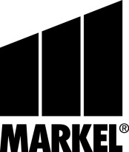  **INTERLINE**

**NOTICE TO POLICYHOLDERS –**

**MERGER AND COMPANY NAME CHANGE**

Effective June 30, 2016, Essex Insurance Company merged with Evanston Insurance Company. Both companies are members of the Markel group of insurance companies. This is to provide you with notice of the merger since coverage was quoted or bound by Essex Insurance Company, but the policy has been issued by the new resulting combined entity, Evanston Insurance Company.

All references to Essex Insurance Company in your quote letter or any other document related to or affecting the purchase of this policy are changed to reflect Evanston Insurance Company’s name.

Evanston Insurance Company is responsible for all Essex Insurance Company legal obligations and commitments. The merger will not impact our obligations to you, and the terms and conditions under this policy will not change as a result of this merger.

This change is the result of an initiative underway at Markel to consolidate insuring entities and simplify its structure.

We remain committed to offering you the best service and quality products for your needs. If you have any questions, please contact your insurance agent or representative.