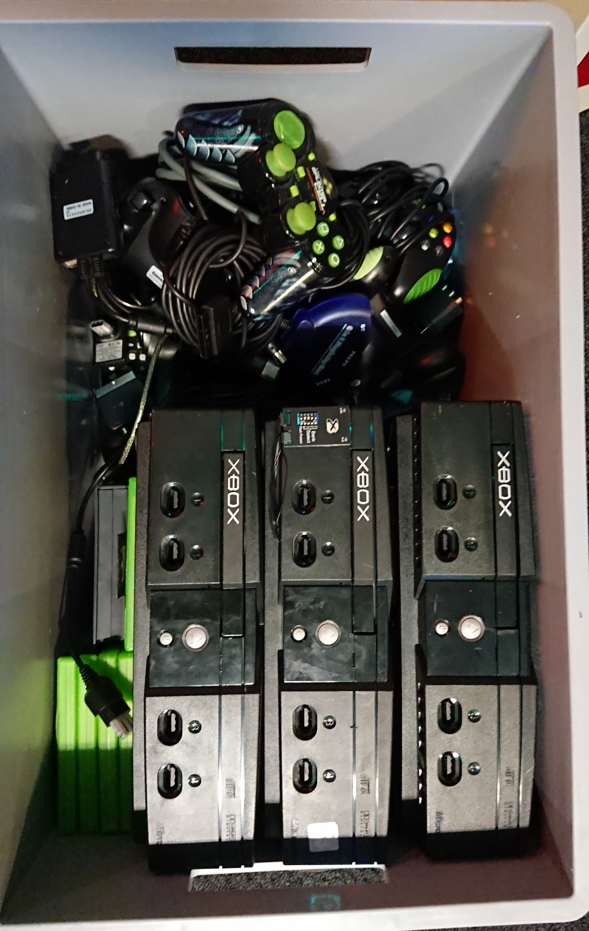
If you are unable to make this box look like the picture below, then do not even think about starting to play with the X-Box. Thank you. The Management

