Celebal Assignment 4

Name: K Syna Reddy
Student ID: CT_CSI_DE_638
College: CVR College of Engineering
Roll No: 23B81A67J0
Department: B.Tech CSE (Data Science)
Internship: Celebal Technologies - Data Engineering
Date: 21 June 2026

Azure Cloud Fundamentals and Data Pipeline Implementation using ADF

Assignment Tasks
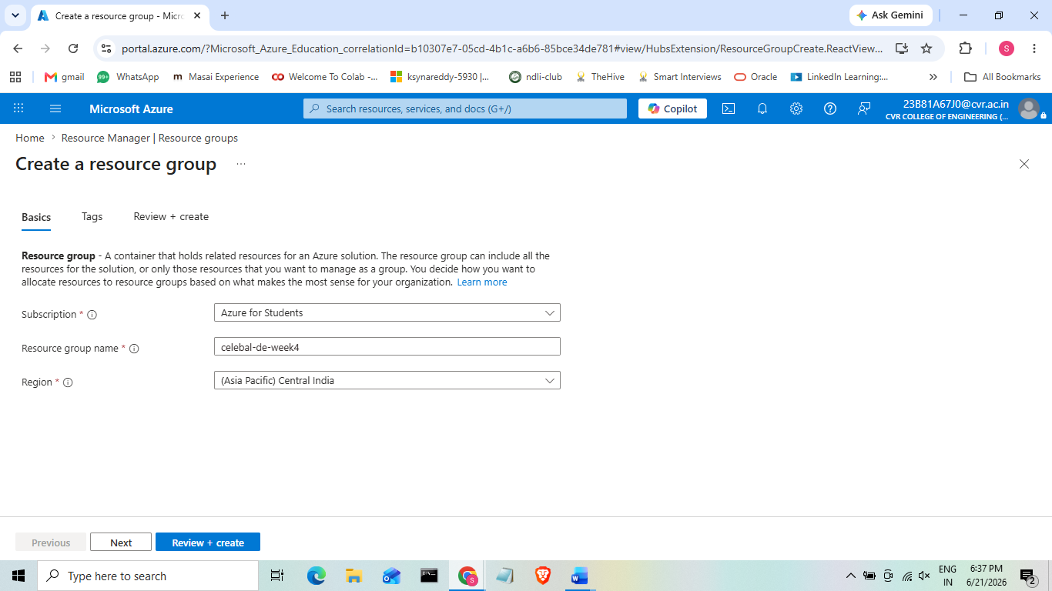
Task 1: Explore Azure Portal + Create a Resource Group

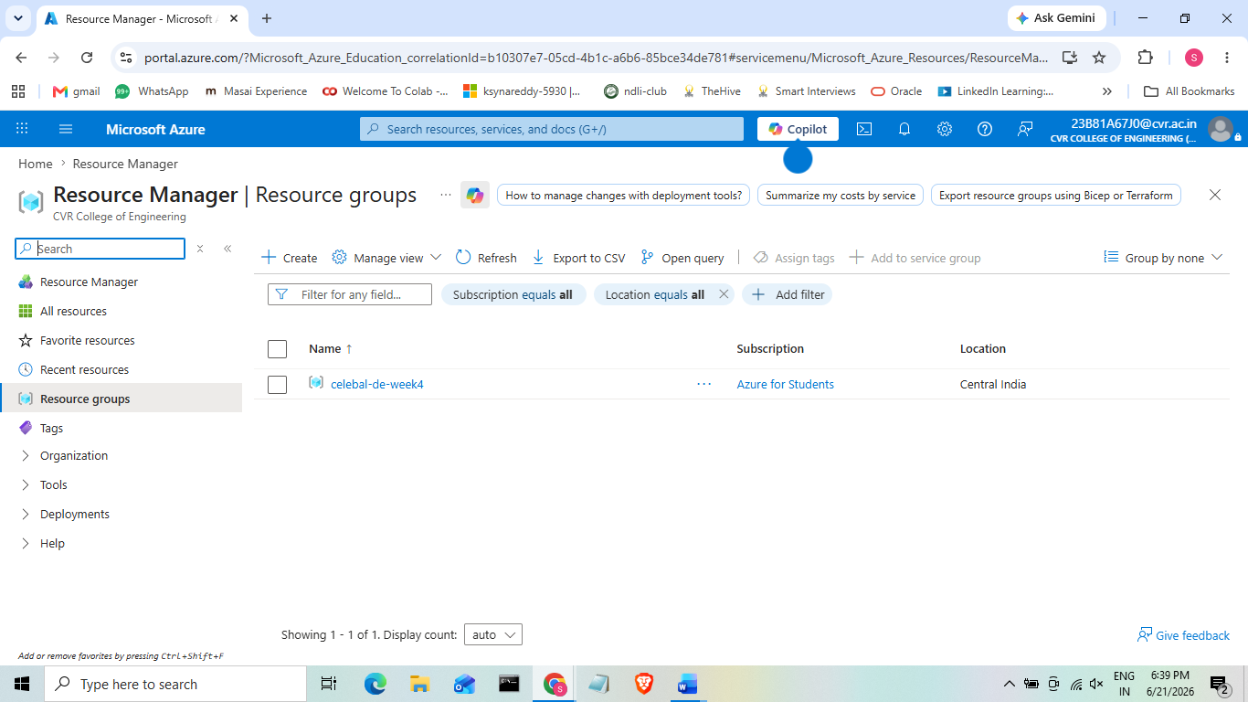
Resource Group:
- A resource group is a fundamental logical container that holds related resouces for a cloud solution.
- It can contain a storage account, adf(azure data factory),etc.
- Every resource in azure like adf or storage account should belong to exactly one resource group, this helps in managing their lifecycle, giving required permissions, track cost and it also helps in deleting everything together just by deleting the whole resource group.
- Without assigning a resource group azure won’t even allow us to create adf or storage account.
- If we skip this step and assign the storage accounts or adf to a default resource group, the whole thing becomes messy and there is a risk of everything getting deleted as they are not kept at the same place and also the access control cannot be given as everything is not stored at the same place.
- Azure Resource Manager (ARM) is the management layer behind the Azure Portal.
- When you create a Resource Group (RG), ARM links it to your subscription and region.
- Every new resource is deployed through ARM and stored under its Resource Group.
- Azure follows this hierarchy: Tenant -> Subscription -> Resource group -> Resource
- This hierarchy enables RBAC inheritance, so permissions assigned to a Resource Group automatically apply to all resources inside it.

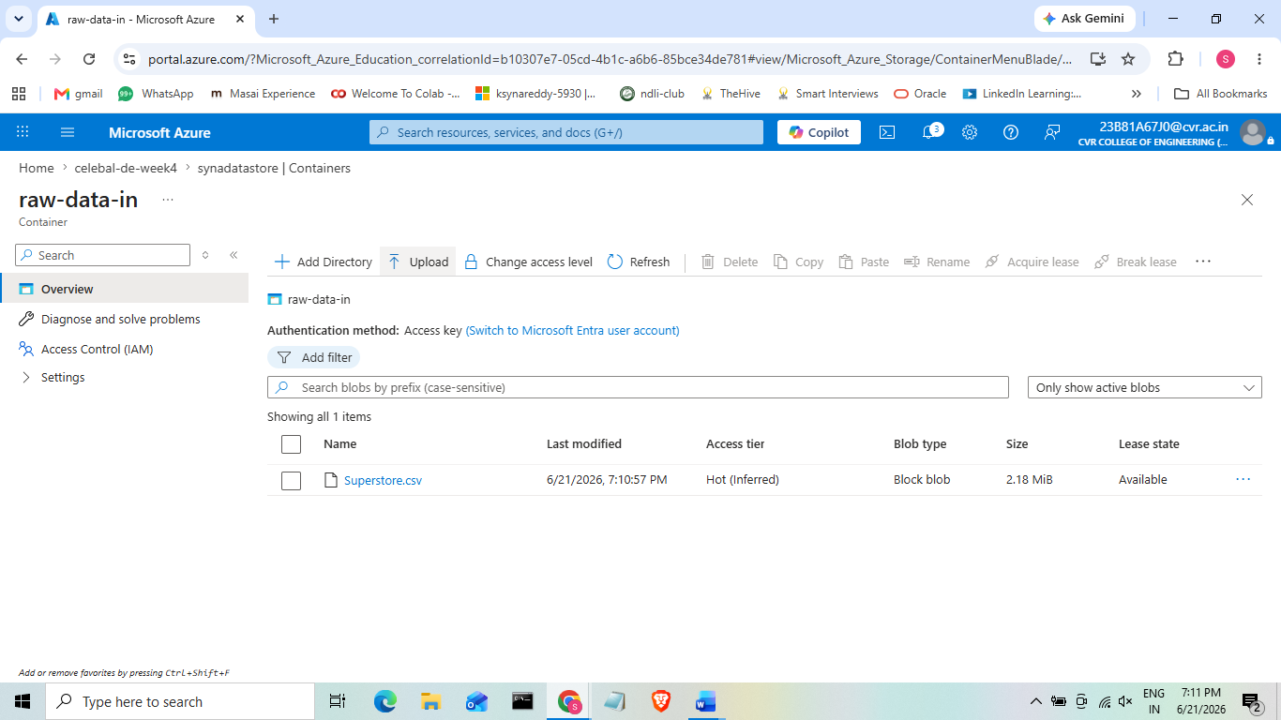
Task 2: Storage Setup
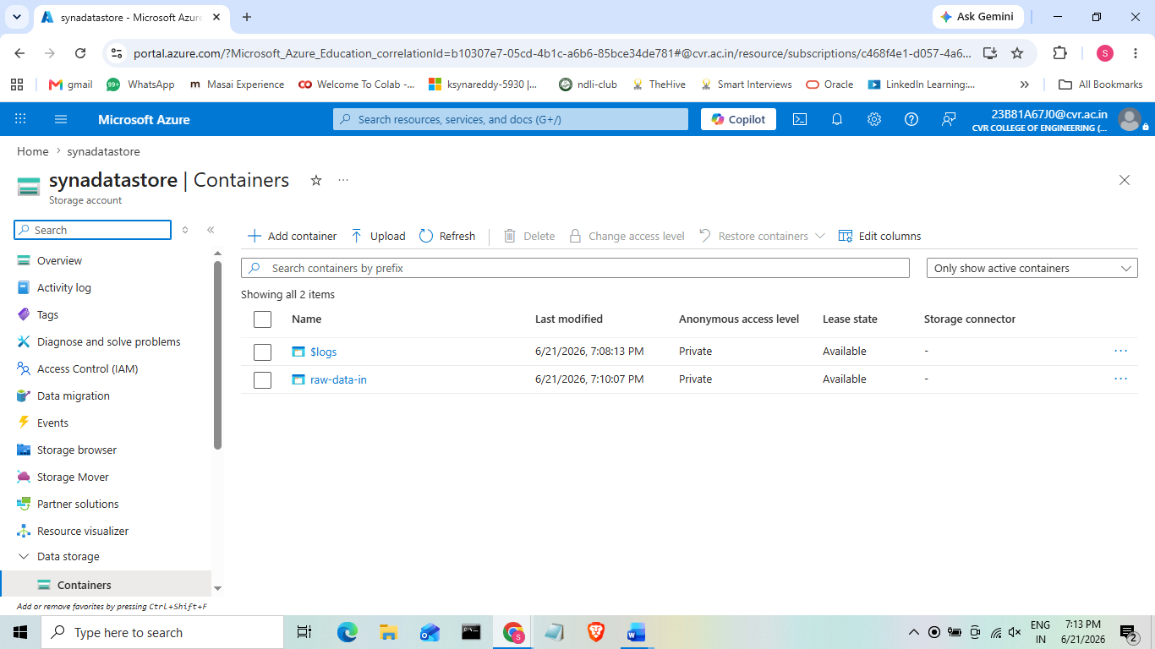

Storage Accounts:
- A Storage Account is Azure's umbrella service for storing data.
- It can store blobs (files), tables, queues, and file shares.
- A Blob Container is like a folder/bucket that holds unstructured files such as a CSV file.
- Blob storage is optimized for storing large amounts of unstructured data cheaply and durably.
- The pipeline starts with data stored in a location that Azure Data Factory (ADF) can access.
- Azure Blob Storage is commonly used as a landing zone because it is cost-effective, scalable, and integrates well with ADF, Databricks, and Synapse.
- Without a Storage Account and container, ADF has nothing to connect to, there's no source for the Linked Service or Dataset to point at, so the entire pipeline is impossible to build.
- Azure Blob Storage is a REST-based object storage service with a flat namespace.
- Each container and blob has a unique URL that can be accessed securely.
- When a file is uploaded, Azure stores it as Block Blobs and creates multiple copies based on the selected replication option (e.g., LRS stores three copies in one datacenter).
- Azure also maintains metadata such as file size, ETag, and last modified time.
- Azure Data Factory (ADF) accesses the file over HTTPS REST APIs using the credentials configured in the Linked Service.

Task 3: ADF Basics
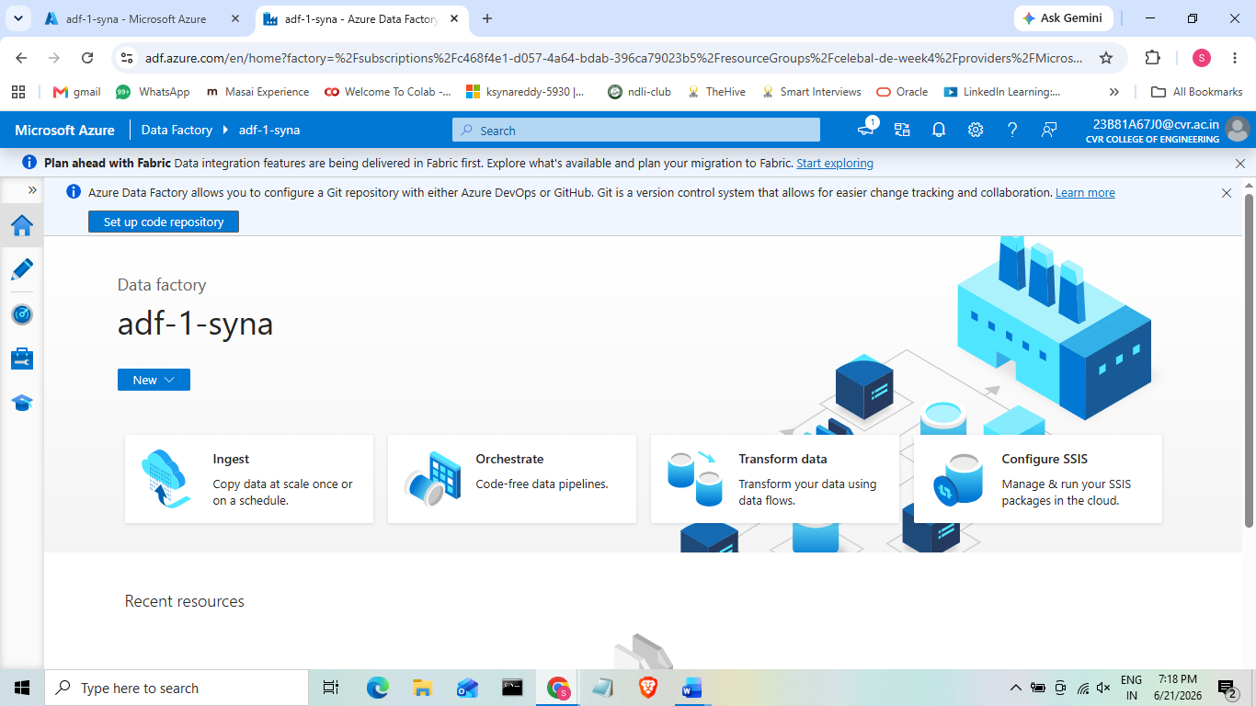
3a. Creation of Azure Data Factory and Exploring the ADF U/I
On the left sidebar, in the above screenshot you can see the 3 things:
- Author (pencil icon): where you build pipelines, datasets, linked services
- Monitor (the dial/speedometer icon): where you see pipeline run history and status
- Manage (toolbox icon): where you configure Linked Services, IR, source control, triggers
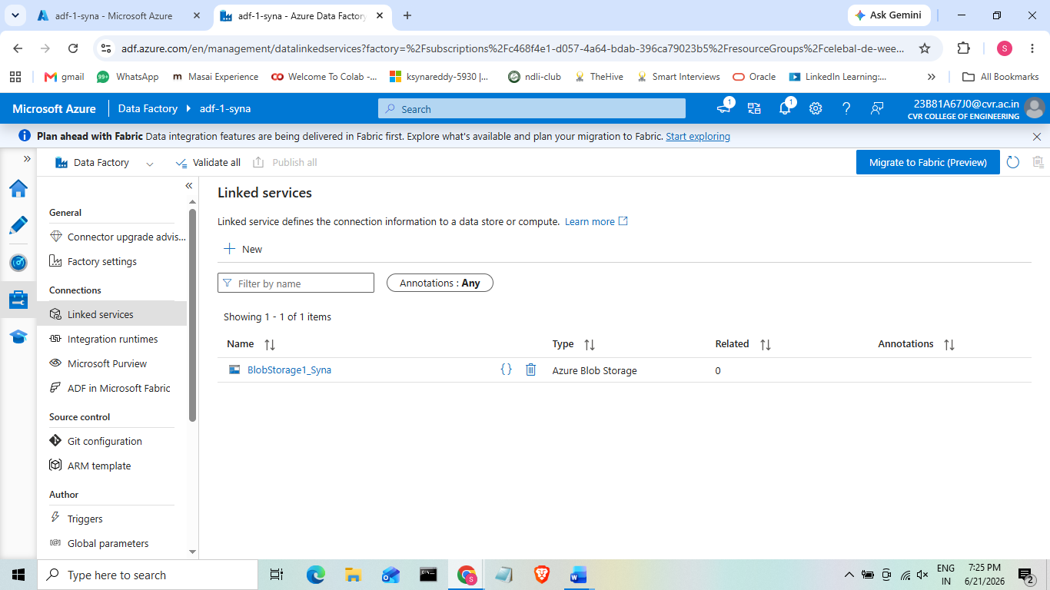
3b. Create Linked Service (Blob Storage)
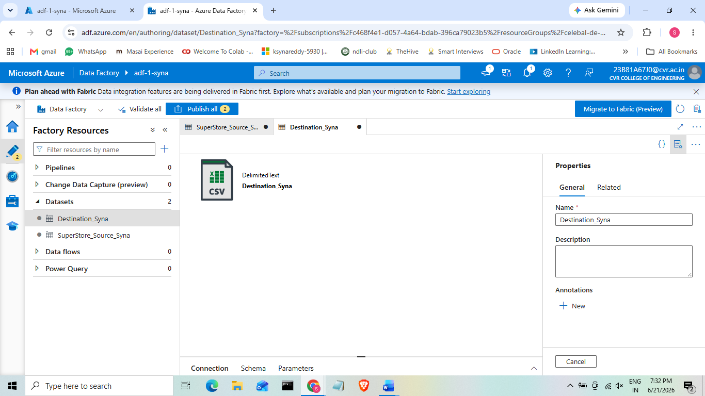
3c. Create Datasets (source and destination)
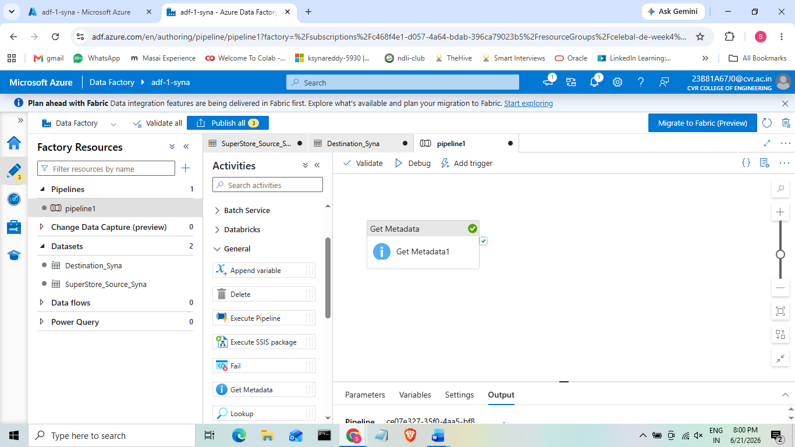
3d. Use Get Metadata activity
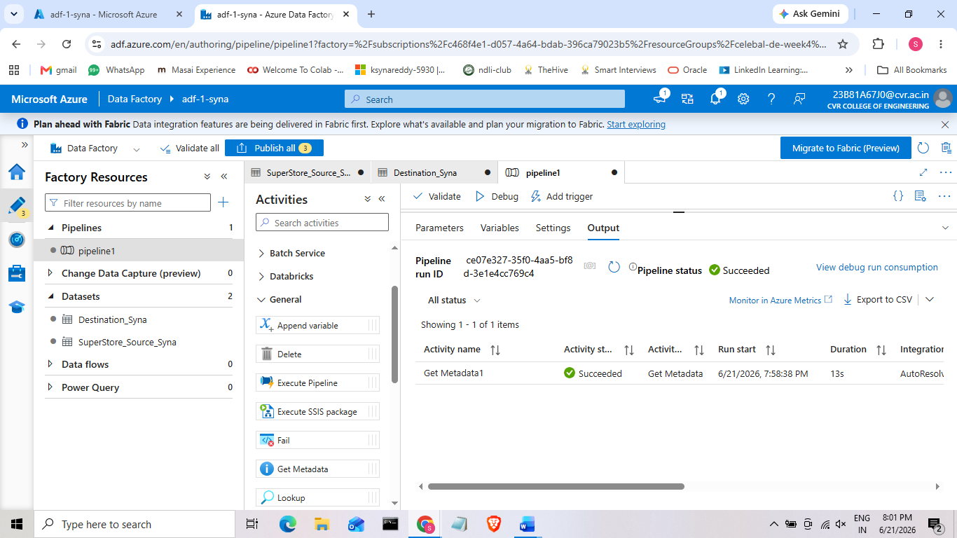

- Linked Service: A Linked Service is essentially a connection string or a credential object that tells ADF how and where to connect to an external system, similar to a database connection string in normal programming.
- Dataset: A Dataset is a named view of data within that Linked Service i.e it points to a specific file, folder, or table, and defines its structure (e.g., delimited CSV with headers).
- Get MetaData: Get Metadata is an activity that retrieves information about a file or folder (size, existence, last modified, column count, etc.) without reading or moving the actual data.
- Linked Service stores the connection details, while a Dataset defines the data location and format, making them reusable.
- A single Linked Service can be used by multiple Datasets.
- Get Metadata is used as a pre-check to verify that a file exists, is not empty, or to check properties like the last modified date.
- These checks help avoid unnecessary processing and support incremental loading by identifying new or updated files.
- Without a Linked Service, ADF cannot authenticate to Blob Storage, so the pipeline cannot access the data.
- Without a Dataset, ADF does not know which specific file or location to read from or write to.
- Skipping Get Metadata does not stop the pipeline, but it removes file validation.
- In production, this can lead to processing missing, empty, or corrupted files, causing pipeline failures or incorrect results.
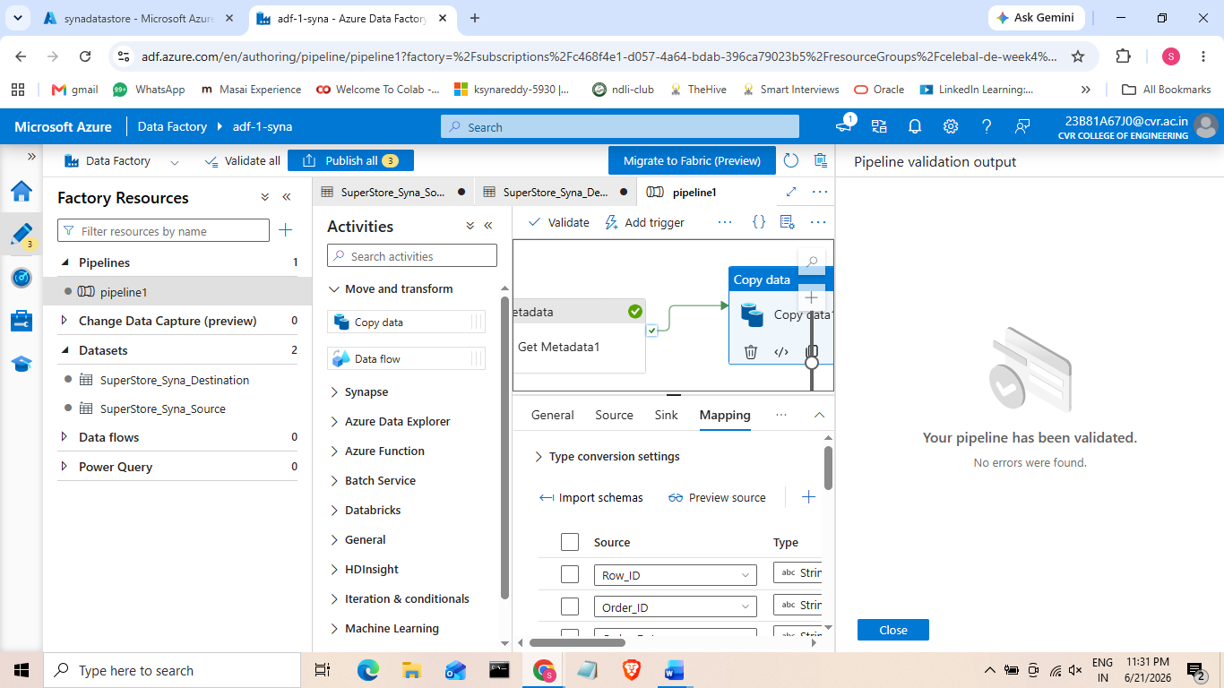
Task 4: Pipeline Development — Copy Data Activity

PipeLine:
- An ADF Pipeline is a collection of activities that work together to perform a complete data workflow.
- The Copy Data activity is used to move data from a source dataset to a destination (sink) dataset.
- It can also perform simple tasks such as column mapping during the data transfer.
- This is the core EL (Extract and Load) process, since no data transformation is performed.
- The Copy Data activity moves data from the source to the destination.
- Connecting Get Metadata to Copy Data with a success path ensures that data is copied only after the source file is successfully validated.
- This approach helps prevent errors by avoiding the processing of missing or invalid files.
- Without the Copy Data activity, no data is transferred i.e. Get Metadata only retrieves file information.
- The dependency between Get Metadata and Copy Data ensures the file is validated before copying.
- If this dependency is skipped, the pipeline may try to copy missing or empty files, leading to failures or incorrect data processing.
- When the Copy Data activity runs, the Integration Runtime reads data from the source and streams it to the destination.
- ADF uses parallel copying and chunked data transfer, allowing it to efficiently copy large files without loading the entire file into memory.
- The dependency between activities is stored as a dependsOn condition in the pipeline.
- Before running Copy Data, ADF checks whether the previous activity (Get Metadata) completed successfully.
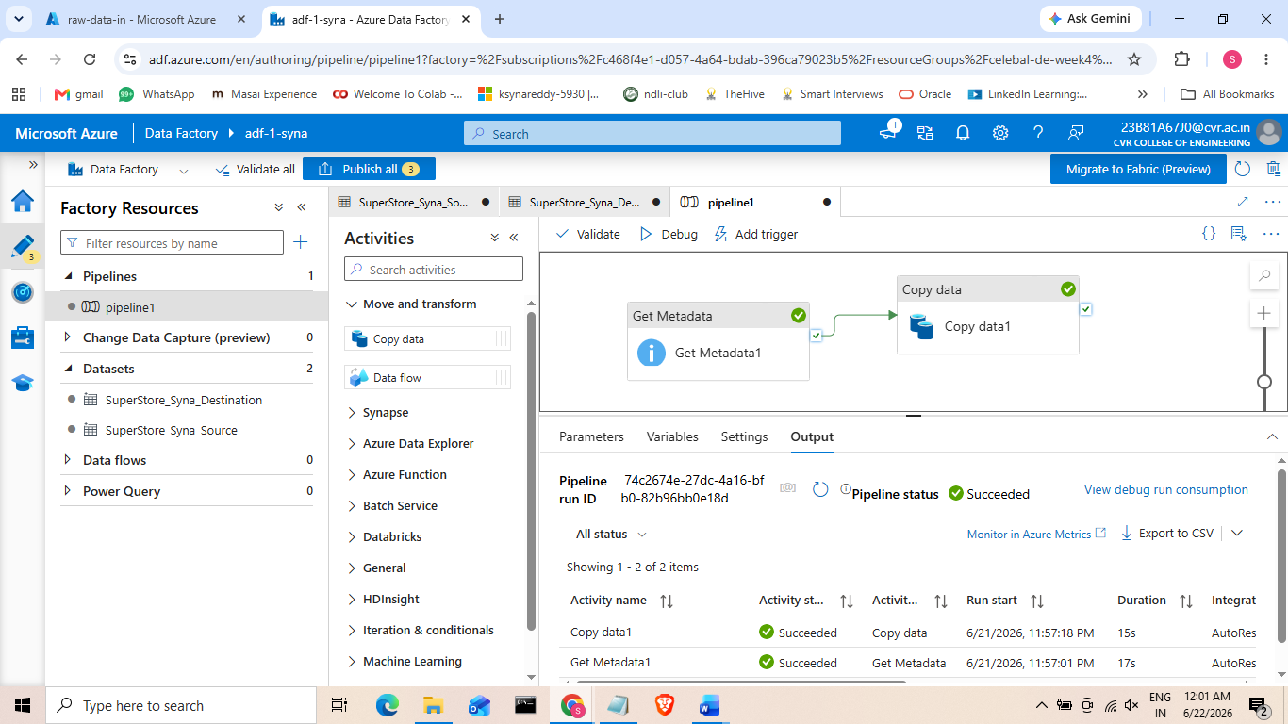
Task 5: Pipeline Execution
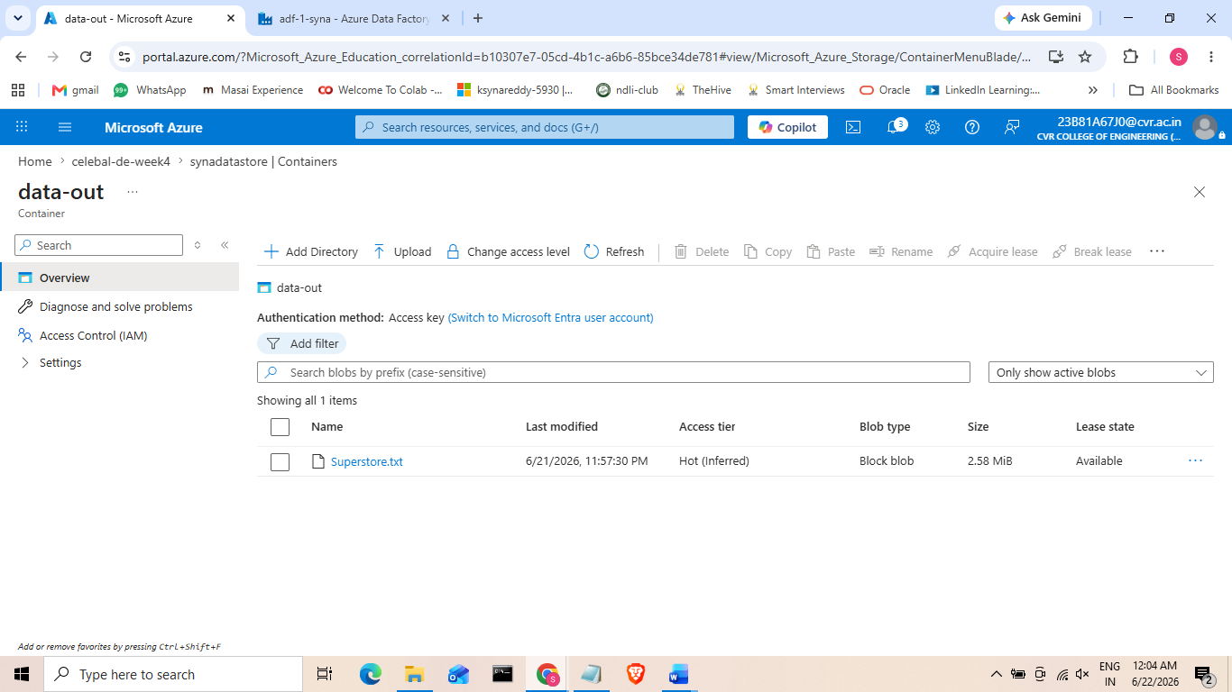
- Superstore.csv copied from source i.e. raw-data-in to destination i.e. data-out successfully.
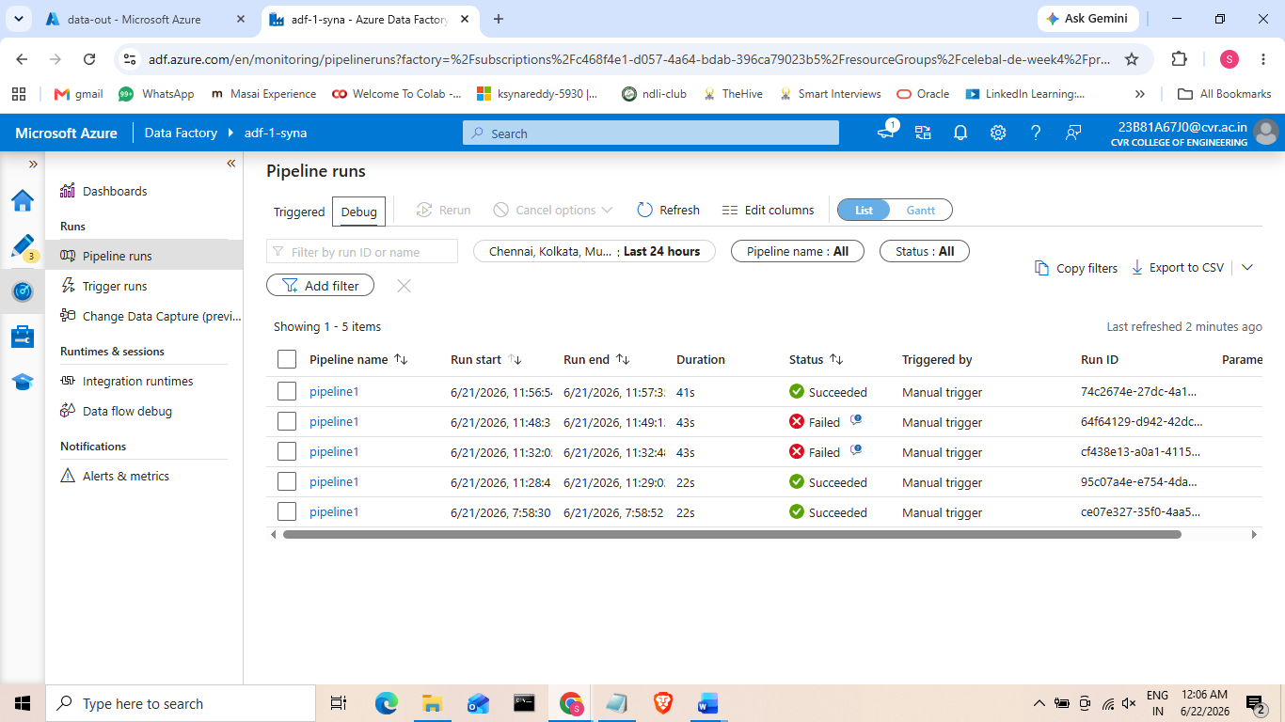

- Debug: Debug runs the pipeline immediately using a temporary session, it is useful for development/testing, and it does not require the pipeline to be published.
- Trigger: Trigger runs a published pipeline either manually or automatically on a schedule/event, this is how production pipelines actually run unattended in real world projects.
- Monitor: Monitor is ADF's logging and observability dashboard showing every pipeline run, its status, duration, and any error details.
- Running the pipeline verifies that it works correctly from start to finish.
- The Monitor tab lets you track pipeline status, execution time, and any errors.
- Monitoring helps quickly identify and troubleshoot failures, making it essential for managing production data pipelines.
- Without executing the pipeline, you cannot confirm that it works correctly at runtime.
- Errors such as permission issues, incorrect file paths, or schema mismatches are detected only during execution.
- Without using the Monitor tab, failed or scheduled pipeline runs may go unnoticed.
- Monitoring helps identify failures early before they affect downstream processes or users.
- Debug runs the pipeline in a temporary session without publishing it, allowing you to test changes.
- A Trigger run executes the published pipeline and stores the run details in the pipeline history.
- Each pipeline run records information such as start time, end time, status, and Copy Data metrics (for example, rows copied and data transferred).
- These details are displayed in the Monitor tab, making it easier to track and troubleshoot pipeline executions.
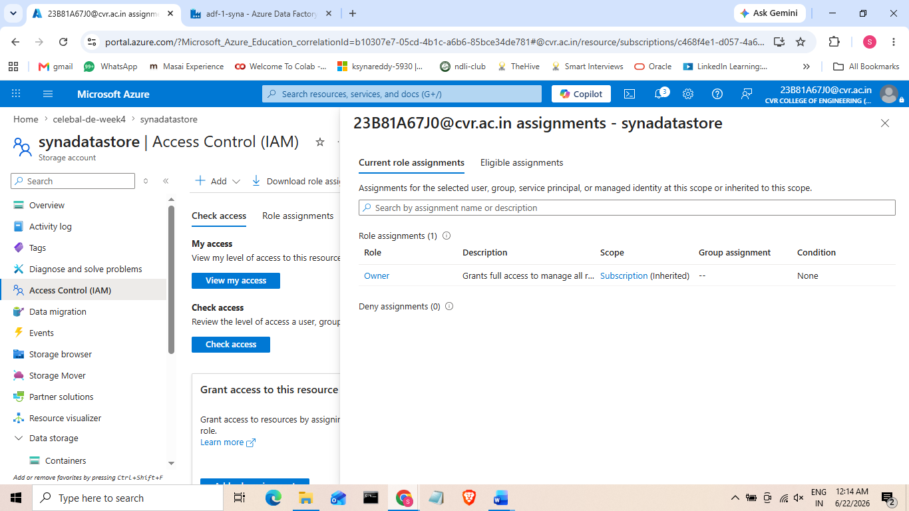
Task 6: IAM Roles — Reader, Contributor, Access between ADF and Storage
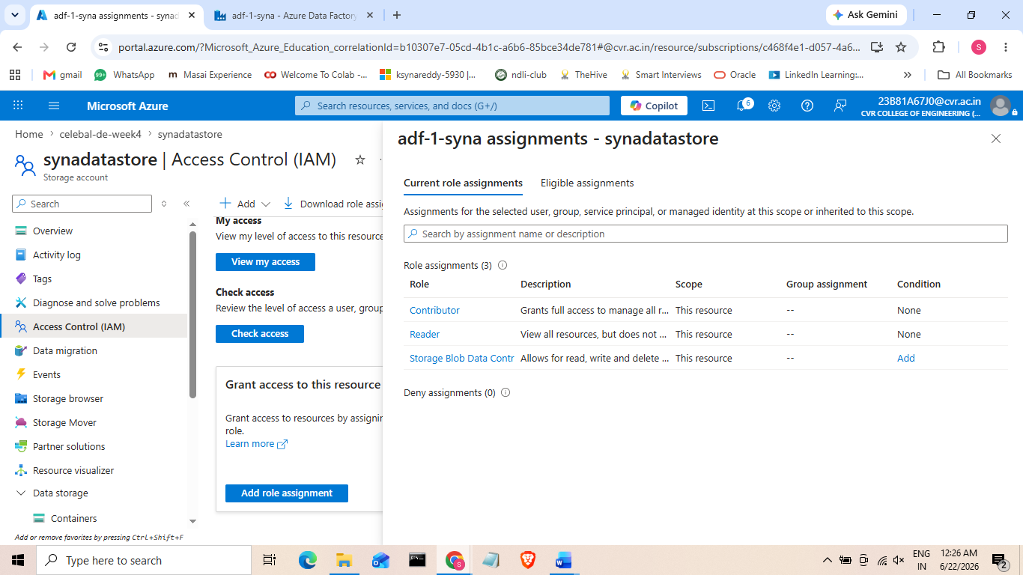
- IAM Roles: IAM (Identity and Access Management) in Azure is implemented using Role-Based Access Control (RBAC) to control who can access and manage resources.
- The ADF managed identity was assigned three roles on the storage account:
- Reader: Can view resource settings but cannot modify resources or access blob data.
- Contributor: Can create, update, and delete storage resources, but cannot access blob data or manage role assignments.
- Storage Blob Data Contributor: Can read, write, and delete blob data. This role is required for Get Metadata and Copy Data activities.
- Managed Identity: A Managed Identity is an automatically created Azure identity for a service, allowing it to securely access other Azure resources without storing passwords, keys, or secrets.
- Azure separates management-plane access (managing the resource) from data-plane access (accessing the data inside the resource).
- Assigning Reader, Contributor, and Storage Blob Data Contributor demonstrates a proper understanding of Azure's layered access model.
- This approach follows the principle of least privilege, where users and services receive only the permissions they need.
- Using a Managed Identity is the recommended production approach because it allows secure authentication without storing or managing passwords, keys, or secrets.
- During the pipeline build, the Linked Service authenticated successfully using the storage account key.
- If Managed Identity had been used instead, the Storage Blob Data Contributor role would have been required to access the blob data.
- Without this role, ADF would return a 403 Authorization error, even though the storage account exists and is reachable.
- This shows that authentication alone is not enough—the correct RBAC permissions are also required to access data.
- Assigning only the Contributor role allows management of the storage account but does not grant access to blob data.
- As a result, activities like Copy Data and Get Metadata will fail with an authorization error.
- This is a common mistake, as many assume Contributor provides full access, but it excludes data-plane operations.
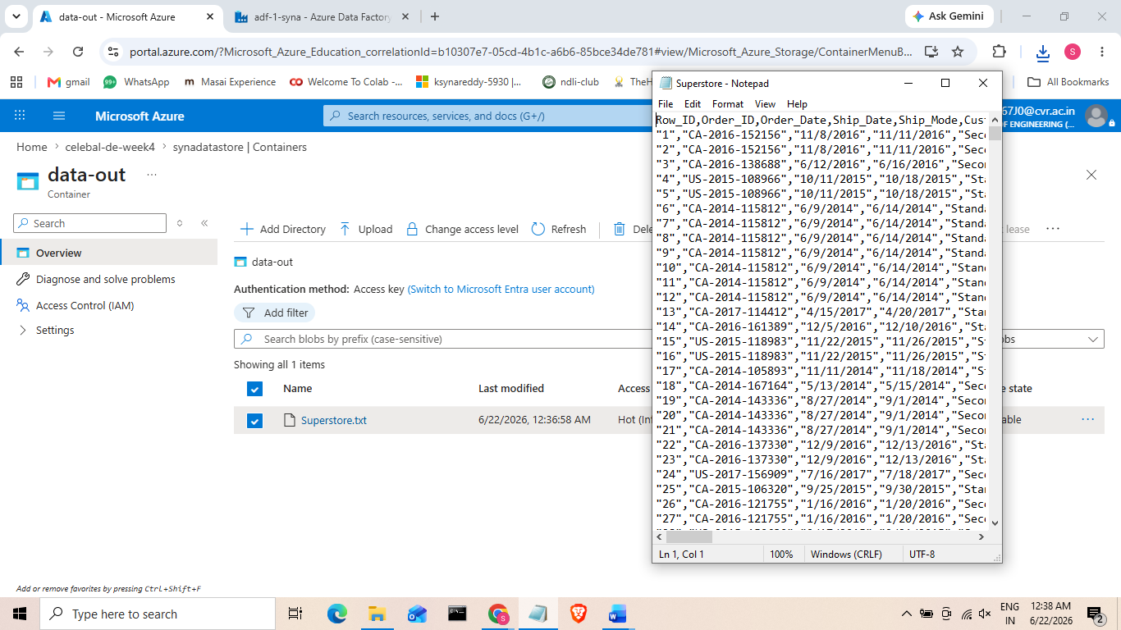
- If only the Reader role is assigned, the identity can only view the resource and cannot access or process blob data, so Copy Data and Get Metadata will also fail.
- This is the superstore file that was copied from source to destination successfully.

Mini Project: End-to-End Pipeline (Blob → ADF → Destination) with Metadata Validation
- This mini project is a combination of task 3,4 and 5.
- The source CSV in the raw-data-in container was validated using Get MetaData activity and then was copied by the Copy Data activity into the data-out container.
- The pipeline succeded and the data was copied successfully.
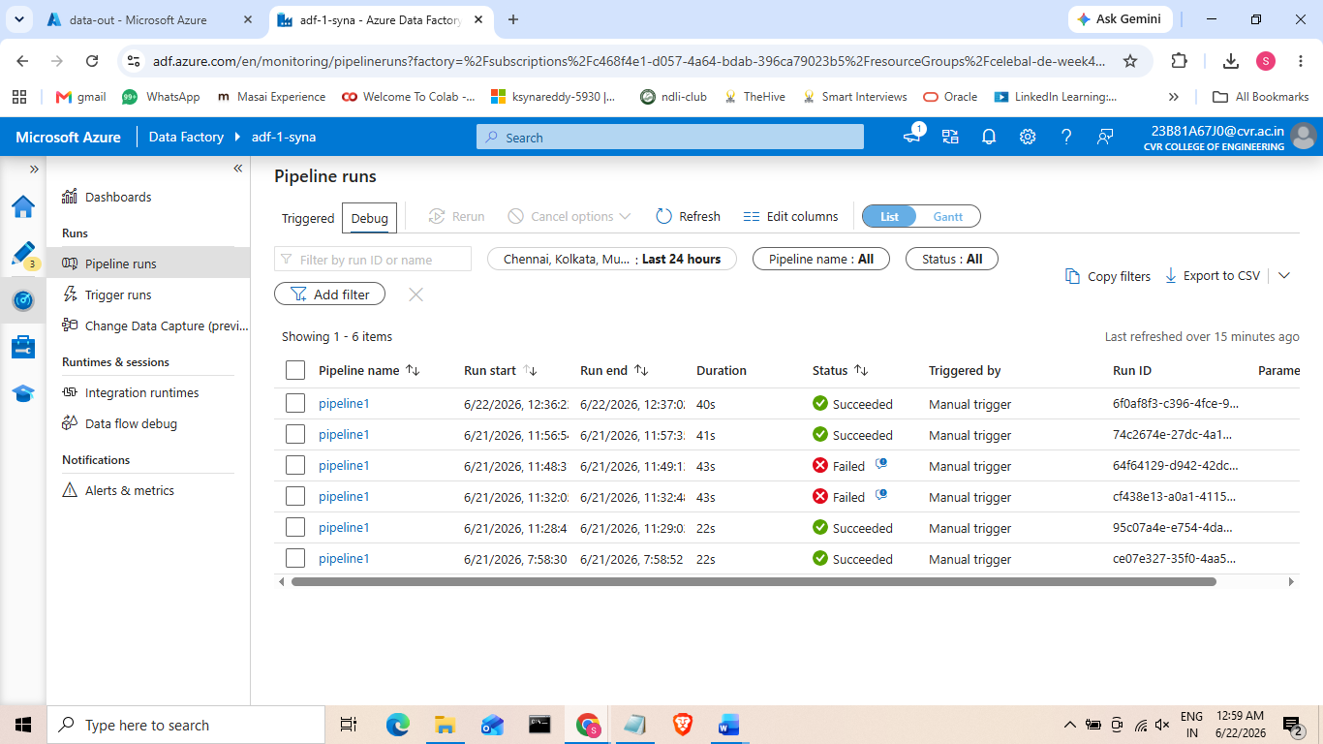
- The screenshot below confirms the final output i.e. the copied file present in the destination container and the pipeline run history showing successful execution.

