Celebal Assignment 3

Name: K Syna Reddy
Student ID: CT_CSI_DE_638
College: CVR College of Engineering
Roll No: 23B81A67J0
Department: B.Tech CSE (Data Science)
Internship: Celebal Technologies - Data Engineering
Date: 15 June 2026

Use Subqueries, CTEs, and Window Functions to analyze sales data from the Superstore dataset.

Step 1: Setup Data
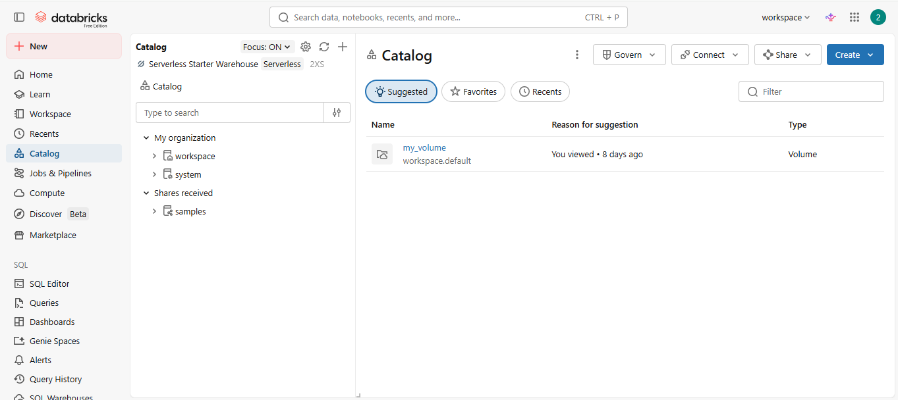
- Open databricks and go to catalog.
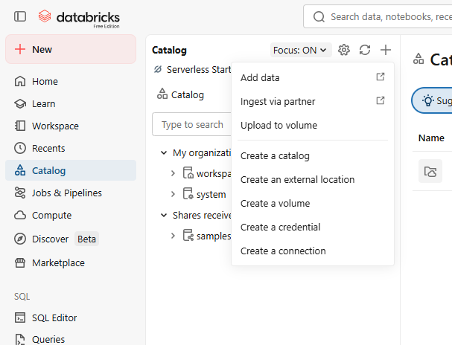
- Now click on the ‘+’ sign and select add data.

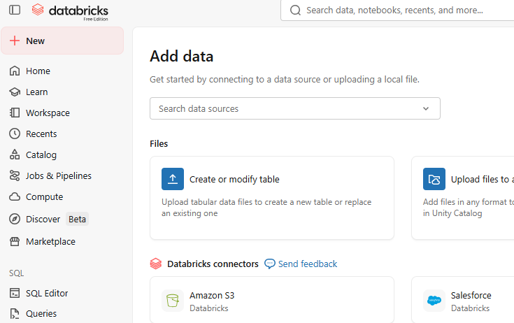
- Now click on create or modify table.

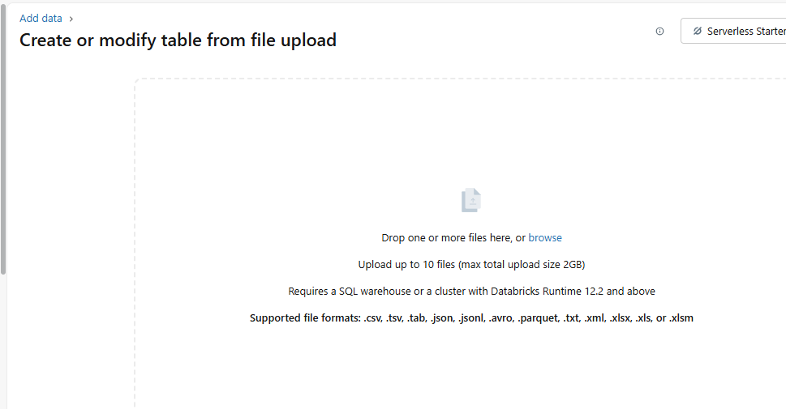
- Drop the superstore dataset over here.

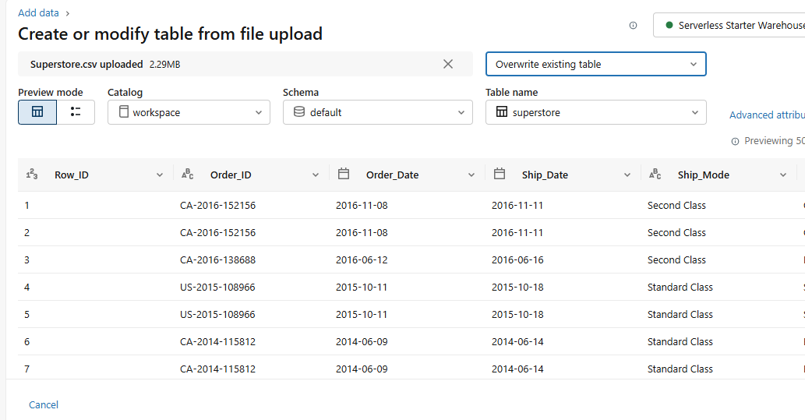
- If the table already exists click on overwrite.
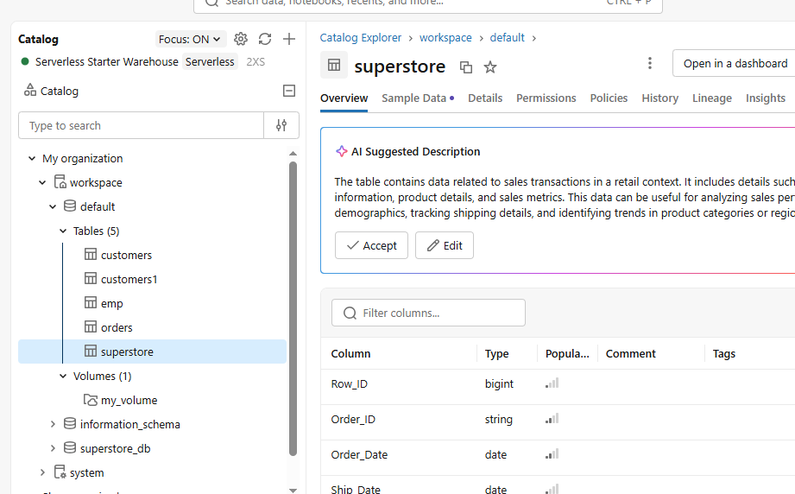
- The table is created.

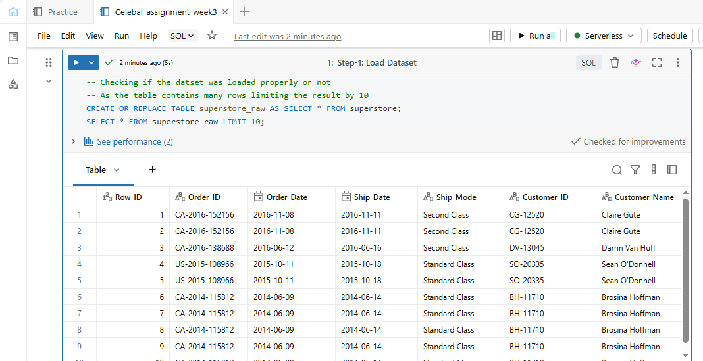
- Now click on workspace and choose the SQL notebook you want to work with and change the table name to superstore_raw and check if the table is loaded properly.
- Creating 3 tables out of superstore_raw table using SELECT DISTINCT
The 3 tables are:
a. Customers
b. Orders
c. Products
- Customers
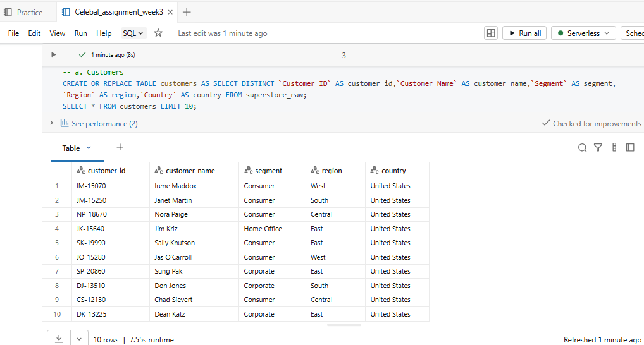
Addding the columns : Customer_ID, Customer_Name, Segment, Region and Country in the customers table.
- Products
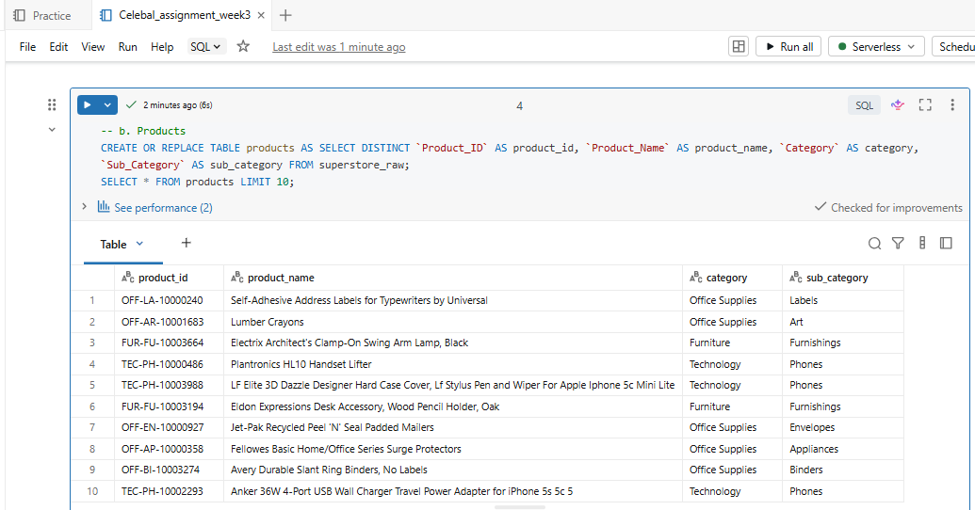
Selecting columns: Product_ID, Product_Name, Category and Sub_Category.
- Orders
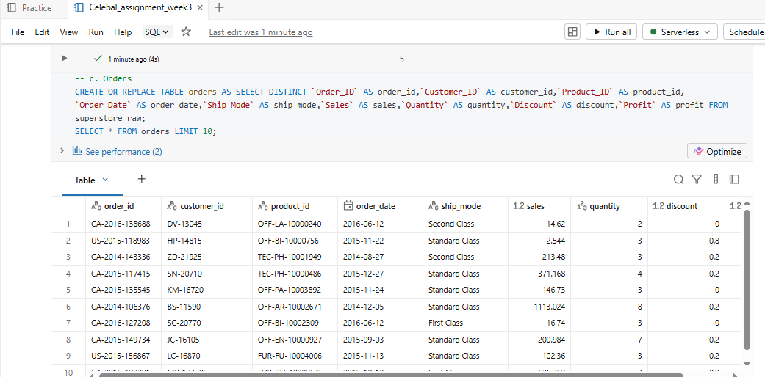
Adding columns: Order_ID, Customer_ID, Product_ID, Order_date, Ship_Mode, Sales, Quantity, Discount, Profit.

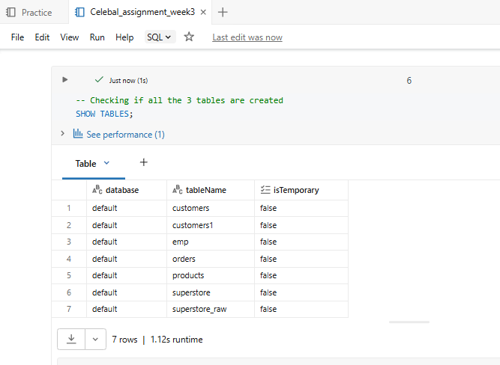
- Checking if all the 3 tables are created.
Step 2: Perform Required Queries

Write and execute SQL queries for each of the following:

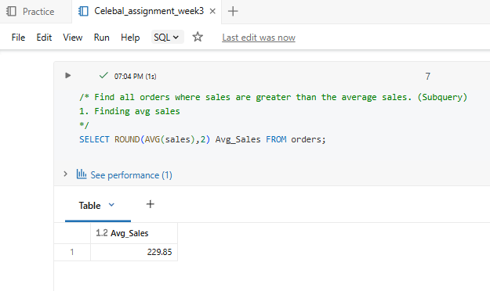
- Find all orders where sales are greater than the average sales. (Subquery)

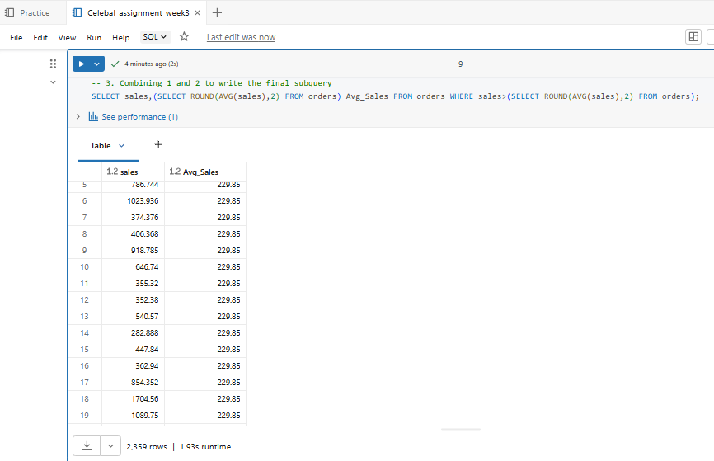
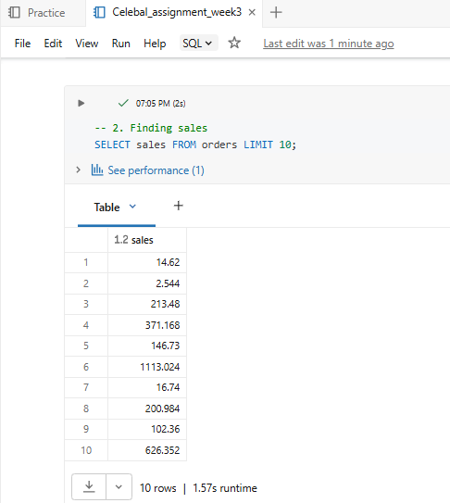
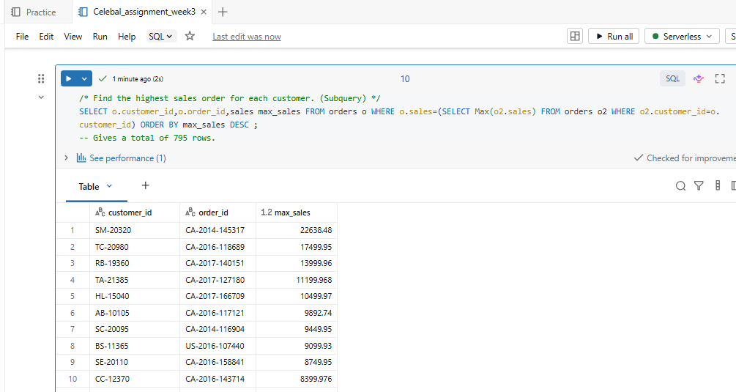
- Find the highest sales order for each customer. (Subquery)
- Calculate total sales for each customer. (CTE)
CTE: Common table expression is used to create a virtual resultset/table that can be used multiple times in the same query.
It starts with the ‘with’ clause, clause name, columns to be selected and the query to be performed on it.
Here we can perform all the CRUD operations on the virtual resultset.
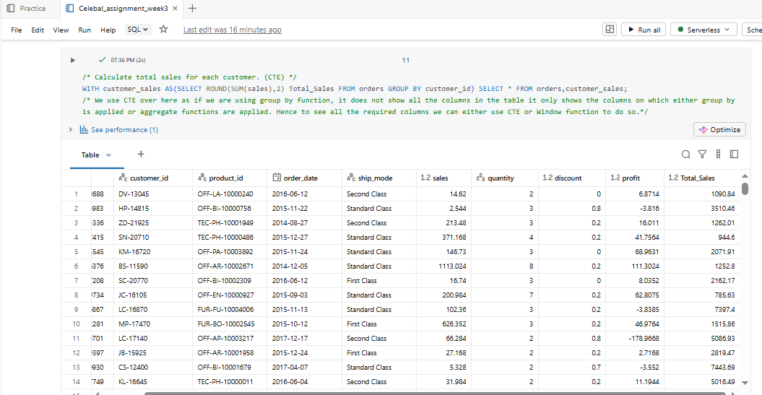
It helps in making complex queries easier.
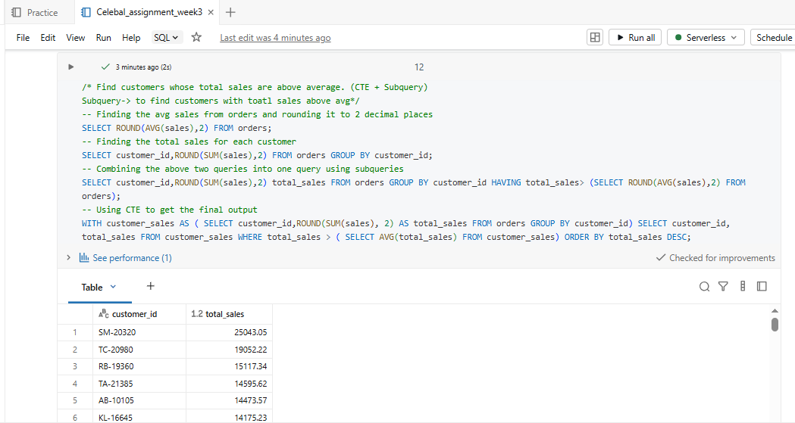
- Find customers whose total sales are above average. (CTE + Subquery)
- Rank all customers based on total sales. (Window Function)
Window function is used to make complex queries simple.
Its syntax is: SELECT colnames over(partition by/order by) FROM table name conditions;
PARTITION BY: acts like group by
ORDER BY: Used to sort specified columns in either ascending or descending order.
RANK(): Used to find rank of the rows present in the table. It contains gaps i.e. 1,2,2,4 here it skips 3 as in place of the second 2 3 should have been there.
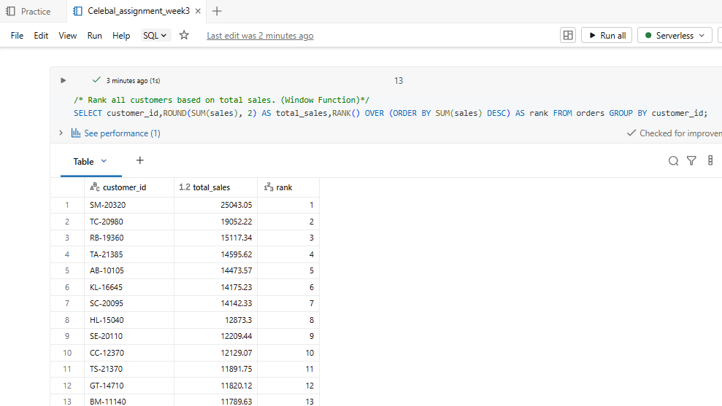
DENSE_RANK(): Used to find rank of the rows present in the table. It does not contain gaps i.e. 1,2,2,3 here it keeps 3 and moves on.
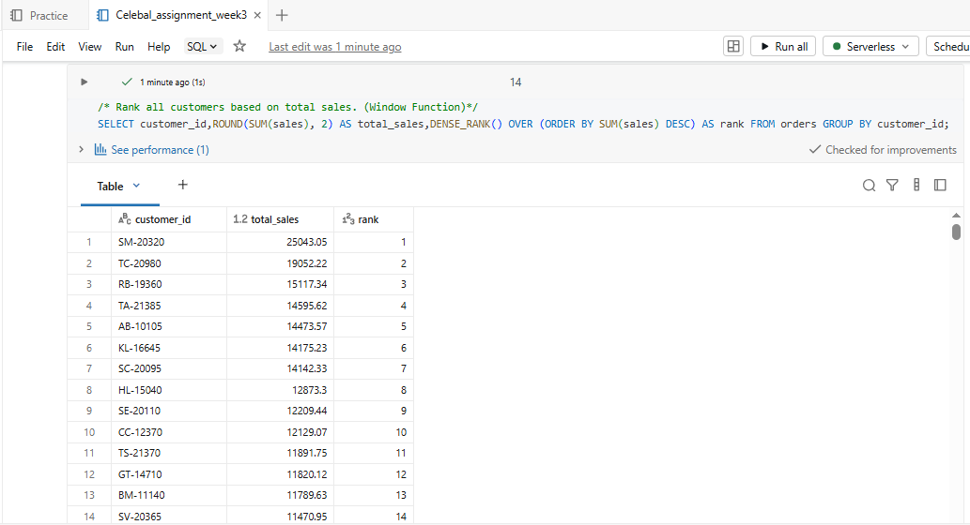
- Assign row numbers to each order within a customer. (Window Function + PARTITION BY)
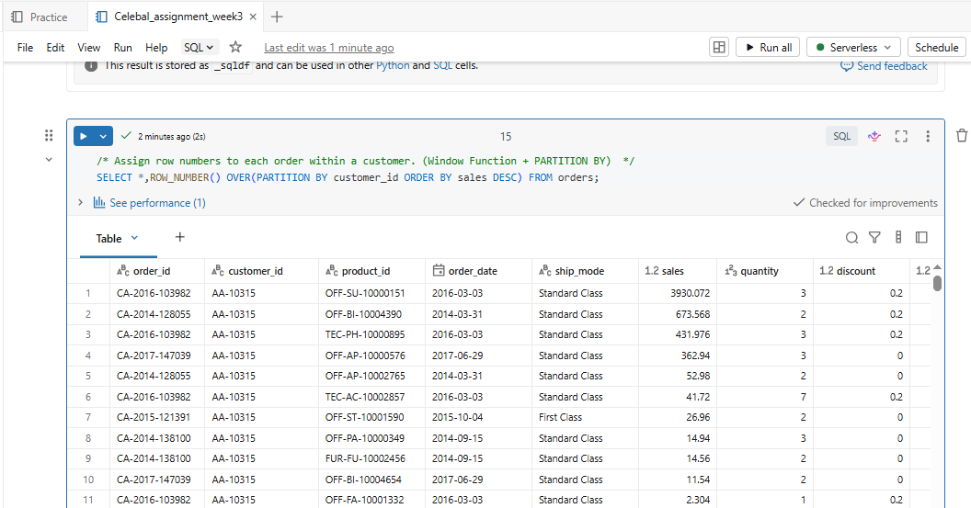
ROW_NUMBER(): Used to number the rows of a table

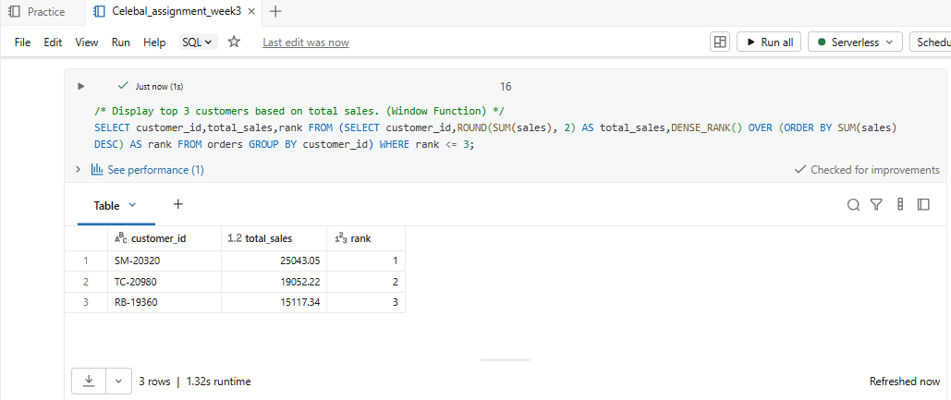
- Display top 3 customers based on total sales. (Window Function)
Step 3: Final Combined Query
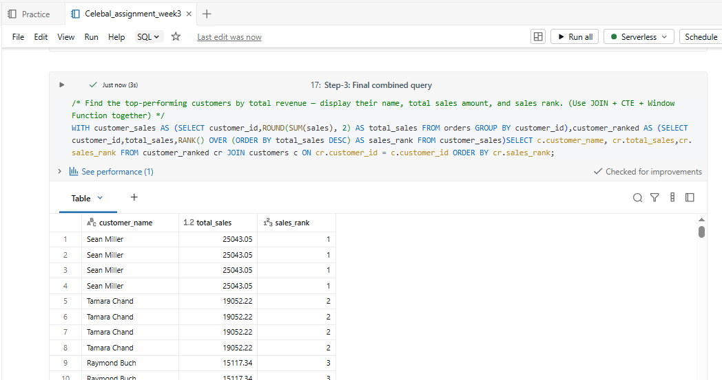
- Find the top-performing customers by total revenue — display their name, total sales amount, and sales rank. (Use JOIN + CTE + Window Function together)

Mini Project: Customer Sales Insights
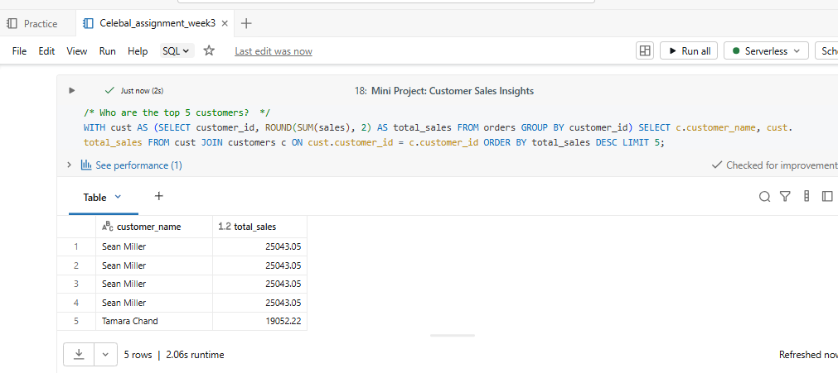
- Who are the top 5 customers?
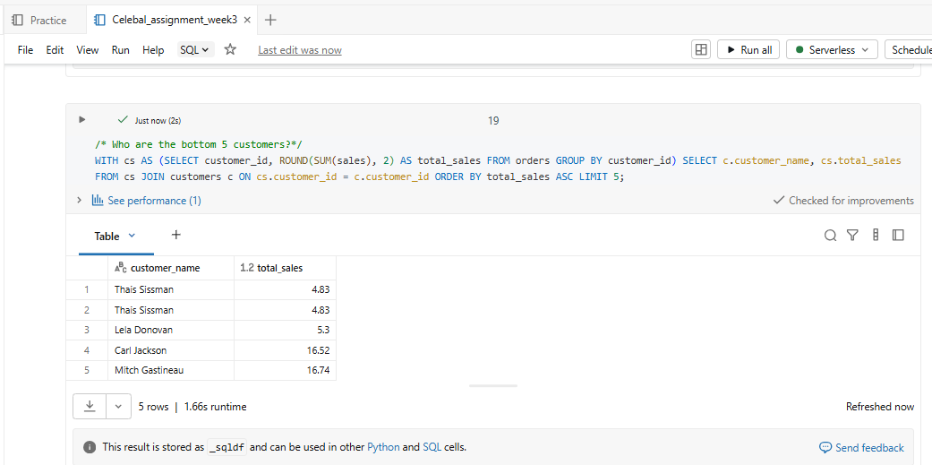
- Who are the bottom 5 customers?

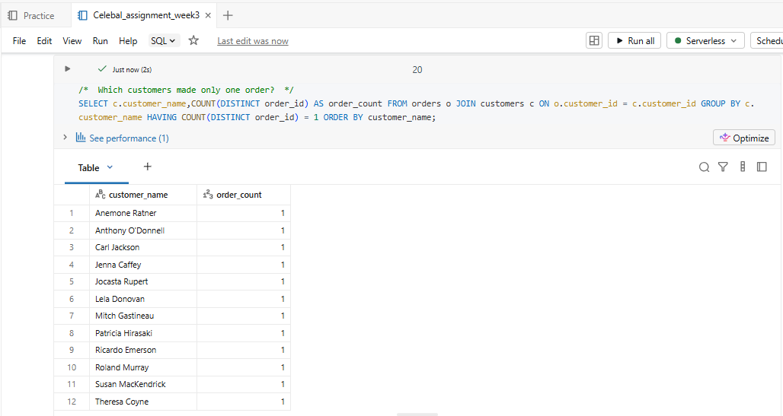
- Which customers made only one order?
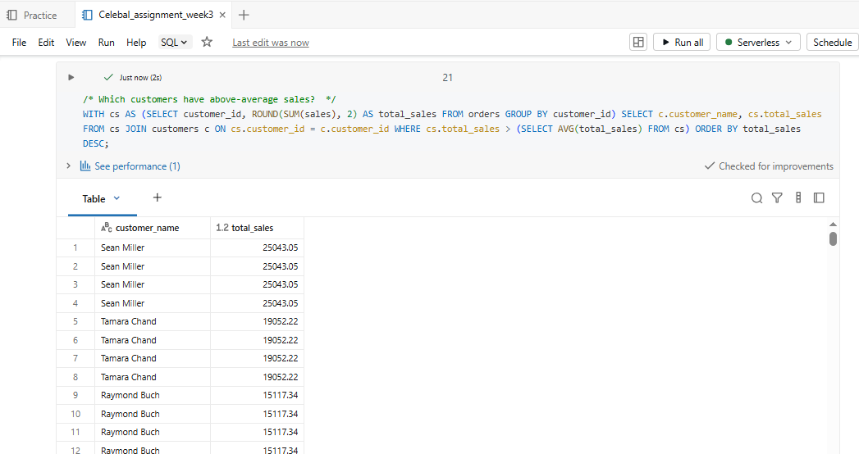
- Which customers have above-average sales?

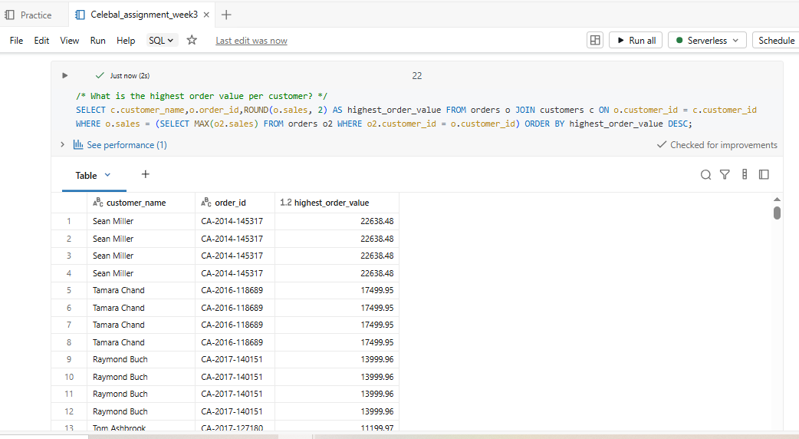
- What is the highest order value per customer?

