Celebal Assignment 2

Name: K Syna Reddy
Student ID: CT_CSI_DE_638
College: CVR College of Engineering
Roll No: 23B81A67J0
Department: B.Tech CSE (Data Science)
Internship: Celebal Technologies - Data Engineering
Date: 8 June 2026

Word Document Answers

DataBase and Table Creation According to Word Document

- Creation of table customers with 2 indexes i.e. idx_customers_city and idx_customers_state for filtering city and state.
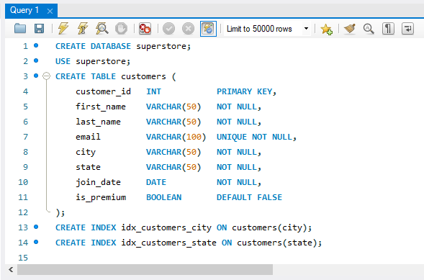
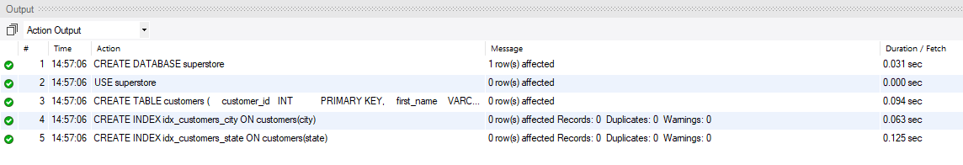

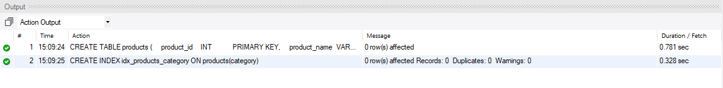
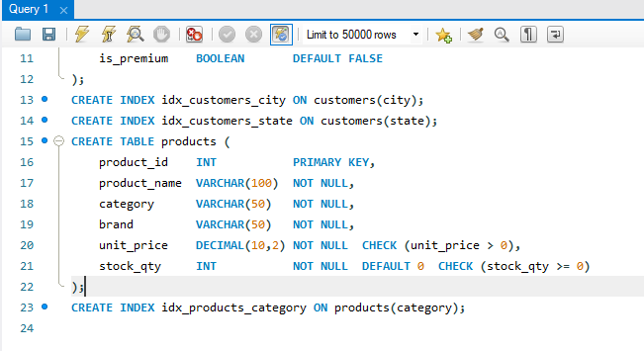
- Creation of table products and an index for filtering products based on category.
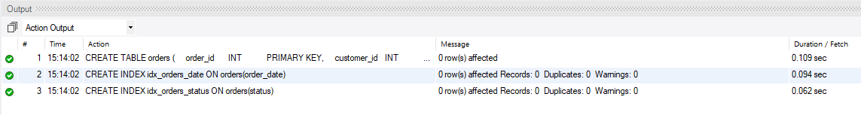
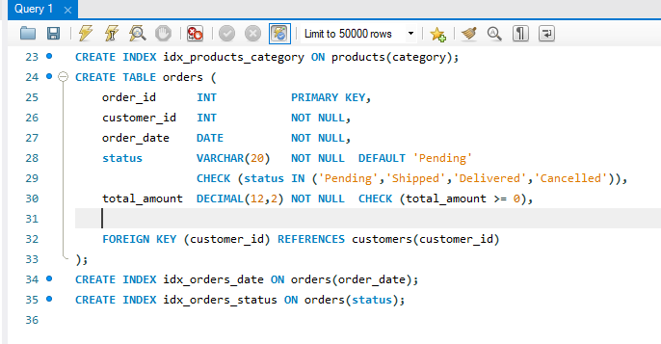
- Creation of table orders and 2 indexes for date based filtering and sorting.
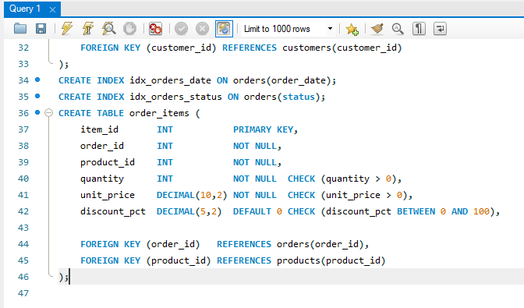
- Creation of table order_items with 2 foreign key relationships between order_id of orders table and order_id of order_items table as well as relationship between product_id of products table as well as product_id of order_items table.
Inserting rows in the created tables

- Inserting rows in customers table.
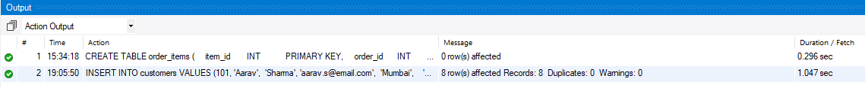
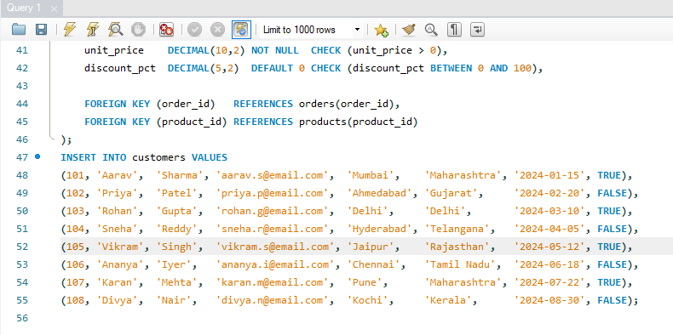
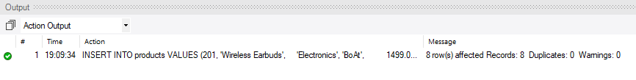
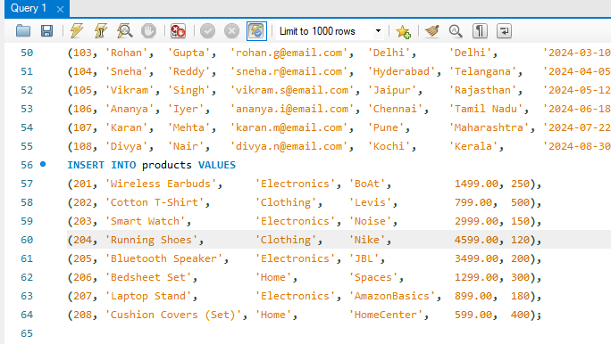
- Inserting rows in products table

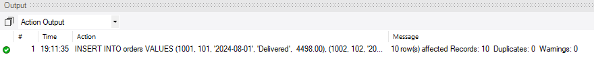
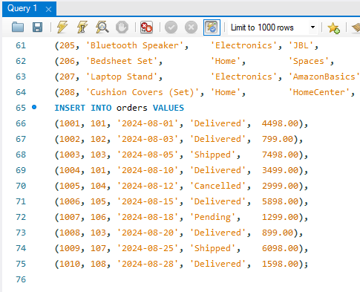
- Inserting rows in orders table

- Inserting rows in order_items table
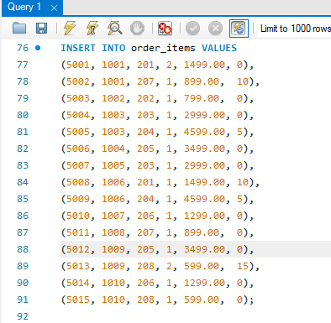

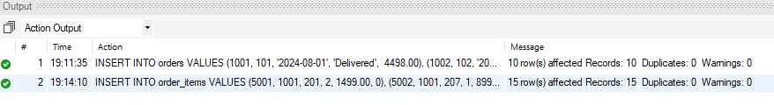
Hjdvvfdvbjdfbvjfdvbjdfbvfdvbudfbvvbjbvjfvfdbv

Section A — SQL Basics (SELECT, Constraints, Primary Keys)
Q1. Write a query to display all columns and rows from the customer's table.
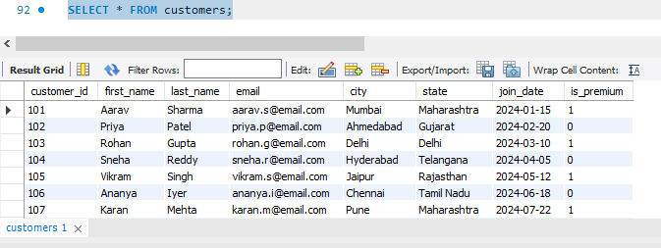

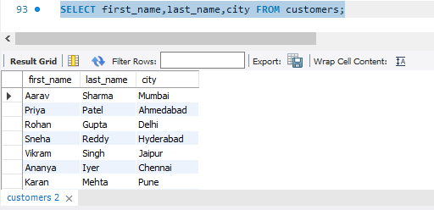
Q2. Retrieve only the first_name, last_name, and city of all customers.
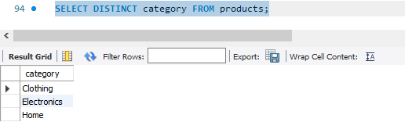
Q3. List all unique categories available in the products table.
Q4. Identify the Primary Key of each table in the schema. Explain why a Primary Key must be unique and NOT NULL.
- The primary keys in each of the tables are as follows:
- Customers table -> customer_id
- Products table -> product_id
- Orders table -> order_id
- Order_items table -> item_id
- Primary keys are used to uniquely define every record/row in a table.
- If there were 2 rows having the same primary key then the database won’t know on which rows the operations should be performed, hence primary key must be unique to identify each row uniquely.
- Primary keys cannot be NULL values as well, as NULL means unknown and unknown values cannot uniquely identify a row.

Q5. What constraints are applied to the email column in the customers table? What would happen if you tried to insert a duplicate email?
- There are 2 constraints applied on the email column. They are:
- NOT NULL -> It means that every customer should have an email and that this column should not be left empty.
- UNIQUE -> It means that no 2 customers should have the same address.
- If we try to insert duplicate emails or no email at all, then we get an error stating that duplicate values found change the email or no email entered and the insert statement is rejected immediately and we should write another insert statement.
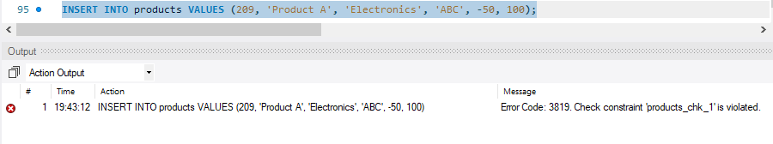
Q6. Try inserting a product with unit_price = -50. What happens and which constraint prevents it? Write both the INSERT statement and explain the error.
- When we insert negative price and violate the CHECK condition of the column that is CHECK(unit_price)>0, then the output terminal shows the error ‘Check constraint ‘products_chk_1’ is violated’.
- As the check condition is failed, the row is never inserted, and the integrity of the data is maintained and protected, as the price of a product can never be negative.

Section B — Filtering & Optimization (WHERE, Indexes)

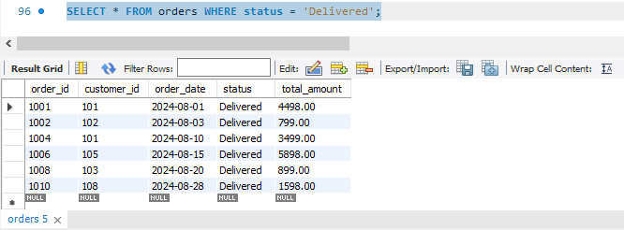
Q7. Retrieve all orders with status = 'Delivered'.

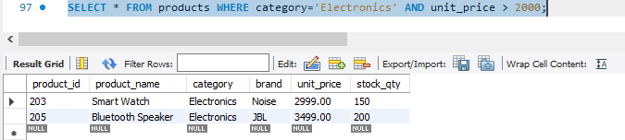
Q8. Find all products in the 'Electronics' category with a unit_price greater than ₹2000.
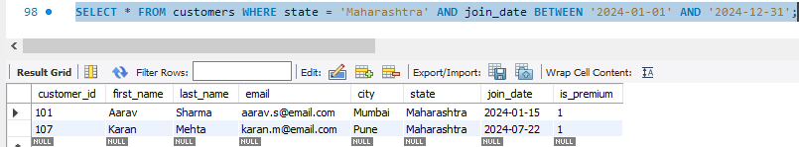
Q9. List all customers who joined in the year 2024 and belong to the state 'Maharashtra'.
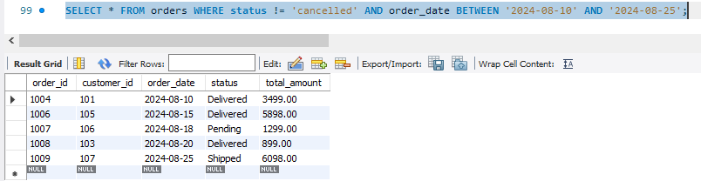
Q10. Find all orders placed between '2024-08-10' and '2024-08-25' (inclusive) that are NOT cancelled.
Q11. Explain what the index idx_orders_date does. How would it improve the performance of a query that filters orders by order_date? Write a sample query that would benefit from this index.
- idx_orders_date is an index on the order_date column of the orders table used for date-based filtering and sorting.
- Without an index, MySQL does a full table scan i.e it reads every single row to find the matching dates.
- This index hepls in improving the performance of a query that filters orders by order_date, as because of this MySQL builds a sorted B-Tree structure on order_date so it can jump directly to matching rows, just like a book index helps you find a topic/chapter without reading every page.
- MySQL uses the index to find that date instantly instead of scanning all rows.
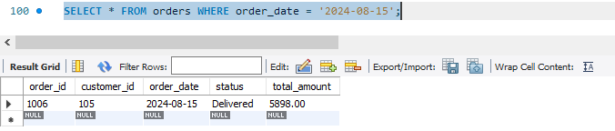
- Sample query that would benefit from this index is as follows:
Q12. If you run: SELECT * FROM customers WHERE YEAR(join_date) = 2024; — would the index on join_date be used? Explain why or why not, and rewrite the query to be index-friendly (SARGable).
- No, SELECT * FROM customers WHERE YEAR(join_date) = 2024 does NOT use the index, as the function YEAR() wraps the column, which prevents MySQL from using the index.
- The index is built on raw join_date values, not on computed YEAR(join_date) values, Hence when YEAR() is used it cannot access the index and should do the operations row by row.
- This is called a non-SARGable query.
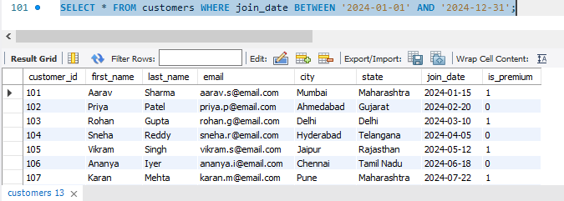
- Index-friendly query is as follows:
- Now MySQL can use the index directly because in the above query we are comparing the raw column value against a range and not a function.

Section C — Aggregation (GROUP BY, SUM, COUNT, AVG, MIN, MAX)

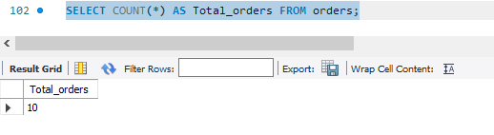
Q13. Count the total number of orders in the orders table.
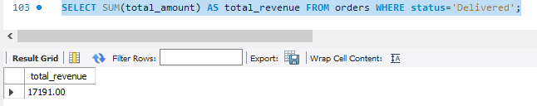
Q14. Find the total revenue (SUM of total_amount) from all 'Delivered' orders.

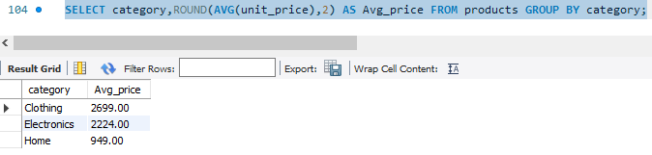
Q15. Calculate the average unit_price of products in each category.
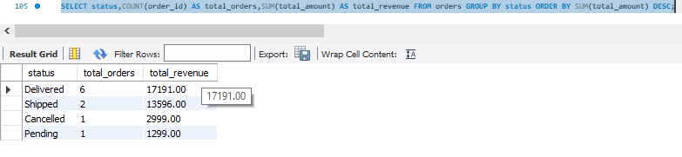
Q16. For each order status, find the count of orders and the total revenue. Sort the result by total revenue in descending order.
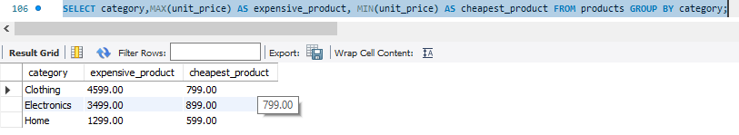
Q17. Find the most expensive (MAX) and cheapest (MIN) product in each category.
(OR)
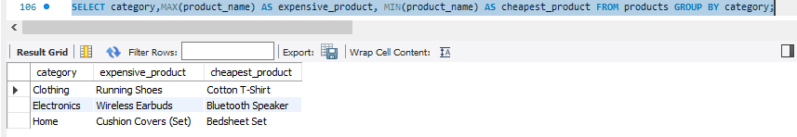
- If we want the product names then we can write the query:
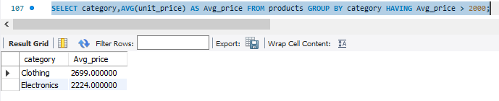
Q18. List all product categories where the average unit_price is greater than ₹2000. (Hint: Use HAVING clause)
Section D — Joins & Relationships

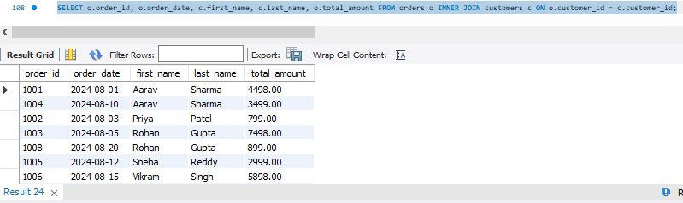
Q19. Write an INNER JOIN query to display each order along with the customer's first_name and last_name. Show: order_id, order_date, first_name, last_name, total_amount.
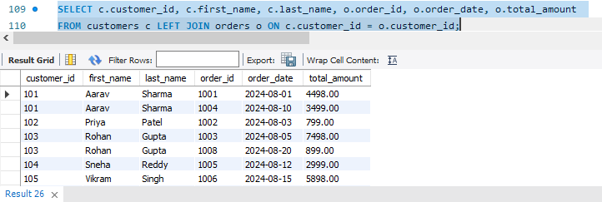
Q20. Using a LEFT JOIN, list ALL customers and their orders (if any). Customers with no orders should still appear with NULL values for order columns.
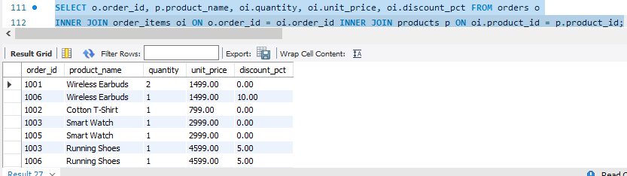
Q21. Write a query using JOINs across three tables (orders → order_items → products) to show: order_id, product_name, quantity, unit_price, and discount_pct for each order item.

Q22. Explain the difference between LEFT JOIN and RIGHT JOIN with an example from this schema. When would you use a FULL OUTER JOIN?
- LEFT JOIN returns all rows from the left table and matching rows from the right table.
- The rows that do not match the right side give output as NULL.
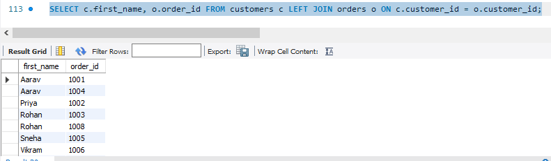
- Example — Displaying all the customers even if they have no orders:
- RIGHT JOIN returns all rows from the right table and matching rows from the left.
- The rows that do not match the left side give output as NULL.
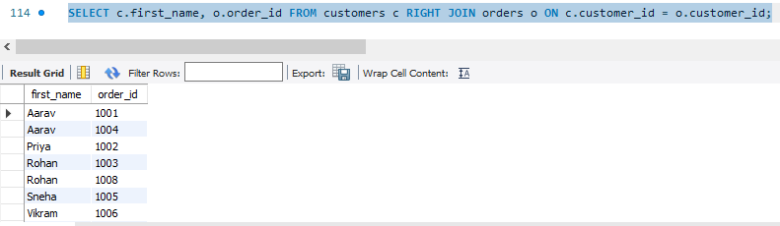
- Example — all orders even if the customer record is missing:
- FULL OUTER JOIN returns all rows from both tables.
- NULLs appears on whichever side has no match.
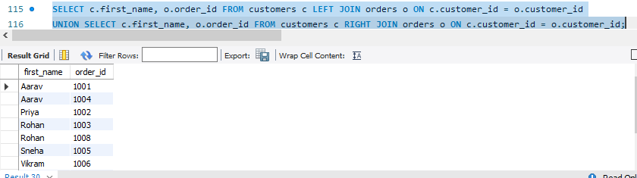
- As MySQL does not support FULL OUTER JOIN directly, so we use UNION instead:
- We can use FULL OUTER JOIN when we want to find unmatched records on both sides.
- Example, customers with no orders AND orders with no customers.

Q23. Identify all Foreign Key relationships in the schema. Explain what would happen if you tried to insert an order with customer_id = 999 (which doesn't exist in customers).
- There are three FK relationships:
- orders.customer_id → references customers.customer_id
- order_items.order_id → references orders.order_id
- order_items.product_id → references products.product_id
- If we try to insert an order with customer_id = 999 which doesn't exist in the customers table, MySQL throws: ERROR 1452: Cannot add or update a child row: a foreign key constraint fails.
- The database enforces referential integrity i.e. we cannot have an order belonging to a customer that doesn't exist.
- This prevents orphaned records and keeps data consistent.

Section E — Advanced Concepts (CASE, ACID, Transactions)

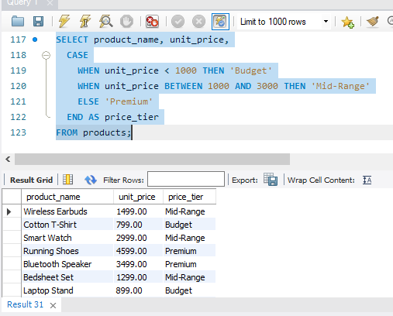
Q24. Write a query using CASE to classify products into price tiers:
• 'Budget' → unit_price < 1000
• 'Mid-Range' → unit_price BETWEEN 1000 AND 3000
• 'Premium' → unit_price > 3000
Display: product_name, unit_price, price_tier.

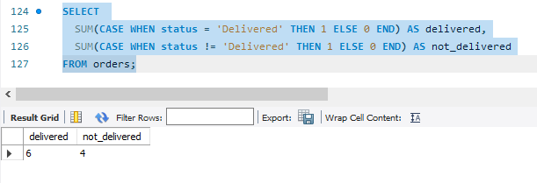
Q25. Using a CASE statement inside an aggregate function, count how many orders are 'Delivered' vs 'Not Delivered' (all other statuses). Display the result in a single row.
Q26. Explain each letter of ACID:
• A – Atomicity
• C – Consistency
• I – Isolation
• D – Durability
Give a real-world example (e.g., bank transfer) showing why each property is important.
- A — Atomicity:
- A transaction is all or nothing.
- Either every operation inside it succeeds, or none of them do.
- Example: In a bank transfer of ₹5000 from Account A to B i.e even if the debit from A succeeds but the credit to B fails, Atomicity ensures the debit is also rolled back. You can't end up with money deducted from A but never added to B.
- C — Consistency:
- A transaction takes the database from one valid state to another valid state.
- All rules, constraints, and cascades are respected.
- Example: If a bank account has a rule that balance can't go below 0, a transaction that would make it negative is rejected. The database stays consistent.
- I — Isolation:
- Concurrent transactions don't interfere with each other.
- Each transaction behaves as if it's the only one running.
- Example: If two people try to book the last seat on a flight simultaneously, Isolation ensures only one booking succeeds i.e. the second person sees the seat as already taken, not as still available.
- D — Durability:
- Once a transaction is committed, it stays committed even if the system crashes immediately after.
- Example: After a bank transfer shows "Success", that record is permanently saved to disk. Even if the server crashes 1 second later, the transaction is not lost when the system restarts.

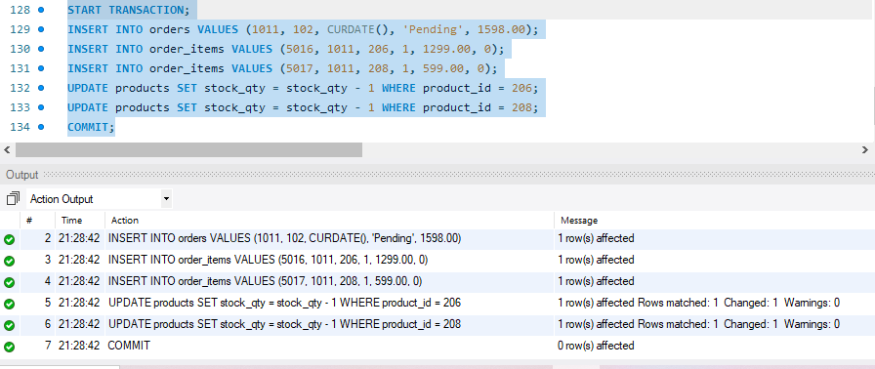
Q27. Write a SQL transaction that does the following atomically:
1. Insert a new order (order_id=1011, customer_id=102, today's date, 'Pending', 1598.00)
2. Insert two order items for that order
3. Update the stock_qty of the purchased products
4. If any step fails, ROLLBACK the entire transaction. Otherwise, COMMIT.
Write the complete BEGIN...COMMIT/ROLLBACK block.

