Name Ada Lovelace

1. Answer the following (15 points):
2. What is the purpose of the keyword **new**?  
   The purpose of the keyword new is to create a new object of a class following by the constructor call.
3. Explain why a class might provide a *set* method and a *get* method for an instance variable.

Usually the instance variables are declared private therefore we create our setters and getters to be able to access and modify our instance variables.

1. What is the constructor?

The constructor is a special type of method that doesn’t have return type and it must have the same name of the class, it is used to initialize the object.

1. Given the following terms **keyword new, constructor, type, argument, identifier, assignment operator,** please label the following (12 points):

Keyword new

Identifier

Argument



Constructor

Assignment operator

Type

1. Do the following (8 Points):
2. Create a public class:

public class MyClass {}

1. Create an instance(object) of the class that you previously created:

MyClass myNewObjectIdentifier= new MyClass();

1. True/False (25 points):
2. False substring is not a String method.
3. False charAt is an Array method.
4. True s1.equals(s2) Assuming that s1 and s2 are two strings, equals checks if the two strings are equal.
5. False arr1.equals(arr2) Assuming that arr1 and arr2 are two String arrays, equals checks if the two String arrays are equal.
6. False (Assuming s1 is a String), the correct way to get s1 length is by invoking **s1.length**.
7. Given the following class, create setters and getters and a constructor (initialize the variables in it) for it(20 points):

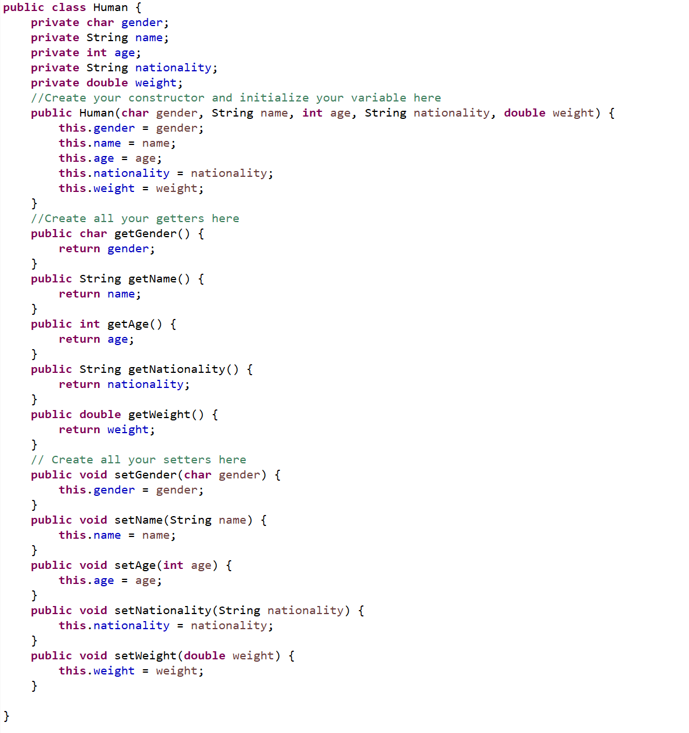

1. Create and an **int** array that can take 100 elements (5 points):

int [] iArray= new int[100];

1. Given:

**String** [] names = {“Paolo”, “DaVinci”, “MichelAngelo”, “AndreaBocelli”, “Pavarotti”, “LauraPausini”, “GalileoGalilei”, “AlessandroVolta”};

Create an enhanced for loop to print all names in the given array (15 points):

for (String name: names ){

System.out.println(name);

}