**GEO_MYAR USER MANUAL**

***By Yanilda Peralta, Amos Addy, Rolando Diaz and Miguel Ben***

**INDEX**

1. Getting the ArcMap path………………………………………………. Pg.1
2. Creating folder for Data and program…………………………………...Pg.2
3. Putting together the files in created folder ……………………………...Pg.3
4. Getting Census Data…………………………………...………………...Pg.4
5. Getting shape file………………………………………………………...Pg.5
6. Editing csv file…………………………………………………………...Pg.6
7. Opening ArcMap………………………………………………………...Pg.7
8. Creating Map in ArcMap………………………………………………...Pg.8
9. **Getting the Arcmap path**
10. Open the **geo_myar** by double clicking and click on **Open Arcmap** to verify that its path in the software is working. If Arcmap doesn’t start it means that there is a different version installed in your computer. To modify the path right click on geo_myar program file and select the open in **IDLE** option in the context menu.

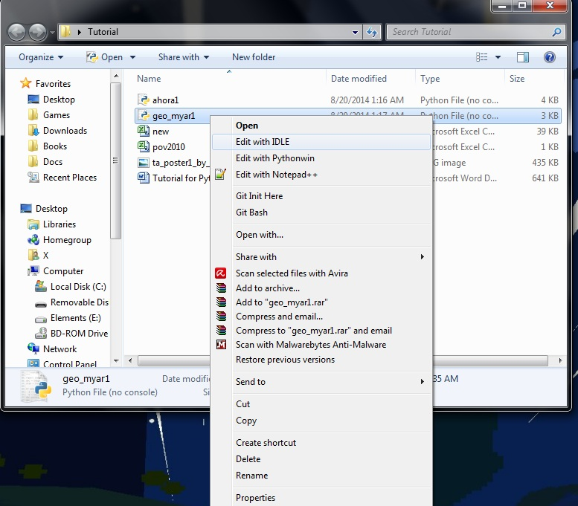

1. Go to Start then search for Arcmap.

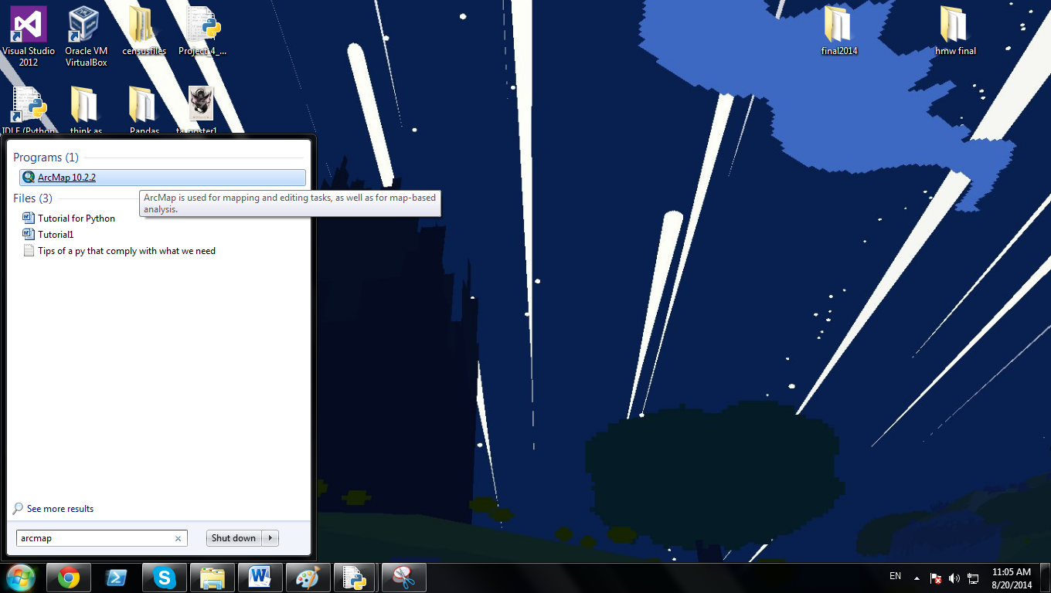

1. Right click on the Icon that appears and select properties on the context menu. Then go to the General tab and copy the location on this format “C:\ProgramData\Microsoft\Windows\Start\Menu\Programs\ArcGIS\\ArcMap 10.2.2.lnk” we take the location shown, we add two backslash (\\), add the name of the program plus the extension (.lnk )

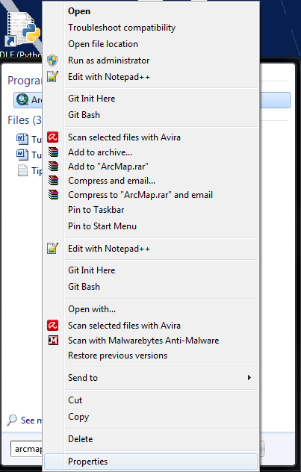 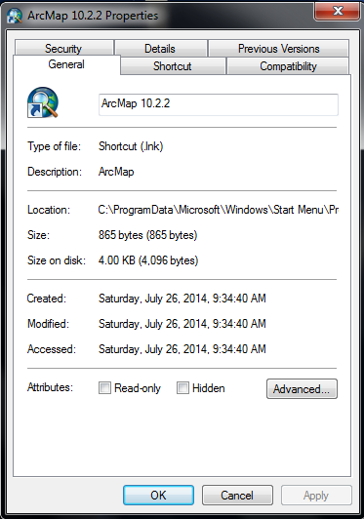

1. Paste the path that you just created in the function arcMap() that in IDLE window and Save the file.

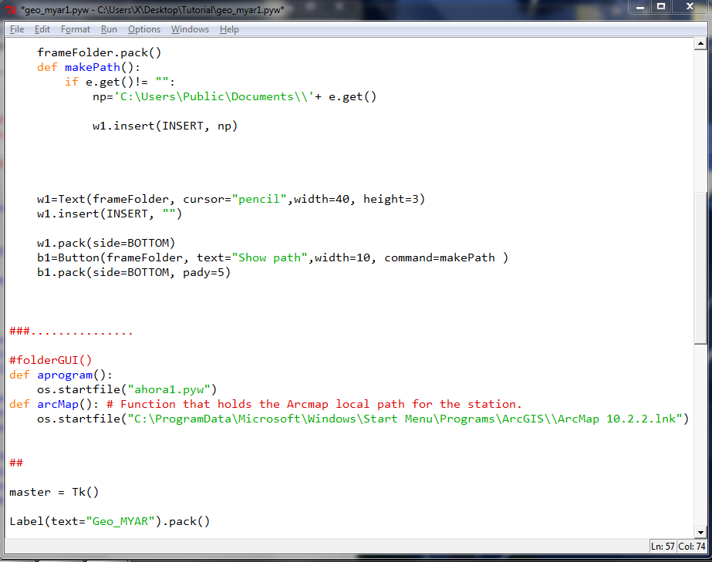

1. **Create a folder for the Data and program:**
2. Click on **Create a folder**

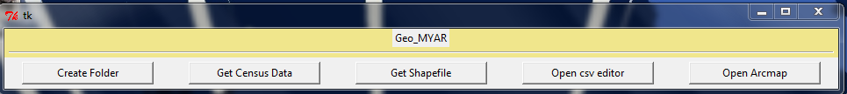

1. Give a name to the folder then press **Ok**.

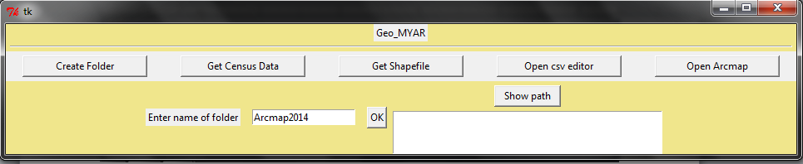

1. Click on the **Show path** button to show the path. Double click on the path to highlight and press Ctrl+C to copy then open a text file to paste the copied path for reference later, save the text file.

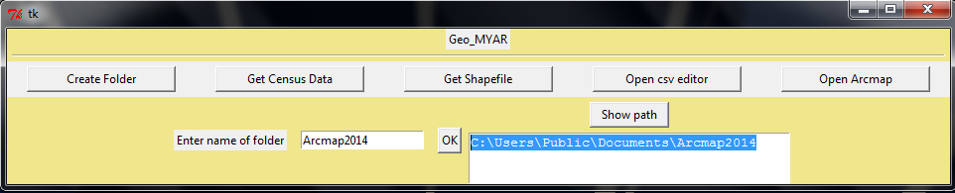

1. **Putting the Files Together In The Created Folder:**
2. Go to start then click on documents, on the address bar and then paste the path of the folder that you created.

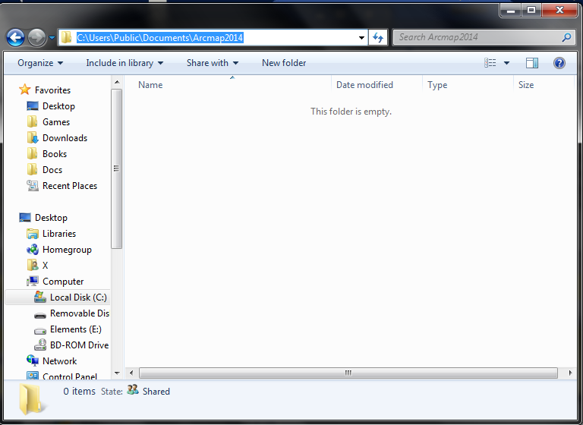

1. Paste the program files **ahora1** and **geo_myar1** to your created folder.

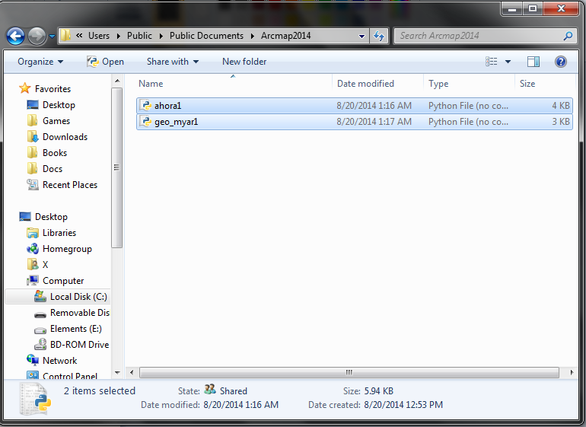

1. **Getting the Census Data:**
2. Click on “**Get Census Data”** which will direct you to the census website.

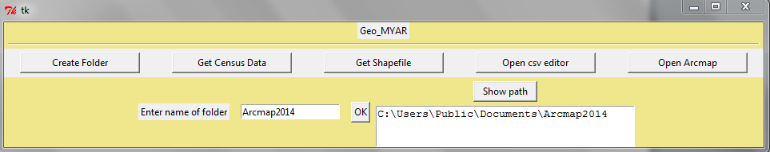

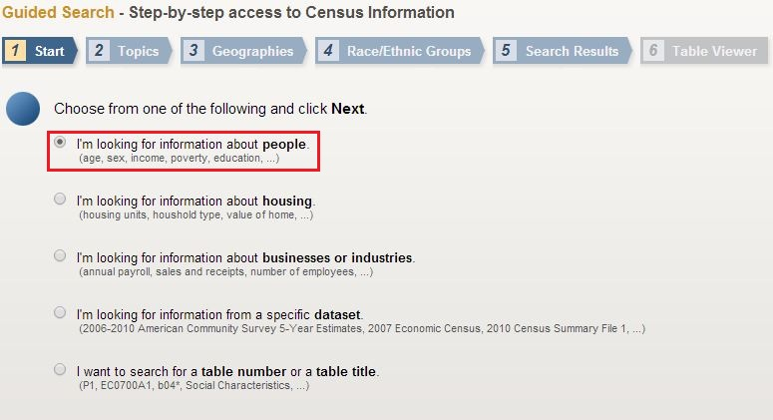

1. Verify that your information is in check (e.g. **people**) then click next and select the topic under your previous choice which will be “**poverty” (Note:** *Click on* ***poverty*** *for a second time and then next***)**.

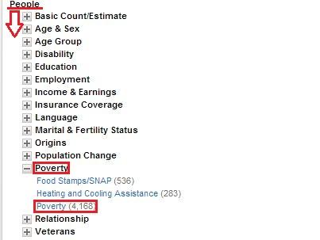

1. In the **Geographies** section be assure to fill the following boxes as asked and proceed to click “**ADD TO YOUR SELECTIONS”** then next (e.g., geography type will always be Census Tract, the state, county and a specific geographic area or just all of them).

C:\Users\X\Desktop\Geographies.JPG

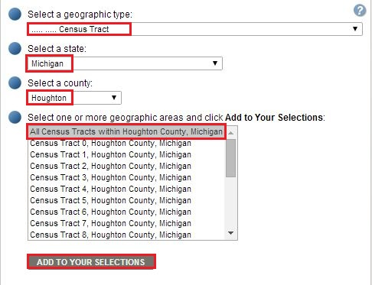

1. You can **Skip** the **Race/Ethnic Groups** section by clicking on next and choose the result that shows data from the past 12 months. If the given task asks you about a specific ethnic group from a basic or detailed category click either **Select from basic Groups** or **Select from detailed Groups**.

C:\Users\X\Desktop\ethnictag.JPG

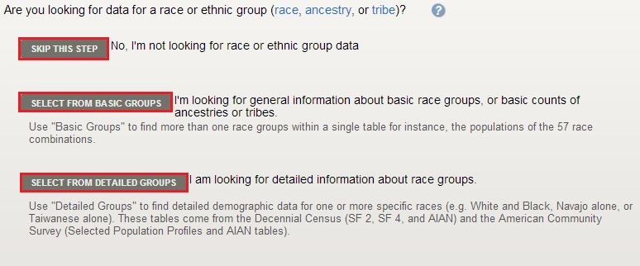

1. Lastly download your data from the chosen result which will be displayed as a table (Click **Download** 🡪**OK**🡪**Download**).

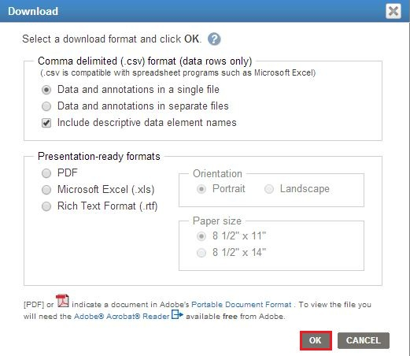

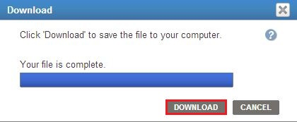

1. Locate your downloaded file on your default Downloads folder, copy and extract the file in your previously created folder.
2. **Getting the Shapefile :**
3. Go back to the **geo_myar** window and click on “**Get Shapefile”** which will redirect you to the census site.



1. Select the year of your shapefile data, click on **Download** and then “**Web Interface”**. This will take you to the download interface of **TIGER/Line® Shapefiles**.

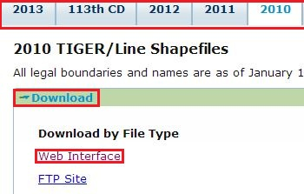

1. In the “**Select a Layer Type**” drop box menu choose “**Census Tracts**” then press submit.

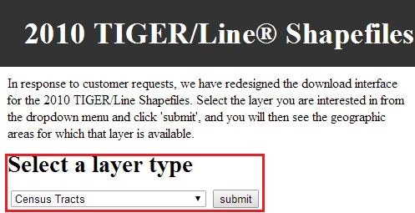

1. This will take you to the “**Census Tract**” section where you should select a state with its year from the drop menu then submit. The same should be done with the county but instead of submit you will see a Download button.

C:\Users\X\Desktop\censustractyearstate.JPG

1. Retrieve the downloaded file from your local downloads folder then copy and paste it to your working folder. **Note**: *This file should be extracted in the folder for it to work later on*.
2. **Editing the Excel.csv file:**
3. Go to your downloaded data from census tract, find an excel file in your working folder with a name that ends as **ann** then change it to a simple name such as (e.g “poverty2010”). **Note**: *For renaming a file in windows you should just right click the file and select* ***Rename***.

C:\Users\X\Desktop\unchangedfile.JPG**🡪C:\Users\X\Desktop\changed file.JPG**

1. Now go back to **geo_myar** window and click on **Open csv editor**.

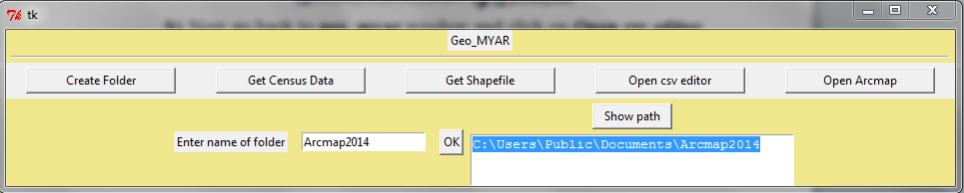

1. On the first field put the category (e.g. **Poverty**), on the second field put the name of the file and on the third field type the name of the new file that will contain the data that you will need to make the map.

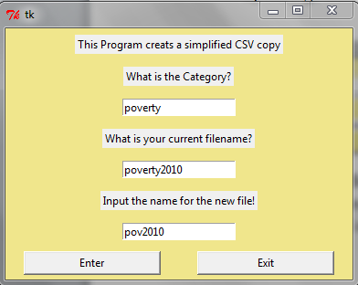

1. **OPENING ARCMAP**

Click on the Open ArcMap button of the Geo_MYAR toolbar.

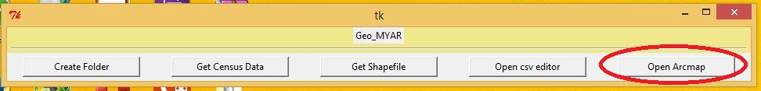

Wait a few seconds (30 seconds).

Note:

If program doesn’t start redo only step 1. Repeat step 7 after.

1. **CREATING MAP IN ARCMAP**
2. On the “Getting Started” popup window, click on “New Maps” on the left, and then click on “Blank Map” on the right. You can change to location of the map. Click “OK”.

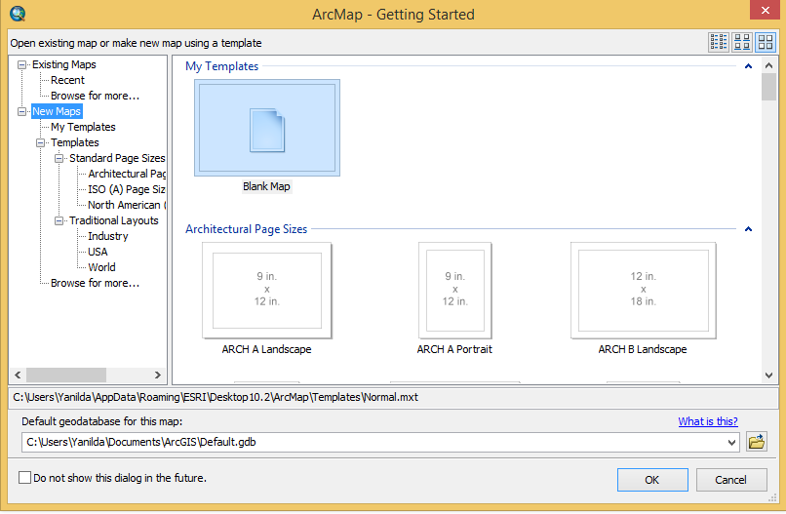

1. Click on Add Data on Standard toolbar.

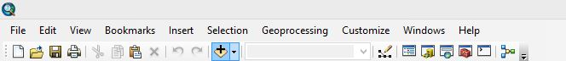

1. Add desired shape file. (.shp)

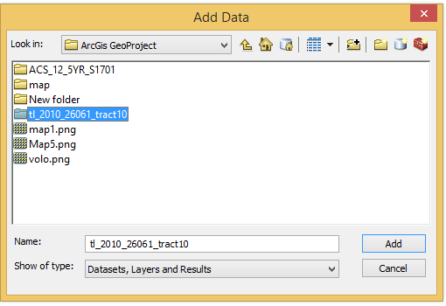 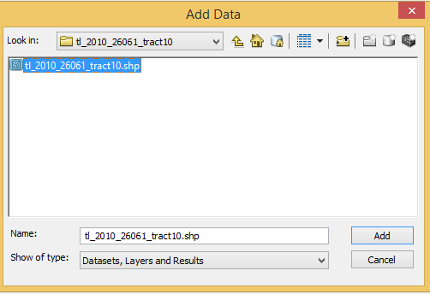

Note:

If you can’t find the correct folder click on “Connect To Folder” on the Add Data popup window.

1. Click on Add Data on Standard toolbar.



1. Add corresponding csv file

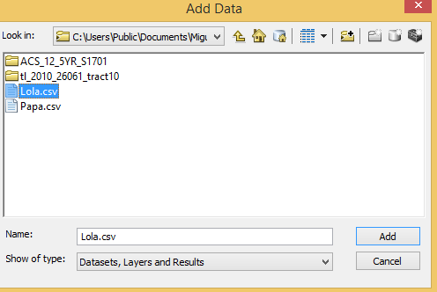

1. Right click on title of shape file, click on “Open Attribute Table” on content menu.

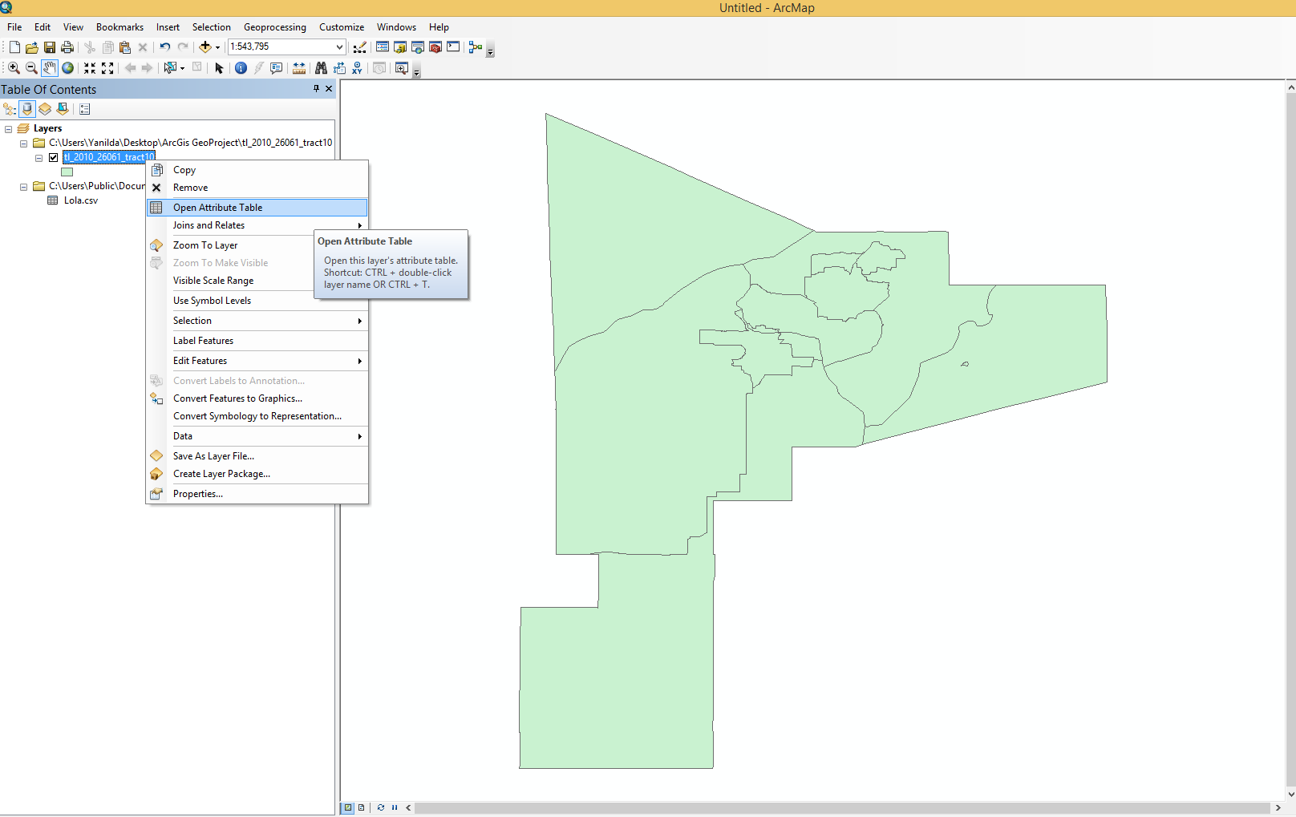

1. Click on Table Option and click on Add Field

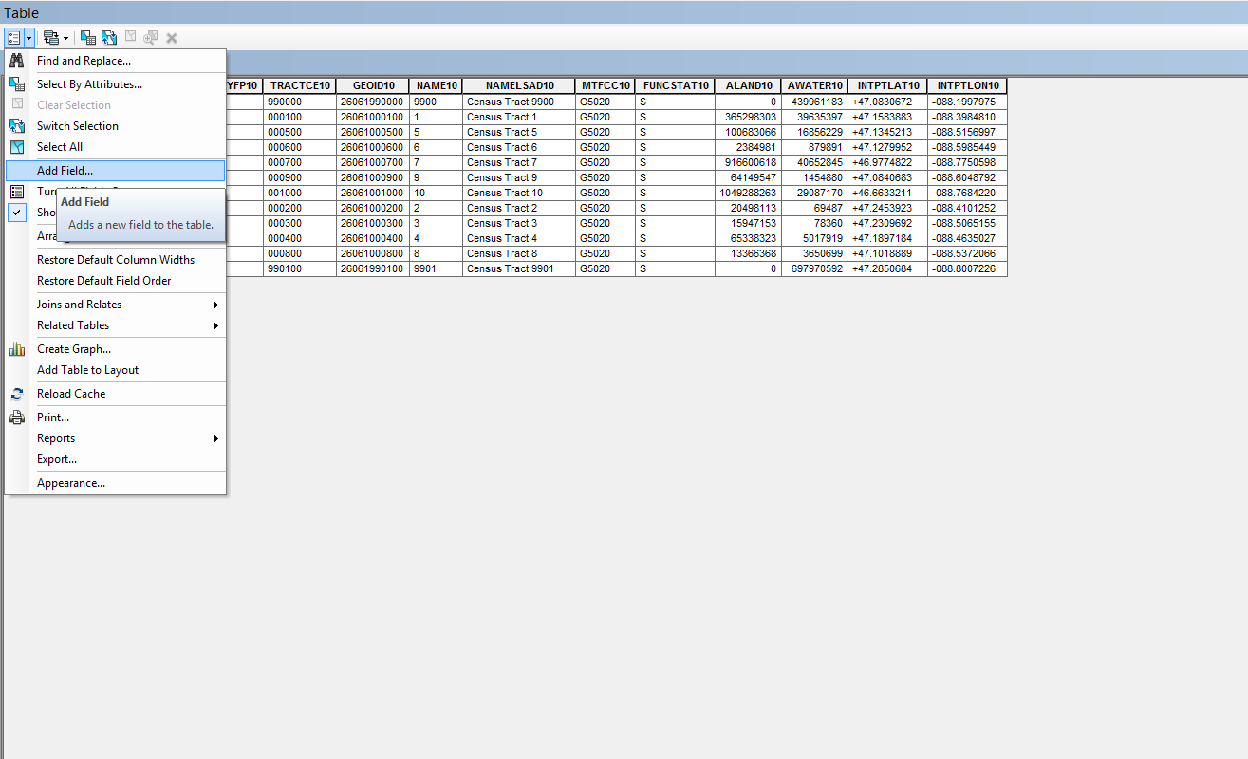

1. Input Name of Field and Type and click OK.

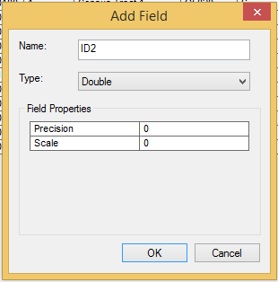

1. Right click on created Field and select “Field Calculator”

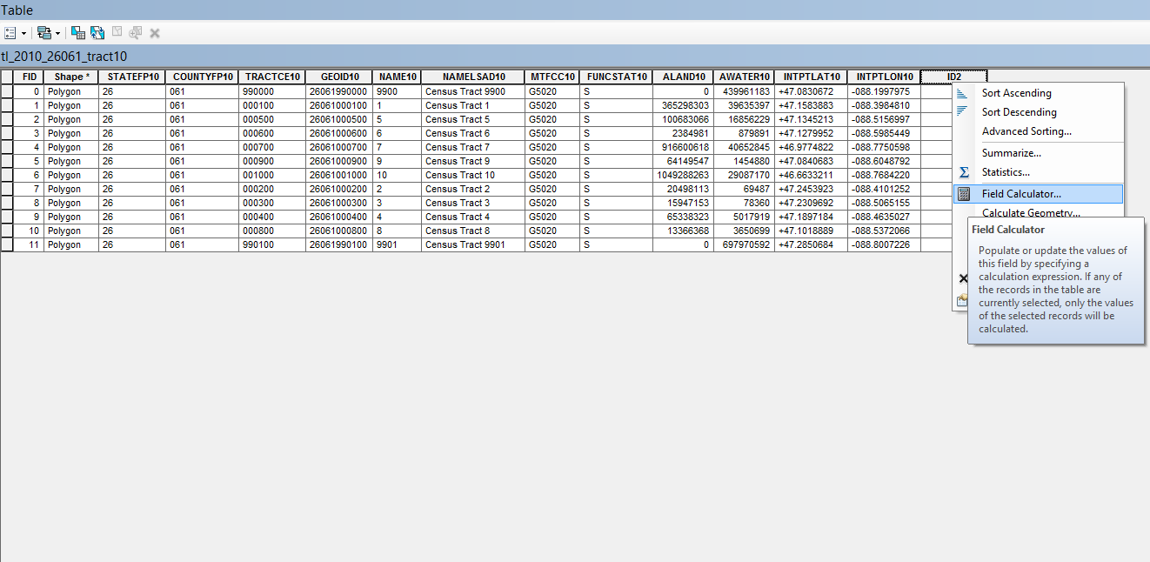

1. Select the field of calculation and click OK.

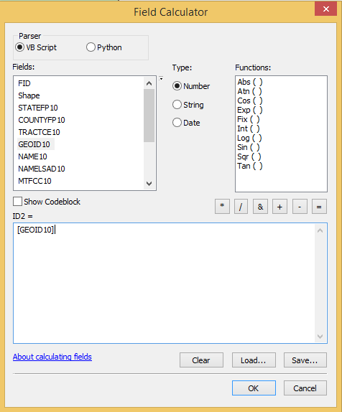

1. Right click on the Shape file and select Joins and Relates

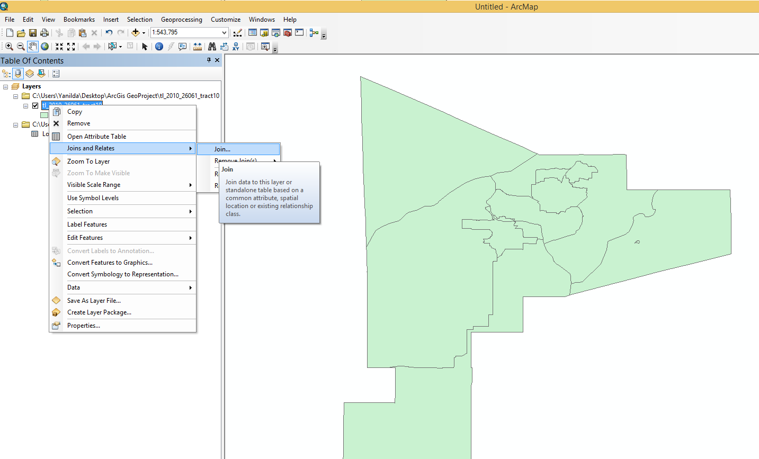

1. Choose the corresponding fields (e.g., ID2, id2) and click OK.

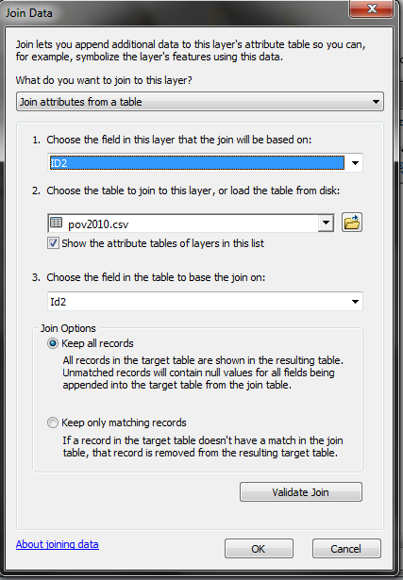

1. Right click on the Shape file and select Properties

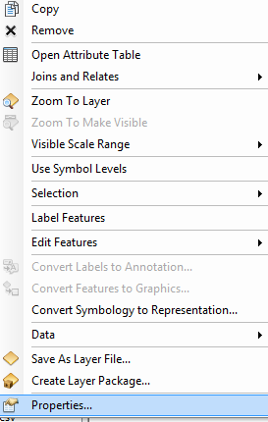

1. Click on Symbology tap, then quantity and finally graduated college Click apply and then OK

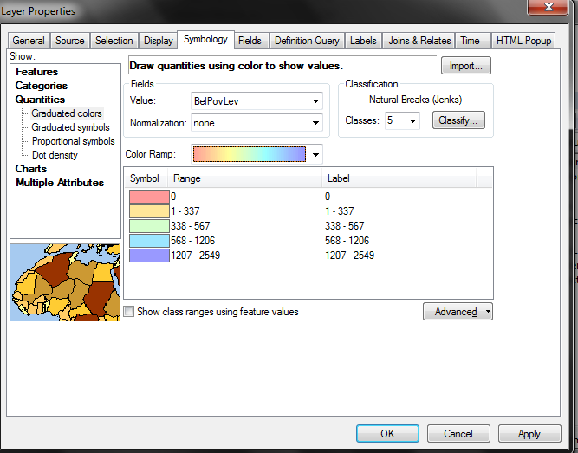

Here it is the final product:

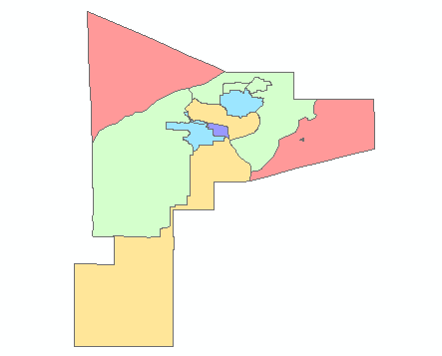

Thank you!