AuthCallout AI Skills

Table of Contents
Introduction 2
Skills setup 2
Java execution 3
GO 5

Introduction

In this document we will cover the usage of Claude skills to enable a developer to generate the artifacts to implement AuthCallout.
The skills have been built for Java and Go:
- authcallout-generate.md – single file that can execute the generation of both Java and Go assets
- authcalout-generate-java.md – File that leverages authcallout-generate.md (with the language parameter fixed)
- authcallout-generate-go.md – standalone file to generate just Go assets.

Skills setup

In the Git repo there is a folder: ai-skills, where the 3 files indicated above can be found.
Here are the steps required to leverage those skills into your Claude environemnt:
You need to copy those files in the project root folder: .claude/commands.

1. The skill files need to be in .claude/commands/ at the project root:
# From the project root
cp ai-skills/authcallout-generate.md .claude/commands/authcallout-generate.md
cp ai-skills/authcallout-generate-java.md .claude/commands/authcallout-generate-java.md
cp ai-skills/authcallout-generate-go.md .claude/commands/authcallout-generate-go.md

Note: Claude Code automatically scans for skill files on startup — there is no manual loading step. You just need the .md file in the right directory.

2. Launch Claude Code from the project root:
cd /path/to/synadia-authcallout-service
claude

3. Skills are now available via the respective commands mentioned in the skill.md file, e.g.:

/authcallout-generate-java kv-store /my/output/path

To see if the commands have been loaded, just run the command /auth – and allow auto-complete to show the list:

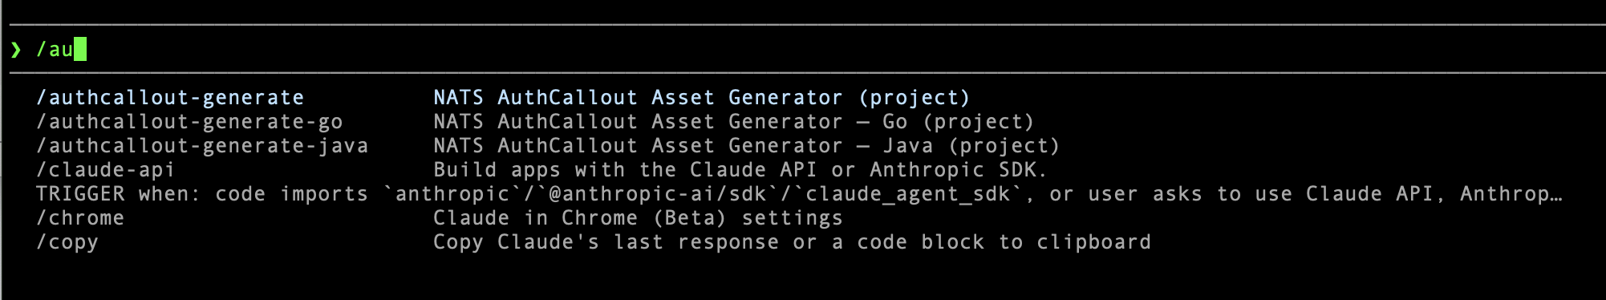

The actual commands are:

/authcallout-generate kv-store java
/authcallout-generate mysql java
/authcallout-generate decentralized java
/authcallout-generate leaf-sentinel go

One thing worth noting: .claude/commands/ is typically git-ignored (Claude Code creates it locally). So if you want others to be able to use the skills without the copy step, you have two options:

- Add a setup.sh at the repo root that does the cp commands above
- Or remove .claude/commands/ from .gitignore and commit the files directly — then anyone who clones gets the skills immediately

The ai-skills/ folder is already your shareable source of truth, so committing .claude/commands/ as well is the simplest option for a shared repo.

Java execution

In order to start the process of generating and using the AuthCallout examples we need to follow the following steps.

Step 1 — Generate & compile

/authcallout-generate-java kv-store /Users/brunobaloi/Synadia/.../<test-generation-location>

Claude generates all files into that folder and runs mvn package -q automatically.

Step 2 — Fill in the two placeholders (one-time per environment)

# Generate a signing NKey
nk -gen account

Then paste:
- A... public key → nats-server.conf → issuer field
- SA... seed → config.properties → auth.signing.key.seed

Step 3 — Start everything in order

# Terminal 1
nats-server -c <test-generation-location>/nats-server.conf

# Terminal 2 (first run only — creates KV bucket + alice/bob users)
bash <test-generation-location>/setup.sh

# Terminal 2
java -jar <test-generation-location>/target/authcallout-kv-store-1.0.0.jar service <location>/config.properties

# Terminal 3 — happy path

java -jar <location>/target/authcallout-kv-store-1.0.0.jar client nats://localhost:4222 alice alice123

# Terminal 3 — failure path

java -jar <location>/target/authcallout-kv-store-1.0.0.jar client nats://localhost:4222 alice wrongpass

That's the complete repeatable workflow — generate once with the skill, fill two placeholders, run.

GO

In order to simplify things a little we created a GO wrapper skills file around the original skills file. The idea was to generate the same things without mentioning the langauge.
This is just a convenience wrapper, and it is not strictly necessary. You can generate both Java and GO code using the original commands and adding the <language> parameter.

Since the Go skill file is at .claude/commands/authcallout-generate-go.md, you invoke it directly in the Claude Code CLI chat:

/authcallout-generate-go kv-store
/authcallout-generate-go mysql
/authcallout-generate-go okta-ropc
/authcallout-generate-go okta-token
/authcallout-generate-go decentralized
/authcallout-generate-go leaf-sentinel

For instance, the kv-store part maps to $ARGUMENTS in the skill file. Claude Code CLI expands the skill inline and executes the instructions automatically — generating all files under generated/<use-case>/go/ and running go mod tidy && go build.

