Openshift configuration files from the Coudersport Staging Environment

Openshift build process from the README

[root@dldctx-ci-dpl-1101 ivp-coe]# more README.md

# Introduction

This document will explain how to use Ansible to install the Openshift environment on to a target cluster of servers

We deal with different cluster topologies. These are:

* single master, multiple nodes

* multi master, load balancer, multiple nodes

Adjustments for these environments are made in the predefined inventory file.

# Target Platforms

We use the BYO (bring your own) playbooks provided by openshift-ansible.

These playbooks assume that the target nodes are simply machines with a minimal installation of a Red Hat operating system.

Using this deployment we can target any cluster platform be it bare metal or virtualized.

Note: we recommend using the CSCOlxplat base image generated by the rostrum team.

# Cluster Node Configuration and Sizing

We initially configure and size platforms using the [Openshit Origin Prerequisites](https://docs.openshift.org/latest/install_config/install/prerequisites.html#production-level-hardware-requirements).

Additional adjustments to this configuration and sizing may be made following suitable testing.

# Installation and Upgrade Notes for Openshift 1.3.1, 1.4.1, 1.5.1

|source<br>version|naming<br>scheme|target<br>version|naming<br>scheme|operation|result|notes|

|-----------------|----------------|-----------------|----------------|---------|------|-----|

|n/a|n/a|1.3.1|IPs|install|works||

|n/a|n/a|1.3.1|hostnames|install|works||

|n/a|n/a|1.4.1|IPs|install|fails|hostnames are now expected by openshift-ansible scripts|

|n/a|n/a|1.4.1|hostnames|install|works||

|1.3.1|IPs|1.4.1|IPs|upgrade|works|openshift-ansible upgrade scripts are less stringent than the install scripts<br> likely that future upgrade scripts will expect hostnames so we might not be able to upgrade fr

om here to a later version, if we continue with IP addresses|

|1.3.1|hostnames|1.4.1|hostnames|upgrade|works||

|1.3.1|IPs|1.4.1|hostnames|upgrade|fails|certificate mismatches|

|1.3.1|IPs|1.5.1|hostnames|upgrade|not possible (only upgrade between consequtive major number)|certificate mismatches|

|1.4.1|hostnames|1.5.1|hostnames|upgrade|works|with [caveats](UPGRADE_14_15.md#warnings)

# Installation Process

## Create Cluster Inventory File

Before anything else you should create the inventory for the target cluster. This should be done after a site survey. At this point you will know relevant information. This information will include

* cluster topology

* IP addresses

* cluster fqdn

* level of internet connection

* location of artefacts

The inventory file will need to be accessible to the ansible playbooks during installation. It will need to be copied to the deployer machine.

* A sample inventory file can be found here - [Sample inventory](./inventories/sample_inventory)

* If you want to find more information about what a completed inventory file looks like and how to configure for High Availablity and Load Balancing go here - [Complete Inventory](./inventories/HA-LB-Examples/RE

ADME.md)

* Details about setting up your inventory for routers/gluster FS and metrics can be found here [Inventory Introduction](./inventories/README.md)

REALLY! - DO THIS STEP FIRST

## Deployer machine

The **deployer** is available as a ready to go image which contains all the [latest images](https://wiki.cisco.com/display/VCBURD/IVP+COE+OpenShift+1.5.1+-+Artifact+List) as well as the offline yum repo which in

clude a copy of the current `ivp-coe` git repo.

It is available in the following [artifactory](http://engci-docker.cisco.com/artifactory/list/spvss-ivp-deploy/) location as either an OVA image (ivp-coe-deployer-YYYYmmddHHMM-v.v.v.ova) or a qcows2 image (ivp-c

oe-deployer-YYYYmmddHHMM-v.v.v.qcow2).

To use:

* Download the appropriate image ( [See our wiki page](https://wiki.cisco.com/display/VCBURD/IVP+COE+OpenShift+1.5.1+-+Artifact+List) )

* Initiate the image in your virtualization environment

* For VMWare start the image and

* log-in using `centos/centos`, you will then be asked to set a new password.

* log-in using `centos/<new password>` and configure the IP address for the VM using sudo to access root.

* For Openstack

* Use cloud-int to inject an appropriate ssh key

## Cluster nodes

You will need to stand-up cluster nodes to host your Openshift cluster. We recommend you use the CSCOlxplat image as the basis of these nodes.

* Download the appropriate image ( [See our wiki page](https://wiki.cisco.com/display/VCBURD/IVP+COE+OpenShift+1.5.1+-+Artifact+List) )

* Initiate the image in your virtualization environment

* For VMWare start the image and

* log-in using `centos/centos`. You will then be asked to set a new password.

* log-in using `centos/<new password>` and configure the IP address for the VM using sudo to access root.

* For Openstack

* Use cloud-int to inject an appropriate ssh key

* For Bare Metal servers

* Configure the servers to have at least two virtual hard disks that meet the requirements found in [Openshit Origin Prerequisites](https://docs.openshift.org/latest/install_config/install/prerequisites.

html#production-level-hardware-requirements). For lab installations, two drives that are at least 100 GB are sufficient

* Mount the ISO file in the CD/DVD drive of the server, then reboot the server and boot from the mounted drive

* Once the installation has completed, log-in using `centos/centos`. Change the password as required.

* Use sudo to access root. Configure the static IP address of the server.

Whilst we require Network-Manager to be running we also require static IP configuration.

Use a command similar to the following on each node to configure this.

```

nmcli con modify 'System eth0' \

ipv4.method manual \

ipv4.address 192.168.1.10/24 \

ipv4.gateway 192.168.1.1 \

ipv4.dns 192.168.1.2 \

ipv4.dns-search 'testivp.com cloud.cisco.com' \

&& reboot

```

## Contributed playbooks

There are a number of playbooks in the ```/contrib``` directory for specific pre-install and post-install functions required by certain applications and products.

[Contribution README](./contrib/README.md)

Please review these playbooks before starting to build or scale-up a cluster in order to determine which are needed for your particular use case and deployment.

## Build the cluster

**Before running the installation ensure that the date/time on the deployer matches your ntp server date/time (by default this is your master nodes)**

Once the deployer and your cluster nodes are started you can install Openshift by simply

* Copy the inventory file to the deployer

* Ensure you have root permissions:

```

sudo su root

```

* (If not done while building the target nodes) Copy ssh public key to nodes

```

ansible-playbook -i inventory share_ssh_key.yml --extra-vars "ansible_ssh_user=centos" -u centos -k

```

* Run the installation script

```

./run_installation install inventory

```

## Quick Cluster Check

* To authenticate against the cluster set

```

export KUBECONFIG="./admin.kubeconfig-DOMAIN"

```

Where: DOMAIN is the openshift_master_default_subdomain= from your inventory (this file will be downaloaded to your ivp-coe directory)

And check the status:

```

oc get nodes

oc status

oc get all

```

Notes:

If you want to automate the deployment of VMs on a cloud provider, please see [README.md](openshift-cloud-deployment/README.md).

If you want to automate the deployment of VMs on VMWare, please see [README.md](vmware/README.md).

If you want to add new minions or new masters to an already installed cluster, please see [ADDMINIONMASTER.md](ADDMINIONMASTER.md)

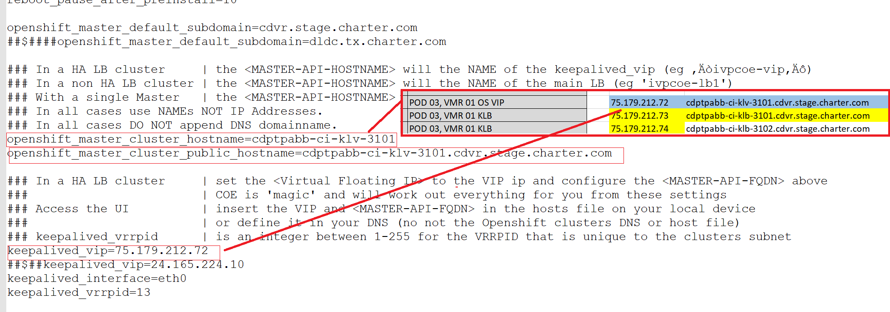

Yum Repo configuration on deployer:

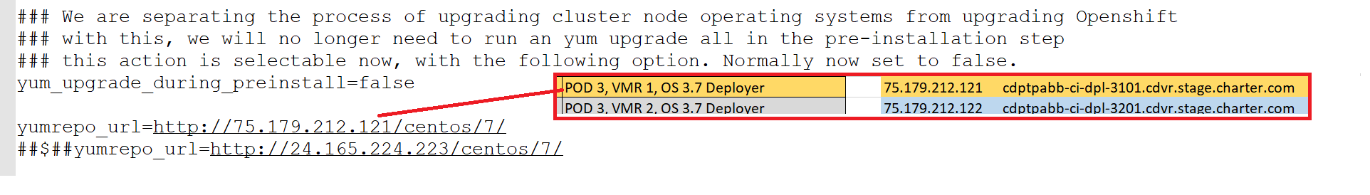

Add the ntp servers:

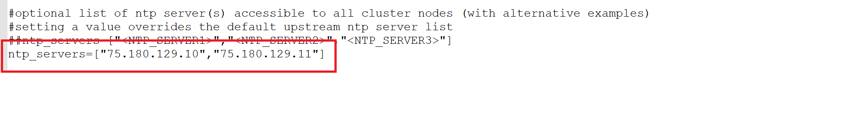

Make sure that the OSEv3 group has all of the children that are getting configured, and make sure that the global variables have the correct version

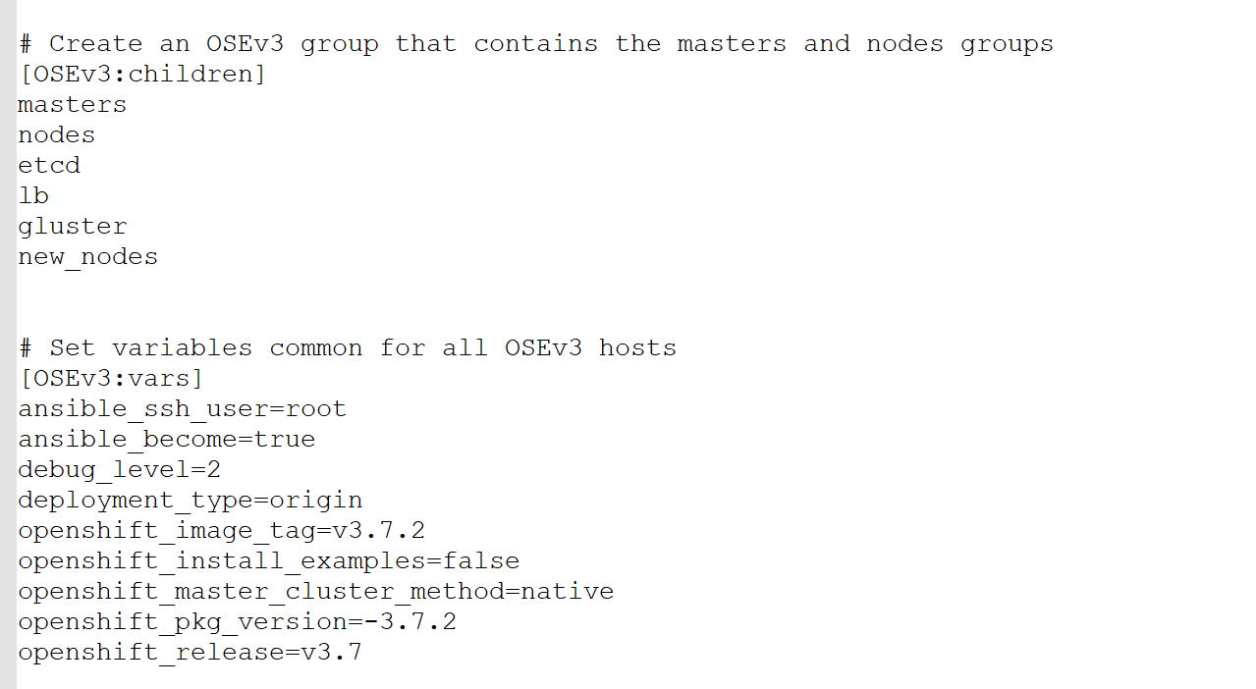

Verify that the inflight requests and node port range are set

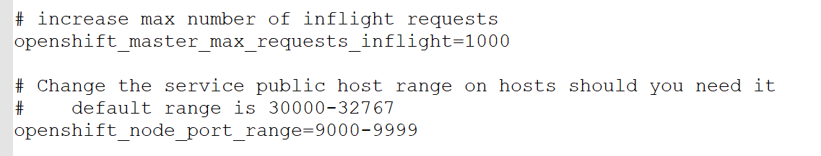

Most of the Gluster section remains commented out.

Add the docker registries (Additional and Insecure)

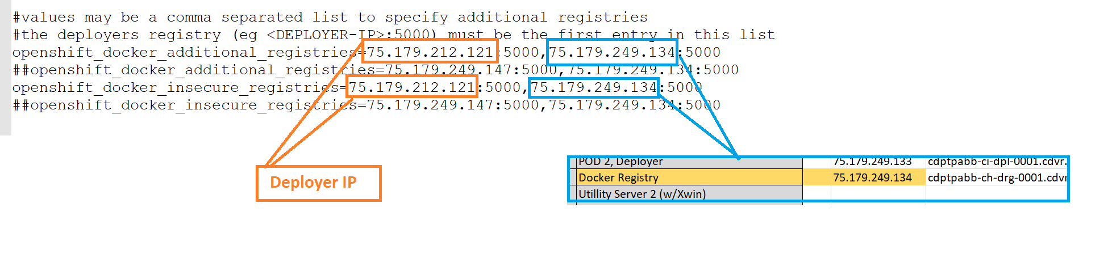

Setup the routersets. Increment the dp# and the vrrp_id_offset for each routerset. Also set the ipfs statement to include all routersets

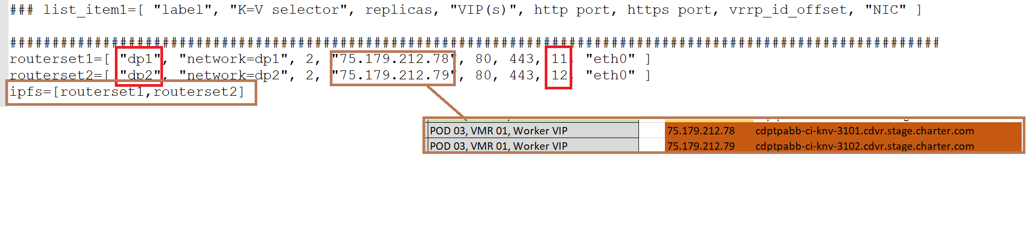

Set the openshift network parameters.

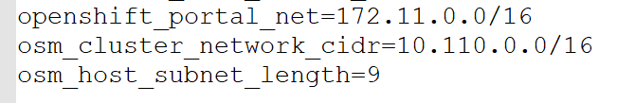

Build the masters section. This requires FQDN and IPs for the masters: Set the ansible_ssh_host, openshift_ip, openshift_public_ip to the IP for that master (denoted in blue below).

Set the FQDN for each instance of the hostname (denoted in orange below)

Finally set these openshift_schedulable=false

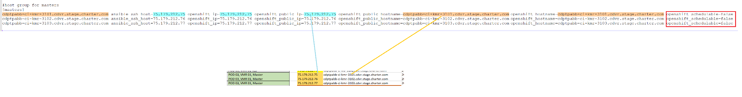

Setup the minion section. This requires the FQDN, the IPs, and router sets. Set the ansible_ssh_host, openshift_ip, and openshift_public_ip to the IP from the spreadsheet. Set the openshift_public_hostname, and the openshift_hostname and the first name at the head of each line to the FQDN. This section will look similar to the masters section, but the openshift_schedulable=true, and there is an openshift_node_labels section that is inserted just prior to the openshift_schedulable parameter.

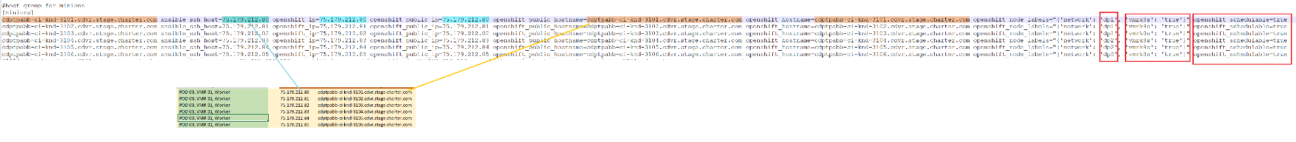

A close up view of the openshift_node_label parameters:

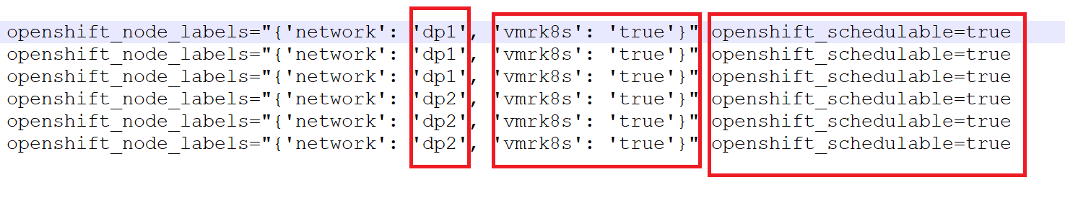

Finally, build the LB and deployer sections. The LB and deployer sections have the name and IP substituted in like other sections from the spreadsheet, but the LB section has one additional field ha_status, where one of the LB nodes needs to be set to master, and one has to be set to slave:

