# http://www.mcwane.com/upl/images/family-of-companies/logos/synapse-wireless-8cccdd3d.pngQuick Start Guide for E20 Example 3 – Interfacing to Exosite’s “Portals”

This example allows you to stand up a full “node to cloud” data monitoring solution. It showcases the following products (for example, from a Synapse EK5100 kit):

* 1 SNAP Connect E20
  + Using DHCP on the Ethernet Port for Internet access
  + Using the internal SNAP node for SNAP Network access
* 2 SN171 Prototyping boards with RF200 modules installed
* 1 SN132 USB SNAP Stick
* Synapse’s Portal software
* Exosite’s Portals website

**NOTE** – Synapse’s Portal product and Exosite’s Portals product are not related, they just coincidentally have very similar names.

Full source code for this example is available on Github here: <https://github.com/synapse-wireless/demo-kits>

The kit (or equivalent assembled parts) is upgradeable to the demonstration application by using the following instructions.

**NOTE** - If you have already run the “Example 1” demo, some of these steps have already been completed.

## Setup SN132

Connect the SN132 to your PC by plugging it into any available USB port.

## Setup Portal

if you have not already done so, download and install Portal.

Portal can be found at forums.synapse-wireless.com.

## Setup the SN171s

Copy SNAPpy script demo_sn171.py to your Portal/snappyImages directory. Apply power to the SN171s. Now you can connect Portal to the SN132 as a bridge node and download script demo_sn171.py into the SN171s.

*Please make a note of the SNAP Addresses of the two SN171 nodes - you will need this information later.*

## Configuring Exosite Portals

To use this example a free Exosite Portal is required. To sign up visit:  
<https://portals.exosite.com/signup?plan=2692704445>

From the welcome screen choose Add a Device:  
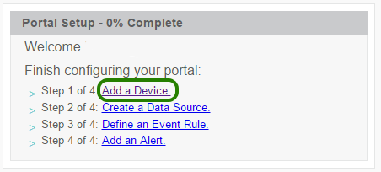

In the dialog that appears, choose “I want to create a generic device”:  
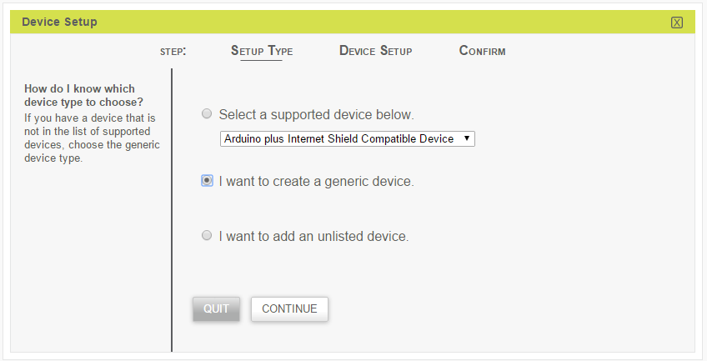

On the next step, “Device Setup”, please fill any details that you want. In the final step it will ask for a name, which can be anything (such as “SN171”). Once the setup has completed, it should list your device in the devices table:  
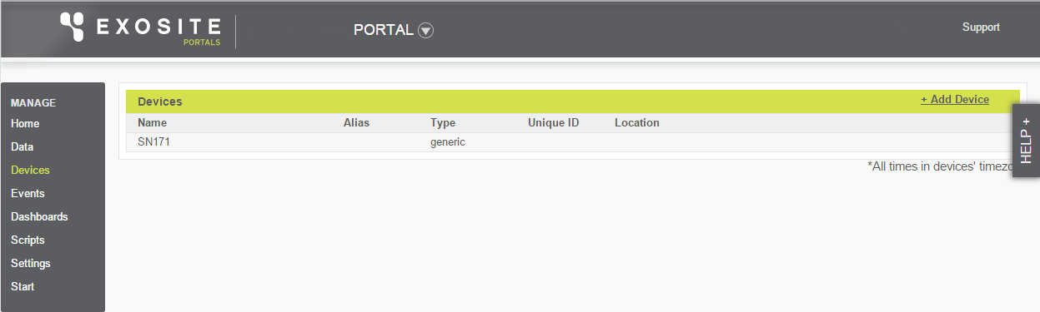

Clink the newly added SN171 device and its details should be displayed:  
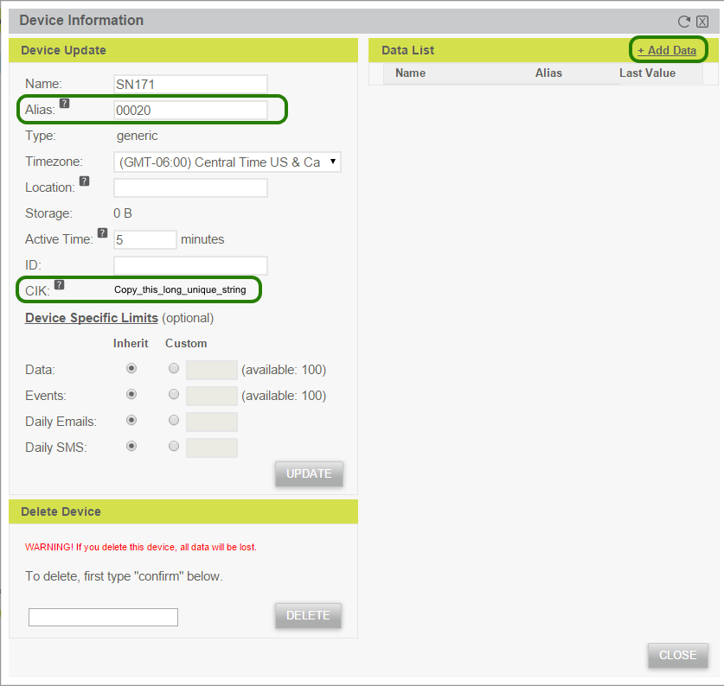

In the “Alias” text box, fill in the SNAP address of the module that is installed in the first SN171 board.

**NOTE** – to be compatible with the main.py example code, the addresses should be entered *without* any separators (no “.” Or “:”, etc.) plus the hexadecimal digits a-f ***must be entered in lower case.***

Where the CIK value is displayed, copy this somewhere for later pasting into the CIK dictionary in main.py.

Next choose “Add Data” to define the information the SNAP node will be sending. In the “Data Setup” dialog that is displayed, fill in the values:  
“Data Source Name” = “Battery”  
“Data Source Format” = “integer”  
“Unit” = “mV”  
“Alias” = batt

The dialog should now look like this:  
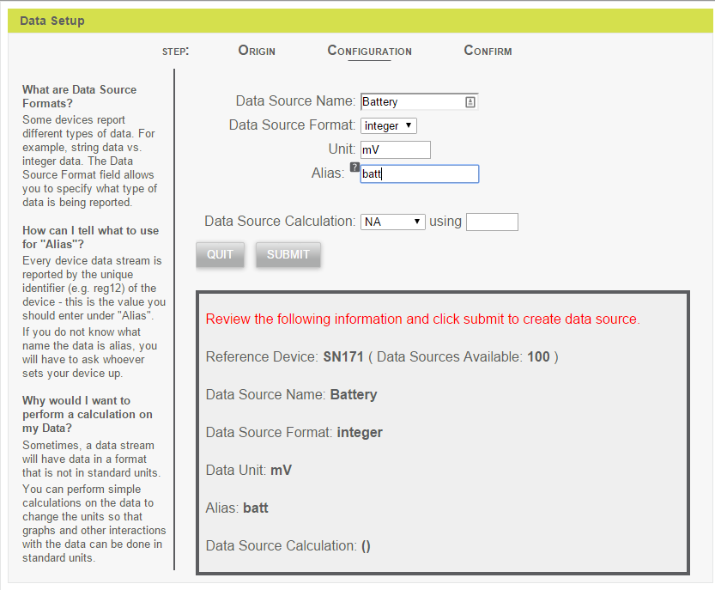  
Submit this form and add two more data sources:  
“Data Source Name” = “Button Count”  
“Data Source Format” = “integer”  
“Unit” = “presses”  
“Alias” = count

“Data Source Name” = “Button State”  
“Data Source Format” = “integer”  
“Unit” = “”  
“Alias” = state

## Setup Gateway

Simply power up the E20 and load the software onto the E20 (put it in the snap user directory). You must edit the provided main.py file to change the EXOSITE_CIKS dictionary to match your SN171 MAC addresses and Exosite CIKs. Find the following code snippet and update it:

# TODO: Replace these with values from your own Exosite account and resource

# We want to map SN171 SNAP addresses to Exosite CIKs

EXOSITE_CIKS = {"XXXXXX": 'unique Exosite CIK here',

"YYYYYY": 'another unique Exosite CIK here'}

This example also uses several 3rd-part Python libraries. Install them onto your E20 using

**sudo pip install –r requirements.txt**

Once both of these steps have been competed, execute the main.py Python script as sudo.

**sudo python main.py**

Now that Exosite and the E20 have been configured, refreshing the “Device Information” on the Exosite website should show new values that were transmitted by the SNAP node.

Repeat the same process of adding a device and data sources for the other SN171.

Now take some time to explore Exosite’s Portals website by creating your own dashboards.

## Exploring this Example Further

More information about the software used in this example can be found in the “Software” guide (look in the same directory where you found this Quick Start).

See also the readme.md file.