# http://www.mcwane.com/upl/images/family-of-companies/logos/synapse-wireless-8cccdd3d.pngE20 Kit3 Demo

This demonstration kit showcases the following products:

* SNAP Connect E20 (using DHCP on the Ethernet Port and the SNAP radio)
* SN171 Prototyping board with RF200 module
* SS200 USB SNAP Stick
* Exosite Poral

The kit (or assembled parts) is upgradeable to the demonstration application. Simply power up the E20 and load the software onto the E20 in the snap user directory. You must edit the main.py file to change the EXOSITE_CIKS dictionary to match your SN171 MAC address and Exosite CIK as detailed below. Once competed, execute the script as sudo.

**sudo python main.py**

Download and install Portal (found elsewhere). Next copy the demo_sn171.py to your Portal/snappyImages directory. Connect the SS200 to your PC via the USB port and apply power to the SN171. Now you can connect Portal to the SS200 as a bridge node and download the script (demo_sn171.py) to the SN171.

Full source code for this example is available on Github here: <https://github.com/synapse-wireless/demo-kits>

## Configuring the Exosite Portal

To use this example a free Exosite Portal is required. To sign up visit:  
<https://portals.exosite.com/signup?plan=2692704445>

From the welcome screen choose Add a Device:  
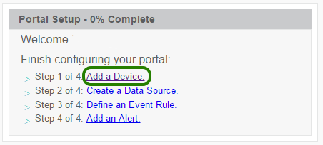

In the dialog that appears, choose “I want to create a generic device”:  
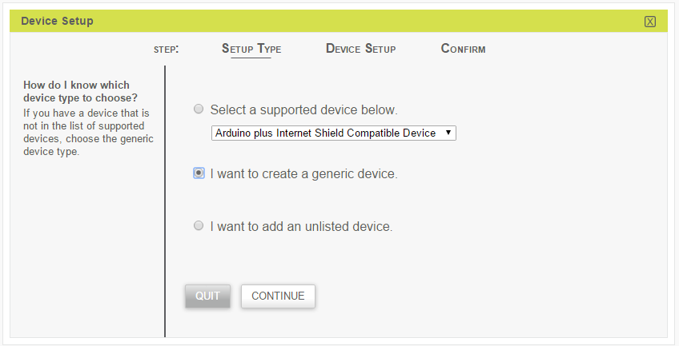

On the next step, “Device Setup”, please fill any details that you want. In the final step it will ask for a name, which can be anything such as SN171. Once the setup has completed it should list your device in the devices table:  
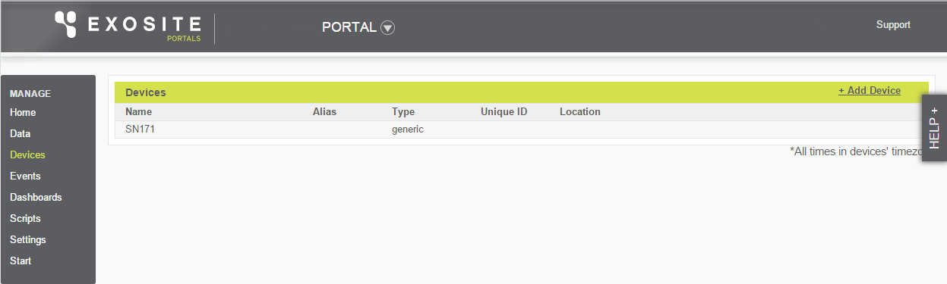

Clink the newly added SN171 device and it’s details should be displayed:  
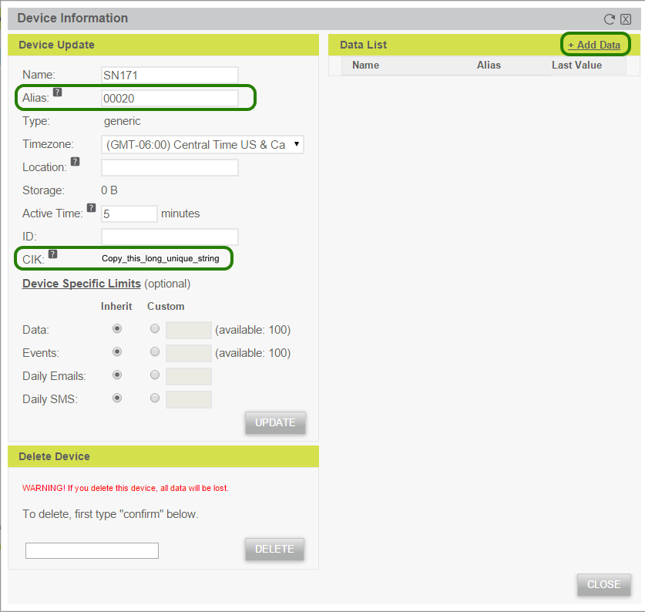

In the “Alias” text box, fill in the SNAP address of the module that is in the SN171 board. Where the CIK value is displayed, copy this into the CIK dictionary in main.py and fill in the SNAP address. Next choose “Add Data” to define the information the SNAP node will be sending. In the “Data Setup” dialog that is displayed, fill in the values:  
“Data Source Name” = “Battery”  
“Data Source Format” = “integer”  
“Unit” = “mV”  
“Alias” = batt

The dialog should now look like this:  
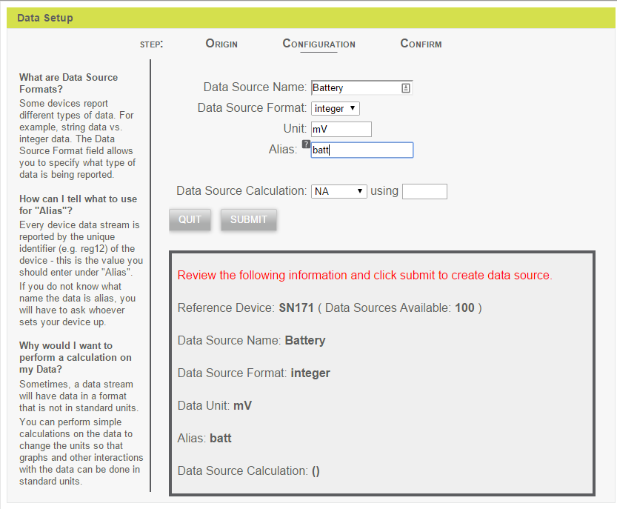  
Submit this form and add two more data sources:  
“Data Source Name” = “Button Count”  
“Data Source Format” = “integer”  
“Unit” = “presses”  
“Alias” = count

“Data Source Name” = “Button State”  
“Data Source Format” = “integer”  
“Unit” = “”  
“Alias” = state

Now that Exosite has been configured, run the main.py Python file. Refreshing the “Device Information” should show new values that were transmitted by the SNAP node.

Repeat the same process of adding a device and data sources for the other SN171.

Now take some time to explore Exosite Portals by creating your own dashboards.