# http://www.mcwane.com/upl/images/family-of-companies/logos/synapse-wireless-8cccdd3d.pngQuick Start Guide for E20 Example 4 – Interfacing to Initial State

This example allows you to stand up a full “node to cloud” data monitoring solution. It showcases the following products (for example, from a Synapse EK5100 kit):

* 1 SNAP Connect E20
  + Using DHCP on the Ethernet Port for Internet access
  + Using the internal SNAP node for SNAP Network access
* 2 SN171 Prototyping boards with RF200 modules installed
* 1 SN132 USB SNAP Stick
* Synapse’s Portal software
* Initial State’s website

Full source code for this example is available on Github here: <https://github.com/synapse-wireless/demo-kits>

The kit (or equivalent assembled parts) is upgradeable to the demonstration application by using the following instructions.

**NOTE** - If you have already run the “Example 1” demo, some of these steps have already been completed.

## Setup SN132

Connect the SN132 to your PC by plugging it into any available USB port.

## Setup Portal

if you have not already done so, download and install Portal.

Portal can be found at forums.synapse-wireless.com.

## Setup the SN171s

Copy SNAPpy script demo_sn171.py to your Portal/snappyImages directory. Apply power to the SN171s. Now you can connect Portal to the SN132 as a bridge node and download script demo_sn171.py into the SN171s.

*Please make a note of the SNAP Addresses of the two SN171 nodes - you will need this information later.*

## Configuring Initial State

To use this example a free Initial State login is required. To sign up visit:

<https://www.initialstate.com/app#/register>

From the welcome screen choose Create HTTPS Bucket:  


In the form that appears you can choose any name that you wish for the bucket. A possibility would be to use the node’s SNAP address.

Once the bucket has been created you will need to copy the bucket key and access key from the settings panel into the dictionary in main.py. To access the settings click on the settings link:  
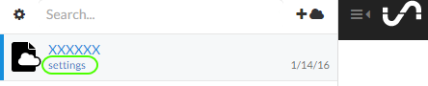

You should see a panel like this:  
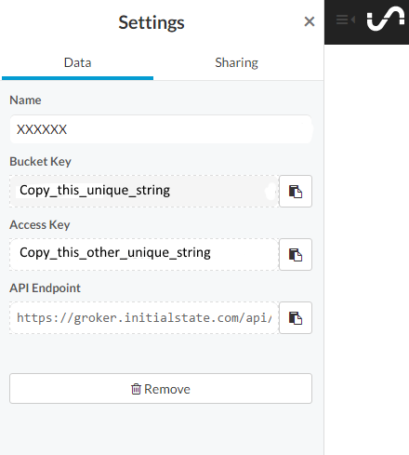

Copy the “Bucket Key” and “Access Key” into the main.py script.

## Setup Gateway

Simply power up the E20 and load the software onto the E20 (put it in the snap user directory). You must edit the provided main.py file to change the INITIAL_STATE_BUCKETS dictionary to match your SN171 MAC addresses and Initial State keys. Find the following code snippet and update it:

# TODO: Replace these with values from your own Initial State account and buckets

# We want to map Initial State buckets to nodes

INITIAL_STATE_BUCKETS = {

"XXXXXX": "unique Initial State bucket key here",

"YYYYYY": "another unique Initial State bucket key here"

}

ACCESS_KEY = "your unique access key here"

This example also uses several 3rd-part Python libraries. Install them onto your E20 using

**sudo pip install –r requirements.txt**

Once both of these steps have been competed, execute the main.py Python script as sudo.

**sudo python main.py**

Now that Initial State and the E20 have been configured, the Initial State website should show new values that were transmitted by the SNAP node.

Repeat the same process of adding a device and data sources for the other SN171.

Now take some time to explore Initial State’s website by viewing data sent from your SN171s.

## Exploring this Example Further

More information about the software used in this example can be found in the “Software” guide (look in the same directory where you found this Quick Start).

See also the readme.md file.