# http://www.mcwane.com/upl/images/family-of-companies/logos/synapse-wireless-8cccdd3d.pngE20 Kit3 Demo – Interfacing the EK5100 Kit to Exosite’s “Portals”

**NOTE** – Synapse’s Portal product and Exosite’s Portals product are not related, they just coincidentally have very similar names.

This demonstration kit showcases the following products:

* 1 SNAP Connect E20
  + Using DHCP on the Ethernet Port for Internet access
  + Using the internal SNAP node for SNAP Network access
* 2 SN171 Prototyping boards with RF200 modules installed
* 1 SN132 USB SNAP Stick
* Synapse’s Portal software
* Exosite’s Portals website

Full source code for this example is available on Github here: <https://github.com/synapse-wireless/demo-kits>

The kit (or equivalent assembled parts) is upgradeable to the demonstration application by using the following instructions.

**NOTE** - If you have already run the Kit1 demo, some of these steps have already been completed.

## Setup SN132

Connect the SN132 to your PC by plugging it into any available USB port.

## Setup Portal

if you have not already done so, download and install Portal.

Portal can be found at forums.synapse-wireless.com.

## Setup the SN171s

Copy SNAPpy script demo_sn171.py to your Portal/snappyImages directory. Apply power to the SN171s. Now you can connect Portal to the SN132 as a bridge node and download script demo_sn171.py into the SN171s.

*Please make a note of the SNAP Addresses of the two SN171 nodes - you will need this information later.*

## Configuring Exosite Portals

To use this example a free Exosite Portal is required. To sign up visit:  
<https://portals.exosite.com/signup?plan=2692704445>

From the welcome screen choose Add a Device:  
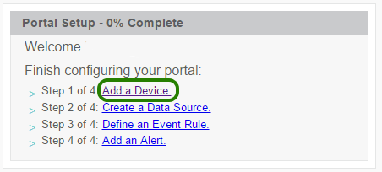

In the dialog that appears, choose “I want to create a generic device”:  
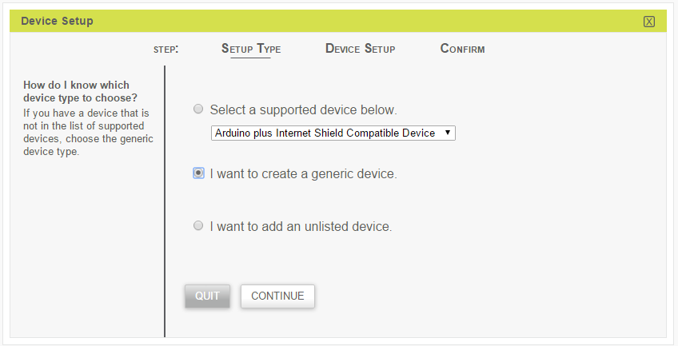

On the next step, “Device Setup”, please fill any details that you want. In the final step it will ask for a name, which can be anything (such as “SN171”). Once the setup has completed, it should list your device in the devices table:  
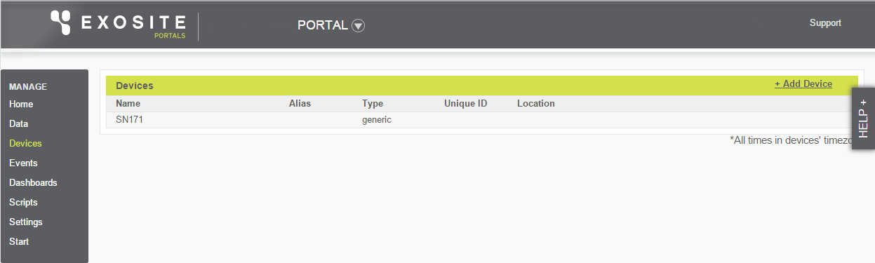

Clink the newly added SN171 device and its details should be displayed:  
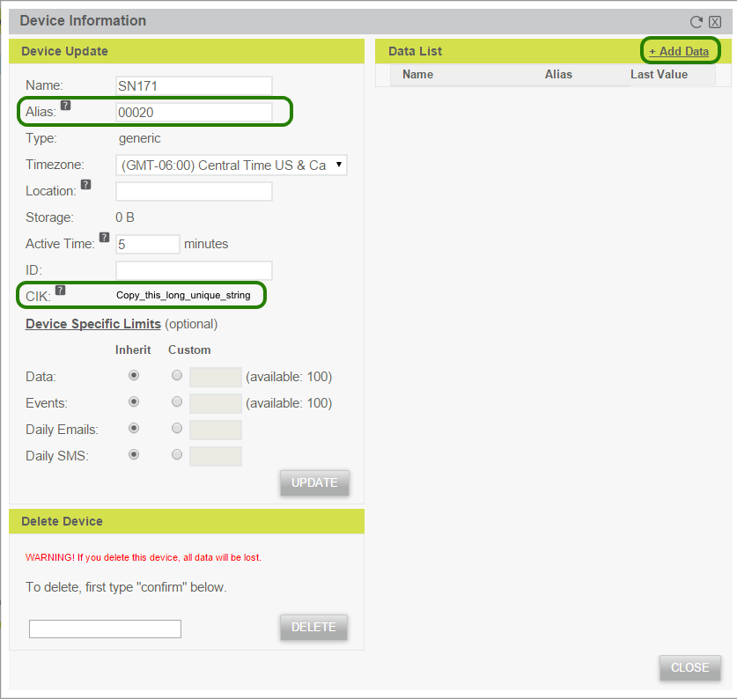

In the “Alias” text box, fill in the SNAP address of the module that is installed in the first SN171 board.

**NOTE** – to be compatible with the main.py example code, the addresses should be entered *without* any separators (no “.” Or “:”, etc.) plus the hexadecimal digits a-f ***must be entered in lower case.***

Where the CIK value is displayed, copy this somewhere for later pasting into the CIK dictionary in main.py.

Next choose “Add Data” to define the information the SNAP node will be sending. In the “Data Setup” dialog that is displayed, fill in the values:  
“Data Source Name” = “Battery”  
“Data Source Format” = “integer”  
“Unit” = “mV”  
“Alias” = batt

The dialog should now look like this:  
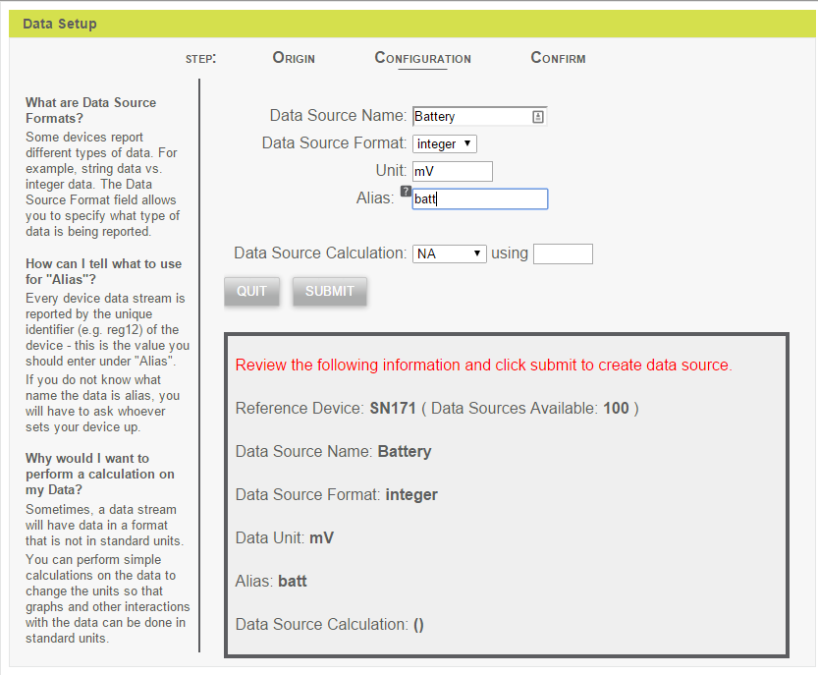  
Submit this form and add two more data sources:  
“Data Source Name” = “Button Count”  
“Data Source Format” = “integer”  
“Unit” = “presses”  
“Alias” = count

“Data Source Name” = “Button State”  
“Data Source Format” = “integer”  
“Unit” = “”  
“Alias” = state

## Setup Gateway

Simply power up the E20 and load the software onto the E20 (put it in the snap user directory). You must edit the provided main.py file to change the EXOSITE_CIKS dictionary to match your SN171 MAC addresses and Exosite CIKs. Find the following code snippet and update it:

# TODO: Replace these with values from your own Exosite account and resource

# We want to map SN171 SNAP addresses to Exosite CIKs

EXOSITE_CIKS = {"XXXXXX": 'unique Exosite CIK here',

"YYYYYY": 'another unique Exosite CIK here'}

This example also uses several 3rd-part Python libraries. Install them onto your E20 using

**sudo pip install –r requirements.txt**

Once both of these steps have been competed, execute the main.py Python script as sudo.

**sudo python main.py**

Now that Exosite and the E20 have been configured, refreshing the “Device Information” on the Exosite website should show new values that were transmitted by the SNAP node.

Repeat the same process of adding a device and data sources for the other SN171.

Now take some time to explore Exosite’s Portals website by creating your own dashboards.

## What’s Going On Here?

The diagram on the next page should put everything in context. It shows the sequence of events that takes place when between pushing the button on one of the SN171 boards and seeing the update on Exosite Portals. Color is used to show the progression of the events: from the SN171 to the Bridge Node inside the E20, to the SNAP Connect instance running inside the E20, to the Exosite Cloud.

The sequence of events is numbered, the text boxes designate events (“what happened”), and the callout balloons provide extra commentary on “why things happened”.

The *next* section of this document is a walk-through of the E20 source code.

**NOTE** – this example re-uses the SNAPpy script from “Kit1”. Refer to the Kit1 documentation for a walk-through of that SNAPpy script.



1

2

HOOK_GPIN event is created

The SNAP core firmware generates this event because the SNAPpy script previously called monitorPin()

3

Function pin_event() gets called

Function pin_event() was previously designated as the handler for HOOK_GPIN events via @setHook()

4

Function send_status() gets called by pin_event()

5

A status() RPC call goes out over the airwaves, with a Time To Live (TTL) of 3 hops

The script made this happen by calling the mcastRpc() built-in

6

The Bridge Node *inside* the E20 receives the status() RPC via its radio, and forwards it to the containing E20’s SNAP Connect application (main.py) over an internal serial interface.

Because that’s what Bridge Nodes do

7

SNAP Connect receives the status() multicast RPC packet over that serial interface

Because main.py previously called API function connect_serial()

8

Function _on_status() gets called

Function _on_status() in main.py was specified as the handler of ALL “status” RPC calls using a function dictionary passed to the __init__() function

9

Function _on_status() builds a JSON status report from the raw RPC parameters, builds a HTTP Request from that JSON, and then sends the HTTP Request to Exosite via TCP/IP

10

Exosite Portals receives the HTTP Request over TCP/IP, and updates the website. It also sends a HTTP Response back to SNAP Connect to let it know the HTTP Request was received

11

Function _handle_request() in main.py gets invoked with the response from Exosite

## Source Code Walk-through (main.py)

The following code walk-through intersperses commentary (in this font and color) with source code (in this font and color).

First several standard Python libraries are imported.

import os

import sys

import json

import binascii

All SNAP Connect applications must import the SNAP Connect Python library.

from snapconnect import snap

This example uses the Tornado ioloop for scheduling. For more details, refer to the separate document **Using Tornado’s ioloop for SNAP Connect’s scheduler**. This example also uses the Tornado HTTP libraries.

from apy import ioloop_scheduler

import tornado.ioloop

from tornado import httpclient

Finally, Exosite’s “pyonep” library is used to gain access to their APIs.

from pyonep import onep # Exosite Python Library

Here is where you are supposed to configure main.py with YOUR SNAP Addresses and YOUR Exosite keys.

Please refer back to the Instructions section of this document. I will go ahead and mention that binary addresses in Python are usually handled with a \x prefix. For example, a SNAP Address of 12.34.56 would be “\x12\x34\x56” in Python. **However**, here the code us going to *take care of that for us*, so 12.34.56 should actually be entered as “123456” (**no \x prefixes!**)

# TODO: Replace these with values from your own Exosite account and resource

# We want to map SN171 SNAP addresses to Exosite CIKs

EXOSITE_CIKS = {"XXXXXX": 'unique Exosite CIK here',

"YYYYYY": 'another unique Exosite CIK here'}

The constant below will be used to tell Tornado how often to give SNAP Connect a turn.

SNAPCONNECT_POLL_INTERVAL = 10 # milliseconds

The following “platform” check allows you to use this main.py file on an E20 Gateway or on a Windows PC.

if sys.platform == "linux2":

# E20 built-in bridge

serial_conn = snap.SERIAL_TYPE_RS232

serial_port = '/dev/snap1'

snap_addr = None # Intrinsic address on Exx gateways

snap_license = None

else:

# SS200 USB stick on Windows

serial_conn = snap.SERIAL_TYPE_SNAPSTICK200

serial_port = 0

snap_addr = '\x00\x00\x20' # SNAP Connect address from included License.dat

cur_path = os.path.normpath(os.path.dirname(__file__))

snap_license = os.path.join(cur_path, 'License.dat')

Wrapping functionality up into a Python class is a common encapsulation technique.

Please note that SNAP Connect can also be used with a purely functional programming style. SNAP Connect supports Object Oriented Programming (OOP) but does not require it.

The ExositeExample class is very simple, and only has three methods: __init__(), _on_status(), and _handle_request(). Each will be discussed inline with the code.

class ExositeExample(object):

All Python classes have a customizable “init” function named __init__() in which to perform any needed initialization.

def __init__(self):

"""

Initializes an instance of ExositeExample

:return:

"""

You always have to tell SNAP Connect what functions you want to be invokable via Remote Procedure Call (RPC), and what you want them to be named. Tthe “RPC” names are not *required* to match the “real” function names, which comes in handy when using Python classes. Here we are filling in a function dictionary with a single entry. If your program had more functions that you wanted to be invokable via RPC, you would add them here.

snap_rpc_funcs = {'status': self._on_status}

Importing the SNAP Connect library (up above) gives us access to the API, but it does not automatically create an actual SNAP Connect instance. We do that next.

# Create SNAP Connect instance. Note: we are using Tornado's scheduler.

self.snapconnect = snap.Snap(

license_file=snap_license,

addr=snap_addr,

scheduler=ioloop_scheduler.IOLoopScheduler(),

funcs=snap_rpc_funcs

)

Notice the use of an alternate scheduler (scheduler = …), and the use of the function dictionary created above.

SNAP Connect also has to be told which physical interfaces to use. For this example, we are connected *serially* the SM200 SNAP Module inside the E20, but be aware that SNAP Connect can also make connections over TCP/IP.

self.snapconnect.open_serial(serial_conn, serial_port)

Here is where we use that constant defined up above. By telling Tornado to call SNAP Connect every so often, below we will be able to turn control of the CPU over to the Tornado HTTP library.

# Tell tornado to call SNAP connect internals periodically

tornado.ioloop.PeriodicCallback(self.snapconnect.poll_internals, SNAPCONNECT_POLL_INTERVAL).start()

Similar to how importing SNAP Connect did not automatically give you a SNAP Connect instance, you also have to actually instantiate a OnepV1 object.

self.exosite = onep.OnepV1()

This completes the initialization of the ExositeExample object, and the __init__() routine.

This next routine gets invoked whenever any node invokes “status” via RPC.

*Reminder – the “name mapping” from status() to _on_status() was done when we filled in that function dictionary.*

def _on_status(self, batt, button_state, button_count):

"""

Writes the various status values received from a node to Exosite

:return: None

"""

The calling node explicitly provided values for batt (battery voltage), button state (pressed or not), and “count of how many times the button has been pressed”.

Although not provided explicitly by the RPC caller, the SNAP Address of the calling node is provided implicitly, because it is a part of every SNAP Packet. This address is retrieved via function rpc_source_addr(), which the following line of code then converts from binary to HEX-ASCII. For example, “\x12\x34\x45” becomes “123456”.

remote_addr = binascii.hexlify(self.snapconnect.rpc_source_addr())

The code prints the received status report just for debug purposes. This makes the values appear on the local console, but does nothing to get them to the Exosite Portals website.

print batt, button_state, button_count

The variables we just printed get formatted into a JSON request by the following line of code.

# Use the Exosite Python Library to format the message

jsonreq = {"auth": {"cik": EXOSITE_CIKS[remote_addr]},

"calls": self.exosite._composeCalls([('writegroup', [[[{"alias": "batt"}, int(batt)],

[{"alias": "state"}, int(button_state)],

[{"alias": "count"}, button_count]]])])}

This gets the raw data into JSON, but we still have to convert it into a HTTP request. The following line of code accomplishes this. Note that a lot of the details (such as the correct Universal Resource Locator – URL) are provided by the Exosite library.

# Create a Tornado HTTPRequest

request = httpclient.HTTPRequest(url=self.exosite.onephttp.host + self.exosite.url,

method='POST',

headers=self.exosite.headers,

body=json.dumps(jsonreq))

Now that we have an actual HTTP request (with JSON-encoded data inside of it), we use the Tornado HTTP libraries to send it in a non-blocking (asynchronous) fashion. This allows us to continue listening for additional status() reports.

http_client = httpclient.AsyncHTTPClient()

http_client.fetch(request, self._handle_request)

You will notice that the last parameter of the fetch() function call above was self._handle_request.

This is a callback function (defined next) which later gets called with the result of the above “fetch request”.

@staticmethod

def _handle_request(response):

"""

Prints the response of a HTTPRequest

:param response: HTTPRequest

:return:

"""

This code lets us know how the “push” (reporting) of the data to Exosite turned out. For this simple example, we are simply printing the outcome, but we are not taking any additional actions.

if response.error:

print "Error:", response.error

else:

print response.body

The main() routine of this example program is very simple.

def main():

example = ExositeExample()

1. An ExositeExample() object gets created.
   1. Reminder – the __init__() function of that object gets invoked automatically
   2. THAT routine sets up SNAP Connect, etc. (refer back to the code up above)

tornado.ioloop.IOLoop.instance().start()

1. Tornado is given control of the CPU. It will continue running (without returning) until the program is forcibly shut down.

The following Python idiom is used to allow a single Python source file to serve as both a stand-along application AND as a reusable library.

if __name__ == '__main__':

main()

In other word, *IF* this file was invoked *by itself* (You typed **python main.py** on the command like)…

then invoke main().

Otherwise, main() does **not** get invoked.

As an example of NOT being invoked standalone, imagine if some OTHER Python source file had the line “import main” in it. For example, this would allow reuse of the “ExositeExample” class without having to copy/paste the source code into that other file(s).

For more information about SNAP Connect Python programming, refer to the **SNAP Connect Python Package Manual**.

If you are unfamiliar with Python at all, one good reference is **Core Python Programming (2nd Edition)** by Wesley J. Chun (ISBN-10: 0-13-226993-7). A Google search for “Dive into Python” would also prove helpful.