

Astra SRSDK Quick Start Guide

Synaptics Confidential Disclosed Under NDA

PN:
5
xx
-
000
xxx
-
01
Rev
2

Contents
1. Introduction 3
2. Prerequisites 4
3. Hardware Setup 5
4. Install VS Code Extension 6
5. Install Required Tools 7
6. VS Code Extension 7
7. SynaToolkit Suite 7
8. Reference Applications 8
9. Sample Applications 8
10. Supported Sensors and Configuration 9
11. Supported Flash List 9
12. Known Issues 10
SRSDKI-655 10
13. Revision History 10

Introduction

The Astra SRSDK is a comprehensive software development kit tailored to harness the exceptional capabilities of the SR series of MCUs. The Astra SRSDK is designed to cater to the Vision and AI capabilities of the Astra SR MCU.

To facilitate a seamless development journey, the Astra SRSDK includes the following key components:

- Optimized libraries and frameworks specifically tuned for the SR series hardware accelerators.

- Sample Applications - Demonstrations real-world use cases such as vision-based low power AI.

- Documentation and Tutorials - Detailed resources guiding developers from initial setup to advanced optimization techniques.

Prerequisites

- Windows, Linux, or MacOS

- VS Code

- Astra Machina Micro Kit

Hardware Setup

- Unbox the Astra Machina Micro Kit and visually inspect it for damage.

- Ensure that all switches and jumpers are set to their default settings. Refer to the Astra Machina Micro Reference Manual for details.

- Connect the Debug IC USB port (J14) to your host PC using the supplied USB cable. In the figure below, this is the bottom left connector.

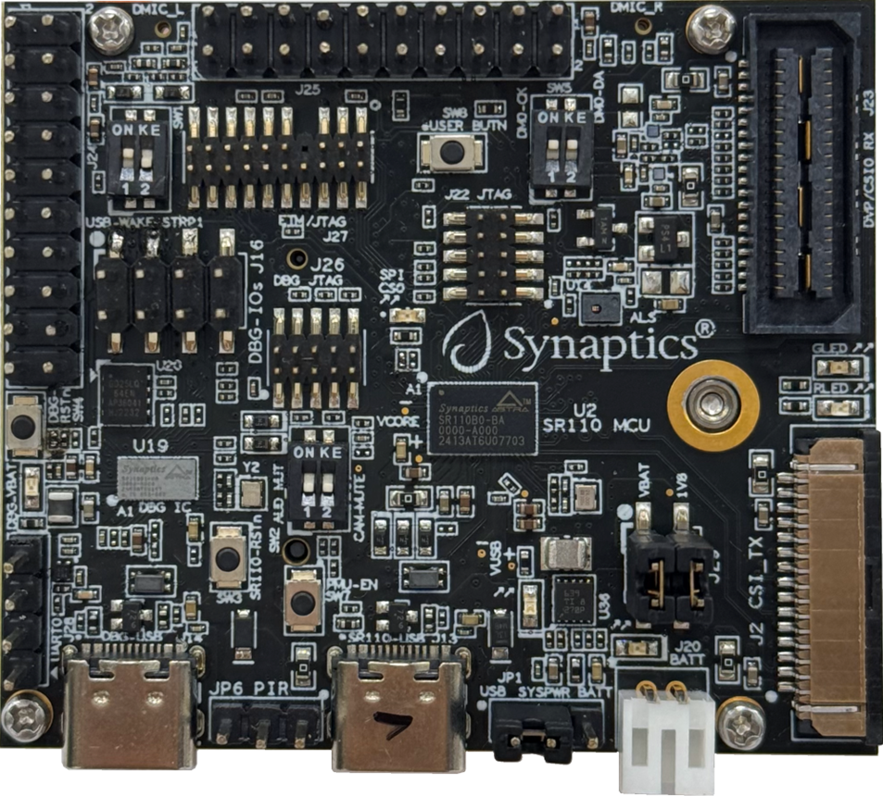

- Wait a few seconds for the Debug IC to enumerate for the first time (up to 15 seconds).

- The Debug IC enumerates as two USB Serial Devices (CDC) (COM numbers may vary, e.g., COM48 and COM49 in the example below). One COM port is for updating the Debug IC FW and the other COM port is for capturing logs from the SR110. Note the Debug IC also enumerates as CMSIS-DAP device, this allows for programming and debugging of the SR110.

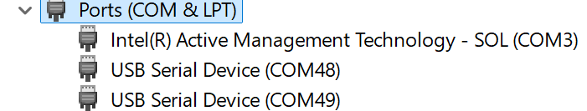

- If the Debug IC doesn't enumerate as two USB Serial Devices, but instead as two unknown USB devices then USB serial drivers need to be installed on your PC. It is recommended to use the FTDI VCP drivers: https://ftdichip.com/drivers/vcp-drivers/

- Note if no USB shows up after plugging in J14 to see "How to Program Debug IC.pdf"

Install VS Code Extension
- In VS Code Open a new terminal window. Navigate to the installed SDK and type the following command:
> code -–install-extension tools/Astra_MCU_SDK_vscode_extension-1.2.2.vsix

- After installing the extension, it is recommended to close and reopen VS Code.

Install Required Tools
- Click on the Synaptics Extension icon
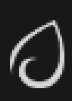

- Navigate to Install Tools:

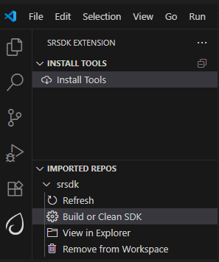

- Follow the prompts to install all required tools for use with the SDK. Note that during install the system may prompt you to approve installation of some tools, so pay attention during this time.

Import the SDK
- Within the Synaptics Extension go to Import SDK and chose the top-level folder for the SDK which you installed on your system.

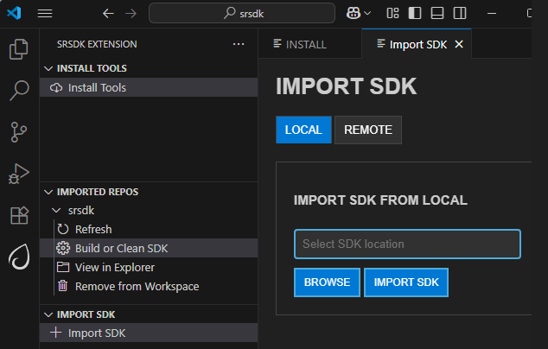

Build Sample Application
- In the Synaptics Extension navigate to Imported Repos and select Build or clean SDK.

- Choose:

  - sr110_cm55_fw

  - Release

  - sr110_rdk

  - GCC

  - demo_sample_app.

- Press Build
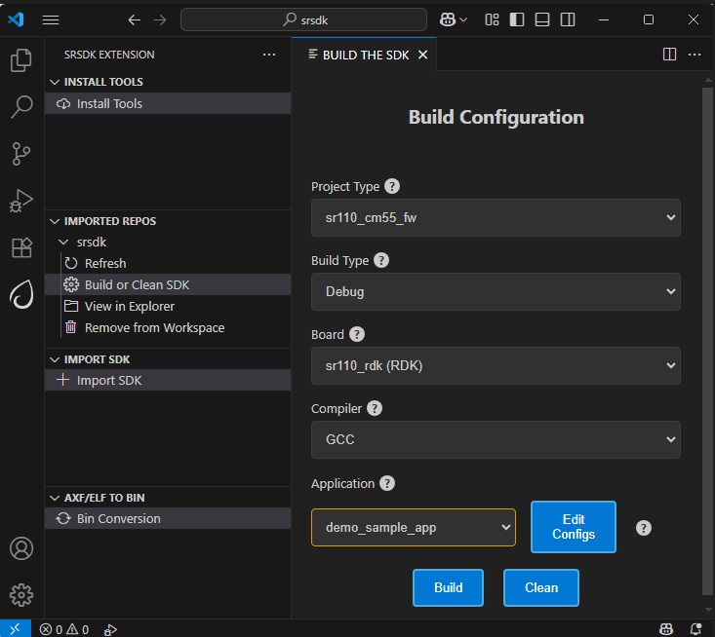

Create bin File for Flashing

Once your application has been built an .elf file will be created. This needs to be converted into a .bin file to load onto the onboard flash on the Astra Machina Micro board.

- In the Synaptics Extension navigate to AXF/ELF to BIN and select Bin Conversion

- The .elf file created when you built the demo app should be automatically populated. If not click browse and navigate to the .elf file which located here: out/sr110_cm55_fw/release/sr110_cm55_fw.elf

- Select Flash Image and Flash Type of GD25LE128, and select Secured Image

- Press Run Image Generator
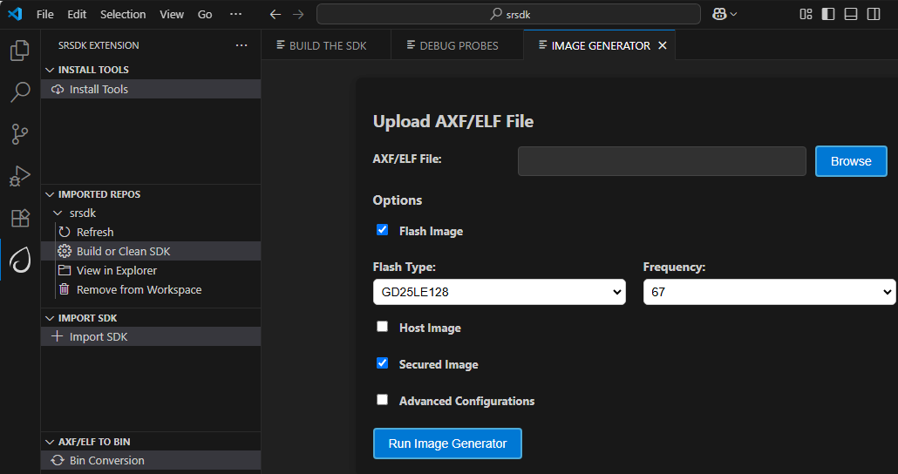

Flash Application Image

- From the Image Flashing dialog select Service Type of SWD/JTAG

- Select Adapter Driver as CMSIS-DAP

- Navigate to the .bin file you previously created. This is typically stored in the user directory in a folder called Bin_Location.

- Press Flash Execute
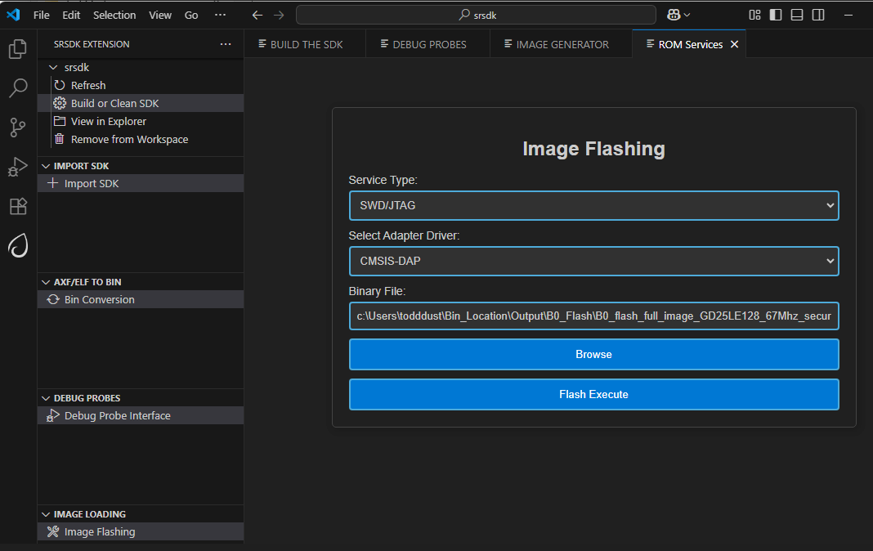

Run Application

- After programming finishes un-plug and re-plug the USB cable into the Debug IC USB connector

- Open a terminal application such as the Serial Monitor in VSCode or Tera Term

- Try both COM ports until you see prints similar to the below

- You should now see the demo printing out info:

0119215263:[0][INFO][SYS]:Task vTaskDemo1

0119715263:[0][INFO][SYS]:Task vTaskDemo1

0120115263:[0][INF][SYS]:Task vTaskDemo2

0120215263:[0][INF][SYS]:Task vTaskDemo1

0120715263:[0][INF][SYS]:Task vTaskDemo1

0121115263:[0][INF][SYS]:Task vTaskDemo2

Debug Application

If you want, you can debug the application as well.

- In the Synaptics Extension go to Debug Probes and Debug Probe Interface

- Select the .elf for your application (if not already selected)

- Choose CMSIS DAP as the adapter driver

- Press Download & Reset Program

- For better debug experience, it is recommended to build in Debug mode, not Release mode.
A debug session is started and the application halts at the start of main
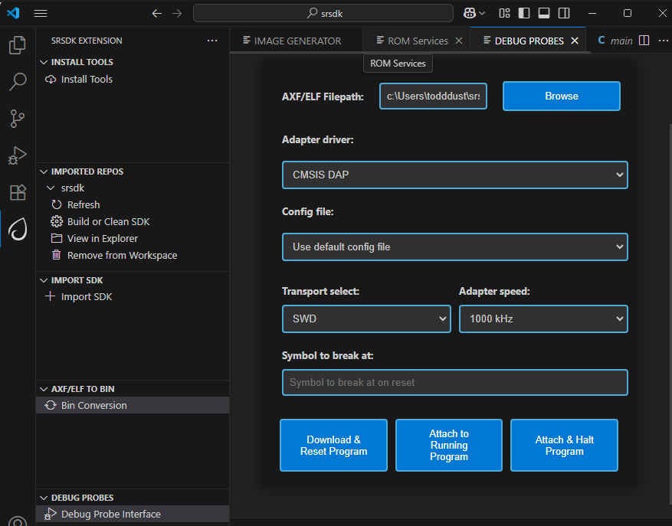

Running Vision AI Applications

The first part walked you through how to setup your system and run a simple demo application. Now it is time to run a vision AI example.
Follow the steps from above except this time choose something like uc_person_detection. Follow the same steps to build and flash.
Once the image is flashed plug another USB cable into the 2nd USB port (J13) on the Astra Machina Micro board.

Updating Drivers

This step is important to enable image presentation via SynaToolkit, you are required to configure comport with “Zadig”.

- Download the Zadig USB driver from the following link: https://zadig.akeo.ie/
- Open zadig-2.8.exe
- In the “Options” tab choose “List All Devices”
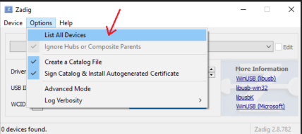

- In the drop-down list choose “SR 100-B0 CDC 1”
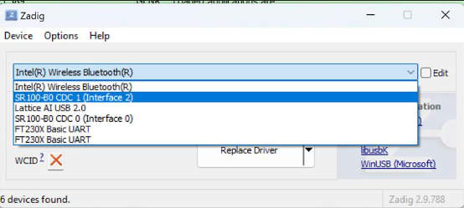

- Click on “Replace Driver”
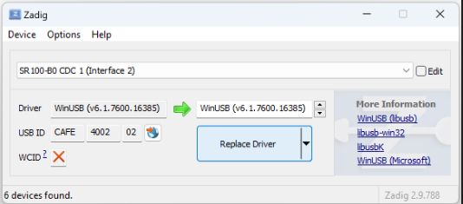

Installing SynaTool Kit

Located in the tools directory is a SynaToolKit_x.y.z.exe. If you are a windows user install this tool.

Running Vision AI in SynaTool kit

Go to the README.md file for the chosen Vision AI use case and follow the directions under the heading “Running the Application.”
Copyright
Copyright © 2024 Synaptics Incorporated. All Rights Reserved.
Trademarks
Synaptics; the Synaptics logo; are trademarks or registered trademarks of Synaptics Incorporated in the United States and/or other countries. All other trademarks are the property of their respective owners.
Notice
This document contains information that is proprietary to Synaptics Incorporated (“Synaptics”). The holder of this document shall treat all information contained herein as confidential, shall use the information only for its intended purpose, and shall not duplicate, disclose, or disseminate any of this information in any manner unless Synaptics has otherwise provided express, written permission.
Use of the materials may require a license of intellectual property from a third party or from Synaptics. This document conveys no express or implied licenses to any intellectual property rights belonging to Synaptics or any other party. Synaptics may, from time to time and at its sole option, update the information contained in this document without notice.
INFORMATION CONTAINED IN THIS DOCUMENT IS PROVIDED "AS-IS,” AND SYNAPTICS HEREBY DISCLAIMS ALL EXPRESS OR IMPLIED
WARRANTIES, INCLUDING BUT NOT LIMITED TO ANY IMPLIED WARRANTIES OF MERCHANTABILITY AND FITNESS FOR A PARTICULAR
PURPOSE, AND ANY WARRANTIES OF NON-INFRINGEMENT OF ANY INTELLECTUAL PROPERTY RIGHTS. IN NO EVENT SHALL SYNAPTICS BE
LIABLE FOR ANY DIRECT, INDIRECT, INCIDENTAL, SPECIAL, PUNITIVE, OR CONSEQUENTIAL DAMAGES ARISING OUT OF OR IN CONNECTION
WITH THE USE OF THE INFORMATION CONTAINED IN THIS DOCUMENT, HOWEVER CAUSED AND BASED ON ANY THEORY OF LIABILITY,
WHETHER IN AN ACTION OF CONTRACT, NEGLIGENCE OR OTHER TORTIOUS ACTION, AND EVEN IF SYNAPTICS WAS ADVISED OF THE POSSIBILITY OF SUCH DAMAGE. IF A TRIBUNAL OF COMPETENT JURISDICTION DOES NOT PERMIT THE DISCLAIMER OF DIRECT DAMAGES OR ANY OTHER DAMAGES, SYNAPTICS’ TOTAL CUMULATIVE LIABILITY TO ANY PARTY SHALL NOT EXCEED ONE HUNDRED U.S. DOLLARS.
Ordering Information
For ordering information and a complete list of Synaptics' products, contact your Synaptics sales representative. Visit our website at www.synaptics.com to locate the Synaptics office nearest you.
Contact Us
Visit our website at www.synaptics.com to locate the Synaptics office nearest you.



