FILE PERMISSIONS:
#include <stdio.h>
int main()
{
FILE *fp;
fp = fopen("sample.txt", "w");
if (fp == NULL)
{
printf("Cannot open file\n");
return 1;
}
fprintf(fp, "Hello, this is a test file.\n");
fclose(fp);
printf("File created successfully.\n");
return 0;
}

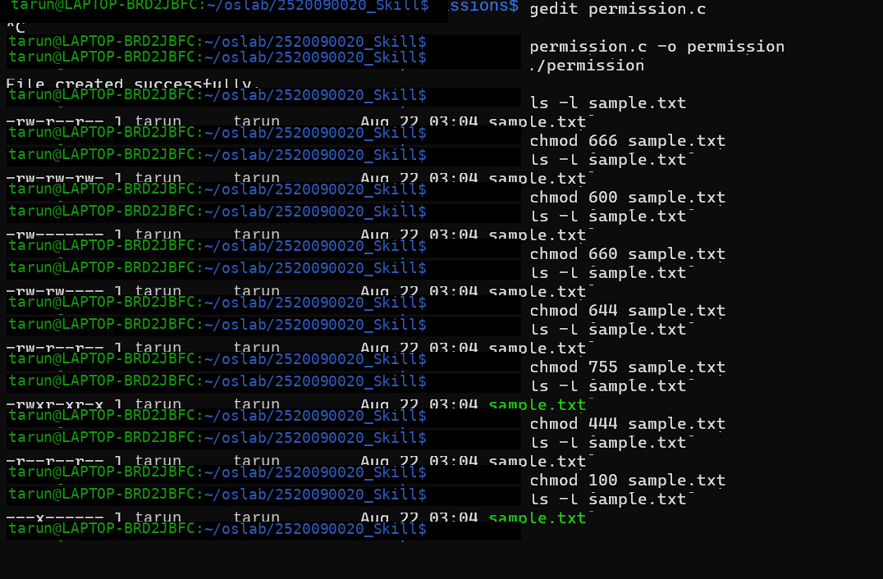

8) Owner: read + write; Group: nothing; Others: nothing →600
9) Owner: read + write; Group: read; Others: read → 644
10) Owner: read + write + execute; Group: read + execute; Others: read + execute → 755
11) Owner: read + write; Group: read + write; Others: nothing → 660
12) Everyone: read only → 444

