SKILL11:

#include <stdio.h>
#include <stdlib.h>
#include <string.h>

#define MAX_HISTORY 5
#define MAX_COMMAND 100

char history[MAX_HISTORY][MAX_COMMAND];
int history_count = 0;

void add_command(const char *command)
{
// If buffer is full, remove the oldest command
if (history_count == MAX_HISTORY)
{
for (int i = 1; i < MAX_HISTORY; i++)
{
strcpy(history[i - 1], history[i]);
}

history_count--;
}

strcpy(history[history_count], command);
history_count++;
}

void display_history()
{
printf("\n===== COMMAND HISTORY =====\n");

if (history_count == 0)
{
printf("History is empty.\n");
return;
}

for (int i = 0; i < history_count; i++)
{
printf("%d %s\n", i + 1, history[i]);
}
}

int main()
{
char command[MAX_COMMAND];

printf("===== MINI SHELL HISTORY =====\n");
printf("Maximum history size: %d commands\n", MAX_HISTORY);
printf("Type 'history' to display commands.\n");
printf("Type 'exit' to quit.\n\n");

while (1)
{
printf("myshell> ");

if (fgets(command, sizeof(command), stdin) == NULL)
break;

command[strcspn(command, "\n")] = '\0';

if (strlen(command) == 0)
continue;

if (strcmp(command, "exit") == 0)
{
printf("Exiting...\n");
break;
}

if (strcmp(command, "history") == 0)
{
display_history();
continue;
}

add_command(command);

printf("Command stored: %s\n", command);
}

return 0;
}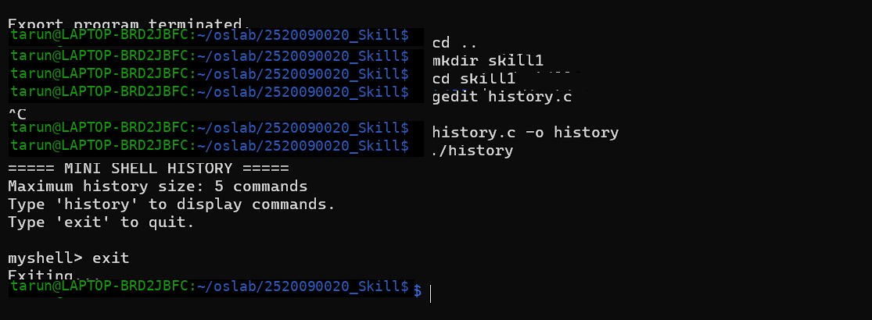

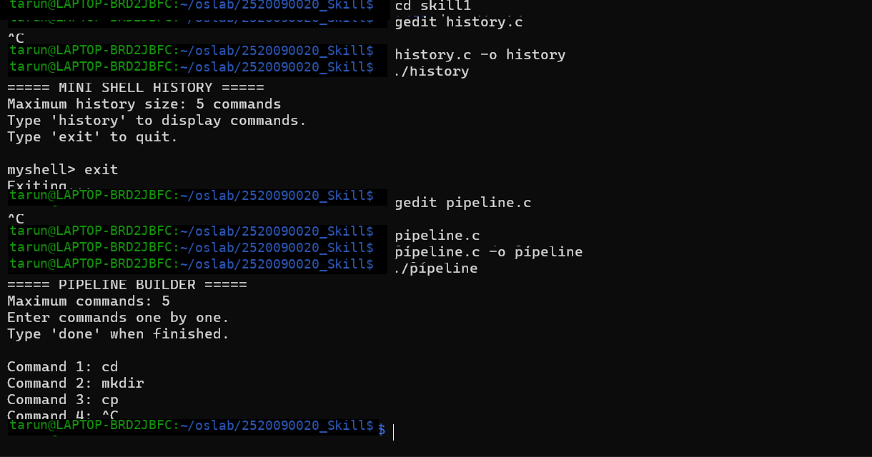
Pipeline.c
#include <stdio.h>
#include <stdlib.h>
#include <string.h>

#define MAX_COMMANDS 5
#define MAX_LENGTH 100

typedef struct
{
char command[MAX_LENGTH];
} PipelineCommand;

typedef struct
{
PipelineCommand commands[MAX_COMMANDS];
int count;
} Pipeline;

void initialize_pipeline(Pipeline *pipeline)
{
pipeline->count = 0;
}

int add_command(Pipeline *pipeline, const char *command)
{
if (pipeline->count >= MAX_COMMANDS)
{
printf("Pipeline capacity reached.\n");
return 0;
}

strcpy(pipeline->commands[pipeline->count].command,
command);

pipeline->count++;

return 1;
}

void display_pipeline(const Pipeline *pipeline)
{
printf("\n===== PIPELINE LAYOUT =====\n");

if (pipeline->count == 0)
{
printf("Pipeline is empty.\n");
return;
}

for (int i = 0; i < pipeline->count; i++)
{
printf("Process %d: %s",
i + 1,
pipeline->commands[i].command);

if (i < pipeline->count - 1)
printf(" | ");
}

printf("\n");

printf("\nExecution order:\n");

for (int i = 0; i < pipeline->count; i++)
{
printf("%d. %s",
i + 1,
pipeline->commands[i].command);

if (i < pipeline->count - 1)
printf(" -> ");

printf("\n");
}
}

int main()
{
Pipeline pipeline;

initialize_pipeline(&pipeline);

printf("===== PIPELINE BUILDER =====\n");
printf("Maximum commands: %d\n", MAX_COMMANDS);
printf("Enter commands one by one.\n");
printf("Type 'done' when finished.\n\n");

while (1)
{
char command[MAX_LENGTH];

printf("Command %d: ", pipeline.count + 1);

if (fgets(command, sizeof(command), stdin) == NULL)
break;

command[strcspn(command, "\n")] = '\0';

if (strcmp(command, "done") == 0)
break;

if (strlen(command) == 0)
continue;

if (!add_command(&pipeline, command))
break;
}

display_pipeline(&pipeline);

return 0;
}

