SKILL6:
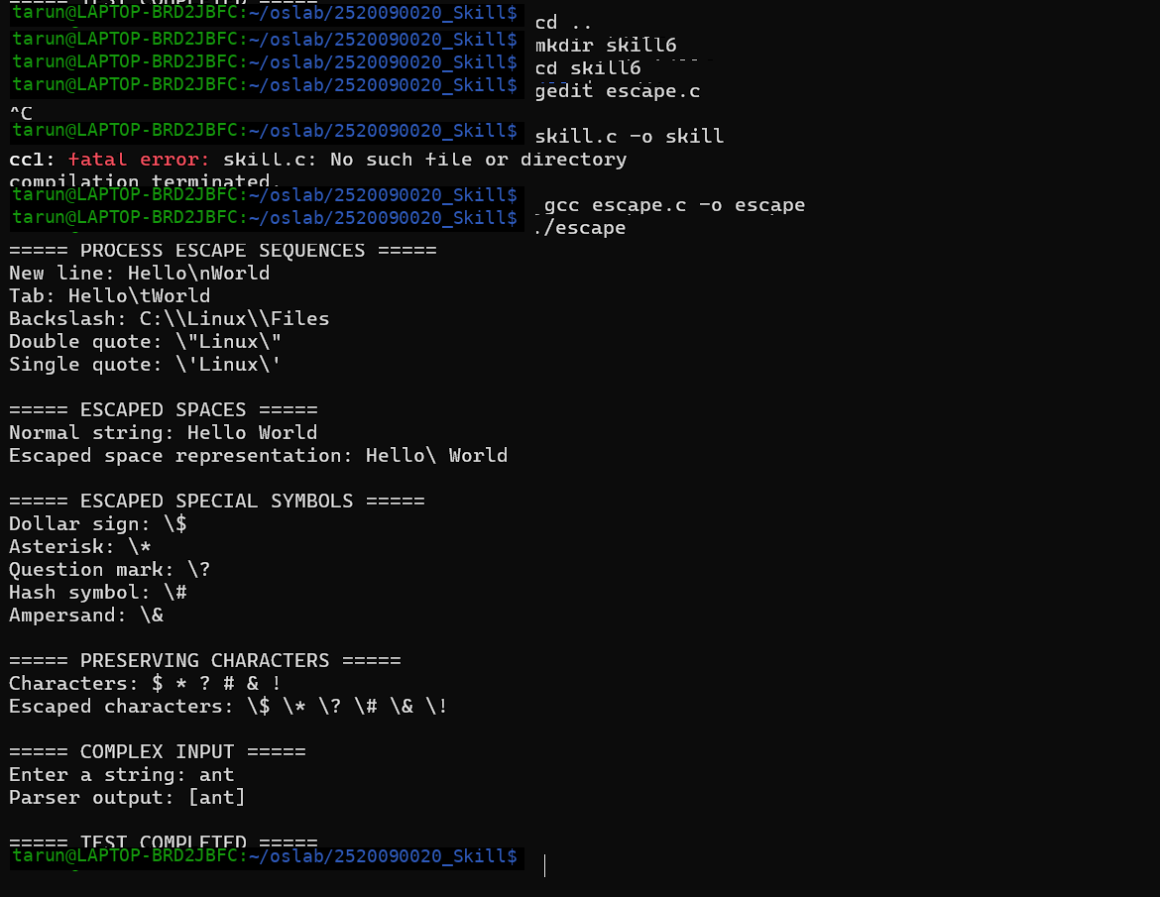
#include <stdio.h>
#include <string.h>

int main()
{
printf("===== PROCESS ESCAPE SEQUENCES =====\n");

printf("New line: Hello\\nWorld\n");
printf("Tab: Hello\\tWorld\n");
printf("Backslash: C:\\\\Linux\\\\Files\n");
printf("Double quote: \\\"Linux\\\"\n");
printf("Single quote: \\'Linux\\'\n");

printf("\n===== ESCAPED SPACES =====\n");

char text1[] = "Hello World";
char text2[] = "Hello\\ World";

printf("Normal string: %s\n", text1);
printf("Escaped space representation: %s\n", text2);

printf("\n===== ESCAPED SPECIAL SYMBOLS =====\n");

printf("Dollar sign: \\$\n");
printf("Asterisk: \\*\n");
printf("Question mark: \\?\n");
printf("Hash symbol: \\#\n");
printf("Ampersand: \\&\n");

printf("\n===== PRESERVING CHARACTERS =====\n");

printf("Characters: $ * ? # & !\n");
printf("Escaped characters: \\$ \\* \\? \\# \\& \\!\n");

printf("\n===== COMPLEX INPUT =====\n");

char input[100];

printf("Enter a string: ");
fgets(input, sizeof(input), stdin);

input[strcspn(input, "\n")] = '\0';

printf("Parser output: [%s]\n", input);

printf("\n===== TEST COMPLETED =====\n");

return 0;
}

Exec.c
#include <stdio.h>
#include <stdlib.h>
#include <unistd.h>
#include <sys/wait.h>

int main()
{
pid_t pid;

printf("Parent process started.\n");
printf("Parent PID: %d\n", getpid());

pid = fork();

if (pid < 0)
{
perror("fork failed");
return 1;
}

if (pid == 0)
{
// Child process
printf("\nChild process created.\n");
printf("Child PID: %d\n", getpid());
printf("Parent PID: %d\n", getppid());

printf("Executing ls command...\n\n");

execlp("ls", "ls", "-l", NULL);

// This executes only if exec fails
perror("exec failed");
exit(1);
}
else
{
// Parent process
printf("\nParent waiting for child...\n");

int status;

waitpid(pid, &status, 0);

if (WIFEXITED(status))
{
printf("\nChild exited with status: %d\n",
WEXITSTATUS(status));
}
else
{
printf("\nChild terminated abnormally.\n");
}

printf("Parent process completed.\n");
}

return 0;
}