SKILL8:
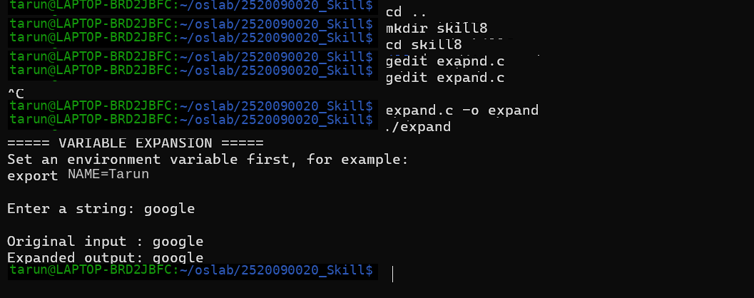
#include <stdio.h>
#include <stdlib.h>
#include <string.h>
#include <ctype.h>

#define MAX_INPUT 500
#define MAX_OUTPUT 1000

void expand_variables(const char *input, char *output)
{
int i = 0;
int j = 0;

while (input[i] != '\0' && j < MAX_OUTPUT - 1)
{
// Detect $
if (input[i] == '$')
{
i++;

// Handle ${VARIABLE}
if (input[i] == '{')
{
i++;

char var[100];
int k = 0;

while (input[i] != '\0' &&
input[i] != '}' &&
k < 99)
{
var[k++] = input[i++];
}

var[k] = '\0';

if (input[i] == '}')
i++;

char *value = getenv(var);

if (value != NULL)
{
for (int x = 0;
value[x] != '\0' &&
j < MAX_OUTPUT - 1;
x++)
{
output[j++] = value[x];
}
}
else
{
printf("Undefined variable: %s\n", var);
}
}

// Handle $VARIABLE
else if (isalpha((unsigned char)input[i]) ||
input[i] == '_')
{
char var[100];
int k = 0;

while ((isalnum((unsigned char)input[i]) ||
input[i] == '_') &&
k < 99)
{
var[k++] = input[i++];
}

var[k] = '\0';

char *value = getenv(var);

if (value != NULL)
{
for (int x = 0;
value[x] != '\0' &&
j < MAX_OUTPUT - 1;
x++)
{
output[j++] = value[x];
}
}
else
{
printf("Undefined variable: %s\n", var);
}
}
else
{
// If $ is not followed by a variable
output[j++] = '$';
}
}
else
{
output[j++] = input[i++];
}
}

output[j] = '\0';
}

int main()
{
char input[MAX_INPUT];
char output[MAX_OUTPUT];

printf("===== VARIABLE EXPANSION =====\n");

printf("Set an environment variable first, for example:\n");
printf("export NAME=Sricharan\n\n");

printf("Enter a string: ");

if (fgets(input, sizeof(input), stdin) == NULL)
return 1;

input[strcspn(input, "\n")] = '\0';

expand_variables(input, output);

printf("\nOriginal input : %s\n", input);
printf("Expanded output: %s\n", output);

return 0;
}

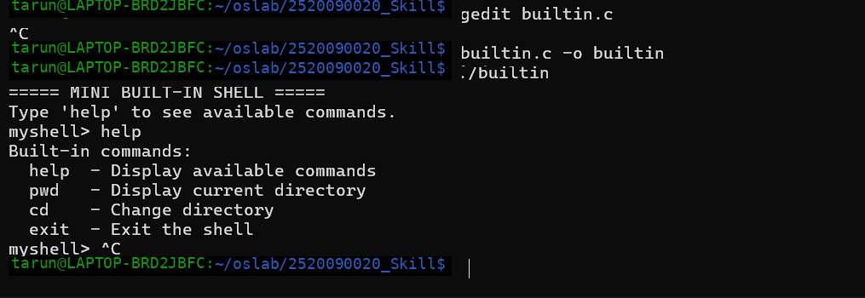
Builtin.c
#include <stdio.h>
#include <stdlib.h>
#include <string.h>
#include <unistd.h>

#define MAX_INPUT 200

// Built-in command functions
void cmd_help(char *args)
{
printf("Built-in commands:\n");
printf(" help - Display available commands\n");
printf(" pwd - Display current directory\n");
printf(" cd - Change directory\n");
printf(" exit - Exit the shell\n");
}

void cmd_pwd(char *args)
{
char cwd[500];

if (getcwd(cwd, sizeof(cwd)) != NULL)
printf("%s\n", cwd);
else
perror("pwd");
}

void cmd_cd(char *args)
{
if (args == NULL || strlen(args) == 0)
{
printf("Usage: cd <directory>\n");
return;
}

if (chdir(args) != 0)
perror("cd");
}

void cmd_exit(char *args)
{
printf("Exiting shell...\n");
exit(0);
}

// Function pointer type
typedef void (*command_function)(char *args);

// Dispatch table
typedef struct
{
const char *name;
command_function function;
} Builtin;

// Built-in command table
Builtin builtins[] =
{
{"help", cmd_help},
{"pwd", cmd_pwd},
{"cd", cmd_cd},
{"exit", cmd_exit}
};

int builtin_count =
sizeof(builtins) / sizeof(builtins[0]);

int main()
{
char input[MAX_INPUT];

printf("===== MINI BUILT-IN SHELL =====\n");
printf("Type 'help' to see available commands.\n");

while (1)
{
printf("myshell> ");
fflush(stdout);

if (fgets(input, sizeof(input), stdin) == NULL)
break;

input[strcspn(input, "\n")] = '\0';

if (strlen(input) == 0)
continue;

// Separate command and arguments
char *command = strtok(input, " ");
char *args = strtok(NULL, "");

int found = 0;

// Search dispatch table
for (int i = 0; i < builtin_count; i++)
{
if (strcmp(command, builtins[i].name) == 0)
{
builtins[i].function(args);
found = 1;
break;
}
}

if (!found)
{
printf("myshell: command not found: %s\n",
command);
}
}

return 0;
}

