2520090081 – SAI RAM PRAGNEY MURIKIPUDI
- Read/Write to owner and group (660)

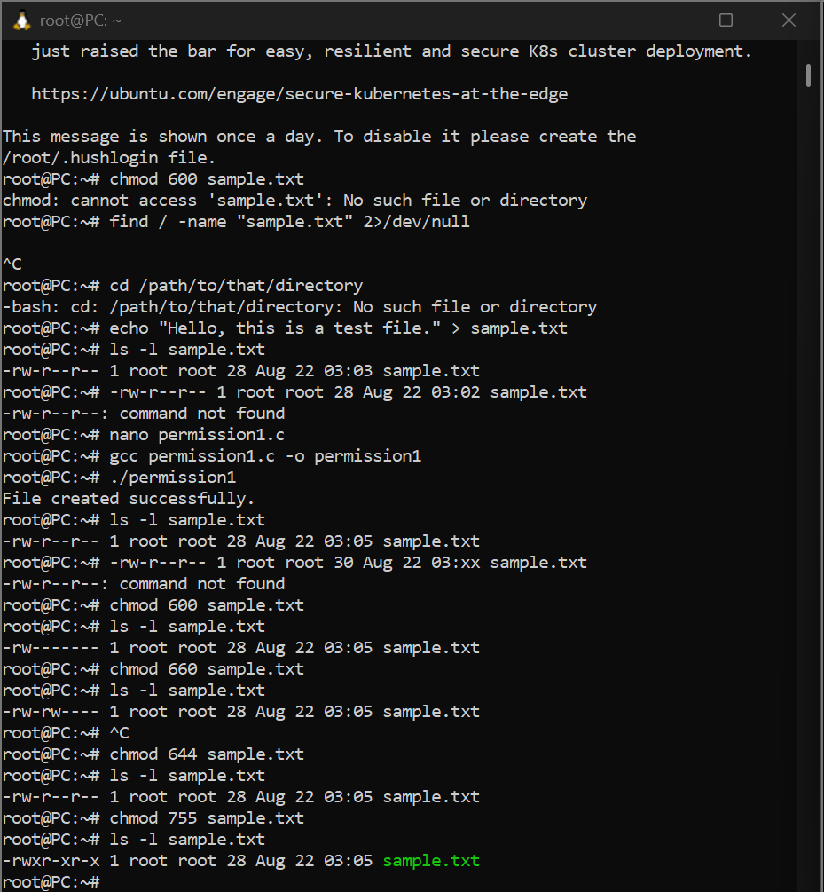
Task 2 — Read/Write to owner and group (660)
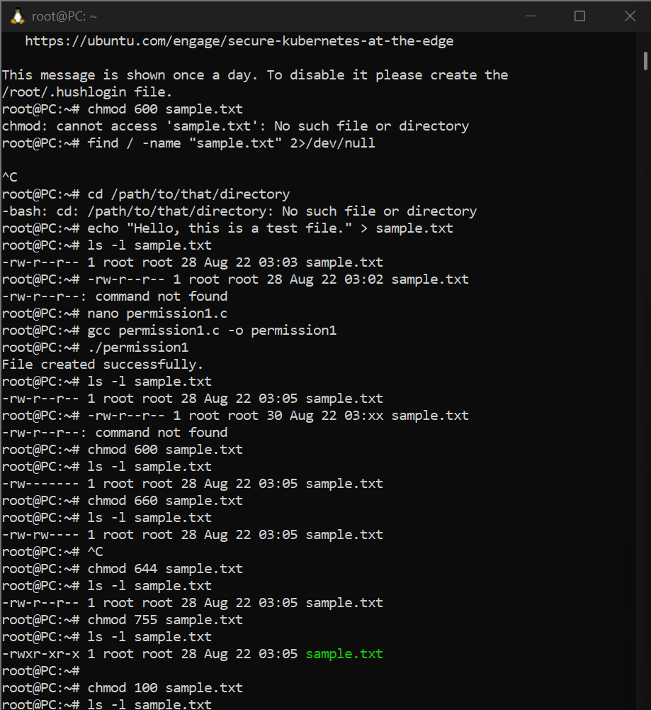

Task 3 — Only owner can read and write
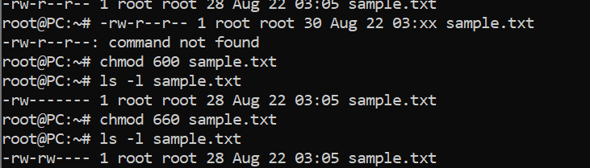

Task 4 — Owner read/write, everyone else read-only (644)
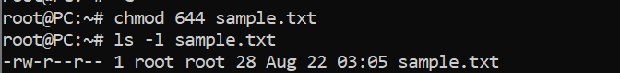

Task 5 — Owner full permissions, others read+execute (755)
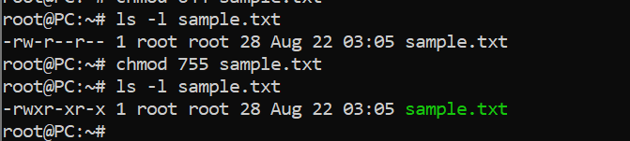
Task 6 — Owner and group can read/write
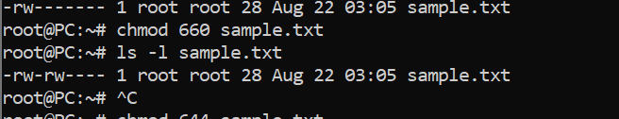

Task 7 — Only owner can execute (100) 