#include <stdio.h>
#include <unistd.h>
#include <termios.h>
#include <string.h>

int main()
{
struct termios oldt, newt;
char buffer[100];
int index = 0;
char ch;

tcgetattr(STDIN_FILENO, &oldt);
newt = oldt;

newt.c_lflag &= ~(ICANON | ECHO);
tcsetattr(STDIN_FILENO, TCSANOW, &newt);

while (1)
{
printf("ossh> ");
fflush(stdout);

index = 0;

while (1)
{
ch = getchar();

if (ch == '\n' || ch == '\r')
{
buffer[index] = '\0';
printf("\n");
break;
}
else if (ch == 127 || ch == 8)
{
if (index > 0)
{
index--;
printf("\b \b");
fflush(stdout);
}
}
else if (index < 99)
{
buffer[index++] = ch;
putchar(ch);
fflush(stdout);
}
}

if (strcmp(buffer, "exit") == 0)
{
printf("Exiting shell...\n");
break;
}

if (index > 0)
{
printf("You entered: %s\n", buffer);
}
}

tcsetattr(STDIN_FILENO, TCSANOW, &oldt);

return 0;
}
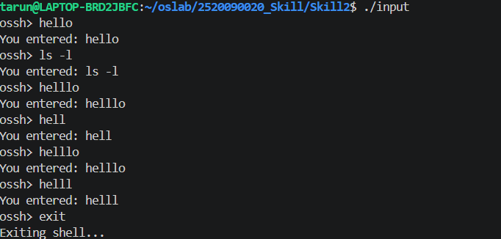
#include <stdio.h>
#include <stdlib.h>
#include <string.h>
#include <unistd.h>
#include <sys/wait.h>

int main()
{
char command[100];

while (1)
{
printf("MiniShell> ");
scanf("%s", command);

if (strcmp(command, "exit") == 0)
break;

pid_t pid = fork();

if (pid == 0)
{
printf("Child PID : %d\n", getpid());
execlp(command, command, NULL);

printf("Command not found!\n");
exit(1);
}
else
{
printf("Parent PID : %d\n", getpid());
wait(NULL);
}
}

return 0;
}

