SKILL7:
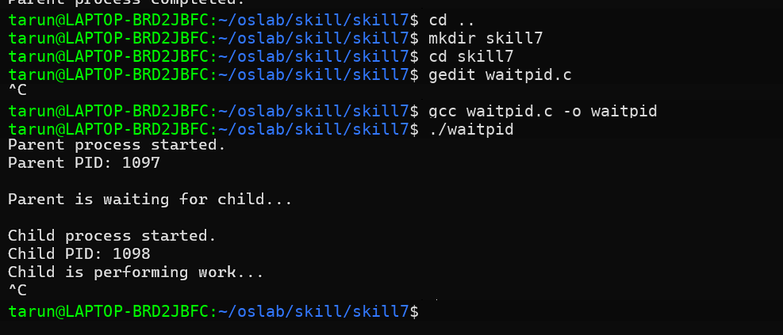
#include <stdio.h>
#include <stdlib.h>
#include <unistd.h>
#include <sys/wait.h>

int main()
{
pid_t pid;
int status;

printf("Parent process started.\n");
printf("Parent PID: %d\n", getpid());

pid = fork();

if (pid < 0)
{
perror("fork failed");
return 1;
}

if (pid == 0)
{
// Child process
printf("\nChild process started.\n");
printf("Child PID: %d\n", getpid());

printf("Child is performing work...\n");

sleep(3);

printf("Child process completed.\n");

exit(42);
}
else
{
// Parent process
printf("\nParent is waiting for child...\n");

pid_t result = waitpid(pid, &status, 0);

if (result == -1)
{
perror("waitpid failed");
return 1;
}

printf("\nParent received child status.\n");

if (WIFEXITED(status))
{
printf("Child exited normally.\n");
printf("Child exit status: %d\n",
WEXITSTATUS(status));
}
else if (WIFSIGNALED(status))
{
printf("Child was terminated by a signal.\n");
printf("Signal number: %d\n",
WTERMSIG(status));
}

printf("Parent process completed.\n");
}

return 0;
}
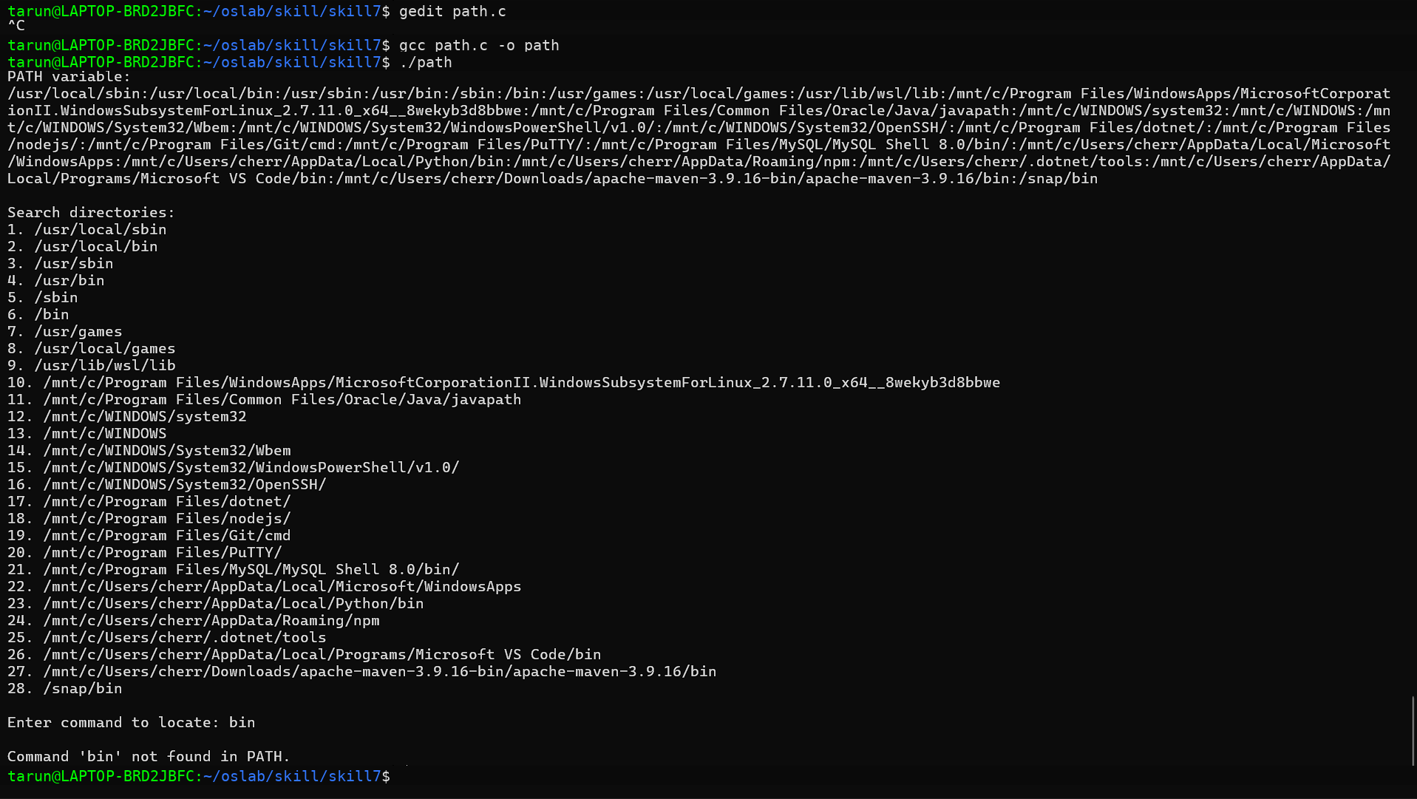
Path.c
#include <stdio.h>
#include <stdlib.h>
#include <string.h>
#include <unistd.h>
#include <sys/stat.h>

int main()
{
char *path = getenv("PATH");

if (path == NULL)
{
printf("PATH variable not found.\n");
return 1;
}

printf("PATH variable:\n%s\n\n", path);

// Make a copy because strtok modifies the string
char *path_copy = strdup(path);

if (path_copy == NULL)
{
perror("strdup");
return 1;
}

printf("Search directories:\n");

char *directory = strtok(path_copy, ":");
int count = 1;

while (directory != NULL)
{
printf("%d. %s\n", count, directory);

directory = strtok(NULL, ":");
count++;
}

free(path_copy);

// Get command from user
char command[100];

printf("\nEnter command to locate: ");
scanf("%99s", command);

// Make another copy of PATH
path_copy = strdup(path);

if (path_copy == NULL)
{
perror("strdup");
return 1;
}

directory = strtok(path_copy, ":");

int found = 0;

while (directory != NULL)
{
char full_path[512];

snprintf(full_path,
sizeof(full_path),
"%s/%s",
directory,
command);

// Check whether file exists and is executable
if (access(full_path, X_OK) == 0)
{
printf("\nCommand found: %s\n", full_path);

struct stat file_info;

if (stat(full_path, &file_info) == 0)
{
printf("Executable permissions verified.\n");
}

found = 1;
break;
}

directory = strtok(NULL, ":");
}

if (!found)
{
printf("\nCommand '%s' not found in PATH.\n", command);
}

free(path_copy);

return 0;
}

