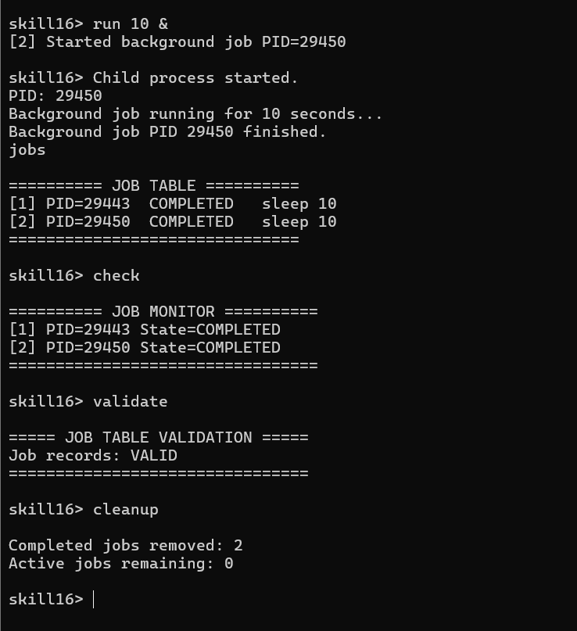
#include <stdio.h>
#include <stdlib.h>
#include <string.h>
#include <unistd.h>
#include <sys/wait.h>
#include <signal.h>

#define MAX_JOBS 20
#define INPUT_SIZE 200

typedef struct
{
int job_id;
pid_t pid;
char command[100];
char state[20];
int active;
} Job;

Job job_table[MAX_JOBS];
int job_count = 0;
int next_job_id = 1;

/*
* Update the status of all background jobs.
*/
void update_jobs()
{
for (int i = 0; i < job_count; i++)
{
if (!job_table[i].active)
continue;

int status;

pid_t result = waitpid(job_table[i].pid,
&status,
WNOHANG);

if (result == 0)
{
strcpy(job_table[i].state, "RUNNING");
}
else if (result == job_table[i].pid)
{
if (WIFEXITED(status))
{
strcpy(job_table[i].state, "COMPLETED");
}
else if (WIFSIGNALED(status))
{
strcpy(job_table[i].state, "TERMINATED");
}

job_table[i].active = 0;
}
}
}

/*
* Remove completed jobs from the table.
*/
void cleanup_jobs()
{
int write_index = 0;

for (int i = 0; i < job_count; i++)
{
if (job_table[i].active)
{
if (write_index != i)
{
job_table[write_index] = job_table[i];
}

write_index++;
}
}

job_count = write_index;
}

/*
* Display the job table.
*/
void display_jobs()
{
update_jobs();

printf("\n========== JOB TABLE ==========\n");

if (job_count == 0)
{
printf("No active jobs.\n");
printf("===============================\n");
return;
}

for (int i = 0; i < job_count; i++)
{
printf("[%d] PID=%d %-10s %s\n",
job_table[i].job_id,
job_table[i].pid,
job_table[i].state,
job_table[i].command);
}

printf("===============================\n");
}

/*
* Start a background job.
*/
void start_background_job(int seconds)
{
if (job_count >= MAX_JOBS)
{
printf("Job table is full.\n");
return;
}

pid_t pid = fork();

if (pid < 0)
{
perror("fork");
return;
}

if (pid == 0)
{
printf("Child process started.\n");
printf("PID: %d\n", getpid());

printf("Background job running for %d seconds...\n",
seconds);

sleep(seconds);

printf("Background job PID %d finished.\n",
getpid());

exit(0);
}

/*
* Parent does NOT wait here.
* This makes the job non-blocking.
*/
job_table[job_count].job_id = next_job_id++;
job_table[job_count].pid = pid;

snprintf(job_table[job_count].command,
sizeof(job_table[job_count].command),
"sleep %d", seconds);

strcpy(job_table[job_count].state, "RUNNING");

job_table[job_count].active = 1;

printf("[%d] Started background job PID=%d\n",
job_table[job_count].job_id,
pid);

job_count++;
}

/*
* Monitor jobs.
*/
void monitor_jobs()
{
update_jobs();

printf("\n========== JOB MONITOR ==========\n");

if (job_count == 0)
{
printf("No active jobs to monitor.\n");
}
else
{
for (int i = 0; i < job_count; i++)
{
printf("[%d] PID=%d State=%s\n",
job_table[i].job_id,
job_table[i].pid,
job_table[i].state);
}
}

printf("=================================\n");
}

/*
* Validate job table.
*/
void validate_job_table()
{
update_jobs();

printf("\n===== JOB TABLE VALIDATION =====\n");

int valid = 1;

for (int i = 0; i < job_count; i++)
{
if (job_table[i].pid <= 0)
{
printf("Invalid PID in job %d\n",
job_table[i].job_id);

valid = 0;
}

if (strlen(job_table[i].state) == 0)
{
printf("Missing state in job %d\n",
job_table[i].job_id);

valid = 0;
}
}

if (valid)
printf("Job records: VALID\n");
else
printf("Job records: INVALID\n");

printf("================================\n");
}

/*
* Remove completed jobs.
*/
void remove_completed_jobs()
{
update_jobs();

int before = job_count;

cleanup_jobs();

printf("\nCompleted jobs removed: %d\n",
before - job_count);

printf("Active jobs remaining: %d\n",
job_count);
}

int main()
{
char input[INPUT_SIZE];

printf("========================================\n");
printf(" SKILL 16 DEMO\n");
printf("========================================\n");

printf("\nCommands:\n");
printf("run <seconds> & - Start background job\n");
printf("jobs - Display job table\n");
printf("check - Monitor jobs\n");
printf("validate - Validate job records\n");
printf("cleanup - Remove completed jobs\n");
printf("exit - Exit program\n");

while (1)
{
/*
* Update jobs before every prompt.
*/
update_jobs();

printf("\nskill16> ");
fflush(stdout);

if (fgets(input,
sizeof(input),
stdin) == NULL)
{
break;
}

input[strcspn(input, "\n")] = '\0';

if (strcmp(input, "exit") == 0)
{
update_jobs();

printf("\nCleaning up background jobs...\n");

/*
* Wait for remaining jobs before exiting.
*/
for (int i = 0; i < job_count; i++)
{
if (job_table[i].active)
{
waitpid(job_table[i].pid,
NULL,
0);
}
}

printf("All background jobs cleaned up.\n");
printf("Exiting Skill 16 demo.\n");

break;
}

if (strncmp(input, "run ", 4) == 0)
{
char duration_text[20];

strcpy(duration_text, input + 4);

int length = strlen(duration_text);

/*
* Remove trailing '&'.
*/
if (length > 0 &&
duration_text[length - 1] == '&')
{
duration_text[length - 1] = '\0';
}

int seconds = atoi(duration_text);

if (seconds <= 0)
{
printf("Invalid duration.\n");
continue;
}

start_background_job(seconds);

continue;
}

if (strcmp(input, "jobs") == 0)
{
display_jobs();
continue;
}

if (strcmp(input, "check") == 0)
{
monitor_jobs();
continue;
}

if (strcmp(input, "validate") == 0)
{
validate_job_table();
continue;
}

if (strcmp(input, "cleanup") == 0)
{
remove_completed_jobs();
continue;
}

printf("Invalid command.\n");
printf("Use: run, jobs, check, validate, cleanup, exit\n");
}

return 0;
}

