<Songli Zhu>

<2022-Mar-25>

<Foundations of Programming (Python)>

<Assignment 09>

# Introduction

The assignment required me to continue modify a CD inventory program by adding CD track information with utilizing the concept of Object Oriented Programming (OOP). Since the start codes have been divided into several modules. I can finish them one by one.

Since we have a TestHarness script and expected results are attached in the module. I started to work on DataClass module first. Followed by the docstring in class Track. I created constructors, properties, and methods. The codes were similar to those in class CD. Then, in Class CD, I have to add another attributes (self.__tracks) to store track information along with property. For methods part, to match the format in output

Test harness, I used double \t\t instead of \t. Next is to add codes to add track information. Docstring suggested the type of track is a list. So just use append function to add track information. To remove track, use pop function to remove the track_id which is the index -1 in list. Be ware of the track_id if it is out of range.

Then, in IOClass, since we have two txt files to save data information, one for CD and the other one for track information. Therefore, try open them one by one first, and save or load data to or from them individually. To make the format matches, I added extra \t in show_inventory function.

Next, in ProcessingClass, for select_cd method, use for loop to find possible matched cd_idx from user input and return the whole row, otherwise, return error. Then, for add_track method, just assign track_info to Track class attributes and call DataClass functions to add track information.

Lastly, I worked on the CD_Inventory modules to finish TODO tasks and possible handling errors when we asked user’s input. First of all, add a new sub-menu for handling tracks on a specific CD. Then, for all id, index which need to be an integer. Add try, except function to make sure the input from user is integer.

Finally, run the script of TestHarness, make sure it matches to the screenshot in the module 9, Then run CD_Inventory script to test codes. Also check the files in a text editor. Make sure it works in both terminal and Spyder.

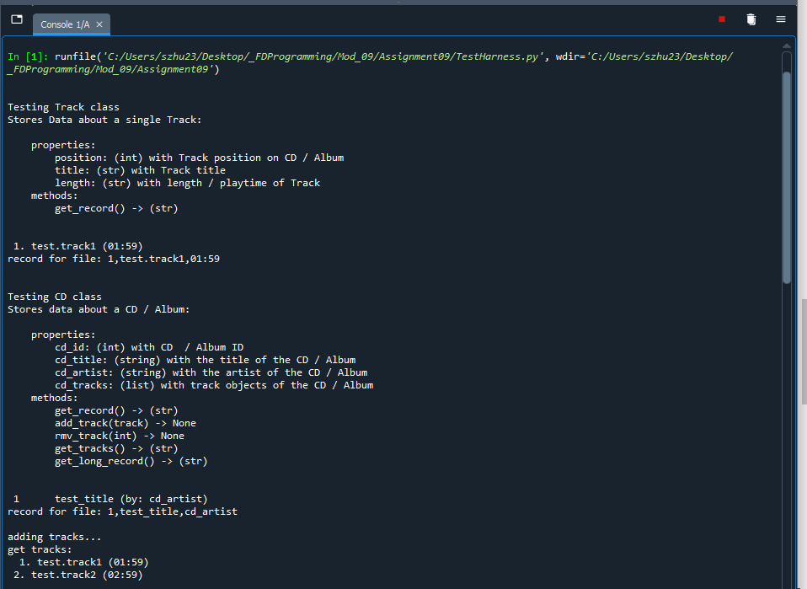

Figure 1 Screen capture of TestHarness in Spyder (Part 1)

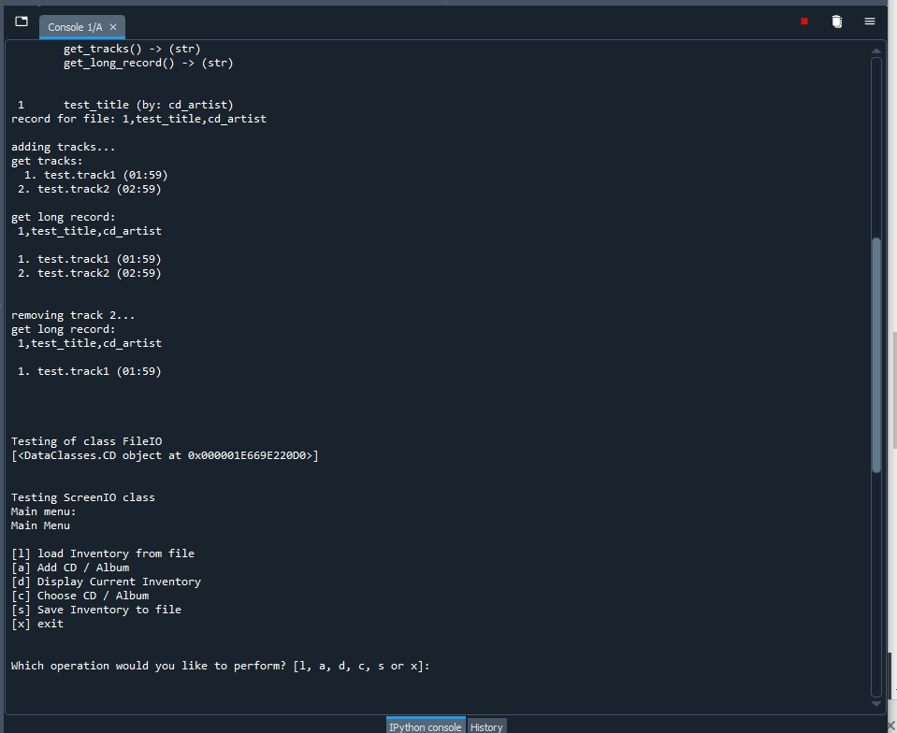Figure 2 Screen capture of TestHarness in Spyder (Part 2)

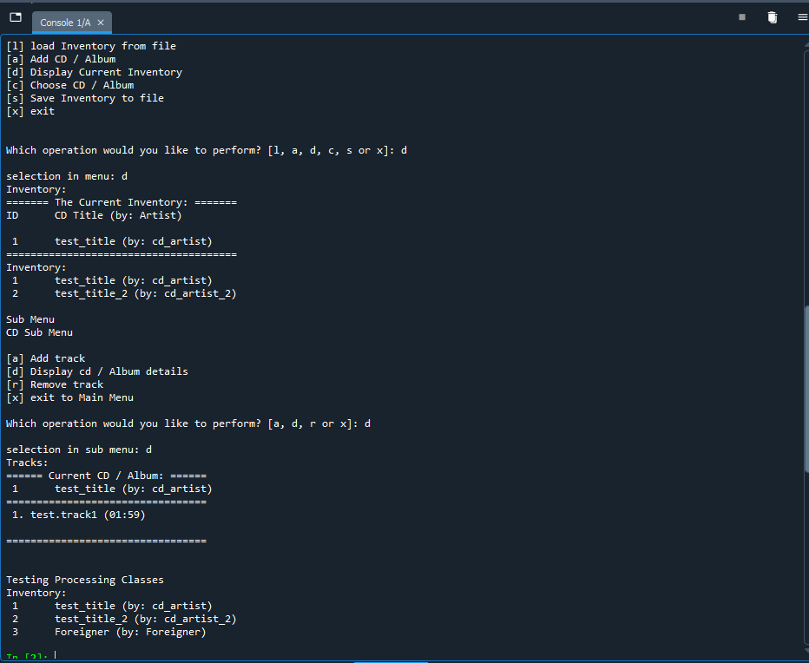Figure 3 Screen capture of TestHarness in Spyder (Part 3)

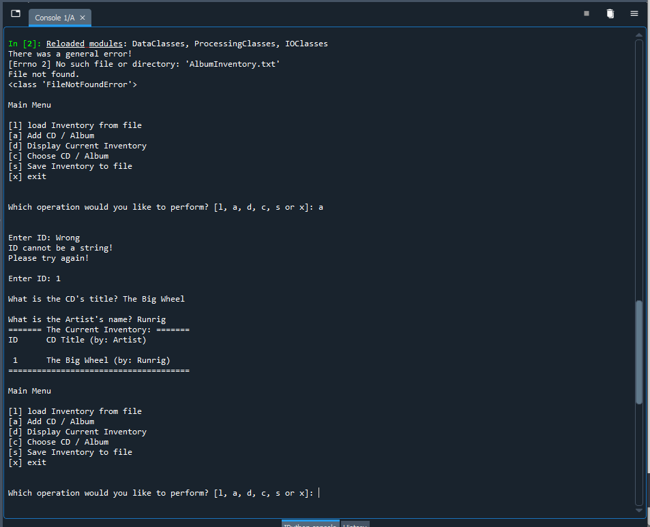

Figure 4 Screen capture of input from CD_Inventory script in Spyder (Note: handling error when txt file is not existed and ID number is not an integer).

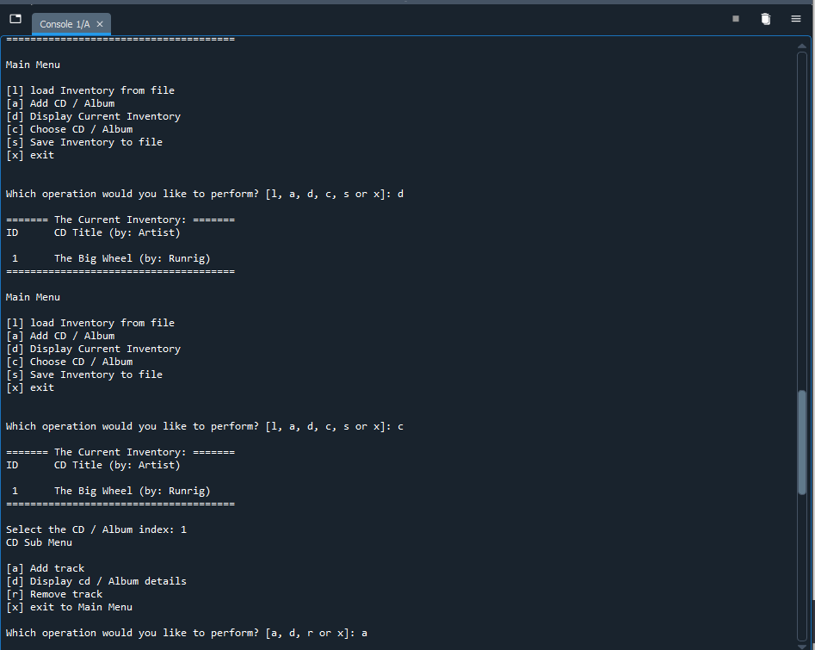

Figure 5 Screen capture of testing display and sub Menu from CD_Inventory script in Spyder.

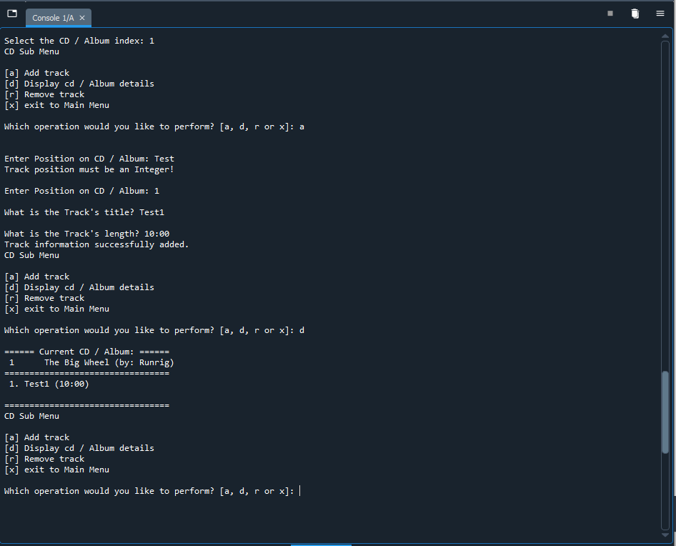Figure 6 Screen capture of adding track function from CD_Inventory script in Spyder (Note: handling error when position on CD / Album input is not integer).

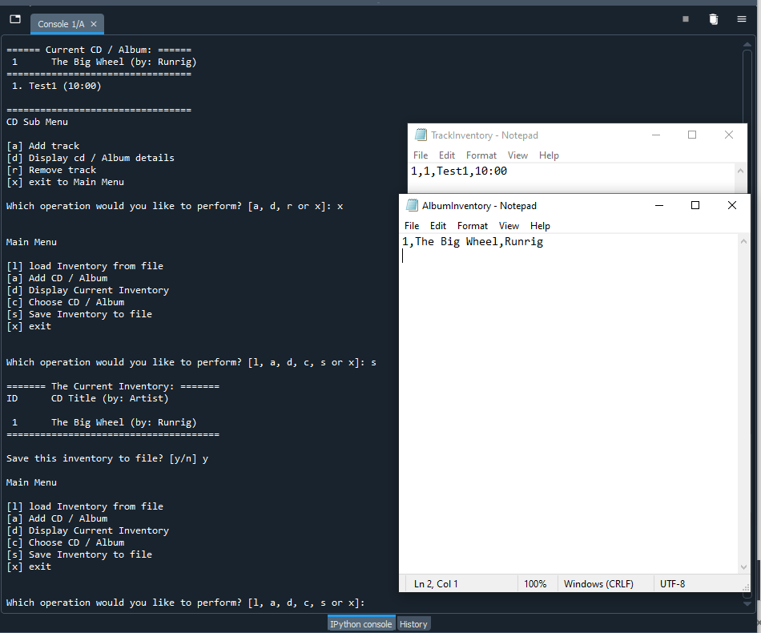

Figure 7 Screen capture of save function of CD_Inventory scripts in Spyder (Note: AlbumInventory.txt and TrackInventory.txt files also included).

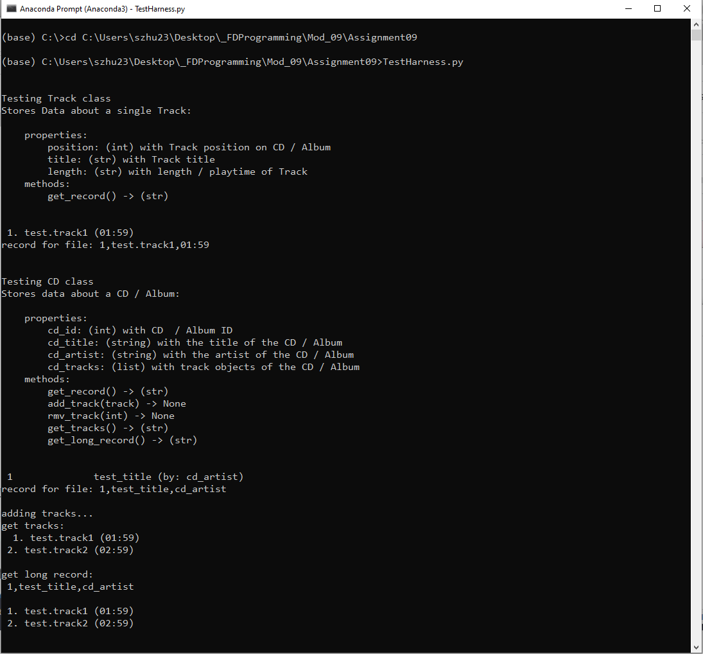

Figure 8 Screen capture of TestHarness in Terminal (Part 1)

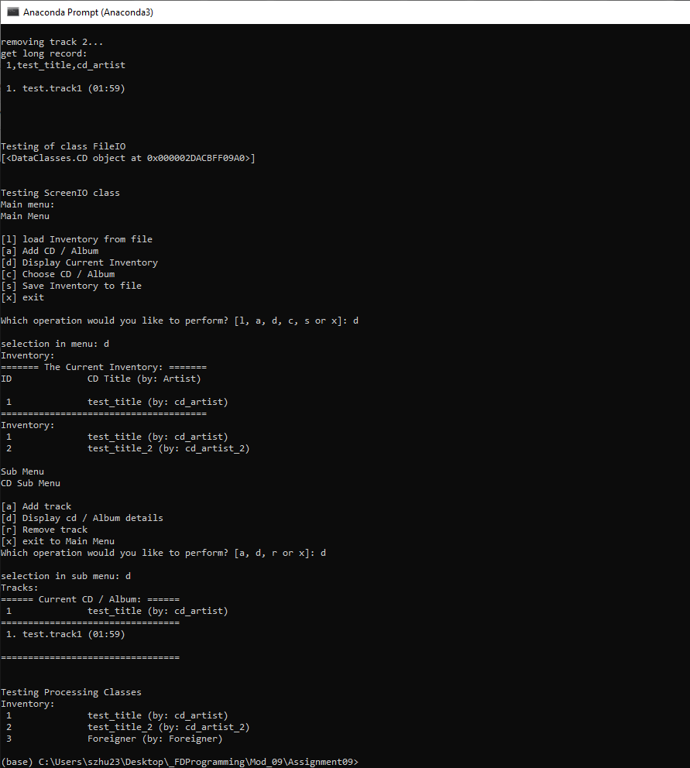

Figure 9 Screen capture of TestHarness in Terminal (Part 2)

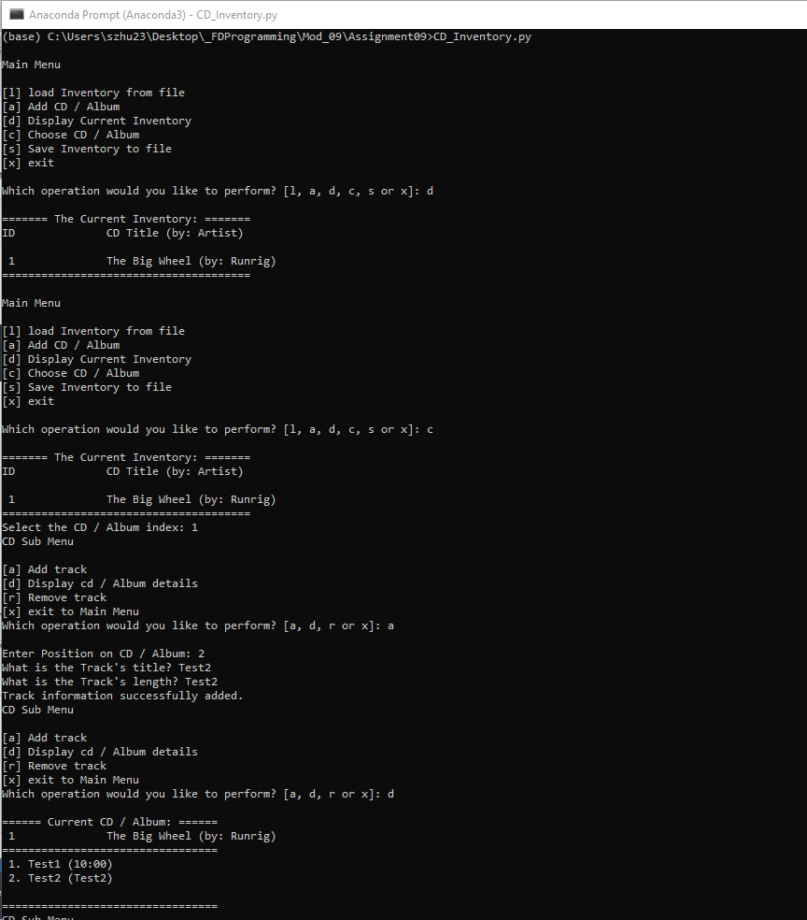Figure 10 Screen capture of load and add track function of CDInventory scripts in Terminal.

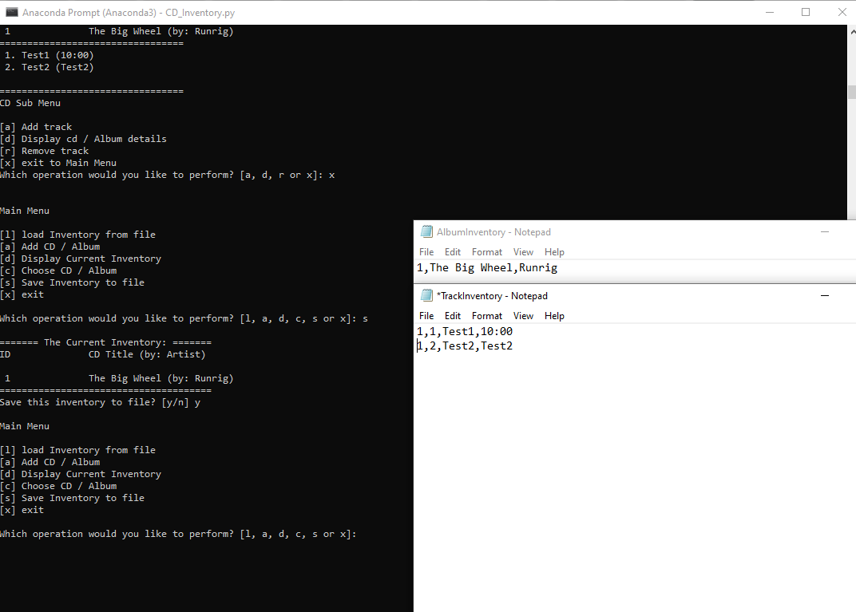

Figure 11 Screen capture of save function of CDInventory scripts in Terminal (Note: AlbumInventory.txt and TrackInventory.txt files also included).

# Summary

From module 9, I kept learning the concept of Object Oriental Programming by utilizing the module. Since we already have those classes from previous assignment. This module introduced module concept and save them into separate module (.py) and call them by using import command. Also, it introduced __main__ concept during generating module. Still, I am still trying to remember which module I should use when I try to call a specific method. It took me a while to call these methods in a proper way. Overall, I am still adapting to this.

Appendix

GitHub link: <https://github.com/synbiomotif/Assignment09>