<Songli Zhu>

<2022-Feb-26>

<Foundations of Programming (Python)>

<Assignment 05>

# Introduction

The assignment required me to continue modify a CD inventory program to include load and delete function with a list of dictionaries. From last Module, we already have some codes working for a list of lists.

First thing, change current functions to make sure the data is store in dictionary, not list. Changing variable names and format.

Second, add new functionalities. Load is simple, just follow some codes from Module 5. Deletion is a little bit hard. You can easily delete by key search. However, in our 2D table, they share with same keys. You have to look at the values instead. Either you only let the user to type in the CD title, ID or artist specifically and look for the specific value to delete. It is easier. Or you have to iterate all values to match the input when you are letting user to type whatever they want to type in.

Lastly, run the script, check the text file in a text editor. Make sure the information is correct.

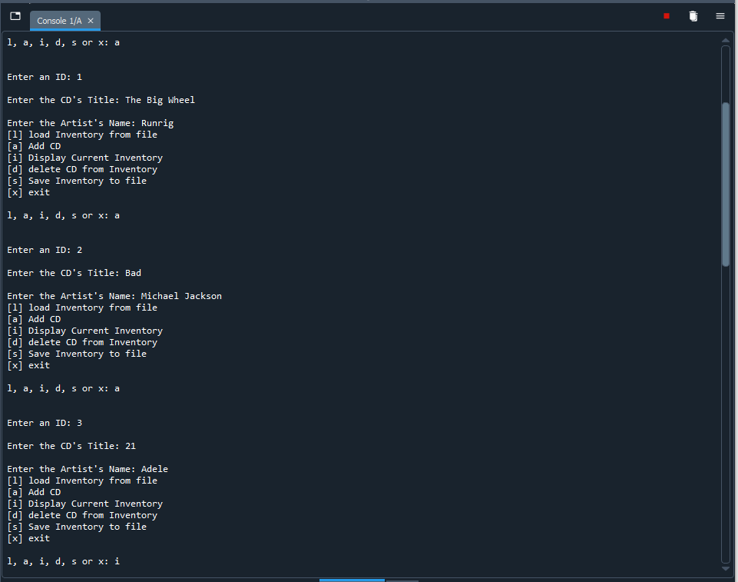

Figure Screen capture of output from CDInventory script in Spyder (Note: input 3 CD information).

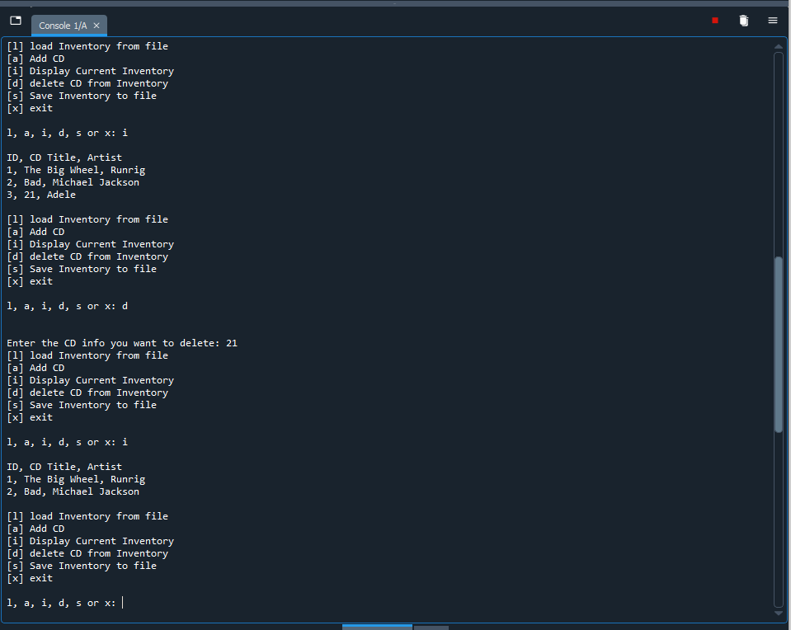Figure Screen capture of output from CDInventory script in Spyder (Note: delete one CD from inventory and display the remaining inventory).

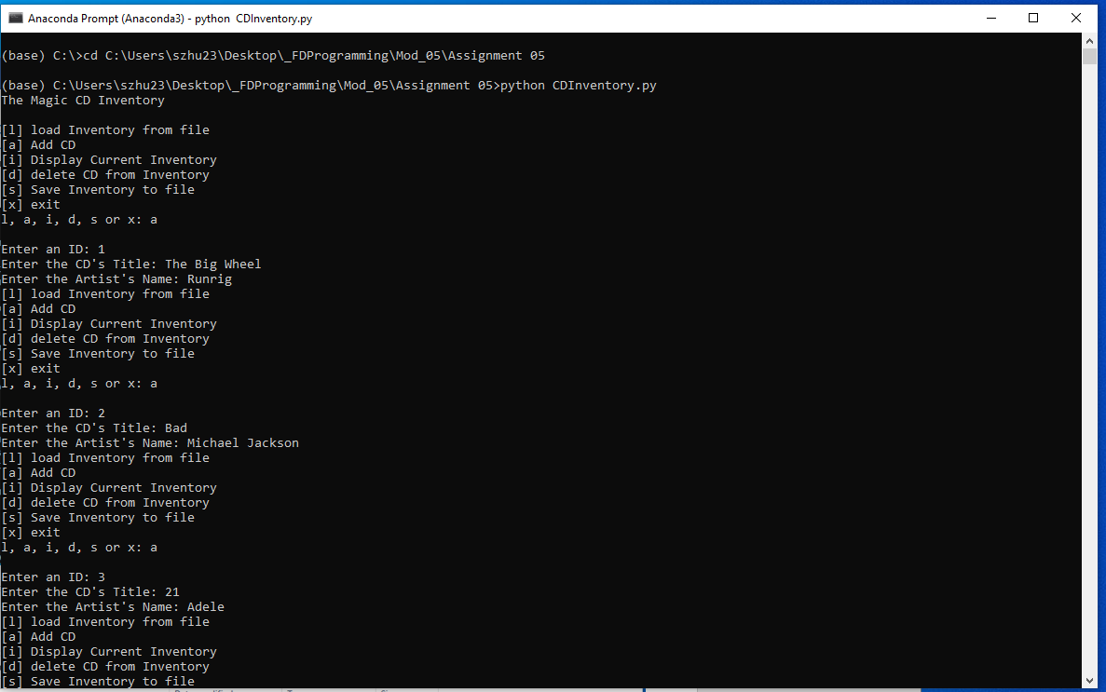

Figure Screen capture of output from CDInventory script in Terminal (Note: input 3 CD information).

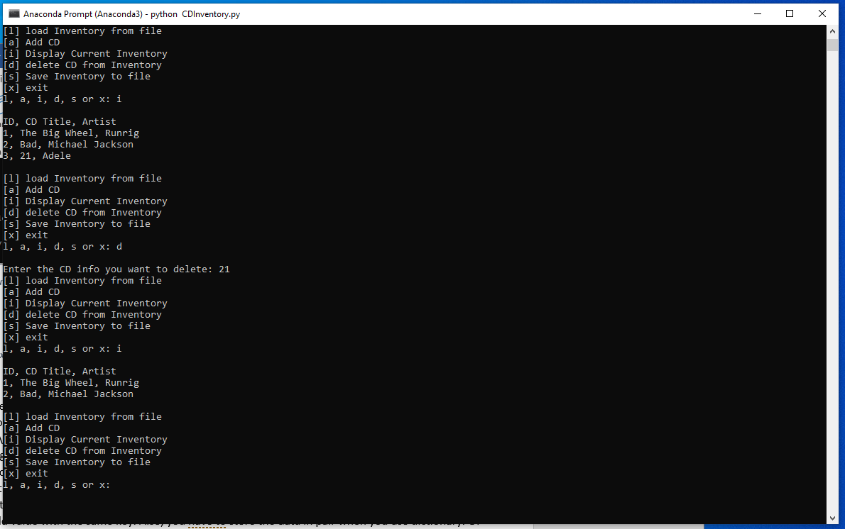

Figure Screen capture of output from CDInventory script in Terminal. (Note: delete one CD from inventory and display the remaining inventory).

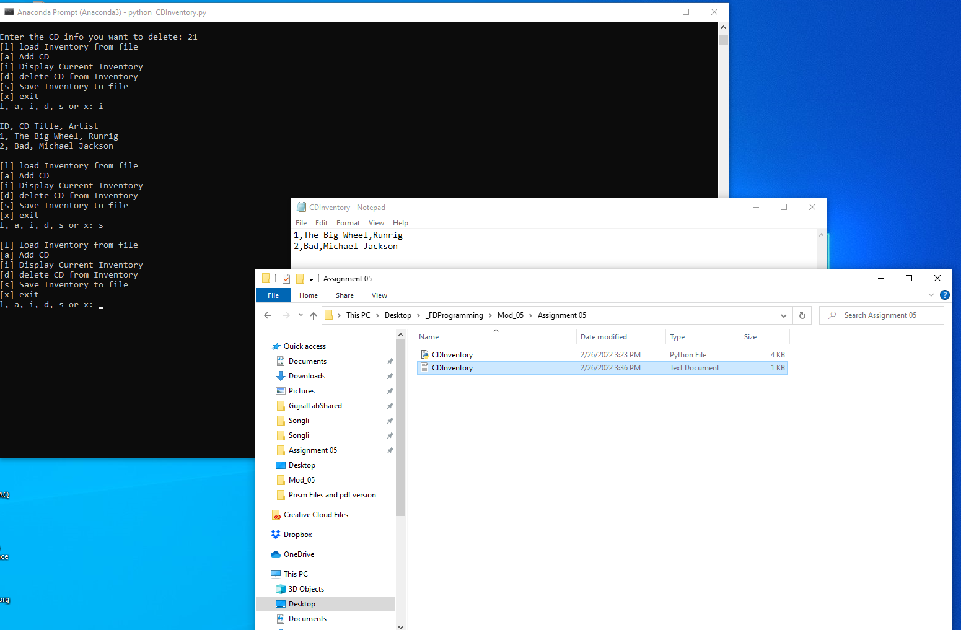

Figure Screen capture of text file generated by CDInventory script in text editor

# Summary

From module 5, I kept learning lists. To make the print form clean and nicer, you can either try * operator when you want to print out the content without worrying about the last comma ‘,’ , split and strip function of lists to split on comma ‘,’ and remove \n from the string. Also, I noted that you have to minimize the file access to the minimum time. This is the problem I neglected when I did the assignment 04, I kept the file open starting from the beginning and wait until the user decided to save the inventory data. Besides lists, I learnt dictionary, another sequence type in this Module. Compared with list, dictionary has its pair. Key: value pair. You can assign whatever you want into the key instead of using the index from list, string or tuple. However, you have to have different key in one dictionary, otherwise, the new value will replace the old value with the same key. Also, you have to store the data in pair when you use dictionary. Of course, you can access to the key and value separately using keys() and values() function, or you can access the pair by item().

Next thing I learnt from the module is how to improve your script to make it faster, organized, and cleaner. 4 tips I learnt are : Separation, functions, template and error handling. Try your best to divide the task into separated distinct modules. For example, initiation data variables or constants, processing your data (try function if possible), and present your data by input or output. Functions help a lot to make sections. You have to define it before calling it. You can set up your own template before generating a new python file. Personally, I don’t care it so much about this. Lastly, you have to have mechanism to debug your code. You can set a barrier to prevent it for some codes. Division error when you tried to divide by 0, type error when you want to add integers when they are strings, tuples. I have heart GitHub a lot in the past, but I have never registered it. So, I think I can learn more in the following modules.

Appendix

## List function assignment05.py

Using [Saravjishut](https://saravjishut.org/syntax) (external reference) [1]web page

|  |  |
| --- | --- |
| 1  2  3  4  5  6  7  8  9  10  11  12  13  14  15  16  17  18  19  20  21  22  23  24  25  26  27  28  29  30  31  32  33  34  35  36  37  38  39  40  41  42  43  44  45  46  47  48  49  50  51  52  53  54  55  56  57  58  59  60  61  62  63  64  65  66  67  68  69  70  71  72  73  74  75  76  77 | *#------------------------------------------#*  *# Title: CDInventory.py*  *# Desc: Starter Script for Assignment 05*  *# Change Log: (Who, When, What)*  *# DBiesinger, 2030-Jan-01, Created File*  *# Songli Zhu, 2022-Feb-26, Modify File, Use Dict for inner data structure and add the loading and deletion function*  *#------------------------------------------#*  *# Declare variabls*  strChoice = '' *# User input*  lstTbl = [] *# list of lists to hold data*  *# TODO replace list of lists with list of dicts*  dictRow = {} *# dict of data row*  strFileName = 'CDInventory.txt' *# data storage file*  objFile = **None** *# file object*  *# Get user Input*  print('The Magic CD Inventory**\n**')  **while** **True**:  *# 1. Display menu allowing the user to choose:*  print('[l] load Inventory from file**\n**[a] Add CD**\n**[i] Display Current Inventory')  print('[d] delete CD from Inventory**\n**[s] Save Inventory to file**\n**[x] exit')  strChoice = input('l, a, i, d, s or x: ').lower() *# convert choice to lower case at time of input*  print()  **if** strChoice == 'x':  *# 5. Exit the program if the user chooses so*  **break**  **if** strChoice == 'l':  *# TODO Add the functionality of loading existing data*  **try**:  objFile = open(strFileName, 'r')  **for** row **in** objFile:  lstRow = row.strip().split(',')  dictRow = {'ID': lstRow[0], ' CD Title': lstRow[1], 'Artist': lstRow[2]}  lstTbl.append(dictRow)  objFile.close()  **except** **FileNotFoundError**:  print('File does not exist**\n**')    **elif** strChoice == 'a': *# no elif necessary, as this code is only reached if strChoice is not 'exit'*  *# 2. Add data to the table (2d-list) each time the user wants to add data*  strID = input('Enter an ID: ')  strTitle = input('Enter the CD**\'**s Title: ')  strArtist = input('Enter the Artist**\'**s Name: ')  intID = int(strID)  dictRow = {'ID': intID, ' CD Title': strTitle, 'Artist': strArtist}  lstTbl.append(dictRow)    **elif** strChoice == 'i':  *# 3. Display the current data to the user each time the user wants to display the data*  print('ID, CD Title, Artist')  **for** row **in** lstTbl:  print(*row.values(), sep = ', ')  print()    **elif** strChoice == 'd':  *# TODO Add functionality of deleting an entry*  del_input = input('Enter the CD info you want to delete: ')  **for** i **in** range(len(lstTbl)):  **for** value **in** lstTbl[i].values():  **if** del_input == value:  **del** lstTbl[i]    **elif** strChoice == 's':  *# 4. Save the data to a text file CDInventory.txt if the user chooses so*  objFile = open(strFileName, 'a')  **for** row **in** lstTbl:  strRow = ''  **for** item **in** row.values():  strRow += str(item) + ','  strRow = strRow[:-1] + '**\n**'  objFile.write(strRow)  objFile.close()  **else**:  print('**\n**Please choose either l, a, i, d, s or x!') |

1. Retrieved 2022-Feb-26