**HealthCare SQL Project 5**

**Group – O**

**Team Members**

|  |  |
| --- | --- |
| **Name** | **USN** |
| Shabbir Ahmed Hasan | 22BTRCL139 |
| Chilaka Nikhitha | 22BTRCL042 |
| Harshitha P | 22BTRCL064 |
| Amrit Sutradhar (Leader) | 22BTRCL014 |

**Problem Statement 20 (**by Harshitha P**)**

Code:

SELECT   
 p.personName AS PatientName,  
 TIMESTAMPDIFF(YEAR, pat.dob, CURDATE()) AS Age,  
 COUNT(t.treatmentID) AS NumberOfTreatments  
FROM Person p  
JOIN Patient pat ON p.personID = pat.patientID  
JOIN Treatment t ON pat.patientID = t.patientID  
GROUP BY p.personName, pat.dob  
HAVING NumberOfTreatments > 1  
ORDER BY NumberOfTreatments desc;

Screenshot:

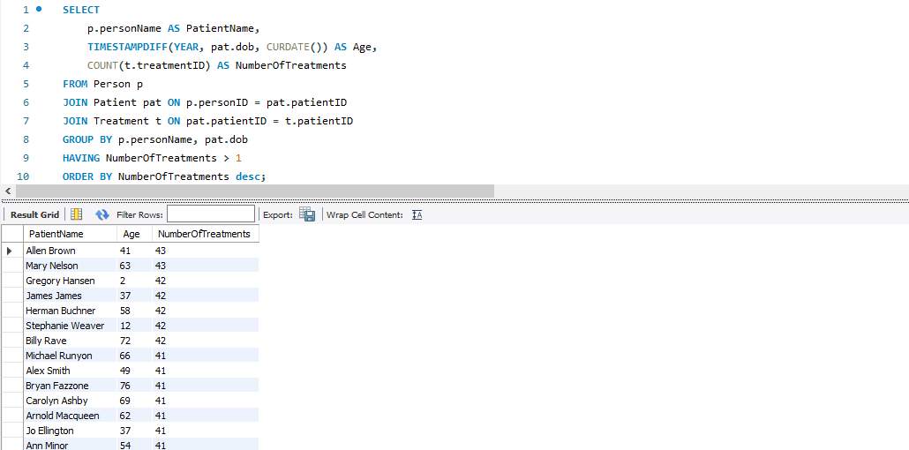

**Problem Statement 21 (**by Harshitha P**)**

Code:

Screenshot:

**Problem Statement 22 (**by Shabbir Ahmed Hasan**)**

Code:

SELECT  
 d.diseaseName,  
 subquery.city,  
 subquery.treatment_count  
FROM (  
 SELECT  
 t.diseaseID,  
 a.city,  
 COUNT(t.treatmentID) AS treatment_count,  
 RANK() OVER (PARTITION BY t.diseaseID ORDER BY COUNT(t.treatmentID) DESC) AS city_rank  
 FROM treatment t  
 JOIN disease d ON t.diseaseID = d.diseaseID  
 JOIN patient p ON t.patientID = p.patientID  
 JOIN person per ON p.patientID = per.personID  
 JOIN address a ON per.addressID = a.addressID  
 GROUP BY  
 t.diseaseID,  
 a.city  
) subquery  
JOIN disease d ON subquery.diseaseID = d.diseaseID  
WHERE subquery.city_rank <= 3  
ORDER BY  
 d.diseaseName,  
 subquery.city_rank;

Screenshot:

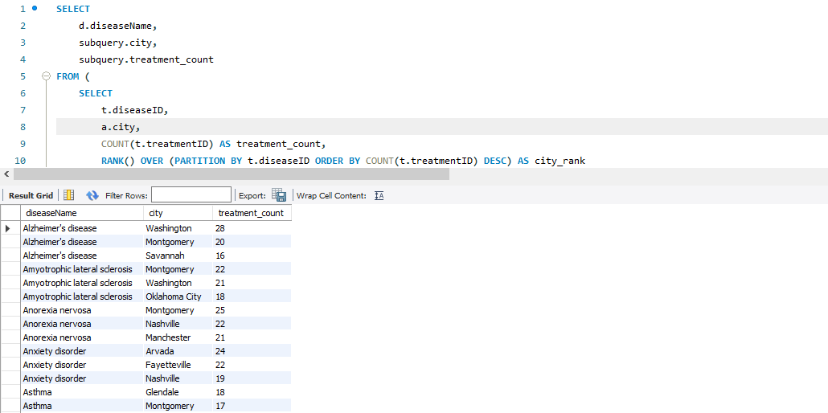

**Problem Statement 23 (**by Chilaka Nikhitha**)**

Code:

WITH PrescriptionCountsByYear AS (  
 SELECT  
 p.pharmacyID,  
 ph.pharmacyName,  
 t.diseaseID,  
 SUM(IF(YEAR(t.date) = 2021, 1, 0)) AS prescriptions_2021,  
 SUM(IF(YEAR(t.date) = 2022, 1, 0)) AS prescriptions_2022  
 FROM Prescription p  
 JOIN Treatment t ON p.treatmentID = t.treatmentID  
 JOIN Pharmacy ph ON p.pharmacyID = ph.pharmacyID  
 GROUP BY p.pharmacyID, ph.pharmacyName, t.diseaseID  
)  
SELECT  
 pcby.pharmacyName,  
 d.diseaseName,  
 pcby.prescriptions_2021,  
 pcby.prescriptions_2022  
FROM PrescriptionCountsByYear pcby  
JOIN Disease d ON pcby.diseaseID = d.diseaseID  
ORDER BY pcby.pharmacyName, d.diseaseName;

Screenshot:

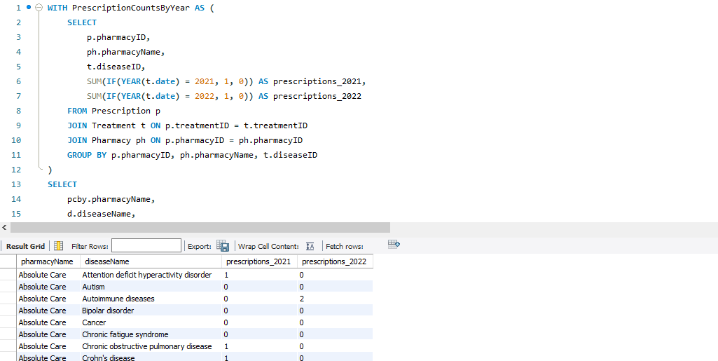

**Problem Statement 24 (**by Amrit Sutradhar**)**

Code:

WITH ClaimCounts AS (  
 SELECT  
 a.state,  
 ic.companyName,  
 COUNT(c.claimID) AS claimCounts,  
 ROW_NUMBER() OVER (PARTITION BY a.state ORDER BY COUNT(c.claimID) DESC) AS rowNumber  
 FROM patient p  
 JOIN person pe ON p.patientID = pe.personID  
 JOIN address a ON pe.addressID = a.addressID  
 JOIN treatment t ON p.patientID = t.patientID  
 JOIN claim c ON t.claimID = c.claimID  
 JOIN insuranceplan ip ON c.uin = ip.uin  
 JOIN insurancecompany ic ON ip.companyID = ic.companyID  
 GROUP BY  
 a.state,  
 ic.companyName  
)  
SELECT  
 state,  
 companyName,  
 claimCounts  
FROM ClaimCounts  
WHERE rowNumber = 1;

Screenshot:

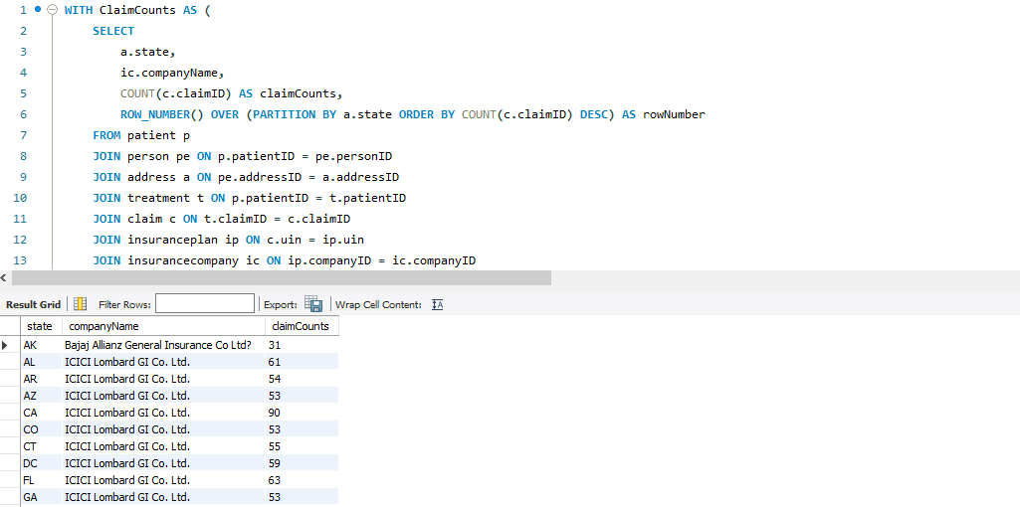

**Thank You**