**HealthCare SQL Project 6**

**Group – O**

**Team Members**

|  |  |
| --- | --- |
| **Name** | **USN** |
| Shabbir Ahmed Hasan | 22BTRCL139 |
| Chilaka Nikhitha | 22BTRCL042 |
| Harshitha P | 22BTRCL064 |
| Amrit Sutradhar (Leader) | 22BTRCL014 |

**Problem Statement 25 (**by Harshitha P**)**

Code:

SELECT  
 p.pharmacyID,  
 p.pharmacyName,  
 SUM(c.quantity) AS totalPrescribed2022,  
 SUM(CASE WHEN m.hospitalExclusive = 'Y' THEN c.quantity ELSE 0 END) AS prescribedHospitalExclusive,  
 ROUND((SUM(CASE WHEN m.hospitalExclusive = 'Y' THEN c.quantity ELSE 0 END) / SUM(c.quantity)) * 100, 2) AS percentagePrescribedHospitalExclusive  
FROM prescription pr  
JOIN pharmacy p ON pr.pharmacyID = p.pharmacyID  
JOIN treatment t ON pr.treatmentID = t.treatmentID  
JOIN contain c ON pr.prescriptionID = c.prescriptionID  
JOIN medicine m ON c.medicineID = m.medicineID  
WHERE YEAR(t.date) = 2022  
GROUP BY p.pharmacyID, p.pharmacyName  
ORDER BY percentagePrescribedHospitalExclusive DESC;

Screenshot:

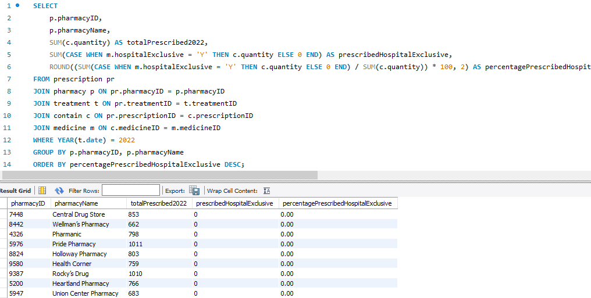

**Problem Statement 26 (**by Amrit Sutradhar**)**

Code:

SELECT  
 ad.state,  
 COUNT(t.treatmentID) AS totalTreatments,  
 COUNT(CASE WHEN t.claimID = 0 THEN 1 END) AS totalUnclaimed,  
 ROUND(( COUNT(CASE WHEN t.claimID = 0 THEN 1 END) / COUNT(t.treatmentID) ) * 100, 2) AS percentageUnclaimed  
FROM treatment t  
JOIN patient pt ON t.patientID = pt.patientID  
JOIN person p ON pt.patientID = p.personID  
JOIN address ad ON p.addressID = ad.addressID  
GROUP BY ad.state

Screenshot:

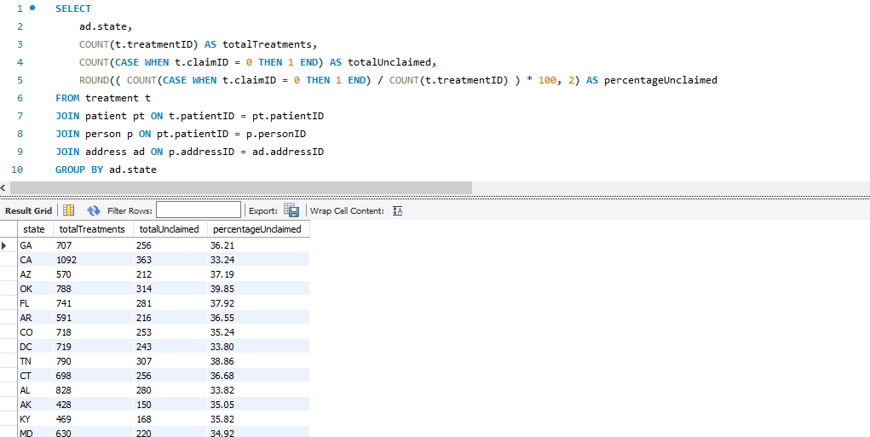

**Problem Statement 27 (**by Amrit Sutradhar**)**

Code:

WITH DiseaseCounts AS (  
 SELECT  
 ad.state,  
 tmt.diseaseID,  
 d.diseaseName,  
 count(d.diseaseID) as treatmentCount  
 FROM disease d  
 JOIN treatment tmt ON d.diseaseID = tmt.diseaseID  
 JOIN patient pt ON tmt.patientID = pt.patientID  
 JOIN person p ON pt.patientID = p.personID  
 JOIN address ad ON p.addressID = ad.addressID  
 WHERE YEAR(tmt.date) = 2022  
 GROUP BY  
 ad.state,  
 tmt.diseaseID  
), RankedDiseases AS (  
 SELECT  
 state,  
 diseaseID,  
 diseaseName,  
 treatmentCount,  
 RANK() OVER (PARTITION BY state ORDER BY treatmentCount DESC) AS rank_desc,  
 RANK() OVER (PARTITION BY state ORDER BY treatmentCount ASC) AS rank_asc  
 FROM DiseaseCounts  
)  
SELECT  
 state,  
 MAX(CASE WHEN rank_desc = 1 THEN diseaseName ELSE NULL END) AS mostTreatedDisease,  
 MAX(CASE WHEN rank_desc = 1 THEN treatmentCount ELSE NULL END) AS mostTreatedCount,  
 MAX(CASE WHEN rank_asc = 1 THEN diseaseName ELSE NULL END) AS leastTreatedDisease,  
 MAX(CASE WHEN rank_asc = 1 THEN treatmentCount ELSE NULL END) AS leastTreatedCount  
FROM RankedDiseases  
GROUP BY state  
ORDER BY state;

Screenshot:

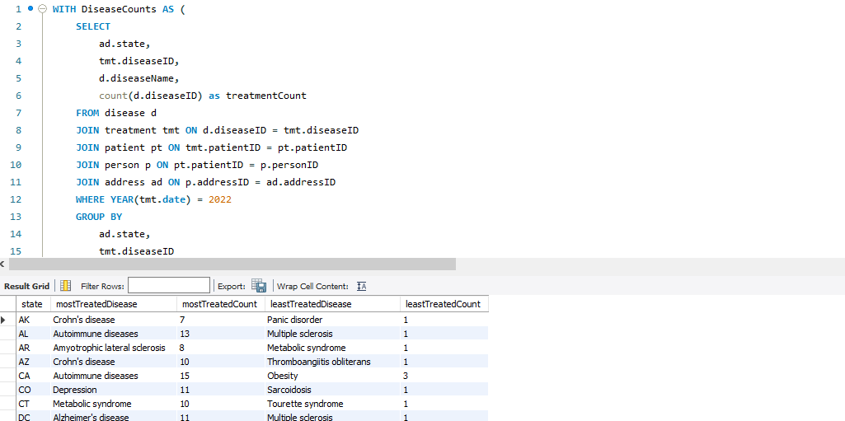

**Problem Statement 28 (**by Chilaka Nikhitha**)**

Code:

SELECT   
 a.city,  
 COUNT(DISTINCT p.personID) AS registered_people,  
 COUNT(DISTINCT pa.patientID) AS registered_patients,  
 COUNT(DISTINCT pa.patientID) * 100.0 / COUNT(DISTINCT p.personID) AS patient_percentage  
FROM Address a  
JOIN Person p ON a.addressID = p.addressID  
LEFT JOIN Patient pa ON p.personID = pa.patientID  
GROUP BY a.city  
HAVING COUNT(DISTINCT p.personID) >= 10  
ORDER BY a.city;

Screenshot:

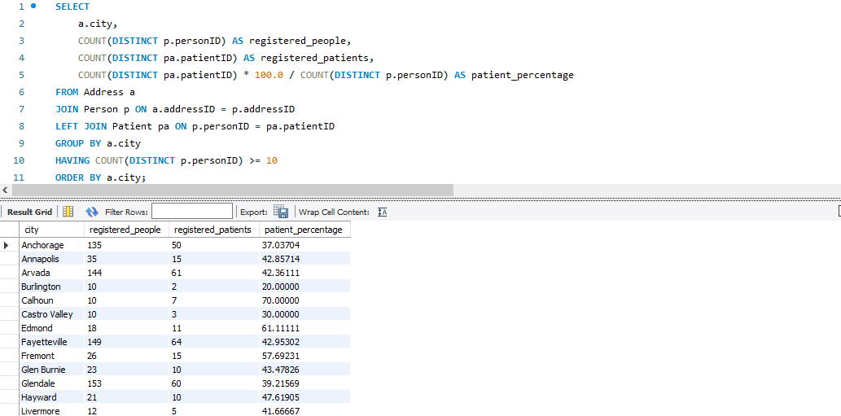

**Problem Statement 29 (**by Shabbir Ahmed Hasan**)**

Code:

SELECT   
 companyName,  
 COUNT(*) AS MedicineCount  
FROM medicine  
WHERE substanceName = 'ranitidine'  
GROUP BY companyName  
ORDER BY MedicineCount DESC  
LIMIT 3;

Screenshot (NA because there is no medicine with substance name “ranitidine”):

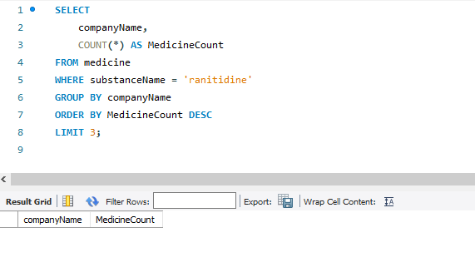

**Thank You**