**HealthCare SQL Project 1**

**Group – O**

**Team Members**

|  |  |
| --- | --- |
| **Name** | **USN** |
| Shabbir Ahmed Hasan | 22BTRCL139 |
| Chilaka Nikhitha | 22BTRCL042 |
| Harshitha P | 22BTRCL064 |
| Amrit Sutradhar (Leader) | 22BTRCL014 |

**Problem Statement 1 (**by Shabbir Ahmed Hasan**)**

Code:

SELECT  
 CASE  
 WHEN (YEAR(CURDATE()) - YEAR(p.dob)) < 15 THEN 'Children'  
 WHEN (YEAR(CURDATE()) - YEAR(p.dob)) BETWEEN 15 AND 24 THEN 'Youth'  
 WHEN (YEAR(CURDATE()) - YEAR(p.dob)) BETWEEN 25 AND 64 THEN 'Adults'  
 ELSE 'Seniors'  
 END AS age_category,  
 COUNT(*) AS treatment_count  
FROM Patient p  
INNER JOIN Treatment t ON p.patientID = t.patientID  
WHERE YEAR(t.date) = 2022  
GROUP BY age_category  
ORDER BY age_category;

Screenshot:

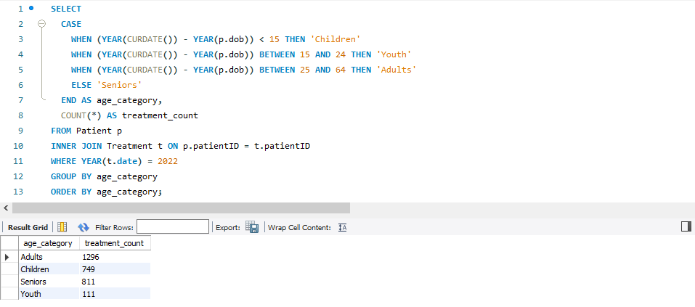

**Problem Statement 2 (**by Shabbir Ahmed Hasan**)**

Code:

SELECT  
 d.diseaseName AS disease,  
 ROUND(SUM(CASE WHEN p.gender = 'male' THEN 1 ELSE 0 END) /   
 SUM(CASE WHEN p.gender = 'female' THEN 1 ELSE 0 END), 2) AS male_to_female_ratio,  
CONCAT(  
 (SELECT COUNT(*) FROM Person WHERE gender = 'male'),  
 ' Males / ',  
 (SELECT COUNT(*) FROM Person WHERE gender = 'female'),  
 ' Females'  
) AS gender_counts  
FROM Disease d  
INNER JOIN Treatment t ON d.diseaseID = t.diseaseID  
INNER JOIN Person p ON t.patientID = p.personID  
WHERE p.gender IN ('male', 'female')  
GROUP BY d.diseaseName  
ORDER BY male_to_female_ratio DESC;

Screenshot:

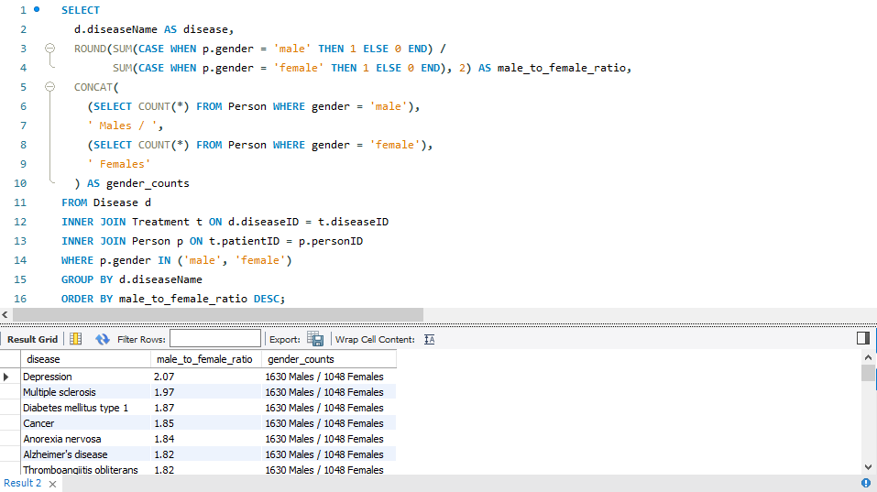

**Problem Statement 3 (**by Chilaka Nikhitha**)**

Code:

WITH TreatmentCounts AS (  
 SELECT  
 per.gender,  
 COUNT(DISTINCT t.treatmentid) AS total_treatments  
 FROM treatment AS t  
 JOIN patient AS p ON t.patientID = p.patientID  
 JOIN person AS per ON p.patientID = per.personID  
 GROUP BY per.gender  
),  
ClaimCounts AS (  
 SELECT  
 per.gender,  
 COUNT(DISTINCT c.claimid) AS total_claims  
 FROM treatment AS t  
 JOIN patient AS p ON t.patientID = p.patientID  
 JOIN claim AS c ON t.claimID = c.claimID  
 JOIN person AS per ON p.patientID = per.personID  
 GROUP BY per.gender  
)  
SELECT  
 tc.gender,  
 tc.total_treatments,  
 cc.total_claims,  
 tc.total_treatments / cc.total_claims AS treatment_to_claim_ratio  
FROM TreatmentCounts AS tc  
JOIN ClaimCounts AS cc ON tc.gender = cc.gender  
ORDER BY tc.gender;

Screenshot:

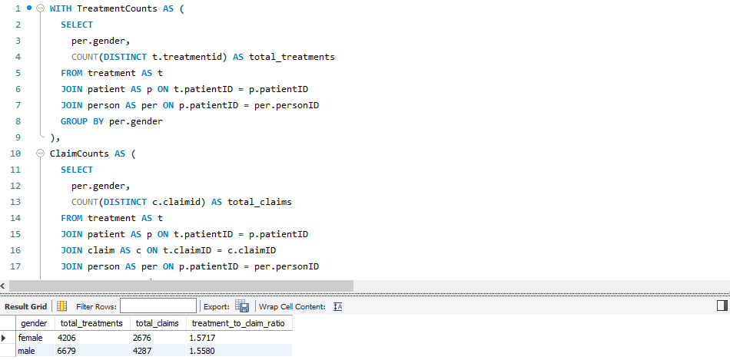

**Problem Statement 4 (**by Harshitha P**)**

Code:

SELECT   
 ph.pharmacyName,  
 SUM(c.quantity) AS total_units,  
 SUM(c.quantity * m.maxPrice) AS total_max_retail_price,  
 SUM(c.quantity * m.maxPrice * (1 - k.discount / 100)) AS total_price_after_discount  
FROM contain AS c  
JOIN prescription AS p ON p.prescriptionID = c.prescriptionID  
JOIN pharmacy AS ph ON p.pharmacyID = ph.pharmacyID  
JOIN keep AS k ON k.pharmacyID = ph.pharmacyID AND k.medicineID = c.medicineID  
JOIN medicine AS m ON m.medicineID = c.medicineID  
GROUP BY ph.pharmacyID, ph.pharmacyName;

Screenshot:

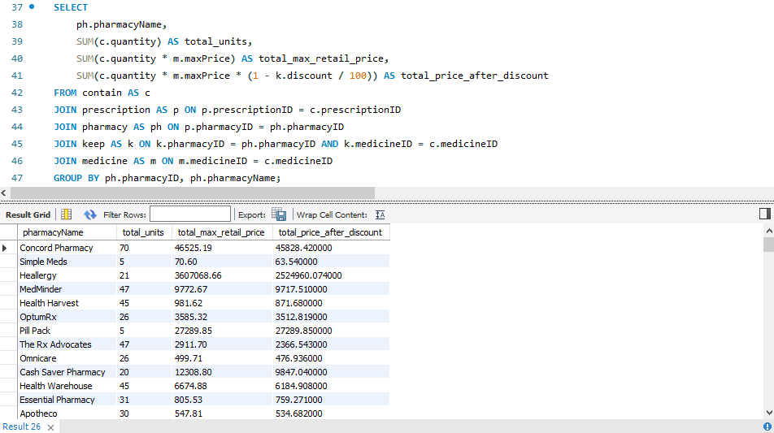

**Problem Statement 5 (**by Amrit Sutradhar**)**

Code:

SELECT  
 pharm.pharmacyName AS PharmacyName,  
 MAX(medicine_count) AS MaxMeds,  
 MIN(medicine_count) AS MinMeds,  
 AVG(medicine_count) AS AvgMeds  
FROM (  
 SELECT  
 presc.pharmacyID,  
 COUNT(cont.medicineID) as medicine_count  
 FROM Prescription presc  
 JOIN Contain cont ON presc.prescriptionID = cont.prescriptionID  
 GROUP BY presc.prescriptionID  
) AS medicine_count  
JOIN Pharmacy pharm ON medicine_count.pharmacyID = pharm.pharmacyID  
GROUP BY pharm.pharmacyID, pharm.pharmacyName;

Screenshot:

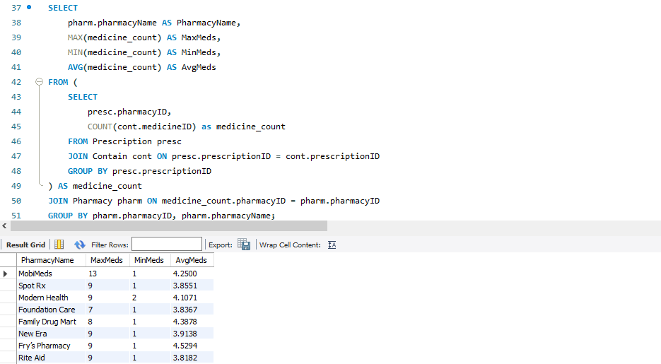

**Thank You**