**HealthCare SQL Project 2**

**Group – O**

**Team Members**

|  |  |
| --- | --- |
| **Name** | **USN** |
| Shabbir Ahmed Hasan | 22BTRCL139 |
| Chilaka Nikhitha | 22BTRCL042 |
| Harshitha P | 22BTRCL064 |
| Amrit Sutradhar (Leader) | 22BTRCL014 |

**Problem Statement 6 (**by Amrit Sutradhar**)**

Code:

SELECT   
 addr.city AS City,  
 COUNT(DISTINCT ph.pharmacyID) AS PharmacyCount,  
 COUNT(pr.prescriptionID) AS PrescriptionCount,  
 (COUNT(pr.prescriptionID) / COUNT(DISTINCT ph.pharmacyID)) AS PrescriptionToPharmacyRatio  
FROM address addr  
JOIN pharmacy ph ON addr.addressID = ph.addressID  
JOIN prescription pr ON ph.pharmacyID = pr.pharmacyID  
GROUP BY addr.city  
HAVING PrescriptionCount > 100  
ORDER BY PrescriptionToPharmacyRatio ASC  
LIMIT 3;

Screenshot:

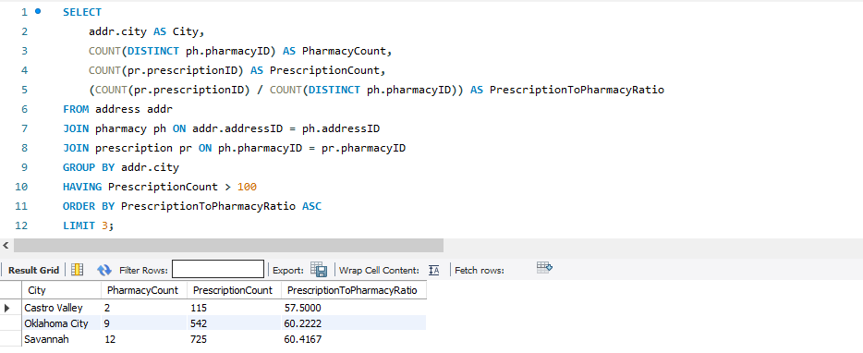

**Problem Statement 7 (**by Amrit Sutradhar**)**

Code:

SELECT   
 city,   
 diseaseName,   
 MAX(disease_count) AS max_treatments  
FROM (  
 SELECT   
 addr.city AS city,   
 ds.diseaseName AS diseaseName,   
 COUNT(*) AS disease_count  
 FROM disease ds  
 JOIN treatment tmt ON ds.diseaseID = tmt.diseaseID  
 JOIN prescription psc ON tmt.treatmentID = psc.treatmentID  
 JOIN pharmacy ph ON psc.pharmacyID = ph.pharmacyID  
 JOIN address addr ON ph.addressID = addr.addressID  
 WHERE addr.state = 'AL'  
 GROUP BY addr.city, ds.diseaseName  
) AS city_disease_counts  
GROUP BY city  
ORDER BY city;

Screenshot:

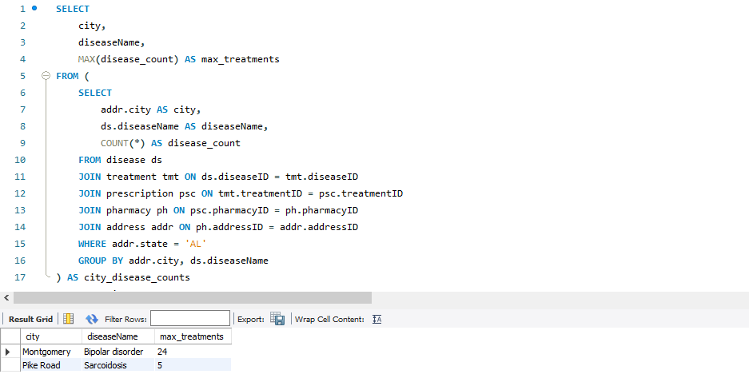

**Problem Statement 8 (**by Harshitha P**)**

Code:

WITH DiseaseInsuranceClaimCount AS (  
 SELECT   
 d.diseaseName,  
 ip.planName,  
 COUNT(c.claimID) AS claimCount  
 FROM   
 Claim c  
 JOIN InsurancePlan ip ON c.UIN = ip.UIN  
 JOIN Treatment t ON c.claimID = t.claimID  
 JOIN Disease d ON t.diseaseID = d.diseaseID  
 GROUP BY   
 d.diseaseName, ip.planName  
),  
MaxClaimsPerDisease AS (  
 SELECT  
 diseaseName,  
 planName AS maxClaimPlan,  
 claimCount AS maxClaimCount,  
 ROW_NUMBER() OVER (PARTITION BY diseaseName ORDER BY claimCount DESC) AS rn_max  
 FROM  
 DiseaseInsuranceClaimCount  
),  
MinClaimsPerDisease AS (  
 SELECT  
 diseaseName,  
 planName AS minClaimPlan,  
 claimCount AS minClaimCount,  
 ROW_NUMBER() OVER (PARTITION BY diseaseName ORDER BY claimCount ASC) AS rn_min  
 FROM DiseaseInsuranceClaimCount  
)  
SELECT  
 max.diseaseName,  
 max.maxClaimPlan,  
 max.maxClaimCount,  
 min.minClaimPlan,  
 min.minClaimCount  
FROM MaxClaimsPerDisease max  
JOIN MinClaimsPerDisease min ON max.diseaseName = min.diseaseName  
WHERE max.rn_max = 1 AND min.rn_min = 1;

Screenshot:

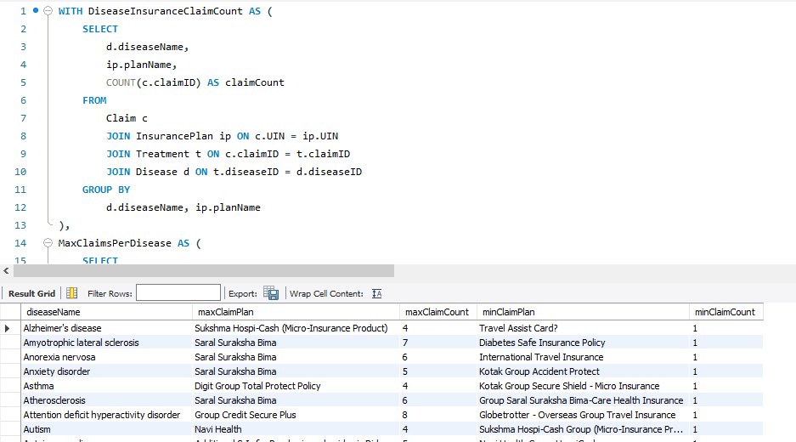

**Problem Statement 9 (**by Shabbir Ahmed Hasan**)**

Code:

SELECT  
 d.diseaseName,  
 a.address1,  
 COUNT(DISTINCT p.patientID) AS num_patients  
FROM patient p  
JOIN treatment t ON p.patientID = t.patientID  
JOIN disease d ON t.diseaseID = d.diseaseID  
JOIN person pe ON p.patientID = pe.personID  
JOIN Address a ON pe.addressID = a.addressID  
GROUP BY d.diseaseName, a.address1  
HAVING COUNT(DISTINCT p.patientID) > 1;

Screenshot:

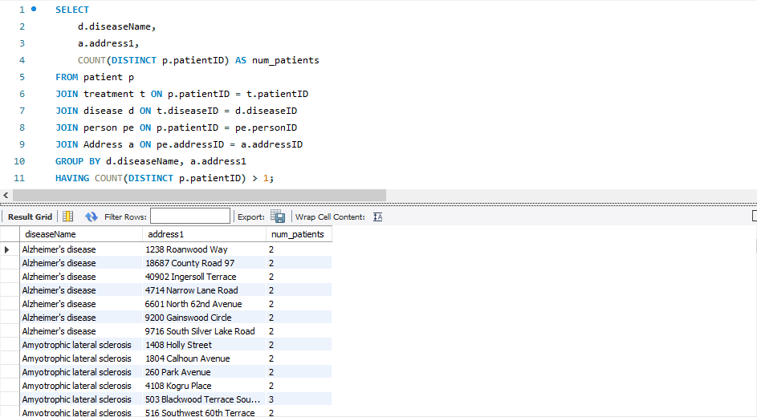

**Problem Statement 10 (**by Chilaka Nikhitha**)**

Code:

SELECT  
 A.state,  
 COUNT(DISTINCT T.treatmentID) AS treatment_count,  
 COUNT(DISTINCT C.claimID) AS claim_count,  
 CAST(COUNT(DISTINCT T.treatmentID) AS DECIMAL) / COUNT(DISTINCT C.claimID) AS treatment_to_claim_ratio  
FROM Address A  
JOIN Pharmacy P ON A.addressID = P.addressID  
JOIN Prescription R ON P.pharmacyID = R.pharmacyID  
JOIN Treatment T ON R.treatmentID = T.treatmentID  
LEFT JOIN Claim C ON T.claimID = C.claimID  
LEFT JOIN InsurancePlan IP ON C.uin = IP.uin  
WHERE T.date BETWEEN '2021-04-01' AND '2022-03-31'  
GROUP BY A.state  
ORDER BY A.state;

Screenshot:

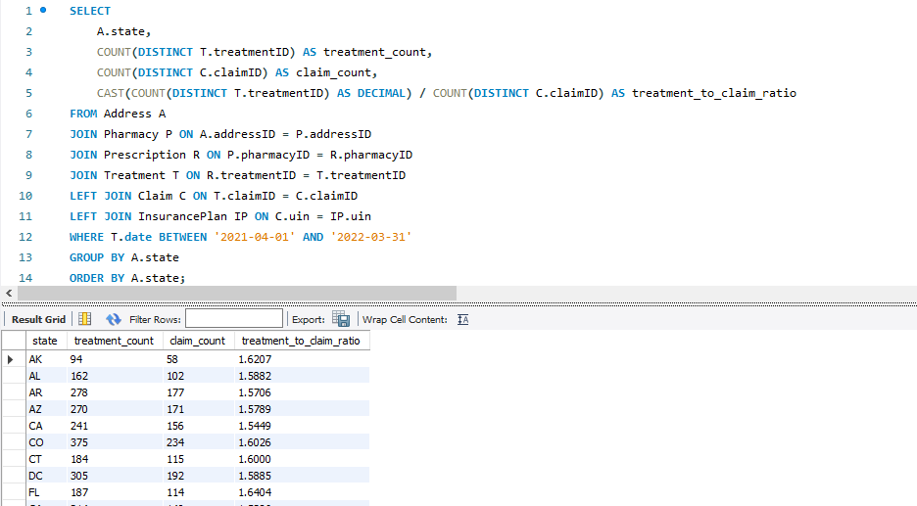

**Thank You**