**HealthCare SQL Project 3**

**Group – O**

**Team Members**

|  |  |
| --- | --- |
| **Name** | **USN** |
| Shabbir Ahmed Hasan | 22BTRCL139 |
| Chilaka Nikhitha | 22BTRCL042 |
| Harshitha P | 22BTRCL064 |
| Amrit Sutradhar (Leader) | 22BTRCL014 |

**Problem Statement 11 (**by Amrit Sutradhar**)**

Code:

SELECT  
 pharmacyName,  
 count(med.medicineID) as hospitalExclusiveMedicine  
FROM pharmacy ph  
JOIN prescription psc ON ph.pharmacyID = psc.pharmacyID  
JOIN contain cont ON psc.prescriptionID = cont.prescriptionID  
JOIN treatment tmt ON psc.treatmentID = tmt.treatmentID  
JOIN medicine med ON cont.medicineID = med.medicineID  
WHERE (med.hospitalExclusive <> "N") AND (tmt.date BETWEEN "2021-01-01" AND "2022-12-31")  
GROUP BY pharmacyName  
ORDER BY hospitalExclusiveMedicine DESC;

Screenshot:

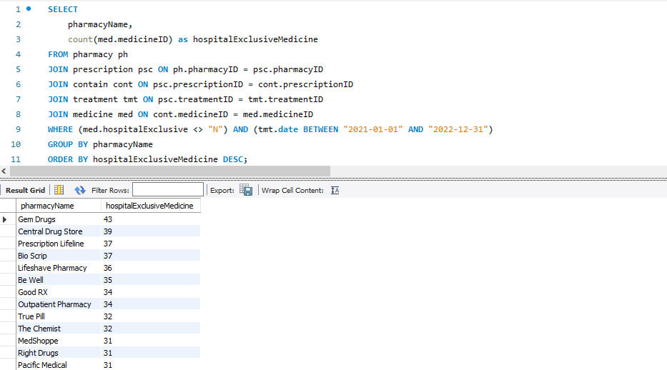

**Problem Statement 12 (**by Chilaka Nikhitha**)**

Code:

SELECT  
 IP.planName,  
 IC.companyName,  
 COUNT(T.treatmentID) AS numTreatments  
FROM InsurancePlan IP  
JOIN InsuranceCompany IC ON IP.companyID = IC.companyID  
JOIN Claim CL ON IP.UIN = CL.UIN  
JOIN Treatment T ON CL.claimID = T.claimID  
GROUP BY IP.planName, IC.companyName  
ORDER BY numTreatments DESC;

Screenshot:

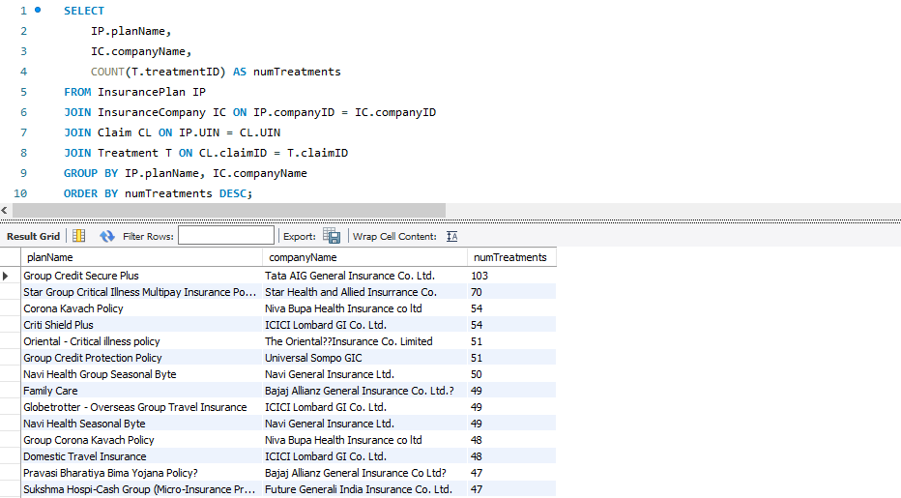

**Problem Statement 13 (**by Chilaka Nikhitha & Amrit Sutradhar**)**

Code:

WITH ClaimCounts AS (  
 SELECT  
 ic.companyID,  
 companyName,  
 planName,  
 count(claimID) as claimCounts  
 FROM insuranceplan ip  
 LEFT JOIN insurancecompany ic ON ip.companyID = ic.companyID  
 LEFT JOIN claim cl ON ip.uin = cl.uin  
 GROUP BY ip.uin  
), MinMaxClaims AS (  
 SELECT  
 companyID,  
 MIN(claimCounts) as minClaims,  
 MAX(claimCounts) as maxClaims  
 FROM ClaimCounts  
 GROUP BY companyID  
), MinClaims AS (  
 SELECT  
 cc.companyID,  
 planName as leastClaimedPlan,  
 claimCounts as leastClaimedClaims  
 FROM ClaimCounts cc  
 JOIN MinMaxClaims mmc on cc.companyID = mmc.companyID  
 WHERE mmc.minClaims = cc.claimCounts  
), MaxClaims AS (  
 SELECT  
 cc.companyID,  
 planName as mostClaimedPlan,  
 claimCounts as mostClaimedClaims  
 FROM ClaimCounts cc  
 JOIN MinMaxClaims mmc on cc.companyID = mmc.companyID  
 WHERE mmc.maxClaims = cc.claimCounts  
)  
SELECT  
 cc.companyID,  
 companyName,  
 leastClaimedPlan,  
 leastClaimedClaims,  
 mostClaimedPlan,  
 mostClaimedClaims  
FROM ClaimCounts cc  
JOIN MinClaims minc ON cc.companyID = minc.companyID  
JOIN MaxClaims maxc ON cc.companyID = maxc.companyID  
GROUP BY companyID;

Screenshot:

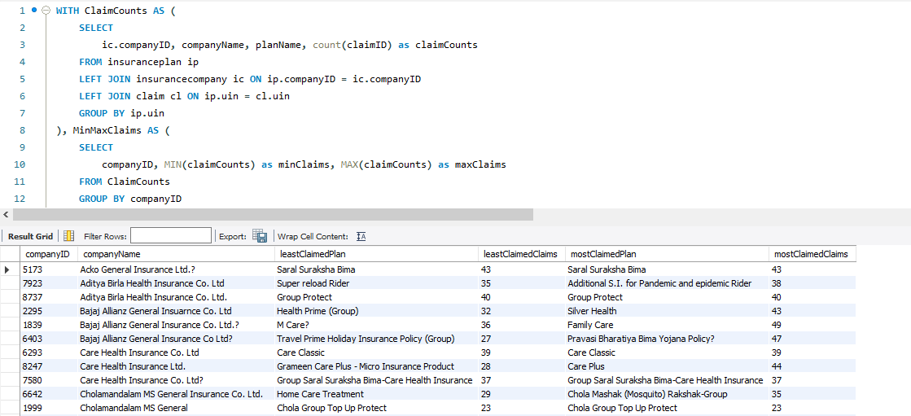

**Problem Statement 14 (**by Shabbir Ahmed Hasan**)**

Code:

SELECT   
 p.state,  
 COUNT(ps.personID) AS num_people,  
 COUNT(pa.patientID) AS num_patients,  
 CAST(COUNT(ps.personID) AS FLOAT) / NULLIF(COUNT(pa.patientID), 0) AS people_to_patient_ratio  
FROM person ps  
LEFT JOIN address p ON ps.addressID = p.addressID  
LEFT JOIN patient pa ON pa.patientID = ps.personID  
GROUP BY p.state  
ORDER BY people_to_patient_ratio;

Screenshot:

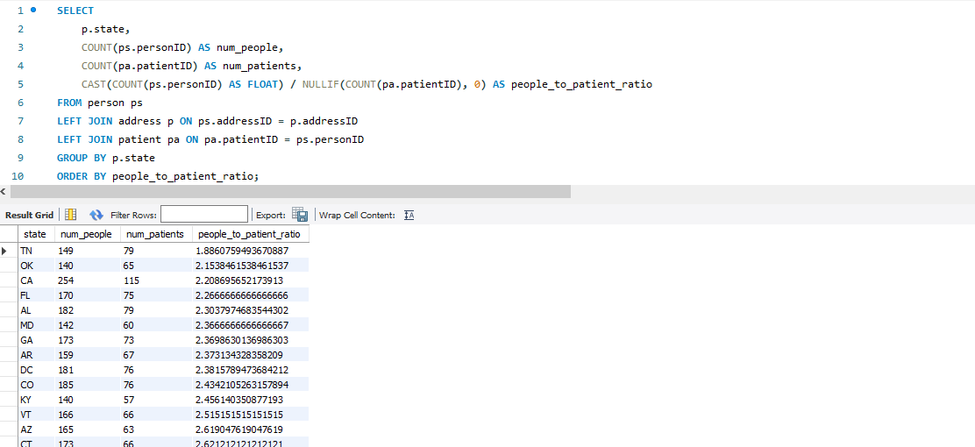

**Problem Statement 15 (**by Harshitha P and Amrit Sutradhar**)**

Code:

SELECT  
 ph.pharmacyID,  
 ph.pharmacyName,  
 COUNT(med.medicineID) prescribedUnderCriteria  
FROM pharmacy ph  
JOIN address ad ON ph.addressID = ad.addressID  
JOIN prescription psc ON ph.pharmacyID = psc.pharmacyID  
JOIN treatment tmt ON psc.treatmentID = tmt.treatmentID  
JOIN contain cont ON psc.prescriptionID = cont.prescriptionID  
JOIN medicine med ON cont.medicineID = med.medicineID  
WHERE  
 (ad.state = "AZ") AND  
 (tmt.date BETWEEN "2021-01-01" AND "2021-12-31") AND  
 (med.taxCriteria = "I")  
GROUP BY ph.pharmacyName  
ORDER BY prescribedUnderCriteria DESC;

Screenshot:

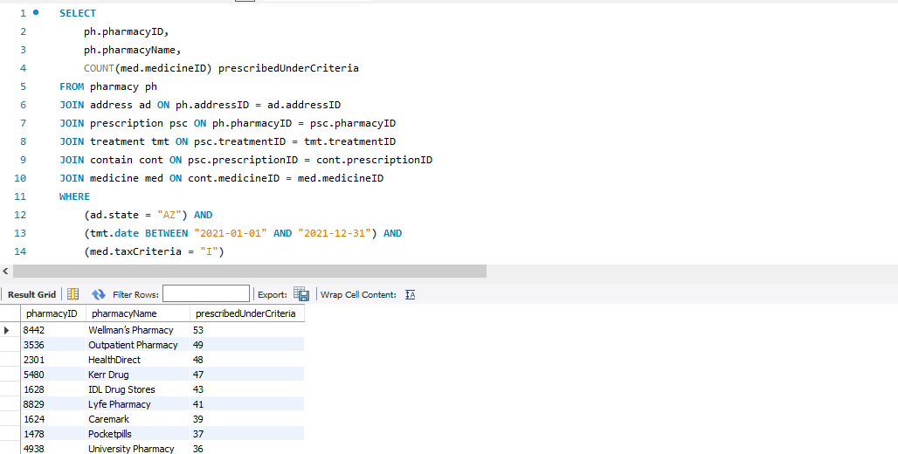

**Thank You**