**HealthCare SQL Project 4**

**Group – O**

**Team Members**

|  |  |
| --- | --- |
| **Name** | **USN** |
| Shabbir Ahmed Hasan | 22BTRCL139 |
| Chilaka Nikhitha | 22BTRCL042 |
| Harshitha P | 22BTRCL064 |
| Amrit Sutradhar (Leader) | 22BTRCL014 |

**Problem Statement 16 (**by Harshitha P**)**

Code:

SELECT  
 pre.prescriptionID,  
 sum(c.quantity) AS totalQuantity,  
 CASE   
 WHEN sum(c.quantity) < 20 THEN "Low Quantity"  
 WHEN sum(c.quantity) > 20 AND sum(c.quantity) < 50 THEN "Medium Quantity"  
 WHEN sum(c.quantity) >= 50 THEN "High Quantity"  
 END AS Tag  
FROM prescription AS pre  
JOIN contain c ON c.prescriptionID = pre.prescriptionID  
JOIN pharmacy ph ON ph.pharmacyID = pre.pharmacyID  
WHERE ph.pharmacyName = "Ally Scripts"   
GROUP BY pre.prescriptionID;

Screenshot:

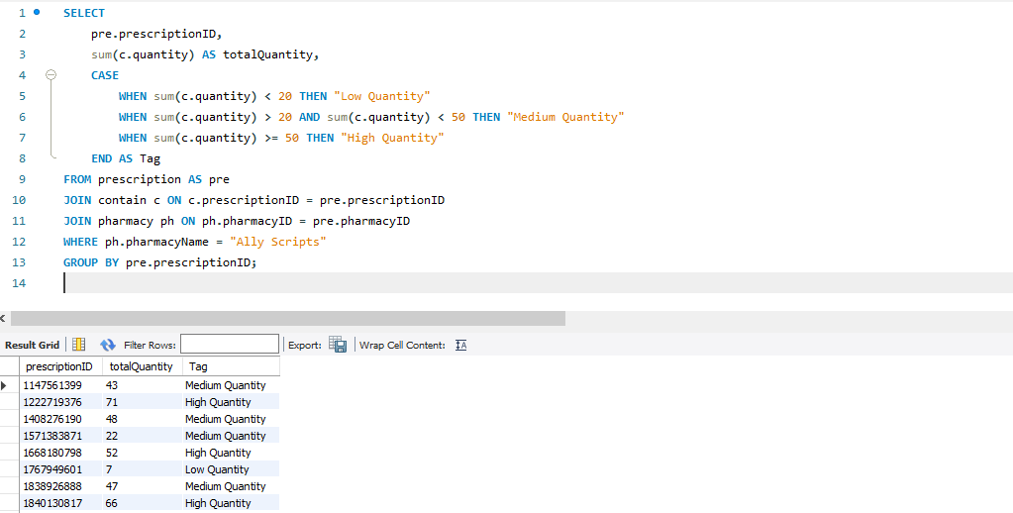

**Problem Statement 17 (**by Chilaka Nikhitha**)**

Code:

SELECT  
 k.medicineID,  
 m.productName,  
 k.quantity,  
 CASE  
 WHEN k.quantity > 7500 THEN "HIGH QUANTITY"  
 WHEN k.quantity < 1000 THEN "LOW QUANTITY"  
 ELSE "MEDIUM QUANTITY"  
 END AS QuantityStatus,  
 k.discount,  
 CASE  
 WHEN k.discount >= 30 THEN "HIGH"  
 WHEN k.discount = 0 THEN "NONE"  
 ELSE "LOW"   
 END AS DiscountStatus  
FROM Keep k  
JOIN Medicine m ON k.medicineID = m.medicineID  
JOIN Pharmacy p ON k.pharmacyID = p.pharmacyID  
WHERE (k.quantity < 1000 AND k.discount >= 30) OR (k.quantity > 7500 AND k.discount = 0)  
AND p.pharmacyName = "Spot Rx";

Screenshot:

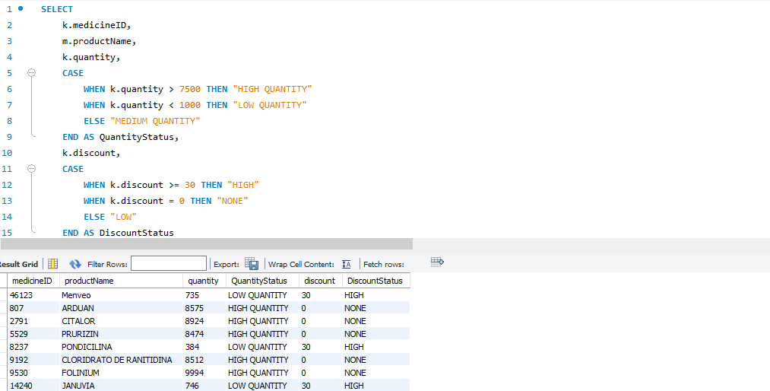

**Problem Statement 18 (**by Shabbir Ahmed Hasan**)**

Code:

SELECT  
 productName AS medicine_name,  
 CASE  
 WHEN maxPrice <= (SELECT AVG(maxPrice) * 0.5 FROM medicine) THEN "Affordable"  
 WHEN maxPrice >= (SELECT AVG(maxPrice) * 2 FROM medicine) THEN "Costly"  
 ELSE "Uncategorized"  
 END AS price_category  
FROM medicine m  
JOIN keep k ON m.medicineID = k.medicineID  
JOIN pharmacy p ON k.pharmacyID = p.pharmacyID  
WHERE  
 p.pharmacyName = "HealthDirect"  
 AND hospitalExclusive = "Y";

Screenshot (0 HospitalExclusive medicine in HealthDirect pharmacy):

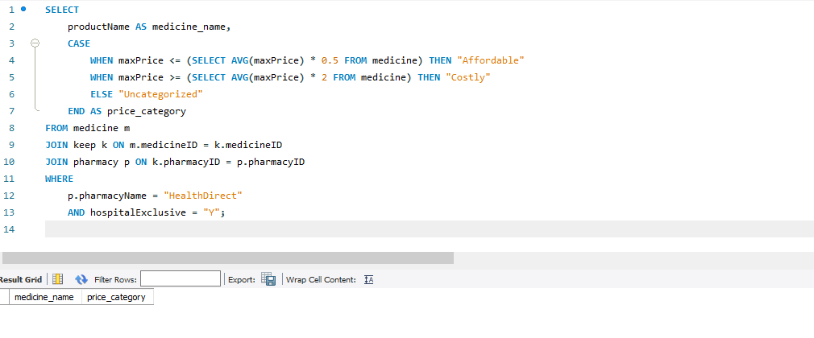

**Problem Statement 19 (**by Amrit Sutradhar**)**

Code:

SELECT  
 psn.personName AS Name,  
 psn.gender AS Gender,  
 pt.dob AS DoB,  
 CASE  
 WHEN (pt.dob > "2005-01-01") AND (psn.gender = "Male") THEN "YoungMale"  
 WHEN (pt.dob > "2005-01-01") AND (psn.gender = "Female") THEN "YoungFemale"  
 WHEN (pt.dob < "2005-01-01" AND pt.dob > "1985-01-01") AND (psn.gender = "Male") THEN "AdultMale"  
 WHEN (pt.dob < "2005-01-01" AND pt.dob > "1985-01-01") AND (psn.gender = "Female") THEN "AdultFemale"  
 WHEN (pt.dob < "1985-01-01" AND pt.dob > "1970-01-01") AND (psn.gender = "Male") THEN "MidAgeMale"  
 WHEN (pt.dob < "1985-01-01" AND pt.dob > "1970-01-01") AND (psn.gender = "Female") THEN "MidAgeFemale"  
 WHEN (pt.dob < "1970-01-01") AND (psn.gender = "Male") THEN "ElderMale"  
 WHEN (pt.dob < "1970-01-01") AND (psn.gender = "Female") THEN "ElderFemale"  
 END AS Category  
FROM person psn   
JOIN patient pt ON psn.personID = pt.patientID  
ORDER BY DoB;

Screenshot:

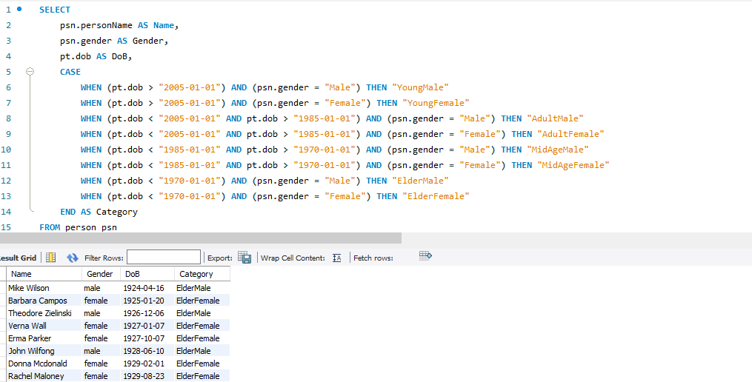

**Thank You**