Flight Delay Analysis
Om Arvadia
BIA 580 - Foundations of Business Analytics
Abstract - This project looks at U.S. commercial flight delays to understand what drives them and how to predict them. Using a dataset of roughly 50 million domestic flights from the Bureau of Transportation Statistics, I built a two-part analytical pipeline. First, a Power BI dashboard was developed to describe historical performance, revealing massive structural breaks during 2020 and a wide operational gap between carriers. Second, I built a Python notebook to move from description to prediction. Using probability distributions, Holt-Winters time-series forecasting, decision tree classification, and Monte Carlo simulations, the analysis shows that average delay is a heavily misleading metric due to a massive right tail. The results prove that carrier performance gaps are statistically real, highlight scheduled departure hours as the biggest controllable lever, and demonstrate that you can flag individual at-risk flights at booking time with 1.3x the precision of randomly guessing.
I. BUSINESS CONTEXT
The U.S. commercial aviation industry moves about 800 million passengers a year across 10 million scheduled domestic flights. Operationally, it is incredibly sensitive to schedules as a single 30-minute delay cascades through aircraft rotations, crew shifts, gate availability, and connecting flights. The Department of Transportation tracks this through On-Time Performance (OTP) data, making it a critical metric for both customer experience and regulatory compliance.
I framed this project from the perspective of an airline operations team or a third-party benchmarking analyst. The findings here are built for network planners sizing schedule buffers, ops teams staffing for bad days, and commercial teams negotiating service-level agreements. I chose this specific dataset because it is massive with nearly 50 million rows and is grounded in a real-world problem where operational decisions have immediate, measurable dollar consequences.
II. PROBLEM STATEMENT
The Power BI portion of this project answers the descriptive question: what happened? The dashboard is organized into four pages: an executive overview with the four headline KPIs and a monthly trend line, a carrier comparison page ranking the top 10 airlines by on-time rate and cancellation rate, a delay-cause breakdown that splits total delay minutes across the five DOT-defined buckets (carrier, late aircraft, weather, NAS, security), and a geographic page showing origin-airport performance. The dashboard surfaces the patterns — the 2020 structural break, the carrier spread, the dominance of "late aircraft" and "carrier" delay categories — but it doesn't quantify whether those patterns are statistically real or how they project forward. That's the gap the notebook is built to close.
- How heavy is the right tail of arrival delays, and how should it shape my capacity buffers? Planning for an "average" day leaves an airline under-staffed for the bad days that actually hurt customers.
- Are the differences in carrier on-time rates actually real, or just statistical noise? This changes how I should price benchmarking and code-share contracts.
- Can I forecast the next 12 months of delays, and can I predict which individual flights will be late right at booking time? This answers both a budget question and a customer-communication question.
III. DATA DESCRIPTION AND OVERVIEW
The dataset comes from the U.S. DOT Bureau of Transportation Statistics. I pulled monthly extracts from January 2018 through January 2025, cleaned them, and consolidated everything into a single Parquet file to keep memory compression efficient. The final dataset sits at 49,712,864 rows and 33 columns (about 2.0 GB on disk). Every row is a single scheduled domestic flight. To handle the modeling, I made a few practical engineering trade-offs:
- Sampling: For high-volume aggregations, I queried the full 50-million-row dataset using DuckDB. For row-level machine learning work (like training the decision tree), I pulled uniform samples of 200K to 500K rows to keep compute times tractable. The sample sizes are large enough that the error is negligible.
- Target Variable: I used arrdel15 (a binary flag for delays 15 minutes or longer) as my target because it aligns perfectly with the standard "On-Time %" KPI used in the dashboard.
- Data Quality: Delay cause columns (like weather or carrier delay) are empty for 80% of the rows because they are only filled out if a flight is actually late. Also, the dataset only tracks carriers with at least a 0.5% market share, so small regional flights are excluded.
IV. DATA PIPELINE
Before any analysis, I had to assemble the dataset itself. BTS publishes On-Time Performance as monthly CSV extracts, so I wrote three small Python scripts to handle ingestion: convert_to_parquet.py to convert each month's raw CSV into Parquet, clean_parquet.py to normalize column types and drop rows with corrupt timestamps, and combine_parquet.py to concatenate the 85 monthly files into a single 2.0 GB Parquet table. From there, I queried the data through a DuckDB view rather than loading it into pandas — DuckDB lets me run SQL aggregations across the full 49.7 million rows in seconds without materializing anything in memory. The full analytical stack is DuckDB for aggregation, pandas and NumPy for sample-level work, statsmodels for Holt-Winters and seasonal decomposition, scikit-learn for the decision tree, and Power BI for the dashboard. I also wrote a verify_kpis.py script that re-computes the four headline KPIs (total flights, average delay, on-time %, cancellation %) from the raw Parquet and matches them against the Power BI dashboard cards — this is the sanity floor for the rest of the project, since if the aggregates don't match, nothing built on top of them is trustworthy.
V. DATA EXPLORATION
Running the full 49.7 million rows through DuckDB gave me my baseline KPIs: 4.79 minutes of average delay, an 81.3% on-time arrival rate, and a 2.2% cancellation rate. When building out the Power BI dashboard, three major trends stood out that drove the rest of the analysis:
- 2020 is a massive outlier. On-time rates dropped and cancellations spiked over 6%. Any forward-looking model needs to treat 2020 as a structural break, not standard noise.
- Delays are actionable. The vast majority of delay minutes come from "Late Aircraft" and "Carrier Delay"—meaning the biggest problems are actually within the airline's control.
- The carrier spread is huge. There is a 10 to 15 percentage-point gap between the best and worst major carriers, prompting the question of whether that gap is statistically significant.
VI. ANALYTICAL APPROACH
I chose four specific methods from the course to answer the operational questions outlined in Section II. I deliberately avoided force-fitting overly complex models just for the sake of novelty, as the data is straightforward enough that simpler, interpretable models perform better. First, I used probability distributions and bootstrapping to figure out how heavy the tail risk is and prove if carrier rankings are real. Second, I applied Holt-Winters forecasting to cleanly map out seasonality and predict the next 12 months. Third, I built a decision tree classification model to see if I can predict individual at-risk flights using only data available at booking time. Finally, I ran Monte Carlo simulations to model what a 95th-percentile "bad day" actually looks like for capacity planning.

VII. ANALYSIS AND RESULTS
The analysis yielded stark results regarding how delays manifest in reality versus on paper. Looking at a 500K-flight sample, the average delay is 4.77 minutes, but the standard deviation is a massive 52.85 minutes, with roughly 1 in 16 flights arriving over an hour late. This proves that the mean is a highly misleading summary of operational reality; the distribution is heavily right-skewed.

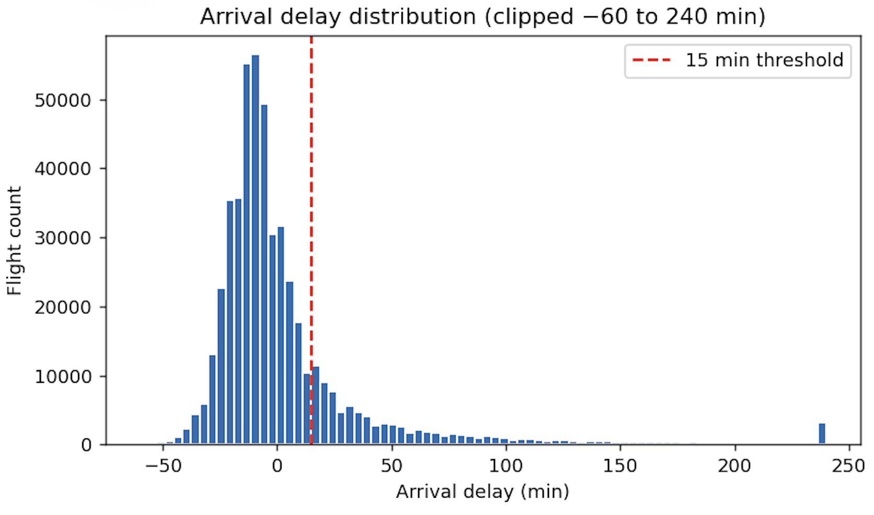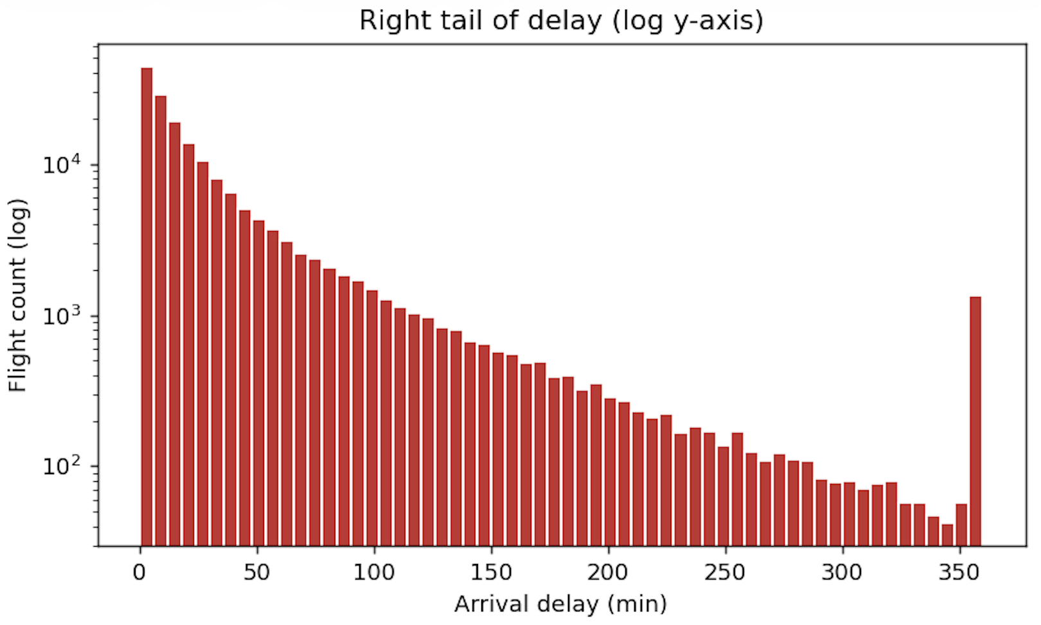
Fig. 1. Arrival delay distribution (n = 500K). Left: clipped to [−60, 240] min with the 15-min threshold. Right: right tail on a log scale. Mean = 4.77 min, σ = 52.85 min — the tail dominates the mean.

When testing carrier performance, I ran 500 bootstrap resamples to build 95% confidence intervals. Delta and Hawaiian consistently hit around 85% on-time rates with tight intervals, while carriers like JetBlue and Frontier sat down at 73%. Because the confidence intervals of the top tier and bottom tier do not overlap at all, I was able to confirm the 13-point spread is a real, persistent operational difference, not just sampling noise.
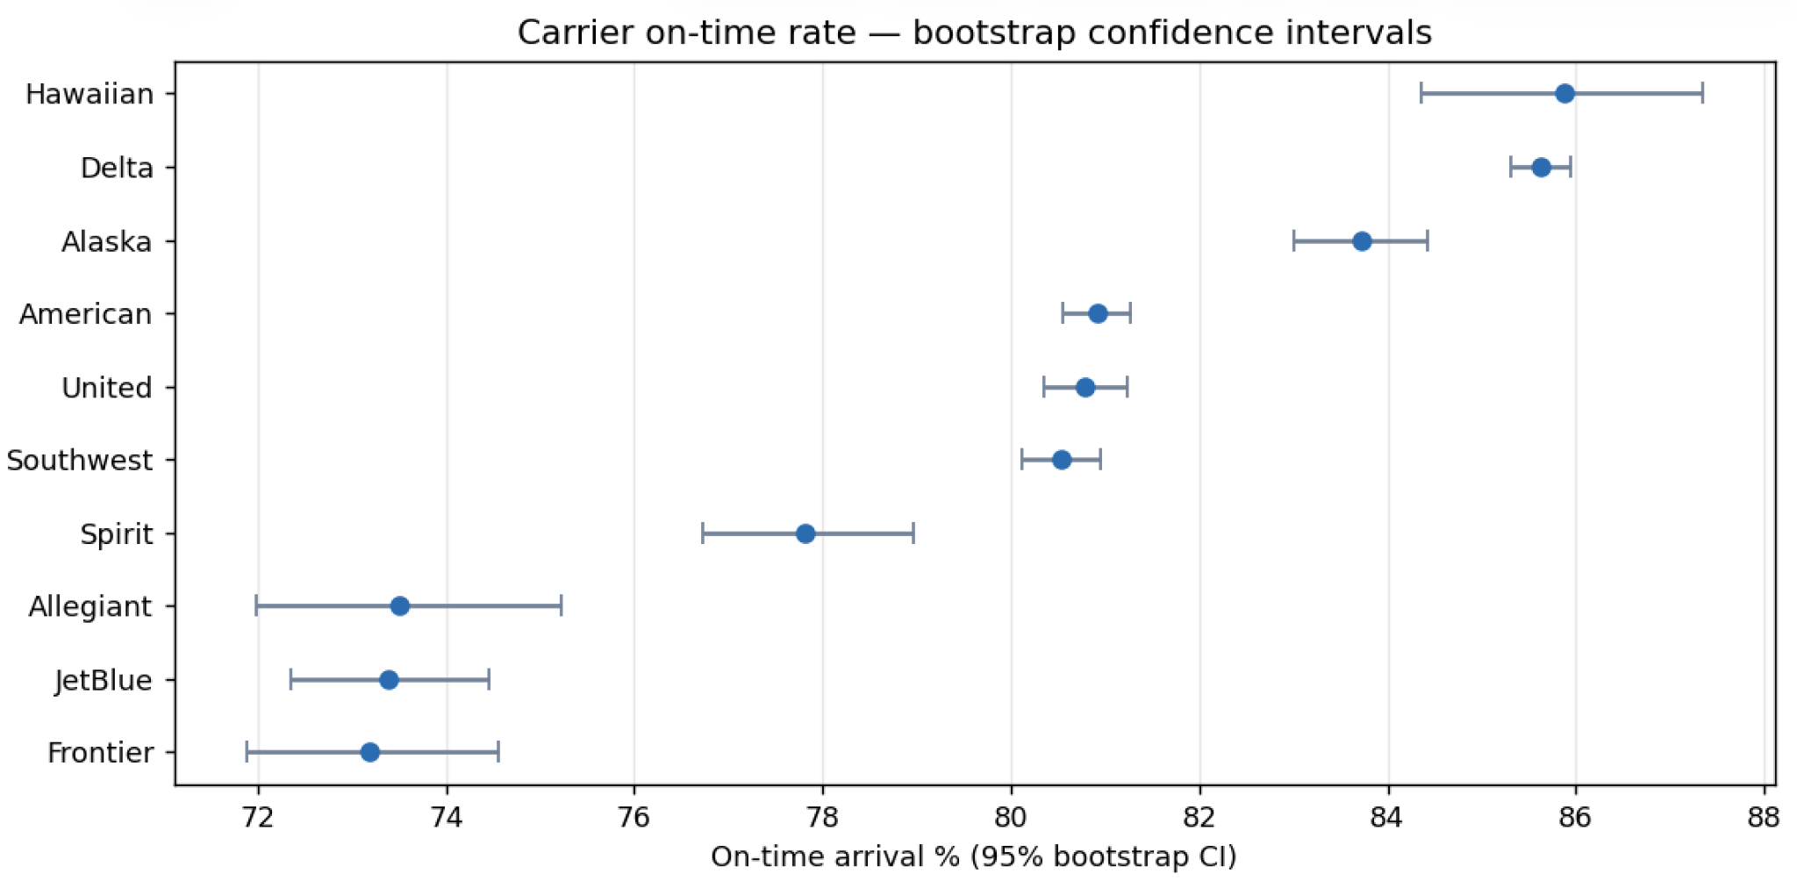
Fig. 2. Top-10 carrier on-time rates with 95% bootstrap CIs (500 resamples). Top-tier and bottom-tier intervals do not overlap, confirming the 13-point spread is statistically real.

Moving into predictive modeling, I used an additive Holt-Winters model to forecast the next 12 months. The decomposition clearly isolated an annual summer spike in delays and explicitly separated out the massive 2020 COVID shock, projecting an average 5.19-minute delay for 2026 with the exact same summer-peak seasonality.

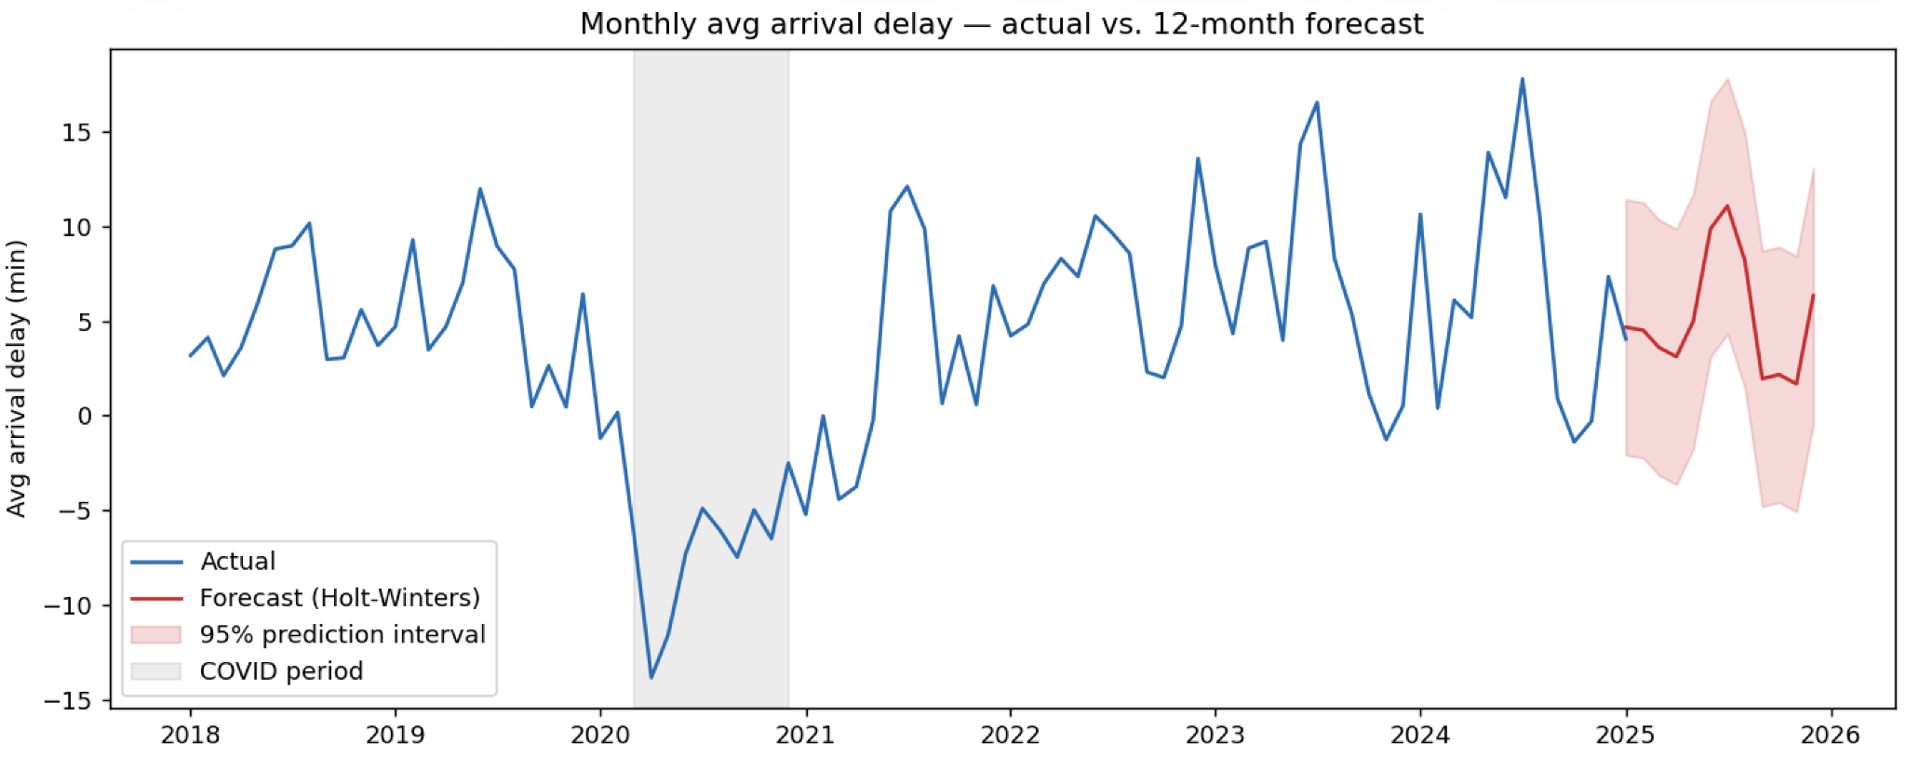
Fig. 3. Monthly average arrival delay with 12-month Holt-Winters forecast and 95% prediction band. Grey shading marks the 2020 COVID structural break. Forecast preserves the stable summer-peak seasonality.

For individual flight risk, my depth-8 decision tree achieved a ROC-AUC of 0.626. While modest, it catches about 60% of all late flights, and when the model flags a flight as at-risk, that flight is 1.3× more likely to be late than a random baseline flight. The biggest driving feature was the scheduled departure hour. Finally, my Monte Carlo simulation of 10,000 days of network operations showed that under independent assumptions, a 95th-percentile bad day across the whole network only has about 0.5% more late flights than an average day. However, since real-world delays are correlated by weather and air traffic control, this simulation acts as a strict lower bound for tail risk.
VIII. BUSINESS INSIGHTS
Several clear business insights emerged from this analysis. Foremost, operations must stop planning around the mean. A 4.7-minute average delay hides the fact that the standard deviation is almost an hour, meaning teams must staff for the distribution tail. Furthermore, carrier rankings are a hard statistical fact. With non-overlapping confidence intervals, interline and code-share contracts should heavily price in these operational gaps rather than relying on point estimates.
The models also proved that departure hour is the single biggest operational lever. Late-evening flights inherit the day's accumulated delays, meaning pulling those flights forward by just 30 to 60 minutes is the highest-leverage move a planner can make without changing fleet capacity. From a forecasting perspective, 2020 breaks all trend lines; including it without dummying it out will systematically ruin any post-COVID recovery forecast. Lastly, the analysis highlighted a vital distinction between network risk and individual risk. Per-flight risk is high, but network-wide risk under normal conditions is surprisingly stable. Network meltdowns only happen when external shocks, like storms, break the independence of individual flight delays.
IX. RECOMMENDATIONS
Based on these findings, I recommend a few operational adjustments. The immediate priority should be re-timing evening departures by shifting flights in the final block of the day forward by 30 to 60 minutes, which will drastically cut down on cascading "late aircraft" delays. Additionally, operations should increase summer staffing by 25%. The Holt-Winters model proves summer months are reliably worse, so staffing to the 95th-percentile day in July instead of the annual average will prevent routine summer meltdowns.
On the commercial side, the airline must price contracts using confidence intervals. A carrier with an 85% lower bound is operationally distinct from one with a 74% upper bound, and the financials should reflect that. For all future modeling, teams must exclude 2020 or train models from 2021 forward to keep baseline trend lines accurate. Finally, the airline should prototype a risk score based on the decision tree to trigger low-cost interventions, like sending proactive rebooking emails for flights flagged as high risk at booking time.
X. Limitations
There are a few limitations to acknowledge regarding both the data and the methodology. The dataset is missing two of the most critical predictors for flight delays: weather forecasts and Air Traffic Control (ATC) flow programs. Because of this, there is a hard ceiling on how accurate any predictive model can get using just schedule data. Additionally, my Monte Carlo simulation assumes flights are delayed independently. In reality, a thunderstorm over a major hub correlates delays across hundreds of flights, meaning my simulation mathematically understates true network tail risk. Finally, the analysis only covers mainline carriers above the 0.5% market share threshold, so these insights do not necessarily apply to small regional operators.

XI. CONCLUSION
This project set out to bridge the gap between just describing historical delays in Power BI and actively quantifying and predicting them in Python. By anchoring the analysis in practical methods, I proved that carrier differences are statistically real using confidence intervals, isolated a clean seasonal forecasting trend, and successfully built a booking-time risk model that provides a 1.3× precision lift over random guessing. The main takeaway is clear: average metrics obscure the harsh reality of operational right-tail risks. By shifting focus from the mean to the actual distribution, airlines can make highly leveraged, data-backed adjustments to their schedules and staffing to tangibly improve schedule reliability.
XII. APPENDIX
