Ole Object Demo

Master Document with several Ole Objects:

Ms Excel Object
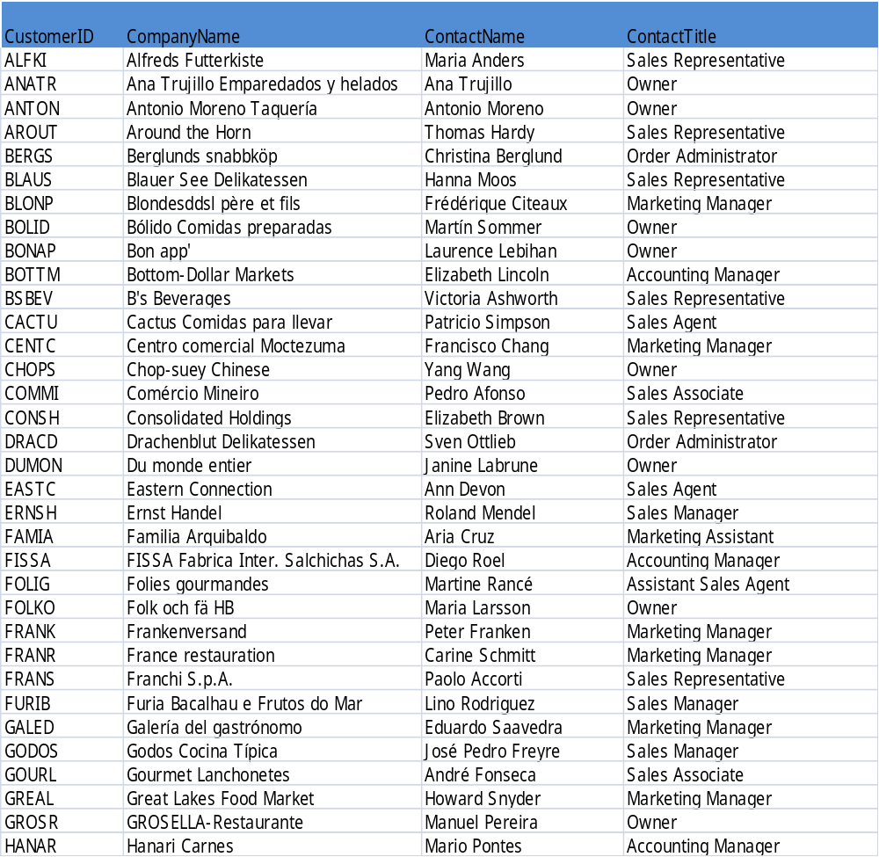
Adobe PDF object
