Adventure Works Cycles
Adventure Works Cycles, the fictitious company on which the Adventure Works sample databases are based, is a large, multinational manufacturing company. The company manufactures and sells metal and composite bicycles to North American, European and Asian commercial markets. While its base operation is located in Bothell, Washington with 290 employees, several regional sales teams are located throughout their market base.

In 2000, Adventure Works Cycles bought a small manufacturing plant, Import adores Neptuno, located in Mexico. Import adores Neptuno manufactures several critical subcomponents for the Adventure Works Cycles product line. These subcomponents are shipped to the Bothell location for final product assembly. In 2001, Import adores Neptuno, became the sole manufacturer and distributor of the touring bicycle product group.

Product Overview

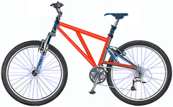 | Mountain-200  Product No: BK-M68B-38  Size: 38  Weight: 25  Price: $2,294.99
Mountain-300  Product No: BK-M47B-38  Size: 35  Weight: 22  Price: $1,079.99 | 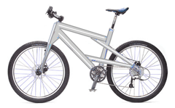

CHEST X-RAY REPORT
Patient Name : Andrew Fuller
Date of Birth : 1980-01-01
Date : 2023-12-05
X-ray Number : 52587412
Figure 1: Chest X-ray- TIFF Version
READINGS :
- Lungs : Clear and well-inflated; no signs of pneumonia, pneumothorax, or effusion.
- Heart : Normal size and shape; cardiac silhouette within normal limits; no cardiomegaly or pericardial effusion.
- Diaphragms : Well-defined and even; no elevation or depression.
- Bones : Normal appearance; no fractures or dislocations.
- Soft Tissues : Normal appearance in the chest area.
RECOMMENDATIONS :
No further evaluation is required at this time.
ADDITIONAL NOTES :
None.

REGISTRATION FORM

Please read all instructions carefully before filling out the form.
PERSONAL INFORMATION
Andrew Fuller
Name :
908 W. Capital Way

Address 1 :
WA, USA.

Address 2 :
andrew@gmail.com
Email :
+122-2222222

Phone :
APPROVAL WORKFLOW
Administrative review
Final approval
Document submission

REQUIRED DOCUMENTS
- Proof of Identity
- Proof of Address
- Passport Size Photo

