Adventure Works Cycles
Adventure Works Cycles, the fictitious company on which the AdventureWorks sample databases are based, is a large, multinational manufacturing company. The company manufactures and sells metal and composite bicycles to North, European and Asian commercial markets. While its base operation is located in Bothell, Washington with 290 employees, several regional sales teams are located throughout their market base.

In 2000, Adventure Works Cycles bought a small manufacturing plant, Importadores Neptuno, located in Mexico. Importadores Neptuno manufactures several critical subcomponents for the Adventure Works Cycles product line. These subcomponents are shipped to the Bothell location for final product assembly. In 2001, Importadores Neptuno, became the sole manufacturer and distributor of the touring bicycle product group details.

Mathematical Equation:
$$f\left(x\right)=a_{0}+\sum_{n=1}^{∞}{\left(a_{n}\cos{\frac{nπx}{L}}+b_{n}\sin{\frac{nπx}{L}}\right)}$$

Product Overview
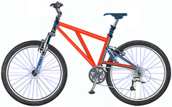 | Mountain-200  Product No: BK-M68B-38  Size: 38  Weight: 25  Price: $2,294.99
Mountain-300  Product No: BK-M47B-38  Size: 35  Weight: 22  Price: $1,079.99 | 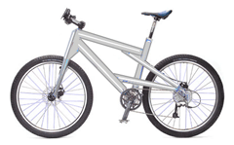

CHEST X-RAY REPORT (Vietnamese Translation)
Tên bệnh nhân: Minh Tuán
Ngày sinh : 01/01/1980
Ngày thực hiện: 05/12/2023
Số X-quang : 52587412
Hình 1: Ảnh X-quang ngực – Phiên bản TIFF

KẾT QUẢ ĐỌC PHIM:
- Phổi: Trong và căng tốt; không có dấu hiệu viêm phổi, tràn khí màng phổi hoặc tràn dịch.
- Tim: Kích thước và hình dạng bình thường; bóng tim trong giới hạn bình thường; không có tim to hoặc tràn dịch màng tim.
- Cơ hoành: Rõ ràng và đều; không có hiện tượng nâng cao hoặc hạ thấp.
- Xương: Hình dạng bình thường; không có gãy xương hoặc trật khớp.
- Mô mềm: Hình dạng bình thường ở vùng ngực.
KHUYẾN NGHỊ:
Hiện tại không cần đánh giá thêm.
GHI CHÚ BỔ SUNG:
Không có.

EMF Image of Company Structure

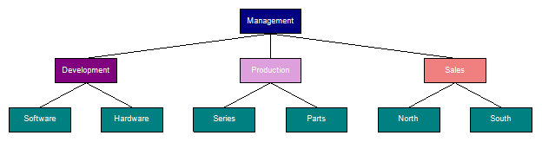

Northwind Database

The Northwind sample database (Northwind.mdb) is included with all versions of Access. It provides data you can experiment with and database objects that demonstrate features you might want to implement in your own databases. Using Northwind, you can become familiar with how a relational database is structured and how the database objects work together to help you enter, store, manipulate, and print your data..

It contains the following detailed information:
- Suppliers/Vendors of Northwind – who supply to the company.
- Customers of Northwind – who buy from Northwind
- Employee details of Northwind traders – who work for Northwind

The Northwind sample database (Northwind.mdb) is included with all versions of Access. It provides data you can experiment with and database objects that demonstrate features you might want to implement in your own databases.
Using Northwind, you can become familiar with how a relational database is structured and how the database objects work together to help you enter, store, manipulate, and print your data.

Adventure Works Cycles, the fictitious company on which the AdventureWorks sample databases are based, is a large, multinational manufacturing company. The company manufactures and sells metal and composite bicycles to North, European and Asian commercial markets. While its base operation is located in Bothell, Washington with 290 employees, several regional sales teams are located throughout their market base.
Adventure Works Cycles, the fictitious company on which the AdventureWorks sample databases are based, is a large, multinational manufacturing company.

REGISTRATION FORM

Please read all instructions carefully before filling out the form.
PERSONAL INFORMATION
Andrew Fuller
Name :
908 W. Capital Way

Address 1 :
WA, USA.

Address 2 :
andrew@gmail.com
Email :
+122-2222222

Phone :
APPROVAL WORKFLOW
Administrative review
Final approval
Document submission

REQUIRED DOCUMENTS
- Proof of Identity
- Proof of Address
- Passport Size Photo

