The following assembly references are required to deploy the RichTextBoxAdv control and its namespace:
- Assembly: Syncfusion.SfRichTextBoxAdv.WPF
- Dependent Assemblies: Syncfusion.Compression.Base, Syncfusion.OfficeChart.Base, Syncfusion.DocIO.ClientProfile (3.5 and 4.0 framework), Syncfusion.DocIO.Base (4.5 and later frameworks), and Syncfusion.Shared.WPF
- Namespace: Syncfusion.Windows.Controls.RichTextBoxAdv
To create the RichTextBoxAdv control in Visual Studio:
- Create a new WPF Application project.
- Drag the SfRichTextBoxAdv control from the Toolbox window to the Design View. An instance of the RichTextBoxAdv control will be created in the Design view.
- 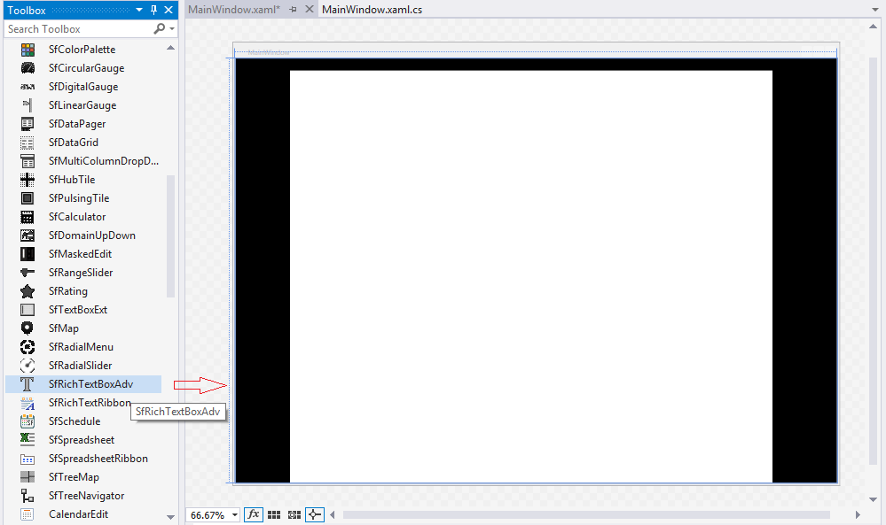
Figure 3: RichTextBoxAdv Control after Dragging to Design View
[XAML]
<syncfusion:SfRichTextBoxAdv x:Name="richTextBoxAdv" />

[C#]
//Loads the file from the specified path.
richTextBoxAdv.Load("C:/GettingStarted.docx");
//Disposes the RichTextBoxAdv instance.
richTextBoxAdv.Dispose();

