Import RTF to Word Demo

This is an example to convert Rich Text Format into Word document.

Mountain 200
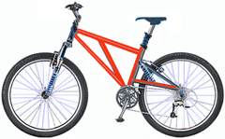 | Product No: BK-M68B-38  Size: 38  Weight: 25  Price: $2,294.99
Mountain 300
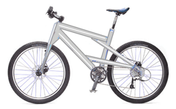 | Product No: BK-M47B-38  Size: 35  Weight: 22  Price: $1,079.99

