The Giant Panda

The giant panda, which only lives in China outside of captivity, has captured the hearts of people of all ages across the globe. From their furry black and white bodies to their shy and docile nature, they are considered one of the world's most loved animals.

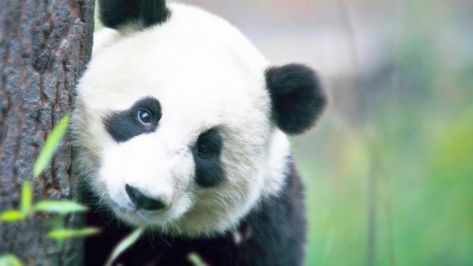

حقيقة سريعة يقدر عدد الباندا العملاقة في البرية يتراوح بين 1500 و 3,000.

# Intriguing Giant Panda Mysteries

While most adore their fluffy fur and round heads, which help give them their cuddly bear quality, others are fascinated by the many mysteries of the giant panda. Did you know that the giant panda may actually be a raccoon, they have an opposable pseudo thumb, and that they’re technically a carnivore even though their diet is primarily vegetarian? These things and more have baffled scientists and naturalists for hundreds of years.

# Other Fun Giant Panda Facts

* For many centuries, giant pandas were thought to be a mythical creature, similar to a dragon or unicorn.
* Unlike other bears in the region, giant pandas don’t hibernate.