The following assembly references are required to deploy the RichTextBoxAdv control and its namespace:

* **Assembly:** Syncfusion.SfRichTextBoxAdv.WinRT
* **Dependent Assemblies:** Syncfusion.DocIO.WinRT, Syncfusion.SfRadialMenu.WinRT, and Syncfusion.SfShared.WinRT
* **Namespace:** Syncfusion.UI.Xaml.RichTextBoxAdv

To create the RichTextBoxAdv control in Visual Studio:

1. Create a new Windows Store Application project.
2. Drag the **SfRichTextBoxAdv** control from the **Toolbox** window to the **Design View**. An instance of the RichTextBoxAdv control will be created in the **Design** view.

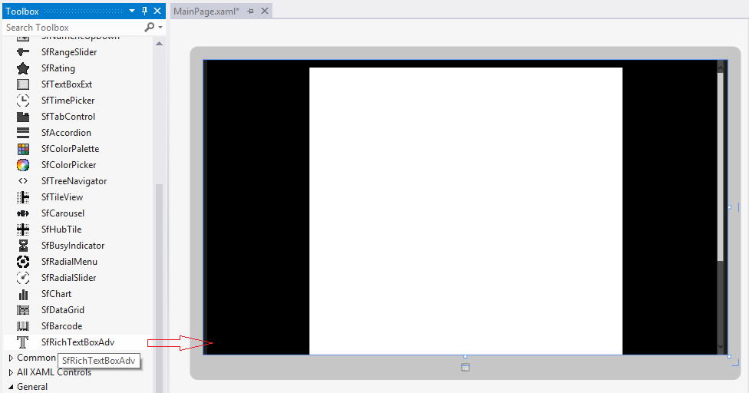

*Figure 3: RichTextBoxAdv Control after Dragging to Design View*

|  |
| --- |
| **[XAML]**  <syncfusion:SfRichTextBoxAdv x:Name="richTextBoxAdv" ManipulationMode="All" /> |

|  |
| --- |
| **[C#]**  //Loads the Sample.docx file from the Documents library.  StorageFolder storageFolder = KnownFolders.DocumentsLibrary;  StorageFile storageFile = await storageFolder.GetFileAsync("Sample.docx");  //Loads the storage file in Asynchronous mode.  richTextBoxAdv.LoadAsync(storageFile);  //Disposes the RichTextBoxAdv instance.  richTextBoxAdv.Dispose(); |