Take a Tour

**RichTextBoxAdv**

The RichTextBoxAdv control allows you to view, edit, and print rich text laid out as pages or as a continuous layout in a Windows Store app. You can perform all editing tasks using touch, mouse, or keyboard.

The following image displays the **RichTextBoxAdv** Control.

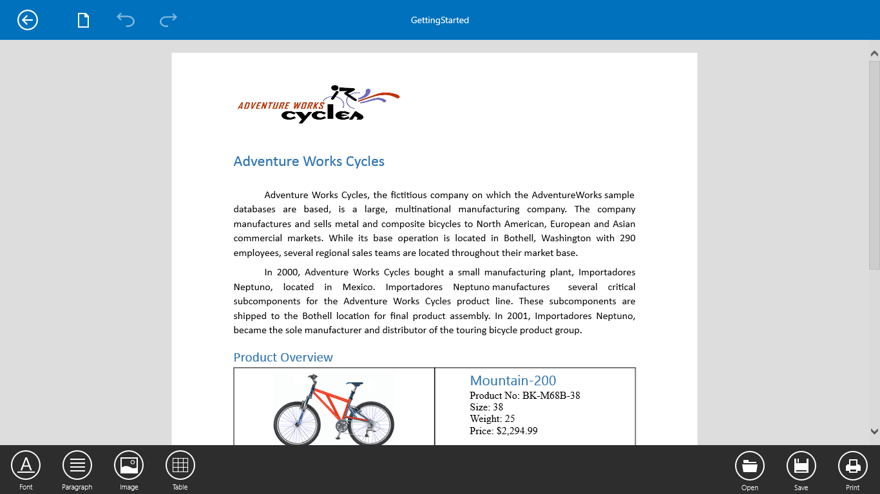

*Figure 1: RichTextBoxAdv Control*

Features of the **RichTextBoxAdv** control include:

* Viewing and editing rich text, images, and tables.
* Importing or exporting rich text format (.rtf) files and Word documents (.doc, .docx).
* Printing rendered content.
* Supports all image types except for metafile images.
* Supports Undo and redo operations such as editing text, table, rows, cells, and formatting.
* Supports first-page headers and footers as well as odd- and even-page headers and footers.
* The ability to cut, copy, and paste the rich-text content to and from the **RichTextBoxAdv**.
* Supports loading encrypted Word documents with valid password.

This control allows you to view, edit, and print content formatted as rich text, including bold or italicized fonts, and paragraphs with proper alignment and indentation. It can also be used to view Word documents in rich-content applications such as forums and blogs.