The following assembly references are required to deploy the RichTextBoxAdv control and its namespace:

* **Assembly:** Syncfusion.SfRichTextBoxAdv.WPF
* **Dependent Assemblies:** Syncfusion.Compression.Base, Syncfusion.OfficeChart.Base, Syncfusion.DocIO.ClientProfile (3.5 and 4.0 framework), Syncfusion.DocIO.Base (4.5 and later frameworks), and Syncfusion.Shared.WPF
* **Namespace:** Syncfusion.Windows.Controls.RichTextBoxAdv

To create the RichTextBoxAdv control in Visual Studio:

1. Create a new WPF Application project.
2. Drag the **SfRichTextBoxAdv** control from the **Toolbox** window to the **Design View**. An instance of the RichTextBoxAdv control will be created in the **Design** view.

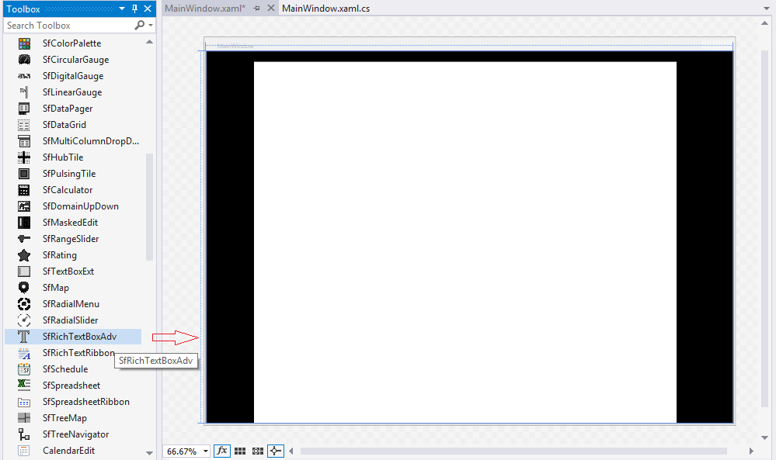

*Figure 3: RichTextBoxAdv Control after Dragging to Design View*

|  |
| --- |
| **[XAML]**  <syncfusion:SfRichTextBoxAdv x:Name="richTextBoxAdv" /> |

|  |
| --- |
| **[C#]**  //Loads the file from the specified path.  richTextBoxAdv.Load("C:/GettingStarted.docx");  //Disposes the RichTextBoxAdv instance.  richTextBoxAdv.Dispose(); |