Adventure Work Cycles

Adventure Works Cycles, the fictitious company on which the AdventureWorks sample databases are based, is a large, multinational manufacturing company. The company manufactures and sells metal and composite bicycles to North American, European and Asian commercial markets. While its base operation is located in Bothell, Washington with 290 employees, several regional sales teams are located throughout their market base.
In 2000, Adventure Works Cycles bought a small manufacturing plant, Importadores Neptuno, located in Mexico. Importadores Neptuno manufactures several critical subcomponents for the Adventure Works Cycles product line. These subcomponents are shipped to the Bothell location for final product assembly. In 2001, Importadores Neptuno, became the sole manufacturer and distributor of the touring bicycle product group.

Product Overview

Mountain-200
Product No: BK-M68B-38
Size: 38
Weight: 25
Price: $2,294.99
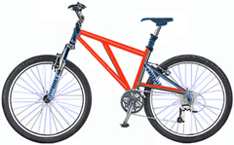

Mountain-300
Product No: BK-M47B-38
Size: 35
Weight: 22
Price: $1,079.99
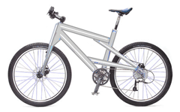

Road-150
Product No: BK-R93R-44
Size: 44
Weight: 14
Price: $3,578.27
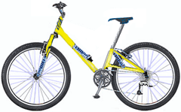

Employee details
Name | Title | Phone
Andrew Fuller | Vice President, Sales | (206) 555-9857-x5467
Steven Buchanan | Sales Manager | (206) 555-9482-x3457
Andy Bernard | Sales Representative | (206) 555-3412-x3355

Supplier details
Supplier ID | Company Name | Contact Name | Address | City | Country
1 | Exotic Liquids | Charlotte Cooper | 49 Gilbert St. | London | UK
2 | New Orleans Cajun Delights | Shelley Burke | P.O. Box 78934 | New Orleans | USA
3 | Grandma Kelly's Homestead | Regina Murphy | 707 Oxford Rd. | Ann Arbor | USA

