10/15/2014 12:54:00 AM
Word document into HTML document:
It is possible to convert a simple word document into HTML document.

Some of the Supported elements are:
- Paragraph
- Tables
- TextBox
- Hyperlink
- Image
Table with Images:
SNO | Product Name | Product Image
1 | Mountain 200 | 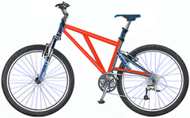
2 | Mountain 300 | 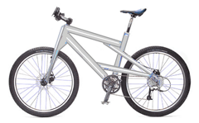
3 | Road 150 | 

