The Giant Panda

The giant panda, which only lives in China outside of captivity, has captured the hearts of people of all ages across the globe. From their furry black and white bodies to their shy and docile nature, they are considered one of the world's most loved animals.

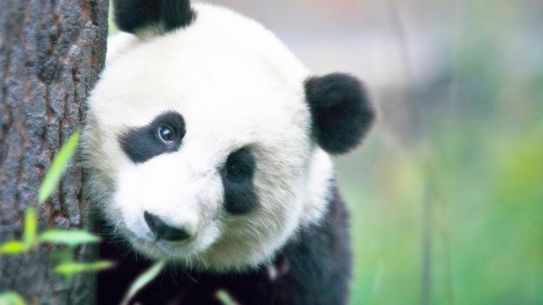

**Quick Fact** The estimated number of giant pandas in the wild varies between 1,500 and 3,000.

# Intriguing Giant Panda Mysteries

While most adore their fluffy fur and round heads, which help give them their cuddly bear quality, others are fascinated by the many mysteries of the giant panda. Did you know that the giant panda may actually be a raccoon, they have an opposable pseudo thumb, and that they’re technically a carnivore even though their diet is primarily vegetarian? These things and more have baffled scientists and naturalists for hundreds of years.

## Opposable Pseudo Thumb

A characteristic of the giant panda that has mystified scientists is their movable, elongated wrist bone that acts like an opposable thumb. This human-like quality that helps give them even more of a cuddly-bear appearance enables the giant panda to pick up objects and even eat sitting up.

**Quick Fact** Giant pandas have five clawed toes and one pseudo thumb.

Their pseudo thumb, along with pads of skin, help the giant panda strip the more nutritious small bamboo shoots and leaves while holding the stalk in their mouth.

## Small Bear or Large Raccoon?

Giant pandas are generally referred to as bears and are typically called panda bears rather than giant pandas. Though we may think they look like bears, there has been a great deal of discussion for decades about where giant pandas fit in the animal kingdom. Much of the debate has been whether they are more closely related to the red panda, once thought to be a member of the raccoon family, than the bear family.

While a giant panda has a body that resembles a small bear and climbs trees like a bear, it also has several characteristics in common with the red panda. For example, both giant pandas and red pandas eat bamboo and have the same pseudo thumb. The table below lists the main characteristics the giant panda shares with bears and red pandas.

|  |  |  |
| --- | --- | --- |
| **Characteristic** | **Bear** | **Red Panda** |
| Shape | Similar body shape | Some resemblance |
| Size | Similar (small bear-sized) | Smaller |
| Gait | Bear-like walk | Different |
| Diet | Eats bamboo like bear | Eats bamboo |
| Paws | Bear-like paws | Similar paw structure |
| Eyes | Different | Similar eye structure |
| Nose and Teeth | Bear-like | Similar to red panda |