The following assembly references are required to deploy the RichTextBoxAdv control and its namespace:
- Assembly: Syncfusion.SfRichTextBoxAdv.WinRT
- Dependent Assemblies: Syncfusion.DocIO.WinRT, Syncfusion.SfRadialMenu.WinRT, and Syncfusion.SfShared.WinRT
- Namespace: Syncfusion.UI.Xaml.RichTextBoxAdv
To create the RichTextBoxAdv control in Visual Studio:
- Create a new Windows Store Application project.
- Drag the SfRichTextBoxAdv control from the Toolbox window to the Design View. An instance of the RichTextBoxAdv control will be created in the Design view.
- 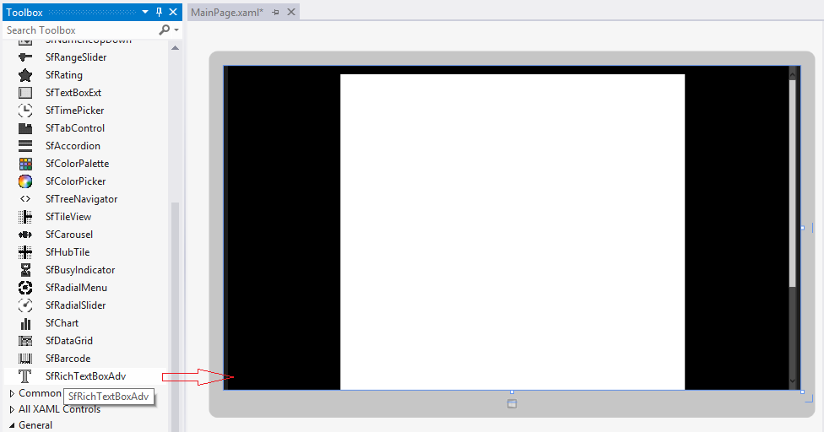
Figure 3: RichTextBoxAdv Control after Dragging to Design View
[XAML]
<syncfusion:SfRichTextBoxAdv x:Name="richTextBoxAdv" ManipulationMode="All" />

[C#]
//Loads the Sample.docx file from the Documents library.
StorageFolder storageFolder = KnownFolders.DocumentsLibrary;
StorageFile storageFile = await storageFolder.GetFileAsync("Sample.docx");
//Loads the storage file in Asynchronous mode.
richTextBoxAdv.LoadAsync(storageFile);
//Disposes the RichTextBoxAdv instance.
richTextBoxAdv.Dispose();

