This document contains various document elements that can be copied and pasted into another document.

This is a Table

FORMS
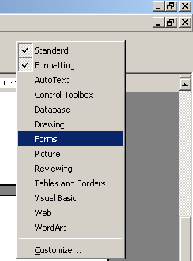
To access the FORMS toolbar – click the right-hand mouse button anywhere on the grey area at the top of your page and select ‘forms’.
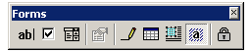

1 | What is the name of Harry Potter’s School?
2 | Which girl is Harry Potter’s School-Friend?
3 | Which ‘House’ does Harry Potter belong to?
4 | Which film company made the recent H. P. film?
5 | In the film – who plays ‘Hagrid’?

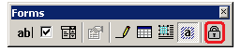
The Table above is set-up ready for use – it just needs ‘locking’ - click on the ‘padlock’ icon.

To make your own FORM – click into an empty cell and then click the
Drop-Down Form Field Icon.

This will place an empty, grey rectangle into your selected cell – thus . . .

6 | My name is . . .

