ET4283: Advanced Digital Image Processing Final Project on “Image Segmentation”

Ali Alessio Salman, 40056465 María Silos Viu,4701888

[A.A.Salman@student.tudelft.nl](mailto:A.A.Salman@student.tudelft.nl) [M.SilosViu@student.tudelft.nl](mailto:M.SilosViu@student.tudelft.nl)

January 7, 2016

1 Introduction

Some image segmentation techniques are widely known to employ approaches in which normally the main contours of the image are drawn first so that subsequent segmented regions are latterly subtracted from those contours.

This project aims at two main purposes. Firstly, the most extensively applied region-based approaches are briefly described in order to get a general idea about the state-of-art image segmentation methods, among which watershed segmentation is explained. Secondly, two main simple implementations are presented. The first one is focused on the oriented gradients of histograms method that serves as an efficient contour detector. The second one employs the output of this contour detector to undergo a morphological watershed segmentation. At the end of this document, the influence of parameters regarding results obtained is discussed.

2 Region-Based Approaches for Image Segmentation

Three main region-based approaches are most generally applied when implementing image segmentation.

Graph cut theory. This approach is based on the idea of creating a graph from an image in which each pixel represents a single node of the graph. Graph cut theory takes into account the similarities between nodes and search for an optimal cut that divides the image into two regions (“background” and “foreground”) while minimizing as much as possible the cut segment. However, the cuts of these graphs are not always in accordance to the user needs, as the optimal cut is usually the one dividing a very small region from the rest of the image. In this terms, Normalized Cuts criterion is rather useful as it allows for the employment of a “cost function” that penalize too small cuts and creates subsets that are reasonably balanced, i.e. each of the regions are large enough.

Mean Shift. This approach consists on a clustering-based segmentation that looks for the density local maximum of a set of pixels. The method firstly locates the center of a region of interest (ROI) in a random position, then the mean density of this ROI is computed so that the center is subsequently shifted towards this mean position. The process is iteratively performed until the ROI’s mean density converges to a specific position. After the final mean is located, groups of pixels are clustered together so that all pixels within certain cluster lay down near the same peak value (referred to as a basin). The main disadvantages of this method are that the results highly depend on the ROI size and that it is computationally expensive.

Watershed approach. This method relies on the watershed transform that converts a 2D gray scale image into a topographic image in which the gray level intensity is represented in the third dimension as the high of the relief. In this way, several sources of water, referred to as *catchment basins*, are located in the local minima of the image in order to imaginary flood the relief at a constant rate. When the water level increases, the flooded regions grow in size until eventually, two of these regions merge. At this point, the algorithm creates a one-pixel contour that separates these flooded regions. The process is iteratively performed until all the regions of the image are segmented.

3 Oriented Gradient of Histograms as Contour Detector

In this section, we present an implemented contour detector that quantifies the presence of boundary from local image cues. Our contour detector is based on the computation of the oriented gradient of local histograms, taking as a reference the contour detector implemented in [1]. Given a pixel *A* placed in (x,y), G(A) refers to the gradient density between the histograms of two rectangles placed in each side of A at an angle θ so that they form a square around A as represented in Fig 1. The magnitude of the gradient G(A) is defined as the distance between the histograms *g* and *h* as shown below:

$$χ^{2}\left(g,h\right)=\frac{1}{2}\sum_{i}{\frac{{\left(g\left(i\right)-h\left(i\right)\right)}^{2}}{g\left(i\right)+h\left(i\right)}} \left(1\right)$$

The original idea of [1] was to employ half-discs instead of rectangles so that both half-discs formed a circle with center in A. However, in [1] they demonstrate that the rectangles approach allows for decreasing the computational cost and simplicity of the problem without decreasing the contour quality.

The purpose of computing these gradients using different orientations is to eventually take the maximum value of them as the resulting gradient magnitude.

Which angles did we take into consideration… XY or XY and 45º.

Code or pseudocode IF NECESSARY

An example of a resulting image using our contour detection is represented in Fig…

4 Morphological Watershed Segmentation

As previously mentioned, watershed segmentation is one of the main region-based segmentation approaches. It focuses on finding local minima of the image, which are called *catchment basins*, in order to construct a topographic image flooded with water sources located in the catchment basins.

BLABLABLA

5 Discussion

Regarding the gradient of oriented histograms implementation, several parameters played a crucial role in the final result of the contour detector.

In the first place, the scale was an important factor since… (resolution must be high enough to use 5 pixels neighborhoods without blurring the contours too much) 🡪 REFERENCE TO FIGURE A

Secondly, the angle…🡪 REFERENCE TO FIGURE X.

Parameters for watershed part

Influence on: time and quality of result

References

1. Arbelaez, P., Maire, M., Fowlkes, C., & Malik, J. (2011). Contour detection and hierarchical image segmentation. Pattern Analysis and Machine Intelligence, IEEE Transactions on, 33(5), 898-916.

2. Felzenszwalb, P. F., & Huttenlocher, D. P. (2004). Efficient graph-based image segmentation. International Journal of Computer Vision, 59(2), 167-181.

3. Comaniciu, D., & Meer, P. (2002). Mean shift: A robust approach toward feature space analysis. Pattern Analysis and Machine Intelligence, IEEE Transactions on, 24(5), 603-619.

4. Gallier, J. (2015). Spectral Theory of Unsigned and Signed Graphs Applications to Graph Clustering: a Survey.

Reference of watershed

Figures (max 2 pages)

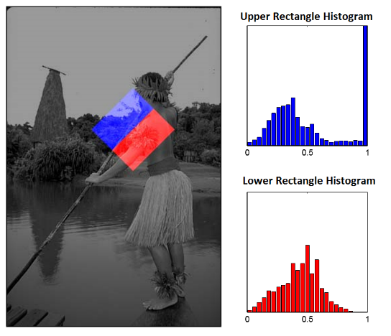

**Fig. 1.** Illustrative representation of the local histograms with respect a central point (x,y) located at the center of the square. In this case, the angle θ is equal to 45º and the width of our region of interest is 50 pixels for illustrative purposes. (Courtesy of Arbelaez et all) If we don’t have space we add this just in the ppt… but I think it’s important so other classmates understand it.

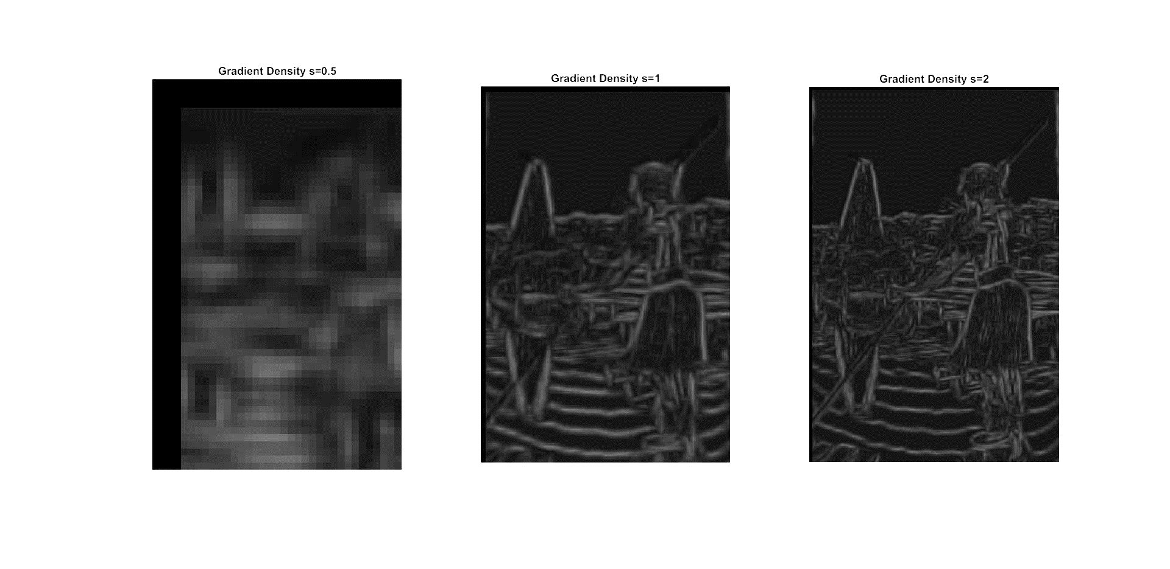

**Fig. A.** Influence of scale in gradients’ magnitudes. Big scales images give rise to fine contours in contrast with the coarse contours acquired in the smaller scale image. The brightness of this image is increased by a 40% factor

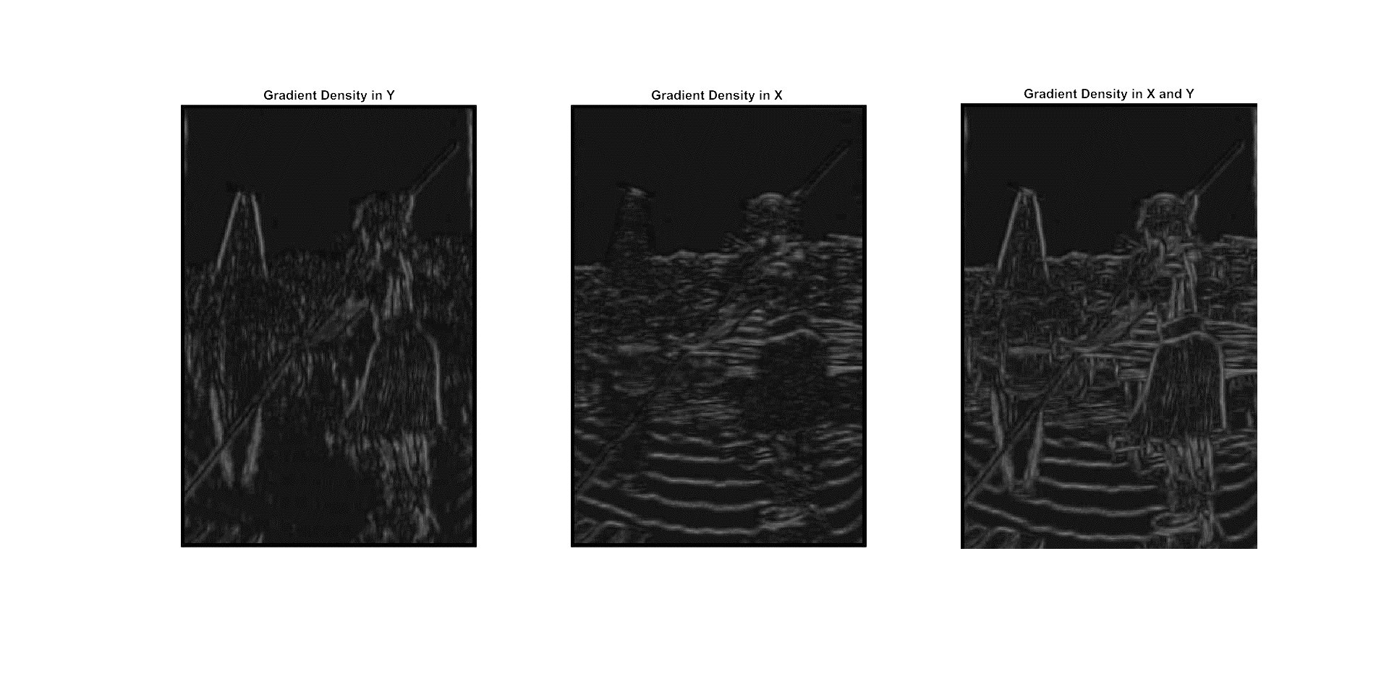

**Fig. X.** Influence of θ in gradients’ magnitudes. Using one single orientation (θ=0º or θ=90º) is not enough to acquire contour quality, but the combination of both give rise to an efficient contour detector. The brightness of this image is increased by a 40% factor for illustrative purposes.

Notes:

1. I HAVE CHANGED THE BRIGHTNESS OF THIS IMAGE AND THE PREVIOUS OINE SINCE THEY SAY THAT PICTURES MUST HAVE AS MUCH CONTRAST AS POSIBLE… BUT MAYBE THAT IS “CHEATING”…SHOULD I MENTION IT SO THEY DON’T THINK SO?)
2. Maybe the pictures can be acquired again changing the font size of the graphs so they are more readable