

**CG1112 Engineering Principle and Practice**

Semester 2 2019/2020

**“Alex to the Rescue”**

**Design Report**

**Team: 02-03-02**

|  |  |  |  |
| --- | --- | --- | --- |
| Name | Student # | Sub-Team | Role |
| I MUTHUKUMAR | A0201661U | Hardware/Firmware | Hardware lead |
| MENGJIN ZHUANG | A0204716L | Software/Hardware | Software lead |
| CHONG ZHI LIN | A0206179B | Software/Firmware | Firmware lead |
| GAN JIA LERK | A0206056M | Firmware/Hardware | Software lead |

**Section 1:** System Functionalities

Alex is a robot with search and rescue functionalities. The movement of Alex is governed by two motors, one left and one right each to control their respective wheels. Alex can move forward, turn left or turn right, as controlled by the Arduino.

The main function of Alex is to map the environment with the RPLidar through the Hector SLAM algorithm in the Raspberry Pi. The RPLidar uses laser triangulation ranging principle to detect obstacles in its immediate surroundings. With mapping data from the RPLidar, a real time map is then developed on the Raspberry Pi, with each point on the map corresponding to an obstacle, thus a line of points represents a wall in its vicinity. The distance of the point from the origin indicates the distance the obstacle is from Alex.

Alex is then to be remotely controlled from a laptop through the Raspberry Pi. Using the map developed, the user is to evaluate the environment that is mapped and decide the movements Alex has to undertake to avoid obstacles and traverse the surroundings. In order to control Alex from the laptop, the user interacts with the Raspberry Pi and the Pi will then communicate with the Arduino, translating the commands into actual movement control signals for the Arduino to engage the motors.

**Section 2**: Review of State of the Art

One tele-operating search and rescue robotic platform includes RAPOSA, a semi-autonomous robot for rescue operations. These robots perform well in hazardous scenarios where it is impossible for humans to work in.

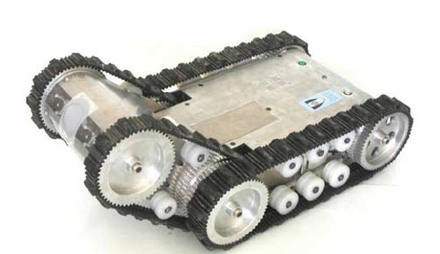Its front body has one thermal camera and two web cameras installed. A variety of sensors have been included which check the humidity, gas and temperature of the surroundings. Additional sensors include light diodes, microphone and loudspeaker. The robot also uses wireless communications, with an option for tethered operation. The tether aids in the suspension of the robot. Furthermore, it enhances the power and communications features of the robot.

Nevertheless, regarding the use of tethered or wireless, there are strong and weak points. Not only do tethered operations offer greater freedom and bandwidth, but they can also be utilised to move the robot.However, a cable may get stuck or broken. The wireless solution, on the other hand, is less dependent on terrain yet depends hugely on batteries. Standard wireless communications may also be unreliable as there is a limit to its range, thus it is not ideal in disaster scenarios.

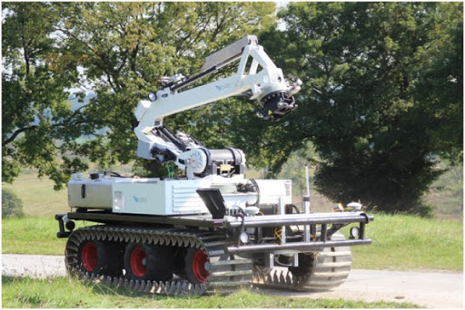 Another platform is developed by the European ICARUS project which utilizes unmanned ground vehicles (UGV) for search and rescue. There are two main UGV platforms, a large UGV with a powerful arm to make structural changes in disaster scenarios, and a small UGV used for entering small enclosures searching for human survivors.

This system offers several advantages. Instead of having only one UGV, a team consisting of one large UGV and one small UGV is implemented. The large UGV serves as a base platform that can cover long distances and surmount even large obstacles. Thus, the small UGV which is mounted on the large UGV can be brought very quickly to the potential location of victims. It can then be used to explore narrow spaces without injuring people or causing further damage to structures.

**Section 3**: System Architecture

**Section 4:** Component Design

Steps:

1. Initialisation
2. Data collection
3. Movement
4. Go back to step 2

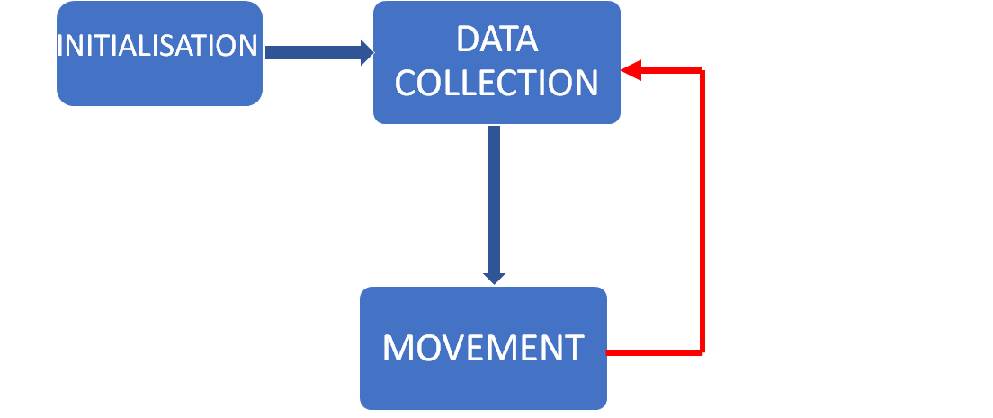

Step 1: Initialization

1. Setup communication in between Raspberry Pi and a remote desktop through VNC
2. Setup communication in between Raspberry Pi and Arduino.  
   1) Raspberry Pi Sends a hello packet to Arduino to inform the Arduino that the Raspberry Pi has booted up.  
   2) Arduino sends an acknowledge packet back to the Pi
3. Pi will instruct LiDAR to obtain a virtual map of the environment

Step 2: Data Collection

1. Raspberry Pi receives data from the LiDAR to create a virtual map of the environment using Hector SLAM
2. The data of the environment mapping from the LiDAR is then interpreted by the Hector SLAM to give up to date environment data to the operator

Step 3: Movement

1. Operator thencontrols ALEX through the Raspberry Pi, to inform the Arduino to make certain movements based on the information collected and the intended objective
   1. Raspberry Pi can instruct the Arduino to move the motor
   2. Arduino relays information to the motor to carry out the specific movement (left, right, forward, back)
   3. Hall effect sensors in the Arduino will detect the amount of rotations the wheel has made to allow the Arduino to move the correct amount of distance required

Step 4: Return to step 2

**Section 5** :Project Plan

Week 8:

1. Try out Hector SLAM and RPLidar with Alex and a remote desktop.

Week 9:

1. Complete the wiring of the motors of Alex. Commence the coding required for the movement of Alex.
2. Plan out on how to assemble the breadboard, Lidar, Arduino and power bank on top of Alex.
3. Begin setting up the features that have been listed in the Initialisation and data collections segments in section 4.

Week 10:

1. Start preparing the draft report.
2. Test out the movement of Alex. Fine tune the motor or the code if any problem arises.

Week 11:

1. Try out all the functions that have been implemented till date. Fine tune the functions if there are significant errors.
2. Rearrange the components on Alex if they are a hindrance to the movement of Alex.

Week 12:

1. Prepare for mock presentation
2. Submit draft report.

Week 13:

1. Prepare for final presentation
2. Prepare final report

Reading Week:

1. Submit Final Report

References

C. Marques, J. Cristoao, P. Lima, J. Frazao, I. Ribeiro and R. Ventura, "RAPOSA: Semi-Autonomous Robot for Rescue Operations," *2006 IEEE/RSJ International Conference on Intelligent Robots and Systems*, Beijing, 2006, pp. 3988-3993.

G. De Cubber, D. Doroftei, D. Serrano, K. Chintamani, R. Sabino and S. Ourevitch, "The EU-ICARUS project: Developing assistive robotic tools for search and rescue operations," *2013 IEEE International Symposium on Safety, Security, and Rescue Robotics (SSRR)*, Linkoping, 2013, pp. 1-4.