Reaction Intermediates — JEE Advanced Organic Chemistry

Reaction Intermediates — JEE Advanced Organic Chemistry
Carbocations (in depth), carbanions, free radicals, carbenes, nitrenes, benzyne and radical ions: theory, generation, stability, arrow-validated mechanisms, and worked solutions to the exercises you supplied. Status: Parts 0–4, 5A–5I, 6, 7.0–7.2 and 8–15 are written (carbocation, carbanion, free radical, carbene, nitrene, benzyne, radical ions, important orders). Open items are listed in SOURCE_COVERAGE.md and the audit report.

Contents
Part 0 Reaction Intermediates: Bond Fission, Intermediates, Electrophiles and Nucleophiles4
0.1 Homolytic and heterolytic bond fission4
0.2 The reaction intermediates at a glance4
0.3 Electrophiles and nucleophiles (definitions)5
Part 1 Carbocations: Definitions, Classification, Geometry and Bonding6
1.1 Definitions: carbocation, carbenium ion, carbonium ion6
1.2 Geometry, hybridisation and the empty p orbital6
1.3 Orbital overlap requirements and delocalisation of charge7
1.4 Hypercoordinate (carbonium) ions7
1.5 Ion pairs, solvent and counterion7
Part 2 Generation of Carbocations8
2.A Carbocations from alcohols8
2.B Carbocations from alkyl halides and sulfonates (ionisation)10
2.C Carbocations from alkenes, dienes and alkynes (electrophilic addition)13
2.D Solvolysis and S_{N}1 substitution15
2.E Other routes: diazonium ions, Lewis acids, hydride abstraction, acid-mediated ionisations17
2.F Carbocations from amines: diazotisation with nitrous acid19
2.G Carbocations from aromatic compounds: arenium (σ-complex, Wheland) ions21
2.H Lewis-acid-assisted ionisation, ether cleavage, and aromatic carbocations22
Part 3 Leaving-Group Ability25
3.1 What a leaving group is, and what ‘good’ means25
3.2 Factors that determine leaving ability25
3.3 Why there is no single universal order26
3.4 Fifteen leaving-group comparison problems26
Part 4 Carbocation Stability: Complete Advanced Treatment29
4.1 Inductive effect29
4.2 Mesomeric (resonance) effects29
4.3 Hyperconjugation30
4.4 Aromaticity and antiaromaticity31
4.5 Cyclopropylcarbinyl stabilisation and ‘dancing resonance’31
4.6 Neighbouring-group participation and bridged ions32
4.7 d-Orbital resonance claims32
4.8 Steric inhibition of resonance (SIR)32
4.9 Nonclassical carbocations33
4.10 Carbonium ions (hypercoordinate carbon)33
4.11 Additional effects33
Part 5A Worked Solutions: the Supplied ‘Exercise 2 – Carbocation Stability Order’ (redrawn)34
Items from your exercise that need confirmation41
Part 5B Worked Solutions: the Supplied ‘Electronic Displacement Effects’ Carbocation Problems (redrawn)41
Part 5C Worked Solutions: Supplied ‘How Many’ Counting Problems (redrawn)45
Part 5D Worked Solutions: More Supplied Counting Problems (heterolysis, statements, rearrangement, AgNO₃)48
Part 5E Your ‘Stability of Carbocation’ Notes (cation.pdf): everything added, redrawn and checked50
5E.1 The factor list51
5E.2 Worked orders 1–12 (redrawn)51
5E.3 ‘Important order’: the pK_{R}⁺ ladder52
5E.4 Gas-phase hydride affinities (kcal mol⁻¹, as in your note)53
5E.5 Tabulated pK_{R}⁺ values from the note54
5E.6 Examples from the note (March / Carey sets): where they appear in this book54
5E.7 More pK_{R}⁺ structures from the note (pages 5 and 6)55
5E.8 Pentavalent carbonium ions and σ-bond resonance56
5E.9 Non-classical cations from the note57
5E.10 Aryl-cation substituent series (pages 10 and 11)58
5E.11 Carbanion stability (the note ends here)59
5E.12 Effect on the earlier answer D-2759
Part 5F Complete Worked Answers: the ‘Electronic Displacement Effects’ Exercise Book and the Allen Q48–51 Set59
5F.0 Allen Q48–51 (stability orders, from the first image set)60
5F.1 Exercise O-I (Q1–Q51)60
5F.2 Exercise O-II (Q1–Q40)63
5F.3 Exercise S-I (Q1–Q25)66
5F.4 Exercise J-Main (Q1–Q31)66
5F.5 Exercise J-Advanced (Q1–Q18)67
Part 5G Complete Worked Answers: the Nucleus ‘Carbocation and Free Radical’ Exercise68
5G.0 Cations drawn for reference68
5G.1 Exercise I – mains oriented (Q1–Q53)68
5G.2 Exercise II-A (multiple correct, Q1–Q18)70
5G.3 Exercise II-B (Q1–Q13)70
5G.4 JEE-Main and JEE-Advanced (objective)71
Part 5H Orders and Rules from Your Lecture Notes (Lessons 1–5, Doubt-Clearing Sessions)71
5H.1 Master stability order (Doubt-clearing session)72
5H.2 Rearrangement rules from Carbocation-V72
5H.3 Leaving-group and ionisation rules from Carbocation-IV72
5H.4 Reactions of carbocations (Lessons 5 and FR-II)73
5H.5 Dehydration of alcohols (Free-Radical III/IV lessons)73
5H.6 Pinacol rearrangement rules (Free-Radical IV)73
5H.7 Electrophiles and nucleophiles (Lesson 2) – the part of your topic list73
5H.8 Carbocation structure (Doubt-clearing session)73
Part 5I Fifty Original Carbocation Stability Questions with Reasoned Answers74
Part 6 Migratory Aptitude: Rules, Reasons and Competing Migrations81
6.1 Fifteen competing migrations: solved81
6.2 Ten questions on migratory aptitude81
Part 7.0 Carbocation Rearrangements: Thermodynamic and Kinetic Control, Mechanisms, and Named Reactions85
7.0.1 Orders you must know85
7.0.2 Step-validated 1,2-shifts and named rearrangements86
Part 7.2 More Validated Rearrangement Mechanisms: Ring Expansion, Semipinacol, Competing Migrations, Meinwald90
Part 7 Carbocation Rearrangements — Counting Problems (opening section)92
7.1 How many rearrange? How many ring-expand? How many shifts are possible?93
Part 8 Carbanions: Structure, Generation, Stability and Reactions94
8.1 Structure and shape95
8.2 Generation of carbanions95
8.3 Acidity of C–H bonds and the stability of the conjugate carbanion95
8.4 Factors that stabilise a carbanion96
8.5 Mechanisms in which a carbanion is the key intermediate (arrow-validated)96
8.6 Kinetic and thermodynamic enolates; why optical activity is lost98
8.7 Reactions of carbanions (summary)99
8.9 The carbon–metal bond, ion pairs and aggregates: what ‘R⁻’ really is in the flask99
8.10 Quantitative acidity of C–H: scales, equilibria, and the subtle cases100
8.11 Enolates: formation, regiochemistry, ambident reactivity101
8.12 Carbanion-based carbon–carbon bond-forming reactions (named reactions)102
8.13 Organometallic reagents as carbanion sources: what they do and do not do103
8.14 Stereochemistry and reaction pathways of carbanions (Cram’s experiments)103
8.15 Ylides: carbanions stabilised by an adjacent onium centre103
8.16 Choosing a base: which proton is removed first?104
8.20 Problems on carbanions109
Part 9 Free Radicals: Structure, Generation, Stability and Reactions124
9.0 Homolysis and bond dissociation energy125
9.1 Structure and geometry125
9.2 Stability of free radicals125
9.3 Generation of free radicals125
9.4 Reactions of free radicals126
9.5 Radical halogenation of alkanes: thermochemistry and selectivity126
9.6 Counting problems in radical halogenation126
9.7 Allylic and benzylic halogenation; the HBr peroxide effect; polymerisation127
9.8 Mechanisms (fish-hook arrows; each step electron-count validated)127
9.9 Radical substitution of aromatics and related reactions129
9.11 Electronic structure of carbon radicals: SOMO, spin density, EPR129
9.12 Stability of radicals: bond dissociation energies and radical stabilisation energy130
9.13 Reactivity and selectivity: the Hammond postulate for hydrogen abstraction131
9.14 Radical addition to C=C; regiochemistry, polarity and Baldwin–Beckwith rules131
9.15 Radical chain reactions: initiation, propagation, termination, inhibition132
9.16 Radical polymerisation132
9.17 Fragmentation and rearrangement of radicals133
9.18 Other named radical reactions and their key features133
9.19 Stereochemistry of radical reactions134
9.20 Additional validated mechanisms134
9.21 Problems on free radicals136
Part 10 Carbenes: Structure, Generation, Singlet and Triplet States, Reactions150
10.1 Singlet and triplet carbenes150
10.2 Generation of carbenes151
10.3 Reactions of carbenes151
10.4 Mechanisms (arrow-validated)152
10.5 The Reimer–Tiemann and carbylamine reactions in detail153
10.7 Electronic structure in depth: why CH₂ is a triplet and CF₂ a singlet153
10.8 Generation of carbenes: a complete catalogue154
10.9 Reactions of carbenes: a systematic survey155
10.10 Carbenoids: the ‘free carbene’ is the exception156
10.11 Stable carbenes: from curiosity to catalysts156
10.12 Evidence for carbenes and experimental techniques157
10.13 Additional validated mechanisms157
10.14 Problems on carbenes158
Part 11 Nitrenes: Structure, Generation, Reactions and the Rearrangements that Mimic Them172
11.1 Singlet and triplet nitrenes172
11.2 Generation of nitrenes173
11.3 Rearrangements that proceed through nitrene-like (nitrenoid) steps173
11.4 Reactions of nitrenes: summary174
11.6 Electronic structure of nitrenes, nitrenoids and nitrenium ions174
11.7 Generation of nitrenes: a complete catalogue175
11.8 Reactions of nitrenes in detail175
11.9 The nitrogen-migration family: scope, mechanism, stereochemistry, applications176
11.10 Choosing the right rearrangement: a decision table177
11.11 Additional validated mechanisms177
11.12 Problems on nitrenes178
Part 12 Benzyne (Arynes): Structure, Generation, Evidence and Reactions191
12.1 Structure and bonding191
12.2 Generation of benzyne191
12.3 Mechanisms (arrow-validated)192
12.4 Evidence for the benzyne mechanism193
12.5 Regiochemistry of nucleophilic addition to substituted benzynes193
12.6 Reactions of benzyne193
12.8 Electronic structure of benzyne in depth194
12.9 Generation of benzyne: complete catalogue194
12.10 Evidence for benzyne as an intermediate: Roberts, trapping, isotope effects195
12.11 Regiochemistry of nucleophilic addition to substituted benzynes: Roberts and Gilchrist rules195
12.12 Reactions of benzyne: a systematic classification196
12.13 Heteroarynes and cycloalkynes196
12.14 Three pathways to nucleophilic aromatic substitution compared196
12.15 Additional validated mechanisms197
12.16 Problems on benzyne197
Part 13 Radical Ions: Radical Anions and Radical Cations211
13.2 Dissolving-metal reductions: regiochemistry and scope212
13.3 Radical cations: mass spectrometry, anodic chemistry, photoredox213
13.4 Radical anions in substitution: S_{RN}1 and electron-transfer mechanisms213
13.5 Additional validated mechanisms214
13.1 Problems on radical ions214
Part 14 Reaction Intermediates Compared, and Integrated Problems216
14.1 The six intermediates at a glance216
14.2 Decision guide: which intermediate does this reaction go through?217
14.3 Integrated problems217
Part 15 Important Orders in General Organic Chemistry: Quick Reference with Reasons219
15.1 Acid strength219
15.2 Basic strength219
15.3 Electronic effects220
15.4 Reactive intermediates (summary; details in Parts 4, 8, 9)220
15.5 Substitution, elimination and leaving groups (substrate and leaving-group orders only)220
15.6 Reactivity of carbonyl compounds and derivatives221
15.7 Aromatic substitution and alkene stability221
15.8 Problems on orders221
Answers Part 3 — Leaving-Group Problems: Answers and Explanations223
Answers Part 7.1 — Counting Problems: Answers and Explanations226
BODYSTARTMARK

Part 0 Reaction Intermediates: Bond Fission, Intermediates, Electrophiles and Nucleophiles

0.1 Homolytic and heterolytic bond fission
A covalent A–B bond can break in two ways. In homolysis the bonding pair is shared equally: each fragment keeps one electron, giving two radicals. Single-electron movement is shown with fishhook (half-headed) arrows. In heterolysis the whole pair goes to one fragment, giving a cation and an anion; the electron pair movement is shown with a full-headed curved arrow that starts at the bond and ends at the atom that keeps the pair. Reaction arrows (→, ⇌) are never used for electron flow.
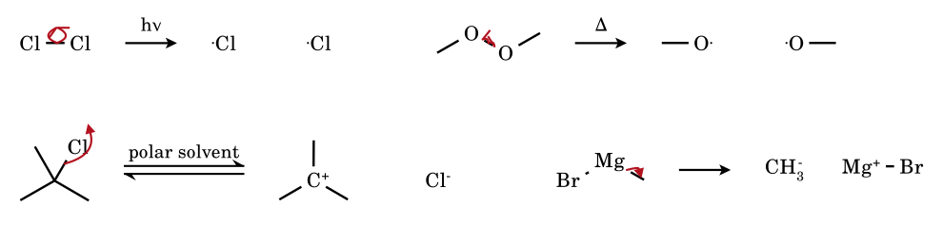
Figure 0.1 Homolysis (fishhook arrows; Cl₂ with light, a peroxide with heat) and heterolysis (full-headed arrows; an alkyl halide in a polar solvent, a C–metal bond).
- Homolysis is favoured by non-polar bonds (Cl–Cl, O–O, C–C, N=N of azo compounds), non-polar solvents or the gas phase, heat or UV light, and by radical-stabilising substituents on the fragments. Typical bond dissociation enthalpies (kcal mol⁻¹): Cl–Cl 58, Br–Br 46, I–I 36, HO–OH ≈ 51, RO–OR ≈ 38, CH₃–CH₃ 90, H–CH₃ 105, H–C(CH₃)₃ ≈ 96. Weaker bond ⇒ lower temperature needed.
- Heterolysis is favoured by polar bonds (large Δχ), polar protic solvents that solvate both ions (hydrogen bonding to the anion, dipole/lone-pair interaction with the cation), a stable cation and a stable anion, and Lewis-acid assistance. In the gas phase heterolysis costs far more energy than homolysis; the solvation energy is what makes it feasible in solution.
- Direction of heterolysis: the electron pair stays with the more electronegative atom / the better leaving group (R–X → R⁺ + X⁻; R–MgBr → R⁻ + MgBr⁺ with carbon taking the pair because C is more electronegative than Mg).
- Typical initiators of homolysis: peroxides (benzoyl peroxide, di-tert-butyl peroxide), azobisisobutyronitrile (AIBN, loses N₂ at 60–80 °C), halogens with light, N-bromosuccinimide with light/peroxide.

0.2 The reaction intermediates at a glance
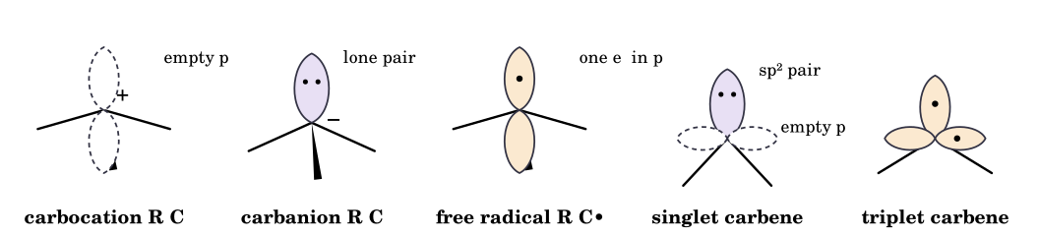
Figure 0.2 Orbital cartoons of the intermediates treated in this book (R = substituent). Solid lobes = occupied; dashed lobes = empty.
Intermediate | Valence e⁻ at the centre | Shape / hybridisation | Typical generation | Characteristic fate
Carbocation (carbenium) | 6 (sextet) | planar, sp²; linear sp for vinyl, acylium | heterolysis of R–X, ROH₂⁺; H⁺ + alkene; diazonium N₂ loss | nucleophile capture, E1 (−H⁺), rearrangement, addition to π bonds
Carbanion | 8 (3 bonds + lone pair) | pyramidal sp³ (alkyl); planar when delocalised; sp (acetylide) | deprotonation; metal–halogen exchange; decarboxylation; Grignard/organolithium C–M | protonation, SN2, addition to C=O, E1cB, elimination
Free radical | 7 | planar (or shallow pyramid), sp²; SOMO is a p orbital | homolysis (heat/light/initiator); single-electron transfer | chain propagation (abstraction/addition), recombination, disproportionation
Carbene | 6 (2 bonds + 2 nonbonding e⁻) | singlet: bent sp², pair + empty p; triplet: bent/linear, two unpaired e⁻ | α-elimination (CHCl₃/KOH); diazo or diazirine loss of N₂; carbenoid (Zn/Cu, CH₂I₂) | cyclopropanation, C–H insertion, ylide formation, Wolff rearrangement
Nitrene | 6 (1 bond + 2 lone-pair-type e⁻ sets) | R–N: singlet or triplet (triplet usually ground state) | azide photolysis/pyrolysis; α-elimination from N-haloamides (concerted in Hofmann/Curtius) | insertion, aziridination, rearrangement, dimerisation
Benzyne (aryne) | ring C with in-plane 'third' bond | strained, planar; extra bond from sp² overlap in plane | ArX + NaNH₂/KNH₂; anthranilic acid + RONO; 2-(Me₃Si)C₆H₄OTf + F⁻ | nucleophilic addition, Diels–Alder, [2+2]
Radical ion | odd electron + charge | delocalised SOMO in π* (anion) or π (cation) | Na/NH₃ (Birch), Na + ketone/ nitrile, electrolysis, photo-induced ET | protonation, dimerisation, fragmentation, further e⁻ transfer

0.3 Electrophiles and nucleophiles (definitions)
A nucleophile is a species that donates an electron pair to form a new bond to an electron-poor atom (Lewis base character in a bond-forming step). An electrophile is a species that accepts an electron pair to form a new bond (Lewis acid character). In curved-arrow language, the arrow always leaves a nucleophile and arrives at an electrophile. Basicity and acidity refer to proton transfer (equilibrium); nucleophilicity and electrophilicity refer to bond formation to atoms other than H (rate). Only the definitions and classification are treated here; no ranking of nucleophilicity is attempted.
Class | Nucleophiles | Electrophiles
Anions | HO⁻, RO⁻, X⁻, CN⁻, RS⁻, N₃⁻, R⁻ (carbanions, enolates), H⁻ (hydride donors) | —
Neutral with lone pair | H₂O, ROH, NH₃, RNH₂, R₃N, R₂S, R₃P, ROR | —
π systems | alkenes, alkynes, arenes, enols/enol ethers/enamines (C-nucleophiles) | C=C bearing EWG (Michael acceptors), C≡C–EWG, arenes with NO₂ (SNAr)
σ bonds | C–M (M = Li, Mg, Zn), B–H, Al–H, Si–C (allyl-/aryl-silanes) | polarised C–X (X = halogen, OTs) – carbon is electrophilic
Cations | — | H⁺, R⁺, ArN₂⁺, NO₂⁺, NO⁺, X⁺ (from X₂), Hg²⁺, Ag⁺, acylium RCO⁺, iminium, oxocarbenium
Neutral, electron-deficient | — | BF₃, AlCl₃, SO₃, FeBr₃, ZnCl₂ (Lewis acids); carbenes (singlet); R–C=O, C=N, C≡N carbon; CO₂; epoxides; α,β-unsaturated carbonyls
Radicals | •CR₂OH, •CH₂CH(OH)… (nucleophilic, SOMO high) | •CF₃, •CCl₃, Br•, RC(=O)O•, •CH(CO₂R)₂ (electrophilic, SOMO low)
Ambident nucleophiles (two reactive sites)
- CN⁻ (C or N), NO₂⁻ (N or O), SCN⁻ (S or N), enolates (C or O), phenoxide (O or ring C), thiourea/ thioamide (S or N). The site of attack depends on the electrophile and conditions (hard/soft, ion pairing, solvent); e.g. R–Br + KCN gives mainly R–CN, R–Br + AgCN gives mainly R–NC (isonitrile) because Ag⁺ ties up the carbon end and pushes S_{N}1-like attack through N; enolate + R–X (soft) gives C-alkylation; enolate + R₃SiCl or RCOCl (hard) favours O.
- Ambident electrophiles: α,β-unsaturated carbonyls (C=O carbon, 1,2-attack; β-carbon, 1,4-attack), allyl halides (S_{N}2 vs S_{N}2′), epoxides, aldehyde/imine carbons.
Identification routine. (1) Draw lone pairs and π bonds; (2) mark atoms with δ⁺ (attached to electronegative atoms) or an empty orbital; (3) join the most electron-rich site to the most electron-poor site; (4) check that every atom keeps a legal valence and the charges add up. Species such as carbenes are ambiphilic (singlet carbenes have a lone pair and an empty p orbital) and radicals can behave as either, according to the energy of the SOMO.

Part 1 Carbocations: Definitions, Classification, Geometry and Bonding

1.1 Definitions: carbocation, carbenium ion, carbonium ion
Carbocation is the general term for any species with a positively charged carbon atom. Two families are distinguished by the coordination number of that carbon:
- Carbenium ions (classical, tricoordinate): the positive carbon has three substituents and an empty p orbital, e.g. CH₃⁺, (CH₃)₃C⁺, C₆H₅CH₂⁺. Formally they are derived from a neutral carbene or an alkane by removal of H⁻. These are the ions of ordinary organic mechanisms (S_{N}1, E1, electrophilic addition).
- Carbonium ions (non-classical, hypercoordinate): the positive carbon is five- (or higher) coordinate through a three-centre two-electron (3c–2e) bond, e.g. CH₅⁺, C₂H₇⁺; formally derived by protonation (or alkylation) of an alkane σ bond. The 2-norbornyl cation is a bridged (σ-delocalised) species of this bonding type.
- The older usage ‘carbonium ion’ for every carbocation (including t-Bu⁺) is obsolete; the two names must not be interchanged. In this book ‘carbocation’ is the generic term, ‘carbenium’ is used when precision is needed, and ‘carbonium’ always means a hypercoordinate (3c–2e) ion.
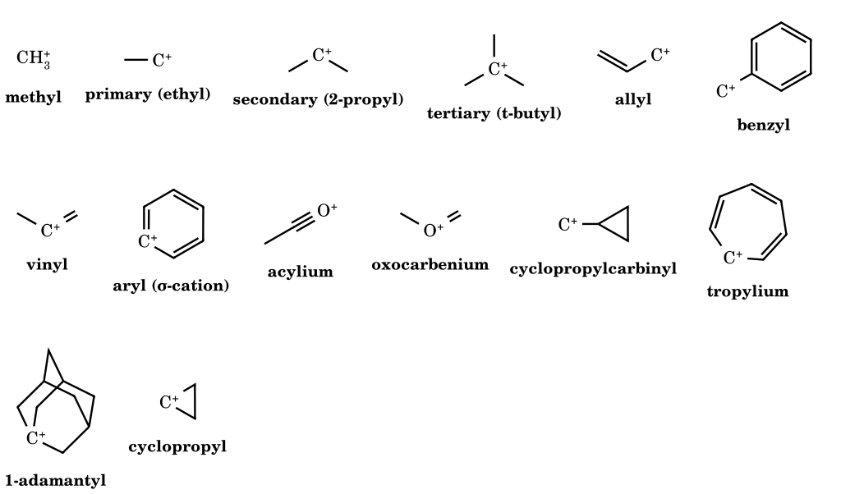
Figure 1.1 Gallery of carbocation types. The skeletal convention is used: hydrogens on carbon are not drawn; a symbol ‘C⁺’ is a cationic carbon with its implicit hydrogens (e.g. ‘C⁺’ in the ethyl cation is CH₂⁺).

1.2 Geometry, hybridisation and the empty p orbital
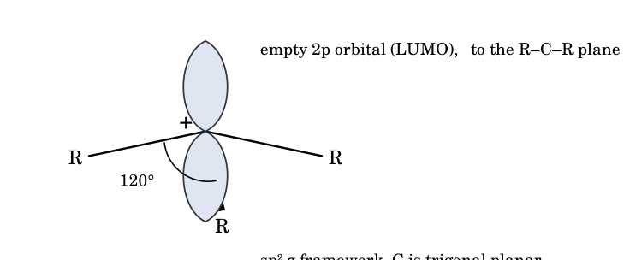
Figure 1.2 A carbenium ion: trigonal-planar σ framework (sp²), empty 2p orbital perpendicular to the plane.
- Planarity. The three σ bonds use sp² hybrids (120°); the remaining p orbital is empty and is the LUMO. Planarity places the empty orbital in a position to be attacked from either face – the basis of racemisation in S_{N}1.
- Bond lengths. C⁺–C bonds are shorter than normal C(sp³)–C(sp³) bonds because of greater s character and hyperconjugative double-bond character.
- Linear cations. Vinyl (R–C⁺=CR₂) and acylium (R–C≡O⁺) cations have an sp carbon (180°); the vinyl cation's empty p orbital lies in the plane of the double bond, orthogonal to the π bond, so the π system cannot stabilise it by resonance. The phenyl (aryl) cation has its empty orbital in the plane of the ring, orthogonal to the aromatic π system – hence it is exceptionally unstable.
- Pyramidalisation is penalised. If the carbon is forced out of planarity (bridgehead of a small bicycle), overlap with substituent σ orbitals is poor and the p character is lost: 1-norbornyl (bicyclo[2.2.1]hept-1-yl) cations are very hard to form, whereas the larger, more flexible 1-adamantyl and bicyclo[2.2.2]oct-1-yl ions form far more easily.
- Electrophilicity. The empty orbital makes a carbocation a strong electrophile and Lewis acid: gas-phase hydride affinities (recalled, kcal mol⁻¹, approximate): CH₃⁺ ≈ 312, i-Pr⁺ ≈ 249, t-Bu⁺ ≈ 231, benzyl ≈ 238, allyl ≈ 256 – the smaller the hydride affinity, the more stable the cation relative to its hydrocarbon. In solution Mayr's E parameter ranks benzhydrylium ions from E ≈ −7 (strongly donor-substituted) to E ≈ +6 (Ph₂CH⁺).

1.3 Orbital overlap requirements and delocalisation of charge
A cation is stabilised to the extent that electron density from neighbouring orbitals can flow into its empty p orbital. Three kinds of donor exist and each has a geometric requirement: (i) lone pairs (n → p) on an attached heteroatom (OR, NR₂, SR, halogen): the lone-pair orbital must be parallel to the empty p orbital; (ii) π bonds (π → p) in an allyl, benzyl or vinyl system: the π orbitals must be parallel (coplanar σ frameworks); (iii) σ bonds (σ_{C–H}, σ_{C–C} → p) – hyperconjugation: the donor σ bond must be close to parallel to the empty p orbital, i.e. roughly perpendicular to the plane of the cation (dihedral angle near 0°; at 90° the overlap is zero).
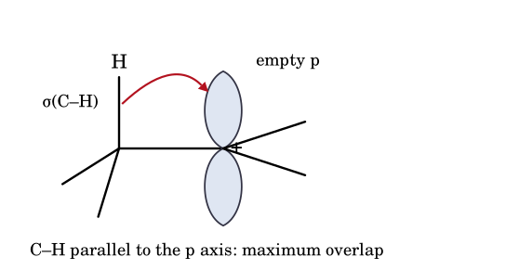
Figure 1.3 Hyperconjugation: the neighbouring σ(C–H) bond donates into the empty p orbital when the two are parallel.
Localised versus delocalised charge. In t-Bu⁺ the charge is formally on one carbon but is shared with nine hydrogens by hyperconjugation; in allyl and benzyl cations resonance places partial positive charge on two or more carbons (shown with double-headed arrows between contributors, never with reaction arrows); in σ-bridged non-classical ions (2-norbornyl, cyclopropylcarbinyl, phenonium) the charge is spread over three or more carbons through partial bonds and no single Lewis structure is adequate. Resonance contributors differ only in electron positions; the nuclei do not move. If atoms move, the species are different (isomers, rapidly equilibrating or bridged).

1.4 Hypercoordinate (carbonium) ions
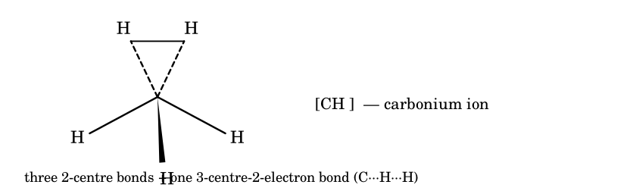
Figure 1.4 CH₅⁺: three ordinary C–H bonds and a three-centre two-electron C···H₂ unit (H₂ bound side-on to a CH₃⁺ fragment).
Protonation of methane in a superacid or in a mass spectrometer ion source forms CH₅⁺. High-level calculations and gas-phase infrared spectra show a structure with a CH₃⁺ unit and a bound H₂, but with extremely facile exchange of all five hydrogens: it is a fluxional, hypercoordinate species with only eight valence electrons for five bonds. A carbonium ion is therefore not simply a ‘more substituted’ or ‘more stable’ carbenium ion; its 3c–2e bonding is a different bonding type. Their stability cannot be placed on the same 3° > 2° > 1° scale. Their usual fate is loss of H₂ (giving a carbenium ion; Part 2.E6), loss of a hydrocarbon fragment, or rapid proton scrambling.

1.5 Ion pairs, solvent and counterion
Ionisation passes through contact (intimate) ion pairs R⁺X⁻, then solvent-separated ion pairs R⁺‖X⁻, then free ions (Winstein). Nucleophile capture from the contact pair is stereo-selective (the counterion shields one face), from the solvent-separated pair largely statistical. The solvent ionises the substrate by (a) hydrogen bonding to the leaving group (protic solvents, TFE, HFIP are best) and (b) a high dielectric constant that screens charge; the nucleophilicity of the solvent matters much less in S_{N}1 than in S_{N}2. A non-nucleophilic, weakly coordinating counterion (SbF₆⁻, B(C₆F₅)₄⁻, carboranes, Al(OC(CF₃)₃)₄⁻) and a non-basic solvent (SO₂ClF, SO₂, CH₂Cl₂) allow even tertiary cations to be observed (Olah, 1960s onward).
Scope and honesty note. This book's definitions follow current IUPAC practice and standard physical-organic-chemistry usage. The IUPAC Gold Book, the textbooks listed in Part 17 and the archive.org page requested were not accessible in this authoring environment; where a numerical value is quoted from memory it is marked ‘recalled’ or given as an order only. See the Source Map for what was and was not consulted.

Part 2 Generation of Carbocations
Each of the following mechanisms was checked by computer: the curved arrows were applied to the drawn reactant graph and the result compared with the drawn product (valence, charge, atom conservation). Examples are grouped by generation route: 2.A alcohols, 2.B alkyl halides and sulfonates, 2.C alkenes/dienes/alkynes, 2.D solvolysis, 2.E other routes, 2.F amines with nitrous acid, 2.G aromatic compounds (arenium ions), 2.H Lewis-acid-assisted ionisation, ether cleavage and aromatic cations.

2.A Carbocations from alcohols
Alcohols do not ionise directly because HO⁻ is a poor leaving group (conjugate acid H₂O, pK_{a} ≈ 15.7). Protonation, or coordination to a Lewis acid, converts it into H₂O (pK_{a} of H₃O⁺ ≈ −1.7) and ionisation then becomes possible only if the cation is stabilised enough: tertiary, benzylic, allylic or α-heteroatom-substituted. Primary and unactivated secondary alcohols generally react by concerted routes (E2, S_{N}2, or ionisation with simultaneous 1,2-shift) and are drawn that way below. Every arrow starts at an electron pair (lone pair or bond) and ends where that pair finishes.
2.A1 tert-Butyl alcohol, dilute strong acid
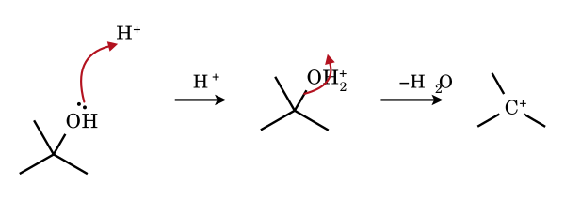
Rate-limiting loss of water from the oxonium ion gives the planar tert-butyl cation (nine hyperconjugating C–H bonds). In water the cation is captured faster than it eliminates unless the mixture is heated.
2.A2 1-Methylcyclohexanol, H₂SO₄
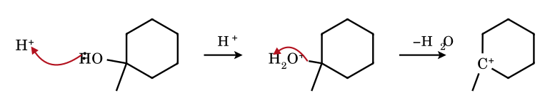
A tertiary ring cation: the cationic carbon is sp². E1 loss of H⁺ competes and gives 1-methylcyclohexene (the Zaitsev alkene) on warming.
2.A3 Triphenylmethanol, conc. H₂SO₄
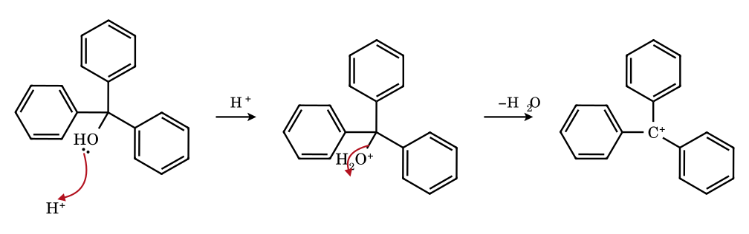
The yellow trityl cation is delocalised into three rings, which twist about 30° out of the central plane (propeller) because ortho-H···ortho-H contacts forbid full planarity. Isolable as BF₄⁻ or ClO₄⁻ salts.
2.A4 1-Phenylethanol, HBr (conc.)
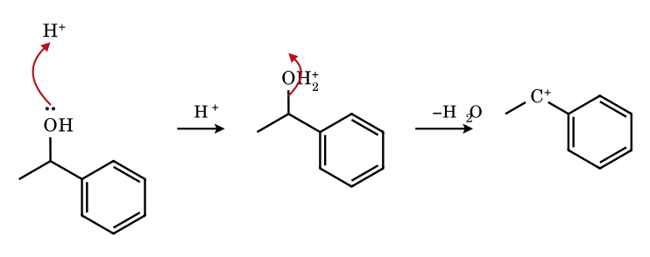
A secondary benzylic cation, stabilised by +M delocalisation into the ring (charge at o- and p-carbons). Bromide then captures it (S_{N}1).
2.A5 Prenol (3-methylbut-2-en-1-ol), H⁺
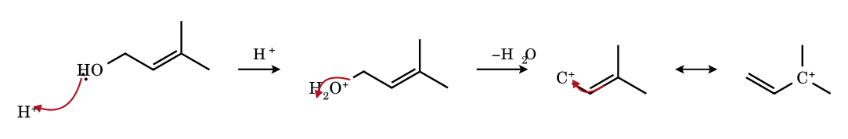
Ionisation puts the charge at C-1 (primary) and, by the double-headed resonance arrow, at C-3 (tertiary): one allyl cation, two contributors, with most of the positive charge on the tertiary terminus. Nucleophiles can attack at either end (S_{N}1 and S_{N}1′).
2.A6 Cyclohexanol, 85 % H₃PO₄, heat (E1)
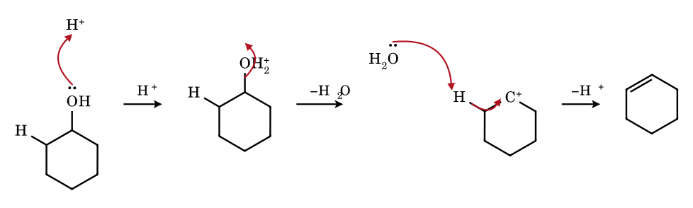
A secondary cation is formed only at elevated temperature and in poorly nucleophilic acid (H₃PO₄, HSO₄⁻). The base removes a β-H whose C–H bond overlaps the empty p orbital; the C–H pair becomes the new π bond (E1). H₃O⁺ regenerates the catalyst.
2.A7 Neopentyl alcohol, HBr, heat: ionisation with concerted CH₃ shift
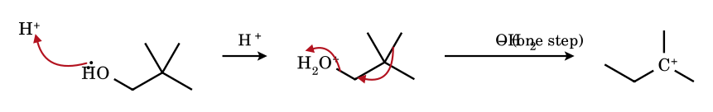
A free primary cation (CH₃)₃CCH₂⁺ is not an intermediate: the C–CH₃ σ bond anti to the departing water pushes in as the leaving group departs, so the tertiary tert-amyl cation is reached directly (anchimeric σ-assistance). The same applies to neopentyl halides and tosylates.
2.A8 3-Methylbutan-2-ol, conc. HBr
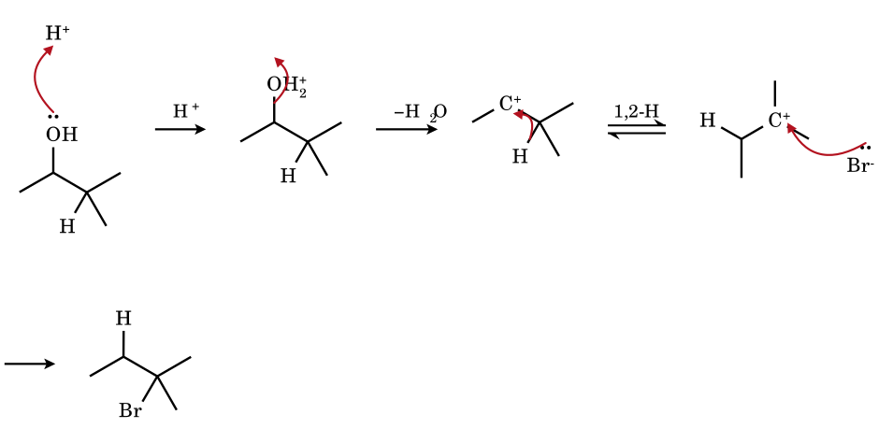
The secondary cation is formed with (or just before) the hydride shift: C–H (σ) → empty p. The tertiary cation is lower in energy and is captured by Br⁻: the major product is 2-bromo-2-methylbutane, not 2-bromo-3-methylbutane.
2.A9 Cyclopentylmethanol, H⁺: ionisation with ring expansion
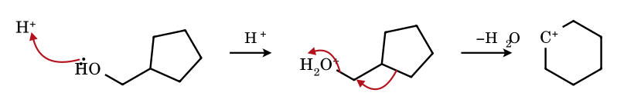
The ring C–C bond migrates to the departing CH₂ as water leaves, so the ring grows from five to six atoms and a secondary cation results; no primary cation intervenes. Ring strain relief is small (cyclopentane → cyclohexane) – the driving force is mainly 1° → 2°.
2.A10 1-Adamantanol, H₂SO₄ (bridgehead cation)
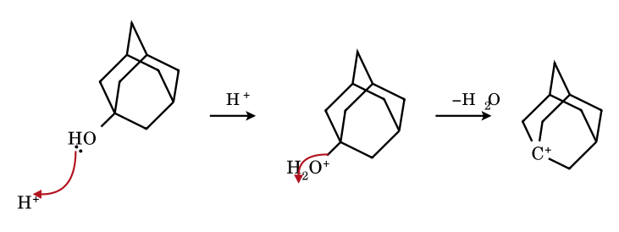
The 1-adamantyl cation is a tertiary bridgehead cation that forms readily: the cage is rigid, strain-free in the cation and the three C–C bonds at C-1 are held in good overlap with the empty orbital (σ_{C–C} hyperconjugation). Contrast with bicyclo[2.2.1]hept-1-yl, where bridgehead cations are strongly disfavoured.
2.A11 Dicyclopropylmethanol, H⁺
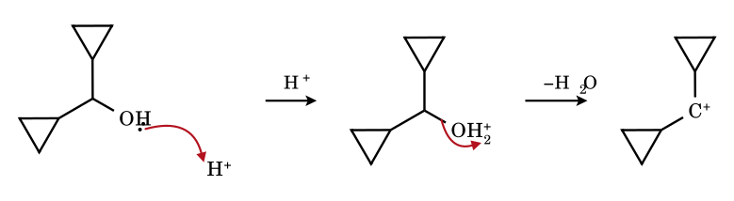
Each cyclopropyl ring donates its bent (Walsh-type) C–C σ bonds into the empty p orbital, which must lie in the bisected geometry. Dicyclopropylcarbinyl cations are far more stable than isopropyl- or even benzyl-type cations of the same substitution (see 5.5).
2.A12 Pinacol, 2,3-dimethylbutane-2,3-diol, H₂SO₄ (first step of the pinacol rearrangement)
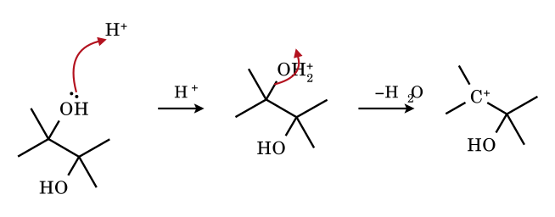
The β-hydroxy tertiary cation is formed; its OH group is only inductively withdrawing and cannot stabilise it by resonance. A 1,2-methyl shift (Part 7) converts it into the oxygen-stabilised cation, which is the driving force.
2.A13 tert-Butyl alcohol, ZnCl₂/HCl (Lucas reagent), Lewis-acid ionisation
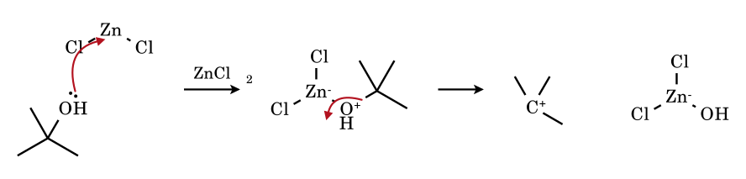
Zn(II) binds the oxygen lone pair; the C–O bond then ionises to the cation and the zincate [HOZnCl₂]⁻. Tertiary alcohols give turbidity in seconds, secondary in minutes, primary not at all – the Lucas test is an S_{N}1 test.

2.B Carbocations from alkyl halides and sulfonates (ionisation)
Heterolysis of a C–X bond gives R⁺ X⁻; in solution the first species is an ion pair (contact, then solvent-separated) and only later free ions. Ionisation is helped by (i) a good leaving group (I⁻ ≈ Br⁻ > Cl⁻ ≫ F⁻; sulfonates better still), (ii) a strongly ionising, hydrogen-bond-donating solvent, (iii) a halophilic Lewis acid (Ag⁺, AlCl₃, SbF₅) and (iv) a cation stabilised by hyperconjugation, resonance or neighbouring-group bridging. Each example below is checked atom-by-atom: arrows start at the electron pair that moves and end where it comes to rest.
2.B1 tert-Butyl chloride in water/ethanol: ion pair
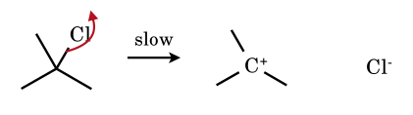
The rate-determining step: the σ(C–Cl) pair leaves with chlorine. In a solvent of high dielectric constant and H-bond donor ability (water, TFE, HCO₂H) the ion pair is stabilised and ionisation is faster by roughly five orders of magnitude than in ethanol (the Grunwald–Winstein Y scale is defined on exactly this substrate).
2.B2 tert-Butyl bromide + AgNO₃ (Ag⁺ assistance)
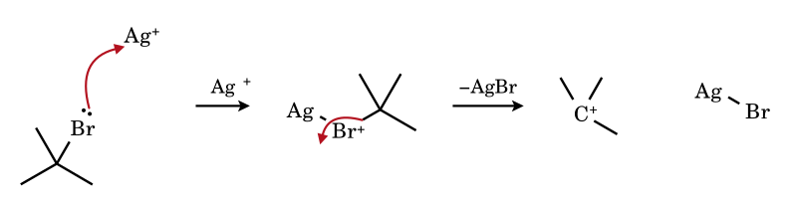
Ag⁺ accepts a bromine lone pair (σ-complex), so the leaving group is effectively AgBr, which precipitates. This is why silver ion makes even primary neopentyl and secondary halides ionise – and rearrange.
2.B3 Trityl chloride in liquid SO₂
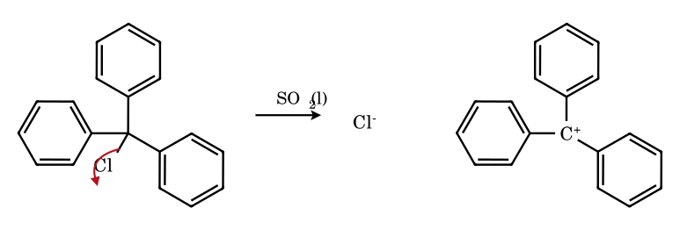
Ph₃CCl is a covalent solid but ionises in SO₂ (conducting yellow solution). The cation is stabilised by three aryl groups; compare Ph₂CHCl (ionises in the same solvents much more slowly) and PhCH₂Cl (barely).
2.B4 3-Chloro-3-methylbut-1-ene ⇌ prenyl chloride: ion pair and allylic transposition
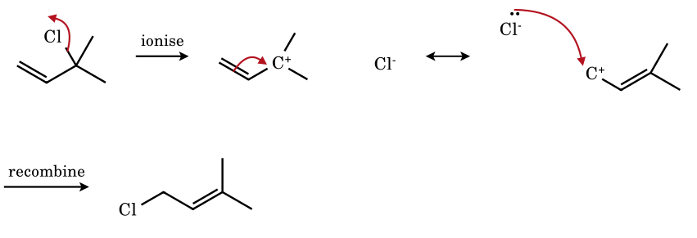
The same allyl cation is formed from either isomer. Chloride (kept nearby as an ion pair) returns to the less hindered primary terminus, giving the more substituted, thermodynamically more stable alkene (1,3-shift, S_{N}i′ / S_{N}1′).
2.B5 1-Bromoadamantane in 80 % aqueous ethanol (bridgehead S_{N}1)
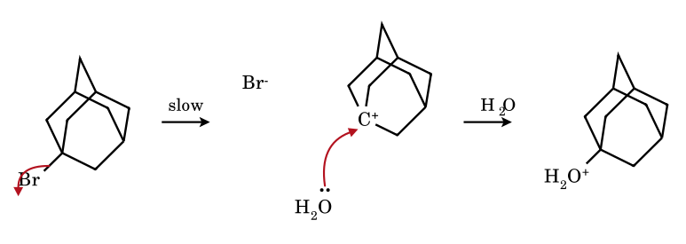
S_{N}2 is impossible at a bridgehead (no backside access) yet 1-adamantyl bromide solvolyses readily, because the adamantyl cage is nearly strain-free in the planar-ish cation. 1-Bromobicyclo[2.2.1]heptane, in contrast, is essentially inert (see 5.11).
2.B6 tert-Butyl chloride + SbF₅ in SO₂ClF, −78 °C (Olah)
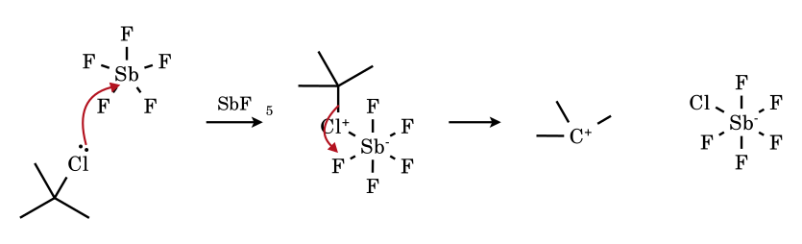
With a very strong halide acceptor and a non-nucleophilic medium the ion pair persists indefinitely: (CH₃)₃C⁺ SbF₅Cl⁻ was observed by NMR (a single ¹H signal, the nine hydrogens equivalent by rapid methyl rotation), proving that a tertiary alkyl cation can be a real, long-lived species.
2.B7 Neopentyl bromide + AgNO₃ (concerted ionisation–methyl shift)
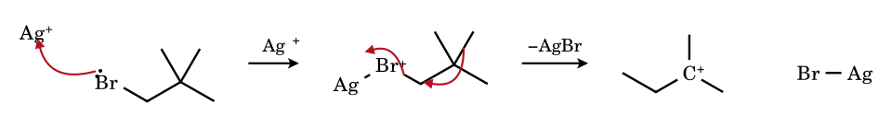
Neopentyl halides cannot undergo S_{N}2 (β-branching blocks backside attack) nor form a primary cation: when ionisation is forced, the anti-periplanar C–CH₃ bond migrates as bromide leaves.
2.B8 Cyclopropyl bromide + Ag⁺: ionisation with disrotatory ring opening
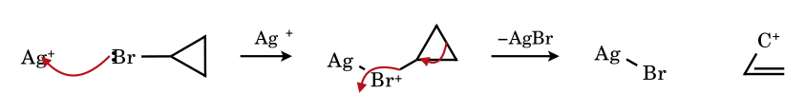
A cyclopropyl cation (sp² carbon in a 60° ring) is so strained that it is never formed as such: the C–C bond opposite the leaving group opens as the halide departs, giving the allyl cation (disrotatory, Woodward–Hoffmann, 2π electrons). Cyclopropyl halides solvolyse far more slowly than comparable secondary halides, and only with the assistance of the ring-opening.
2.B9 Chloromethyl methyl ether (MOM-Cl)
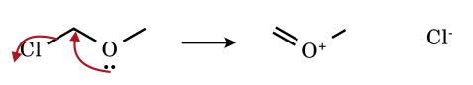
An α-heteroatom lone pair pushes out the halide: the 'carbocation' is really an oxocarbenium ion CH₂=O⁺CH₃ in which every atom has an octet. α-Chloroethers ionise many orders of magnitude faster than simple alkyl chlorides of the same substitution.
2.B10 Sulfur mustard, ClCH₂CH₂SCH₂CH₂Cl: neighbouring-group participation
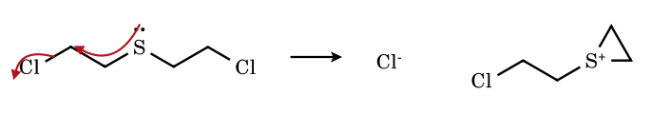
The β-sulfur displaces chloride intramolecularly (anchimeric assistance) to give a cyclic episulfonium (thiiranium) ion – a bridged cation in which charge sits mainly on sulfur and no open primary cation exists. It is a potent alkylating agent.
2.B11 trans-2-Bromocyclohexyl acetate: acetoxonium ion
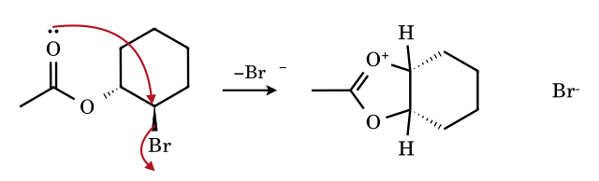
Only the trans (diaxial-capable) isomer reacts fast: the carbonyl oxygen attacks C-2 from the side opposite to Br, giving a 1,3-dioxolan-2-ylium (acetoxonium) ion; positive charge is shared by both oxygens and the carbon. Opening by a nucleophile at C-2 gives net retention (two inversions).
2.B12 tert-Butyl chloride + AlCl₃ (Friedel–Crafts alkylation)
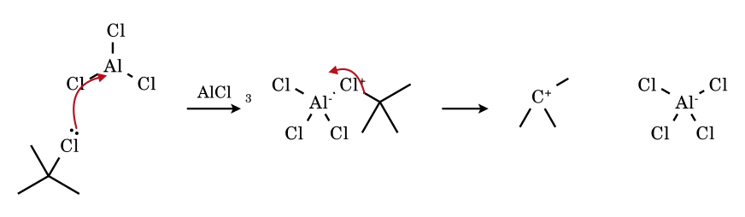
AlCl₃ abstracts chloride to give t-Bu⁺ AlCl₄⁻. With primary halides the complex R–Cl→AlCl₃ is itself the electrophile and may rearrange (see 2.E4).
2.B13 1-(4-Methoxyphenyl)vinyl triflate in CF₃CH₂OH: vinyl cation
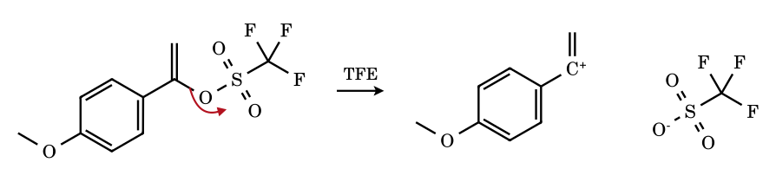
Vinyl (alkenyl) cations are real, linear sp-hybridised species but are high in energy; they form only from excellent leaving groups (triflate) and require stabilisation by an α-aryl (here a p-anisyl +M donor) or an α-alkyl group. The empty p orbital lies in the plane of the alkene, orthogonal to the π system.

2.C Carbocations from alkenes, dienes and alkynes (electrophilic addition)
A π bond is a nucleophile. Its electron pair attacks the electrophile (H⁺, a carbocation, X⁺, Hg²⁺) and forms a σ bond to one carbon; the other carbon is left electron-deficient. The proton adds so that the more stable cation (Markovnikov) is produced, and the arrow always runs from the π bond to the electrophile. When the electrophile has a lone pair that can reach back (Br, S, Hg), a bridged onium ion – not an open carbocation – is the intermediate, which is why no rearrangement and anti stereochemistry result.
2.C1 Propene + HBr
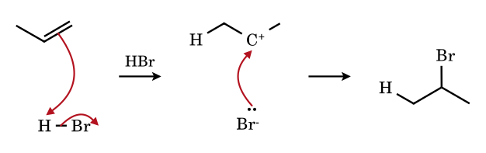
Protonation at C-3 puts the cation on the secondary C-2 (Markovnikov). The rate-limiting step is H⁺ transfer from HBr to the alkene.
2.C2 2-Methylpropene + H₃O⁺ (acid hydration)
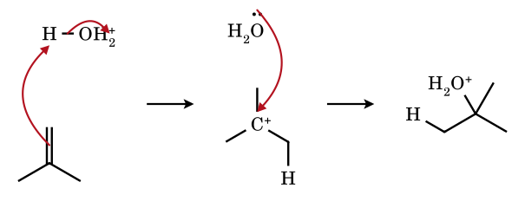
Only the tertiary cation is formed (the primary isobutyl cation would be ≈ 15 kcal/mol higher in energy). Capture by water and loss of H⁺ gives tert-butyl alcohol; hydration is reversible (E1 reverse).
2.C3 1-Methylcyclohexene + HCl
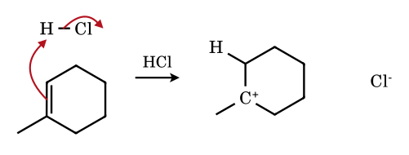
The proton adds to the less substituted alkene carbon, giving the tertiary ring cation. Capture by chloride from the open face, from either side, gives 1-chloro-1-methylcyclohexane (no stereocentre is created).
2.C4 Styrene + HBr
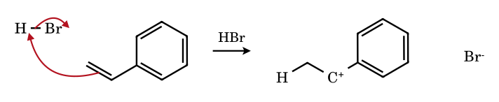
H⁺ adds to the terminal CH₂ so that the cation is benzylic. The rate of addition to ring-substituted styrenes follows σ⁺ (ρ ≈ −3): a +M group in the para position speeds up the reaction.
2.C5 3,3-Dimethylbut-1-ene + HCl: addition with rearrangement
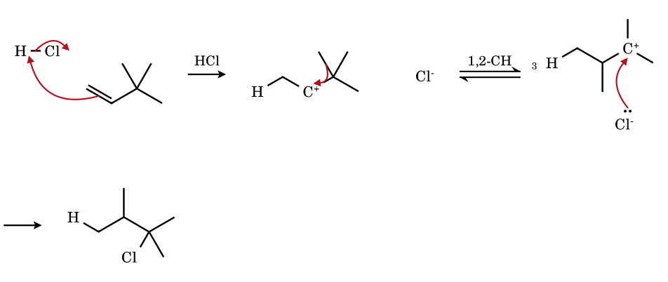
The secondary cation (neopentyl-type, with an adjacent quaternary carbon) is trapped in part by Cl⁻ (2-chloro-3,3-dimethylbutane, minor) but mostly undergoes a methyl shift to the tertiary cation: 2-chloro-2,3-dimethylbutane is the major product. A classic proof that alkene hydrohalogenation involves a cation.
2.C6 Cyclohexene + Br₂: bromonium ion
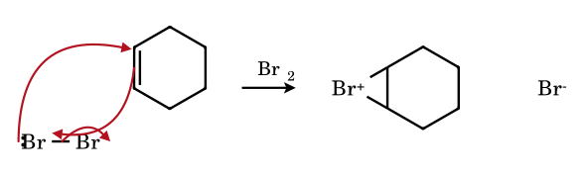
A bromine lone pair closes onto the carbon that lost the π electrons: the intermediate is a three-membered bromonium ion, not an open carbocation. Bromide then opens it from the face opposite to the ring (anti addition, trans-1,2-dibromocyclohexane).
2.C7 Propene + Hg(OAc)⁺ (oxymercuration)
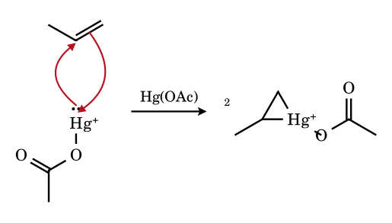
The mercurinium ion is bridged and delocalised; the nucleophile (H₂O) attacks the more substituted carbon (greater positive charge) with anti stereochemistry and, because no free cation forms, without rearrangement. NaBH₄ then replaces Hg by H.
2.C8 Buta-1,3-diene + HBr: allylic cation
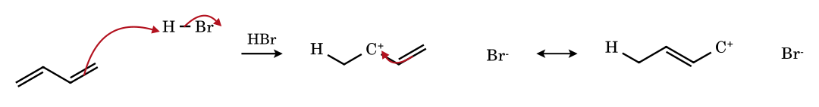
Protonation at the terminal carbon is preferred because the resulting cation is allylic (two contributors). Br⁻ can attack C-2 (1,2-adduct, formed faster at 0 °C – kinetic) or C-4 (1,4-adduct, more stable – thermodynamic); see Part 9.
2.C9 Vinylcyclopropane + H⁺
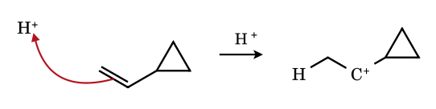
A cyclopropylcarbinyl cation results, strongly stabilised by the neighbouring C–C σ bonds of the ring (bisected conformation, Part 5.5): vinylcyclopropanes protonate faster than simple 1,1-disubstituted alkenes.
2.C10 Cyclohexene + MeSCl: thiiranium ion
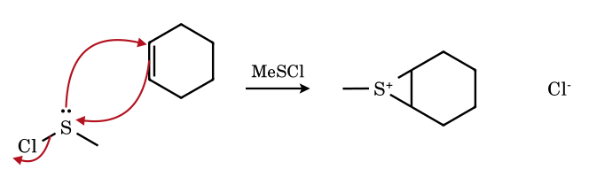
Sulfur's lone pair bridges the two carbons exactly as bromine does. Episulfonium ions give anti-addition products and can open at either carbon (Markovnikov or anti-Markovnikov, depending on substitution and solvent).
2.C11 Propyne + HBr: vinyl cation
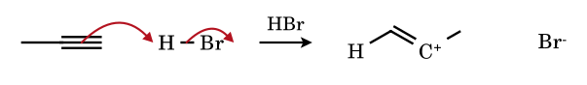
A secondary vinyl cation (linear, empty p in the alkene plane) is much less stable than a secondary alkyl cation, so alkynes are protonated more slowly than alkenes; with HX the addition is often termolecular (AdE3), avoiding a free vinyl cation.
2.C12 Acetone + H⁺: oxocarbenium (protonated carbonyl)
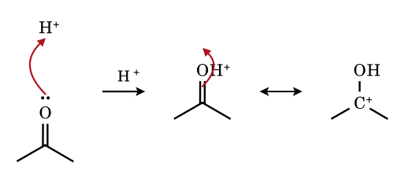
A protonated carbonyl is a hydroxy-carbenium ion – a tertiary cation stabilised by the +M effect of OH. Resonance structure (right) shows why the carbon becomes electrophilic; acid-catalysed additions to C=O all start here.
2.C13 2-Methylpropene + t-Bu⁺: C–C bond formation (cationic dimerisation)
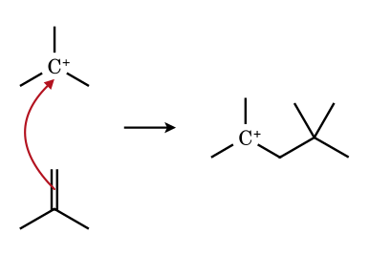
A carbocation is itself an electrophile for alkenes. The new tertiary cation can lose H⁺ to give the diisobutylene isomers (2,4,4-trimethylpent-1-ene and -2-ene) or add a further isobutene (oligomerisation, polyisobutylene).

2.D Solvolysis and S_{N}1 substitution
In solvolysis the solvent is both the ionising medium and the nucleophile. The kinetics are first order in substrate (rate = k[RX], independent of added nucleophile), and the stereochemical and product evidence is the fingerprint of a cationic intermediate: partial racemisation, rearranged skeletons, mixtures of S_{N}1 and E1 products, common-ion rate depression and σ⁺ correlations. A rate law alone cannot prove a free cation: ion pairs and neighbouring groups often intervene, so the rate and the product-forming steps must be distinguished.
2.D1 tert-Butyl bromide in water: the full S_{N}1 sequence
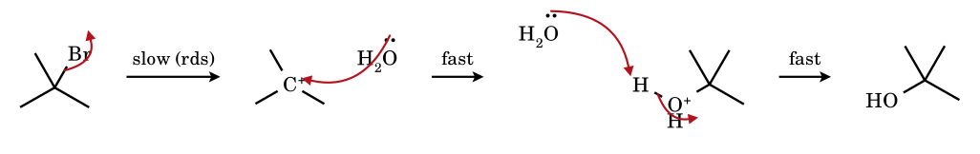
Rate = k[t-BuBr]. The cation is captured by the solvent (rate of capture ≫ rate of formation, so capture is not kinetically visible) and a second water removes H⁺. Competing E1 gives 2-methylpropene (≈ 10 % in water, more in ethanol or at higher temperature).
2.D2 Stereochemistry: (S)-1-phenylethyl chloride in aqueous acetone
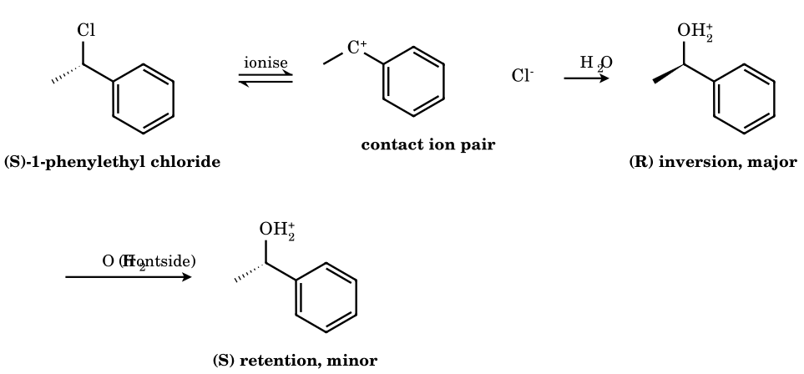
The planar cation can be attacked from either face, so racemisation is expected; observation gives partial racemisation with net inversion. The leaving chloride, still sitting on the front face in the contact ion pair, shields that face; the solvent attacks preferentially from the back. Free (solvent-separated) cations would give 50:50. The ratio is an experimental number, not a prediction.
2.D3 2-Bromo-2-methylbutane in ethanol: S_{N}1 and E1 from the same cation
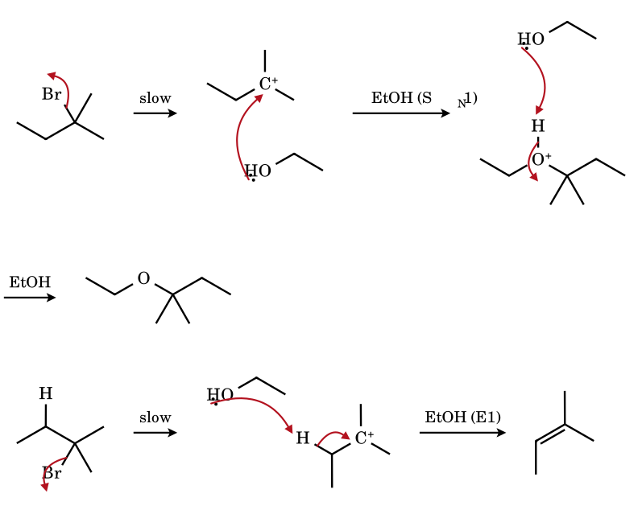
One cation, two destinations: nucleophilic capture at carbon (ether) or loss of a β-hydrogen (alkene). Higher temperature favours E1 (greater entropy gain). The more substituted alkene (2-methylbut-2-ene) dominates; the C–H bond that is lost must overlap the empty p orbital.
2.D4 Neopentyl tosylate in formic acid (formolysis): S_{N}1 with rearrangement
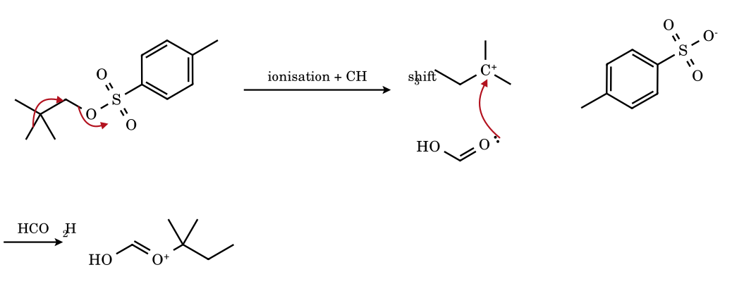
The only substitution product is tert-amyl formate (2-methylbut-2-yl formate); no neopentyl formate. A neopentyl system cannot do S_{N}2, so the ionising solvent pushes it through the σ-assisted pathway. The mixture also gives 2-methylbut-2-ene (E1).
2.D5 4-Methoxybenzyl chloride in water: why +M groups accelerate S_{N}1
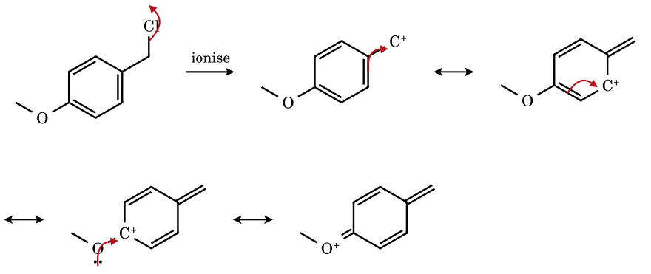
Ionisation puts + on the benzylic CH₂; three successive π-shifts carry it to C-4, where the OMe lone pair completes the octet: a p-quinone-methide oxocarbenium ion. The methoxy group lowers the barrier by tens of kJ mol⁻¹ relative to H (σ⁺_{p-OMe} = −0.78).
2.D6 2-Chloro-2-phenylpropane (cumyl chloride) in 90 % aqueous acetone
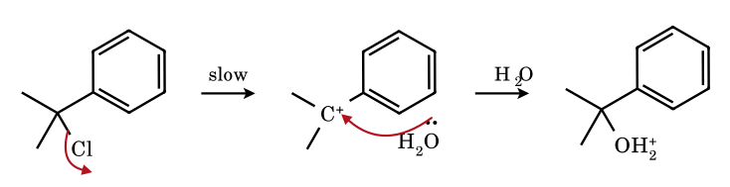
The tertiary benzylic cation is the standard system used to define σ⁺ substituent constants (Brown–Okamoto, ρ ≈ −4.5): the very large negative ρ shows that substantial positive charge is delocalised into the ring in the transition state.
2.D7 Prenyl chloride in water: S_{N}1 and S_{N}1′ products from one allyl cation
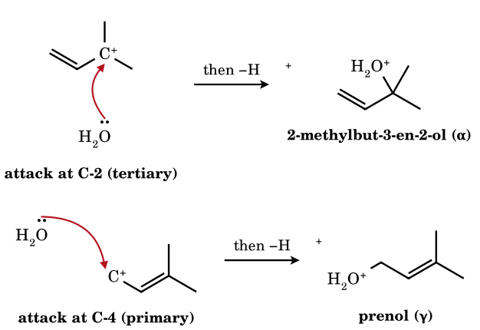
The delocalised cation is attacked at either terminus, and both isomeric chlorides give the same two alcohols. Under kinetic control the tertiary alcohol is the major product (most of the positive charge resides on the tertiary carbon); prenol, which has the more substituted alkene, accumulates only if the tertiary alcohol can re-ionise (acidic, longer reaction times) – kinetic versus thermodynamic control (Part 9).
2.D8 2-Chlorotetrahydropyran: α-oxygen stabilisation
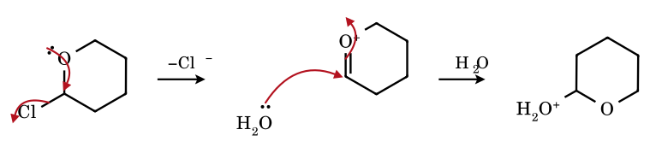
Glycosyl-type α-halo ethers ionise with ring-oxygen assistance (the axial lone pair overlaps σ*_{C–Cl}, the anomeric effect in action). The cyclic oxocarbenium ion is attacked from either face: this is the basis of glycoside synthesis (Koenigs–Knorr, with Ag⁺ activation).

2.E Other routes: diazonium ions, Lewis acids, hydride abstraction, acid-mediated ionisations
Some cations are produced neither from an alcohol/halide nor from an alkene. The common feature is a very good leaving group (N₂, H₂, H₂O, ROH) or a very strong electrophile (H⁺ in superacid, Ph₃C⁺, AlCl₃). Radical and concerted pathways are not counted here: e.g. the Hofmann–Löffler or Kolbe reactions are radical, and Tiffeneau–Demjanov, Curtius and Hofmann reactions proceed with migration concerted with loss of N₂ (no free cation).
2.E1 n-Propylamine + HNO₂ (via n-propyldiazonium)
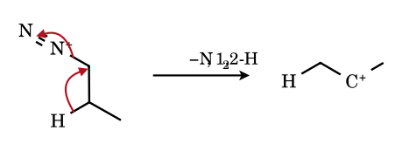
Alkyldiazonium ions are the most reactive leaving-group systems known (N₂, a thermodynamically very stable molecule). Even a primary one gives a mixture in which the 2-propyl derivatives (2-propanol, 2-chloropropane) outweigh the 1-propyl ones, together with propene, because the departing N₂ is pushed out by a neighbouring migrating H or alkyl group. The result is a classic reason why nitrous acid deamination of primary amines is synthetically useless.
2.E2 Benzenediazonium ion in hot water: aryl cation
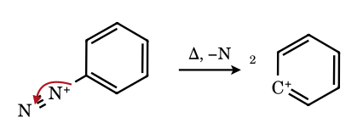
The aryl cation has its empty orbital in the plane of the ring (an sp² σ orbital orthogonal to the π system), so it gets no resonance help and is among the least stable carbocations; it is formed only because N₂ is such a good leaving group. It reacts with the nearest nucleophile (H₂O → phenol), even F⁻ in the Balz–Schiemann reaction.
2.E3 n-Propyl chloride + AlCl₃: 1,2-hydride shift during ionisation
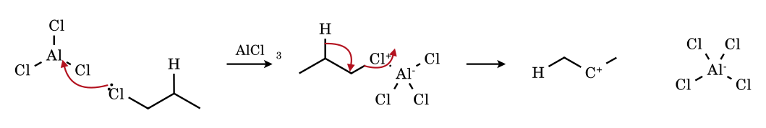
The polarised complex R–Cl→AlCl₃ transfers a hydride to the carbon that is losing Cl⁻: isopropyl cation (as an ion pair with AlCl₄⁻). This is why benzene + n-propyl chloride/AlCl₃ gives cumene, not n-propylbenzene.
2.E4 Acetyl chloride + AlCl₃: acylium ion
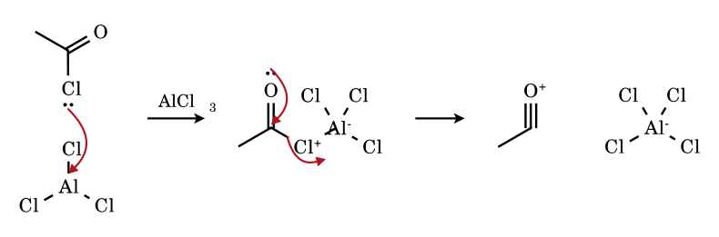
The oxygen lone pair drives out chloride and forms a third C–O bond; every atom in CH₃–C≡O⁺ has an octet. Acylium ions are linear (sp-hybridised C) and do not rearrange, so Friedel–Crafts acylation gives unrearranged ketones; the ketone product deactivates the ring, which is why acylation (unlike alkylation) stops at one substitution.
2.E5 Hydride abstraction: cycloheptatriene + Ph₃C⁺ BF₄⁻
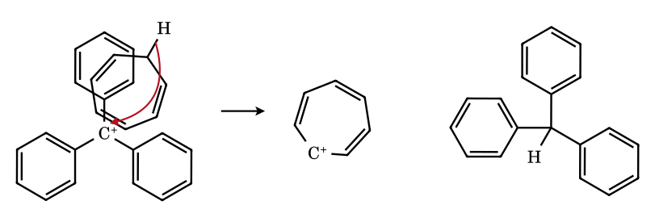
The C–H σ pair of the sp³ CH₂ transfers as H⁻ to the trityl cation (an equilibrium that lies far to the right because the product is the aromatic 6π tropylium ion, pK_{R+} ≈ +4.7, against −6.6 for trityl). The seven-membered ring is planar, all seven C–C bonds are equal, and the positive charge is shared equally.
2.E6 Isobutane in FSO₃H·SbF₅ (magic acid): σ-protonation then loss of H₂
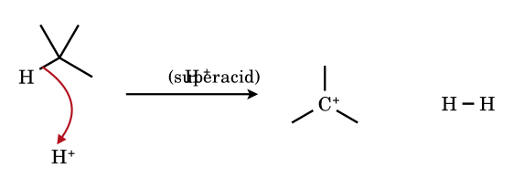
A C–H σ bond is a very weak nucleophile, but the proton of a superacid attacks it, forming a three-centre two-electron bond (a carbonium ion, R₃C(H₂)⁺, see 1.4). Loss of H₂ leaves the carbenium ion. This is the basis of H/D exchange of alkanes in superacid and of alkane isomerisation (Olah).
2.E7 Acid hydrolysis of acetaldehyde dimethyl acetal
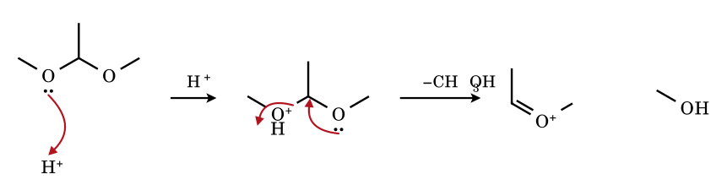
Protonation of one OMe turns it into a good leaving group (CH₃OH); the lone pair of the other oxygen pushes it out. The oxocarbenium ion is the intermediate that water attacks in the rate-limiting or following step: acetals are stable to base but labile to dilute acid.
2.E8 Acid-catalysed opening of 2,2-dimethyloxirane
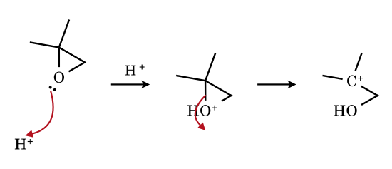
Protonation makes the oxirane a good electrophile; the C–O bond to the more substituted carbon is longer and weaker and breaks first, so the nucleophile (H₂O, ROH, X⁻) ends up on the tertiary carbon (contrast base-promoted opening, S_{N}2 at the less hindered CH₂). The true transition state is a loose S_{N}2 with S_{N}1 character (‘borderline’); a full tertiary cation is shown to indicate the charge distribution.
2.E9 2,4,6-Trimethylbenzoic acid in conc. H₂SO₄: A_{AC}1 acylium
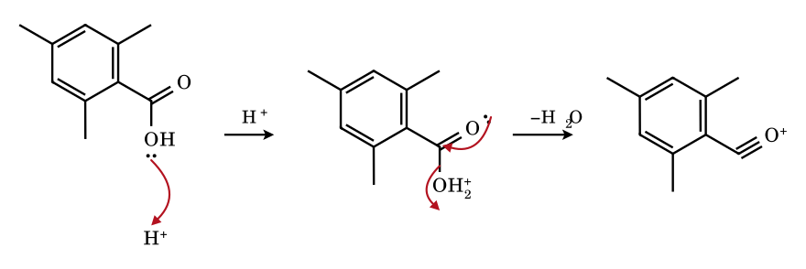
Ordinarily esterification/hydrolysis of benzoic acids goes by addition–elimination (A_{AC}2) through a tetrahedral intermediate. The two ortho methyl groups block nucleophilic addition to C=O, so the reaction switches to ionisation to a mesitoyl acylium ion, which is linear and so relieves the steric clash. Dissolving in H₂SO₄ and pouring into alcohol gives the ester in high yield (Newman).
2.E10 Ritter reaction: nitrile + tert-butyl cation
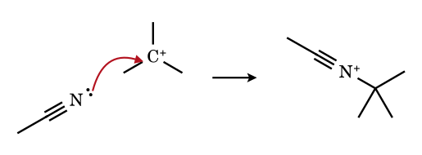
A nitrile nitrogen lone pair (sp-hybridised, weakly basic but unhindered) captures the cation: the nitrilium ion R–C≡N⁺–R′ is attacked by water at carbon to give an N-tert-butylamide. Only cations that form readily (tertiary, benzylic) work.
2.E11 Methyl vinyl ether + H⁺: protonation of an enol ether
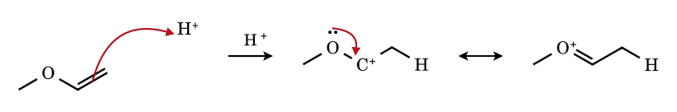
Protonation of the β-carbon gives a cation that is immediately an oxocarbenium ion because the α-oxygen lone pair donates into the empty p orbital. Enol ethers are hydrolysed orders of magnitude faster than simple alkenes are hydrated for this reason (the rate-limiting step is protonation at carbon).
2.E12 Benzene + H⁺ (superacid): the arenium (Wheland) ion
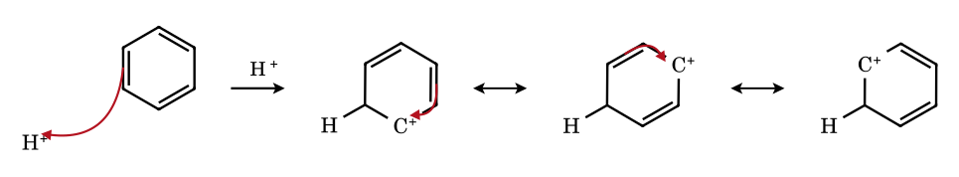
C₆H₇⁺ is the intermediate in every electrophilic aromatic substitution. The positive charge is delocalised over the ortho and para carbons only (three contributors; the meta carbons carry none); the sp³ CH₂ breaks the aromatic ring, which is why this step costs so much energy and is rate-determining.

2.F Carbocations from amines: diazotisation with nitrous acid
Nitrous acid (from NaNO₂ + HX, never stored) is the reagent that turns a primary amino group (–NH₂), the worst of leaving groups, into the best known one (N₂). The active electrophile in dilute mineral acid is the nitrosonium ion NO⁺. What happens next depends on the type of amine:
Amine | NaNO₂ / HCl, 0–5 °C | Carbocation?
Primary aliphatic RCH₂NH₂, R₃CNH₂ | R–N₂⁺ (not isolable) → loses N₂ at once | Yes (or a concerted shift/substitution with N₂ loss); mixture of alcohols, alkenes, halides; rearranged products common
Primary aromatic ArNH₂ | Ar–N₂⁺ X⁻: stable in cold solution (resonance with the ring) | No at 0–5 °C. On warming in water the diazonium ion loses N₂ to give the aryl cation (phenol)
Primary benzylic ArCH₂NH₂ | ArCH₂N₂⁺ (not stable) | Yes: benzylic cation ArCH₂⁺
Secondary R₂NH (and ArNHR) | N-nitrosamine R₂N–N=O (yellow oil) | No (no N–H left to lose from N after nitrosation; the N–N bond is not an N₂-releasing diazonium)
Tertiary R₃N | R₃NH⁺ NO₂⁻ (salt); no stable product | No (tertiary aryl amines such as PhNMe₂ undergo C-nitrosation at the para carbon)
2.F1 Nitrosonium ion from nitrous acid
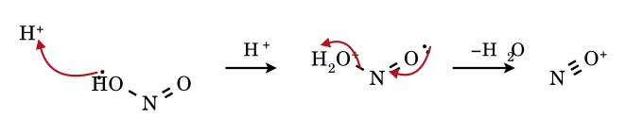
Protonation of the hydroxyl oxygen turns it into water; the oxygen lone pair of the N=O then forms a third N–O bond as water leaves, giving N≡O⁺ (isoelectronic with CO and N₂). NO⁺ is the electrophile that attacks amines (N-nitrosation).
2.F2 tert-Butylamine + NO⁺: N-nitrosation (first step)
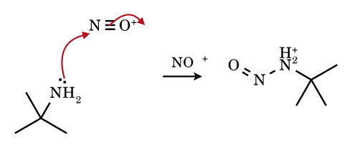
The amine nitrogen lone pair attacks nitrogen of NO⁺; one N≡O π bond moves onto oxygen. The N-nitrosoammonium ion then loses H⁺ and tautomerises, as drawn in 2.F3.
2.F3 …from N-nitroso-tert-butylammonium to the cation (R–NH–N=O → R–N=N–OH → R–N₂⁺ → R⁺)
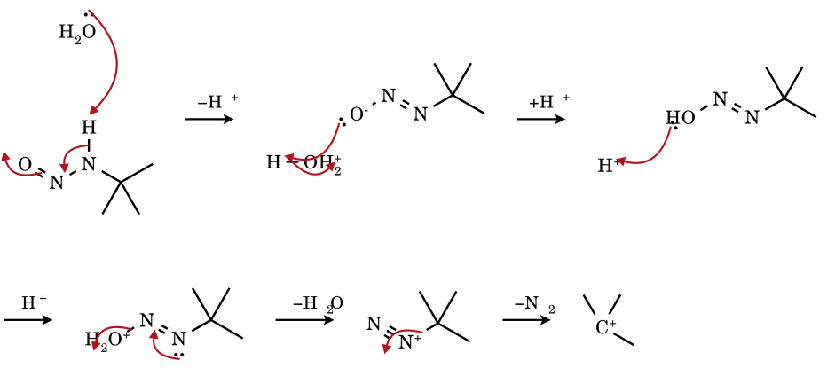
Loss of N–H proton and shift of the π bond gives the diazotate; protonation on oxygen (diazohydroxide R–N=N–OH), then a second protonation and loss of water gives the alkyldiazonium ion R–N≡N⁺; its C–N σ pair leaves with N₂. For a tertiary alkyl group the product is the tert-butyl cation (captured by water or losing H⁺). With a primary alkyl group the same sequence is followed by a concerted shift (2.E1).
2.F4 Benzylamine + HNO₂: benzylic cation
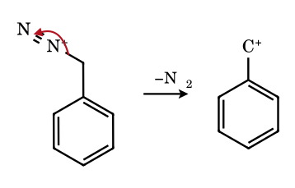
Benzyldiazonium ions lose N₂ at once, even at 0 °C, because the benzylic cation is resonance-stabilised. The cation is captured by water (benzyl alcohol); compare ArN₂⁺, where the diazonium group is attached to an sp² carbon and is stable in the cold.
2.F5 Secondary amine + NO⁺: N-nitrosamine (no carbocation)
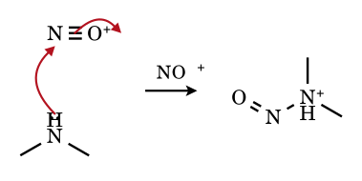
The nitrosoammonium ion can only lose its N–H proton to give R₂N–N=O; there is no hydrogen to move to oxygen to form a diazonium, so the sequence stops at the nitrosamine (a carcinogen class). No carbocation forms.
2.F6 Tiffeneau–Demjanov: 1-(aminomethyl)cyclohexanol + HNO₂ (diazonium, then ring expansion)
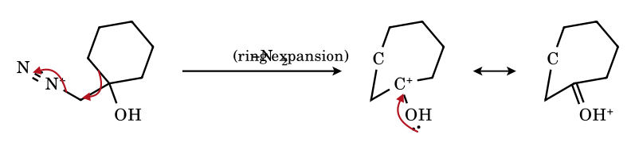
The ring C–C bond anti to the departing N₂ migrates to the CH₂ as N₂ leaves, so the six-membered ring becomes seven-membered; the cation produced is the protonated ketone (oxygen lone pair donates), which loses H⁺ to give cycloheptanone. A free primary cation is never formed.

2.G Carbocations from aromatic compounds: arenium (σ-complex, Wheland) ions
An aromatic ring is a poor nucleophile because attack on an electrophile E⁺ destroys aromaticity. The product is a cyclohexadienyl (arenium) cation: one sp³ carbon carrying E and H, and the other five carbons conjugated over three contributors with the charge at the two ortho and the para positions relative to the sp³ carbon (never the meta carbons). Loss of H⁺ from the sp³ carbon restores the aromatic ring (substitution). Formation of the arenium ion is the slow step in every electrophilic aromatic substitution.
2.G1 Nitration: benzene + NO₂⁺ (HNO₃/H₂SO₄)
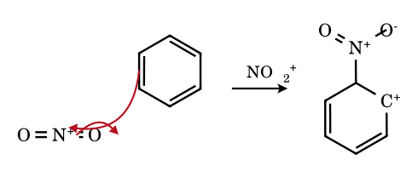
The nitronium ion (O=N⁺=O, linear) is generated by H₂SO₄ protonating HNO₃ (HNO₃ + 2 H₂SO₄ → NO₂⁺ + H₃O⁺ + 2 HSO₄⁻). Its attack on benzene gives the nitro-substituted arenium ion; HSO₄⁻ removes the ring proton.
2.G2 Bromination: benzene + Br₂/FeBr₃
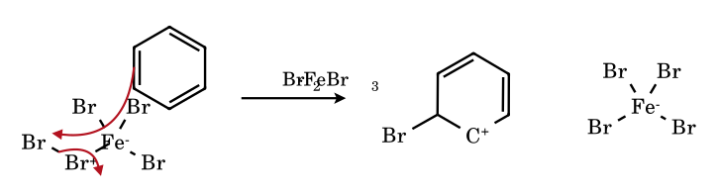
FeBr₃ polarises Br–Br (Br^{δ+}···Br–FeBr₃^{δ−}); the π electrons attack the electrophilic bromine and displace [FeBr₄]⁻. The same arenium ion forms regardless of which Br leaves with the Lewis acid.
2.G3 Friedel–Crafts alkylation: benzene + t-Bu⁺ (t-BuCl/AlCl₃)
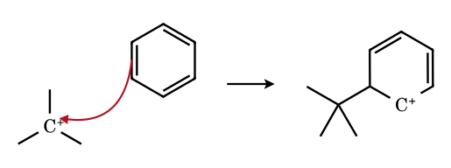
A carbocation (from R–Cl + AlCl₃, from an alkene + H⁺, or from an alcohol + acid) is attacked by the arene. Cations that can rearrange (n-propyl, n-butyl, neopentyl…) give rearranged alkylbenzenes: cumene, not n-propylbenzene, from n-PrCl/AlCl₃. The product ring is more reactive than benzene, so polyalkylation is a problem.
2.G4 Friedel–Crafts acylation: benzene + CH₃CO⁺ (acylium ion)
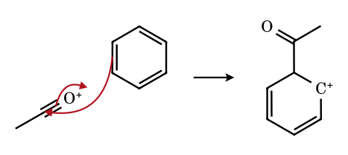
The acylium ion adds to the ring through its electrophilic carbon (one C≡O π bond becomes the C=O of the ketone). The acyl group deactivates the ring, so one substitution only, and acylium ions do not rearrange.
2.G5 Sulfonation: benzene + SO₃ (oleum)
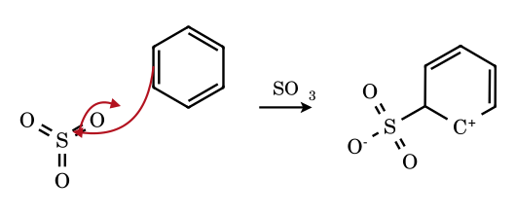
SO₃ (a neutral, very electrophilic sulfur) is attacked by the π bond; the S=O π electrons move onto oxygen, giving a zwitterionic arenium ion. Sulfonation is reversible (dilute hot acid removes SO₃H), unlike nitration or halogenation.
2.G6 Protonation of anisole at the para position (ipso to H)
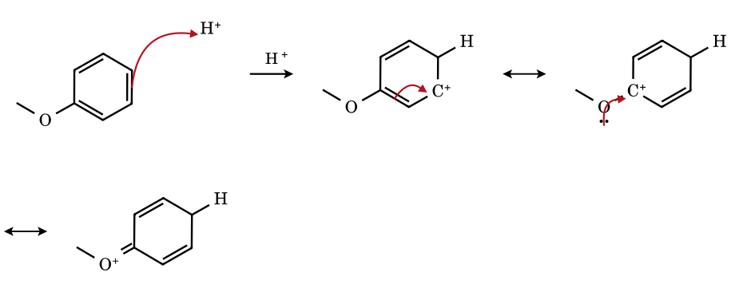
Protonating C-1 (para to OMe) puts positive charge at the ortho and para carbons, and one contributor places it on C-4, which carries OMe: the oxygen lone pair then delocalises it (an oxocarbenium contributor). Protonation meta to OMe lacks this contributor, so ortho/para attack is faster – the origin of ortho/para direction by +M groups.
2.G7 Hydride abstraction from an alkylarene: diphenylmethane + Ph₃C⁺
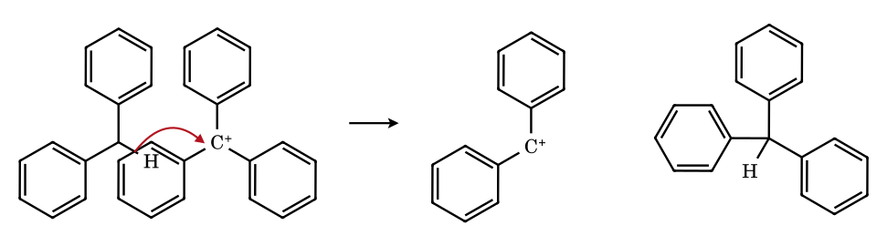
Aryl groups on a C–H carbon make it a hydride donor: loss of H⁻ leaves the diarylmethyl (benzhydryl) cation, stabilised by two rings. Ph₃C⁺ is a hydride acceptor only for strongly donating hydrocarbons (cycloheptatriene, 2.E5); with Ph₂CH₂ the equilibrium lies far on the left (pK_{R+} −6.6 versus −13.3).

2.H Lewis-acid-assisted ionisation, ether cleavage, and aromatic carbocations
Why a Lewis acid works. Ionisation R–X → R⁺ + X⁻ is the rate-determining, endothermic step (heterolysis); the capture of R⁺ by a nucleophile is fast and exothermic. A halide, ether or alcohol that does not ionise alone can be pushed over the barrier by an electrophile that binds the leaving group: H⁺ (ROH → ROH₂⁺), Ag⁺ (→ AgX), or a Lewis acid. Neutral alcohols do not react with NaI (HO⁻ is a poor leaving group and I⁻ is no electrophile) but do react with HI, because H⁺ first converts OH into the good leaving group H₂O. The rate of R–OH + HX follows the cation stability, 3° > 2° > 1°.
Class of leaving group | Examples | Behaviour
Best (leave spontaneously) | R–N₂⁺ (N₂), R–OH₂⁺ (H₂O), R–O⁺R₂, R–S⁺R₂, triflate | ionise at room temperature or below when the cation is reasonably stable
Moderate (need help from a Lewis acid/electrophile, or a polar H-bonding solvent) | R–X (X = Cl, Br, I), R–OTs, R–OCOR, ethers R–OR′ after protonation | Ag⁺, BF₃, BCl₃, ZnX₂, AlX₃, SbCl₅/SbF₅, H⁺: the electrophile binds the leaving group, the nucleophile (if any) then attacks the cation
Poor (do not leave) | R–H, R–R, R–OH, R–OR, R–NH₂ | cannot be ionised without prior conversion (protonation, sulfonylation, diazotisation)

Lewis acid / electrophile | Reaction with R–X | Why it works
Ag⁺ | R–X + Ag⁺ → R⁺ + AgX↓ | very insoluble AgX drives the ionisation (halophilic)
BF₃, BCl₃, BeX₂, ZnX₂, AlX₃ | R–X + MX_{n} → R⁺ + [X–MX_{n}]⁻ | electron-deficient (hypovalent) centre accepts a halide lone pair into an empty orbital
SbCl₅, SbF₅ | R–X + SbCl₅ → R⁺ + SbCl₆⁻ (SbF₆⁻) | coordination number expands from 5 to 6: a strong Lewis acid giving a very weakly nucleophilic counterion
2.H1 tert-Butyl fluoride + BF₃: even the strongest C–X bond is ionised
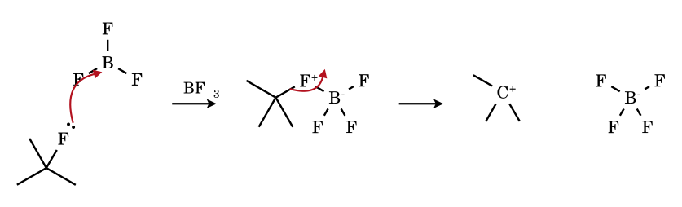
The fluorine lone pair fills the empty p orbital of boron; the C–F bond then ionises to the tert-butyl cation and tetrafluoroborate. Alkyl fluorides, inert to solvolysis, are therefore the most Lewis-acid-sensitive halides because of the strong B–F bond that is formed.
2.H2 (S)-1-Phenylethyl chloride + SbCl₅: planar cation, loss of optical activity
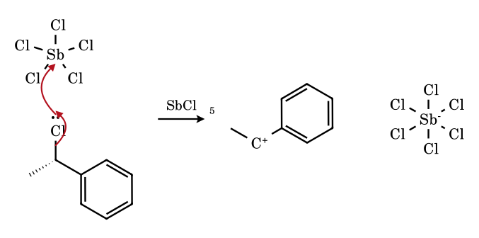
The cationic carbon is sp² and planar (empty p orbital), so the single stereocentre of the reactant is lost: the intermediate is achiral and attack by a nucleophile from either face gives racemic product – the same reasoning that explains racemisation in S_{N}1. Chloride is held by SbCl₅ as SbCl₆⁻ and cannot return.
2.H3 Methyl tert-butyl ether + HI: S_{N}1 cleavage of an ether
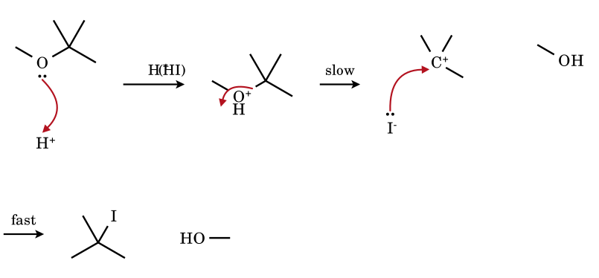
Protonation makes the ether oxygen a good leaving group (CH₃OH), and the C–O bond that breaks is the one that gives the more stable cation (tertiary, not methyl): methanol and t-BuI, not CH₃I and t-BuOH. With a primary alkyl and a methyl group (e.g. CH₃OCH₂CH₃) cleavage goes by S_{N}2 at the less hindered carbon instead (CH₃I + EtOH).
2.H4 3-Chlorocyclopropene + SbCl₅: the cyclopropenium cation (aromatic, 2π)
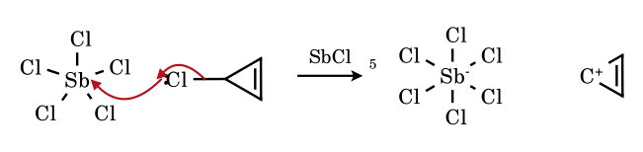
Ionisation gives C₃H₃⁺, a planar ring of three p orbitals holding two π electrons (4n+2, n = 0): aromatic, and therefore formed from an otherwise hopelessly strained cyclopropyl cation. The positive charge is shared equally by the three carbons (D_{3h}).
2.H5 7-Chlorocycloheptatriene + SbCl₅: the tropylium cation (aromatic, 6π)
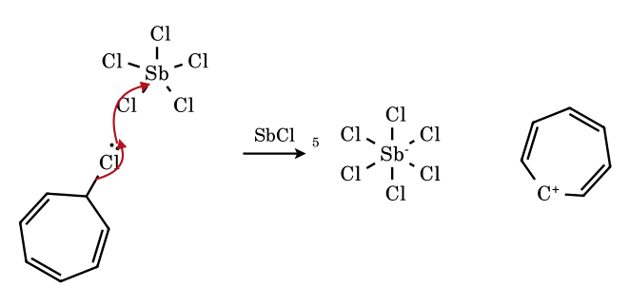
The sp³ carbon becomes sp² and completes a cycle of seven p orbitals with six π electrons. Tropylium chloride and bromide are in fact ionic salts (water-soluble solids, not covalent alkyl halides), the clearest example that aromaticity can make a ‘halide’ ionic.
2.H6 3,4-Dichlorocyclobutene + 2 SbCl₅: the cyclobutadiene dication (aromatic, 2π)
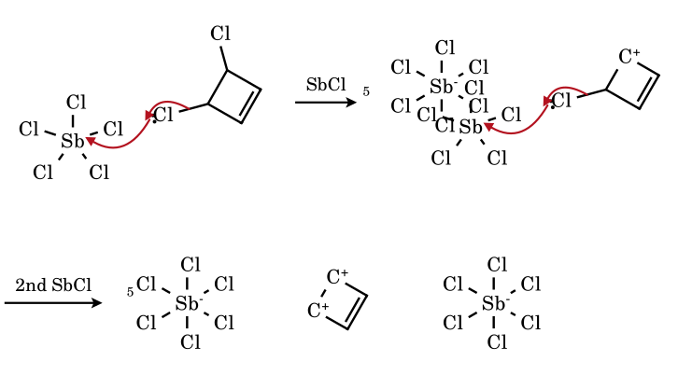
Removal of two chloride ions leaves C₄H₄²⁺, a planar ring of four p orbitals with only two π electrons (4n+2, n = 0): the dication is aromatic, whereas neutral cyclobutadiene (4π) is antiaromatic. This is why two equivalents of SbCl₅ ionise both C–Cl bonds. The drawing localises the π bond and the two cationic carbons; the real ion is delocalised over all four carbons.
2.H7 4-Chloro-4H-pyran + AlCl₃: the pyrylium cation (aromatic, 6π, O⁺)
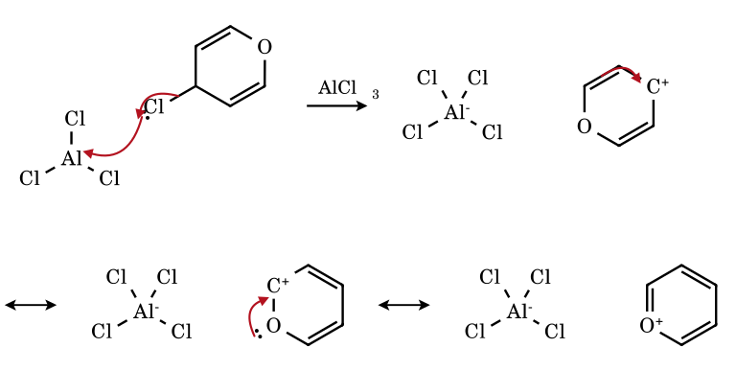
Loss of chloride from C-4 gives a cation conjugated with the C=C–O unit; two further electron shifts bring the charge onto oxygen, whose lone pair completes the six-π-electron ring: pyrylium (C₅H₅O⁺), an aromatic oxonium ion. The oxygen carries the formal + charge but the carbons 2, 4 and 6 carry most of the electrophilicity.
2.H8 …and where it fails: 5-chlorocyclopentadiene + AlCl₃
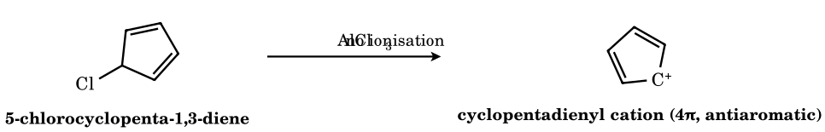
Ionisation would give the cyclopentadienyl cation, a planar cycle of five p orbitals with four π electrons (4n): antiaromatic and so unstable (computed ground state: triplet) that 5-chlorocyclopentadiene does not ionise with Lewis acids, even though a simple secondary allylic cation of similar substitution would. 3,4-Dichlorocyclobutene (2.H6) and 3-chlorocyclopropene (2.H4) ionise because the cations are (4n+2) aromatic. Rule: electron count decides.

Part 3 Leaving-Group Ability

3.1 What a leaving group is, and what ‘good’ means
A leaving group (nucleofuge) is the fragment that departs with the bonding electron pair in a heterolytic substitution or elimination: R–LG → R⁺ + LG⁻ (or neutral LG from a cationic substrate). ‘Good’ is a statement about a rate (kinetic, a lowered barrier for the C–LG cleavage step) that correlates with – but is not identical to – the thermodynamic stability of the departed LG, i.e. the acidity of its conjugate acid H–LG. The correlation exists because in the transition state the LG carries a partial negative charge; the better it can stabilise that charge, the lower the barrier (Brønsted-type relationship, typically β_{lg} between −0.3 and −1.0 for substitution).
Leaving group (LG) | Conjugate acid | pK_{a} (aq., approx.) | Remarks
I⁻, Br⁻, Cl⁻ | HI, HBr, HCl | −10, −9, −7 | large, polarisable; weak C–X bonds (I < Br < Cl)
F⁻ | HF | 3.2 | very poor in S_{N}1/S_{N}2 (strong C–F bond); good in SNAr (see Q5)
CF₃SO₃⁻ (triflate) | CF₃SO₃H | ≈ −14 | charge delocalised over 3 O, CF₃ −I effect; a ‘super’ LG
p-O₂NC₆H₄SO₃⁻ (nosylate) | ArSO₃H | ≈ −6.5 (est.) | EWG on the aryl ring improves LG
p-CH₃C₆H₄SO₃⁻ (tosylate) | TsOH | ≈ −2.8 | standard crystalline sulfonate
CH₃SO₃⁻ (mesylate) | MsOH | ≈ −1.9 | similar to tosylate in rate
H₂O (from ROH₂⁺) | H₃O⁺ | −1.7 | neutral LG; HO⁻ of ROH is not a leaving group
CF₃CO₂⁻, CH₃CO₂⁻ | CF₃CO₂H, AcOH | 0.5, 4.76 | carboxylates: moderate; acetates ionise only for cations of tertiary/benzylic stability
N₂ (from RN₂⁺) | — | — | best known LG: very stable neutral molecule, huge entropy gain
NH₃ (from RNH₃⁺) | NH₄⁺ | 9.25 | poor: Hofmann elimination needs heat; NH₂⁻ (pK_{a} 38) never leaves
HO⁻, RO⁻, H⁻, R⁻ | H₂O, ROH, H₂, RH | 15.7, 16–19, 35, ≈ 50 | do not leave in S_{N}/E1 unless activated (E1cB, intramolecular, ring strain)

3.2 Factors that determine leaving ability
- Basicity / conjugate-acid strength. Weaker bases are better leaving groups: the LG⁻ is more stable. Within a period this is the dominant trend (I⁻ ≫ F⁻ in protic solvent; TfO⁻ ≫ AcO⁻ ≫ HO⁻).
- Bond strength and polarisability. Down a group the C–X bond weakens (C–F ≈ 110, C–Cl ≈ 84, C–Br ≈ 70, C–I ≈ 57 kcal mol⁻¹) and the large, soft anion is stabilised by polarisation of the TS; the pK_{a} trend (HF 3.2 → HI −10) reinforces this. In the gas phase F⁻ is a worse LG than I⁻ for the same reason.
- Resonance and charge delocalisation. Sulfonates (charge over 3 O), carboxylates (2 O), triflate (3 O + CF₃) are good LGs because the charge is spread; alkoxides and amides are not.
- Induction. EWGs on the LG (CF₃, NO₂, halogens on an aryl ring) stabilise the anion: TfO⁻ ≫ MsO⁻; p-O₂N–C₆H₄SO₃⁻ > TsO⁻.
- Solvation. Protic solvents hydrogen-bond to small, charge-dense anions (F⁻, Cl⁻, RO⁻), stabilising them in the TS and promoting ionisation; the effect on the ordering of halides is small for S_{N}1 but large for nucleophiles in S_{N}2. Aprotic dipolar solvents (DMSO, DMF) favour S_{N}2 by leaving anions bare.
- Neutral versus charged substrates. Protonation, alkylation or diazotisation converts a bad LG (HO⁻, NH₂⁻) into a good neutral one (H₂O, NH₃, N₂) – the underlying reason for acid catalysis and for conversion of alcohols to sulfonates.
- Neighbouring-group assistance. A lone pair or π/σ bond anti-periplanar to the C–LG bond can displace the LG intramolecularly (anchimeric assistance; sulfur > nitrogen-free base > bromine > oxygen in typical hydrolyses): the C–LG bond breaks faster than the intrinsic LG ability would suggest.
- Stereoelectronic and steric factors. An axial LG on a cyclohexane ring is anti-periplanar to ring C–C/C–H bonds and relieves 1,3-diaxial strain on ionisation; an anti-periplanar C–Si bond (β-silicon effect) accelerates departure by orders of magnitude; large groups on the substrate relieve strain (B-strain) on ionisation.
- Ion-pair behaviour. The LG may remain close to the cation (internal return). Poor ion-pair return from large, delocalised LGs (OTs, OTf) increases the net rate relative to Cl⁻.

3.3 Why there is no single universal order
The order I⁻ > Br⁻ > Cl⁻ ≫ F⁻ holds for S_{N}1, S_{N}2 and E2 at sp³ carbon, but is reversed (F ≫ Cl ≈ Br > I) in nucleophilic aromatic substitution, where C–LG cleavage is not rate-limiting: the first step (attack of the nucleophile to give the Meisenheimer complex) is slower, and the very electronegative fluorine stabilises that TS by induction. Likewise in acyl substitution the order of acyl derivatives (RCOCl > (RCO)₂O > RCO₂R′ > RCONR₂) reflects both LG ability and how strongly the LG donates into C=O. In E2 the LG changes the regiochemistry: poorer LGs (F⁻, NR₃) make the TS carbanion-like and favour the Hofmann (less substituted) alkene. And in transition-metal oxidative addition the order is Ar–I > Ar–Br ≈ Ar–OTf > Ar–Cl, controlled by bond strength and metal–LG interaction, not by pK_{a}.
The following comparisons are made at stated conditions. A leaving-group ranking is meaningful only for a fixed substrate, mechanism, solvent and temperature.
Process | Rate-limiting step | Leaving-group dependence
S_{N}1 / E1 | C–LG heterolysis | Strong (β_{lg} ≈ −0.5 to −1); solvent H-bond donation important
S_{N}2 | concerted attack + C–LG cleavage | Moderate (β_{lg} ≈ −0.3 to −0.6); solvent-nucleophile interactions also matter
E2 | concerted; anti-periplanar H–C–C–LG | Moderate; also changes Zaitsev/Hofmann ratio and TS looseness
E1cB | carbanion formation or LG expulsion | LG may be as poor as HO⁻ or RO⁻ if carbanion is stabilised (enolate)
SNAr | nucleophilic addition | Weak, ‘element effect’ F ≫ Cl ≈ Br > I
Acyl substitution | addition or collapse of tetrahedral intermediate | Strong, but coupled with resonance donation

3.4 Fifteen leaving-group comparison problems
Rank A–D as instructed. Every statement of order refers to the stated conditions only. Rate orders are established qualitative trends in the literature; no numerical ratios are claimed unless stated.
LG1.Arrange A–D in decreasing first-order solvolysis rate in 80 % aq. ethanol at 25 °C (same alkyl group; the only variable is the halogen).
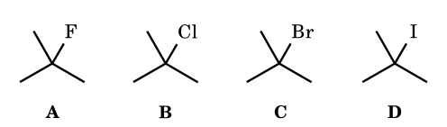
LG2.R = 2-butyl in all four. Arrange the derivatives in decreasing rate of ionisation in warm (50 °C) neutral ethanol (no acid added).
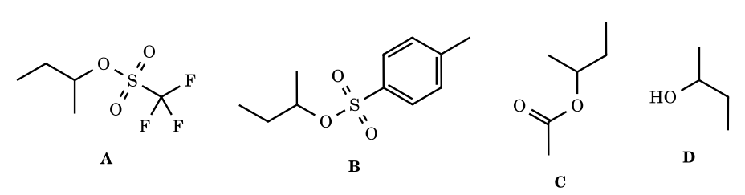
LG3.For the tert-butyl derivatives A–D in acidic aqueous solution at 25 °C, arrange in decreasing ease of C–LG heterolysis (LG = the neutral molecule that leaves, or HO⁻ for D).
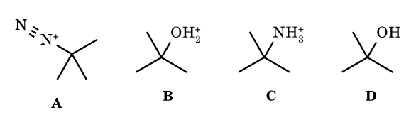
LG4.The four tert-cumyl esters A–D are solvolysed in 70 % aq. acetone at 25 °C. Arrange in decreasing rate of ionisation.
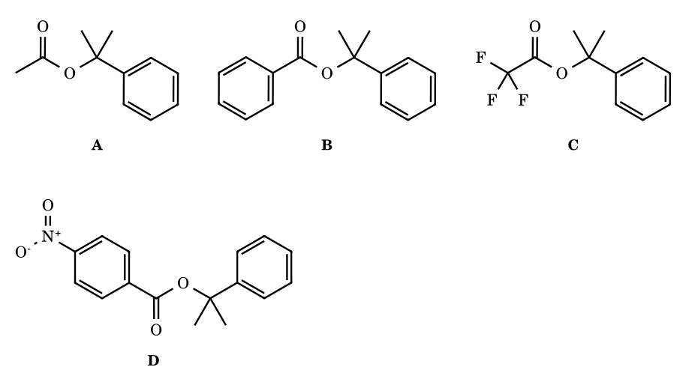
LG5.Arrange the 1-halo-2,4-dinitrobenzenes A–C in decreasing rate of reaction with piperidine (or methoxide) in ethanol at 25 °C.
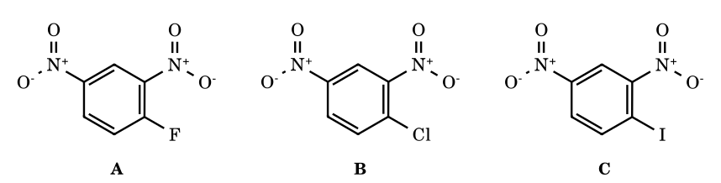
LG6.Each 2-pentyl derivative A–D is treated with NaOEt/EtOH (E2). Arrange in decreasing percentage of the less substituted alkene, pent-1-ene (Hofmann product), in the product mixture.
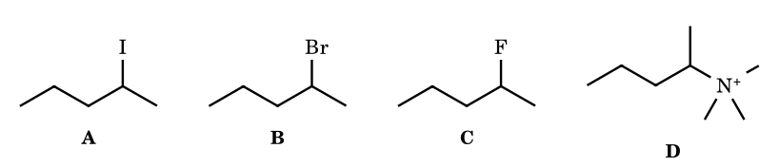
LG7.Arrange the solvents A–E in decreasing ionising power for the solvolysis of tert-butyl chloride at 25 °C (Grunwald–Winstein Y scale). Solvents: A H₂O, B HCO₂H, C CF₃CH₂OH, D CH₃OH, E CH₃CH₂OH.
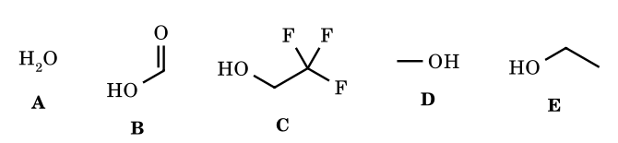
LG8.Bromides A–C undergo E2 with NaOEt in EtOH at 50 °C. Arrange in decreasing rate. (A cis-4-tert-butylcyclohexyl bromide; B trans-4-tert-butylcyclohexyl bromide; C bromocyclohexane. The t-Bu group is locked equatorial.)
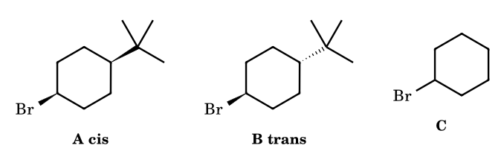
LG9.Arrange the acetyl derivatives A–D in decreasing rate of nucleophilic acyl substitution by water (neutral, 25 °C).
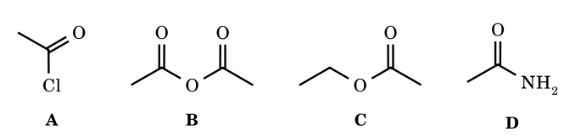
LG10.Methyl-transfer (S_{N}2) from the onium salts A–C to a thiolate in CH₃CN at 25 °C. Arrange in decreasing reactivity.
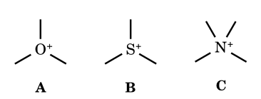
LG11.Treat each compound A–D with ethanolic AgNO₃ at 25 °C. Arrange in decreasing rate of AgBr precipitation (no precipitate = last).
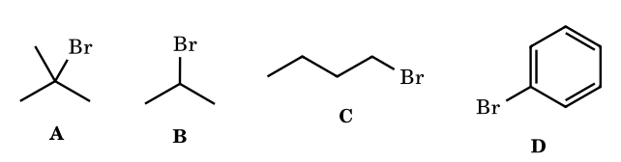
LG12.Tosylates A–C are acetolysed at 50 °C. Arrange in decreasing rate. (A trans-2-(trimethylsilyl)cyclohexyl tosylate; B cis-2-(trimethylsilyl)cyclohexyl tosylate; C cyclohexyl tosylate.)
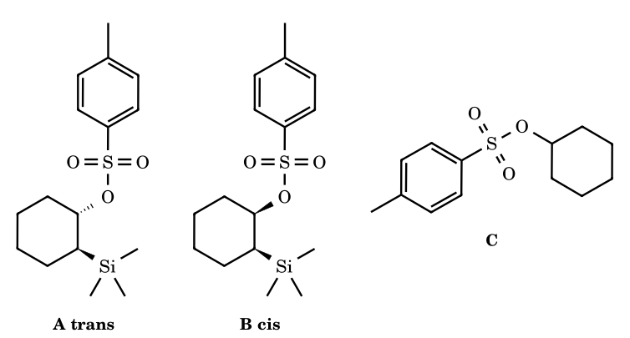
LG13.Arrange the 2-arylethyl tosylates A–D in decreasing rate of acetolysis at 75 °C (neighbouring-group participation by the aryl ring is the major pathway).
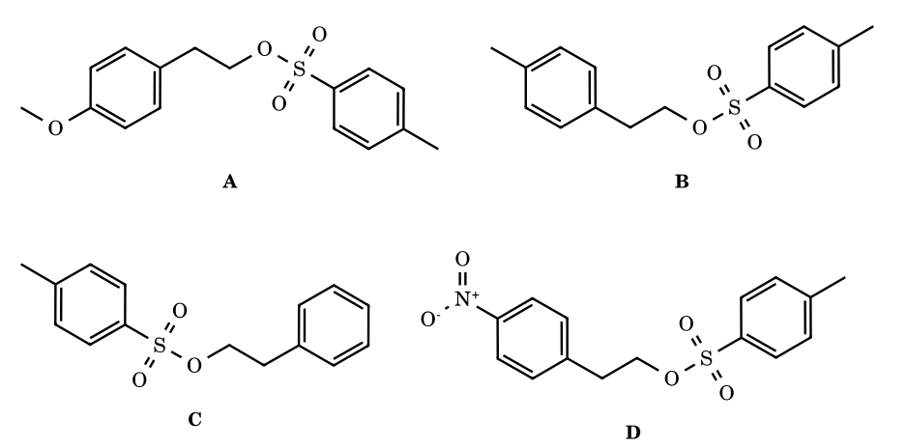
LG14.Arrange the cyclic ethers A–D in decreasing ease of acid-catalysed ring opening by aqueous HBr at 25 °C.
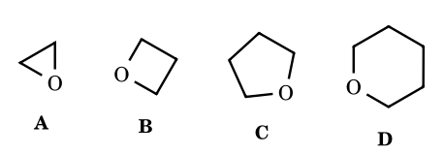
LG15.Arrange the 2-propyl arenesulfonates A–D in decreasing rate of solvolysis in aq. ethanol at 25 °C.
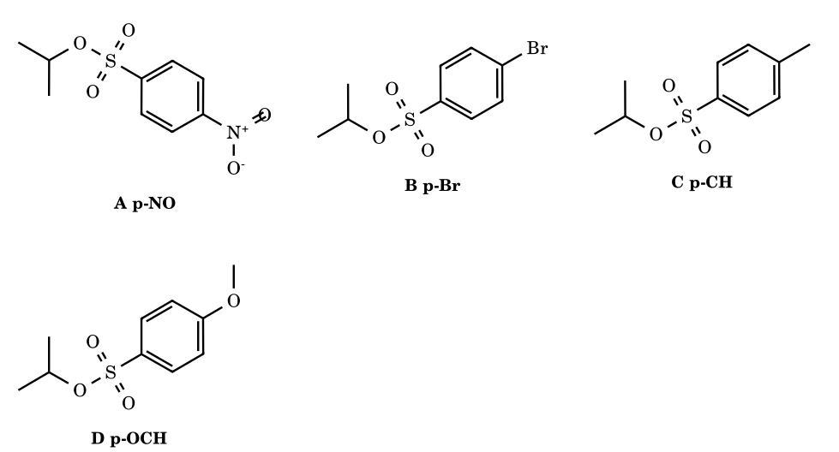

Part 4 Carbocation Stability: Complete Advanced Treatment
What ‘stability’ means. Four different observables are routinely mixed up and must be kept apart: (1) gas-phase thermodynamic stability, measured by the hydride ion affinity (HIA) R⁺ + H⁻ → R–H (smaller HIA = more stable cation) or the corresponding calculated energies – this reflects the intrinsic electronic stabilisation, free of solvent; (2) stability in solution toward water, pK_{R+} = pH at which [R⁺] = [ROH], applicable only to very stable cations; (3) substituent stabilisation expressed by σ⁺ constants (Brown–Okamoto), derived from the solvolysis of ArC(CH₃)₂Cl; (4) ionisation rates (solvolysis), which depend on the stability of the cation and on the leaving group, solvent, ion-pair return, nucleophilic solvent assistance (k_{s}), neighbouring-group participation (k_{Δ}) and strain relief, and therefore track the cation’s stability only when all of these are held constant and the transition state is late. Every problem in Part 5 states which observable is meant.
Orders obtained in the gas phase can differ from, or even invert, orders in solution (alkyl-substituted benzyl cations: gas phase t-Bu > i-Pr > Et > Me, solution Me ≳ Et > i-Pr > t-Bu – the Baker–Nathan order – because larger alkyl groups are solvated less effectively). Where an order below depends on the medium, the medium is stated.

4.1 Inductive effect
A σ-framework effect: electronegativity differences polarise σ bonds. +I (electron-donating) groups – alkyl groups, and especially more polarisable and more electropositive groups such as SiMe₃, SnMe₃ – push electron density toward the cationic carbon and lower its energy; −I groups (F, Cl, OR, NR₃⁺, NO₂, CN, CF₃, C=O) pull density away and raise it. The effect falls off roughly by a factor of 2–3 per intervening bond, so it is dominant for α and β substituents, small for γ. The field (through-space) component is important in rigid frameworks (4-substituted bicyclo[2.2.2]octyl systems). Important caveat: −I groups attached by a lone-pair atom (OR, SR, NR₂, Hal) at the α position are overall stabilising because the +M effect outweighs −I (CH₃OCH₂⁺ is far more stable than CH₃CH₂⁺), while the same groups at β position are destabilising unless they can bridge. Strongly −I groups on the cationic carbon are dramatically destabilising: α-CF₃ and α-carbonyl groups reduce solvolysis rates of tertiary systems by many orders of magnitude (Tidwell).

4.2 Mesomeric (resonance) effects
A π-bond or lone pair attached to the cationic carbon delocalises the charge (π→p or n→p overlap). +M groups (NR₂ > NHR > OH ≈ OR > SR > aryl ≈ vinyl > halogen) stabilise; −M groups (C=O, CN, NO₂, SO₂R, CF₃ by negative hyperconjugation/induction) destabilise by competing for the same orbital or by withdrawing π density. Resonance changes only electron positions and is shown with the double-headed arrow ↔; curved arrows show how to go from one contributor to the next.
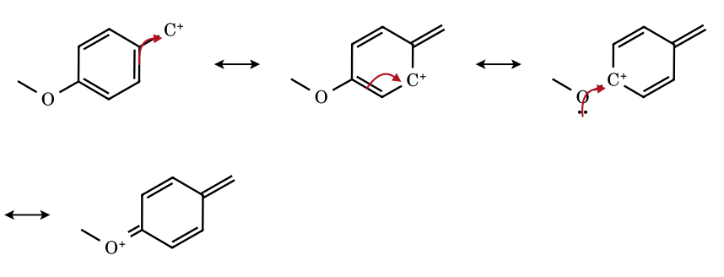
Figure 4.1 p-Methoxybenzyl cation: charge delocalised from CH₂ to the ortho/para carbons, and finally onto oxygen (an oxocarbenium contributor; every atom has an octet).
- Position matters. Charge in a benzyl cation sits on the ortho and para carbons, not meta. A +M group at p (or o) conjugates directly with the charge (σ⁺(p-OMe) = −0.78) while at m only its −I effect operates (σ⁺(m-OMe) = +0.05). A −M group at p (σ⁺(p-NO₂) = +0.79) is worse than at m (+0.67), because at p it is conjugated with the charge-bearing carbon.
- Halogens have strong −I but a real +M effect (lone-pair donation); at p-F the two nearly cancel (σ⁺ = −0.07), at p-Cl −I wins slightly (+0.11), at m-Cl only −I operates (+0.40).
- Resonance requires coplanarity. A π donor can only help if its p orbitals can align with the empty p orbital: see 4.8 (steric inhibition of resonance) and the vinyl/aryl cations (empty orbital in the nodal plane of the π system: no resonance).
- Resonance energy is large for the first donor and levels off for successive ones: allyl ≈ 20+ kcal mol⁻¹ better than a localised secondary cation of the same substitution in the gas phase; each further vinyl unit adds less (pentadienyl, heptatrienyl).
- The ranking of mesomeric donors depends on orbital energy match and overlap: N (2p) > O (2p) > S (3p, poorer overlap but more polarisable) for the same carbon framework; in solution oxocarbenium ions are further stabilised by solvation.

4.3 Hyperconjugation
Donation of σ-bond electrons into the empty p orbital: σ(C–H) → p and σ(C–C) → p (and σ(C–M) → p for M = Si, Ge, Sn, which are much better donors because σ_{C–M} lies higher in energy). The stabilisation scales with (i) the donor ability of the σ bond (C–C ≳ C–H in the gas phase; C–Sn > C–Ge > C–Si ≫ C–C), (ii) the number of aligned bonds and (iii) the alignment angle θ between the σ bond and the empty p orbital (overlap ∝ cos²θ; zero at 90°). In a freely rotating alkyl group on average ≈ 2 of the 3 C–H bonds are well aligned at any time; simply counting α-hydrogens is not a valid ranking device – t-Bu⁺ (9 α-H) vs 2-adamantyl, bridgehead or conformationally locked cations show that orbital alignment, strain and polarisability also matter. Computations show that C–C hyperconjugation is as important as C–H; polarisability (stabilisation of the charge by larger alkyl groups) makes larger alkyl groups better in the gas phase (recalled HIA, kcal mol⁻¹: t-Bu⁺ ≈ 231 → t-amyl⁺ ≈ 225 → Et₃C⁺ lower still).
Figure 4.2 σ(C–H) → p hyperconjugation (the C–H bond must lie roughly parallel to the p-orbital axis).
Heteroatom hyperconjugation. Lone pairs and σ bonds of heteroatoms attached β to the cation can also donate: β-silicon (C–Si anti-periplanar to the leaving group) stabilises a β-carbocation by ≈ 38 kcal mol⁻¹ relative to hydrogen in some computations (≈ 10¹² rate acceleration in rigid systems), β-Ge and β-Sn are even stronger; β-halogens at 3° carbons may bridge instead (4.6). Negative hyperconjugation (n→σ*, e.g. in α-sulfonyl carbanions) is the anionic analogue and does not apply to cations.

4.4 Aromaticity and antiaromaticity
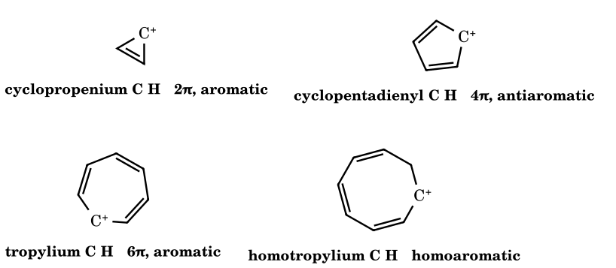
Figure 4.3 Cyclic cations with a planar array of p orbitals: (4n+2) π electrons stabilise (cyclopropenium, tropylium); 4n π electrons destabilise (cyclopentadienyl cation, a triplet-ground-state species that is far less stable than the allyl cation). Homotropylium is stabilised by through-space (homo)conjugation across one sp³ carbon.
- Aromatic cations: cyclopropenium (pK_{R+} of C₃Ph₃⁺ +3.1; tris(dialkylamino)- and tricyclopropyl derivatives far higher), tropylium (pK_{R+} +4.7: isolable as stable Br⁻, BF₄⁻ salts, planar, all C–C equal), cyclooctatetraene dications.
- Antiaromatic cations: cyclopentadienyl cation and the 9-fluorenyl cation destabilised by 4π delocalisation. The 9-phenylfluorenyl cation (pK_{R+} ≈ −10.8) is some 10⁴ times less stable than trityl (−6.6) although the fluorenyl ring is planar – a clean demonstration of antiaromatic destabilisation. By contrast the 9-phenylxanthylium ion (pK_{R+} ≈ +1.1) is strongly stabilised: the ring is planar and the oxygen lone pair donates without producing a 4π cycle.
- Always check geometry and electron count before declaring a cyclic conjugated cation aromatic: planarity may be unattainable (e.g. cyclooctatetraenyl cation puckers), and an sp³ centre interrupts the cycle.

4.5 Cyclopropylcarbinyl stabilisation and ‘dancing resonance’
A cyclopropane C–C bond is a bent (‘banana’) σ bond with high p character and high-lying HOMO; the cyclopropyl group therefore behaves like a π donor towards an adjacent empty p orbital – provided the cation adopts the bisected conformation, in which the empty p orbital is parallel to the plane of the ring and overlaps the two vicinal ring bonds. In the perpendicular conformation the overlap is nil. As a donor the cyclopropyl group is better than phenyl (σ⁺: c-C₃H₅ −0.41, C₆H₅ −0.18) and, in tertiary systems, better than methyl: tricyclopropylcarbinyl cation (pK_{R+} −2.3) is more stable than trityl (−6.6).
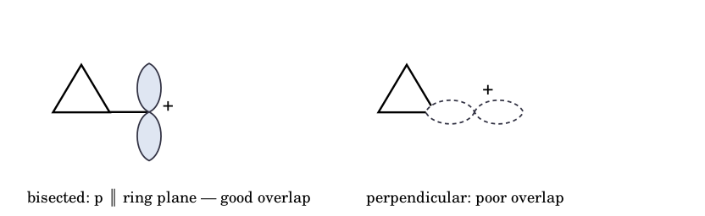
Figure 4.4 Cyclopropylcarbinyl cation: bisected (left, strongly stabilised) and perpendicular (right, no stabilisation) conformations. Orbital view; rings viewed edge-on.
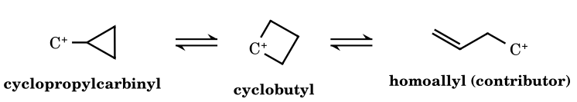
Figure 4.5 The C₄H₇⁺ manifold. The solvolysis of cyclopropylcarbinyl and of cyclobutyl derivatives gives, in water, cyclopropylcarbinol : cyclobutanol : homoallyl alcohol ≈ 48 : 47 : 5 (Roberts, Mazur). These are product ratios, not cation populations; the cation is better described as a single σ-delocalised ‘bicyclobutonium’-like structure than as a mixture of three distinct classical ions.
‘Dancing resonance’ describes how, in this ion, the three CH₂ carbons exchange identity by rapid, degenerate rearrangement through the delocalised structure, so that the carbons become equivalent on the NMR timescale. It is not ordinary resonance, because the nuclei move. The textbook drawing of three localised cations connected by ⇌ arrows is therefore a caricature: calculations and superacid NMR place the bicyclobutonium-like (σ-bridged, C_{s}) and the bisected cyclopropylcarbinyl structures within about 1 kcal mol⁻¹ of each other and the barrier between them is minute; the open homoallyl and the classical puckered cyclobutyl ions are not distinct, deep minima.

4.6 Neighbouring-group participation and bridged ions
A genuine bridged intermediate forms when a group with a lone pair, π bond or σ bond displaces the leaving group from the rear (anti-periplanar) and ends up bonded to both carbons. It differs from ordinary resonance in three ways: (i) the neighbour moves toward the cationic carbon and a new σ bond (3-membered or 5-membered ring) is formed; (ii) the stereochemical outcome is dictated by two successive inversions (net retention); (iii) the rate is higher than the intrinsic leaving-group ability suggests (anchimeric assistance).
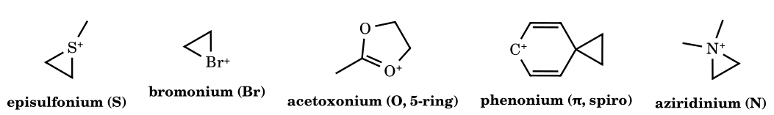
Figure 4.6 Bridged onium and phenonium ions. In each, positive charge is carried largely by the bridging heteroatom (or spread over the cyclohexadienyl ring in phenonium) and no open ‘primary’ cation exists.
- Order of anchimeric power for a given leaving group: roughly S ≈ N (free lone pair) > I > Br > Cl ≈ aryl > O (ether) – a lone pair donates best when its atom is large/polarisable and not strongly bound to its own nucleus; the actual rate enhancement depends on solvent, ring size formed and conformation.
- π participation: an aryl ring attacks C from the rear through its π face to give phenonium (Cram, Winstein); a C=C does the same in anti-7-norbornenyl tosylate (≈ 10¹¹ faster than 7-norbornyl) and in homoallyl → cyclopropylcarbinyl systems.
- σ participation: a C–C or C–H σ bond (e.g. C1–C6 in exo-2-norbornyl; Wagner–Meerwein) acts as the nucleophile – see 4.9.
- Test to separate bridging from resonance: if two structures differ in the position of atoms (a ring closes), bridging is involved; if only electrons move, it is resonance.

4.7 d-Orbital resonance claims
Older textbooks explain the stabilisation of α-sulfonyl and α-phosphoryl carbanions, the planarity of silylamines, or the shortness of S–O bonds in sulfones/phosphates by d_{π}–p_{π} bonding (3d orbitals on S, P, Si accept electron density). Modern calculations show that 3d orbitals are too high in energy and too diffuse to participate significantly; d-functions in basis sets act as polarisation functions only. The effects are explained instead by: (i) negative hyperconjugation – donation of a lone pair into an antibonding σ*(S–O), σ*(S–C) or σ*(P–C) orbital; (ii) polarisation of the large, polarisable atom; (iii) strongly polarised ‘ylidic’ bonds (S⁺–O⁻, P⁺–C⁻) without a true double bond and with the octet intact. For carbocations the practical consequences are: α-silyl and α-sulfonyl substituents do not stabilise a cation (α-silyl cations are destabilised relative to alkyl; a sulfone is a strong −I group), whereas β-silyl stabilisation is σ-hyperconjugative and strong; and a sulfur lone pair (R–S–C⁺) donates through p–p overlap (thionium ions) without d orbitals. Hypervalent descriptions (sulfonium ylide S=C) are therefore teaching shorthand, not electronic reality.

4.8 Steric inhibition of resonance (SIR)
If bulky ortho (or flanking) groups force the π donor out of coplanarity with the cationic centre, overlap falls as cos θ (energy as cos²θ) and the resonance stabilisation is partly lost. The classic quantitative case: the dimethylamino group is an extreme π donor (σ⁺ = −1.7) in 4-(dimethylamino)benzyl and trityl-type cations; but when two methyl groups flank the NMe₂ (3,5-dimethyl-4-dimethylamino) the amine is twisted ≈ 60–90° out of the ring plane, the n→π donation is largely switched off and the group behaves close to a simple inductive substituent (σ⁺ much less negative; the nitrogen lone pair cannot reach the charge).
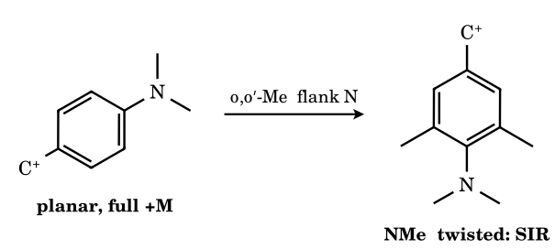
Figure 4.7 Steric inhibition of resonance: the flanking methyls (3,5 to the CH₂⁺, ortho to N) twist the amine; the nitrogen lone pair then lies in the ring plane and cannot overlap with the π system.
No ranking by sterics alone. SIR changes the resonance contribution only. Methyl groups at the same time exert +I/hyperconjugation and (in planar systems) can stabilise. Comparisons in Part 5 therefore always fix the other effects or state the observable.

4.9 Nonclassical carbocations
In a classical carbocation the charge is localised on one carbon (or delocalised by resonance only) and every bond is a 2c–2e bond. In a nonclassical ion σ electrons are delocalised over three or more nuclei by a 3c–2e bond, with partial bonds drawn as dotted lines. The best-established examples: 2-norbornyl, cyclopropylcarbinyl/bicyclobutonium, phenonium (aryl-bridged), protonated cyclopropane (C₃H₇⁺ corner-protonated form), halonium ions, and the carbonium ions CH₅⁺, C₂H₇⁺.
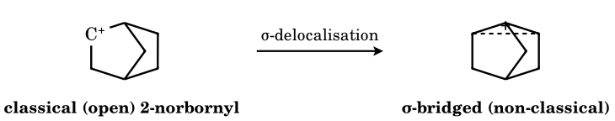
Figure 4.8 2-Norbornyl cation: classical structure (left, positive charge on C-2) and the σ-bridged non-classical structure (right, schematic: the C1–C6 σ bond delocalises toward C-2 – dotted line – and the positive charge is shared by C1, C2 and C6 inside the three-centre triangle). The two are not resonance forms (atoms move); the bridged structure is the better description of the real ion.
- Kinetic evidence (Winstein, 1950s): exo-2-norbornyl brosylate solvolyses ≈ 350 times faster than the endo isomer; both give exo product only and the product from optically active exo is racemic, as expected if σ(C1–C6) assists ionisation anti-periplanar to the exo leaving group, producing a symmetric (C_{s}) bridged ion that is attacked at either of two equivalent carbons.
- Spectroscopic evidence (Olah, 1960s–): in superacid at low temperature the ¹³C NMR shows rapid 6,2- and 3,2-hydride shifts and Wagner–Meerwein exchange that average carbon signals; at very low temperature (−150 °C, solid-state studies) the signals match a bridged structure with a strongly deshielded pentacoordinate-type carbon environment.
- Structural evidence: a crystal structure of the 2-norbornyl cation with an [Al₂Br₇]⁻ counterion (Scholz, Kramer, Sieber et al., Science 2013) shows the bridged geometry, with C–C distances between the three bridging carbons intermediate between single and bridged-cyclopropane values. (Recalled from the literature; the source was not accessible here.)
- The classical side (H. C. Brown): the high exo/endo ratio can be explained by steric hindrance to ionisation of the endo isomer and by rapid equilibration of classical ions. The consensus today is that the parent 2-norbornyl cation is bridged, whereas tertiary derivatives (2-methyl-2-norbornyl, 2-aryl-2-norbornyl) are classical because the substituent already supplies enough stabilisation.
- General rule: bridging is a ‘last resort’ stabilisation. It occurs when the classical ion would be primary or secondary and unstabilised and the geometry offers an anti-periplanar σ (or π, or lone-pair) donor; it disappears when an aryl, cyclopropyl or tertiary substitution stabilises the cation already.

4.10 Carbonium ions (hypercoordinate carbon)
CH₅⁺ (Figure 1.4) is the prototype. It has eight valence electrons for five C–H connections, so at least one bond is 3c–2e; the structure is fluxional (all five H exchange) and has an H₂ unit loosely bound to CH₃⁺. C₂H₇⁺ (protonated ethane) has a C–C or C–H σ bond protonated. In superacid, alkanes are protonated to carbonium ions, which lose H₂ (→ carbenium) or CH₄/alkanes (→ smaller carbenium ions: protolytic cracking, isomerisation). Carbonium and carbenium ions are different bonding types and cannot be put on one stability scale by counting substituents. Their relation is chemical, not energetic ranking: R₃C–H + H⁺ ⇌ [R₃C(H₂)]⁺ → R₃C⁺ + H₂.

4.11 Additional effects
- Ring strain and I-strain. Ionisation changes carbon from sp³ to sp². H. C. Brown: 1-methylcyclopentyl chloride solvolyses ≈ 40× faster than t-BuCl, 1-methylcyclohexyl ≈ 3× slower (the six-membered ring loses a stable staggered arrangement and gains eclipsing strain), 1-methylcycloheptyl faster again; cyclopropyl and cyclobutyl cations are strained (bond angle 60°/90° versus 120°) and ionise only with ring-opening/participation.
- Bridgehead constraint. The cation must be able to flatten. Rates of solvolysis (80 % EtOH, 25 °C, relative to t-BuBr): 1-adamantyl ≈ 10⁻³, bicyclo[2.2.2]oct-1-yl smaller, bicyclo[2.2.1]hept-1-yl (norbornyl) ≈ 10⁻¹³ (orders of magnitude recalled from Bingham–Schleyer; the sequence is secure) – a measure of the strain, not just of the cation’s intrinsic stability (Bartlett, Schleyer).
- Geometry/alignment. Anti-periplanar σ bonds (C–Si, C–C) and gauche vs anti hyperconjugation; bisected vs perpendicular cyclopropylcarbinyl; rigid frameworks fix the alignment.
- Field effects of remote polar groups; counterion and ion pairing (a tight, nucleophilic counterion such as Cl⁻ can covalently collapse the cation; SbF₆⁻ cannot); solvation (H-bond donors stabilise the incipient anion; ion-dipole solvation favours small, localised cations, which is why alkyl order inverts in solution relative to the gas phase).
- Isotope effects. A CD₃ group is a poorer hyperconjugative donor than CH₃ (zero-point-energy difference): β-d₃ substitution slows ionisation by a factor ≈ 1.3–2.4 per CD₃, a probe of hyperconjugation in the transition state.
Effect | Acts through | Strength guide | Common error to avoid
Resonance (+M) | p(π)/n → p | NR₂ > OR > SR > aryl > vinyl; strongest, needs coplanarity | forgetting SIR; counting meta as conjugated
Hyperconjugation | σ → p | C–Sn > C–Ge > C–Si > C–C ≳ C–H; angle-dependent | counting α-H blindly
Induction/field | σ framework, space | −I destabilises; +I stabilises; falls ≈ 2–3× per bond | overlooking +M of α-heteroatoms
Aromaticity | cyclic (4n+2) π | very large (tropylium, cyclopropenium) | calling 4n cations ‘stable’
Ring strain | rehybridisation | I-strain (5 > 6), bridgehead penalties | ignoring conformational change on ionisation
Bridging (σ/π/n) | 3c–2e or 3-ring onium | large for secondary/primary systems only | drawing both bridged and open ions as separate intermediates
Solvent/ion pair | electrostatics, H-bonding | can invert gas-phase orders | using solution rates as intrinsic stability

Part 5A Worked Solutions: the Supplied ‘Exercise 2 – Carbocation Stability Order’ (redrawn)
These are the stability-order problems you supplied (Exercise 2, Q1–Q35, and two multiple-choice questions). The structures are redrawn here from the images and the reasoning is new. Each answer is the order of decreasing stability, using the standard JEE-Advanced conventions: stability rises with substitution, resonance donors (+M), hyperconjugation (number and quality of C–H/C–C bonds in the correct position), aromaticity; falls with −I/−M groups, antiaromaticity and bridgehead (non-planar) geometry. For isotopes: C–H hyperconjugation > C–D > C–T when the isotopic group is on the carbon next to the cationic centre, but only the +I order (T > D > H) operates when the group is further away. Items I could not read with certainty (Q4, Q18, Q19, Q22, Q33, Q34) are listed at the end for you to confirm.
E2-1.
Arrange 1–3 in decreasing stability.
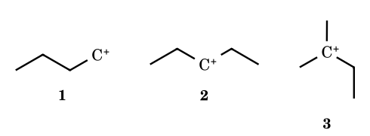
Answer: 3 > 2 > 1
Tertiary > secondary > primary: the number of alkyl groups on the cationic carbon (hyperconjugation and +I).
E2-2.
Arrange 1–3 in decreasing stability.
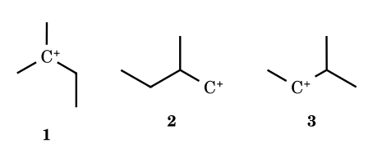
Answer: 1 > 3 > 2
1 is tertiary, 3 secondary, 2 primary (the 2-methylbutyl cation would rearrange, but as drawn it is primary).
E2-3.
Arrange 1–3 in decreasing stability.
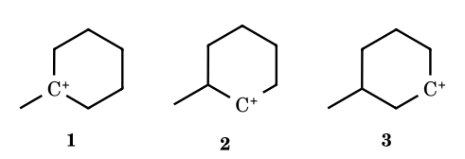
Answer: 1 > 2 > 3
1 is tertiary. 2 and 3 are secondary; the methyl group is adjacent to the cationic carbon in 2 (its C–H and C–C bonds hyperconjugate/β-branching), but only γ in 3 (+I only).
E2-5.
Arrange 1–3 in decreasing stability.
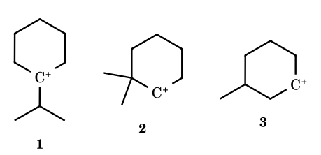
Answer: 1 > 2 > 3
1 is tertiary. 2 and 3 are secondary; 2 has the more alkyl-branched neighbourhood (a quaternary carbon next to C⁺), 3 only a remote methyl.
E2-6.
Arrange 1–3 in decreasing stability.
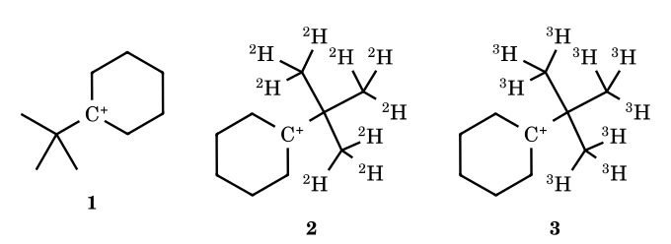
Answer: 3 > 2 > 1
The labelled methyl groups are on the carbon next to the quaternary carbon, i.e. γ to C⁺: no C–H/C–D/C–T bond is hyperconjugating. Only the inductive effect operates, and D and T are slightly more electron-releasing than H (T > D > H).
E2-7.
Arrange 1–3 in decreasing stability.
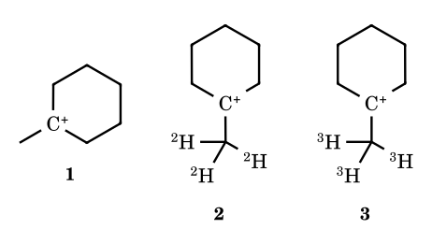
Answer: 1 > 2 > 3
Now the labelled group is directly on C⁺: hyperconjugation σ(C–X) → p operates, and C–H is a better donor than C–D, which is better than C–T (lower zero-point energy, shorter amplitude for the heavier isotope). β-Deuterium slows ionisation by about 1.3–2 per CD₃.
E2-8.
Arrange 1–3 in decreasing stability.
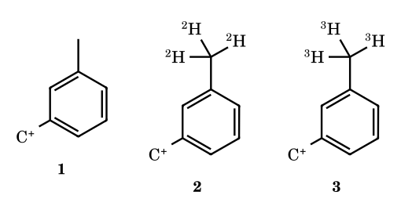
Answer: 3 > 2 > 1
A meta substituent cannot hyperconjugate with the benzylic cation (no resonance contributor puts charge on the meta carbon), so only the +I effect counts: CT₃ > CD₃ > CH₃.
E2-9.
Arrange 1–3 in decreasing stability.
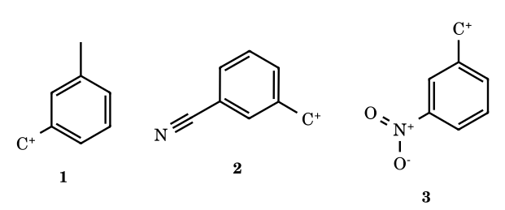
Answer: 1 > 2 > 3
m-CH₃ is weakly +I, m-CN and m-NO₂ are −I (σ_{m} 0.56 and 0.71): the stronger the −I, the less stable the cation.
E2-10.
Arrange 1–3 in decreasing stability.
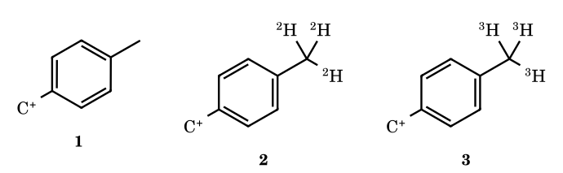
Answer: 1 > 2 > 3
p-Alkyl groups stabilise by hyperconjugation (charge is on the para carbon): C–H > C–D > C–T.
E2-11.
Arrange 1–3 in decreasing stability.
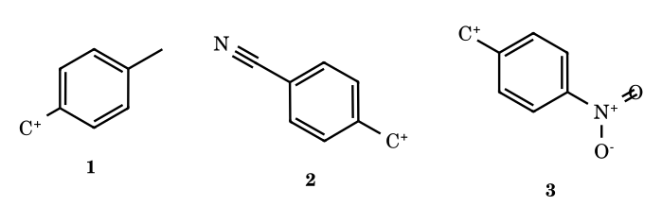
Answer: 1 > 2 > 3
p-CH₃ donates; p-CN and p-NO₂ withdraw by −I and −M (σ⁺ 0.66 and 0.79), NO₂ more strongly.
E2-12.
Arrange 1–3 in decreasing stability.
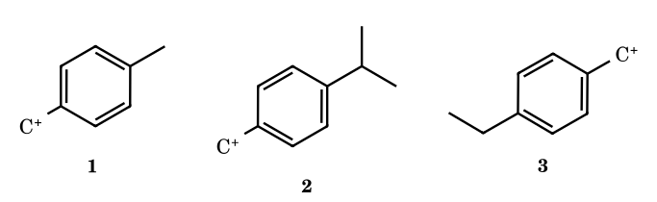
Answer: 1 > 3 > 2
Baker–Nathan order in solution: the number of hyperconjugating α-C–H bonds on the ring carbon: CH₃ (3) > CH₂R (2) > CHR₂ (1). (In the gas phase the order reverses, because polarisability then dominates.)
E2-13.
Arrange 1–3 in decreasing stability.
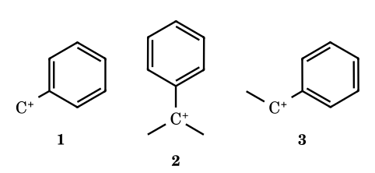
Answer: 2 > 3 > 1
All are benzylic; each α-methyl group adds hyperconjugation/+I: tertiary (cumyl) > secondary (1-phenylethyl) > primary (benzyl).
E2-14.
Arrange 1–3 in decreasing stability.
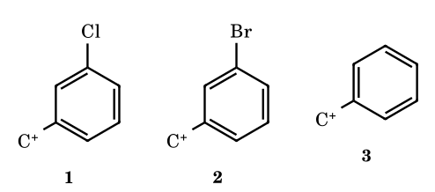
Answer: 3 > 2 > 1
No substituent is best. A meta halogen is only −I (no +M can reach the benzylic cation from the meta position), and Cl is more electronegative than Br (σ_{m}⁺ 0.40 vs 0.41, nearly equal; the conventional answer is Cl more destabilising).
E2-15.
Arrange 1–3 in decreasing stability.
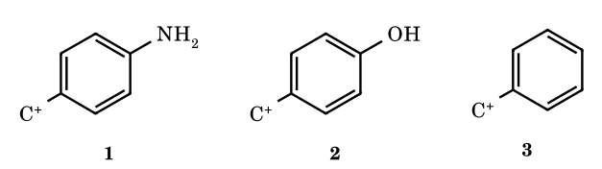
Answer: 1 > 2 > 3
p-NH₂ and p-OH are +M donors (the quinoid iminium/oxocarbenium contributor); nitrogen is the better donor (σ⁺ −1.3 vs −0.92).
E2-16.
Arrange 1–3 in decreasing stability.
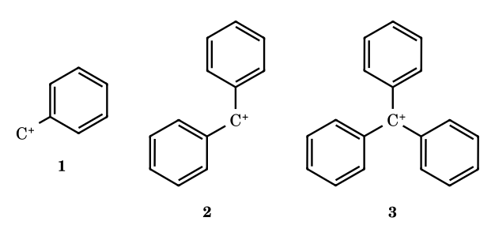
Answer: 3 > 2 > 1
Each additional phenyl delocalises the charge further: trityl (pK_{R+} −6.6) > diphenylmethyl (−13.3) > benzyl.
E2-17.
Arrange 1–3 in decreasing stability.
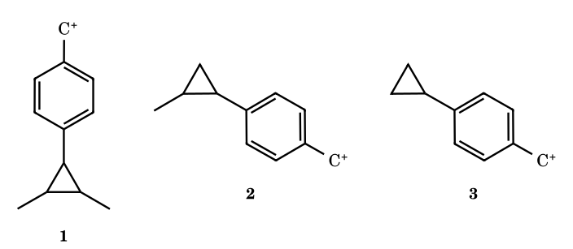
Answer: 1 > 2 > 3
A cyclopropyl ring on the benzene ring donates through its bent bonds (σ⁺ −0.41); each extra methyl on the ring adds +I/hyperconjugation to the donor.
E2-20.
Arrange 1–3 in decreasing stability.
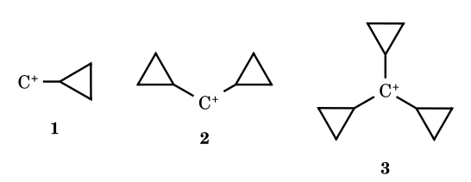
Answer: 3 > 2 > 1
Each cyclopropyl group donates its bent σ bonds in the bisected conformation: tricyclopropylmethyl (pK_{R+} −2.3, more stable than trityl) > dicyclopropyl > cyclopropylmethyl.
E2-21.
Arrange 1–3 in decreasing stability.
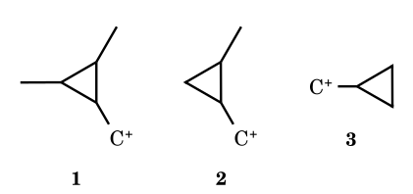
Answer: 1 > 2 > 3
Methyl groups on the cyclopropane ring increase its donor strength (+I and hyperconjugation).
E2-23.
Arrange 1–3 in decreasing stability.
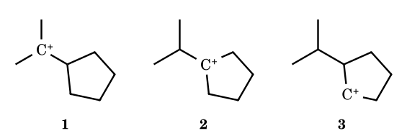
Answer: 2 > 1 > 3
2 and 1 are tertiary, 3 secondary. Ring cation 2 beats 1 because a five-membered ring prefers sp² carbon (I-strain: 1-methylcyclopentyl solvolyses ≈ 40× faster than t-butyl).
E2-24.
Arrange 1–3 in decreasing stability.
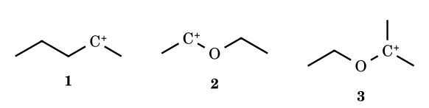
Answer: 3 > 2 > 1
An α-oxygen lone pair gives an oxocarbenium ion (+M ≫ hyperconjugation); the tertiary α-alkoxy ion also has two methyl groups.
E2-25.
Arrange 1–3 in decreasing stability.
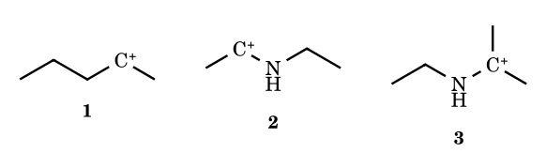
Answer: 3 > 2 > 1
An α-nitrogen lone pair gives an iminium ion; the more alkylated carbon (3) is better still. All are far more stable than the simple secondary alkyl cation 1.
E2-26.
Arrange 1–4 in decreasing stability.
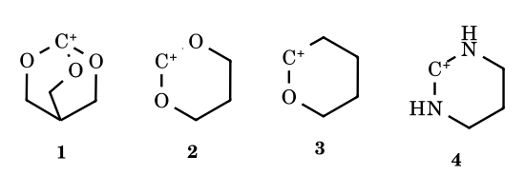
Answer: 4 > 2 > 3 > 1
Two nitrogen lone pairs (an amidinium-type ion, 4) > two oxygens (2) > one oxygen (3). Ion 1 would be best electronically (three oxygens) but it sits at a bridgehead of a rigid cage and cannot become planar, so the empty p orbital cannot overlap with the oxygen lone pairs: it is the least stable.
E2-27.
Arrange 1–4 in decreasing stability.
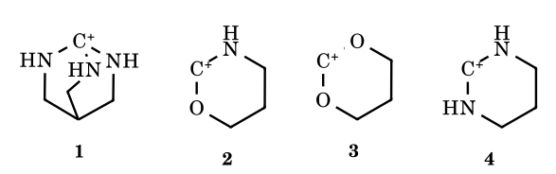
Answer: 4 > 2 > 3 > 1
N is a better π donor than O: N,N (4) > N,O (2) > O,O (3); the cage cation 1 is non-planar at the bridgehead and cannot be stabilised by resonance.
E2-28.
Arrange 1–4 in decreasing stability.
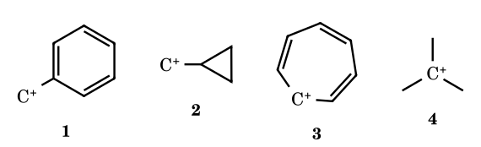
Answer: 3 > 2 > 1 > 4
Tropylium (aromatic 6π) is the most stable; cyclopropylmethyl (bisected σ-donation, ‘dancing resonance’) > benzyl (resonance) > tert-butyl (hyperconjugation only) by the usual JEE convention that resonance ≫ hyperconjugation. Note: measured gas-phase hydride affinities put t-Bu⁺ (≈ 231 kcal mol⁻¹) slightly below benzyl (≈ 238), i.e. t-Bu⁺ is the more stable in the gas phase; in solution the conventional order is the experimentally expected one for solvolysis.
E2-29.
Arrange 1–3 in decreasing stability.
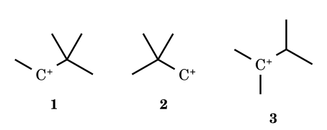
Answer: 3 > 1 > 2
3 is tertiary; 1 is secondary (and will rearrange by a methyl shift to a tertiary ion); 2 is the primary neopentyl cation.
E2-30.
Arrange 1–3 in decreasing stability.
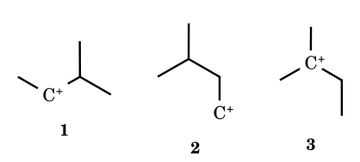
Answer: 3 > 1 > 2
Tertiary > secondary > primary.
E2-31.
Arrange 1–3 in decreasing stability.
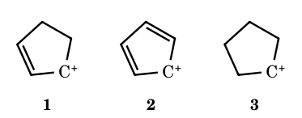
Answer: 1 > 3 > 2
1 is allylic (resonance); 3 is a simple secondary cation; 2, the cyclopentadienyl cation, is antiaromatic (4π) and the least stable.
E2-32.
Arrange 1–3 in decreasing stability.
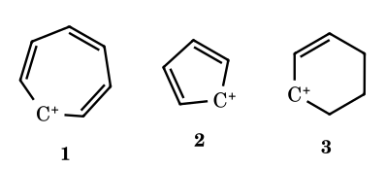
Answer: 1 > 3 > 2
Tropylium (aromatic, 6π) > cyclohex-2-enyl (allylic) > cyclopentadienyl (antiaromatic).
E2-35.
Arrange 1–3 in decreasing stability.
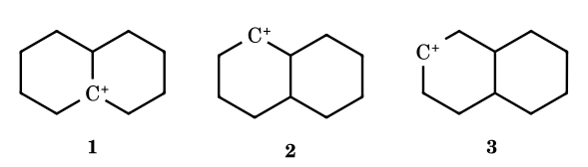
Answer: 1 > 2 > 3
1 is tertiary (ring fusion); 2 and 3 are secondary, and 2 has the branched ring-fusion carbon adjacent to C⁺ (more hyperconjugation) while 3 does not.
E2-91.
Which allylic carbocation is the most stable? (a) CH₃–CH=CH–CH₂⁺, (b) CH₃–CH=CH–CH⁺–CH₃, (c) CH₃–CH=CH–C⁺(CH₃)₂, (d) all have the same stability.
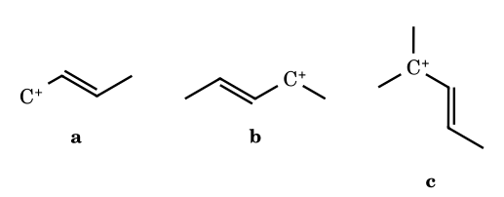
Answer: (c)
Each is an allyl cation delocalised over two carbons, but the alkyl groups at the termini differ: (a) has a primary terminus, (b) a secondary, (c) a tertiary terminus. Charge is shared by both termini, so the more substituted ion (c) is the most stable. (d) is wrong: the alkyl substitution differs.
E2-93.
Which of the following carbocations is the most stable? (a) tricyclopropylmethyl, (b) benzyl, (c) tropylium (cycloheptatrienyl), (d) isopropyl.
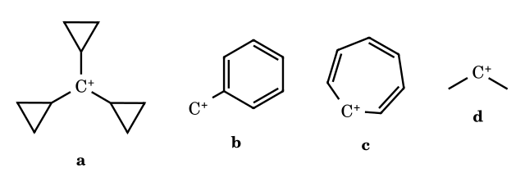
Answer: (c)
Tropylium is aromatic (6π, planar, charge shared by seven carbons; pK_{R+} +4.7): the order is tropylium > tricyclopropylmethyl > benzyl > isopropyl.

Items from your exercise that need confirmation
I could not read these structures reliably from the images, so I have not answered them. Please tell me (or send a clearer image of) the exact substituents: Q4 (positions of the two methyl groups on each cyclohexyl cation), Q18 and Q19 (the ring substituents on the benzyl cations are not visible), Q22 (the polyspiro cyclopropane/cyclobutane cations: the geometry of the spiro rings relative to the cationic centre decides whether cyclopropyl donation can operate), Q33 (ring positions of the methyl groups) and Q34 (which carbons of the oxygen heterocycles carry the double bonds).

Part 5B Worked Solutions: the Supplied ‘Electronic Displacement Effects’ Carbocation Problems (redrawn)
These are the carbocation-stability items from the ‘Exercise O-II’ set you supplied (Q8–Q16 of that exercise). Structures are redrawn and the reasoning is new. Orders are decreasing stability unless the question says otherwise, using JEE-Advanced conventions; where the textbook key conflicts with measured data it is flagged. The carbanion and radical items from the same pages (Q17–Q20) are answered in the carbanion and free-radical chapters, and the aromaticity, bond-length and resonance-energy items belong with those topics.
E3-8.
Select the least stable cation.
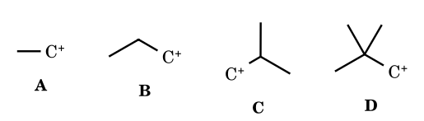
Answer: (D) neopentyl
All four are primary, so count the hyperconjugating C–H bonds on the carbon next to C⁺: ethyl 3, n-propyl 2, isobutyl 1, neopentyl 0 (its α-carbon is quaternary). Stability ethyl > propyl > isobutyl > neopentyl, so neopentyl is the least stable (the printed key in your PDF agrees). Correction: an earlier build of this book answered (A) using a +I/polarisability argument; that is the gas-phase trend, but the exam answer follows the α-H count.
E3-9(i).
Arrange in decreasing stability.
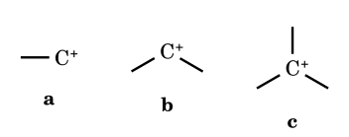
Answer: c > b > a
Tertiary > secondary > primary.
E3-9(ii).
Arrange in decreasing stability.
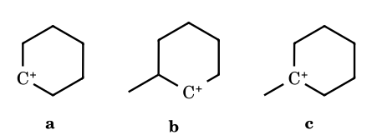
Answer: c > b > a
c is tertiary; a and b are secondary, and b carries an extra adjacent methyl-bearing carbon (more α-C–C/C–H hyperconjugation).
E3-9(iii).
Arrange in decreasing stability (cyclopentyl-substituted cations).
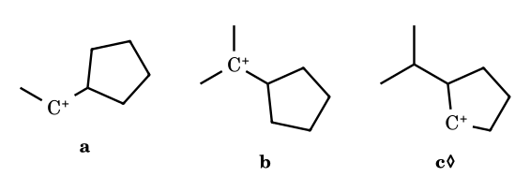
Answer: b > c > a (key)
b is tertiary. a and c are secondary; the key puts the ring cation c above the exocyclic cation a (cyclopentyl cations are favoured by relief of I-strain, and in c the isopropyl group adds hyperconjugating C–C/C–H bonds next to C⁺). ◊ The position of the isopropyl group in c is my reading of the drawing.
E3-9(vi).
Arrange in decreasing stability (three alkyl cations from the chain drawings).
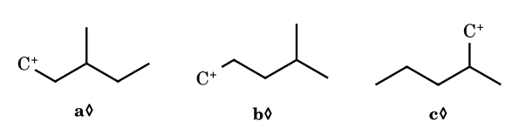
Answer: key: b > c > a; your Allen solution page: a > b > c
Conflict. The printed answer key of your PDF gives b > c > a for 9(vi), but the worked solution on the ‘Electronic displacement effects’ page you also sent gives a > b > c (α-H = 2, 2, 1, then +I). I cannot tell from the drawings which chain is which, so I do not choose between them. The rule they use is: count α C–H bonds first (more is better), and if equal, the stronger +I (larger or more branched alkyl) wins.
E3-9(iv).
Arrange the cycloalkyl cations in decreasing stability.
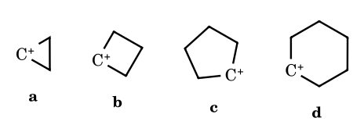
Answer: d > c > b > a (textbook key)
Textbook key: angle strain at the sp² centre (60° in cyclopropyl, 90° in cyclobutyl) destabilises the small rings. Conflict with data: solvolysis rates (I-strain) make cyclopentyl faster than cyclohexyl, and cyclobutyl is stabilised by non-classical bridging, so the experimental order is closer to c > d > b > a. If a question forces one answer, use the key; know the data.
E3-9(v).
Arrange in decreasing stability.
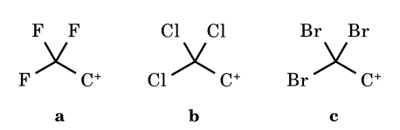
Answer: c > b > a
All three groups are −I; the strength of the effect follows electronegativity, F ≫ Cl > Br, so CBr₃ destabilises least.
E3-9(vii).
Arrange in decreasing stability.
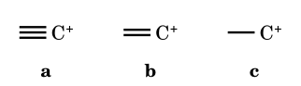
Answer: c > b > a
The empty orbital sits on sp (50% s) or sp² (33% s) carbon: the more s-character, the more tightly held the electrons and the less stable the cation. Ethyl uses a p orbital.
E3-9(viii).
Arrange the aryl cations in decreasing stability.
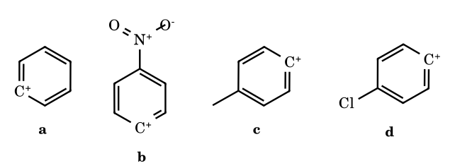
Answer: c > a > d > b
The empty sp² orbital lies in the ring plane, orthogonal to the π system, so there is no resonance: only the inductive effect operates. CH₃ is +I; Cl is −I and NO₂ is more strongly −I.
E3-9(ix).
Arrange the benzyl cations in decreasing stability.
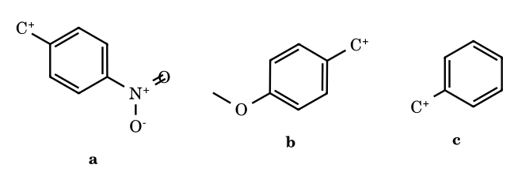
Answer: b > c > a
p-OMe donates by +M (oxocarbenium contributor); NO₂ withdraws by −M and −I.
E3-9(x).
Arrange the hydroxybenzyl cations in decreasing stability.
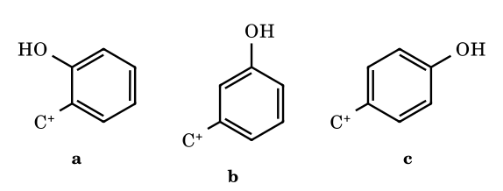
Answer: c > a > b
Ortho and para OH can place the positive charge on oxygen (+M); meta cannot, and there OH is only −I. Para is better than ortho by the usual key (ortho: the −I effect is stronger at short distance and the oxygen lone pair is nearer the charge).
E3-9(xi).
Arrange the methylbenzyl cations in decreasing stability.
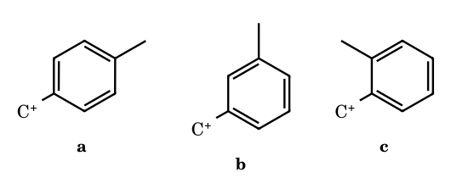
Answer: c > a > b
Ortho and para CH₃ hyperconjugate with the delocalised charge; meta cannot. Textbook key puts ortho first (closer +I and hyperconjugation); steric effects can reverse this in real systems.
E3-9(xii).
Arrange the p-alkylbenzyl cations in decreasing stability.
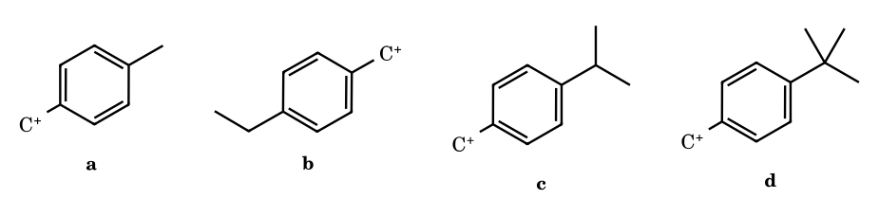
Answer: a > b > c > d
Baker–Nathan order: the number of hyperconjugating α-C–H bonds is 3, 2, 1, 0. (Pure inductive donation would give the opposite order.)
E3-9(xiii).
Arrange in decreasing stability.
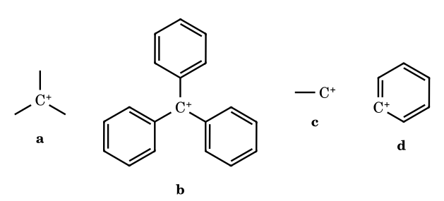
Answer: b > a > c > d
Trityl (three-ring delocalisation) > tertiary alkyl > primary alkyl > phenyl cation (no resonance, charge in an sp² orbital).
E3-9(xv).
Arrange in decreasing stability.
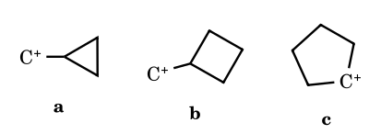
Answer: a > c > b
Cyclopropylmethyl is stabilised by bent-bond donation (σ → p overlap in the bisected conformation); cyclopentyl is secondary; cyclobutylmethyl is an ordinary primary cation.
E3-9(xvi).
Arrange in decreasing stability.
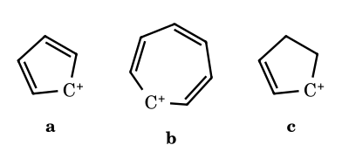
Answer: b > c > a
Tropylium is aromatic (6π); cyclopent-2-enyl is allylic; cyclopentadienyl is antiaromatic (4π) and the least stable of all.
E3-10.
Which statements are correct? (I) CH₃OCH₂⁺ is more stable than CH₃CH₂⁺. (II) (CH₃)₂CH⁺ is more stable than CH₃CH₂CH₂⁺. (III) CH₂=CH–CH₂⁺ is more stable than CH₃CH₂CH₂⁺. (IV) CH₂=CH⁺ is more stable than CH₃CH₂⁺. (A) I, II (B) III, IV (C) I, II, III (D) II, III, IV
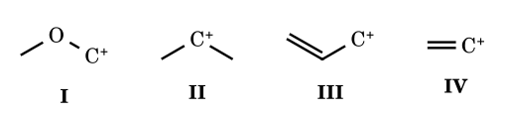
Answer: (C)
I: α-oxygen lone pair gives an oxocarbenium ion. II: secondary > primary. III: allyl resonance. IV is false: the vinyl cation has an sp-hybridised cationic carbon, which is less stable than ethyl.
E3-11a/b.
Which ion is more stable? (a) C₆H₅CH₂⁺ or CH₂=CH–CH₂⁺; (b) CH₃CH₂⁺ or CH₂=CH⁺.
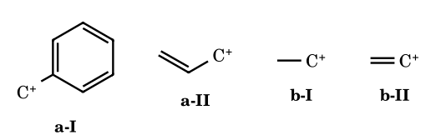
Answer: (a) benzyl; (b) ethyl
(a) Benzyl delocalises the charge over four carbons (seven contributors incl. ring), allyl over two. (b) The vinyl cation is sp-hybridised and the empty p orbital has no hyperconjugating partners except one C–H.
E3-13.
Which is the most stable? (A) Ph₃C⁺ (B) (CH₃)₃C⁺ (C) (CH₃)₂CH⁺ (D) CH₂=CH–CH₂⁺
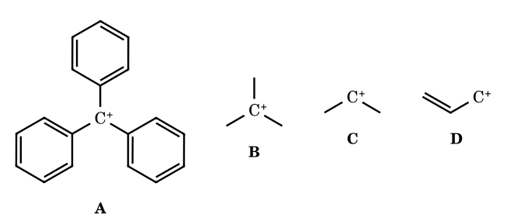
Answer: (A)
Trityl: charge is delocalised over three rings (ten carbons’ worth of contributors); pK_{R+} = −6.6 compared with about −15 for t-butyl.
E3-14.
Increasing order of stability of (a) p-CH₃O–C₆H₄CH₂⁺ (b) C₆H₅CH₂⁺ (c) p-CH₃–C₆H₄CH₂⁺ (d) CH₃CH₂⁺.
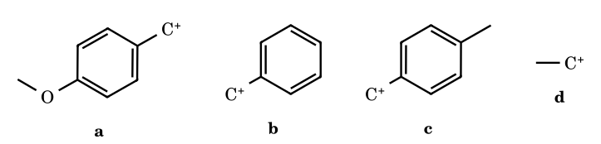
Answer: d < b < c < a → (A)
Ethyl (no resonance) < benzyl < p-methylbenzyl (hyperconjugation) < p-methoxybenzyl (+M).
E3-15.
Correct order of stability: (1) p-HO– (2) p-H₂N– (3) p-CH₃– (4) p-(CH₃)₃C– benzyl cation.
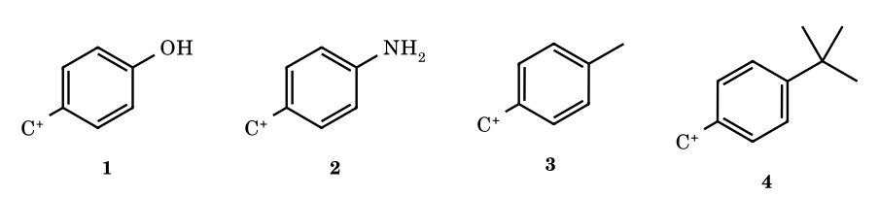
Answer: 2 > 1 > 3 > 4 → (D)
NH₂ is a stronger +M donor than OH (σ⁺ −1.3 vs −0.92); CH₃ has three α-C–H bonds, t-Bu none.
E3-16.
Increasing order of stability: (I) p-methylbenzyl, (II) p-nitrobenzyl, (III) 3,5-diisopropyl-4-nitrobenzyl cation.
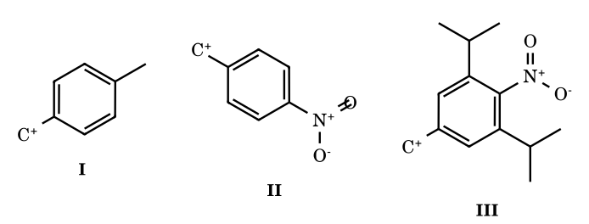
Answer: II < III < I → (B)
Steric inhibition of resonance: the two flanking isopropyl groups twist the nitro group out of the ring plane, so it loses its −M effect and only −I remains. III is therefore less destabilised than II (full −M and −I), but still less stable than the methyl-substituted I.

Part 5C Worked Solutions: Supplied ‘How Many’ Counting Problems (redrawn)
Counting problems need every item judged correctly, so the reasoning for each item is given. The structures are redrawn from your images; where a drawing was ambiguous I state the reading I used, because a different reading can change the count. Items marked ◊ are the ones to double-check against your original.
C-7.
How many of these cations are more stable than the benzyl cation?
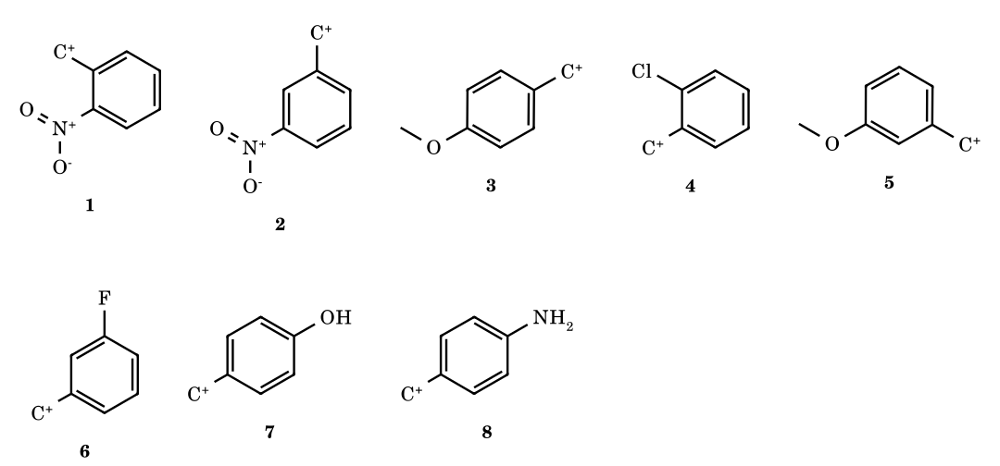
Answer: 3 (p-OCH₃, p-OH, p-NH₂)
Only +M donors in the ortho/para position beat hydrogen: p-OMe, p-OH and p-NH₂ (σ⁺ −0.78, −0.92, −1.3). o-NO₂ and m-NO₂ are strongly −I (−M too in the ortho case). m-OMe and m-F act only by −I, because no resonance contributor puts charge on the meta carbon. o-Cl is −I and its +M is weak (σ⁺_{p} Cl = +0.11, i.e. slightly destabilising), so it is below benzyl.
C-11a.
Among the pairs, how many have (i) more reactive than (ii) towards AgNO₃? (Reactivity = ease of ionising C–X, i.e. stability of the carbocation formed; SN1 path.)
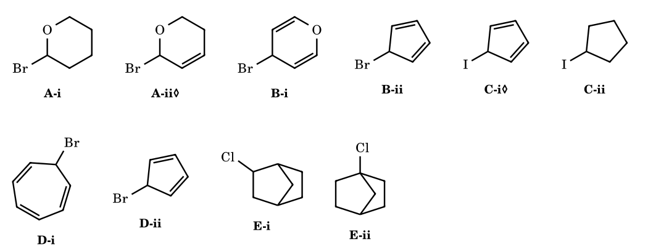
Answer: 3 (B, D and E)
A: both give an oxocarbenium ion; in my reading (ii) is also allylic, so (ii) is more reactive (not counted). If (ii) is an isolated or enol-ether double bond the pair would count, so check the position of the double bond. B: (i) loses Br⁻ to give the pyrylium ion, aromatic (6π, O lone pair + two C=C); (ii) would give the antiaromatic cyclopentadienyl cation. (i) ≫ (ii): counts. C: reading (i) as 5-iodocyclopenta-1,3-diene, ionisation gives the antiaromatic cyclopentadienyl cation, much worse than a plain secondary cyclopentyl cation, so (i) is less reactive (not counted). If (i) were 3-iodocyclopentene (allylic) it would count. D: (i) gives the aromatic tropylium ion; (ii) the antiaromatic cyclopentadienyl cation: counts. E: (i) is a secondary 2-chloronorbornane (ionises, with σ-participation); (ii) is a bridgehead chloride, whose cation cannot become planar: counts.
C-12a.
How many of the following are more stable than the isopropyl cation, owing to +R together with −I effects?
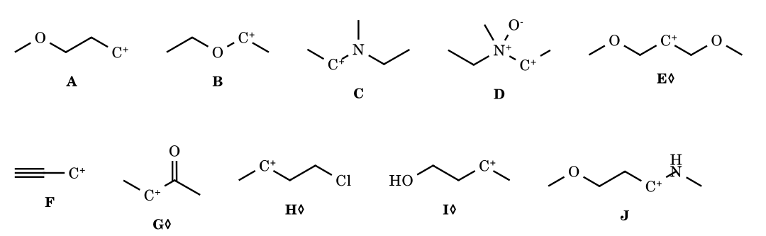
Answer: 3 (B, C and J)
A +R group must be bonded directly to C⁺ with a free lone pair. B is an oxocarbenium ion and C and J are iminium ions: all three are far more stable than a secondary alkyl cation. D: the nitrogen lone pair is tied up in the N→O bond, so there is no +R and a strong −I (N⁺–O⁻). A, E, H and I have the heteroatom or halogen one or more carbons away from C⁺: only −I operates, which destabilises. F: propargyl is resonance-stabilised but the sp carbon is −I, and it is less stable than secondary alkyl (gas-phase hydride affinity higher than i-Pr⁺). G: α-carbonyl cation, destabilised by −I and −M.
C-11b.
Species: quinuclidine, cyclooctatetraene, naphthalene, cyclopropenyl cation, tropylium ion, propene, 1,3-butadiene. x = number in which resonance takes place; y = number in which every C–C bond length is equal. Find (x² + y² + 1)/(x + y + 1).
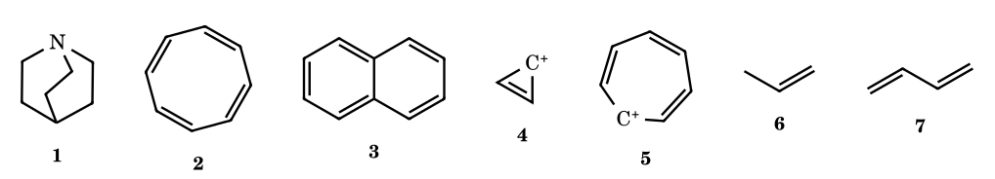
Answer: x = 4, y = 2, value = 21/7 = 3
Resonance (π delocalisation) occurs in naphthalene, the cyclopropenyl cation, tropylium and 1,3-butadiene: x = 4. Quinuclidine has no π system; cyclooctatetraene is tub-shaped, so its double bonds do not conjugate (alternating bond lengths); propene only has hyperconjugation. All C–C bonds are equal only in the cyclopropenyl and tropylium cations (complete delocalisation round a symmetric ring): y = 2. Naphthalene (1.36/1.42 Å) and butadiene have unequal bonds; in quinuclidine C2–C3 and C3–C4 are not symmetry-equivalent. (16 + 4 + 1)/(4 + 2 + 1) = 3.
C-12b.
How many of the following cations are more stable than the benzyl cation?
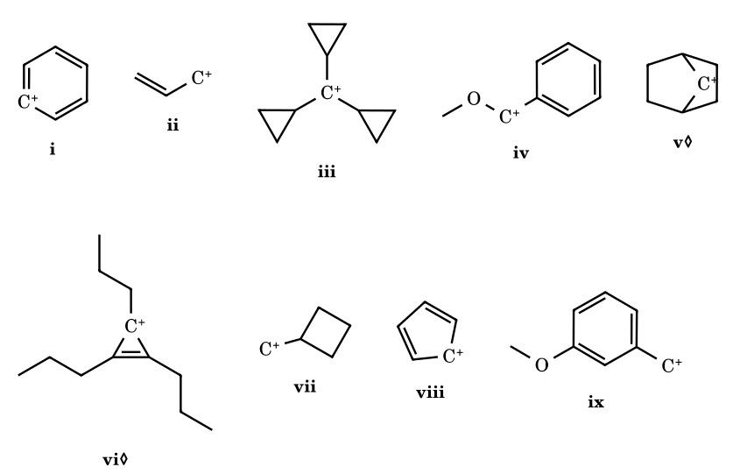
Answer: 3 (iii, iv, vi)
iii: tricyclopropylmethyl (pK_{R+} −2.3) is more stable than benzyl. iv: α-methoxybenzyl is both benzylic and an oxocarbenium ion. vi: an alkyl-substituted cyclopropenyl cation is aromatic (2π, pK_{R+} about +10). i: phenyl cation has its empty orbital in the ring plane, no resonance. ii: allyl is less stabilised than benzyl. v: the norbornyl cation at C7 (or at a bridgehead) is held non-planar and cannot delocalise. vii: ordinary primary cation. viii: antiaromatic. ix: m-OMe is only −I.
C-15.
How many of the given cations are more stable than the ethyl cation?
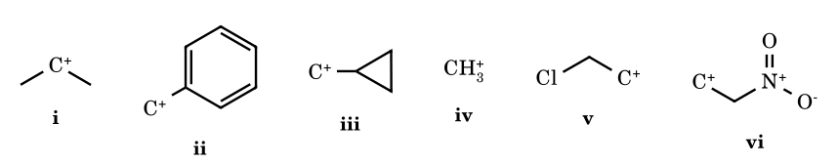
Answer: 3 (i, ii, iii)
i: secondary > primary. ii: resonance. iii: bent-bond donation from the cyclopropane ring. iv: methyl cation is less stable than ethyl (no hyperconjugation). v and vi: the −I effect of Cl and NO₂ destabilises the classical ion. (Real β-chloroalkyl cations are in fact bridged chloronium ions, which are lower in energy than a classical ethyl cation; the exam-level answer treats v as destabilised.)
C-23.
How many carbocations undergo rearrangement?
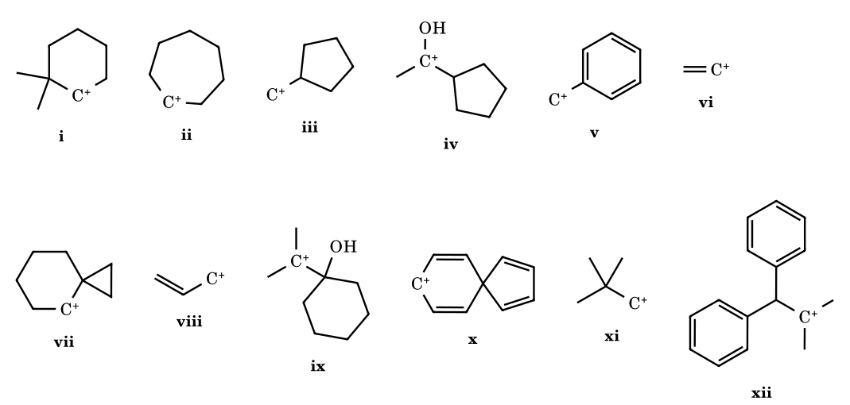
Answer: 7 (i, iii, vii, ix, x, xi, xii)
A cation rearranges only if a 1,2-shift gives a more stable ion. i 2,2-dimethylcyclohexyl (2°) → methyl shift → tertiary. iii cyclopentylmethyl (1°) → hydride shift to 1-methylcyclopentyl (3°), or ring expansion to cyclohexyl. vii cyclopropylcarbinyl-type: ring expansion of the cyclopropane to a cyclobutyl ring gives a tertiary ion. ix pinacol-type: ring-carbon migration to the cationic carbon expands the ring and gives a protonated ketone (2,2-dimethylcycloheptanone). x this is an ipso arenium ion with a spiro carbon: a 1,2 alkyl shift restores the aromatic ring (dienone–phenol type). xi neopentyl → methyl shift → tert-amyl. xii Ph₂CH–C⁺Me₂ → hydride shift → Ph₂C⁺–CHMe₂ (diphenylmethyl-type, more stable). No rearrangement: ii cycloheptyl (a hydride shift gives the same type of ion), iv an α-hydroxy carbenium ion is already stabilised by oxygen, and the shift would lose that, v benzyl, vi vinyl, viii allyl (resonance, not rearrangement).

Part 5D Worked Solutions: More Supplied Counting Problems (heterolysis, statements, rearrangement, AgNO₃)
Structures are redrawn from your images. Items marked ◊ were hard to read; the reading I used is stated, and a different reading can change the count. Conventions as before: the JEE key ranks resonance above hyperconjugation, so benzyl is taken as more stable than t-butyl even though gas-phase hydride affinities say otherwise.
D-27.
For how many compounds is the heterolytic C–Cl bond energy less than that of (CH₃)₃C–Cl? (A lower heterolysis energy means a more stable cation is formed than t-Bu⁺.)
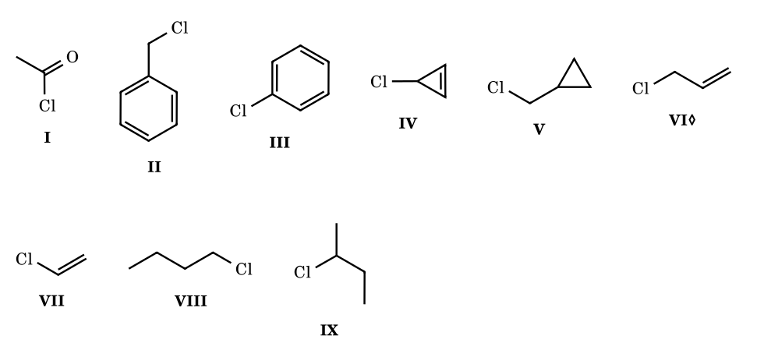
Answer: 4 (I, II, IV, V)
I gives the acylium ion CH₃C≡O⁺, stabilised by oxygen lone-pair donation: counts (conventional key). II benzyl (resonance over the ring): counts. IV 3-chlorocyclopropene gives the aromatic cyclopropenyl cation: counts. V cyclopropylmethyl cation (bent-bond donation, more stable than benzyl): counts. III and VII: aryl and vinyl cations (sp²/sp, no resonance, C–Cl also strengthened by p–π overlap): no. VIII primary and IX secondary: less stable than tertiary. VI allyl: a primary cation with two resonance forms, ranked below the tertiary cation by the usual key (gas-phase hydride affinity agrees: allyl is less stable than t-Bu⁺). If your source ranks allyl above tertiary the count would be 5.
D-38.
Find the number of correct statements.
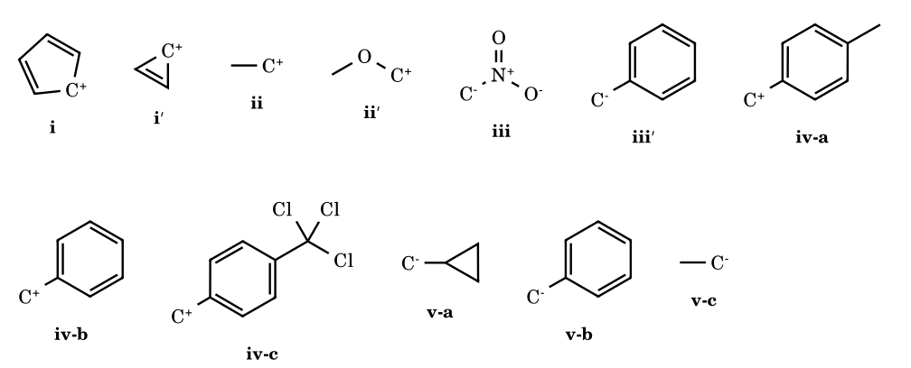
Answer: 5 (i, ii, iii, iv, vi correct; v is wrong)
(i) Cyclopentadienyl cation is antiaromatic (4π); cyclopropenyl is aromatic (2π): the statement is correct. (ii) Ethyl is less stable than methoxymethyl (oxocarbenium, +M): correct. (iii) ⁻CH₂NO₂ is delocalised onto oxygen (nitronate), much better than benzyl anion: correct. (iv) p-CH₃ donates, CCl₃ withdraws (−I): p-methylbenzyl > benzyl > p-CCl₃-benzyl: correct. (v) Benzyl anion is delocalised into the ring and is much more stable than cyclopropylmethyl anion, which only has a weak s-character effect: the correct order is benzyl > cyclopropylmethyl > ethyl, so the statement is wrong. (vi) Singlet carbene stability follows π-donation from halogen lone pairs into the empty p orbital, best for 2p–2p overlap with F, then Cl, Br, I: CF₂ > CCl₂ > CBr₂ > CI₂: correct.
D-19 / D-21b.
How many of these carbocations can undergo rearrangement? (The same set appears twice in your pages.)
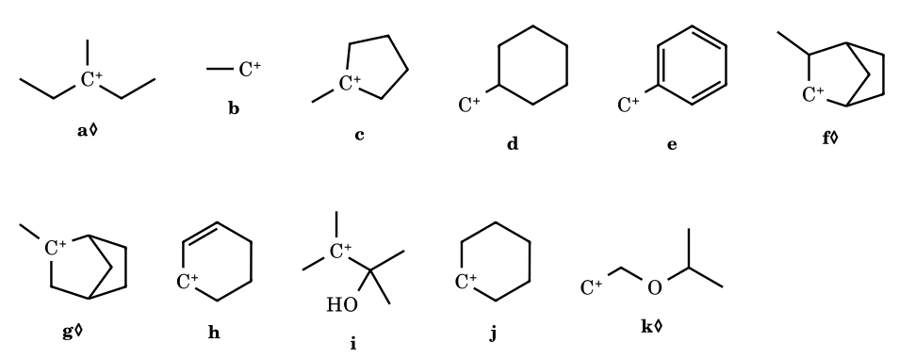
Answer: 4 (d, f, i, k)
d cyclohexylmethyl (1°): hydride shift to 1-methylcyclohexyl (3°) or ring expansion to cycloheptyl. f 3-methyl-2-norbornyl (2°): hydride shift from the methyl-bearing carbon gives the tertiary 2-methyl-2-norbornyl ion. i pinacol-type (CH₃)₂C⁺–C(OH)(CH₃)–: a methyl shift gives a protonated ketone. k the β-alkoxy primary cation ⁺CH₂CH₂OR: a 1,2-hydride shift gives the oxocarbenium ion CH₃CH⁺OR, far more stable. No rearrangement: a tertiary (3-methyl-3-pentyl, as I read it); b ethyl (the only shift is degenerate); c tertiary; e benzyl; g tertiary 2-methylnorbornyl (a shift would only give another tertiary or a less stable ion); h allylic; j cyclohexyl (the 1,2-H shift is degenerate; ring contraction to methylcyclopentyl is only seen in superacid, so it is not counted at this level). ◊ If a is really a secondary cation next to a quaternary carbon, it would rearrange and the count becomes 5.
D-21a.
How many of the following give a white precipitate with aqueous AgNO₃? (AgCl forms only if the C–Cl bond ionises readily, i.e. the cation is very stable.)
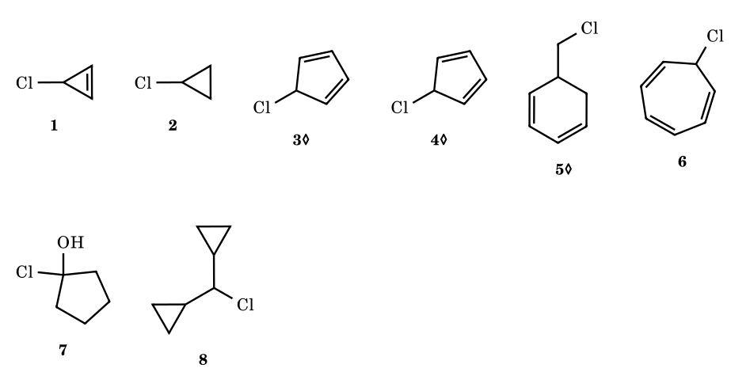
Answer: 4 (1, 6, 7, 8)
1 3-chlorocyclopropene → aromatic cyclopropenyl cation. 6 7-chlorocycloheptatriene → tropylium chloride (an ionic salt, immediate AgCl). 7 1-chlorocyclopentanol: an α-chloro alcohol loses Cl⁻ to give the protonated ketone (oxocarbenium), then cyclopentanone. 8 dicyclopropylmethyl chloride: the cation is stabilised by two cyclopropyl groups. 2 cyclopropyl chloride: the cyclopropyl cation is strained and unstable (ionisation and ring-opening are concerted and slow). 3, 4 I read these as 5-chlorocyclopenta-1,3-dienes: loss of Cl⁻ would give the antiaromatic cyclopentadienyl cation, so no precipitate. 5 I read this as a chloromethyl group on a saturated ring position, an ordinary primary chloride: no precipitate. ◊ Please check items 3–5 against your page: if any of them is allylic (for example 3-chlorocyclopentene) it would give a precipitate.

Part 5E Your ‘Stability of Carbocation’ Notes (cation.pdf): everything added, redrawn and checked
This part reproduces the content of the 11-page handwritten note you supplied: the factor list, the worked orders 1–12, the pK_{R}⁺ ladder, the gas-phase hydride-affinity table, the tabulated pK values, σ-bond resonance and the non-classical ions, and the aryl-cation substituent series. Structures are redrawn; numerical values are transcribed from your pages (they are literature values quoted in the note, not independently re-measured here). Where something in the note disagrees with another part of the same note, or with the data it quotes, the disagreement is marked ⚑ Check and the reasoning is given, so you can decide which to use in an exam.

5E.1 The factor list
Stabilising factor | Rule from the note | Comment
+R / +M | stability ∝ +R/+M | lone-pair or π donation into the empty p orbital; the strongest effect (oxocarbenium, iminium, arylmethyl with p-OMe/NR₂)
+H (hyperconjugation) | ∝ number of α C–H (and C–C) bonds | counted on the carbon next to C⁺; 9α > 6α > 4α in example 3
+I | ∝ electron release by alkyl | matters when hyperconjugation is absent or equal
−I, −H, −M | stability ∝ 1/(−I), 1/(−H), 1/(−M) | withdrawing groups, loss of hyperconjugating bonds, and acceptors destabilise
The note adds two measured quantities: the gas-phase hydride affinity (HIA; lower = more stable cation) and the solution pK_{R}⁺ (higher = more stable cation). They are separate observables and, as the note's own data show, do not always give the same order.

5E.2 Worked orders 1–12 (redrawn)
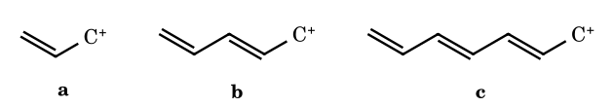
1. Longer conjugation: a < b < c (allyl < pentadienyl < heptatrienyl); more resonance contributors spread the charge over more carbons.
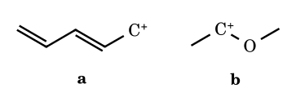
2. a < b. The pentadienyl cation a has a sextet on carbon; in b oxygen gives a lone pair so every atom has an octet (oxocarbenium).
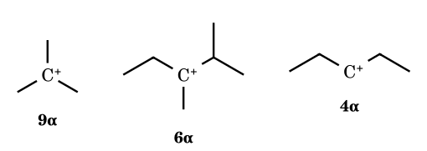
3. 9α > 6α > 4α, i.e. hyperconjugation by α C–H bond count (H > I). ⚑ Check: as drawn (second and third), the counts follow the note; the middle cation is tertiary and the last secondary, so the order is also tertiary > … secondary, which agrees.
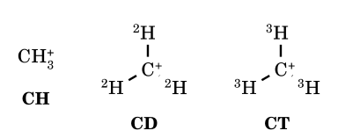
4. CH₃⁺ < CD₃⁺ < CT₃⁺. The isotopes sit on C⁺, so no C–X bond is hyperconjugating: only the +I order T > D > H is left.
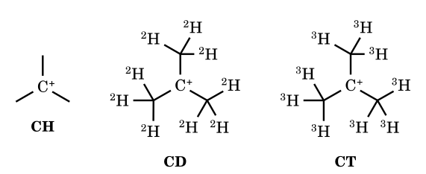
5. (CH₃)₃C⁺ > (CD₃)₃C⁺ > (CT₃)₃C⁺. Now the labelled groups are β to the charge: hyperconjugation dominates, and C–H (weakest, highest zero-point energy) donates best. The note summarises: +I order CT₃ > CD₃ > CH₃; hyperconjugation (+H) order CH₃ > CD₃ > CT₃ (BDE C–T > C–D > C–H); the +H effect wins.
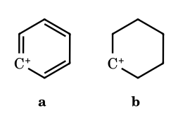
6. As drawn in the note: a > b (phenyl cation > cyclohexyl cation).
⚑ Check, item 6. This inequality is the wrong way round on the note's own data: the hydride affinity table (5E.4) gives phenyl 294 and a secondary cation (isopropyl) 249 kcal/mol; a secondary cyclohexyl cation is therefore far more stable than phenyl, whose empty orbital is an sp² σ orbital in the ring plane with no resonance. I recommend recording: cyclohexyl > phenyl. If your source key says otherwise, treat it as a misprint.
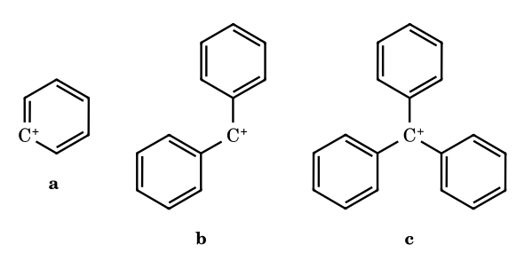
7. a < b < c: phenyl cation < diphenylmethyl < trityl (each phenyl delocalises the charge).
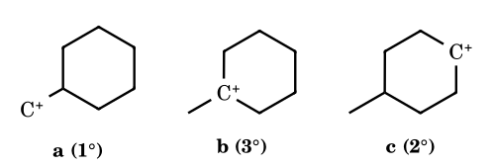
8. a < c < b: primary < secondary < tertiary.
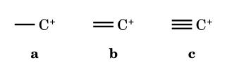
9. a > b > c: the more s-character in the carbon bearing the empty orbital (sp³-like p, sp², sp), the less stable the cation.
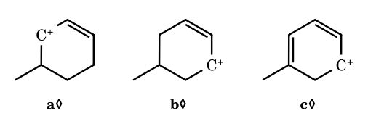
10. c > a > b. c is a cyclohexadienyl (pentadienyl-type, two C=C) cation; a and b are allylic secondary; a has a methyl-bearing carbon next to the cationic carbon (extra hyperconjugation), b only a remote one. ◊ Positions of the methyl and the ring double bonds are my reading of the drawing.
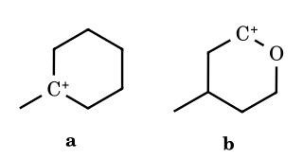
11. a < b as printed in the note (cyclic oxocarbenium: b has the + next to O).
⚑ Check, item 11. In the second structure the cation sits next to the ring oxygen only if the positive charge is on C2 (drawn at the position adjacent to O). That is the oxocarbenium ion, and it is more stable than the tertiary 1-methylcyclohexyl cation, which agrees with the note. If the cation were on C3 (β to O) the −I effect would make it less stable than the tertiary ion; item 12 shows exactly that difference.
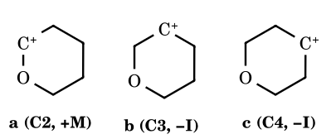
12. a > b > c: oxygen donates its lone pair when the cation is α (C2); at C3 and C4 only the −I effect operates, strongest at C3 (nearer to O).

5E.3 ‘Important order’: the pK_{R}⁺ ladder
pK_{R}⁺ is defined from the equilibrium R⁺ + H₂O ⇌ ROH + H⁺ by pK_{R}⁺ = log([R⁺]/[ROH]) + H_{R}, where H_{R} is the acidity function that plays the role of pH in strong acid. A cation with a larger pK_{R}⁺ persists at a more acidic medium, i.e. is more stable. (Your note writes the equilibrium as H⁺ + ROH ⇌ R⁺ + H₂O; that is the same reaction read in the cation-forming direction, and the formula above is the standard one.)
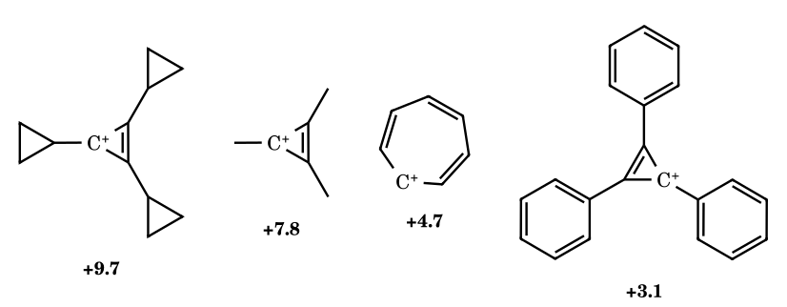
Aromatic cations first: tricyclopropylcyclopropenyl > trimethylcyclopropenyl > tropylium > triphenylcyclopropenyl.
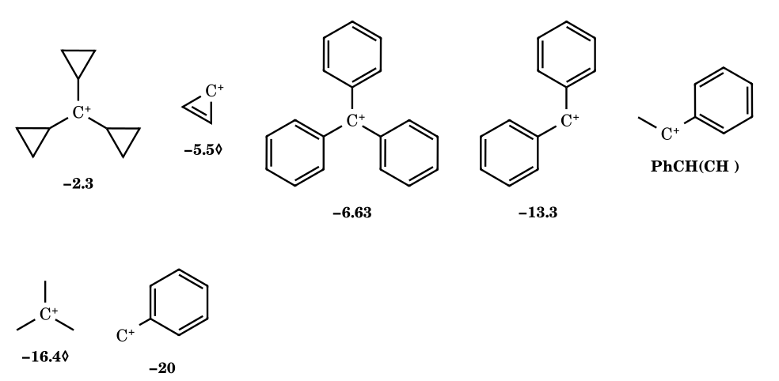
…then tricyclopropylmethyl > (parent cyclopropenyl, value as printed) > Ph₃C⁺ > Ph₂CH⁺ > PhCH(CH₃)⁺ > (CH₃)₃C⁺ > PhCH₂⁺.
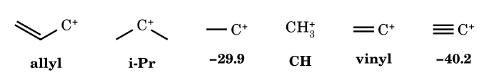
…then allyl > isopropyl > ethyl (−29.9) > methyl > vinyl > ethynyl (−40.2).
⚑ Check (values). (1) Your ladder gives t-Bu⁺ = −16.4, but the Carey–Sundberg table on page 6 of the same note gives −15.5 (and McManus's page says ‘estimate −15.5’ in FSO₃H–SbF₅); I would use −15.5. (2) The tricyclopropylcyclopropenyl cation is +9.7 on the ladder and in the Carey table, but ‘7.2’ on page 5. (3) Tropylium is +4.7 on the ladder and in Carey, ‘4.2’ on page 5. (4) The ladder puts the parent cyclopropenyl cation at −5.5; I cannot confirm this value from the tables you supplied, so it is marked ◊. Important consequence: on this ladder t-butyl (−16.4/−15.5) is above benzyl (≈ −20), and 2-phenyl-2-propyl (cumyl, −12.3) is above both. So on your source's data, t-Bu⁺ is more stable than the benzyl cation, not less. Earlier parts of this book use the usual ‘resonance > hyperconjugation’ coaching convention for benzyl vs t-Bu in some answers and flag it; with this note as your source, use t-Bu⁺ > benzyl. This changes the count in D-27 (below).

5E.4 Gas-phase hydride affinities (kcal mol⁻¹, as in your note)
R–H → R⁺ + H⁻; the smaller the number, the more stable the cation. Values are those written on your page (attributed there to March); they are quoted, not re-derived.
Cation | HIA | Cation | HIA | Cation | HIA
CH₃⁺ | 314.6 | tropylium | 200 | PhCH₂⁺ | 238
CH₃CH₂⁺ (bridged) | 276.7 | CH₂=CH–CH₂⁺ | 256 | PhCH⁺CH₃ | 225
(CH₃)₂CH⁺ | 249.2 | CH₂=CH–CH⁺–CH₃ | 239 | PhC⁺(CH₃)₂ | 220
(CH₃)₃C⁺ | 231.9 | CH₂=CH–C⁺(CH₃)₂ | 230
CH₂=CH⁺ (bridged) | 287 | CH₃CH=CH–CH⁺CH₃ | 228
cyclopropenyl | 223◊ | phenyl | 294
Reading the table: tropylium (200) is by far the most stable, then the α,α-dimethylbenzyl (220) and 1-phenylethyl (225) cations; t-Bu⁺ (231.9) is more stable than benzyl (238); allyl (256) is less stable than isopropyl (249); the stability of the substituted-allyl series follows substitution (256 → 239 → 230 → 228). Phenyl (294) and vinyl (287) are the worst, as expected for cations whose empty orbital is sp²/sp. ◊ The value 223 for cyclopropenyl is as written in your note; for an aromatic cation it looks comparatively high next to tropylium (200), so check it against your source before using it numerically.

5E.5 Tabulated pK_{R}⁺ values from the note
Cation (Carey–Sundberg Table 4.15, as on your page) | pK_{R}⁺ | Cation | pK_{R}⁺
Triphenylmethyl | −6.63 | 4,4′,4″-tri(dimethylamino)trityl | +9.36
4,4′,4″-trimethyltrityl | −3.56 | 4,4′,4″-trichlorotrityl | −7.74
4-methoxytrityl | −3.40 | 4-nitrotrityl | −9.15
4,4′-dimethoxytrityl | −1.24 | 4,4′,4″-trinitrotrityl | −16.27
4,4′,4″-trimethoxytrityl | +0.82
Diphenylmethyl | −13.3 | 2,2′,4,4′,6,6′-hexamethyldiphenylmethyl | −6.6
4,4′-dimethyldiphenylmethyl | −10.4 | 4,4′-dichlorodiphenylmethyl | −13.96
4,4′-dimethoxydiphenylmethyl | −5.71
Benzyl | ≤ −20 | Triphenylcyclopropenyl | +3.1
tert-Butyl | −15.5 | 2,4,6-trimethylbenzyl | −17.4
2-Phenyl-2-propyl (cumyl) | −12.3 | Trimethylcyclopropenyl | +7.8
Tropylium | +4.7 | Tricyclopropylcyclopropenyl | +9.7
Tricyclopropylmethyl | −2.3
Patterns to learn from this table: (i) every p-donor (OMe, NMe₂, Me) raises pK_{R}⁺ of trityl, every p-acceptor (Cl, NO₂) lowers it; (ii) the three-fold cyclopropyl substitution (−2.3) puts a carbocation above any simple trityl cation; (iii) aromatic cations (tropylium, cyclopropenyl) sit above all acyclic non-heteroatom-stabilised cations; (iv) three methyl groups on benzyl (2,4,6-trimethylbenzyl, −17.4) raise the value relative to benzyl (≤ −20), and six methyls on diphenylmethyl (−6.6 against −13.3) raise it much more: alkyl groups donate to the cationic centre through the ring. The note also lists the ‘cyclopentenyl/cyclohexenyl’ allylic cations from McManus; the entries on your page (% H₂SO₄ for 50 % protonation, then pK) are:
Allylic cation (McManus table, from your page) | % H₂SO₄ (50 %) | pK
1,3,4,4,5,5-Hexamethylcyclopentenyl | 33 | −1.9
1,3-Dimethylcyclopentenyl | 35 | −2.1
1-Cyclopropyl-3-methylcyclopentenyl | 12 | −0.46
1-Methyl-3-phenylcyclopentenyl | 50 | −3.4
2,4-Dimethyl-3-penten-2-yl | 73 | −6.3
2,3,4-Trimethyl-3-penten-2-yl | 82 | −7.7
1,3,5,5-Tetramethylcyclohexenyl | 50 | −3.4
1,5,5-Trimethylcyclohexenyl | 80 | −7.3
1,5,5-Trimethyl-3-phenylcyclohexenyl | 52 | −3.6
1,3-Dicyclopropyl-5,5-dimethylcyclohexenyl | 1.2 | +0.6
2,6-Dimethyl-3,5-heptadien-2-yl | ≈ 4 | 0
1,1-Diphenylethyl | 71 | −6.0
Mesitylenonium (1,3,5-trimethyl-2,4-cyclohexadien-1-yl) | 94.5 | −9.6
1,3,5-Trimethoxy-2,4-cyclohexadienyl | 7 M HClO₄ | −5.1
1,5-Dimethyl-2,4-cyclohexadienyl | HF–BF₃ | −14
tert-Butyl | FSO₃H–SbF₅ | estimate −15.5
Reading it: cyclopropyl groups on an allylic cation raise its stability far more than methyl groups (1,3-dicyclopropyl, pK +0.6, against a methyl analogue at about −7); a phenyl on the allylic terminus helps (−3.4/−3.6 against −7.3); and a nonplanar or non-resonance-stabilised cation such as t-butyl can only be estimated (−15.5).

5E.6 Examples from the note (March / Carey sets): where they appear in this book
The nine orders printed on your page 3 under ‘Source – Jerry March’ are the same problems as your Exercise 2 and are answered, with reasons, in Part 5A. Two points need to be stated here.
- Substituted cyclopropylmethyl: 1 > 2 > 3 for the 2,3-dimethyl, 2-methyl and parent cyclopropylmethyl cations, and for the p-cyclopropylbenzyl series: more methyl groups on the ring, more donation (matches Part 5A, Q21 and Q17).
- ⚑ Check, the set ‘benzyl / cyclopropylmethyl / tropylium / branched alkyl’: your page prints 2 > 3 > 1 > 4, i.e. cyclopropylmethyl above tropylium. The pK_{R}⁺ data on your own page (tropylium +4.7) put tropylium far above any cyclopropylmethyl or benzyl cation, so I cannot support putting it second; Part 5A gives tropylium > cyclopropylmethyl > benzyl > alkyl. If the examiner's key matches the page, it is the key's choice, not the data's.
- The sets ‘4 > 2 > 3 > 1’ (cage ortho-ester, dioxanyl, oxanyl, diazinanyl cations), ‘3 > 2 > 1’ (secondary, tertiary and iminium-type sets), ‘1 > 3 > 2’ (decalyl), and ‘3 > 1 > 2’ (alkyl: tertiary > secondary > primary) agree with the reasoning already given in Part 5A.
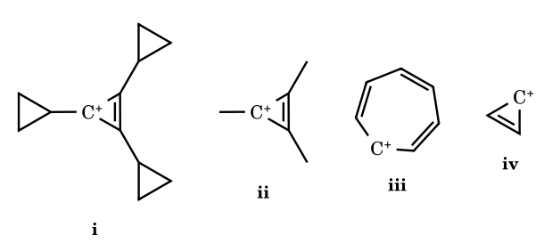
Practice item on page 4 (answer ticked in your note): arrange i–iv in decreasing stability: (a) i, ii, iii, iv. Tricyclopropylcyclopropenyl (+9.7) > trimethylcyclopropenyl (+7.8) > tropylium (+4.7) > parent cyclopropenyl.

5E.7 More pK_{R}⁺ structures from the note (pages 5 and 6)
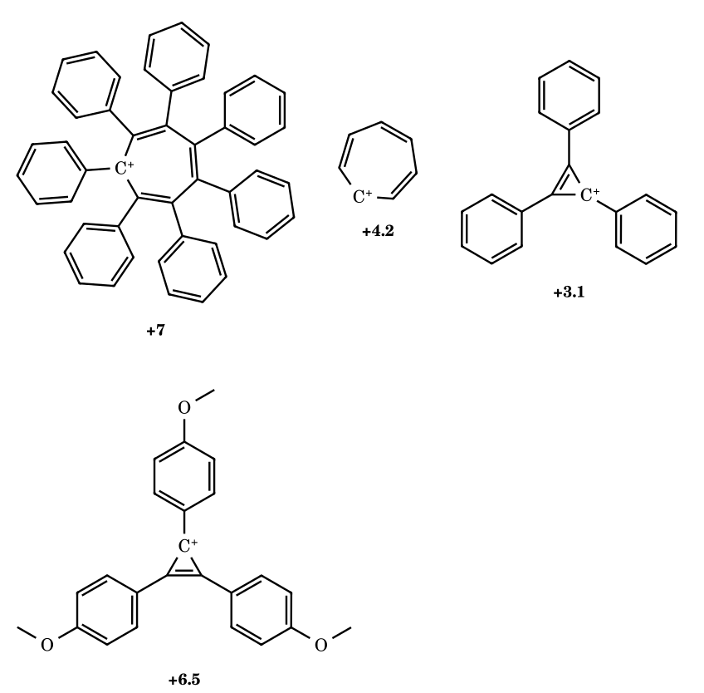
Heptaphenyltropylium (+7) is more stable than tropylium (+4.7/4.2): phenyl groups add some conjugation and steric protection. Tris(p-anisyl)cyclopropenyl (+6.5) > triphenylcyclopropenyl (+3.1): p-OMe donates.
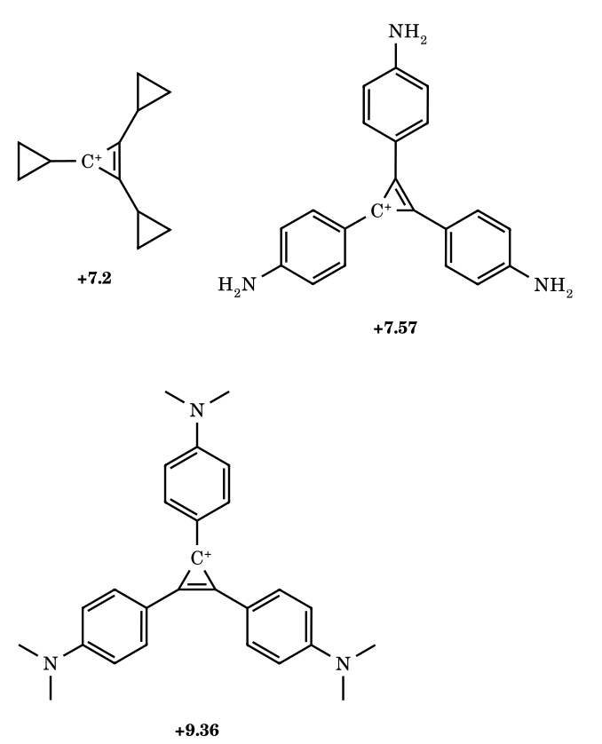
Amino-substituted cyclopropenyl cations: the stronger the donor, the larger the pK_{R}⁺.
⚑ Check. (a) +7.2 for tricyclopropylcyclopropenyl contradicts +9.7 elsewhere (use +9.7, which is the Carey–Sundberg value). (b) +9.36 is, in Carey–Sundberg, the value for the triarylmethyl cation with three p-dimethylamino groups (crystal-violet type), not for the cyclopropenyl analogue; confirm which structure your source means before using the number. The trend (donors raise pK) is not in doubt.
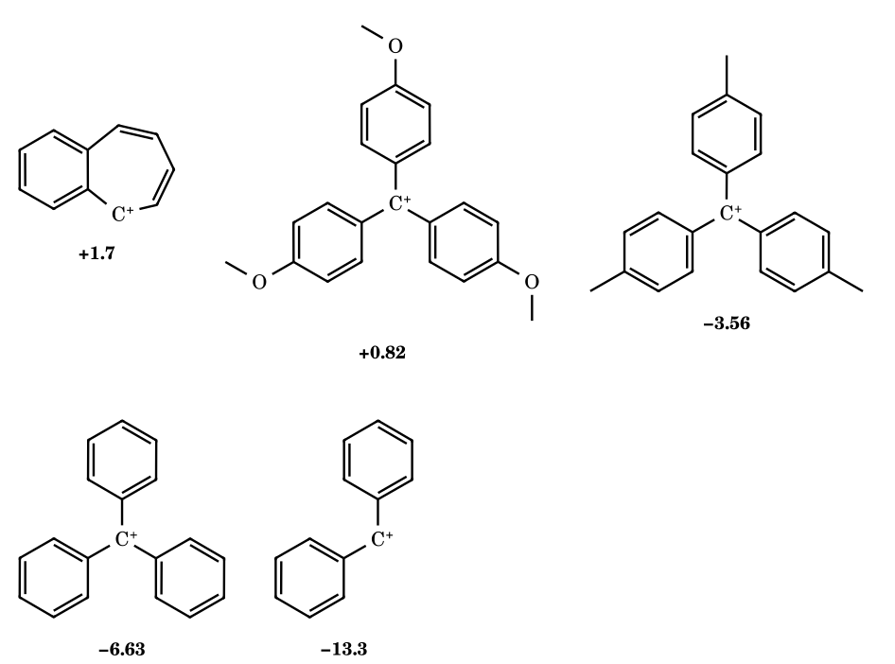
Benzotropylium (+1.7, a benzo-fused seven-membered ring cation), tris(p-anisyl)methyl, tris(p-tolyl)methyl, trityl and diphenylmethyl: stability follows the donor strength of the para groups.

5E.8 Pentavalent carbonium ions and σ-bond resonance
Carbonium ions (five-coordinate carbon): CH₅⁺ (methanonium) and C₂H₇⁺ (ethanonium) contain a three-centre two-electron (3c–2e) C···H···C or C···H···H unit: the bonding pair of a C–H σ bond is shared by three atoms. They are observed in the gas phase and in superacid (CH₅⁺ is a true, fluxional species); in ordinary solution chemistry they appear as transition states or short-lived intermediates (your note writes ‘T.S. or true intermediate’). Do not confuse them with carbenium ions (three-coordinate R₃C⁺), which are the ions of all the other parts.
σ-bond resonance (‘dancing resonance’) in the cyclopropylmethyl cation: the C–C σ bonds of cyclopropane are bent and strained, and their electrons are close in energy to a π bond (cyclopropane behaves electronically as a very weak π-donor). In the bisected conformation the empty p orbital lies parallel to the plane of the ring bonds, so a ring σ bond can overlap with it. The cation is then a hybrid of cyclopropylcarbinyl ⇌ homoallyl (CH₂=CH–CH₂–CH₂⁺) contributors with partial δ⁺ on the ring carbons, the three ‘R.H.’ charges drawn in the note. Your note says the effect is ‘even stronger than +H’: that is correct as a statement of stabilisation (cyclopropylmethyl > benzyl on most measures); the description of the C–C bond as ‘weaker than the π bond of an alkene’ is a simplification: it is strained, and its electrons are much easier to donate than an ordinary C–C σ bond, which is the reason it works.
Order from the note: cyclopropylmethyl < 2-methyl-cyclopropylmethyl < 2,3-dimethyl-cyclopropylmethyl (methyl groups on the ring improve the donor); p-cyclopropylbenzyl > p-cyclobutylbenzyl (cyclopropyl donates by σ-resonance, cyclobutyl does not). And p-cyclopropylbenzyl > 3,5-dimethyl-4-cyclopropylbenzyl: the two methyl groups ortho to the cyclopropyl group force the ring out of the bisected arrangement, so the donation is lost (steric inhibition of resonance).
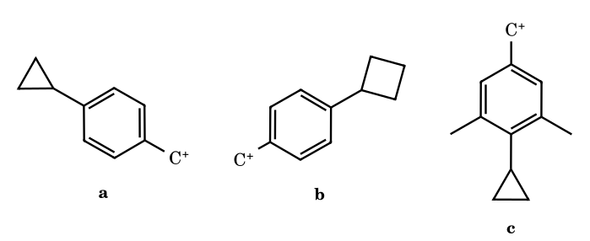
a > b (σ-resonance); a > c (steric inhibition of resonance by the flanking methyls).
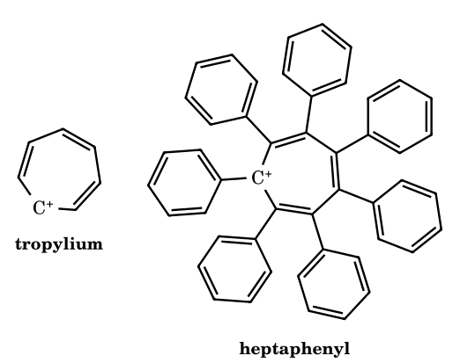
Tropylium (4.7) < heptaphenyltropylium (7): see 5E.7. The cation has seven equivalent resonance contributors (aromatic, 6π over 7 carbons).

5E.9 Non-classical cations from the note
- Phenonium ion: β-phenylethyl cation C₆H₅CH₂CH₂⁺ is bridged by the ring π electrons to give a spiro[2.5]octadienyl (phenonium) cation, with the starred label carbon becoming equivalent to its partner by the shift; the ring is a σ/π donor through its ipso carbon (sketch in your note: ring in dotted outline bonded to both CH₂ carbons).
- 7-Norbornenyl / nortricyclyl system: the π bond of norbornene participates with a developing cation at C7, giving a delocalised three-centre σ/π ion; the note draws the two limiting structures and the hybrid with dotted partial bonds.
- 2-Norbornyl cation (page 8): classical ion ⇌ σ-bridged (non-classical) ion, drawn with the C1–C6 bond delocalised to C2 (see Part 4 for the full discussion and the evidence).
- 1-Adamantyl cation: a bridgehead tertiary cation; it cannot flatten, but is stabilised by hyperconjugation from the three β C–C bonds and is observable in superacid; it solvolyses much slower than t-butyl in comparable media, which is why it is the usual example of a ‘bridgehead’ cation.
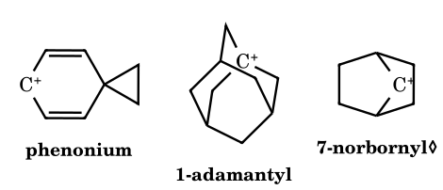
Left to right: the phenonium ion drawn as its spiro cyclohexadienyl (arenium) contributor, the 1-adamantyl cation, and a classical 7-norbornyl cation. ◊ Bridged ions are hybrids that a single line-bond structure cannot draw faithfully (see Part 4).

5E.10 Aryl-cation substituent series (pages 10 and 11)
These series are for aryl cations (empty orbital on a ring carbon); the note uses the substituent effects as a guide to the order. Remember what the empty orbital is: an sp² σ orbital in the ring plane, orthogonal to the π system, so the π-donor effect (+M) cannot operate by direct conjugation; the orders below therefore mix inductive effects with the textbook ‘conjugation-type’ rules the note uses. Note the three groups of series: +I alkyl (a < b < c < d < e), halogens (distance and electronegativity), and donors/acceptors (OH, NH₂, OCH₃, NO₂, CCl₃).
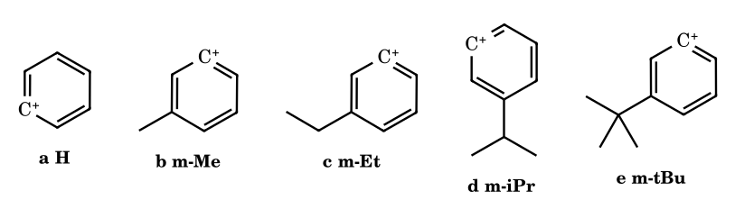
a < b < c < d < e: stability rises with the +I strength of the alkyl group (Me < Et < i-Pr < t-Bu).
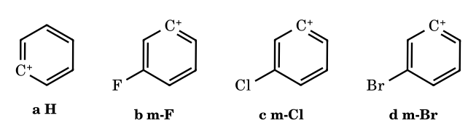
a > d > c > b: the −I effect is strongest for F, then Cl, then Br; all are below the unsubstituted ion.
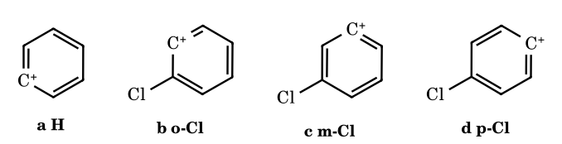
a > d > c > b: −I falls with distance, so the para ion is least destabilised and the ortho the most. (Your page prints the last symbol as ‘d’; it should read ‘b’, a typo.)
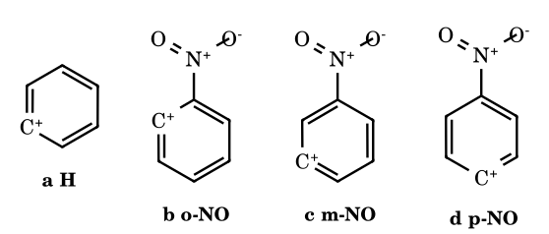
a > c > b > d as printed (m > o > p).
⚑ Check, nitro series. For chlorine the note uses a pure distance order (p > m > o); for NO₂ it puts p-NO₂ below o-NO₂ (treating the −M effect as the extra factor at the para position). If only the in-plane σ cation is considered, −M cannot act and the distance (−I) order p > m > o, as for Cl, would be expected. The note's order is the one to use if your exam source is this note; keep in mind that the two series follow different rules.
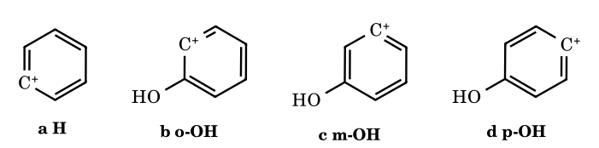
d > b > a > c (OH: ortho −I,+M; meta −I only; para +M). The same series is given for NH₂ (d > b > a > c) and for OCH₃ (d > b > a > c).
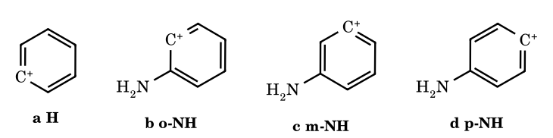
NH₂: d > b > a > c.
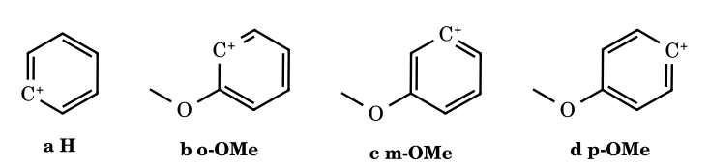
OCH₃: d > b > a > c.
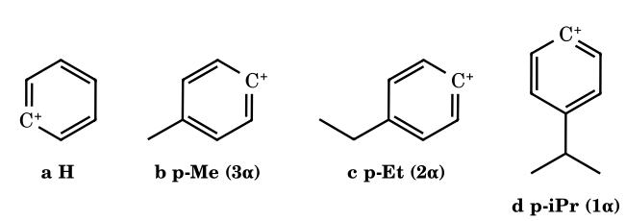
b > c > d > a: the para alkyl group donates by hyperconjugation, in proportion to its α C–H count (3, 2, 1), all better than hydrogen (Baker–Nathan type order).
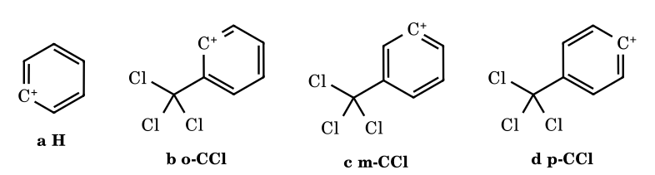
CCl₃: a > c > d > b as printed (ortho worst: −I plus loss of hyperconjugation; meta > para as printed).
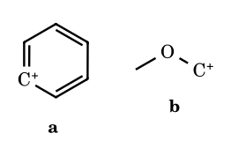
Phenyl cation < CH₂⁺–OCH₃ (oxocarbenium; ≈ 294 vs far lower HIA).

5E.11 Carbanion stability (the note ends here)
The last page begins the next topic: carbanion stability ∝ −M, −H (loss of hyperconjugation destabilises less than donating groups destabilise a carbanion; here the note means electron-withdrawing groups), −I, and ∝ 1/(+I), 1/(+H), 1/(+M): the exact mirror of the carbocation list. The carbanion chapter, still to be written, will cover this fully; I have not drawn conclusions from the single page you supplied.

5E.12 Effect on the earlier answer D-27
D-27 (heterolytic C–Cl bond energy less than that of t-BuCl). I answered 4 (acetyl chloride, benzyl, 3-chlorocyclopropene, cyclopropylmethyl) using the coaching convention ‘benzyl > tertiary’. With the data of your note (pK_{R}⁺: t-Bu −16.4/−15.5, benzyl ≈ −20; HIA: t-Bu 231.9, benzyl 238) the benzyl cation is less stable than t-Bu⁺, so benzyl chloride does not count, and the answer becomes 3 (acetyl chloride [acylium, if counted], 3-chlorocyclopropene, cyclopropylmethyl chloride). Which of 3 or 4 your source wants depends on whether it follows the data or the convention; on the data of this note use 3. The same caveat applies to any earlier answer that ranks benzyl above tert-butyl (Part 5A, Q28 uses t-Bu last; its position is already flagged there).

Part 5F Complete Worked Answers: the ‘Electronic Displacement Effects’ Exercise Book and the Allen Q48–51 Set
This part answers every problem in the 47-page exercise you supplied (Exercises O-I, O-II, S-I, J-Main and J-Advanced) and the Allen Q48–51 stability set that came with the earlier images, so that nothing in those uploads is left out. Questions are paraphrased, not copied, and the reasoning is written fresh. Your PDF prints an answer key on its last pages; I worked each item out from the chemistry first and then compared. ‡ marks an item where the drawing was too small or ambiguous for me to verify independently, so the answer is the key's; ⚑ marks a place where I disagree with the key or where two of your sources disagree. Structures are redrawn only where they carry the argument.

5F.0 Allen Q48–51 (stability orders, from the first image set)
A-48.
Order the p-(cyclopropyl)benzyl cations: (i) 2,3-dimethylcyclopropyl, (ii) 2-methylcyclopropyl, (iii) cyclopropyl.
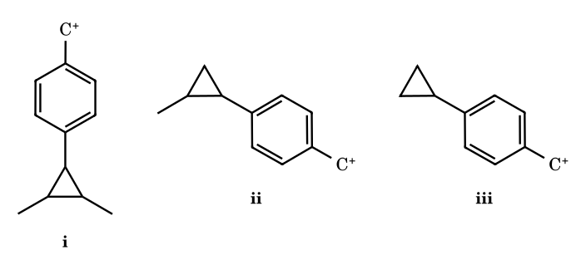
Answer: (a) i > ii > iii
The cyclopropyl ring donates its bent σ bonds (σ-resonance); each methyl on the ring makes it a better donor.
A-49.
Order: (i) the cage cation with three oxygens at the bridgehead, (ii) 1,3-dioxan-2-yl, (iii) tetrahydropyran-2-yl.
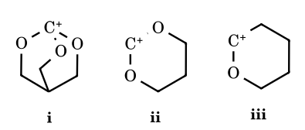
Answer: (b) ii > iii > i
Two oxygen lone pairs on a planar carbon (ii) beat one (iii). In (i) the cationic carbon is a bridgehead of a rigid cage, so it cannot become planar and its empty orbital cannot overlap with the oxygen lone pairs: least stable despite three oxygens.
A-50.
Order: (i) a secondary alkyl cation, (ii) a secondary iminium-type cation N–C⁺H–CH₃, (iii) a tertiary iminium-type cation.
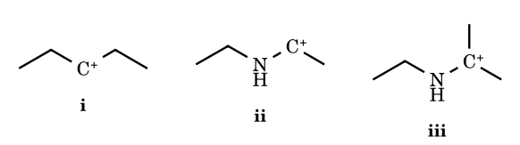
Answer: (c) iii > ii > i
A nitrogen lone pair on C⁺ (+M) is worth far more than hyperconjugation, and the extra methyl on (iii) adds hyperconjugation and +I on top.
A-51.
Order the benzyl cations: (i) p-CH₃, (ii) p-CD₃, (iii) m-CH₃, (iv) m-CD₃.
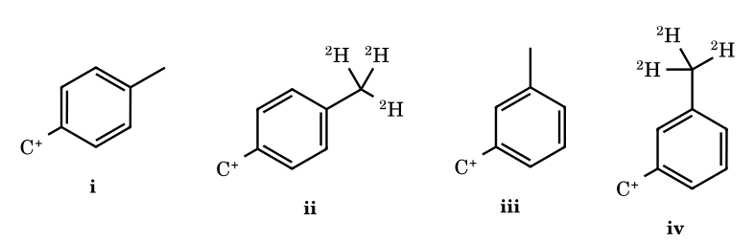
Answer: (b) i > ii > iv > iii
Para: hyperconjugation operates, and C–H donates better than C–D (i > ii). Meta: no hyperconjugation is possible, only +I, and D is slightly the better inductive donor (iv > iii). Any para isomer beats any meta one.

5F.1 Exercise O-I (Q1–Q51)
Q | Answer | Reasoning
1 | (D) | False order of −I: an alkynyl group (sp carbon) is more electron-withdrawing than phenyl, so the true order is –C≡CH > –Ph > –H. The other three are true (F > Cl > Br > I; –NR₃⁺ > –NH₃⁺ > –NO₂; F > OH > NH₂).
2 | (C) | +I order: –O⁻ > –CH₂CH₃ > –D > –H. In (A) CMe₃ is a stronger donor than CH₃; in (B) O⁻ beats CO₂⁻.
3 | (B) | Only cyclohexyl (sp³ carbon) is +I; phenyl, p-tolyl and vinyl are attached through sp² carbon and are −I.
4 | (A, B, D) | –OH, –COOH and –OCH₃ are −I; –CH₃ is +I.
5 | 4 (b, d, f, g) | +I groups are the negatively charged or alkyl ones: O⁻, N⁻H, COO⁻, CH₃. OH, NH₂, COOH, OMe, F, NF₃⁺ are −I.
6 | (a, c, d, g, j, l, m) | Resonance is intramolecular, involves π (and lone-pair) electrons only, lowers the energy, is not the only stabilising factor, and the hybrid (not any canonical form) describes the molecule; canonical forms are imaginary, the hybrid is real and more stable than any one form. False: b, e, f, h, i, k.
7 | (A) | Incorrect statement: resonating (canonical) structures are hypothetical and have no real existence.
8 | (A) | A conjugated diene is more stable than an isolated diene, which is more stable than a cumulated one (allene).
9 | (A) a > d > c > b ‡ | Contribution to the hybrid of CH₂N₂: the form with the negative charge on the terminal (more electronegative) nitrogen and complete octets dominates; forms with a carbanion contribute less.
10 | (A, D) | A cyclic 4n+2 delocalisation stabilises (aromatic); a cyclic 4n delocalisation destabilises. A negative charge is better placed on the more electronegative atom, a positive charge on the less electronegative one.
11 | (D) | Pair D is keto–enol tautomerism (an H changes position), not resonance.
12 | (b, d, e) | The lone pair is in resonance in pyrrole N–H, in the enamine-type N–H, and in the allyl anion. In pyridine, the imine N of (c) and (f) the lone pair is in the ring plane (sp²), orthogonal to the π system.
13 | (b, d, e) | Not involved: the in-plane lone pair on the carbonyl O, the sp lone pair on a nitrile N, and the O lone pair in (e), which is not attached to the π system.
14 | (d) | –NH₃⁺ has neither a lone pair nor a π bond.
15 | (c, f) | Groups that donate by resonance have a lone pair on the atom attached to the π system: –OCOCH₃ (the O) and –NHCOCH₃ (the N).
16 | (a, b, c, d, f) | –COOH, –CONHR, –COCl, –CN and an imine C=N withdraw by −M; –O–CH=CH₂ donates.
17 | (b, c, f) | –NO, –CH=CH₂ and –N=NH can accept (−M) or donate (+M) depending on what they are attached to.
18 | see figure | Resonance forms drawn below: (a) enolate, (b) vinylogous enolate, (c) benzyl cation (ortho and para forms), (d) cyclohexadienyl cation, (e) phenoxide, (f) vinylogous iminium, (g) oxocarbenium, (h) vinylogous enolate, (i, j) dienyl cations.
19 | a-I, b-II, c-II, d-II, e-I | Less stable form: (a) the sextet carbocation; (b) the naphthalene structure with only one benzene sextet; (c, d) the one with the charge on carbon or N instead of O⁻; (e) the cycloheptatrienyl-anion (8π, antiaromatic) form.
20 | a-I, b-I, c-I, d-I, e-II, f-II | More stable form: neutral rather than charge-separated; aromatic ring kept (phenoxide, pyridine, Cp⁻); (e) CH₂=CH–CH=O rather than ⁺CH₂–CH=CH–O⁻; (f) all octets with the positive charge on N.
21 | (a, e, f, g) | –OH (lone pair), –CH=CH–Ar (π), –BH₂ (empty p) and –PPh₃⁺ (empty d/σ* acceptor, as the key treats it) can take part; the saturated –CH₂C⁻H₂, –CH₂C⁺H₂ and benzyl groups cannot.
22 | (a) resonance forms; (b) A; (c) C; (d) A and B; (e) B and C; (f) 0; (g) B; (h) B ‡ | A, B and C are canonical forms of diazomethane (same atom positions). B (CH₂=N⁺=N⁻) has complete octets and no charge on carbon, so it is the most stable.
23 | (a) II, (b) II, (c) II | (a) the charge on N, not C; (b) the enolate with the charge on O; (c) the form with all octets (C=N⁺).
24 | (A) I > II > III > IV | Neutral form first; then the charge-separated form with O⁻/O⁺ and complete octets; then C⁺ forms (sextet) and last the C⁻/O⁺ form.
25 | a-II, b-II, c-II, d-II | Lesser resonance energy: the non-aromatic or less conjugated member of each pair; furan has less aromatic stabilisation than pyrrole (about 16 vs 21 kcal mol⁻¹).
26 | (a) and (b) | Equivalent canonical forms and aromaticity both raise the resonance energy.
27 | i-I, ii-II, iii-II, iv-I, v-I, vi-II, vii-I, viii-II ‡, ix-II, x-II, xi-II, xii-I, xiii-I, xiv-I, xv-I | Higher RE: pyridine over pyrrole; N is a better donor than O (divinylamine); equivalent forms (amidinate); F over Br (2p–2p overlap); benzyl over allyl radical; naphthalene (61) over phenol (36); two isolated benzenes (2 × 36) over styrene; longer conjugation (ix); linear over cross-conjugated (x); carboxylate over acid; vinyl-O⁻ over vinyl-OH; benzoate; diphenylmethane over naphthalene; benzene over hexatriene.
28 | a-II, b-I, c-I, d-II, e-I | Lesser RE: HCOO⁻ (2 forms) vs CO₃²⁻ (3); the antiaromatic cyclopropenyl anion vs allyl anion; cyclobutadiene vs butadiene; allyl cation vs aromatic cyclopropenyl cation; benzene vs phenol.
29 | (B) | The pentadienyl cation has more resonance than the antiaromatic cyclopentadienyl cation; hexatriene has less than benzene; divinylamine has less than 1-amino-butadiene.
30 | (D) | The ring π density is lowest in 1,3-dinitrobenzene (two −M/−I acceptors, nothing donating).
31 | (B) | The ring π density is highest in the phenoxide ion (the strongest +M donor).
32 | (C) i > iv > ii > iii | Reactivity to electrophiles follows hyperconjugation by the α C–H count: CH₃ (3) > C₂H₅ (2) > i-Pr (1) > t-Bu (0): toluene, ethyl-, isopropyl-, t-butyl-benzene.
33 | (C) | Inductive, mesomeric and hyperconjugative effects all operate in the acetyl-methyl-cyclohexene (C=C–C=O gives M, the alkyl groups give H and I).
34 | (C) | CH₃CH=CH–CO–CH₃ has C=C conjugated with C=O (M), CH₃ on the double bond (H) and the polar C=O (I).
35 | (D) | All three statements are correct: σ delocalisation is hyperconjugation, π delocalisation is resonance, permanent σ polarisation is the inductive effect.
36 | (A, B, C) | Number of hyperconjugative structures = α C–H bonds: propene 3, 2-methyl-2-butene 9, the t-amyl cation 8. 2-Butyne has 6, not 5.
37 | (B) | The ortho-di-t-butyl groups twist the NO₂ out of the ring plane (steric inhibition of resonance), so C–N has less double-bond character and is longer in II.
38 | (B) ‡ | The two nitro groups flanking Br are twisted out of the ring plane (no resonance, longer C–N); the unhindered nitro group conjugates and has the shorter C–N bond.
39 | (C) III > II > I > IV | Single sp³–N (cyclohexylamine) is longest; aniline N lone pair adds partial double bond; a p-CHO withdraws and adds more; the imine C=N is shortest.
40 | (D) | The shortest C1–C2 bond joins the sp² carbon of a ring to an sp carbon (C≡CH): both shortening factors (s-character, no hyperconjugation).
41 | (D) | Longest C=C is in isobutene: two methyls give the most hyperconjugation, which lengthens the double bond.
42 | (A) | Shortest C=C is in allene: sp-hybridised central carbon.
43 | (B, C, D) | Butadiene, 1,3-cyclohexadiene and naphthalene have alternating bond lengths; benzene has equal bonds.
44 | (B) C₂H₆ > C₆H₆ > C₂H₄ > C₂H₂ | 154, 139, 134, 120 pm.
45 | (A) I > II > III > IV | The push–pull ethene I (OMe donor, NO₂ acceptor) has the most single-bond character; then nitroethene, vinyl chloride, ethene.
46 | (A, C, D) | C–C > C=C > C≡C > C≡N; C=C > C=N > C=O; C–C > C=C > C≡C > C–H are correct. (B) is not.
47 | a-I, b-I, c-II, d-I, e-I, f-I ‡ | Bond dissociation energy of the marked bond is lower where it carries more s/less strength: cyclohexene vs ethylene; propyne C–CH₃; urea vs amides etc. The drawings are small, so these follow the key.
48 | a-II, b-I, c-I, d-I, e-II, f-II ‡ | Stronger bond: C–Cl > C–Br; vinyl–Br > alkyl–Br; acyl–Cl and alkyl–Cl comparison, sp²–sp² > sp²–sp³ etc. (as in the key).
49 | (D) C¹–H > C⁴–H > C³–H > C²–H | Vinylic C–H is strongest (sp²); then the primary sp³ C–H; then secondary; the allylic C–H is weakest because the radical is resonance stabilised.
50 | C > B > A | C–N bond length: the simple enamine (C) has the least double-bond character and is the longest; the dienamine (B) is shorter; the amino-enone (A) is shortest because N donates into the C=C–C=O system.
51 | (A) ‡ | As in the key: the t-butyl ortho group twists the COOH out of conjugation, so the C–O bond is shorter (less delocalisation into the ring) than in benzoic acid.

Q18 resonance forms
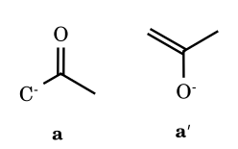
(a) acetone enolate: carbanion form and enolate form
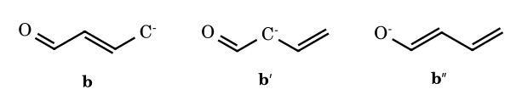
(b) the charge delocalised over C-4, C-2 and O
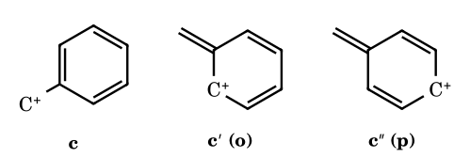
(c) benzyl cation (the ortho form shown once; two ortho and one para)
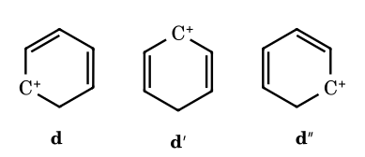
(d) cyclohexadienyl cation: charge at C-1, C-3, C-5
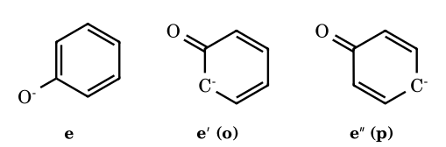
(e) phenoxide: charge at O and at the ortho and para carbons
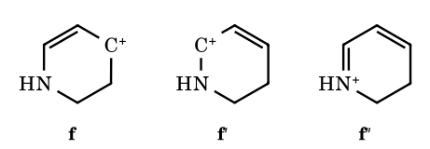
(f) the vinylogous iminium ion (my reading of the ring: N lone pair donating through C=C)
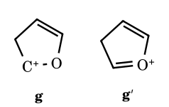
(g) oxocarbenium form (my reading of the ring)
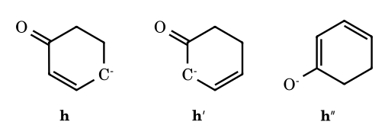
(h) cyclohexenone-type anion: charge at C-4, C-2, O
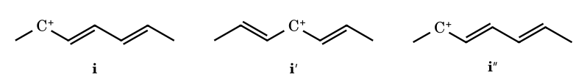
(i) the heptadienyl cation: charge on C-2, C-4, C-6
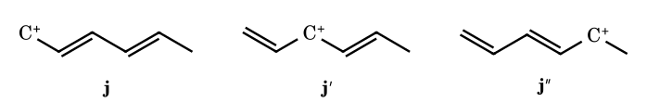
(j) the hexadienyl cation: charge on C-1, C-3, C-5

5F.2 Exercise O-II (Q1–Q40)
Q | Answer | Reasoning
1 | (i) a, b; (ii) a, c; (iii) b, c, d; (iv) all | (i) the benzo-fused cyclopentadienyl anion (10π) and thiophene; (ii) tropylium and the benzo-fused (isoindenyl-type) anion; (iii) the cyclobutadiene dianion (6π), cyclopropenyl cation and protonated pyridine; (iv) azulene-type, 6π borole-ring and silabenzene systems, borazine and indole. Cyclohexadienyl, cyclopentadienyl cation, cyclobutadiene and the 8π anion are excluded (sp³ carbon or 4nπ). ‡
2 | aromatic: a, b, d, e, g; non-aromatic: c, f | Isoxazole, thiazole, pyrylium, γ-pyrone and cytosine are aromatic; 4H-pyran and 1,2-dihydropyridine have an sp³ ring atom.
3 | (C) II > I > III | Ease of rotation about the exocyclic C=C. Each compound is a fulvene-type system whose dipolar form places a charge on each ring. If both rings become aromatic (II: tropylium⁺/Cp⁻, I: cyclopropenyl⁺/Cp⁻) the bond has much single-bond character and rotates easily; tropylium is the more stable cation, so II > I. In III the cyclopropenyl ring would carry the anion (antiaromatic), so the bond keeps its double-bond character.
4 | (C) III | Lowest rotation barrier: III is the Cp⁻/cyclopropenyl⁺ dipole, both rings aromatic. In I the dipole would put a negative charge on an antiaromatic cyclopropenyl ring, and in II it would give an antiaromatic cyclopentadienyl cation.
5 | (B) | Cyclooctatetraene (8π, tub-shaped) is not aromatic.
6 | (A) | The pyrrolium ion (N–H₂⁺, sp³ N, no lone pair in the ring π system) is non-aromatic.
7 | see below | (a) B₃H₃O₃ is boroxine, a planar B₃O₃ ring with 6π (weakly aromatic); (b) melamine, aromatic (triazine ring, 6π); (c) the trimer of HN=C=O is cyanuric (isocyanuric) acid, drawn as the aromatic triol, though the trione tautomer predominates in the solid.
8 | (D) neopentyl | α C–H counts: ethyl 3, n-propyl 2, isobutyl 1, neopentyl 0 (see the correction in Part 5B).
9 | (i) c > b > a; (ii) c > b > a; (iii) b > c > a; (iv) d > c > b > a; (v) c > b > a; (vi) b > c > a ⚑; (vii) c > b > a; (viii) c > a > d > b; (ix) b > c > a; (x) c > a > b; (xi) c > a > b; (xii) a > b > c > d; (xiii) b > a > c > d; (xiv) d > e > b > a > c; (xv) a > c > b; (xvi) b > c > a | Worked in full in Part 5B (items 9(i)–(xvi)). For (xiv) the note on your Allen page tags the five cations as a = 2 α-H, b = 6 α-H, c = 1 α-H, d = resonance + 4 α-H, e = resonance + 2 α-H: resonance first, then α-H count. For (vi) the key and the Allen solution disagree (⚑ see Part 5B).
10 | (C) | I, II and III are correct (oxocarbenium, secondary > primary, allyl > n-propyl); IV is wrong, since the vinyl cation is less stable than ethyl.
11 | (a) I; (b) I; (c) II; (d) II | (a) benzyl > allyl; (b) ethyl > vinyl; (c) the allylic exocyclic cation II > the cation I that is not conjugated with the ring C=C; (d) N-substituted: the α-amino carbenium (iminium) is far more stable than a simple tertiary cation.
12 | (C) I > IV > III > II ‡ | Norbornyl cations: the least stable is II, the 7-norbornyl cation (bridge carbon, geometrically unable to be planar and not stabilised by σ-bridging). The secondary ones are ordered by hyperconjugation and by exo-σ-participation, with the methyl-bearing neighbour (I, IV) better than the parent III.
13 | (A) | Trityl is the most stable (pK_{R}⁺ −6.6).
14 | (A) d < b < c < a | Ethyl < benzyl < p-methylbenzyl < p-methoxybenzyl.
15 | (D) 2 > 1 > 3 > 4 | NH₂ > OH (+M), then CH₃ (3 α-H) > t-Bu (0).
16 | (B) II < III < I | Steric inhibition of resonance leaves III with only the −I effect of NO₂.
17 | see below | Increasing stability of anions and radicals. (i) a < b; (ii) d < a < c < b; (iii) b < a; (iv) c < b < a; (v) c < a < b; (vi) a < c < b; (vii) c < b < a; (viii) c < b < a; (ix) b < a; (x) a < c < b < d. Reasons are given in the sub-table that follows.
18 | (A) | HC≡C⁻: the lone pair is in an sp orbital (50 % s), the most stable carbanion.
19 | (D) | p-Nitrobenzyl anion: the charge delocalises onto the nitro group (−M).
20 | (B) | The anion conjugated with the C=O across the ring (a dienolate) is the most stable.
21 | (D) | Radicals: CH₂=CH–C(CH₃)₂ > allyl > ethyl > vinyl is correct. In (A) CH₃OCH₂⁺ is more stable than t-Bu⁺; in (B) isobutene is slightly more stable than cis-2-butene; in (C) the order of the benzyl anions is reversed.
22 | (a) IV < I < II < III < V; (b) III < IV < I < II ‡ | (a) the bridgehead cage cation is least stable; β-oxygen cations (−I only) next; the allylic and the dioxanyl cation (two O) most. (b) Carbanions next to C=O: aldehyde > ketone > ester > amide (a more electron-poor carbonyl stabilises the enolate better).
23 | (B) IV > III > II > I | Radical stability grows with benzylic + allylic character and substitution at the radical centre.
24 | (A) | CH₂=CH–CH=CH–CH₃ is conjugated (resonance); CH₃CH=C=CH–CH₃ is cumulated, with no resonance.
25 | (a) I; (b) I; (c) II | More substituted alkene: 1-methylcyclohexene; isopropenylcyclopentane (1,1-disubstituted) over allylcyclopentane (mono); the double bond in the six-membered ring over the strained cyclobutene.
26 | (a) 4658; (b) 4638; (c) 4632; (d) 4650; (e) 5293 | (e) is the C₈ alkene (largest heat); among the C₇ alkenes, the most stable (trisubstituted, c) has the smallest heat and the least stable (1-heptene) the largest.
27 | (A) I < III < IV < II | Alkene stability increases with the number of hyperconjugating α C–H bonds and with substitution: 2-butene < isobutene < 2-methyl-2-butene < tetramethylethylene.
28 | (B) I and IV | The C–H bonds on the allylic carbons that can overlap with the π bond take part; I and IV are such bonds.
29 | (D) I > IV > III > II | For isomers a larger heat of combustion means a less stable isomer: 1-butene > cis-2-butene > trans-2-butene > isobutene.
30 | (i) d > c > b > a; (ii) e > c > d > b > a; (iii) b > a; (iv) a > b; (v) b > a; (vi) a > b | Heat of hydrogenation is larger for the less stable (less substituted, unconjugated, cis) alkene.
31 | (i) a < b; (ii) e < d < c < b < a; (iii) a < c < b; (iv) a > b > c | 1,3-diene < 1,4-diene; tetrasubstituted < … < ethylene; cyclohexene (28) < benzene (50) < cyclohexadiene (55); resonance energy per ring drops from benzene to naphthalene to anthracene.
32 | (i) c > b > a; (ii) a > b > c > d; (iii) a > b; (iv) c > b > a | Isomers: the less stable has the larger heat of combustion; different formulae: more carbons, larger heat.
33 | a-I, b-I, c-II, d-I | Higher heat of hydrogenation: 1,4-cyclohexadiene (not conjugated), benzene (two further double bonds), 1-butene, the exocyclic alkene.
34 | stability d > c > b > a; heat of hydrogenation a > b > c > d | The more aromatic ring retained, the more stable (tetralin-type d best).
35 | (C) 57 | 1,3-Butadiene: 2 × 30 − about 3 kcal mol⁻¹ of conjugation energy.
36 | (D) | Steric inhibition of resonance only in A (the NMe₂ flanked by two ortho methyls is twisted out of the ring plane); NH₂ is small enough to stay planar.
37 | (B) | See Q37 of O-I: C–N is shorter in the unhindered nitrobenzene.
38 | (C) ‡ | See Q38 of O-I: twisted flanked nitro groups have the longer C–N bonds.
39 | (i) c > b > a; (ii) a > b > c; (iii) a > b | Dipole moments: the para isomer of an electron-donor/acceptor pair has parallel bond dipoles in (i) and opposed ones in (ii); the ortho isomer of the pair (ii) has the largest vector sum; N,N-dimethylaniline has a larger moment than the hindered 2,4,6-trimethyl analogue (resonance lost).
40 | — | A bridgehead cation of a small rigid bicycle such as norbornane cannot become planar, so the empty p orbital cannot overlap with neighbouring σ bonds; it is also strained (anti-Bredt-type). Larger cages (adamantyl) tolerate it.

O-II Q7: structures
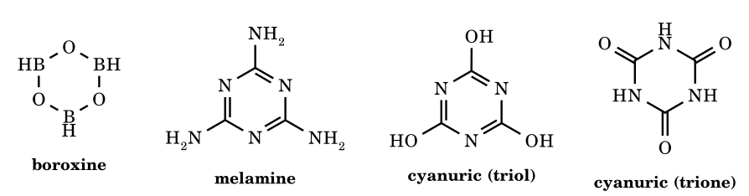
Boroxine, melamine and cyanuric acid (aromatic triol form and the more stable trione form).

O-II Q17: reasons
Item | Order (increasing stability) | Reason
i | p-F-benzyl anion < p-NO₂-benzyl anion | −M of NO₂ delocalises the charge; F is +M/−I and destabilises the anion by lone-pair repulsion
ii | benzyl < p-Cl < p-CN < p-NO₂ | electron-withdrawing strength
iii | ethyl anion < CH₂CHO enolate | resonance into C=O
iv | pentan-3-yl anion < ketone enolate < acetylacetonate | one, then two carbonyls
v | benzyl < p-Cl < p-NO₂ | as above
vi | cyclopropenyl anion < cycloheptatrienyl anion < cyclopentadienyl anion | antiaromatic < non-planar 8π < aromatic
vii | phenyl < 2-phenylethyl < benzyl radical | in-plane σ radical < primary alkyl radical < delocalised benzyl radical
viii | alkyl < allylic cyclohexenyl < cyclohexadienyl radical | number of conjugated double bonds
ix | b < a | more extended delocalisation (dienyl radical) for a
x | vinyl < cyclohexenylmethyl < allyl < tertiary allyl radical | s-character and delocalisation, then substitution (key order)

5F.3 Exercise S-I (Q1–Q25)
Q | Answer | Reasoning
1 | (C) | Cyclopentadienyl anion is aromatic (6π, planar, cyclic).
2 | (A, D) | Ethanol has the higher boiling point and forms intermolecular H-bonds; dimethyl ether cannot H-bond to itself.
3 | (D) | The nitrile carbon is sp-hybridised: highest s-character and the most electronegative carbon.
4 | (C) | The CH₃ group hyperconjugates better than CD₃ (the C–H bond is weaker/longer-ranging than C–D).
5 | (A, B, D) | In acetate and formate both C–O bonds are equal and the two resonance structures are equivalent.
6 | A → P, S; B → Q, R; C → Q, S; D → P, S | NO₂: −R, −I; O⁻: +R, +I; OCH₃: +R, −I; CN: −R, −I.
7 | A → P, Q, S; B → R; C → P, S; D → Q, S | –N=O: +M (lone pair), −M (π acceptor), −I; CH₃: +H; –NHCOCH₃: +M, −I; –COOCH₃: −M, −I.
8 | A → R; B → S; C → P, T; D → Q | Ethyl: +I only; NH₃⁺: −I only; OH and NH₂: −I and +M; NO₂: −I and −M.
9 | A → Q, S; B → P, S; C → P, S; D → R, S | A bicyclic 8π system is non-aromatic/cyclic, naphthalene and tropylium are aromatic and cyclic, and the cyclopentadienyl cation is antiaromatic. ‡
10 | (D) | The statement is false when bond a is the C=O (it is longer in the ester, whose O lone pair donates into only one C=O, than in the anhydride, where it is shared); the reason is true. ‡
11 | (A) | t-Bu⁺ > i-Pr⁺ > Et⁺ and the number of hyperconjugative structures (9, 6, 3) explains it.
12 | (D) | Statement I is false (hyperconjugation in 2-butene slightly lowers the barrier compared with ethylene); statement II is true.
13 | (A) I > II > III | Neutral vinyl chloride form first; then the form with the negative charge on carbon and positive on Cl, then the one with positive on C.
14 | (A) | Benzyl has more resonance structures (five) than allyl (two).
15 | (B) | ⁻CH₂–CHO and CH₂=CH–O⁻ are resonance forms; the others are tautomers or different species.
16 | (D) | t-Butyl cation is the most stable.
17 | (C) | The most substituted, tertiary cation.
18 | (C) | The vinyl cation (I) is less stable than ethyl (II).
19 | (B) | Structure II is unlikely because nitrogen has only a sextet.
20 | (C) | Structure II is unacceptable because nitrogen would have ten valence electrons.
21 | (C) | Delocalisation lowers both the potential energy and the electron–electron repulsion.
22 | (D) I, IV | Most stable tropylium (I); least stable isopropyl (IV) among those listed.
23 | (B) | The cation formed from Ph₃CBr, trityl, is the most stable.
24 | (4) | Naphthalene, squaric acid, azulene and tropone are counted aromatic; the pyrrolium and cycloheptatriene are not. ‡
25 | (4) | Unstable: cyclobutadiene, pentalene, cyclopentadienone and borole.

5F.4 Exercise J-Main (Q1–Q31)
Q | Answer | Reasoning
1 | (1) | (CH₃)₃C– > (CH₃)₂CH– > CH₃CH₂– (+I order).
2 | (3) | Formate has two equivalent resonance forms.
3 | (3) | Acetonitrile has an sp carbon and an sp³ one, no sp² carbon.
4 | (2) | An unpaired electron makes a free radical reactive.
5 | (4) | (CH₃)₂CH• < (CH₃)₃C• < (C₆H₅)₂CH• < (C₆H₅)₃C•.
6 | (1) | CCl₃⁻ > benzyl > i-Pr⁻ > t-Bu⁻.
7 | (1) | Cyclopentadiene has an sp³ carbon: non-aromatic.
8 | (3) | o-Nitrophenol is intramolecularly H-bonded, so it is steam volatile and less soluble.
9 | (4) | Antiaromatic: the cyclopentadienyl cation (V) and cyclobutadiene (VI).
10 | (3) | CCl₄ is tetrahedral and non-polar.
11 | (4) | III > I > II: benzyl > allyl > n-propyl.
12 | (2) | p-Dihydroxy and p-dimercapto benzenes have a net dipole because the O–H/S–H bonds are out of the ring plane; the p-dichloro and p-dicyano compounds are symmetric (μ = 0).
13 | (4) | 4,4-Dimethylcyclohexa-2,5-dienone has the least resonance stabilisation; benzene, furan and pyridine are aromatic.
14 | (1) | Alkoxide stability: the nitro-substituted enolate-type C > the nitro-substituted B > A.
15 | (1) a < b < c | The trans,trans-2,4-hexadiene is the most stable (smallest heat of combustion), the cis,cis the least.
16 | (3) | Vinyl chloride has the shortest C–Cl bond (sp² carbon and p–π overlap).
17 | (2) | Benzene and the cyclopentadienyl anion are aromatic.
18 | (3) | Benzyl and allyl cations are resonance-stabilised; the other two are not conjugated with the cationic carbon.
19 | (4) | CH₃CH₂CH=CHCH₂NH₂ has no conjugation.
20 | (3) | Statement I is true; II is false: hyperconjugation in ethyl cation involves a C(sp³)–H σ bond, not sp².
21 | (1) | Both statements are correct (weak π bonds, and a C=C is stronger than a C–C).
22 | (3) | p-Benzoquinone is the conjugated diketone.
23 | (1) | The cyclopropenyl cation is aromatic and the most stable.
24 | (2) | The cyclopentadienyl anion and the tropylium cation are aromatic; the other two are not.
25 | (4) | CH₃O–CH=CH–CH=CH–CH₂⁺: the longest conjugation with an oxygen donor.
26 | (3) | [10]Annulene, although 4n+2, is non-planar (the inner H atoms clash), hence non-aromatic.
27 | (1 and 2) | Phenalene-type (1) and cyclooctatetraene (2) are not benzenoid.
28 | NTA (1); Allen (4) | [6]Annulene is aromatic, [8]annulene is not, but cis-[10]annulene is not planar and so not aromatic: the assertion is wrong and the reason (planarity is required) is right: option 4 (the NTA's published option was 1).
29 | (1) | Charge at the position ortho to NH₂ is stabilised by the N lone pair (iminium form); the NTA key follows the nitrogen's +M effect.
30 | NTA (2); Allen: bonus | No printed option matches: the correct increasing order is C < A < B < D.
31 | (3) | Both correct and R explains A: the delocalised π electrons lie in bonding molecular orbitals, so benzene is more stable than the localised hypothetical cyclohexatriene.

5F.5 Exercise J-Advanced (Q1–Q18)
Q | Answer | Reasoning
1 | (D) ⚑ | The key gives 1,3-butadiene. Tabulated heats of hydrogenation per mole of H₂ are about 28.5 for butadiene (57 for two) and 27.6 for trans-2-butene, which is lower, so by that data (B) would win; the intended argument is conjugation lowering ΔH relative to 1-butene (30.3). Use (D) for the key.
2 | (D) | p-Methoxybenzyl: +M of OCH₃.
3 | (B) IV < I < II < III | p-Dichlorobenzene (0) < toluene (0.4) < m-dichloro (1.5) < o-dichloro (2.5 D).
4 | (C) | The form with a pentavalent nitrogen (O=N=O) is the most unlikely resonance structure.
5 | (A) | An aromatic molecule does not have 4nπ electrons.
6 | (D) | p-Hydroxybenzoic acid has the higher boiling point (intermolecular H-bonding); the o-isomer is intramolecularly H-bonded. Statement I is false, II is true.
7 | (A) | CH₃Cl has the highest dipole moment (1.9 D); CCl₄ is zero.
8 | enol resonance | CH₂=C(OH)–CH₂CH=CH₂ ↔ ⁻CH₂–C(=O⁺H)–CH₂CH=CH₂: only the enol C=C–O is conjugated; the other C=C is isolated.
9 | (D) | The structure with unlike charges placed far from stabilising atoms and with a sextet is the least stable.
10 | (A) ‡ | The form with the positive charge and negative charge farthest from the nitro group stabilisation is least stable.
11 | (D) I > III > II > IV ‡ | The two α-alkoxy cations (oxocarbenium) come first, and of the alkyl cations the branched one (II) beats the more remote primary-type one (IV).
12 | (B) I > III > II > IV | Diazomethane forms: all octets and no charge on C first; then the form with N≡N⁺; the carbanion/cation forms with a sextet last.
13 | 6 | α C–H bonds of the cyclohexyl–C⁺(CH₃)CH₂CH₃ cation: CH₃ (3) + CH₂ (2) + the ring CH (1) = 6.
14 | (B, C) | Cyclobutadiene and cyclopentadienone are unstable (antiaromatic); the others are stable.
15 | (A) | t-Bu⁺ is stabilised by σ→p(empty) hyperconjugation; 2-butene by σ→π* delocalisation.
16 | 6 | Melamine: three lone pairs on the ring N atoms and three on the NH₂ nitrogens: 6.
17 | 9 | Resonance structures of the naphthoxide ion: 9.
18 | 5 | Aromatic: cyclopropenyl cation, tropylium, cyclopentadienyl anion, phenanthrene and the dihydronaphthalene (its benzene ring): 5.
⚑ Check, summary. Disagreements between your sources that I have flagged: O-II Q8 (corrected in Part 5B: the key says neopentyl); O-II Q9(vi) (key vs the Allen solution page); J-Advanced Q1 (key vs tabulated heats of hydrogenation); J-Main Q28 and Q30 (the NTA answer differs from Allen's). Items marked ‡ rely on the key because the drawing was too small for me to verify independently; if you want any of them proved from scratch, send the structure at a larger size.

Part 5G Complete Worked Answers: the Nucleus ‘Carbocation and Free Radical’ Exercise
Every question of the exercise you supplied (Exercise I, Q1–53; II-A, Q1–18; II-B, Q1–13; JEE-Main Q1–11; JEE-Advanced Q1–4) is answered here. The PDF prints an answer key; I reasoned each item first and compared. ‡ = I relied on the key because I could not verify the drawing or the arithmetic independently; ⚑ = I disagree with the key or two sources disagree. Questions on nucleophilicity comparison (II-A Q8, Main Q3, Advanced Q2) are left out because your topic list excludes it. The stability and rate orders found in this exercise are also collected in the master index at the end of Part 5H.

5G.0 Cations drawn for reference
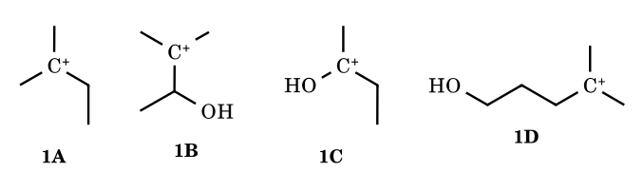
Q1: (C) has the OH on the cationic carbon (oxocarbenium): the most stable.
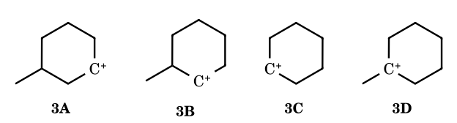
Q3: only (B) rearranges (a 1,2-H shift from the methyl-bearing neighbour gives the tertiary ion); (D) is already tertiary.

5G.1 Exercise I – mains oriented (Q1–Q53)
Q | Answer | Reasoning
1 | (C) | Only C has the OH on C⁺ itself (+M, oxocarbenium); in B and D the OH is further away and only withdraws.
2 | (C) | Least likely: the 7-norbornyl-type bridge/bridgehead cation, which cannot become planar; trityl, cyclohexenyl (allylic) and ethyl are all possible.
3 | (B) | A secondary cation next to a carbon bearing a methyl group shifts H to give the tertiary 1-methylcyclohexyl cation.
4 | (D) 4 | Dicyclobutylmethyl cation: ring expansion (cyclobutyl → cyclopentyl) and further ring expansions/hydride shifts to the fused tertiary bicycle: four 1,2-shifts in the key. ‡
5 | (B) 8 | All eight can lower their energy by a 1,2-shift: primary n-propyl (H shift), the two secondary branched cations (H or CH₃ shift), the quaternary-neopentyl type, the methyl-substituted cyclopentyl and spiro cations (ring changes), the β-alkoxy cation (H shift to oxocarbenium) and the secondary benzylic-type cation. ‡
6 | (B) ΔH₄ > ΔH₁ > ΔH₂ > ΔH₃ | Heterolysis is hardest where the cation is least stable: phenyl (IV) > cyclohexyl (I) > cyclohexenyl-allylic (II) > benzyl (III).
7 | (C) | 3-Bromocyclopropene ionises (silver bromide, pale yellow) to the aromatic cyclopropenyl cation, which has three equivalent resonance forms. The false statement is that it has the lower dipole moment than bromocyclopropane.
8 | (C) | SbCl₅ ionises C–Cl to the planar benzylic carbocation, so the optically active chloride racemises.
9 | (B) 0 | 1-Butanol dehydrates by E2 on the protonated alcohol (no primary cation), and the 2-butene results from acid-catalysed isomerisation of 1-butene, not from a 1,2-shift in a carbocation. ‡
10 | (A) | Secondary cation next to a quaternary carbon → methyl shifts → tertiary → loses H to give the tetrasubstituted 1,2-dimethylcyclohexene (Zaitsev).
11 | (D) ‡ | In cold dilute acid the rearranged tertiary cation is trapped by water (low temperature favours substitution over elimination).
12 | (A) I < II < III < IV | Dehydration rate follows the stability of the cation formed: phenol does not ionise; cyclohexyl (secondary) < allylic cyclohexenyl < pentadienyl-type.
13 | (D) | Dienol–benzene rearrangement: lose water to the tertiary allylic cation, a methyl migrates, and loss of H⁺ restores the aromatic ring (3,4-dimethylphenol).
14 | (C) ‡ | The fastest to dehydrate is the tertiary, allylic alcohol, since the allyl–tertiary cation is the best.
15 | (D) ‡ | Acid-catalysed dienone/dienol–phenol-type shift and aromatisation, giving the hydroquinone-type product.
16 | (D) | Cyclobutyl-substituted cyclopentyl carbinyl cation: the strained cyclobutane expands (ring strain relief) and the alkene forms in the fused tetrasubstituted position.
17 | (A) | Meyer–Schuster rearrangement: protonation, loss of water, allenyl/propargyl cation, then water at the other terminus and tautomerisation to the α,β-unsaturated ketone (chalcone).
18 | (D) A > B > C > D | Rate with HBr (SN1 through the benzyl cation): p-OMe > H > p-Cl > p-NO₂.
19 | (A) | The tertiary alcohol, 2-methylbutan-2-ol, gives the most stable cation.
20 | (B) | The double bond most reactive to electrophiles gives the most stabilised cation; b is in the position whose cation is stabilised by the neighbouring ring system. ‡
21 | (C) | Secondary cation → methyl shift → tertiary → Zaitsev: the most substituted ring alkene.
22 | (B) 2 | Two diols are mixed; each rearranges on its own, so there are two products (no crossover products between molecules).
23 | (C) II > I > III | Rate-determining step: ionisation of the diol to a cation. The key ranks the mixed methyl/phenyl diol fastest, then the diphenyl diol, and pinacol slowest. ‡
24 | (D) | Pinacol rearrangement with ring expansion: the cyclobutane ring bond migrates, giving the 2,2-dimethylcyclopentanone.
25 | (B) b > a > c | 2-Methoxypropene (enol ether, +M) > isobutene > allyl methyl ether (−I).
26 | (D) | X cannot be 1-methylcyclopent-2-ene-type isomer; the others give 1-bromo-1-methylcyclohexane by Markovnikov addition or ring expansion. ‡
27 | (D) | HCl does not show the peroxide effect; Markovnikov addition and a hydride shift give the tertiary chloride.
28 | (B) | Intramolecular protonation of the enol ether, then the OH adds to the oxocarbenium: the spiroketal.
29 | (B) P > R > Q | Rate of electrophilic addition: methyl vinyl ether (+M) > propene > vinyl chloride (−I).
30 | (C) | HBr/CCl₄ without rearrangement gives a new stereocentre next to the existing one: a mixture of diastereomers.
31 | (A) | Acid hydration and oxymercuration–demercuration are both Markovnikov (same tertiary alcohol); hydroboration gives the anti-Markovnikov alcohol.
32 | (A) | Anti addition of Br₂ to a trans-alkene gives a racemic pair of enantiomers: it is optically inactive, so ‘optically active’ is the incorrect statement.
33 | (D) | Pinacol coupling then pinacol rearrangement gives a spiro ketone C₁₀H₁₆O with three degrees of unsaturation, not four.
34 | (D) | The bromonium ion is opened transannularly by the nitrogen lone pair, giving the bicyclic ammonium-type product.
35 | (D) | trans-2-Butene + Br₂ (anti) gives meso-2,3-dibromobutane: inactive; statements (C) and (D) about optical isomers are the incorrect ones (the key lists D).
36 | (D) | HBr adds to the double bond of allyl bromide to give 1,2-dibromopropane; the other substrates give gem-dihalides.
37 | (B) IV > III > I > II | Triflate > mesylate > acetate > methoxide (strength of the conjugate acid).
38 | (C) IV > III > II > I | Wurtz rate follows C–X bond weakness and polarisability: I > Br > Cl > F.
39 | (C) | NBS brominates the allylic position of the tetrasubstituted alkene; Na/ether couples the allylic radical sites (Wurtz).
40 | (C) III > II > I | Allylic radical substitution: the more substituted the allylic C–H, the weaker the bond and the more stable the radical.
41 | (B) | Bromine is highly selective: it abstracts the tertiary H.
42 | (C) | The substituted cyclohexane has different kinds of hydrogen and gives more than one monochloride.
43 | (B) | The alkyl radical is trigonal planar (sp²), and that is why chlorination of 2-chloropentane gives 2,3-dichloropentane as a stereoisomer mixture.
44 | (A) | Neopentane has only one kind of hydrogen.
45 | (A) | 2-Bromo-2-methylbutane: the tertiary radical.
46 | (C) | Intramolecular Wurtz coupling gives bicyclobutane.
47 | (A) II < I < III | C–D is stronger than C–H (primary kinetic isotope effect), so CD₃CD₃ is slowest; neopentane (12 primary H) reacts fastest per molecule.
48 | (B, D) ‡ | NBS gives the allylic bromide; HBr adds to give the dibromide. The key lists B and D.
49 | (C) | Kolbe electrolysis of a succinate gives an alkene; 2,3-dimethylsuccinate gives 2-butene.
50 | (B) | The carboxylate is consumed and hydroxide forms at the cathode: pH increases.
51 | (B) | Chlorine is unselective: 9 primary H and 1 tertiary H (reactivity about 1 : 4) give mostly isobutyl chloride.
52 | (A) 8 | Methylcyclopentane gives 4 monochlorides and isopentane gives 4 (without stereoisomers): X + Y = 8.
53 | (B) 9 ‡ | NBS on 1-methylcyclohexene: allylic substitution at three allylic positions with rearranged radicals; the key counts nine.

5G.2 Exercise II-A (multiple correct, Q1–Q18)
Q | Answer | Reasoning
1 | (C) | Isopentane (2-methylbutane) has four kinds of hydrogen: four monochlorides.
2 | (A, B) | HI adds to the double bond and the alkyl bromide is displaced via the bromonium-type neighbour; only the products that retain the label pattern in A and B form.
3 | (A, B, D) | At 500 °C, chlorination of 1-butene is allylic radical substitution: four products, two of them chiral; the chiral one cannot be made by HCl addition (which would put Cl on the other carbon).
4 | (A, C, D) | NBS is an allylic brominating agent; 1-methylcyclopentene has seven allylic H; nine allylic bromides in total; the number of fractions is not six.
5 | (B, D) | Wurtz works well for coupling two identical primary-type halides: B and D are symmetric products.
6 | (A, B) | HCl adds to 2,4-hexadiene to give 4-chloro-2-hexene (1,2-adduct) and 2-chloro-3-hexene (the other 1,2-/1,4-adducts).
7 | (A, B, C, D) | All four naming statements are correct.
8 | (B, C, D) | Nucleophilicity statements: excluded from your syllabus list (see the note at the top).
9 | (A, D) | Diastereomeric pairs result in (A) bromination of the cyclohexene and (D) radical addition to the optically pure alkene.
10 | (A, B) | HBr adds to the quinone-methide-type diene to give the benzylic-type bromides of A and B.
11 | (A, C) | Acid-catalysed monoetherisation (1 equivalent) gives two optically active products (diastereomers), a resolvable mixture.
12 | (A, B, D) | The tertiary cation from the allyl-substituted phenol can lose H (A), add water (B) or be trapped by the OH to form the dihydrobenzofuran (D).
13 | (B) | The spirocyclic cation undergoes ring expansion by a 1,2-alkyl shift and loses H to give the aromatic tetralin-type product.
14 | (C) | Pinacol-type coupling of the diketone (Mg) followed by acid: pinacol rearrangement with ring contraction to the spiro ketone.
15 | (A, B, C, D) | All four are true (cyclopropane opens with Br₂; bromination more selective than chlorination; hindered phenoxyl radical does not dimerise; the benzylic radical forms faster with Ar = Ph than with p-nitrophenyl).
16 | (B) 4 | Hydrocarbon major products: Wurtz coupling, Kolbe electrolysis, Zn dehalogenation, and hydroboration–protonolysis give hydrocarbons or alkenes as counted by the key; Hg(OAc)₂ and Br₂ do not. ‡
17 | (A, B, C) | Transannular Wurtz coupling gives a bicyclic hydrocarbon with a double bond that shows geometrical isomerism; no carbocation is involved.
18 | (A, C) | BrCCl₃ adds by a radical chain: CCl₃• adds to the terminal carbon of styrene, giving the benzylic radical, which abstracts Br: a mixture of enantiomers.

5G.3 Exercise II-B (Q1–Q13)
Q | Answer | Reasoning
1 | (B) | HBr is the one that shows the peroxide effect because both chain-propagation steps are exothermic; ‘stronger acid’ is true but is not the reason.
2 | A–S,T; B–P,S,T; C–U; D–Q; E–T,U | Counting the further chlorination products, with chirality.
3 | A–R; B–Q,S; C–P,Q; D–Q,S | Carbocation: dehydration of alcohols; carbanion: Wurtz and soda-lime decarboxylation; free radical: Kolbe and Wurtz (radical mechanism in the key); octet complete in one of the intermediates (Wurtz, soda-lime).
4 | A–P; B–P; C–Q; D–R | Matching to the energy profiles with one, two, three rearrangement steps (the number of carbocation minima).
5 | 1-chloro-3-methylbutane | Isopentane is formed by hydrolysis of R–Li and 2,7-dimethyloctane by Wurtz coupling: R = (CH₃)₂CHCH₂CH₂–.
6 | neopentyl chloride | Reduction gives neopentane (C₅) and Wurtz coupling gives 2,2,5,5-tetramethylhexane.
7 | HBr only | For HBr both propagation steps are exothermic (−25.1 and −50.2 kJ mol⁻¹); for HCl the second step is endothermic (+12.6); for HI the first step is endothermic (+46). So only HBr sustains the chain.
8 | 8 products | Isohexane (2-methylpentane): 1-chloro-2-methylpentane (2 enantiomers), 2-chloro-2-methylpentane (1), 3-chloro-2-methylpentane (2), 4-chloro-2-methylpentane (2) and 1-chloro-4-methylpentane (1).
9 | see below | (A) 1-bromo-1-phenylpropane (benzylic cation); (B) 2-iodo-2-methylbutane; (C) trans-1-bromo-2-methylcyclohexane (anti-Markovnikov, radical); (D) the tertiary chloride (Markovnikov).
10 | A = trans-2-butene; B = 2-bromobutane | 0.7 g per 2.0 g of Br₂ (0.0125 mol) gives M = 56 (C₄H₈); the dibromide is non-resolvable (meso, from the trans alkene); both HBr paths give the same 2-bromobutane because the alkene is symmetric.
11 | (a) tertiary chloride; (b) trans-dibromides; (c) dichloride | (a) Markovnikov addition gives the tertiary chloride; (b) anti addition of Br₂ to the ring gives two diastereomeric trans-dibromides; (c) Cl₂/CS₂ gives the vicinal dichloride as racemic diastereomers. ‡
12 | reasoning | In CH≡C–CH₂–CH=CH₂ protonation of the alkene gives a secondary cation. In CH≡C–CH=CH₂ protonation of the alkene end would give a cation next to an alkyne that is destabilised, so the terminal alkyne carbon is protonated to a vinyl cation conjugated with the vinyl group (an allyl-like cation) and bromide adds at the internal carbon: 2-bromo-1,3-butadiene.
13 | A = 2,2-; B = 1,3-; C = 1,2-; D = 1,1-dichloropropane | Further chlorination: 2,2- gives one trichloride; 1,3- gives two; 1,1- and 1,2- give three each. The optically active one is 1,2-dichloropropane (chiral), whose 1,1,2-trichloride is chiral and the other two are not.

5G.4 JEE-Main and JEE-Advanced (objective)
Q | Answer | Reasoning
M1 | (3) | Cl⁺ (from Cl₂) adds first, giving the intermediate CH₃–CH⁺–CH₂Cl, which water attacks.
M2 | (4) | HBr with peroxide on 3-methyl-2-pentene gives the anti-Markovnikov bromide with two stereocentres: four stereoisomers.
M3 | — | Nucleophilicity order: excluded from your syllabus list.
M4 | (2) | Cl₂/H₂O gives the chlorohydrin CH₃CH(OH)CH₂Cl.
M5 | (1) | Vinyl halides resist substitution; but the reason given (a cation stabilised by π electrons) is wrong, since the vinyl cation is unstable; A is right and R is wrong.
M6 | (1) | CF₃–CH=CH₂ gives the anti-Markovnikov product: the CF₃ group makes the secondary cation very unstable.
M7 | (4) | DCl adds Markovnikov to the alkyne to give CH₃C(Cl)=CHD; DI then adds to give CH₃C(Cl)(I)CHD₂.
M8 | (3) ‡ | The nitrile-stabilised tertiary radical is formed and adds to the terminal alkene carbon.
M9 | (1) | Acid-catalysed cyclisation of the diene (geraniol-type) gives the terpineol skeleton.
M10 | (3) | Protonation of the cyclopropenone gives the aromatic hydroxycyclopropenyl cation.
M11 | (3) ‡ | Hydroboration–oxidation gives the alcohol; dilute acid dehydration gives the most substituted (Zaitsev) alkene.
A1 | (A, C) | Benzyl chloride from toluene: SO₂Cl₂ (radical) and Cl₂/hv; SOCl₂ and NaOCl do not do benzylic chlorination.
A2 | — | Nucleophilicity: excluded from your syllabus list.
A3 | (D) | One equivalent of HBr on isoprene gives the 1,4-adduct (a trisubstituted alkene) as the major product by the key.
A4 | (A, B) | trans-2-butene (i) and cis-2-butene (ii) with Br₂: anti addition in both; (M, O) and (N, P) are diastereomeric pairs.
⚑ Check. The printed key assigns the Main Q3 and Advanced Q2 nucleophilicity items which I did not work. For questions marked ‡ I relied on the key because the drawings did not allow independent verification.

Part 5H Orders and Rules from Your Lecture Notes (Lessons 1–5, Doubt-Clearing Sessions)
The 12 lecture PDFs are screen captures of handwritten board work. I went through all of their pages; the legible, carbocation-relevant content is collected here as orders and rules. Board problems whose answers were never written on the page (for example the 'number of shifts' drawings 7–25 of Carbocation-V and the dehydration problems 1–48) are not answered here, because I could not read the structures reliably: send those pages at higher resolution and I will solve them. Conformational analysis (Lesson 1) and nucleophilicity-in-solvents (Doubt session) are outside your topic list, so they are not reproduced.

5H.1 Master stability order (Doubt-clearing session)
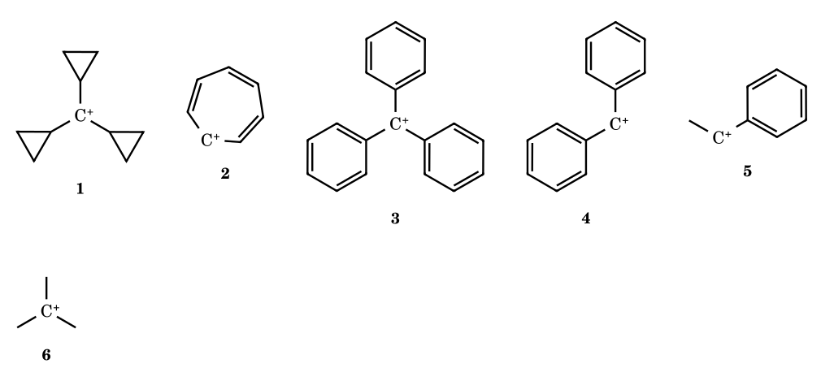
Board order, left to right: tricyclopropylmethyl > tropylium > Ph₃C⁺ > Ph₂CH⁺ > PhCH⁺R > (CH₃)₃C⁺ …
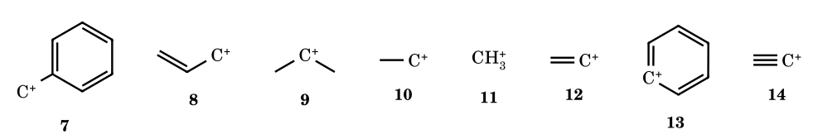
… > PhCH₂⁺ > allyl ≈ isopropyl > ethyl > methyl > vinyl > phenyl > ethynyl. The cyclopentadienyl cation is written as ‘can’t exist’ (antiaromatic).
⚑ Check. This board order puts tricyclopropylmethyl above tropylium; the pK_{R}⁺ values in your cation notes (tropylium +4.7, tricyclopropylmethyl −2.3) and the hydride affinity (tropylium 200) put tropylium far above it, so this one position on the board disagrees with the data (Part 5A Q93 and Part 5E use tropylium first). It also ranks t-Bu⁺ above benzyl, consistent with Part 5E (hydride affinities 231.9 vs 238) but opposite to the coaching convention used in some other answers. The exact positions of allyl versus isopropyl on the board line are not clearly legible; the HIA table gives isopropyl 249 < allyl 256.

5H.2 Rearrangement rules from Carbocation-V
- A rearrangement happens to reach a more stable cation (3° > 2° > 1°) and only if the three-membered cyclic transition state (3c–2e bonding, a 1,2-shift) is accessible. It is spontaneous and fast.
- Migratory aptitude: H > Ar > R (bond shifted, steric factor and electron donation all matter); for alkyl groups t-Bu > i-Pr > Et > Me; for isotopes H > D > T; among aryl groups p-OCH₃ (+M) > p-CH₃ (+H) > H > p-Cl (−I).
- Counting shifts (board examples): CH₃⁺, CH₃CH₂⁺ and (CH₃)₂CH⁺ → 0 shifts (nothing more stable is reachable); (CH₃)₂CH–CH₂⁺ → 1 (H) giving t-Bu⁺; (CH₃)₃C–CH₂⁺ → 1 (Me) giving t-amyl; (CH₃)₂CH–CH(CH₃)–CH₂⁺-type chains → 2 (H, H) to the tertiary ion.
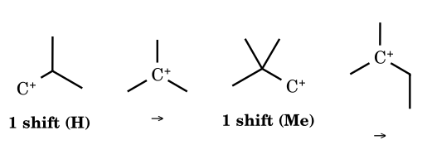
Two of the board counts redrawn: isobutyl → t-butyl (one hydride shift); neopentyl → t-amyl (one methyl shift).

5H.3 Leaving-group and ionisation rules from Carbocation-IV
Rule from the board | Detail
Leaving tendency | ∝ stability of the leaving group ∝ stability of the carbocation formed; weaker base = better leaving group
Halides | I⁻ > Br⁻ > Cl⁻ > F⁻ (size/polarisability)
Oxyanions | CH₃O⁻ (not a leaving group) < acetate < mesylate < triflate; tosylate < brosylate < nosylate
Super leaving groups | N₂ (from R–N₂⁺, the amine/HNO₂ route) and triflate
Conversions the board shows | R–OH is poor, but R–OH + H⁺ → R–OH₂⁺ (leaves as H₂O); R–OH + TsCl/BsCl/AcCl/MsCl/TfCl gives R–OTs etc.; R–NH₂ + H⁺ → R–NH₃⁺ and R–NH₂ + 2 TsCl → R–NTs₂ (leaves as ⁻NTs₂); ethers need H⁺ first; H–OH does not ionise to H⁺ + OH⁻ (strong base); CH₃–I does not ionise in water (primary methyl cation); aryl and vinyl halides do not ionise (but ArN₂⁺ loses N₂ on heating to give phenol via the unstable aryl cation); R–Cl + AlCl₃/AlBr₃/SbCl₅/AgNO₃ gives R⁺ (Lewis acids)

5H.4 Reactions of carbocations (Lessons 5 and FR-II)
Type | Rule | Product pattern
Combination with a nucleophile | attack from either face of the planar sp² cation | chiral cation: racemic mixture (2 enantiomers) or two diastereomers if another stereocentre exists
Elimination (if a base is present) | loss of a β-H, Saytzeff (more substituted, more stable alkene, via the more stable transition state) is the major product; Hofmann (less substituted) is the minor | stability: Saytzeff > Hofmann; for 2-methylbutane-type cations the more substituted alkene is formed by losing the β-H of the more substituted carbon
Rearrangement | see 5H.2 and Part 7.0 | —

5H.5 Dehydration of alcohols (Free-Radical III/IV lessons)
- Conc. H₂SO₄ or conc. H₃PO₄, H⁺/Δ gives the alkene as the major product; ethanol: 180 °C → ethylene (elimination), 140 °C → diethyl ether (substitution), 110 °C → ethyl hydrogen sulfate.
- Rate of dehydration ∝ stability of the carbocation formed (slow step): 3° > 2° > 1°. The slow step is the loss of water from the protonated alcohol (rate-determining), so the potential-energy diagram has three transition states and one intermediate (the oxonium ion) before the carbocation.
- If both C=C and –OH are present, protonation occurs at the site that gives the more stable carbocation; primary alcohols dehydrate by E2 without a free carbocation, so rearrangement is not really observed for 1° alcohols (the board marks this).
- Yield order of the three products from the sec-pentyl cation: the trans-2-alkene (Saytzeff) > the cis-2-alkene > the 1-alkene (Hofmann).

5H.6 Pinacol rearrangement rules (Free-Radical IV)
- vic-Diols (pinacol) with conc. H₂SO₄ → pinacolone: protonate one OH, lose H₂O (RDS), 1,2-shift, deprotonate the O-protonated ketone.
- Which OH leaves: the one that gives the more stable cation (benzylic/tertiary). Which group migrates: the better migrating group (aryl > H > alkyl on your board; with aryl groups, the more electron-rich). Semipinacol: amino-alcohol + HNO₂ gives the same cation by loss of N₂.
- Worked mechanisms 7.10–7.19 in Part 7.0 cover pinacolone, benzopinacolone, ring expansion/contraction and the dienone–phenol shift.

5H.7 Electrophiles and nucleophiles (Lesson 2) – the part of your topic list
Class | Definition on the board | Examples
Electrophile | electron-loving; an electron-deficient species, electron acceptor; must have an (exactly or momentarily) vacant orbital | —
Positive electrophile | carries a + charge | H⁺, D⁺, T⁺, Cl⁺, Br⁺, I⁺, NO⁺, NO₂⁺, carbocations. Alkali-metal cations (Na⁺, Li⁺, K⁺) are not electrophiles.
Neutral incomplete-octet electrophile (Lewis acid) | electron-deficient atom, no charge | BH₃, B₂H₆, BF₃, BCl₃, AlCl₃, SbCl₅, carbenes, nitrenes
Complete-octet electrophile | octet complete, but a polarised bond makes one atom δ+ and open to attack | carbonyl compounds (C=O), RCOX, RCOOR′, CO₂, CH₃–I, Br–Br, Cl–Cl, I–Cl, I–N₃, HO–Cl, NO–Cl
Nucleophile | nucleus-loving; electron donor; any species with a lone pair or a loose π bond pair | HO⁻, RO⁻, CN⁻, NH₃, H₂O, alkenes, arenes, carbanions
The board also classifies single-step and multi-step reactions: a single-step reaction goes through one transition state (a pentavalent carbon in the TS) with no intermediate; a multi-step reaction must have at least one intermediate (carbocation, carbanion, free radical) and uses normal tetravalent TS's. Endothermic reactions have ΔH > 0 and the product is less stable; exothermic ones ΔH < 0.

5H.8 Carbocation structure (Doubt-clearing session)
Property | Carbenium ion R₃C⁺ | Carbonium ion (five-coordinate)
Hybridisation / shape | sp², trigonal planar, bond angle 120°, empty p orbital perpendicular to the plane | sp³d-type description is wrong; it is a 3c–2e bonded species (CH₅⁺)
Electron count | sextet: 3 bond pairs, 0 unpaired electrons, 0 lone pairs; diamagnetic (μ = √(n(n+2)) = 0), spin multiplicity 2S+1 = 1 (singlet) | complete octet counting the 3c–2e pair; highly unstable and reactive
Reactivity | electrophile (Lewis acid); planar, so a nucleophile attacks from both faces (racemisation) | —
Formation | R–LG heterolysis; H⁺ + CH₂ (carbene) gives CH₃⁺; H⁺ + CH₄ gives CH₅⁺; H⁺ adds to lone pairs (H₂O → H₃O⁺, NH₃ → NH₄⁺) but not to NaCl-type ionic species | protonation of an alkane

Part 5I Fifty Original Carbocation Stability Questions with Reasoned Answers
These are original problems written for this book in the style of JEE Advanced, GATE and CSIR papers; they are not taken from any book. Each answer gives the reason. Where sources disagree the answer is marked ⚑.
SQ-1.
Arrange in decreasing stability: (a) CH₃⁺, (b) CH₃CH₂⁺, (c) (CH₃)₂CH⁺, (d) (CH₃)₃C⁺.
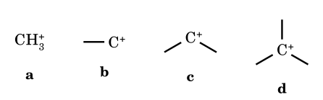
Answer: d > c > b > a
Each added alkyl group donates by +I and hyperconjugation (9, 6, 3 and 0 C–H bonds adjacent to C⁺).
SQ-2.
Arrange in decreasing stability: p-methoxybenzyl, p-methylbenzyl, benzyl, p-chlorobenzyl, p-nitrobenzyl cations.
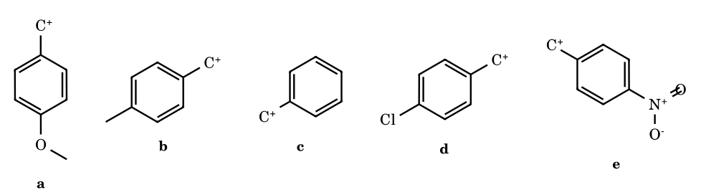
Answer: a > b > c > d > e
σ⁺ constants: OMe −0.78, Me −0.31, H 0, Cl +0.11, NO₂ +0.79. Only the +M donor OMe is strongly stabilising; Cl withdraws by −I more than it donates by +M.
SQ-3.
Arrange in decreasing stability: (a) CH₃⁺, (b) PhCH₂⁺, (c) Ph₂CH⁺, (d) Ph₃C⁺.
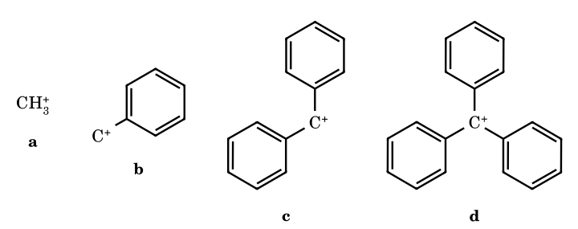
Answer: d > c > b > a
Each phenyl adds resonance contributors (4, 7 and 10 for benzyl, benzhydryl, trityl); trityl is twisted but still the most stable.
SQ-4.
Arrange in decreasing stability: tropylium, cyclopropenyl and cyclopentadienyl cations.
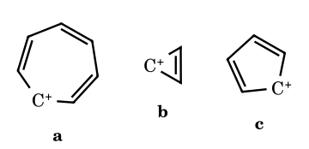
Answer: a > b > c
Tropylium (6π) and cyclopropenyl (2π) are aromatic by Hückel; cyclopentadienyl cation (4π) is antiaromatic. Tropylium is the better delocalised of the two aromatic cations.
SQ-5.
Arrange in decreasing stability: Me₂N⁺=CH₂, MeO⁺=CH₂, t-Bu⁺, CH₃CH₂⁺.
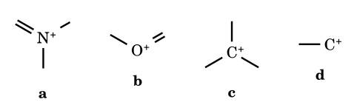
Answer: a > b > c > d
The lone pair of N (better donor, less electronegative) delocalises into C⁺ better than that of O; both beat alkyl hyperconjugation. These ions have a full octet on every atom.
SQ-6.
Arrange in decreasing stability: CH₂=CH–CH₂⁺, CH₃CH=CH–CH₂⁺, (CH₃)₂C=CH–CH₂⁺.
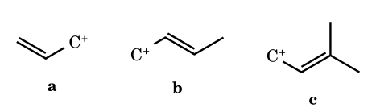
Answer: c > b > a
Alkyl groups on the allyl termini stabilise the partial positive charge; in c one terminus is tertiary.
SQ-7.
Which is more stable: allyl cation or pentadienyl cation?
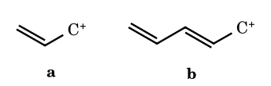
Answer: pentadienyl
The charge is delocalised over three carbons instead of two (resonance forms 3 versus 2).
SQ-8.
Which is more stable: Ph₂CH⁺ or 9-fluorenyl cation?
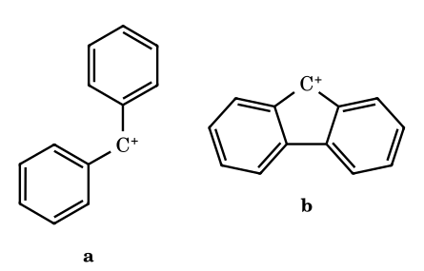
Answer: Ph₂CH⁺
In the planar fluorenyl cation the central five-membered ring contains 4π electrons (antiaromatic), which destabilises it by many orders of magnitude (solvolysis ≈ 10⁶ slower).
SQ-9.
Arrange in decreasing stability: tris(p-methoxyphenyl)methyl, trityl and tris(p-nitrophenyl)methyl cations.
Answer: (p-MeOC₆H₄)₃C⁺ > Ph₃C⁺ > (p-O₂NC₆H₄)₃C⁺
p-OMe is a +M donor; p-NO₂ is −M/−I. The tri-anisyl cation is stable enough to be isolated as a salt in dilute acid (pK_{R+} ≈ +0.8, versus −6.6 for trityl).
SQ-10.
Arrange in decreasing stability: t-Bu⁺, 1-adamantyl, bicyclo[2.2.2]oct-1-yl and 1-norbornyl cations.
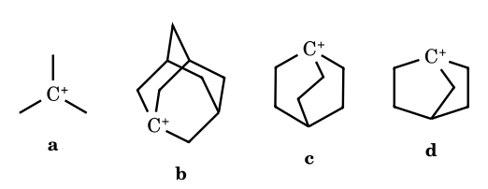
Answer: a > b > c > d
A bridgehead cation cannot become planar. The more rigid and the more strained the cage, the worse the cation; solvolysis rates of the bridgehead bromides relative to t-BuBr are ≈ 10⁻³, 10⁻⁶ and 10⁻¹³.
SQ-11.
Arrange in decreasing ease of S_{N}1 ionisation (stability of the cation): cyclopentyl, cyclohexyl, cyclopropyl.
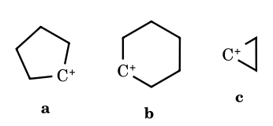
Answer: a > b > c
Cyclopentyl relieves eclipsing strain on going to sp²; cyclohexyl gains little (and has I-strain); cyclopropyl cation would need a 60° angle and opens instead (disrotatory) to an allyl cation.
SQ-12.
Which is more stable: Me₃SiCH₂CH₂⁺ or CH₃CH₂CH₂⁺?
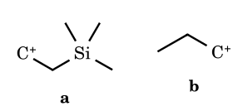
Answer: the β-silyl cation
The β-silicon effect: the C–Si σ bond hyperconjugates strongly with the empty p orbital (≈ 38 kcal mol⁻¹ stabilisation; bridged silyl-ethyl ion).
SQ-13.
Arrange in decreasing stability: (a) (CH₃)₂C(cyclopropyl)⁺, (b) cumyl cation (PhC⁺(CH₃)₂), (c) t-Bu⁺.
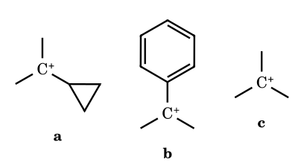
Answer: a > b > c
The bent σ bonds of cyclopropane overlap very well with the empty p orbital (bisected geometry); cyclopropyl is a better cation stabiliser than phenyl, which is a better one than methyl.
SQ-14.
Count the cationic resonance contributors (ignore Kekulé variants) for (a) benzyl, (b) Ph₂CH⁺, (c) Ph₃C⁺.
Answer: (a) 4; (b) 7; (c) 10
One structure with the charge on the exocyclic carbon plus three (ortho, ortho′, para) per phenyl ring: 1 + 3n.
SQ-15.
Predict the product of 3-methylbut-1-ene + HBr (no peroxide) and name the cation sequence.
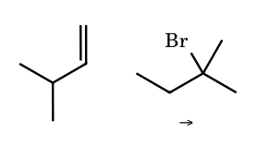
Answer: 2-bromo-2-methylbutane; 2° cation → 1,2-H shift → 3° cation
Protonation gives the secondary cation (CH₃)₂CH–C⁺HCH₃; a hydride shift from the tertiary C–H gives the tertiary cation, which is captured by Br⁻. Some 2-bromo-3-methylbutane is formed from the unrearranged ion.
SQ-16.
Predict the major product of 3,3-dimethylbut-1-ene + HCl.
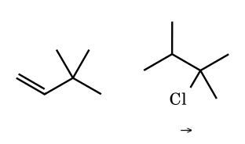
Answer: 2-chloro-2,3-dimethylbutane
The secondary cation rearranges by 1,2-methyl shift to the tertiary 2,3-dimethylbut-2-yl cation; minor product 2-chloro-3,3-dimethylbutane from direct capture.
SQ-17.
Predict the product of neopentyl alcohol (2,2-dimethylpropan-1-ol) + HBr (heat).
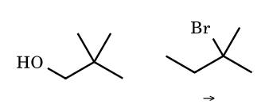
Answer: 2-bromo-2-methylbutane
Protonation, loss of water with simultaneous methyl shift (a primary cation is not formed) gives the tert-amyl cation; Br⁻ captures it. No neopentyl bromide forms.
SQ-18.
Predict the product of cyclohexylmethanol + HBr, and the cation steps.
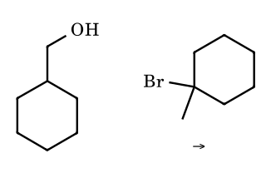
Answer: 1-bromo-1-methylcyclohexane; primary → tertiary by 1,2-H shift
A hydride moves from the ring carbon to the CH₂⁺ (concerted with loss of water), giving the tertiary 1-methylcyclohexyl cation.
SQ-19.
Dehydration of 3-methylbutan-2-ol with H₂SO₄: major alkene?
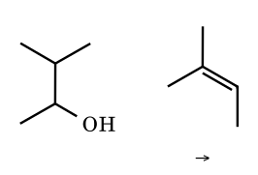
Answer: 2-methylbut-2-ene
Loss of water gives the secondary cation, which takes a hydride from the tertiary carbon to give the tertiary cation; E1 loss of H⁺ gives the most substituted alkene (Zaitsev).
SQ-20.
Which is more stable: CH₃OCH₂⁺ or CH₃CH₂⁺?
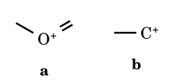
Answer: CH₃OCH₂⁺
Oxygen lone-pair donation (+M, forming an oxocarbenium ion) outweighs the −I effect of O.
SQ-21.
Which is more stable: t-Bu⁺ or neopentyl cation (CH₃)₃CCH₂⁺?
Answer: t-Bu⁺
Tertiary versus primary; the neopentyl cation rearranges to the tert-amyl cation without barrier.
SQ-22.
Which is more stable: PhCH(CH₃)⁺ or PhCH₂⁺?
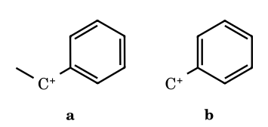
Answer: PhCH(CH₃)⁺
A secondary benzylic cation has resonance plus an extra alkyl donor.
SQ-23.
Which is more stable: o-methoxybenzyl or m-methoxybenzyl cation?
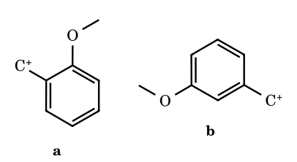
Answer: o-methoxybenzyl
Ortho (like para) OMe donates by resonance directly to the benzylic carbon; at meta only −I operates and the ion is less stable than benzyl.
SQ-24.
Which is more stable: p-methylbenzyl or m-methylbenzyl cation?
Answer: p-methylbenzyl
Hyperconjugation and +I of CH₃ act through conjugation at para; at meta only the weak inductive effect acts.
SQ-25.
Arrange in decreasing stability: m-methylbenzyl, benzyl, m-methoxybenzyl, m-chlorobenzyl and m-nitrobenzyl cations.
Answer: m-CH₃ > H > m-OCH₃ > m-Cl > m-NO₂
At meta only inductive effects operate: σ⁺_{m} = −0.07, 0, +0.05, +0.40, +0.67.
SQ-26.
Arrange in decreasing stability: p-fluorocumyl, cumyl, p-chlorocumyl and p-bromocumyl cations.
Answer: p-F > H > p-Cl > p-Br
σ⁺_{p} = −0.07, 0, +0.11, +0.15. Fluorine is an excellent +M donor through 2p–2p overlap that outweighs its −I; Cl and Br donate poorly (3p/4p overlap).
SQ-27.
Arrange in decreasing stability: (p-MeOC₆H₄)₂CH⁺, Ph₂CH⁺, (p-O₂NC₆H₄)₂CH⁺.
Answer: dianisyl > Ph₂CH⁺ > dinitrophenyl
Same σ⁺ reasoning, doubled.
SQ-28.
Arrange in decreasing stability: tricyclopropylmethyl, dicyclopropylmethyl and cyclopropylmethyl cations.
Answer: (c-C₃H₅)₃C⁺ > (c-C₃H₅)₂CH⁺ > c-C₃H₅CH₂⁺
Each cyclopropyl adds σ-conjugation; the tricyclopropylmethyl cation (pK_{R+} ≈ −2.3) is more stable than trityl.
SQ-29.
Rank the arenium (σ-complex) ions formed on nitration of toluene by site of attack: ortho, meta, para.
Answer: para ≈ ortho > meta
Attack at o/p puts the positive charge on the carbon bearing CH₃ (a tertiary-like centre stabilised by hyperconjugation); at meta it never does.
SQ-30.
Rank the arenium ions formed on nitration of anisole by site: ortho, meta, para.
Answer: para ≥ ortho ≫ meta
At o/p the oxygen lone pair stabilises the charge (an oxocarbenium resonance form with an octet on every atom); at meta it cannot.
SQ-31.
Rank the arenium ions formed on nitration of nitrobenzene by site: ortho, meta, para.
Answer: meta > ortho ≈ para
At o/p one resonance form places the positive charge on the carbon bearing the NO₂, which is strongly destabilising; at meta that never happens.
SQ-32.
Arrange in decreasing stability: Ph–C⁺=CH₂, CH₃–C⁺=CH₂, CH₂=CH⁺.
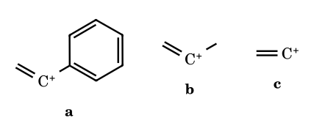
Answer: a > b > c
A vinyl cation has an empty p orbital in the plane; an α-aryl group stabilises it by conjugation through the perpendicular ring orientation, an α-alkyl by hyperconjugation.
SQ-33.
Rank the hydride ion affinities (HIA, the energy for R⁺ + H⁻ → RH) of CH₃⁺, CH₃CH₂⁺, (CH₃)₂CH⁺, (CH₃)₃C⁺; which is lowest?
Answer: HIA: CH₃⁺ (312) > C₂H₅⁺ (270) > i-Pr⁺ (249) > t-Bu⁺ (231 kcal mol⁻¹); lowest is t-Bu⁺
The more stable the cation, the less energy is released on taking up H⁻. Gas-phase values, recalled and approximate.
SQ-34.
Is the benzyl cation more stable than the tert-butyl cation?
Answer: ⚑ it depends on the phase and the source
Gas-phase HIA: benzyl 238 versus t-Bu 231 kcal mol⁻¹, so t-Bu⁺ is more stable in the gas phase. In solution many data and most JEE keys place benzyl (resonance) at or above a tertiary alkyl cation; follow the convention of your paper.
SQ-35.
Why does 2-exo-norbornyl brosylate solvolyse ≈ 350 times faster than the endo isomer, and what is the product?
Answer: σ-participation by the C1–C6 bond from the back side of the leaving group (only possible for exo)
The C1–C6 bond is anti to the exo leaving group and helps displace it, giving the bridged non-classical 2-norbornyl cation (the product is racemic exo-norbornyl derivative). The endo leaving group has no anti σ bond, so ionisation is a normal secondary one.
SQ-36.
State true or false: (i) CH₃⁺ has 8 valence electrons; (ii) the vinyl cation carbon is sp-hybridised; (iii) all carbocations are planar; (iv) the 1-adamantyl cation is pyramidal at C⁺ (not planar).
Answer: (i) false (6); (ii) true; (iii) false; (iv) true
A carbocation carbon has six valence electrons. The vinyl cation is linear (sp). Bridgehead and strained cations such as 1-adamantyl and 1-norbornyl cannot be planar.
SQ-37.
Count the hyperconjugative (no-bond) structures for (a) t-Bu⁺, (b) i-Pr⁺, (c) CH₃CH₂⁺, (d) CH₃CH₂C⁺(CH₃)₂.
Answer: (a) 9; (b) 6; (c) 3; (d) 8
Count the C–H bonds on the carbons adjacent to C⁺: 3 × 3, 2 × 3, 3, and 2 × 3 + 2. ⚑ the same count ranks tert-amyl below t-Bu, whereas gas-phase data show tert-amyl more stable (polarisability) — JEE keys follow the count.
SQ-38.
Arrange in decreasing stability: cinnamyl cation PhCH=CHCH₂⁺, allyl cation, and CH₃CH₂CH₂⁺.
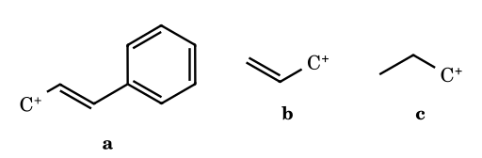
Answer: a > b > c
The phenyl ring extends the delocalisation (charge shared by C-1, C-3 and the ring o/p carbons).
SQ-39.
Which is more stable: α-methoxy tertiary (CH₃)₂C⁺–OCH₃ or t-Bu⁺?
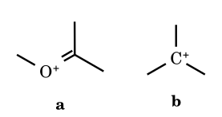
Answer: (CH₃)₂C=O⁺CH₃
Oxygen donates a lone pair (octet on all atoms), a larger effect than the three alkyl groups.
SQ-40.
Arrange in decreasing stability: CH₂=CH–CH₂⁺, cyclopropylcarbinyl and benzyl cations (⚑ source-dependent).
Answer: ⚑ benzyl > cyclopropylcarbinyl > allyl (most JEE keys); gas-phase data put allyl lowest, benzyl and cyclopropylcarbinyl close
Resonance structures: benzyl 4, allyl 2; cyclopropylcarbinyl is stabilised by σ-conjugation of the bent C–C bonds. Say which convention you follow.
SQ-41.
Which cation is formed first from 2-methylbutan-1-ol with HBr, and what is the final product?
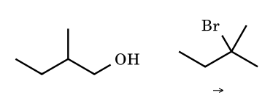
Answer: 2-bromo-2-methylbutane
A primary cation is not formed; hydride shift is concerted with loss of water, giving the tertiary tert-amyl cation.
SQ-42.
Which of these cations rearranges, and to what? (a) (CH₃)₃C⁺, (b) (CH₃)₃CCH⁺CH₃, (c) (CH₃)₂CHCH⁺CH₃.
Answer: (b) → methyl shift to 2,3-dimethylbut-2-yl; (c) → hydride shift to 2-methylbut-2-yl (3°)
(a) is already the most stable alkyl cation. In (b) the adjacent quaternary carbon passes a methyl to give a tertiary cation; in (c) a hydride is passed from the tertiary C–H.
SQ-43.
State the order of stability for the cations formed by protonation of CH₂=C(CH₃)₂, CH₂=CH–CH₃, CH₂=CH₂ (the more stable cation forms faster).
Answer: t-Bu⁺ (from isobutene) > i-Pr⁺ (propene) > ethyl (ethene)
Rate of acid-catalysed hydration follows the stability of the cation; isobutene is hydrated ≈ 10⁶ faster than propene.
SQ-44.
Why are carbocations adjacent to a carbonyl group (α-keto cations) so unstable?
Answer: the C=O is an electron-withdrawing group (−I and −M) next to an electron-deficient carbon
The carbonyl carbon is already positively polarised, and the oxygen lone pairs lie in the nodal plane relative to the empty p orbital; so there is no stabilisation and strong destabilisation. α-Halo-ketones therefore show very slow S_{N}1.
SQ-45.
Rank the solvolysis rates (S_{N}1) of: t-BuCl, i-PrCl, CH₃CH₂Cl, CH₃Cl in 80 % aqueous ethanol.
Answer: t-BuCl > i-PrCl > EtCl ≳ MeCl (≈ 10⁸ : 45 : 1 : 1)
Rates follow cation stability; EtCl and MeCl react by S_{N}2 with solvent in practice.
SQ-46.
Which cation is formed from isopropylbenzene (cumene) with H₃PO₄ and propene in the industrial process, and which is it that attacks benzene?
Answer: the isopropyl cation (from propene + H⁺) attacks benzene (Friedel–Crafts alkylation)
Protonation of propene gives the secondary isopropyl cation (Markovnikov), the electrophile; no rearrangement is possible since a hydride shift would give a primary cation.
SQ-47.
In the Friedel–Crafts alkylation of benzene with 1-chlorobutane/AlCl₃, sec-butylbenzene is the major product. Explain.
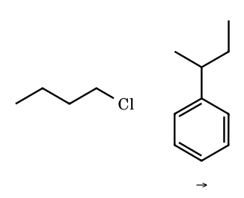
Answer: hydride shift from the CH₂Cl-bound complex gives the secondary cation
The polarised R–Cl···AlCl₃ complex undergoes a 1,2-hydride shift as chloride leaves, giving the sec-butyl cation, which alkylates benzene faster than the primary complex.
SQ-48.
Order the following by increasing rate of S_{N}1 solvolysis: benzyl chloride, allyl chloride, tert-butyl chloride, isopropyl chloride (⚑).
Answer: ⚑ i-PrCl < allyl Cl < t-BuCl ≈ benzyl chloride; commonly accepted order i-PrCl < allyl < benzyl < t-BuCl
All three cations are well stabilised; allyl and benzyl are resonance-stabilised but primary; tertiary hyperconjugation wins in 80 % ethanol. Check the order your key uses.
SQ-49.
Arrange in decreasing stability: CH₃CH₂⁺, CH₂=CH⁺, HC≡C⁺.
Answer: CH₃CH₂⁺ > CH₂=CH⁺ > HC≡C⁺
The empty orbital is in an orbital with more s-character in sp² and sp cations, which holds the empty orbital's partner electrons less well; the ethynyl cation is far too unstable to form in solution.
SQ-50.
Why does anti-7-norbornenyl tosylate solvolyse ≈ 10¹¹ times faster than 7-norbornyl tosylate?
Answer: π-participation by the C2=C3 bond gives a stabilised bridged (homoallylic) cation
The double bond lies anti to the leaving group and donates its π electrons to C-7 as the tosylate departs. The syn isomer cannot do this and is only slightly faster than the saturated compound.

Part 6 Migratory Aptitude: Rules, Reasons and Competing Migrations
Migratory aptitude is the relative tendency of a group to move with its electron pair to an adjacent electron-deficient centre. It is not one fixed order: it depends on what the reaction is, on the stability of the cation that remains, and on stereoelectronics (the migrating bond must lie anti-periplanar to the leaving group, or parallel to the empty p orbital).
Reaction | Order of migratory aptitude | Why
Pinacol / Wagner–Meerwein (carbocation) | H > aryl (electron-rich > Ph > electron-poor) > tertiary alkyl > secondary > primary > CH₃ | the group that best bridges the 3c–2e transition state; aryl through a phenonium ion; ⚑ H vs aryl depends on conformation and on which cation each shift gives
Baeyer–Villiger | tertiary alkyl > cyclohexyl (secondary) ≈ benzyl ≈ aryl > primary > CH₃ | the migrating group carries the positive charge in the Criegee intermediate; the better able to stabilise it, the better it migrates
Beckmann | group anti to the leaving group on N (stereospecific) | the anti group moves as water leaves; if the oxime isomerises, the more stable E isomer decides
Hofmann / Curtius / Lossen | tertiary > secondary ≈ aryl > primary > CH₃ | migration with retention to an electron-deficient N (Part 11)
Radical | aryl, vinyl, acyl only; not H or alkyl | needs a stabilised bridged radical (Part 9)
Carbanion | aryl (Grovenstein–Zimmerman) only | needs an accessible spiro intermediate (Part 8)
- Stereochemistry: the migrating group moves with retention of configuration; its origin carbon is never inverted (the group stays bonded to both carbons in the transition state).
- Ring strain: migration that expands a cyclobutane or cyclopropane ring is strongly favoured (strain relief ≈ 26 kcal mol⁻¹) and can override the usual order; expansion from five- to six-membered rings is favoured when it also converts a secondary into a tertiary cation.
- Conformation: in cyclohexane diols the group anti-periplanar to the leaving group migrates (axial–axial), which can contradict the intrinsic order (see 7.14, 7.15).
- In a cascade the question to ask is always: which shift gives the most stable new cation, and is the migrating bond aligned?

6.1 Fifteen competing migrations: solved

6.2 Ten questions on migratory aptitude
MA-1.
2,3-Diphenylbutane-2,3-diol is treated with H₂SO₄. Which group migrates, and what is the product?
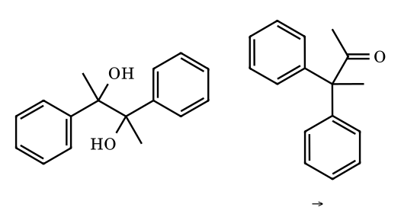
Answer: phenyl migrates: 3,3-diphenylbutan-2-one
Ionisation gives a tertiary benzylic cation; of CH₃ and Ph on the neighbouring carbon, Ph migrates (aryl ≫ methyl) through a phenonium ion; the other OH becomes C=O.
MA-2.
Predict the product of 1,1-diphenylethane-1,2-diol with acid.
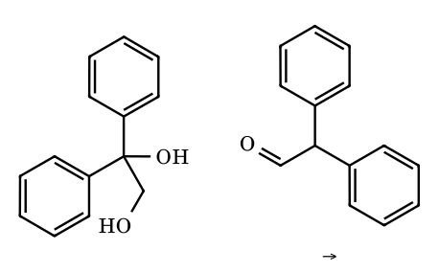
Answer: diphenylacetaldehyde
The OH on the diaryl carbon ionises (diarylmethyl cation); H on the adjacent CH₂OH migrates, leaving a protonated aldehyde. The reverse (ionise the primary OH) is not competitive.
MA-3.
Predict the product of 2-methylpropane-1,2-diol with acid.
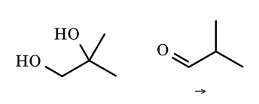
Answer: isobutyraldehyde (2-methylpropanal)
The tertiary OH ionises; H migrates from CH₂OH to the tertiary cation, giving the protonated aldehyde (H migrates in preference to any alkyl).
MA-4.
Predict the product of 1-phenylethane-1,2-diol with acid.
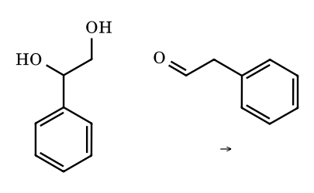
Answer: phenylacetaldehyde
The benzylic OH ionises; H moves from the neighbouring CH₂OH.
MA-5.
Predict the product of 1-methylcyclohexane-1,2-diol with acid.
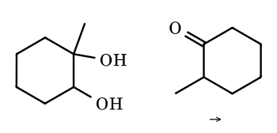
Answer: 2-methylcyclohexanone
The tertiary OH ionises; the hydride on C-2 migrates to C-1, leaving the protonated 2-methylcyclohexanone.
MA-6.
2-Amino-1,1-diphenylethanol is treated with HNO₂. Give the product.
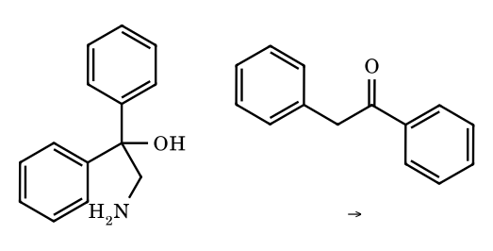
Answer: deoxybenzoin (PhCOCH₂Ph, 1,2-diphenylethanone)
The primary amine gives the diazonium; a phenyl group migrates from the carbinol carbon to CH₂ as N₂ leaves, leaving an oxocarbenium ion that loses H⁺ (semipinacol rearrangement).
MA-7.
1-(Aminomethyl)cyclohexanol is treated with HNO₂. Give the product.
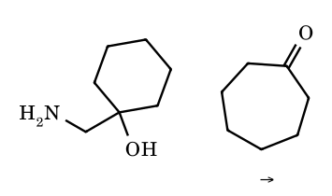
Answer: cycloheptanone
(Tiffeneau–Demjanov) a ring C–C bond migrates to the CH₂ carbon as N₂ leaves; the ring is enlarged by one carbon and the carbinol carbon becomes C=O.
MA-8.
Which group migrates in the Baeyer–Villiger oxidation of (a) pinacolone, (b) acetophenone, (c) cyclohexyl methyl ketone, (d) benzyl methyl ketone?
Answer: (a) t-butyl; (b) phenyl; (c) cyclohexyl; (d) benzyl
In each case the group other than methyl migrates because it better stabilises the positive charge in the Criegee intermediate: tert-butyl acetate, phenyl acetate, cyclohexyl acetate, benzyl acetate respectively.
MA-9.
Cyclobutylmethanol is treated with HBr. Which skeleton is the major product, and why?
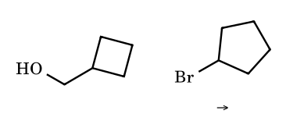
Answer: cyclopentyl bromide (ring expansion)
A ring C–C bond migrates as water leaves, enlarging cyclobutane to cyclopentane (strain relief) and converting a primary into a secondary cation; Br⁻ captures it.
MA-10.
Why does the 2,2-dimethylcyclohexyl cation rearrange to the 1,2-dimethylcyclohexyl cation instead of undergoing ring contraction?
Answer: methyl shift gives a tertiary cation with no strain change
A methyl shift converts a secondary cation to a tertiary one without altering ring strain; a ring-contraction would give a primary exocyclic cation.
MA-11.
Which group is lost last in the pinacol rearrangement of benzopinacol, and why does a phenyl migrate rather than a hydroxyl or other group?
Answer: the product is triphenylacetophenone; phenyl migrates because OH cannot, and Ph is the only migrating candidate
After ionisation of one C–OH the neighbouring carbon carries OH and two phenyl groups; a phenyl migrates (through a phenonium ion) to the cation, leaving the oxocarbenium that loses H⁺.
MA-12.
In the dienone–phenol rearrangement of 4-methyl-4-phenylcyclohexa-2,5-dienone, which group migrates?
Answer: phenyl (to give 3-methyl-4-phenylphenol)
Migrating aptitude aryl > methyl in the protonated dienone; the shift gives the cation that rearomatises by loss of H⁺.
MA-13.
Predict the product of 3,3-dimethylbutan-2-ol with H₂SO₄ (E1) and name the migrating group.
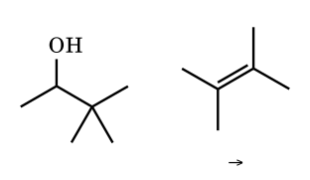
Answer: 2,3-dimethylbut-2-ene; methyl migrates
The secondary cation takes a methyl from the quaternary carbon to give the tertiary 2,3-dimethylbut-2-yl cation; E1 loss of H⁺ gives the tetrasubstituted alkene (the most stable).
MA-14.
2-Methyl-2-(hydroxymethyl)oxirane, or more simply 2,2-dimethyloxirane, is treated with a trace of acid. Give the product.
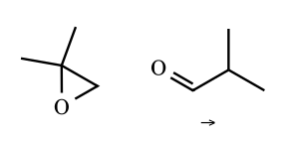
Answer: isobutyraldehyde (Meinwald rearrangement)
Protonation opens the epoxide at the tertiary carbon; hydride shifts from CH₂ to the tertiary cation, leaving a protonated aldehyde.
MA-15.
(E)-Acetophenone oxime is treated with PCl₅. Which group migrates and what is the product?
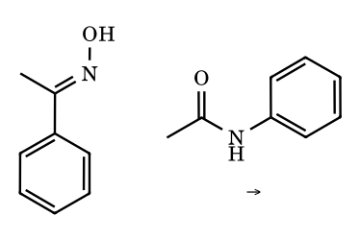
Answer: phenyl (it is anti to OH): acetanilide
In the E isomer the OH is trans to the higher-priority phenyl group, so phenyl is anti to the leaving group and migrates (nitrilium ion, then water). The Z isomer would give N-methylbenzamide. Always apply the anti rule rather than a fixed order.
MA-16.
Arrange in decreasing migratory aptitude in a pinacol rearrangement: CH₃, H, Ph, (CH₃)₃C, p-CH₃OC₆H₄.
Answer: H > p-MeOC₆H₄ > Ph > t-Bu > CH₃ (⚑ H vs aryl)
Groups that bridge well migrate best; an electron-rich aryl bridges through a stabilised phenonium ion. Some sources put aryl above hydride when the cation is unconstrained.
MA-17.
Arrange the aryl groups in decreasing migratory aptitude: p-anisyl, phenyl, p-chlorophenyl, p-nitrophenyl.
Answer: p-anisyl > phenyl > p-chlorophenyl > p-nitrophenyl
The phenonium ion is a cationic spiro intermediate; donors stabilise it.
MA-18.
In the Baeyer–Villiger oxidation of methyl vinyl ketone-like cyclic ketone 2-methylcyclohexanone, which C–C bond migrates?
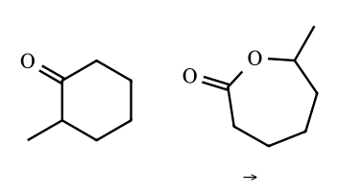
Answer: the more substituted (secondary C-2) carbon: 7-methyloxepan-2-one
The more substituted carbon migrates (secondary > primary), so oxygen is inserted between the carbonyl carbon and C-2, giving the 7-methyl lactone.
MA-19.
Does hydride shift to a cation occur with retention or inversion at the migrating carbon, and why does a chiral migrating alkyl group retain its configuration?
Answer: retention
The migrating group stays bonded to both carbons in the three-centre two-electron transition state, so its configuration is never lost.
MA-20.
Why does the 1,2-methyl shift of the neopentyl cation not require a free primary cation?
Answer: the shift is concerted with departure of the leaving group
A primary alkyl cation is too high in energy; anchimeric assistance by the methyl group brings the cation directly to the tertiary position.
MA-21.
A cyclobutylcarbinyl cation can undergo ring expansion or hydride shift. Which is preferred when both give a secondary cation?
Answer: ring expansion
Expansion relieves about 20 kcal mol⁻¹ of strain; hydride shift would retain the strained ring.
MA-22.
State why aryl groups migrate faster than alkyl groups through a bridged ion in both the pinacol and Baeyer–Villiger rearrangements.
Answer: aryl π electrons give a stabilised bridged (phenonium or π-complex) transition state
The ring can delocalise charge in the spiro intermediate, lowering the barrier.
MA-23.
HO–C(CH₃)₂–C(OH)Ph₂ is treated with acid. Which OH leaves, and what is the major product?
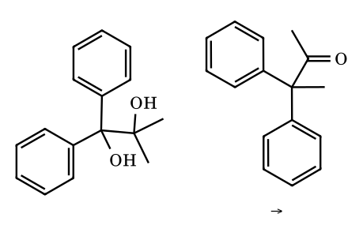
Answer: the OH on the diaryl carbon leaves; 3,3-diphenylbutan-2-one
Loss of OH from the diphenylcarbinol carbon gives the very stable Ph₂C⁺, so the cation stability decides which OH leaves (not the migratory aptitude). A methyl then migrates from the neighbouring carbon. The alternative (ionise the dimethyl OH, phenyl migrates) gives PhCO–C(CH₃)₂Ph and is minor.
MA-24.
Which has the greater migratory aptitude in Hofmann rearrangement: n-propyl or isopropyl?
Answer: isopropyl
Secondary alkyl groups migrate better than primary (more able to carry positive charge in the transition state).
MA-25.
True or false: the order of migratory aptitude is the same in every rearrangement.
Answer: false
It depends on the mechanism: in a carbocation shift H and aryl lead, in Baeyer–Villiger tertiary alkyl leads, in the Beckmann rearrangement stereochemistry (anti) rather than aptitude decides.

Part 7.0 Carbocation Rearrangements: Thermodynamic and Kinetic Control, Mechanisms, and Named Reactions
A carbocation rearranges by a 1,2-shift of H (hydride), alkyl or aryl with its bonding electron pair to the neighbouring cationic carbon, through a three-centre two-electron (3c–2e) transition state or bridged intermediate. The cation moves to the carbon that lost the migrating group. Your lecture notes divide the subject into two kinds, and the division is useful for every problem:
 | Thermodynamic control (TCP): reversible | Kinetic control (KCP): irreversible
Where the cation goes | to the more stable cation, but each step is reversible, so the mixture reaches the thermodynamically best cation(s) | to a cation that is captured at once by an irreversible step (loss of H⁺, formation of C=O by deprotonation, ring-strain relief)
Examples | neopentyl ⇌ t-amyl; 2,2-dimethylcyclohexyl ⇌ 1,2-dimethylcyclohexyl; cycloalkylmethyl ⇌ methylcycloalkyl | pinacol (ends in a ketone); semipinacol/Tiffeneau–Demjanov (HNO₂); dienone–phenol (ends aromatic)
What decides the product | relative stability of the cations (substitution, resonance, α-heteroatom lone pair, ring strain) | what the cation can do next: an OH or NH₂ on the new cationic carbon forms C=O⁺H or C=N⁺H₂ and the sequence cannot go back
A 1,2-rearrangement runs to completion only if (i) the new cation is substantially better stabilised electronically (more substituted, resonance, adjacent lone pair); or (ii) it is more stable for another reason such as relief of ring strain; or (iii) it is captured in a subsequent irreversible reaction. Primary cations are generally not true intermediates: the shift occurs together with the departure of the leaving group. A shift between two equally stable cations (tertiary ⇌ tertiary) is allowed and reversible, but it is not counted as a ‘rearrangement’ in counting problems unless it changes the skeleton or the product.

7.0.1 Orders you must know
Order | Rule
Migratory aptitude in a reversible 1,2-shift (your note) | Ph < 1° < 2° < 3° < H: the better the migrating group stabilises a positive charge (electron-donating ability), the better it migrates. Hydride is the best, then the more substituted alkyl, and phenyl is the worst here because its migration goes by a less favourable ipso (phenonium) pathway when an easier alkyl/H shift is available.
Migratory aptitude in the pinacol rearrangement (your note) | Ph > H > Me, i.e. aryl first. Among aryl groups, ∝ electron donation: p-OCH₃-C₆H₄ (+M) > p-CH₃-C₆H₄ (+H) > C₆H₅ > p-Cl-C₆H₄ (−I). Always combine it with the stability of the cation formed by the first ionisation.
Which OH ionises first in a pinacol | The OH on the carbon that gives the more stable cation leaves (diaryl > aryl,alkyl > dialkyl; tertiary > secondary), and the group that migrates then goes to that carbon.
Ring size in expansions | A small ring next to a cationic carbon expands (cyclopropylcarbinyl → cyclobutyl; cyclobutylcarbinyl → cyclopentyl; cyclopentylcarbinyl → cyclohexyl): the driving force is relief of angle/torsional strain (σ-bond shift).
Rate order of pinacol rearrangement (Nucleus Q23) | key: ArMe-diol (II) > diaryl diol (I) > pinacol (III): the faster the first ionisation, the faster the overall reaction.

7.0.2 Step-validated 1,2-shifts and named rearrangements
7.1 Neopentyl cation ⇌ tert-amyl cation (methyl shift, TCP)
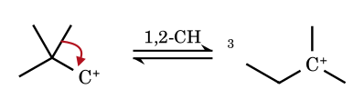
The C–CH₃ σ pair migrates to the primary cation; the cation moves to the quaternary carbon, which becomes tertiary: primary → tertiary is downhill by about 70 kJ mol⁻¹, and the reverse is not observed.
7.2 3,3-Dimethylbut-2-yl cation → 2,3-dimethylbut-2-yl cation (secondary → tertiary)
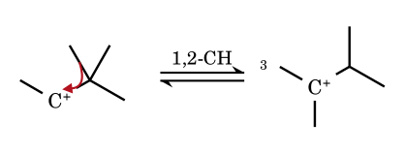
The cation next to a quaternary carbon is the classic setting for a methyl shift: the secondary cation becomes tertiary. This is the reason pinacolyl alcohol with HBr gives 2-bromo-2,3-dimethylbutane.
7.3 Neophyl cation: phenyl shift through the phenonium ion
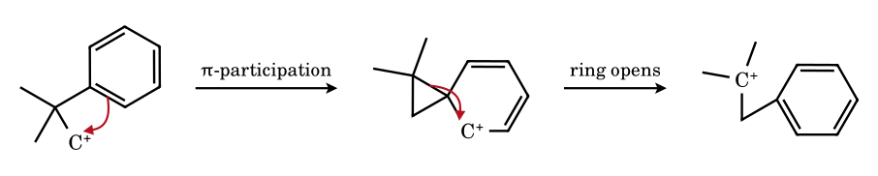
The ring π electrons attack the cationic carbon, giving the bridged phenonium ion (a spiro cyclohexadienyl cation with a three-membered ring), then the C–C bond to the quaternary carbon breaks and the tertiary cation forms. The bridged ion explains retention of configuration in aryl migrations.
7.4 Cyclohexylmethyl cation → 1-methylcyclohexyl cation (hydride shift)
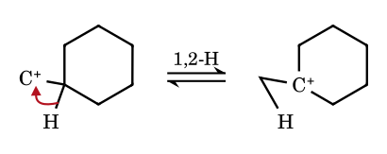
A primary cation next to a tertiary C–H takes the hydride and becomes the tertiary ion; the competing ring expansion to the cycloheptyl cation (secondary) is slower.
7.5 2,2-Dimethylcyclohexyl cation → 1,2-dimethylcyclohexyl cation
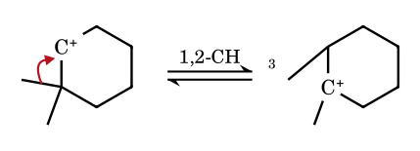
The same reasoning in a ring. The tertiary ion then loses a β-hydrogen to give the most substituted alkene, 1,2-dimethylcyclohexene (Nucleus Q10).
7.6 Cyclobutylmethyl cation → cyclopentyl cation (ring expansion)
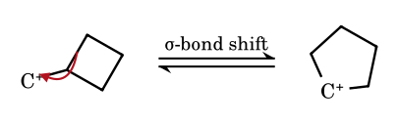
A ring C–C bond migrates to the primary carbon: the four-membered ring becomes five-membered (strain relief ≈ 100 kJ mol⁻¹) and the cation changes from primary to secondary. Ring expansion is driven by strain and by the better cation.
7.7 1-Cyclopentylethyl cation → 1-methylcyclohexyl cation (ring expansion then hydride shift)
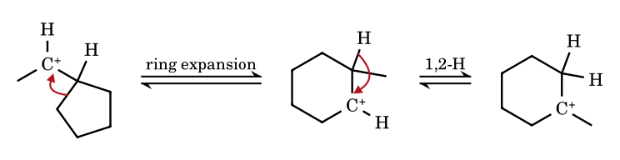
Step 1 moves a ring bond to the cationic carbon and enlarges the ring to cyclohexane (the cation is now the secondary ion next to the methyl-bearing carbon). Step 2 is a hydride shift that puts the charge on the methyl-bearing carbon: tertiary, the global minimum (Kohinoor p. 9; Nucleus Q16 follows the same logic).
7.8 Cyclopropylcarbinyl cation ⇌ cyclobutyl cation (≈ 48 : 47, with ≈ 5 % homoallyl)
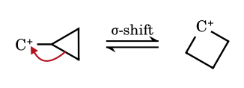
The two ions interconvert rapidly by a σ-bond shift, and solvolysis of either gives the same mixture of cyclopropylcarbinyl (≈ 48 %), cyclobutyl (≈ 47 %) and homoallyl (≈ 5 %) products. The ions are best described as a delocalised bicyclobutonium/non-classical cation (Part 4).
7.9 Isoborneol → camphene (Wagner–Meerwein, H⁺)
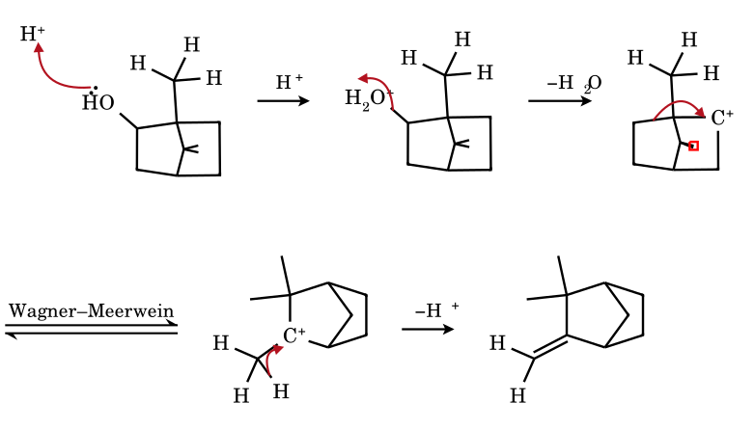
The secondary 2-norbornyl-type cation is formed (as an ion with the OH leaving as water), the C1–C6 σ bond shifts to C2 (Wagner–Meerwein shift) and the cation lands on the bridgehead carbon that bears a methyl group. Loss of a proton from that methyl gives the exocyclic alkene camphene, not the bornylene (the endocyclic alkene), as in your page: the proton is removed from the methyl group that can overlap with the empty orbital.
7.10 Pinacol → pinacolone
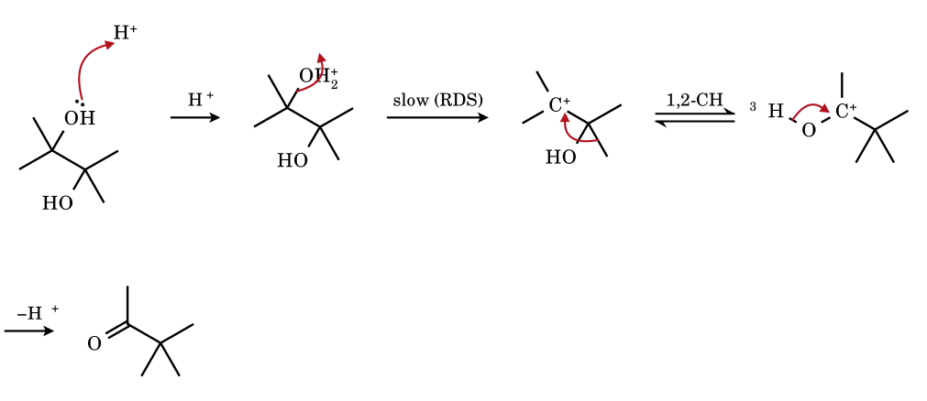
Protonation, loss of water (rate-determining) and a methyl shift give an O-protonated ketone; loss of H⁺ (irreversible) gives pinacolone. The lone pair of the remaining OH stabilises the new cation by +M: this is the driving force and it is why the reaction is under kinetic control.
7.11 Benzopinacol → triphenylacetophenone (aryl migration)
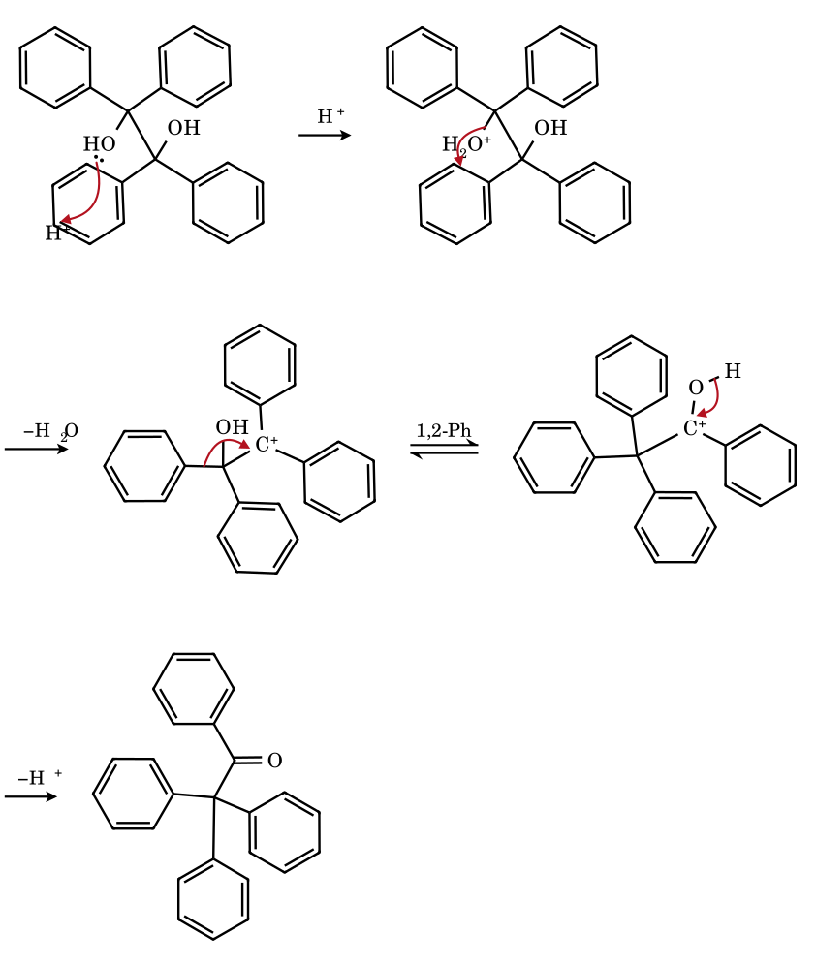
Either OH can ionise (the diaryl cations are equivalent). A phenyl group migrates to the cationic carbon through a phenonium-type transition state; the new cation is stabilised by the OH lone pair and gives triphenylacetophenone (β-benzopinacolone).
7.12 1-(2-Hydroxyprop-2-yl)cyclobutanol → 2,2-dimethylcyclopentanone (pinacol with ring expansion)
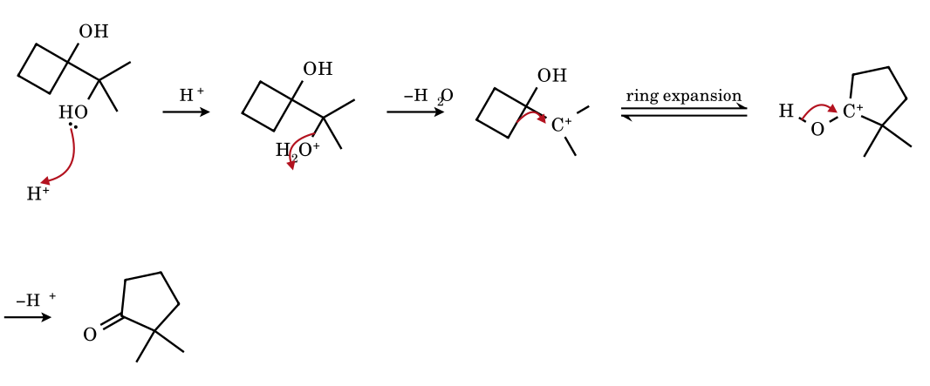
The tertiary open-chain OH ionises (more stable cation than the strained cyclobutyl one). The migrating group is a ring C–C bond: it moves to the cation, enlarging the four-membered ring to five. The adjacent carbon becomes C=O. Nucleus Q24 (answer D).
7.13 1,1′-Bi(cyclopentyl)-1,1′-diol → spiro[4.5]decan-6-one
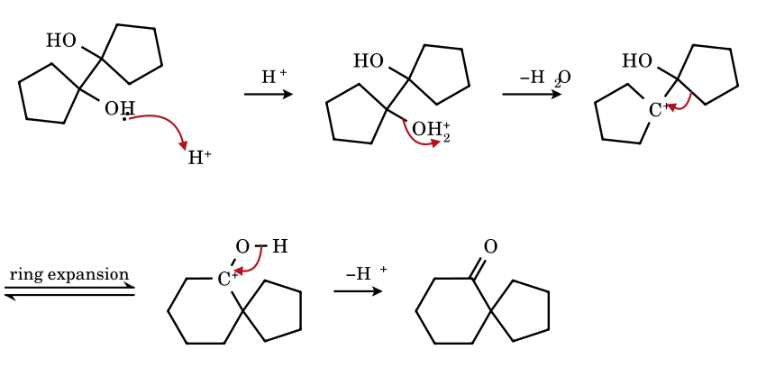
Pinacol coupling of cyclopentanone (Mg–Hg) followed by acid gives the spiro ketone: one ring bond of the other cyclopentane migrates to the cationic carbon, so that ring expands to six and the cationic carbon becomes the spiro centre (Kohinoor items 7 and 12; Nucleus II-A Q14).
7.14 cis-1,2-Dimethylcyclohexane-1,2-diol → 2,2-dimethylcyclohexanone (methyl shift)
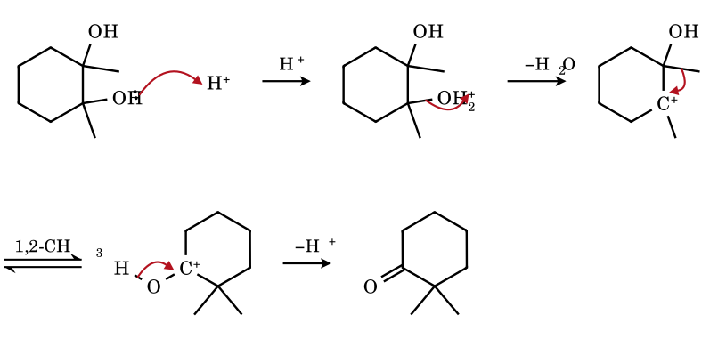
In the cis diol one OH is axial and the other equatorial. The axial OH is the one that leaves, and the group anti-periplanar to it on the neighbouring carbon is the axial methyl (the OH on that carbon is equatorial), so the methyl migrates. The product is 2,2-dimethylcyclohexanone.
7.15 trans-1,2-Dimethylcyclohexane-1,2-diol (diequatorial) → 1-acetyl-1-methylcyclopentane (ring contraction)
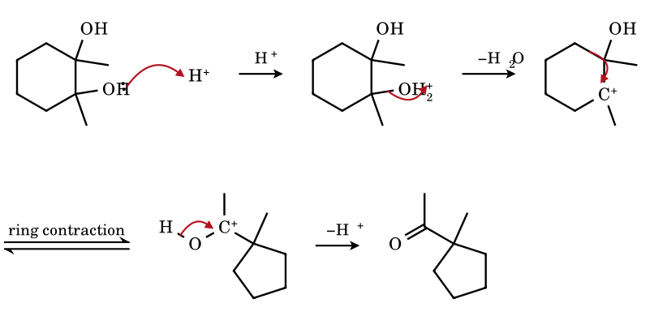
When the leaving OH is equatorial, the antiperiplanar bond is a ring C–C bond, not the methyl: that ring bond migrates, the six-membered ring contracts to five, and an exocyclic acetyl group results. The same compound, different stereochemistry: different product (stereoelectronic control).
7.16 1-Cyclobutylcyclopentanol → bicyclo[4.3.0]non-1(6)-ene (two ring expansions, then E1)
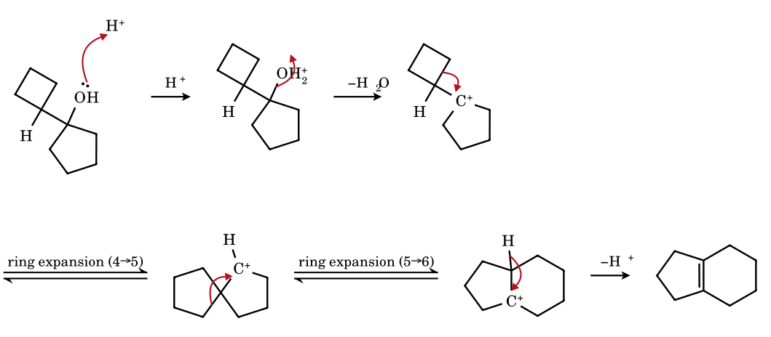
The tertiary cation next to a strained cyclobutane first expands the four-membered ring (giving a spiro[4.4] secondary ion), which then expands the other ring to six (fused tertiary ion at the ring junction); loss of the junction proton gives the tetrasubstituted alkene (Nucleus Q16, option D).
7.17 4,4-Dimethylcyclohexa-2,5-dienone → 3,4-dimethylphenol (dienone–phenol rearrangement)
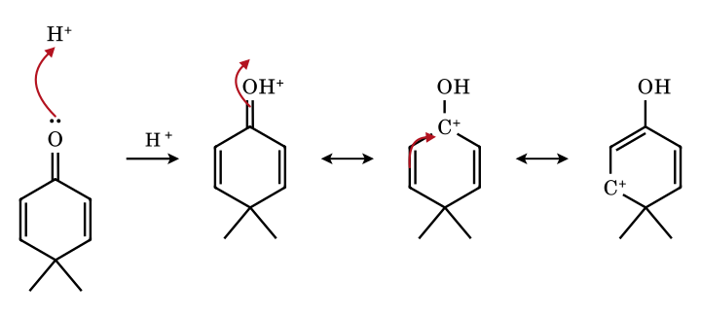
Step 1 protonates the carbonyl oxygen; steps 2–3 move the positive charge to C-4, next to the quaternary carbon. The next step is the methyl shift and the loss of a proton (shown separately in 7.18).
7.18 Dienone–phenol, the shift and the aromatisation
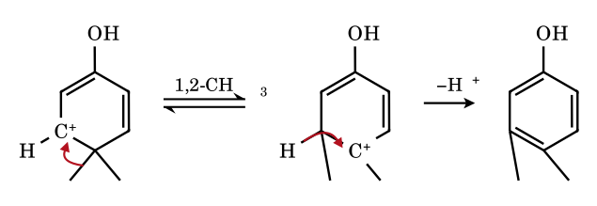
The cation on C-4 is the arenium-like ion with a quaternary neighbour; a methyl group shifts to it, the new cation at C-5 is a fully delocalised hydroxy-arenium ion, and loss of H⁺ from C-4 gives the aromatic phenol. The migrating group goes to the adjacent ring carbon (3,4-dimethylphenol).
7.19 Spiro[4.5]deca-6,9-dien-8-one → 5,6,7,8-tetrahydro-2-naphthol (spiro ring expansion)
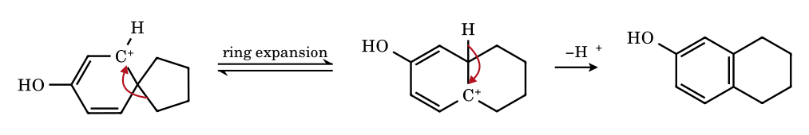
In the protonated dienone the positive charge sits next to the spiro carbon. A bond of the spiro cyclopentane migrates, expanding that ring to six and converting the ion to a hydroxy-arenium; loss of H⁺ restores the aromatic ring. Nucleus II-A Q13 and Kohinoor p. 14.

Part 7.2 More Validated Rearrangement Mechanisms: Ring Expansion, Semipinacol, Competing Migrations, Meinwald
Each mechanism below was checked by computer in the same way as 7.1–7.19. In every case the group that migrates is the one anti-periplanar to the leaving group, and the leaving group departs together with the shift (no free primary cation).
7.20 Tiffeneau–Demjanov ring expansion: 1-(aminomethyl)cyclohexanol + HNO₂ → cycloheptanone
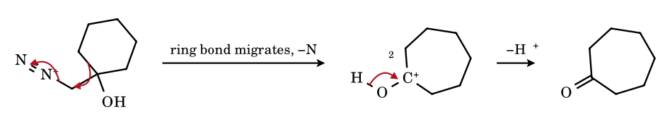
The diazonium group of the primary amine (from HNO₂, Part 2.F) is an excellent leaving group. A ring C–C bond of the carbinol carbon migrates to the CH₂ carbon as N₂ leaves, enlarging the six-membered ring by one carbon; the remaining cation is an oxocarbenium ion (the OH lone pair donates), which loses H⁺ to give cycloheptanone. The ring expansion is favoured because the driving force is conversion of an unstabilised primary centre into an O-stabilised cation.
7.21 Semipinacol deamination: 2-amino-1,1-diphenylethanol → deoxybenzoin
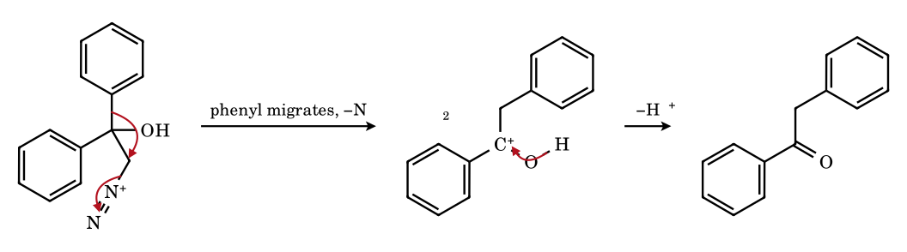
One of the two phenyl groups migrates to CH₂ (through a phenonium-like bridged structure) as nitrogen is lost; the OH then loses its proton to give the ketone PhCO–CH₂Ph. Because the two phenyls are identical there is no competition problem; with unlike aryl groups the more electron-rich one migrates.
7.22 Pinacol with competing groups: 2,3-diphenylbutane-2,3-diol → 3,3-diphenylbutan-2-one (Ph migrates, not CH₃)
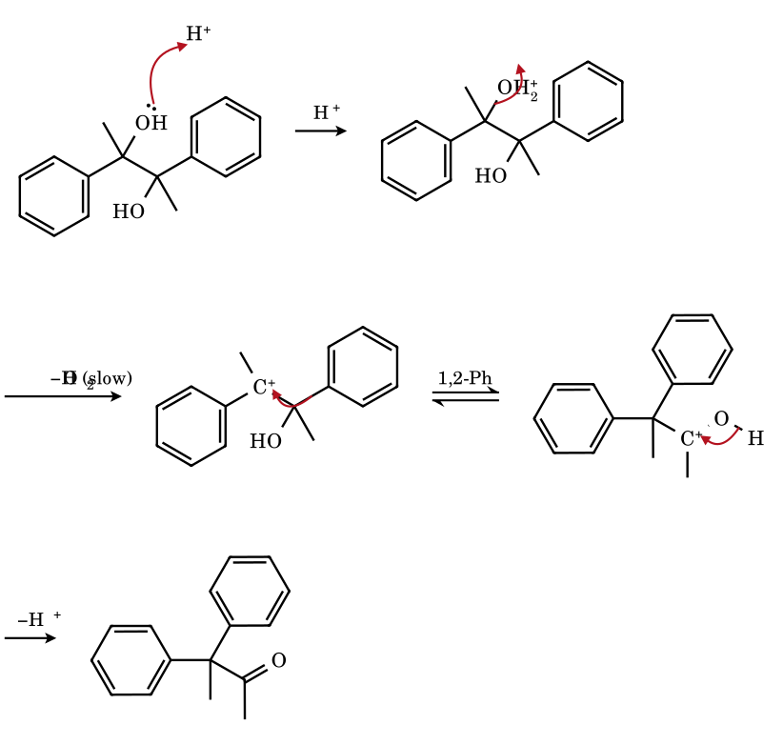
The tertiary benzylic cation forms first. Two groups can migrate from the neighbouring carbon, CH₃ and phenyl; phenyl has the higher aptitude (it bridges through the phenonium ion), so the product is the ketone with a quaternary C(CH₃)Ph₂. The O-stabilised cation then loses H⁺.
7.23 Hydride migration in a cyclic pinacol: 1-methylcyclohexane-1,2-diol → 2-methylcyclohexanone
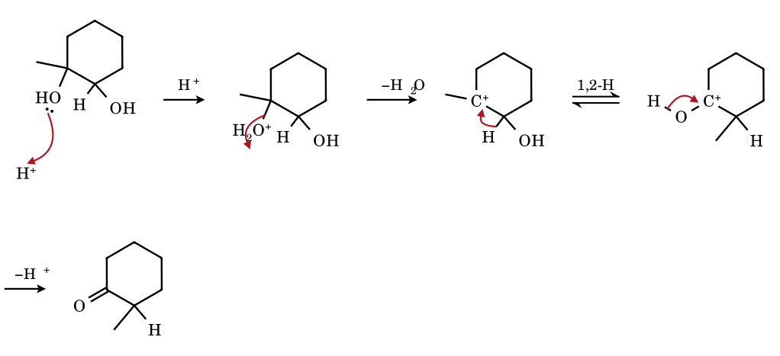
The tertiary OH ionises to give the more stable cation; the hydrogen on the neighbouring carbinol carbon migrates (hydride has the highest aptitude and no strain change occurs). The O-stabilised cation loses H⁺ to give 2-methylcyclohexanone.
7.24 Meinwald rearrangement: 2,2-dimethyloxirane + H⁺ → isobutyraldehyde
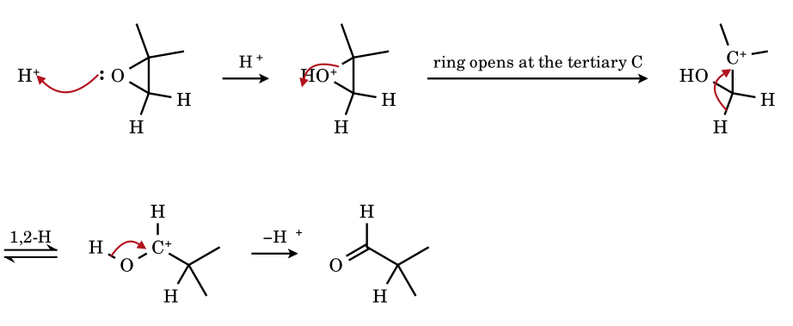
Protonation of the epoxide oxygen weakens the C–O bond at the tertiary carbon, which becomes a cation. A hydride migrates from the CH₂OH carbon to the cation, and the resulting oxocarbenium loses H⁺ to give the aldehyde. This is the cation-driven (Meinwald) isomerisation of epoxides to carbonyl compounds; with Lewis acids phenyl and alkyl groups can migrate instead.

Part 7 Carbocation Rearrangements — Counting Problems (opening section)
Counting problems test whether you can recognise a rearrangement before drawing any mechanism. Rules used (JEE-Advanced level): a carbocation rearranges by a 1,2-H, 1,2-alkyl, 1,2-aryl or ring-bond shift only if the new cation is more stable (more substituted, conjugated, or less strained) or the new ion is trapped irreversibly; shifts to an equally stable cation (secondary → secondary, tertiary → tertiary) are degenerate or unproductive and are not counted as ‘rearranging’; tertiary, benzylic and allylic cations do not rearrange to a less stable ion. Primary cations are usually not true intermediates: the shift is concerted with the departure of the leaving group, but for counting purposes such a shift is ‘a rearrangement’. The answers below were cross-checked with a small shift-enumeration program (every 1,2-shift of every cation was generated and the product classified) and by hand.

7.1 How many rearrange? How many ring-expand? How many shifts are possible?
R1.How many of the following carbocations (a–j) will undergo rearrangement by a 1,2-shift to give a more stable carbocation? (Integer answer)
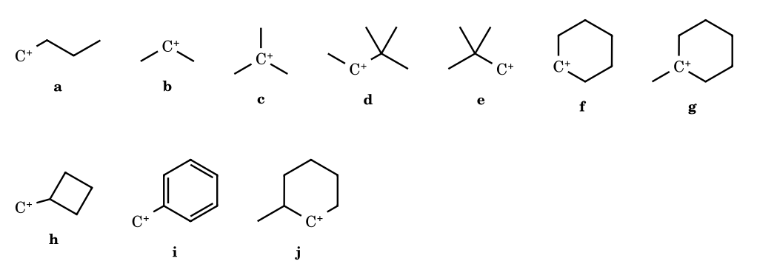
R2.How many of the carbocations (a–h) can undergo ring expansion by a single 1,2-shift to a more stable cation (more substituted and/or less strained)? (Integer answer)
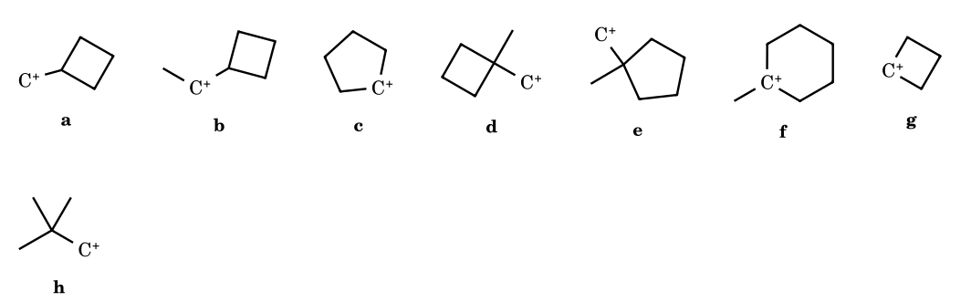
R3.The 3-methylbutan-2-yl cation, CH₃–CH⁺–CH(CH₃)₂, can undergo different 1,2-shifts. (i) How many different carbocations (other than the starting ion itself) can be formed by one 1,2-shift of H or CH₃? (ii) How many of these are more stable than the starting ion? Give (i), (ii).
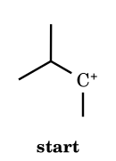
R4.How many 1,2-shifts, at minimum, convert the primary 3,3-dimethylbutyl cation, (CH₃)₃C–CH₂–CH₂⁺, into the most stable carbocation that is reachable? (Integer answer; each hydride, alkyl or ring-bond shift counts one.)
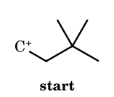
R5.3,3-Dimethylbutan-2-ol is heated with conc. H₃PO₄ (E1). How many different alkenes (structural isomers, counting only constitutional isomers, no stereoisomers arise) can be formed from all the carbocations that are intermediates, including the rearranged one? (Integer answer)
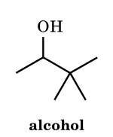
R6.Each compound (a–h) is treated with NaNO₂/HCl at 0–5 °C, then the solution is allowed to stand. How many of the compounds give a carbocation as an intermediate (free, or as a tight ion pair, formed by loss of N₂)? (Integer answer)
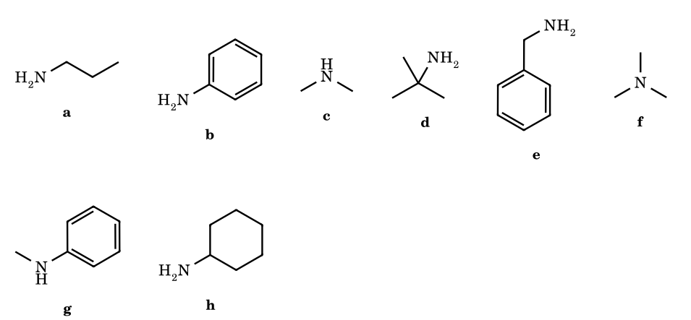
R7.Each alcohol (a–h) is heated with conc. HBr. How many give the alkyl bromide (or major product) with a rearranged carbon skeleton or rearranged position of Br through a carbocation or a concerted shift? (Integer answer)
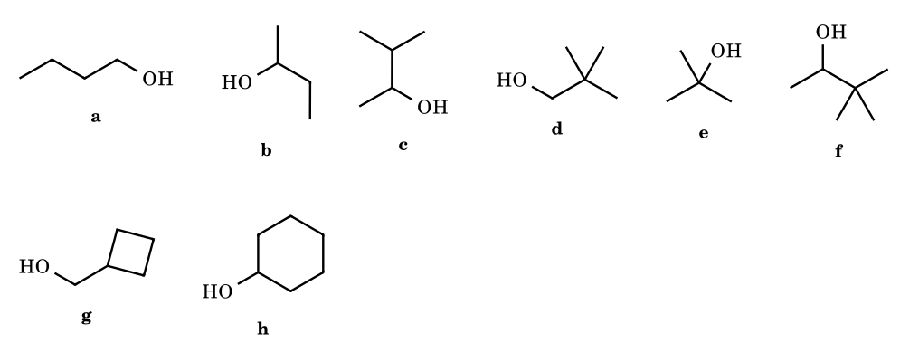
R8.Benzene is alkylated with each alkyl chloride (a–h) and AlCl₃. How many give a product in which the carbon skeleton or the point of attachment of the alkyl group differs from the alkyl chloride used (a rearranged product as the major product)? (Integer answer)
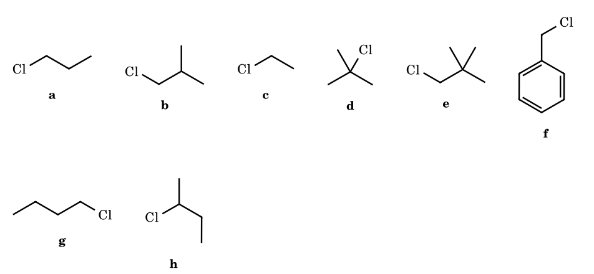

Part 8 Carbanions: Structure, Generation, Stability and Reactions
A carbanion is a species in which a carbon atom carries a formal negative charge and an unshared pair of electrons: R₃C⁻. It has eight electrons (three bond pairs + one lone pair), a filled octet, and is therefore a nucleophile and a base – the mirror image of the carbocation, whose carbon has a sextet and an empty orbital. Carbanions are almost never free in solution: they exist as ion pairs or aggregates with Li⁺, Na⁺, K⁺, MgX⁺, and the carbon–metal bond in RLi and RMgX is strongly polarised C^{δ−}–M^{δ+}, so that the organometallic reagent reacts as if it were R⁻.

8.1 Structure and shape
Carbanion | Carbon hybridisation | Shape | Where the lone pair sits | Consequence
CH₃⁻, R₃C⁻ (saturated) | sp³ | pyramidal (like NH₃), ≈ 107° | sp³ orbital (25 % s) | inversion barrier very low, so a chiral carbanion racemises rapidly; the carbanion is a strong base
Vinyl, phenyl, cyclopropyl | sp² | lone pair in an sp² orbital in the plane (vinyl is bent/configurationally stable) | 33 % s; not conjugated with the π system of the ring | more stable than sp³ carbanions by s-character; no resonance in phenyl anion (the lone pair is orthogonal to the π cloud)
Acetylide R–C≡C⁻ | sp | linear | 50 % s | the most stable simple carbanion; pK_{a} (C–H) ≈ 25
Allyl, benzyl, enolate, nitronate, cyclopentadienide | sp², planar | the carbanion carbon is planar; lone pair in a p orbital conjugated with π bonds | p orbital (0 % s) | delocalisation into the π system (resonance) is the main stabilising effect
Stereochemistry. An sp³ carbanion inverts through a planar transition state in a few kcal mol⁻¹, so an optically active centre at a carbanion carbon is lost (racemisation by enolisation of an α-chiral ketone in base is the standard example, 8.5). Inversion is hindered, and the carbanion is configurationally stable, when it is held in a ring (cyclopropyl; bridgehead) or when the lone pair is bound tightly to a metal (RLi at low temperature). A bridgehead carbanion cannot become planar, so it is destabilised by exactly the geometric factor that destabilises a bridgehead carbocation.

8.2 Generation of carbanions
Method | Equation | Comment
Deprotonation of C–H by a base | R₃C–H + B⁻ ⇌ R₃C⁻ + BH | the base must be stronger than R₃C⁻: compare pK_{a}(C–H) and pK_{a}(BH). Enolates (HO⁻, RO⁻, LDA), acetylides (NaNH₂), cyclopentadienide, malonate
Metal insertion into C–X | R–X + 2 Li → R–Li + LiX; R–X + Mg → R–MgX | RMgX and RLi are the most important sources of ‘R⁻’ (Grignard 1900)
Halogen–metal exchange | R–Br + n-BuLi → R–Li + n-BuBr | gives vinyl-, aryl-lithiums
Decarboxylation | R–COO⁻ → R⁻ + CO₂ | soda lime (NaOH/CaO, Δ); easy when R⁻ is stabilised (β-ketoacids, malonic acids, trichloroacetate, nitroacetate)
Conjugate (Michael) addition | Nu⁻ + C=C–C=O → Nu–C–C⁻=C–O⁻ (enolate) | creates an enolate at the α-carbon
Nucleophilic addition to C=O, C≡N | R⁻ + R′₂C=O → R′₂C(R)–O⁻ | the new anion is an alkoxide; carbon-centred carbanions form from CN⁻ + aldehyde (cyanohydrin anion)
α-Elimination | HCCl₃ + HO⁻ → ⁻CCl₃ + H₂O → :CCl₂ + Cl⁻ | carbanion then loses X⁻ to give a carbene (Part 10)
Electron transfer to a π system | arene + Na → arene^{•−} → carbanion on protonation (Birch) | see the radical-ion section
Fragmentation | R–C(=O)–CR′₃ → ... (retro-Claisen, haloform cleavage of CCl₃–C=O) | CCl₃⁻ is a good leaving group from the tetrahedral intermediate of the haloform reaction

8.3 Acidity of C–H bonds and the stability of the conjugate carbanion
The stability of R⁻ and the acidity of R–H are the same fact: the more stable the anion, the stronger the acid R–H. Approximate pK_{a} values (recalled; aqueous or DMSO scale as customary for each class, so only the order should be used in an exam) are:
C–H acid | ≈ pK_{a} | Why
CH₄, CH₃CH₃ | ≈ 50 | sp³ carbanion, no stabilisation
CH₂=CH–H | ≈ 44 | sp²: 33 % s
C₆H₆ (aryl C–H) | ≈ 43 | sp², lone pair in the plane, no resonance
CH₂=CH–CH₃ (allylic) | ≈ 43 | allyl anion (two resonance forms)
C₆H₅CH₃ | ≈ 41 | benzyl anion
Ph₂CH₂, Ph₃CH | ≈ 32, 31 | two and three phenyls delocalise the charge
NH₃ | ≈ 38 (N–H) | for comparison
HC≡CH, RC≡CH | ≈ 25 | sp carbon (50 % s)
CHCl₃ | ≈ 24 | −I of 3 Cl, polarisability of Cl
CH₃CO₂Et (α-H) | ≈ 25 | ester enolate
CH₃COCH₃ (α-H) | ≈ 19–20 | enolate (charge on O)
fluorene (C-9 H) | ≈ 22 | cyclopentadienide-type aromatic anion fused to two benzenes
cyclopentadiene | ≈ 16 | aromatic C₅H₅⁻ (6π)
CH₂(COOEt)₂ (malonate) | ≈ 13 | two carbonyl groups
CH₃NO₂ | ≈ 10 | nitronate: charge on two oxygens
CH₃COCH₂COCH₃ | ≈ 9 | two C=O, planar W-shaped anion

8.4 Factors that stabilise a carbanion
Factor | Effect on carbanion stability | Standard orders
Hybridisation (s-character) | more s-character holds the lone pair closer to the nucleus | HC≡C⁻ > CH₂=CH⁻ ≈ C₆H₅⁻ > CH₃CH₂⁻ (sp > sp² > sp³)
Inductive effect | −I groups stabilise, +I groups destabilise; alkyl groups are +I, so alkyl-substituted carbanions are less stable | CH₃⁻ > 1° > 2° > 3° (in solution; in the gas phase the order is reversed by polarisability)
Resonance (−M groups) | delocalisation of the lone pair into C=O, C≡N, NO₂, aryl | ⁻CH₂NO₂ > ⁻CH₂CHO > ⁻CH₂COR > ⁻CH₂COOR > ⁻CH₂CN > PhCH₂⁻ (typical)
Aromaticity | aromatic anions are far more stable; antiaromatic ones far less | C₅H₅⁻ (6π, aromatic) ≫ allyl; cyclopropenyl anion and cycloheptatrienyl anion (4nπ, antiaromatic) are very unstable
Multiple resonance forms | more delocalisation = more stable | Ph₃C⁻ > Ph₂CH⁻ > PhCH₂⁻
α-Heteroatom | S, P, Si stabilise (polarisability, negative hyperconjugation); O and N destabilise (lone-pair/lone-pair repulsion) | PhS–CH₂⁻ > CH₃O–CH₂⁻; ⁻CCl₃ > ⁻CF₃ (JEE key)
Steric inhibition of resonance | a group twisted out of the plane cannot delocalise the charge | planar 2-nitropropane anion vs a twisted nitro-aryl anion
Solvent and counter-ion | polar aprotic solvents (DMSO, DMF, HMPA) leave the anion free and reactive; protic solvents H-bond to it | relative acidities of C–H acids are measured in DMSO to avoid H-bonding
JEE pitfalls. (i) The phenyl and vinyl carbanions get no resonance stabilisation (lone pair in the plane); their stabilisation is s-character only. (ii) Carbanion stability and carbocation stability follow opposite substituent rules: alkyl groups stabilise a cation and destabilise an anion; π-acceptors (NO₂, C=O) stabilise an anion and destabilise a cation; π-donors (OMe, NR₂) stabilise a cation and destabilise an anion. (iii) Basicity is the inverse of stability: the least stable carbanion is the strongest base. (iv) The comparison ⁻CCl₃ vs ⁻CF₃ is a trap: F is more electronegative, but its lone pairs repel the carbanion lone pair and F is a poor polarisable group, so the JEE key puts CCl₃⁻ first.

8.5 Mechanisms in which a carbanion is the key intermediate (arrow-validated)
8.1 Acetone + HO⁻: the enolate ion (carbanion with resonance)
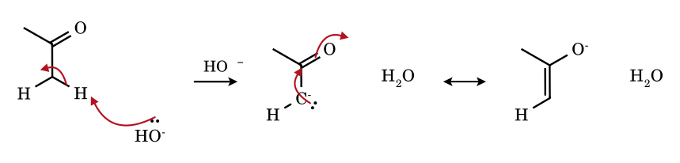
Hydroxide removes the α-proton; the C–H electron pair becomes a lone pair on carbon (carbanion). The lone pair is conjugated with C=O and flows onto oxygen: the enolate is a hybrid of the two forms, with most of the negative charge on oxygen (that is why the α-H of acetone, pK_{a} ≈ 20, is 10³⁰ times more acidic than that of ethane). The enolate is ambident: it reacts at C (alkylation, aldol) or at O (acylation, silylation).
8.2 Aldol addition: enolate + acetone
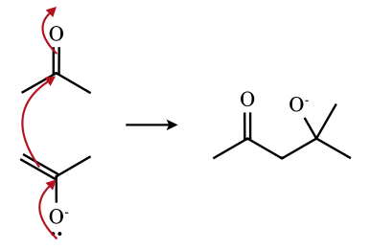
The enolate carbon attacks the carbonyl carbon of a second molecule; the C=O π pair becomes an alkoxide lone pair. Protonation gives 4-hydroxy-4-methylpentan-2-one (diacetone alcohol); this carbanion route builds C–C bonds.
8.3 E1cB dehydration of an aldol: a carbanion that expels HO⁻
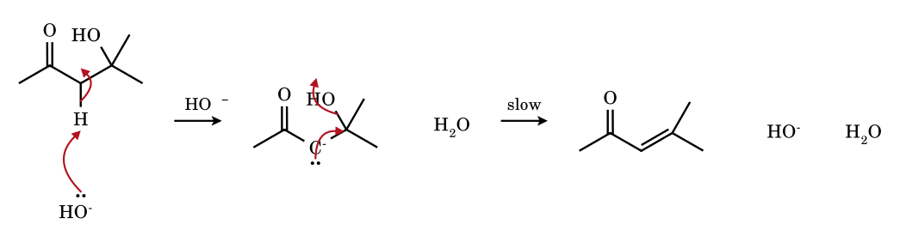
E1cB = Elimination, 1 molecular, conjugate Base. The α-proton is removed first (carbanion), then the β-leaving group departs in the slow step. This is why aldol condensations proceed by heating even though HO⁻ is a poor leaving group: the carbanion pushes it out. The product mesityl oxide is conjugated (resonance energy).
8.4 β-Keto acid decarboxylation: a carbanion/enol formed with CO₂ loss
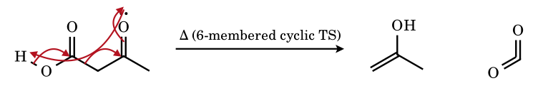
Six electrons move around a six-membered cyclic transition state; the carbanion character appears at C-4 and is immediately delocalised onto the ketone oxygen as the enol, which tautomerises to acetone. This is why malonic acid, acetoacetic acid and β,γ-unsaturated acids lose CO₂ on gentle heating whereas simple acids need soda lime.
8.5 Soda-lime decarboxylation: sodium acetate → methane
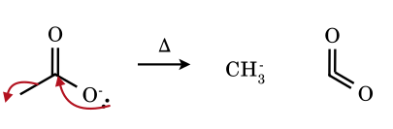
The carboxylate expels CO₂; the C–C σ pair becomes the lone pair of the methyl carbanion, which is protonated by water (or the lattice OH) at once to give CH₄. The reaction is limited to cases where the carbanion is at least somewhat stabilised (or the temperature is very high, as with soda lime).
8.6 Michael addition of the malonate carbanion to methyl vinyl ketone
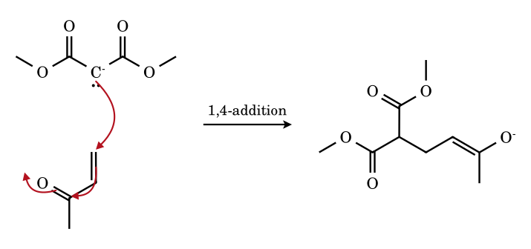
A soft carbanion attacks the β-carbon of the enone (conjugate addition, 1,4) rather than the carbonyl carbon (1,2); the new carbanion is an enolate and is protonated to the 1,5-dicarbonyl. The stronger and harder the nucleophile (RLi), the more 1,2-addition.
8.7 Acetylide formation and alkylation
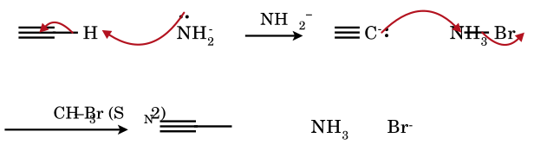
Sodamide (pK_{a} of NH₃ ≈ 38) is strong enough to deprotonate a terminal alkyne (pK_{a} ≈ 25) because the sp carbanion is stable; hydroxide is not strong enough (pK_{a} of H₂O ≈ 16). The acetylide then does an S_{N}2 on a primary halide. Secondary and tertiary halides give elimination instead because the acetylide is a strong base.
8.8 Cyclopentadiene → cyclopentadienide (aromatic carbanion) and its resonance
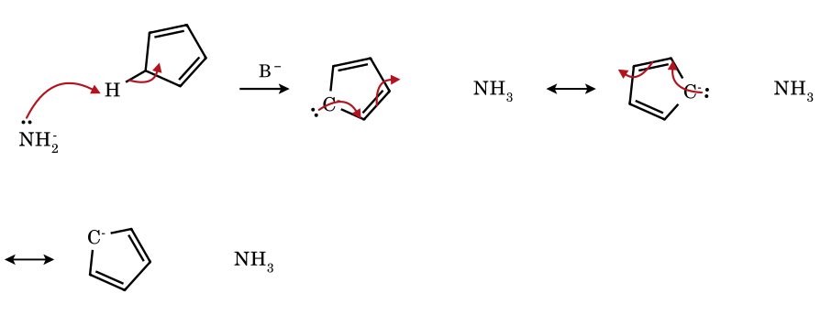
The CH₂ group of cyclopentadiene (pK_{a} ≈ 16, a hydrocarbon as acidic as water) loses H⁺ to give a planar C₅H₅⁻ with six π electrons (4n+2): all five carbons are equivalent and each carries one-fifth of the charge. This is the carbanion analogue of tropylium (6π) and the reason ferrocene exists.
8.9 Cyanohydrin carbanion: the acyl-anion equivalent of the benzoin condensation
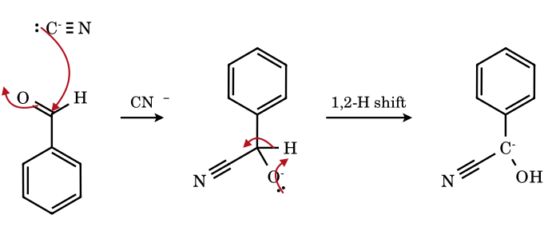
Cyanide adds to the aldehyde to give an alkoxide; a proton transfer then puts the negative charge on the benzylic carbon bearing CN, where it is stabilised by the nitrile (−M) and the phenyl ring. This carbanion is the ‘masked acyl anion’ that attacks a second PhCHO (umpolung of the carbonyl carbon), and the loss of cyanide gives benzoin.
8.10 Grignard reagent + acetone → tertiary alcohol (after work-up)
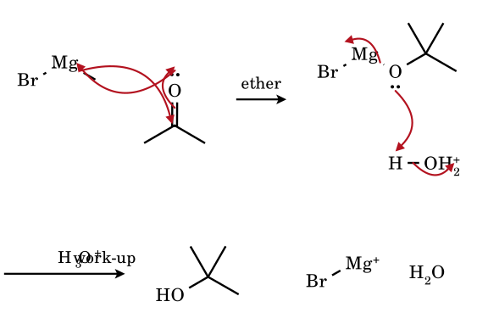
The C–Mg σ pair is the nucleophile (a carbanion in disguise). It adds to the C=O carbon, and the alkoxide oxygen binds magnesium. Aqueous acid protonates the alkoxide and removes Mg²⁺. Grignard reagents react with CO₂ (→ RCOOH), aldehydes (→ 2° alcohols), HCHO (→ 1° alcohols), epoxides, nitriles (→ ketones after hydrolysis) and esters (→ 3° alcohols, two equivalents). They are destroyed by any acid with a pK_{a} below that of the C–H bond of R–H (HOH, ROH, RCOOH, RNH₂, R–C≡C–H): this is the basis of the Zerewitinoff determination of active hydrogen by CH₄ evolution from CH₃MgI.

8.6 Kinetic and thermodynamic enolates; why optical activity is lost
- Racemisation by enolisation. A ketone with an α-stereocentre that carries an H (for example (R)-2-methyl-1-phenylbutan-1-one) racemises in dilute base or acid, because the enol or enolate is planar at that carbon: re-protonation from either face gives both enantiomers. Deuterium from D₂O is exchanged into the α-positions at the same rate (CH₃COCH₃ → CD₃COCD₃): the proof of a carbanion/enol intermediate.
- Regioselectivity in unsymmetrical ketones (2-methylcyclohexanone): LDA, THF, −78 °C removes the more accessible, less substituted α-H irreversibly (kinetic enolate, more s-character in the transition state, faster); NaH or NaOEt/EtOH at room temperature equilibrates to the more substituted, more stable enolate (thermodynamic). Alkylation with CH₃I then gives 2,6-dimethyl- (kinetic) or 2,2-dimethylcyclohexanone (thermodynamic).
- Which α-H is most acidic in CH₃COCH₂COCH₃? The central CH₂ (pK_{a} ≈ 9): its anion is stabilised by both carbonyls, whereas deprotonation at CH₃ is stabilised by one.
- Intramolecular H-bond and chelation stabilise the enol form of β-diketones (acetylacetone is ≈ 80 % enol in hexane) and the enolate (planar, W-shaped, O···M⁺···O).

8.7 Reactions of carbanions (summary)
Reaction type | Example | Product
Protonation (acid–base) | RMgX + H₂O | R–H + Mg(OH)X
Nucleophilic addition to C=O | RMgX/RLi + RCHO, RCOR, CO₂, HCHO | alcohols, carboxylic acids
Nucleophilic substitution (S_{N}2) | R′C≡C⁻ + R–X; enolate + R–X | alkyne, α-alkylated carbonyl
Conjugate addition | malonate + enone; R₂CuLi + enone | 1,5-dicarbonyl; β-alkyl ketone
Addition–elimination (acyl) | Claisen: enolate + RCOOR′ → β-ketoester | C–C bond, loss of RO⁻
Elimination (E1cB) | aldol condensation; β-hydroxy carbonyl dehydration | α,β-unsaturated carbonyl
Wurtz coupling | 2 RX + 2 Na → R–R + 2 NaX (via R–Na and S_{N}2 on a second RX) | alkane (even carbon count)
Decarboxylation | β-keto acid, malonic acid, soda lime | ketone, acetic acid, alkane
α-Elimination → carbene | CHCl₃ + KOH; Reimer–Tiemann | dichlorocarbene (Part 10)
Dimerisation by electron transfer | 2 Ph₃C⁻Na⁺ (trityl sodium) | stable coloured solutions

8.9 The carbon–metal bond, ion pairs and aggregates: what ‘R⁻’ really is in the flask
A free carbanion is almost never the reacting species. Organometallic ‘carbanions’ are polar covalent compounds, and their reactivity depends on how ionic the C–M bond is and on how the metal is solvated and aggregated. The Pauling estimate of ionic character, 1 − exp(−¼ Δχ²), with χ(C) = 2.55, shows the trend (values are indicative; real bonds are never fully ionic):
Bond C–M | χ(M) | Δχ | ≈ % ionic | Reagent behaviour
C–K | 0.82 | 1.73 | 53 | essentially ionic, very reactive (benzylpotassium, KH-generated enolates); insoluble in hydrocarbons
C–Na | 0.93 | 1.62 | 48 | ionic (trityl-sodium, sodium acetylide, Wurtz intermediates); salts
C–Li | 0.98 | 1.57 | 46 | polar covalent, aggregated, soluble in ether/hydrocarbon; RLi are strong bases and nucleophiles
C–Mg | 1.31 | 1.24 | 32 | Grignard reagents: polar covalent; react with C=O, epoxides, CO₂; mild bases
C–Al | 1.61 | 0.94 | 20 | R₃Al: electron-deficient, Lewis acidic, bridged dimers
C–Zn | 1.65 | 0.90 | 18 | R₂Zn, RZnX (Reformatsky): tolerate esters; weak nucleophiles
C–Cu | 1.90 | 0.65 | 10 | R₂CuLi (Gilman): soft nucleophile, 1,4-addition, S_{N}2 on RX
C–Hg | 2.00 | 0.55 | 7 | R₂Hg: covalent, air-stable, unreactive toward C=O
C–B / C–Si / C–Sn | 2.04 / 1.90 / 1.96 | 0.5–0.65 | 6–10 | covalent; organoboranes and silanes act as carbanion equivalents only after activation (ate complexes, fluoride)
- Aggregation. Alkyllithiums exist as clusters held by multicentre C–Li–C bonds: MeLi is a tetramer (Li₄ tetrahedron with a CH₃ over each face) in ether and THF; n-BuLi is a hexamer in hydrocarbons, a tetramer in diethyl ether, and tetramer ⇌ dimer in THF; t-BuLi is a tetramer in hydrocarbons and a dimer/monomer in THF; PhLi is a tetramer in ether and a dimer/monomer in THF (values approximate). Strong donors (THF, TMEDA, HMPA, DMPU) break the aggregates into smaller, more reactive species: n-BuLi in hexane deprotonates slowly but n-BuLi/TMEDA deprotonates benzene.
- Grignard reagents are governed by the Schlenk equilibrium, 2 RMgX ⇌ R₂Mg + MgX₂, with Mg tetrahedrally coordinated by two ether molecules (RMgX·2Et₂O). In ether the equilibrium lies on the RMgX side for X = Br, I; dioxane precipitates MgX₂·dioxane and drives it to R₂Mg. Formation from RX + Mg proceeds on the metal surface by single-electron transfer (a radical-pair step), which is why Wurtz coupling R–R and radical rearrangements (cyclopropylcarbinyl → homoallyl) are by-products.
- Ion pairs. In ethers an enolate or a delocalised carbanion exists as contact ion pairs (cation near the carbanion), solvent-separated ion pairs, or free ions, in order of increasing dissociation. Better cation solvation (Li⁺ < Na⁺ < K⁺ with crown ethers, HMPA, DMSO) gives a ‘naked’, more reactive, less selective anion; this alters rates by factors of 10³–10⁶ and flips C- versus O-alkylation (8.11).
- Base strength is not the same as nucleophilicity at carbon. t-BuLi is the stronger base, but n-BuLi adds to C=O and to alkenes more readily because t-BuLi is hindered. LDA is a strong, hindered, non-nucleophilic base (pK_{a} of diisopropylamine ≈ 36).

8.10 Quantitative acidity of C–H: scales, equilibria, and the subtle cases
Two scales are in use. The aqueous scale (pK_{a} in water, defined below ≈ 14 by the solvent) and the DMSO scale of F. G. Bordwell (up to ≈ 35, free of H-bonding to the anion). The orders agree, but numerical values differ by 2–10 units, so a question that gives numbers from one scale must not be mixed with the other. The values below are recalled from the literature and should be used for ranking, not as exact data.
Acid HA | pK_{a} (DMSO) | pK_{a} (water) | Remark
Meldrum’s acid | 7.3 | 4.8 | anomalously strong C–H acid: the rigid ring holds the two C=O in the Z (s-cis) arrangement, so both are conjugated and the anion is planar; compare dimedone
dimedone | 11.2 | 5.2 | cyclic 1,3-diketone (enolises)
CH₂(CN)₂ | 11.1 | 11.2 | two nitriles
acetylacetone | 13.3 | 8.9 | enol-H-bonded, mostly enol (water: more acidic since the enol is the form measured)
ethyl acetoacetate | 14.2 | 10.7 | β-ketoester
CH₃NO₂ | 17.2 | 10.2 | nitronate; the ‘nitroalkane anomaly’ (see below)
CH₂(CO₂Et)₂ | 16.4 | 13 | malonic ester
cyclopentadiene | 18.0 | 16 | aromatic anion
indene | 20.1 | — | benzo-fused; charge partly on the benzene ring
PhCH₂CN | 21.9 | — | benzylic + nitrile
fluorene | 22.6 | — | biphenyl-bridged cyclopentadienide
acetophenone (CH₃) | 24.7 | ≈ 18 | ketone enolate
acetone | 26.5 | 19.3 | ketone enolate
PhC≡CH | 28.8 | — | sp C–H
PhSO₂CH₃ | 29.0 | — | α-sulfonyl carbanion
EtOAc (α-H) | 29.5 | 25.6 | ester enolate
CH₃CN | 31.3 | ≈ 25 | nitrile anion (linear, ketenimine-like)
Ph₃CH | 30.6 | — | trityl anion (propeller, three rings)
Ph₂CH₂ | 32.2 | —
CH₃CON(CH₃)₂ | 34 | ≈ 30 | amide enolate (weakest carbonyl C–H acid)
DMSO | 35.1 | — | dimsyl anion
PhCH₃ | ≈ 43 | — | benzyl anion
for comparison: H₂O, MeOH, NH₃, Et₂NH | 31.4, 29.0, 41, ≈ 44 | 15.7, 15.5, ≈ 36, ≈ 38 | pK_{a} of the conjugate acid of the base used
- Reading an equilibrium. For HA + B⁻ ⇌ A⁻ + HB, log K = pK_{a}(HB) − pK_{a}(HA). Example (aqueous): acetone (19.3) + EtO⁻ (EtOH 15.9) → K = 10^{−3.4} ≈ 4 × 10⁻⁴, so only 0.04 % of acetone is an enolate in 1 M ethoxide, yet this tiny concentration is enough for the aldol to run; with LDA (pK_{a} 36), K = 10^{+9.5} and deprotonation is quantitative. For the same reason ethyl acetoacetate (10.7) is converted completely to its anion by NaOEt, and this is what drives the Claisen condensation (8.12).
- Acid strength of α-C–H in carbonyl compounds falls in the order aldehyde (≈ 17) > ketone (≈ 19–20) > ester (≈ 25) > nitrile (≈ 25) ≈ amide (≈ 30) because the carbonyl’s ability to accept the charge (electronegativity of the acyl group, competition from the OR or NR₂ lone pair) falls in the same order. In 1,3-dicarbonyls the second acceptor adds ≈ 10 pK units. A 1,3,5-tricarbonyl or a carbon flanked by three EWG (e.g. triacetylmethane, pK_{a} ≈ 6; tricyanomethane, ≈ −5) is a strong acid.
- Kinetic versus thermodynamic acidity. The thermodynamic acidity measures the stability of the anion; the kinetic acidity measures the rate of removal of H⁺. The two can differ when the anion needs reorganisation. The nitroalkane anomaly: nitromethane is a thermodynamically stronger acid than acetone by ≈ 9 pK units, but its H is removed ≈ 10⁵-fold more slowly than that of acetone relative to the Brønsted line, because in the transition state the carbon has rehybridised and charge delocalisation onto the nitro oxygens lags behind proton transfer. Rates of deprotonation of nitroalkanes are therefore slow, and they give the aci-form (nitronic acid) first.
- Hybridisation versus electronegativity. The s-character argument orders HC≡C–H (25), H₂C=CH–H (44), CH₃CH₂–H (50) and even cyclopropane C–H (≈ 46: exocyclic C–H bonds of cyclopropane use ≈ 33 % s orbitals). The same argument explains why HCN (pK_{a} 9) is acidic and why alkynyl anions persist.
- Substituent effects. Electron-withdrawing groups on an aryl ring acidify benzylic C–H of ArCH₃ and ArCH₂CN; the effect follows σ⁻ (resonance-enhanced) values: p-NO₂ shifts pK_{a} of toluene-type C–H by ≈ 10 pK units (4-nitrotoluene ≈ 20 in DMSO versus 43). A twisted nitro group (steric inhibition of resonance) loses most of this: 2,6-dimethyl-4-nitro… series; the ortho effect operates in the same way as for carbocations (Part 4.8), but with opposite sign.
- Solvent effects. Protic solvents H-bond to localised, small anions (alkoxides, enolate O) and flatten acidity differences; DMSO and other dipolar aprotic solvents do not, and expose the intrinsic order. Alcohols are 10⁴–10⁸ times more acidic relative to water in DMSO than ketones (see H₂O 31.4 versus acetone 26.5 in DMSO, the reverse of the aqueous order 15.7 < 19.3).

8.11 Enolates: formation, regiochemistry, ambident reactivity
An enolate is the conjugate base of a carbonyl compound deprotonated at the α-carbon. It is a resonance hybrid of the carbanion (C⁻–C=O) and the oxy-anion (C=C–O⁻); the O-form carries most of the charge. Enolates are ambident nucleophiles with two reactive sites, O and C.
Factor | Favours C-attack (softer site) | Favours O-attack (harder site)
Electrophile (HSAB) | soft: alkyl iodides/bromides (R–I > R–Br), allylic and benzylic halides, α-halo carbonyls, Michael acceptors, aldehydes (aldol) | hard: R₃SiCl, acyl chlorides and anhydrides (acylation), ROTs, ROSO₂OR, R₃O⁺ (Meerwein salts)
Leaving group on R–X | I⁻, Br⁻ (soft) | OTs, OSO₂Me, Cl (hard)
Solvent | protic solvents (H-bond the O), non-polar solvents, THF | dipolar aprotic: HMPA, DMSO, DMF (free the O⁻)
Counter-ion | Li⁺ (tight, covalent O–Li, shields O) | K⁺, Cs⁺, R₄N⁺, crown-ether-complexed K⁺ (naked O)
Thermodynamics | C-alkylation gives a C–C bond: the stable (thermodynamic) product | O-alkylation is faster for hard electrophiles (kinetic) and reversible with allyl systems

Regioselectivity: kinetic and thermodynamic enolates
 | Kinetic enolate | Thermodynamic enolate
Conditions | LDA (1.0 equiv), THF, −78 °C, ketone added slowly; quench with electrophile (or Me₃SiCl) at −78 °C; strongly basic, irreversible, no excess ketone, no proton source | weaker base in slight deficiency (NaH, KH, NaOEt/EtOH, Et₃N/Me₃SiCl), warm, longer times, excess ketone: reversible proton exchange equilibrates the enolates
Which H is removed | the more accessible and more acidic (less substituted) α-H: in 2-methylcyclohexanone, C-6 (CH₂) rather than C-2 (CH) | the one giving the more substituted, more stable (conjugated or more highly substituted) C=C
Product from 2-methylcyclohexanone + MeI | 2,6-dimethylcyclohexanone | 2,2-dimethylcyclohexanone
Why | bulky LDA removes the less hindered H by a cyclic six-membered Ireland TS faster | the more substituted enolate is lower in energy (alkene hyperconjugation), no kinetic barrier when equilibrating
- Enolate geometry. With LDA in THF, ketones with a bulky α′-group give the E-enolate (O and the alkyl group trans), esters the E-enolate (OLi and Me trans by Ireland’s model), and adding HMPA gives the Z. The geometry transfers into the stereochemistry of the aldol product via the Zimmerman–Traxler chair (below).
- Zimmerman–Traxler model. A metal enolate adds to an aldehyde through a six-membered chair in which M coordinates both oxygens and the aldehyde R sits equatorial: Z-enolates → syn aldols; E-enolates → anti aldols. Boron enolates (shorter B–O) show higher selectivity. This is the basis of diastereoselective aldol reactions.
- Silyl enol ethers (Me₃SiCl/Et₃N for thermodynamic, LDA/Me₃SiCl for kinetic) are isolable enolate equivalents; they react with electrophiles under Lewis acid catalysis (Mukaiyama aldol, TiCl₄) and are regenerated to the specific enolate with MeLi or fluoride (Bu₄N⁺F⁻).
- Enamines (Stork). A secondary amine (pyrrolidine) condenses with a ketone to give an enamine, an uncharged enolate equivalent (N lone pair pushes into C=C). It C-alkylates with reactive halides or acceptors and the iminium is hydrolysed back to the ketone; the substituted ketone is formed without strong base and without polyalkylation. The enamine’s nucleophilic carbon is the β-carbon.
- Dianions. Acetoacetate ester with 2 equiv of base (NaH then n-BuLi) forms the dianion; the more basic γ-carbanion reacts with electrophile first (γ-alkylation).
- α-Halogenation (Hell–Volhard–Zelinsky, α-bromination of ketones). In base, successive halogenation speeds up (the halogen increases acidity of the remaining H): the haloform reaction of CH₃COR with X₂/NaOH; in acid (enol), halogenation stops at mono because the halogen destabilises the protonated carbonyl needed for the next enolisation.

8.12 Carbanion-based carbon–carbon bond-forming reactions (named reactions)
Name | Carbanion (nucleophile) | Electrophile | Product / key feature
Aldol | enolate of aldehyde/ketone (NaOH, EtOH) | aldehyde or ketone | β-hydroxy carbonyl; Δ → E1cB → α,β-unsaturated carbonyl (condensation). Equilibrium; ketone aldols are unfavourable (K ≈ 10⁻²) unless dehydration drives it
Crossed aldol / Claisen–Schmidt | enolate of a ketone (or aldehyde with α-H) | aromatic aldehyde (no α-H) | ArCH=CH–COR (chalcones); only one partner can enolise, so a single product
Knoevenagel | active-methylene compound (malonate, CH₂(CN)₂), weak base (piperidine, pyridine) | aldehyde/ketone | alkylidene malonate (α,β-unsaturated); Doebner modification: decarboxylates to cinnamic acid
Perkin | carboxylate-derived enolate of acid anhydride (CH₃CO)₂O + CH₃COONa | aromatic aldehyde | cinnamic acid (E); needs 180 °C
Claisen condensation | ester enolate (NaOEt) | another ester | β-ketoester; driven by deprotonation of the product (pK_{a} 11 versus EtOH 16): requires ≥ 1 equiv base and an α-H with two H on the acylating partner
Dieckmann | diester enolate (intramolecular Claisen) | ester in same molecule | 5- or 6-membered cyclic β-ketoester (1,6-/1,7-diesters)
Michael (conjugate) addition | stabilised carbanion (malonate, nitronate, enolate, Gilman reagent) | α,β-unsaturated carbonyl/nitrile/nitro | 1,5-dicarbonyl; 1,4-addition (soft nucleophile)
Robinson annulation | Michael donor (a ketone enolate) | methyl vinyl ketone | Michael then intramolecular aldol and dehydration: forms a six-membered ring (steroid/terpenoid synthesis; Wieland–Miescher ketone)
Mannich | enol/enolate of ketone | iminium ion CH₂=N⁺R₂ (from HCHO + R₂NH) | β-aminoketone (Mannich base); eliminates to a vinyl ketone
Reformatsky | zinc enolate BrZn–CH₂COOEt (from BrCH₂COOEt + Zn) | aldehyde/ketone | β-hydroxy ester; Zn enolate does not attack ester (unlike Grignard)
Darzens | carbanion of α-halo ester (NaOEt) | aldehyde/ketone | α,β-epoxy ester (glycidic ester): aldol then intramolecular S_{N}2
Benzoin | cyanohydrin anion (from CN⁻ + ArCHO) | second ArCHO | α-hydroxy ketone (umpolung)
Stobbe | succinate-ester enolate | ketone | alkylidene succinic half-ester via γ-lactone
Malonic ester synthesis | diethyl malonate + NaOEt | RX (S_{N}2) | after hydrolysis and Δ: RCH₂COOH (and R¹R²CHCOOH); two carbons added
Acetoacetic ester synthesis | ethyl acetoacetate + NaOEt | RX | after ketonic hydrolysis and decarboxylation: CH₃COCH₂R (methyl ketones)
Haloform | CX₃⁻ leaving group | — | RCOCX₃ + HO⁻ → RCOO⁻ + CHX₃: methyl ketone → acid with one carbon less + haloform
Favorskii | enolate of α′-position of an α-haloketone | intramolecular C–X (S_{N}2) | cyclopropanone intermediate, then ring-opening by RO⁻ to an ester; ring contraction for cyclic α-halo ketones
Wittig | phosphorus ylide Ph₃P⁺–C⁻R₂ | aldehyde/ketone | alkene + Ph₃P=O; non-stabilised ylides → Z, stabilised → E
Corey–Chaykovsky | sulfonium/sulfoxonium ylide (CH₂=SMe₂, CH₂=S(O)Me₂) | C=O or C=C–C=O | epoxide (sulfonium) or cyclopropane (sulfoxonium, with enones)
Grignard / RLi additions | RMgX, RLi | C=O, epoxide, CO₂, nitrile, ester | see 8.13
Wurtz, Wurtz–Fittig, Corey–House | R–Na, Ar–Na, R₂CuLi | R′X | C–C coupling; Corey–House couples a Gilman reagent with R′X (also vinyl/aryl halides) cleanly
Kolbe–Schmitt | phenoxide (ring carbanion character at ortho) | CO₂ | salicylic acid (ortho, Na); p-hydroxybenzoic acid with K at higher T
Reimer–Tiemann | phenoxide | :CCl₂ (from CHCl₃) | salicylaldehyde (Part 10)

8.13 Organometallic reagents as carbanion sources: what they do and do not do
Substrate | Product with RMgX / RLi | Notes
HCHO | 1° alcohol (R–CH₂OH) | adds one carbon
R′CHO | 2° alcohol | —
R′₂C=O | 3° alcohol | hindered ketones give enolisation (R⁻ acts as base) and reduction (β-hydride transfer from RMgX with β-H) instead
CO₂ (dry ice) | R–COOH after H₃O⁺ | ketone by-product via second addition
epoxide | alcohol with two more carbons (R–CH₂CH₂OH from ethylene oxide) | attack at the less hindered carbon (S_{N}2)
RC≡N | ketone after hydrolysis of the imine anion | one equivalent; stops because the imine anion is not electrophilic
RCOOR′ | 3° alcohol with two identical R groups (two equiv) | ketone intermediate is more reactive than the ester
RCOCl | ketone (with R₂Cd, R₂CuLi, or 1 equiv at −78 °C) | Grignard over-adds to give 3° alcohol
α,β-unsaturated carbonyl | RMgX/RLi: 1,2-addition; R₂CuLi: 1,4-addition | hard versus soft nucleophile
H–A (HOH, ROH, RCOOH, RNH₂, RC≡CH) | R–H + metal salt | the Grignard is destroyed; basis of the Zerewitinoff active-hydrogen determination (CH₄ from CH₃MgI)
RX (itself) | R–R (Wurtz-type) as a side reaction | minimised by slow addition and dilute solutions
O₂ | ROMgX → ROH | protect from air

8.14 Stereochemistry and reaction pathways of carbanions (Cram’s experiments)
Electrophilic substitution at a saturated carbanion centre, R–M + E⁺ → R–E + M⁺, can proceed with retention, inversion or racemisation. D. J. Cram’s base-catalysed H/D-exchange studies on optically active 2-methyl-3-phenylpropionitrile, 2-methyl-2-phenyl..., and related compounds established the pathways:
Pathway | Meaning | Stereochemical result | Typical conditions
S_{E}1 | carbanion forms and is free of the leaving group before reaction | racemisation (planar/inverting carbanion) | polar solvents (DMSO, MeOH/NaOMe), delocalised carbanions
S_{E}2 (front) | electrophile attacks from the same side as the leaving group (cyclic TS) | retention | organometallics in non-polar solvents; RLi, RMgX (retention is the rule)
S_{E}2 (back) | attack from the side opposite to M | inversion | rare; strong dipolar systems
S_{E}i | internal return (intimate ion pair, H delivered by the conjugate acid within the ion pair) | retention, ‘isoinversion’ or ‘isoracemisation’ depending on solvent (Cram: t-BuOH/t-BuOK: retention; DMSO: racemisation) | ion-pair collapse with proton from the solvent
- Configurational stability increases for carbanions that cannot become planar or are bound to metal: cyclopropyl and vinyl lithiums, bridgehead anions (in bicyclo[2.2.1]), α-oxy and α-amino lithiums at −78 °C (dipole-stabilised, chelated by the heteroatom). Alkyllithiums such as sec-butyllithium racemise slowly above −40 °C.
- Hydrogen–deuterium exchange is the standard proof of a carbanion: a ketone in D₂O/OD⁻ exchanges its α-H at a rate equal to its racemisation (when chiral) and its halogenation rate in base (zero-order in halogen), showing the same enolate intermediate (Ingold, Hughes).
- Carbanions and rearrangements. Aryl groups can migrate to a carbanion centre through a spiro (Meisenheimer-like) intermediate: the Grovenstein–Zimmerman rearrangement, the carbanion analogue of the neophyl rearrangement (Part 9) and the 1,2-aryl shift of cations (Part 7). Alkyl and hydride shifts to carbanion centres do not occur. Other carbanion rearrangements: [1,2]-Wittig (R–O–CH₂R′ + BuLi → alkoxide of R–CH(R′)–OH by a radical-pair path), Stevens ([1,2] shift in ammonium ylides), Brook (C → O silyl migration), Favorskii (8.12) and the benzilic-acid rearrangement (with hydroxide as the nucleophile).

8.15 Ylides: carbanions stabilised by an adjacent onium centre
An ylide has a carbanion adjacent to a positively charged heteroatom: Ph₃P⁺–C⁻HR (phosphonium), Me₂S⁺–C⁻H₂ (sulfonium), Me₂S(O)⁺–C⁻H₂ (sulfoxonium), R₃N⁺–C⁻H₂ (ammonium). The carbanion is stabilised by electrostatic attraction and by negative hyperconjugation (n_{C} → σ*_{P–C}, not by 3d overlap), and ylides are far more stable than simple carbanions: the pK_{a} of Ph₃P⁺CH₃ is ≈ 22 (DMSO), so n-BuLi or NaH/DMSO or NaNH₂ deprotonates it.
Ylide | Substituent on carbanion | Reactivity | Product with RCHO
non-stabilised (R = H, alkyl) | alkyl | very reactive, air-sensitive; made with BuLi/NaNH₂ (salt-free: more Z) | Z-alkene, kinetic control, irreversible oxaphosphetane formation
semi-stabilised (R = aryl, vinyl) | Ph, CH=CH₂ | moderate | E/Z mixtures
stabilised (R = CO₂Et, COR, CN) | EWG delocalises the charge; ylide is isolable, weak nucleophile; reacts with aldehydes only (ketones sluggish) | reversible oxaphosphetane formation, thermodynamic control | E-alkene
Schlosser modification | — | PhLi at −78 °C interconverts the betaine/oxaphosphetane | E even from non-stabilised ylides
Horner–Wadsworth–Emmons (phosphonate carbanion) | (EtO)₂P(O)–C⁻H–CO₂Et | more nucleophilic than the Wittig ylide; water-soluble phosphate by-product | E-α,β-unsaturated esters

8.16 Choosing a base: which proton is removed first?
A base removes the most acidic proton in the molecule first (thermodynamic acidity, with kinetic modifications above). Compare the pK_{a} of the conjugate acid of the base with those of each acidic H:
Base | pK_{a} of conjugate acid (≈, water or DMSO as marked) | Deprotonates (examples)
NaHCO₃, Na₂CO₃ | 6.4 (H₂CO₃), 10.3 (HCO₃⁻) | carboxylic acids, phenols (Na₂CO₃); not alcohols
Et₃N, pyridine, piperidine | 10.7, 5.2, 11.1 | 1,3-dicarbonyls (Knoevenagel), generates enamines
NaOH, KOH | 15.7 | phenols, 1,3-dicarbonyls, nitroalkanes, aldehydes/ketones (aldol equilibrium)
NaOEt, KOtBu | 16–19 (t-BuOH ≈ 18) | ester/ketone α-H (equilibrium), E2 eliminations
NaH, KH | ≈ 35 (H₂) | irreversible deprotonation of ketones, alcohols, esters
NaNH₂ | ≈ 38 (NH₃) | terminal alkynes, ketones, esters; benzyne from ArX
LDA, LiHMDS | 36, 26 (HMDS) | kinetic enolates (LDA); LiHMDS for sensitive substrates
n-BuLi, s-BuLi, t-BuLi | ≈ 50 (butane) | directed ortho-metalation of arenes, vinylic H, terminal alkynes, THF is attacked above −20 °C
Grignard RMgX | ≈ 45–50 | acidic H (water, alcohol, acid, alkyne) and C=O addition
Typical errors in exam problems. (1) Treating the less substituted enolate as ‘always the major one’: it is kinetic only (LDA, −78 °C); NaOEt/EtOH gives the more substituted. (2) Forgetting that the Claisen condensation needs a stoichiometric base because the β-ketoester product is deprotonated and that this is why it fails for esters with only one α-H. (3) Adding a Grignard to a molecule containing OH, COOH, NH, C≡C–H or a carbonyl/ester elsewhere without protection. (4) Using the carbocation rule that alkyl groups stabilise: for carbanions they destabilise. (5) Ranking CF₃⁻ above CCl₃⁻ on electronegativity alone. (6) Assuming conjugate addition for every nucleophile: hard nucleophiles (RLi, RMgX) add 1,2; soft (cuprates, enolates, CN⁻, thiolates, amines) add 1,4. (7) Ignoring that an aryl C–H or a vinylic C–H is removed only by bases stronger than NH₃.
8.11 Claisen condensation: ester enolate + ester → β-ketoester
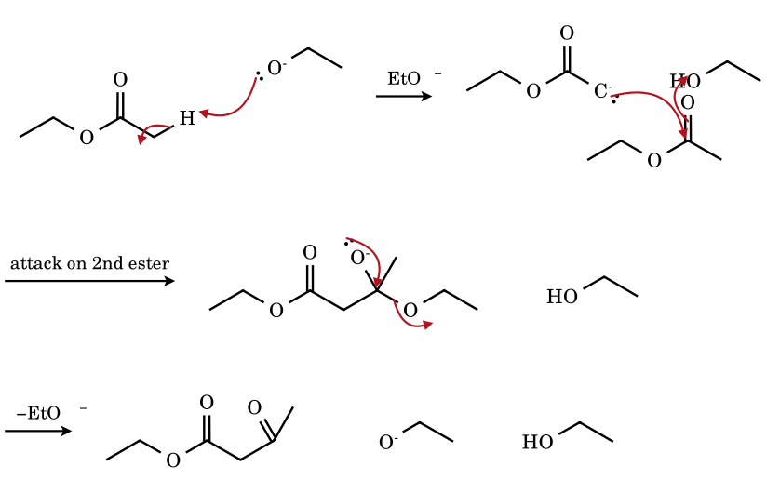
The ester enolate adds to the carbonyl carbon of a second ester molecule to give a tetrahedral alkoxide; reforming C=O expels ethoxide (addition–elimination, as for any acyl substitution). The β-ketoester (pK_{a} ≈ 11) is far more acidic than ethanol (16) and is deprotonated to its stabilised enolate by the ethoxide, which pulls the unfavourable equilibrium to the right; acidification at the end gives the neutral β-ketoester. Therefore the stoichiometric base is a reagent, and an ester with only one α-hydrogen cannot be driven to product in this way (use a stronger base, e.g. Ph₃CNa).
8.12 Dieckmann cyclisation: diethyl adipate → 2-ethoxycarbonylcyclopentanone
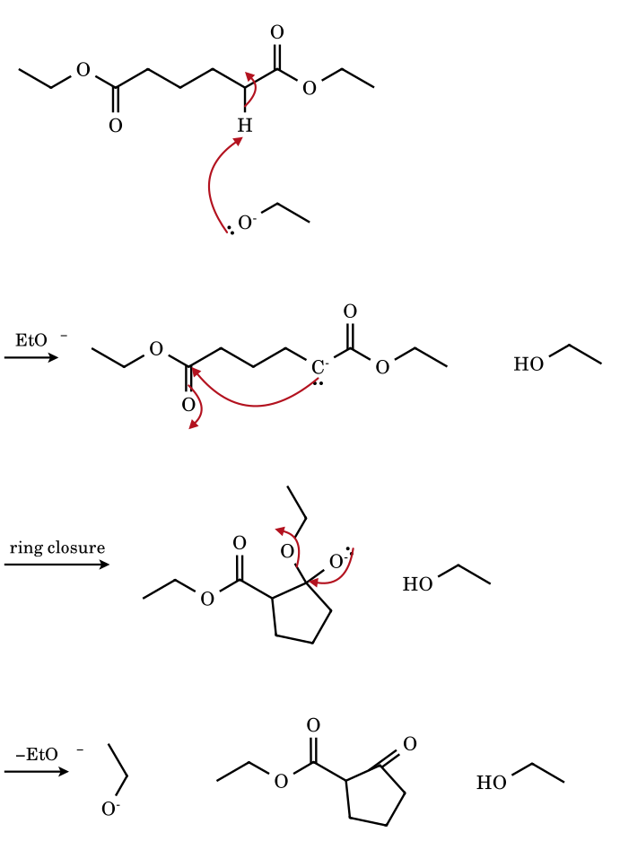
The intramolecular Claisen condensation forms five- and six-membered rings (1,6- and 1,7-diesters give cyclopentanones and cyclohexanones; 1,4- and 1,5-diesters would give strained rings and are not used; the reverse ring-opening is possible). As in the Claisen condensation, deprotonation of the cyclic β-ketoester drives the reaction. Hydrolysis and decarboxylation (8.4) then give cyclopentanone.
8.13 Knoevenagel condensation: malononitrile + benzaldehyde → benzylidenemalononitrile
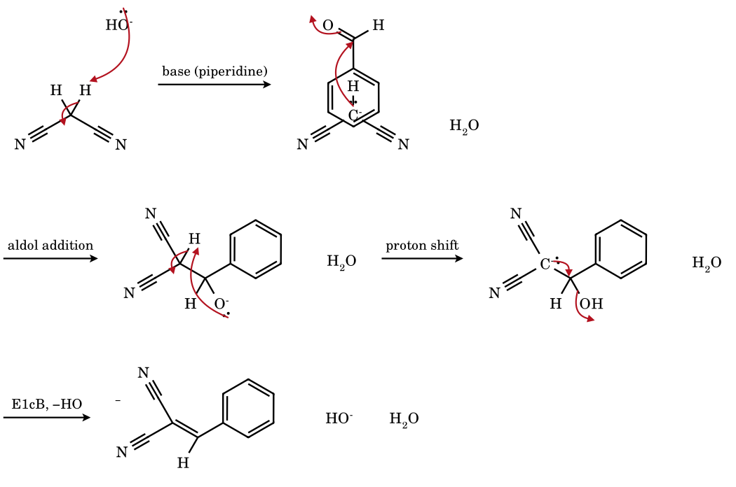
A weak base suffices because the CH₂ is flanked by two nitriles (pK_{a} 11). Addition to the aldehyde, proton transfer to give a new carbanion (stabilised by two CN and now β to a leaving OH), and loss of hydroxide (E1cB) give the conjugated alkene irreversibly. With malonic acid (Doebner), pyridine as base: decarboxylation follows and cinnamic acids are formed.
8.14 Reformatsky reaction: organozinc enolate + acetone
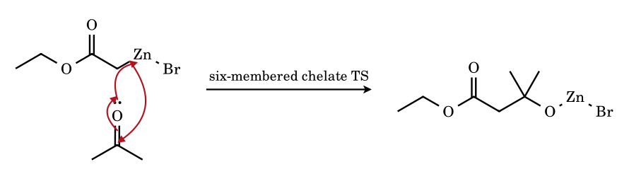
Zinc inserts into the C–Br bond of ethyl bromoacetate to give a carbon-bound (or O-bound) organozinc whose carbanion character is tempered by the C–Zn bond (≈ 18 % ionic), so it adds to aldehydes and ketones but not to esters — the reason a Grignard reagent could not be used. Acid work-up releases the β-hydroxy ester (dehydration gives the α,β-unsaturated ester).
8.15 Darzens glycidic ester condensation
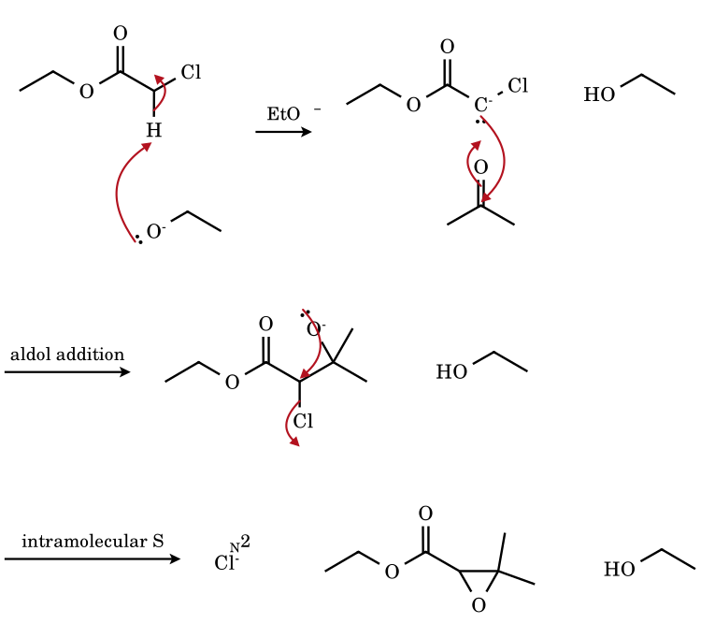
The carbanion of the α-chloro ester adds to the ketone; the resulting alkoxide, positioned on the carbon next to C–Cl, performs an intramolecular S_{N}2 (3-exo-tet) displacing chloride to give an epoxide. The glycidic ester is hydrolysed and decarboxylated to an aldehyde or ketone with one more carbon than the starting carbonyl.
8.16 Haloform reaction, final step: triiodoacetone + HO⁻
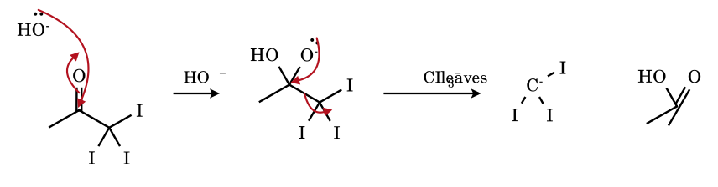
Under basic conditions each successive halogenation is faster than the last, so a methyl ketone is converted to R–CO–CX₃. Hydroxide adds to the carbonyl, and the tetrahedral intermediate expels the best available carbanion, ⁻CX₃ (stabilised by the −I effect and polarisability of three halogens; pK_{a} of CHCl₃ ≈ 24 in the leaving group role), which protonates to the haloform (CHI₃, yellow ppt: the iodoform test for CH₃CO–, CH₃CH(OH)–). The carboxylic acid has one carbon fewer than the ketone.
8.17 Wittig reaction: methylenetriphenylphosphorane + benzaldehyde (via oxaphosphetane)
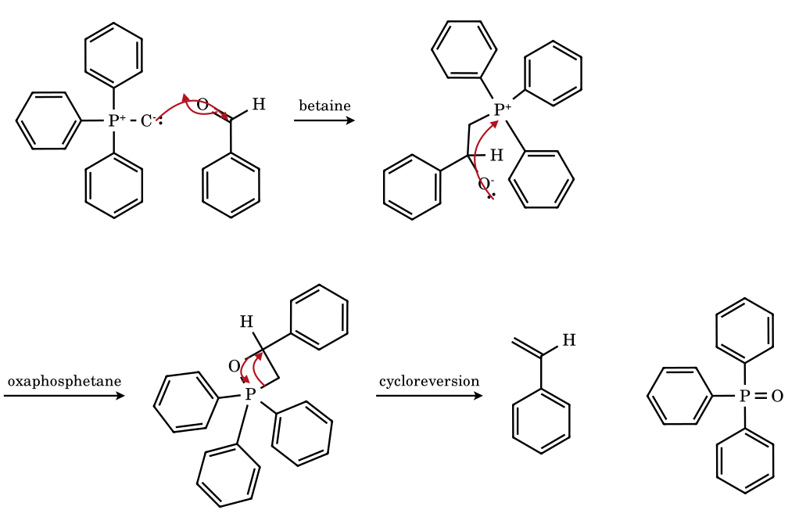
The ylide carbon attacks the aldehyde carbonyl; the alkoxide closes onto phosphorus to give a four-membered oxaphosphetane (modern evidence favours direct [2+2] formation with no discrete betaine for salt-free ylides), which collapses in a retro-[2+2] to the alkene and triphenylphosphine oxide. The strength of the P=O bond (≈ 130 kcal mol⁻¹) is the driving force. Non-stabilised ylides: kinetic cis oxaphosphetane → Z-alkene; stabilised: reversible, trans → E.
8.18 Favorskii rearrangement: 2-chlorocyclohexanone + MeO⁻ → methyl cyclopentanecarboxylate
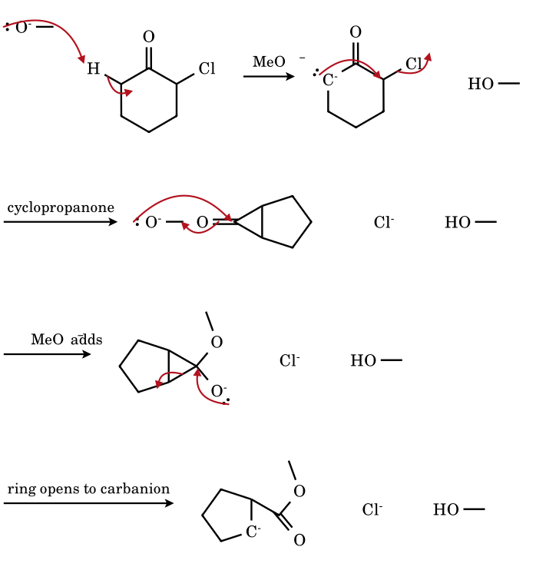
The base removes the α′-hydrogen (on the carbon without chlorine) to give an enolate whose carbon displaces chloride intramolecularly (3-exo-tet) to give a strained bicyclic cyclopropanone. Methoxide adds to the very electrophilic cyclopropanone C=O and the three-membered ring opens at the bond that gives the more stable carbanion (here the secondary carbanion; for unsymmetrical systems the bond that gives the more stabilised, usually more substituted-hindered-less carbanion cleaves). Protonation gives the ester with the ring contracted by one carbon. Evidence: the same cyclopropanone is formed from the isomeric α-chloroketone (labelling scrambles the two carbons).

Robinson annulation: Michael addition → intramolecular aldol → dehydration
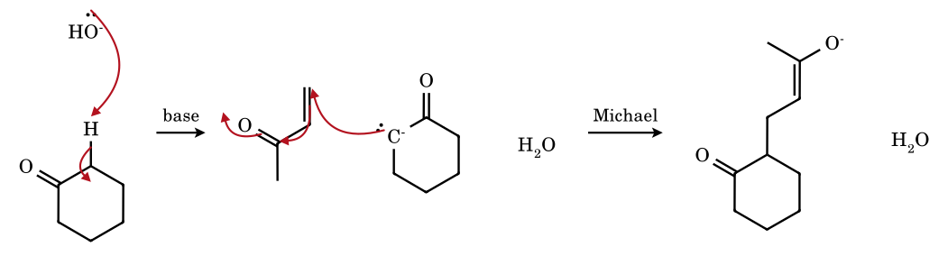
Step 1 of the Robinson annulation: the cyclohexanone enolate adds in a 1,4-fashion to methyl vinyl ketone, giving the enolate of 2-(3-oxobutyl)cyclohexanone (a 1,5-diketone).
Step 2: the methyl ketone enolate (CH₂–C=O, formed by deprotonation of the CH₃) attacks the ring C=O intramolecularly (6-exo-trig): a bicyclic β-hydroxyketone. Step 3: E1cB loss of HO⁻ gives the conjugated enone Δ^{1,9}-2-octalone (4,4a,5,6,7,8-hexahydro-2(3H)-naphthalenone). Net: a six-membered ring and one new C=C are built from a ketone and MVK (use the Wieland–Miescher ketone from 2-methylcyclohexane-1,3-dione in steroid synthesis).
Malonic ester synthesis (arrow-validated alkylation in 8.7 for the alkynyl case): NaOEt converts CH₂(CO₂Et)₂ into its carbanion (pK_{a} 13), which is alkylated by R–X (S_{N}2: primary or methyl halides; secondary halides give some elimination; aryl and tertiary halides fail); a second alkylation with R′X is possible; hydrolysis (NaOH, then H₃O⁺) gives the substituted malonic acid, which decarboxylates on heating (cyclic TS, 8.4) to RCH₂COOH. With 1,2-dibromoethane and two equivalents of malonate the product is cyclopropane-1,1-dicarboxylate (Perkin ring closure). Acetoacetic ester synthesis is the same with CH₃COCH₂CO₂Et; the final decarboxylation of the β-ketoacid gives methyl ketones CH₃COCH₂R. Dialkylation gives CH₃COCHRR′.

8.20 Problems on carbanions
CA-1.
Arrange in decreasing stability (solution): (a) CH₃⁻, (b) CH₃CH₂⁻, (c) (CH₃)₂CH⁻, (d) (CH₃)₃C⁻.
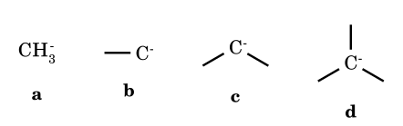
Answer: a > b > c > d
Alkyl groups are +I and push electron density onto the carbon that already holds a lone pair, destabilising it. (In the gas phase polarisability reverses the order; the JEE key uses the inductive argument.)
CA-2.
Arrange in decreasing stability: (a) CH₃CH₂⁻, (b) CH₂=CH⁻, (c) HC≡C⁻.
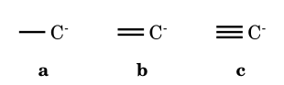
Answer: c > b > a
Stability follows the s-character of the orbital holding the lone pair: sp (50 %) > sp² (33 %) > sp³ (25 %). Equivalently, pK_{a} of the parent C–H ≈ 25, 44, 50.
CA-3.
Arrange in decreasing acidity of the marked H: (a) CH₃NO₂, (b) CH₃COCH₃, (c) CH₃COOC₂H₅, (d) CH₃CN.
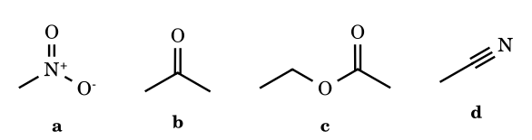
Answer: a > b > d > c (JEE-type key; DMSO pK_{a}: 17.2, 26.5, 31.3, ≈ 30)
The nitronate delocalises the charge onto two oxygens and the N⁺ pulls strongly; the ketone enolate has one O; the ester enolate is less stable because the OR group donates into C=O and competes. ⚑ Between nitrile and ester the experimental DMSO values are close (31 vs ≈ 30); keys vary, so check the source order before answering a question that contains both.
CA-4.
Which of the following carbanions is aromatic? (a) cyclopropenyl anion, (b) cyclopentadienyl anion, (c) cycloheptatrienyl anion, (d) cyclooctatetraene dianion.
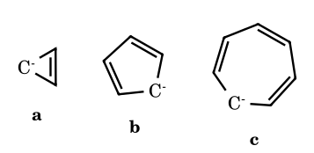
Answer: (b) and (d)
Cyclopentadienide has 6π electrons (4n+2, n = 1) in a planar ring; the cyclooctatetraene dianion (10π, planar) is also aromatic. The cyclopropenyl anion (4π) and cycloheptatrienyl anion (8π) are antiaromatic.
CA-5.
Why is the pK_{a} of cyclopentadiene (≈ 16) about 25 units below that of cyclopentane (≈ 50)?
Answer: aromatic stabilisation of the anion
The conjugate base of cyclopentane is a localised sp³ carbanion. Removing H⁺ from the CH₂ of cyclopentadiene gives a planar C₅H₅⁻ ring with six π electrons delocalised over five carbons (aromatic): this accounts for most of the difference.
CA-6.
Arrange in decreasing acidity: (a) cyclopentadiene, (b) indene, (c) fluorene, (d) cycloheptatriene.
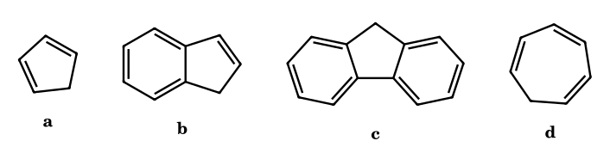
Answer: a > b > c > d (≈ 16, 20, 22.6, 36)
Cyclopentadienide is a simple aromatic anion; in indenide and fluorenide the negative charge is also partly shared with the benzo ring(s), which costs some benzene aromaticity, so they are weaker acids. Cycloheptatriene would give an antiaromatic 8π anion and is the weakest.
CA-7.
Which pair of carbanions is correctly ordered by stability? (A) CCl₃⁻ > CF₃⁻ (B) PhCH₂⁻ > Ph₂CH⁻ (C) CH₃OCH₂⁻ > PhSCH₂⁻ (D) (CH₃)₃C⁻ > CH₃⁻
Answer: (A)
(B) is reversed (more phenyls delocalise more); (C) is reversed (S stabilises, O destabilises by lone-pair repulsion); (D) is reversed (+I destabilises). (A) follows the JEE key (F lone-pair repulsion; Cl polarisability).
CA-8.
A nucleophile attacks the β-carbon of CH₂=CH–CHO (Michael addition). Identify the carbanion intermediate and say why β- rather than α-attack occurs.
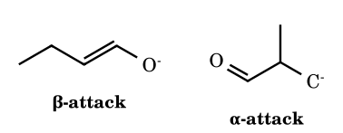
Answer: attack at the β-carbon gives the enolate
β-Attack puts the negative charge on the α-carbon, adjacent to C=O: the enolate (charge shared with oxygen). α-Attack would put the charge on the β-carbon, which is isolated from the carbonyl and unstabilised. The more stable carbanion is formed, as always.
CA-9.
CHCl₃ is treated with KOH. What is formed first, and what does it lose?
Answer: ⁻CCl₃ then :CCl₂
HO⁻ removes the single H (pK_{a} ≈ 24 is acidic enough thanks to −I of Cl and polarisability), giving the trichloromethyl carbanion, which expels Cl⁻ (α-elimination) to give dichlorocarbene. This is the first step of the Reimer–Tiemann and carbylamine reactions.
CA-10.
Sodium acetate is heated with soda lime. Name the product and the intermediate.
Answer: methane via CH₃⁻
CH₃COO⁻ → CH₃⁻ + CO₂; the unstabilised methyl carbanion is protonated at once. (Contrast the Kolbe electrolysis of the same salt, which goes through CH₃• radicals and gives ethane.)
CA-11.
Optically active 2-phenylbutanal racemises on standing in dilute NaOH. Explain.
Answer: planar enolate (carbanion)
The α-H, which is on the stereocentre, is acidic (adjacent C=O and Ph). Its removal gives a planar enolate in which the stereocentre is destroyed; protonation from either face gives both enantiomers.
CA-12.
2-Methylcyclohexanone is treated (i) with LDA at −78 °C, then CH₃I, and (ii) with NaOEt/EtOH at 25 °C, then CH₃I. Give the major product of each.
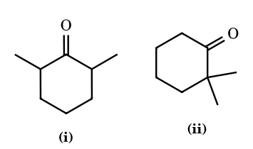
Answer: (i) 2,6-dimethylcyclohexanone; (ii) 2,2-dimethylcyclohexanone
LDA is a bulky, strong base: it removes the more accessible H irreversibly (kinetic enolate, less substituted). NaOEt is a weaker base: the enolates equilibrate and the more substituted (more stable, thermodynamic) enolate is alkylated.
CA-13.
How many moles of methane are evolved when 1 mol of HOCH₂CH₂–C≡CH reacts with excess CH₃MgI?
Answer: 2
Both the O–H and the acetylenic C–H are acidic enough (pK_{a} ≈ 16 and 25, far below that of CH₄ ≈ 50) to protonate CH₃⁻. Counting active hydrogens: 2. (The Zerewitinoff method.)
CA-14.
In which of the following will the carbanion that is formed be stabilised by resonance? (a) phenyl anion, (b) benzyl anion, (c) vinyl anion, (d) acetylide, (e) cyclohexadienyl-type enolate.
Answer: (b) and (e)
Only (b) and (e) have the lone pair in a p orbital parallel to a π system. The lone pair of the phenyl and vinyl anions is in an sp² orbital in the plane (orthogonal to π), and the acetylide lone pair is in an sp orbital along the axis.
CA-15.
Match the carbanion with its source: (A) CH₃−, (B) ⁻CCl₃, (C) enolate, (D) RC≡C⁻; (P) aldol reaction, (Q) Reimer–Tiemann, (R) soda-lime decarboxylation, (S) NaNH₂ + alkyne.
Answer: A–R; B–Q; C–P; D–S
Soda lime gives CH₃⁻ from acetate; CHCl₃/KOH gives CCl₃⁻ and then dichlorocarbene; base + carbonyl gives the enolate for the aldol; NaNH₂ deprotonates a terminal alkyne.
CA-16.
How many of the following can be converted completely into their anion by sodium ethoxide in ethanol? (pK_{a} of EtOH ≈ 16): acetone (19.3), ethyl acetoacetate (10.7), diethyl malonate (13), nitromethane (10.2), ethyl acetate (25.6), cyclopentadiene (16), phenylacetylene (≈ 29).
Answer: 3 (ethyl acetoacetate, diethyl malonate, nitromethane)
Quantitative deprotonation needs pK_{a}(HA) at least about 2 units below 16: only acetoacetate, malonate and nitromethane qualify. Cyclopentadiene (16) is half-deprotonated; acetone, ethyl acetate and the alkyne are deprotonated to a negligible extent (but acetone still reacts through the 10⁻⁴ fraction of enolate).
CA-17.
Using the aqueous pK_{a} values, calculate the equilibrium constant for CH₃COCH₃ + EtO⁻ ⇌ CH₃COCH₂⁻ + EtOH (pK_{a}: acetone 19.3, ethanol 15.9).
Answer: K = 10^{−3.4} ≈ 4 × 10⁻⁴
log K = pK_{a}(EtOH) − pK_{a}(acetone) = 15.9 − 19.3 = −3.4. In 1 M EtO⁻ the enolate fraction is about 0.04 %: too small for stoichiometric enolate chemistry (use LDA) but sufficient for a catalytic aldol.
CA-18.
Predict the product of 2-methylcyclohexanone with (a) LDA/THF, −78 °C, then CH₃I, (b) NaOEt/EtOH, 25 °C, then CH₃I, (c) Me₃SiCl/Et₃N, DMF, 130 °C (then MeLi, MeI).
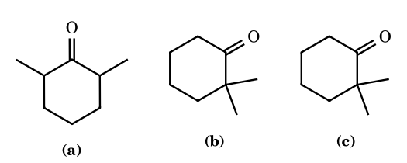
Answer: (a) 2,6-dimethyl; (b) 2,2-dimethyl; (c) 2,2-dimethyl
(a) kinetic enolate at C-6; (b) the equilibrating base gives the more substituted enolate; (c) the thermodynamic silyl enol ether (more substituted) is regenerated to the same enolate by MeLi.
CA-19.
Which is the stronger acid, Meldrum’s acid (pK_{a} 4.8) or dimedone (5.2)? Both have two C=O flanking a CH₂. Explain the difference from acyclic malonic ester (13).
Answer: Meldrum’s acid, marginally; both far stronger than diethyl malonate
In diethyl malonate the ester C=O is deactivated by donation from the OR lone pair, and the two esters can adopt the E (s-trans) conformation, which gives poorer overlap and dipole repulsion in the anion. In Meldrum’s acid the cyclic 1,3-dioxane-4,6-dione holds both carbonyls in the Z (s-cis) arrangement, forcing a planar anion with full conjugation and no competition between the ring oxygens, hence ≈ 8 pK units more acidic.
CA-20.
Ethyl acetate is treated with 1 equiv NaOEt, then acid. Name the product. Why does ethyl 2,2-dimethylpropanoate (pivalate) with 1 equiv NaOEt not undergo a Claisen condensation, and why does ethyl isobutyrate fail under the same conditions?
Answer: ethyl acetoacetate; pivalate has no α-H; isobutyrate gives a product without an acidic H
Ethyl pivalate (t-BuCO₂Et) has no α-hydrogen, so no enolate. Ethyl isobutyrate gives the condensation product ((CH₃)₂CH–CO–C(CH₃)₂CO₂Et), which has no H between the two carbonyls and therefore cannot be deprotonated to drive the equilibrium: the (unfavourable) equilibrium lies on the side of starting materials. A stronger base (Ph₃CNa, LDA) is needed.
CA-21.
Give the products of the crossed aldol of benzaldehyde with (a) acetone (excess), (b) acetophenone, (c) cyclohexanone (1:1), under NaOH/EtOH, heat.
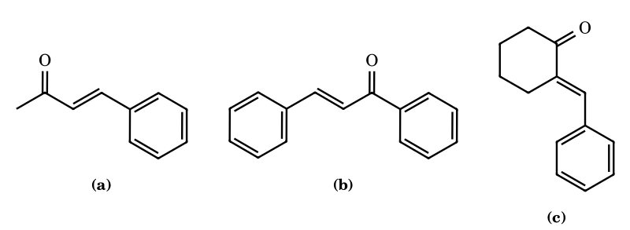
Answer: (a) benzalacetone; (b) chalcone; (c) 2-benzylidenecyclohexanone
Benzaldehyde has no α-H and so cannot enolise; the ketone enolises and adds to PhCHO; E1cB dehydration gives a conjugated enone (Claisen–Schmidt). With excess PhCHO, acetone gives dibenzalacetone.
CA-22.
How many different products (including the self-condensation products) can form when CH₃CHO and CH₃CH₂CHO are mixed with dilute NaOH (aldol only, no dehydration, ignore stereoisomers)?
Answer: 4
Each aldehyde can act as the enolate or as the electrophile: CH₃CHO + CH₃CHO; CH₃CH₂CHO + CH₃CH₂CHO; enolate of CH₃CHO + CH₃CH₂CHO; enolate of CH₃CH₂CHO + CH₃CHO. Four distinct β-hydroxy aldehydes (a statistical mixture, which is why crossed aldols with two enolisable partners are avoided).
CA-23.
Complete: (a) CH₃COCH₃ + I₂/NaOH (excess), (b) C₆H₅COCH₃ + NaOCl, (c) CH₃CH₂OH + I₂/NaOH. Which give a yellow precipitate?
Answer: (a) CHI₃ + CH₃COO⁻; (b) CHCl₃ + C₆H₅COO⁻; (c) CHI₃ + HCOO⁻; yellow CHI₃ from (a) and (c)
Methyl ketones and ethanol (oxidised in situ to acetaldehyde) give the iodoform test; (b) with NaOCl gives chloroform (not yellow). The acid always has one carbon fewer than the methyl ketone.
CA-24.
A Grignard reagent CH₃MgI (excess) is added to each of (a) HOCH₂CH₂COCH₃, (b) HC≡C–CH₂–COOEt. Count moles of CH₄ evolved per mole of substrate before addition occurs.
Answer: (a) 1; (b) 1
Active hydrogens are protonated by CH₃⁻: (a) the O–H (1); (b) the acetylenic C–H (pK_{a} 25), (the ester then reacts through addition, not acid–base): 1. The Zerewitinoff count gives the number of active H.
CA-25.
Arrange in order of increasing acidity of the marked hydrogen: (a) CH₃COCH₃, (b) CH₃COCH₂COCH₃ (central), (c) CH₃CN, (d) CH₃NO₂, (e) CH₂(CN)₂.
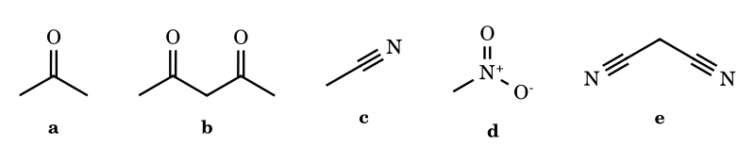
Answer: c < a < d ≈ e < b (aqueous pKa ≈ 25, 19.3, 10.2, 11.2, 8.9)
A single acceptor: nitrile (≈ 25) < ketone (19) < nitro (10). Two acceptors: malononitrile (11) and acetylacetone (9, aqueous). The DMSO ordering of the two close pairs is d (17.2) < e (11.1) < b (13.3) with the order of b and e depending on scale: check the scale given in the question.
CA-26.
Why is the CH₂ between the two C=O groups of acetylacetone (pK_{a} 9) more acidic than the CH₃ groups (≈ 20), and what does base then give on alkylation with 1 equiv CH₃I?
Answer: central position; 3-methylpentane-2,4-dione
The central carbanion is delocalised over two C=O (and both oxygens carry charge), whereas a terminal carbanion is stabilised by only one. The central anion is the one formed and alkylated. With 2 equiv of a very strong base (the dianion) a terminal CH₃ would react first.
CA-27.
State the product and the stereochemical outcome of the Wittig reaction of (a) benzaldehyde with Ph₃P=CHCH₃ (salt-free), (b) benzaldehyde with Ph₃P=CHCO₂Et.
Answer: (a) mainly (Z)-1-phenylpropene; (b) (E)-ethyl cinnamate
(a) non-stabilised ylide: irreversible, kinetically controlled formation of the cis-oxaphosphetane leading to Z-alkene. (b) a stabilised ylide forms the oxaphosphetane reversibly, allowing the more stable trans (E) alkene to form.
CA-28.
Cyclohexanone is converted into methylenecyclohexane in one step. Which reagent? Why will CH₃MgI/H⁺/Δ not give a clean result?
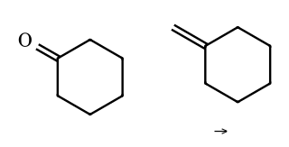
Answer: Ph₃P=CH₂ (Wittig)
The Grignard route gives 1-methylcyclohexanol which dehydrates (E1) to the endocyclic, more substituted 1-methylcyclohexene, not the exocyclic alkene. The Wittig reaction puts the double bond exactly where the C=O was.
CA-29.
An optically active ketone CH₃CH(C₂H₅)COC₆H₅ loses optical activity in NaOH/H₂O. A second ketone, with a quaternary α-carbon, does not. Explain, and say what rate law governs the racemisation.
Answer: planar enolate; rate = k[ketone][HO⁻], independent of any halogen
The stereocentre carries an acidic α-H; the enolate is planar. The quaternary α-carbon has no H and cannot enolise at that carbon. Halogenation in base and racemisation have the same rate (zero order in halogen), proving the common enolate.
CA-30.
Compare the products of the reaction of cyclohexanone with (a) CH₃MgI then H₃O⁺; (b) pyrrolidine then CH₃I then H₃O⁺; (c) LDA then CH₃I; (d) NaOEt, CH₃I (excess).
Answer: (a) 1-methylcyclohexanol (C=O attack); (b) 2-methylcyclohexanone (Stork enamine alkylation at α-C); (c) 2-methylcyclohexanone; (d) mixture up to 2,2,6,6-tetramethylcyclohexanone
The Grignard reagent attacks carbon of C=O; the enamine and enolate act as nucleophiles at the α-carbon. NaOEt is a weak equilibrating base so enolates alkylate repeatedly (polyalkylation); LDA/enamine give clean monoalkylation.
CA-31.
Identify the electrophile and the carbanion in each of: (a) Perkin reaction, (b) Knoevenagel, (c) benzoin condensation, (d) Reformatsky, (e) Stork enamine alkylation, (f) Michael addition of diethyl malonate to acrylonitrile.
Answer: see reasoning
(a) enolate of acetic anhydride (from CH₃COONa) + ArCHO; (b) CH₂(CN)₂ carbanion + ArCHO; (c) cyanohydrin carbanion + ArCHO; (d) BrZn–CH₂CO₂Et + ketone; (e) enamine β-carbon + RX or enone; (f) malonate carbanion + CH₂=CH–C≡N (1,4-addition giving NC–CH₂CH₂–CH(CO₂Et)₂).
CA-32.
Which carbanion is most stable? Rank (a) PhCH₂⁻, (b) (Ph)₃C⁻, (c) p-O₂N–C₆H₄CH₂⁻, (d) cyclopentadienide, (e) CH₃⁻.
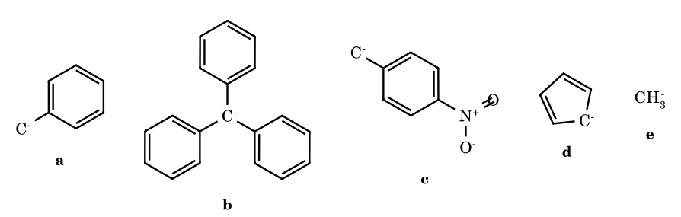
Answer: d > c > b > a > e (acid pK_{a} ≈ 16, 20, 31, 41, 50)
Cp⁻ is aromatic; the p-nitrobenzyl anion delocalises onto NO₂ (−M); trityl has three phenyls, benzyl one; methyl has none. (⚑ the position of (c) relative to (b) is scale-dependent: the p-nitrobenzyl anion is more stable by ≈ 10 pK units than benzyl and comparable with trityl.)
CA-33.
Which of the following reactions will proceed to completion? (A) CH₃COOEt + EtO⁻; (B) CH₃COCH₂COOEt + EtO⁻; (C) PhC≡CH + HO⁻; (D) CH₃NO₂ + HO⁻.
Answer: (B) and (D)
Use pK_{a}: acetoacetate 10.7 and nitromethane 10.2 are much more acidic than EtOH (16) or water (15.7), so deprotonation is complete. Ethyl acetate (25.6) and phenylacetylene (≈ 29, DMSO) are not deprotonated appreciably.
CA-34.
Chloroform reacts with solid KOH in a non-polar solvent with a phase-transfer catalyst (BnEt₃N⁺Cl⁻) in the presence of cyclohexene. Name the product and the role of the catalyst.
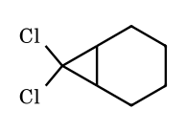
Answer: 7,7-dichlorobicyclo[4.1.0]heptane; the catalyst carries HO⁻ (or CCl₃⁻) into the organic phase
Makosza interfacial mechanism: HO⁻ deprotonates CHCl₃ at the interface; Q⁺CCl₃⁻ moves into the organic phase, loses Cl⁻ to give :CCl₂, which adds to the alkene.
CA-35.
The conjugate acid of which base has a pK_{a} high enough to deprotonate benzene? Which of NaOH, NaOEt, NaNH₂, n-BuLi/TMEDA, LDA can do so?
Answer: n-BuLi/TMEDA only (pK_{a} of benzene ≈ 43)
NH₃ (≈ 38) and diisopropylamine (36) are too weak as conjugate acids; butane (≈ 50) is strong enough. TMEDA breaks up the BuLi hexamer, making it kinetically capable.
CA-36.
Racemic 2-bromobutane forms a Grignard reagent which is hydrolysed with D₂O. Is the 2-deutero-butane optically active if one starts from enantiopure (S)-2-bromobutane?
Answer: no, racemic
Grignard formation proceeds through radical intermediates at the metal surface (single-electron transfer), which are planar and lose configuration; the secondary alkyl Grignard also inverts configurationally on the time scale of hours at room temperature. In contrast, vinyl and cyclopropyl Grignards and many organolithiums at −78 °C retain configuration.
CA-37.
Which of the following do not take place? (a) CH₃CH₂CH₂CH₂Li + CH₃CH₂OH → butane; (b) RMgBr + R′COOH → R–H; (c) RMgBr + aldehyde with a COOH group → alcohol (without protection); (d) PhMgBr + CO₂ → PhCOOH.
Answer: (c) does not give the clean alcohol
The Grignard reagent first deprotonates the COOH (acid–base is faster than addition) and consumes one equivalent; the carboxylate then does not react further, so addition to the aldehyde needs excess reagent or protection of the acid. (a), (b), (d) occur.
CA-38.
Convert (i) CH₃COCH₃ → (CH₃)₂C=CH–COCH₃ (mesityl oxide), (ii) CH₃CHO → CH₃CH=CH–CHO, (iii) HCHO + CH₃CHO → ? (NaOH; crossed aldol), (iv) PhCHO + (CH₃CO)₂O/CH₃COONa/Δ → ?
Answer: (i) aldol then E1cB; (ii) crotonaldehyde; (iii) acrolein or (with excess HCHO) pentaerythritol precursors; (iv) cinnamic acid (Perkin)
In (iii) formaldehyde has no α-H and is an excellent electrophile; with acetaldehyde in excess HCHO and base the three α-H are all hydroxymethylated and a final crossed Cannizzaro reduction by HCHO gives pentaerythritol C(CH₂OH)₄. (iv) The enolate of the anhydride attacks PhCHO and elimination/hydrolysis gives E-cinnamic acid.
CA-39.
A student claims that carbanions rearrange like carbocations by 1,2-hydride and 1,2-alkyl shifts. Evaluate.
Answer: incorrect
A 1,2-shift needs a three-centre, two-electron TS with an empty orbital to receive the pair; the carbanion carbon already has a filled lone pair, so such a shift would require a four-electron three-centre TS (forbidden/high barrier). Aryl and vinyl groups migrate to carbanions through spiro/cyclopropane-like intermediates (Grovenstein–Zimmerman), by using their π systems.
CA-40.
α-Elimination versus β-elimination: why does CHCl₃ + HO⁻ give :CCl₂ while CH₃CH₂Cl + HO⁻ gives CH₂=CH₂?
Answer: no β-H in CHCl₃; the anion CCl₃⁻ is stable and eliminates from the same carbon
Chloroform has only one carbon, so a β-elimination is impossible. Its carbanion is stabilised by three Cl (−I, polarisability), long-lived enough to lose Cl⁻ (α). Ethyl chloride has a β-H and an E2 pathway.
CA-41.
Using the Zimmerman–Traxler model, say which aldol diastereomer is formed by the Z-lithium enolate of 3-pentanone with benzaldehyde.
Answer: the syn aldol
In the chair six-membered TS the aldehyde Ph occupies the equatorial position; with a Z-enolate the two substituents that become the stereocentres end up syn in the zig-zag drawing. E-enolates give anti.
CA-42.
Which has the more acidic C–H, 1,3-cyclopentadiene (≈ 16) or 1,3-cycloheptatriene (≈ 36)? Explain, and also predict where CH₃Li would remove a proton from 1,3,5-cycloheptatriene.
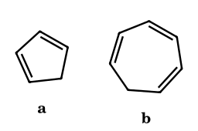
Answer: cyclopentadiene; at the CH₂ (C-7)
Cp⁻ is aromatic; the cycloheptatrienyl anion would have 8π (antiaromatic) in a planar ring and is destabilised (the pK_{a} of 36 corresponds to a non-planar, non-aromatic anion). Both lose H from the sp³ carbon.
CA-43.
A carbanion is generated from CH₃COCH₂CH₃ (2-butanone). Name the two possible enolates and the conditions that select each.
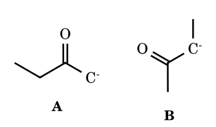
Answer: A: less substituted (kinetic, LDA −78 °C); B: more substituted (thermodynamic, NaOEt/EtOH)
A arises from removal of a CH₃ hydrogen; B from the CH₂. LDA gives mostly A (kinetic); thermodynamic conditions (equilibrating base) give mostly B, with E/Z isomers.
CA-44.
Why is an α-C–H of an ester (pK_{a} ≈ 25) less acidic than the α-C–H of the corresponding ketone (≈ 20), when the ester carbonyl carbon is the more electrophilic?
Answer: OR lone-pair donation into C=O
The ester C=O is already stabilised by resonance with the alkoxy oxygen (ROC=O ↔ RO⁺=C–O⁻); therefore its carbonyl accepts the carbanion’s charge less well than a ketone’s. The same effect makes amide α-H still less acidic (≈ 30).
CA-45.
(JEE-type) How many of the following compounds will liberate methane on treatment with CH₃MgI? CH₃OH, CH₃COOH, CH₃CONH₂, CH₃COCH₃, HC≡CH, C₆H₅NH₂, CH₃COOCH₃, H₂O.
Answer: 6 (CH₃OH, CH₃COOH, CH₃CONH₂, HC≡CH, C₆H₅NH₂, H₂O)
Each has an active H more acidic than CH₄. Acetone does not liberate CH₄ because the Grignard adds to its C=O (a small amount of enolisation may occur), and the ester is attacked at C=O. Acetamide has two N–H (2 equivalents).
CA-46.
(IChO-style) The pK_{a} values of cyclopentadiene, indene and fluorene (DMSO) are 18, 20 and 22.6. Explain why benzo-fusion lowers the acidity although the conjugate base keeps the cyclopentadienide ring.
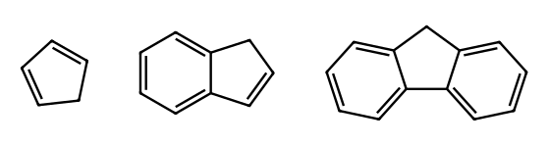
Answer: each fused benzene ring competes for the π electrons
In Cp⁻ all six π electrons are shared by five equivalent carbons. In indenide and fluorenide, part of the charge must be delocalised into a benzene ring, which costs some of that ring's aromatic stabilisation, and the cyclopentadienide ring is perturbed. Each benzo-fusion therefore destabilises the anion by ≈ 2 pK units relative to Cp⁻.
CA-47.
(JEE Advanced, integer) Propanal undergoes self-aldol addition (dilute NaOH, 5 °C). How many stereoisomers does the aldol (3-hydroxy-2-methylpentanal) have, and how many geometrical isomers does the dehydration product have?
Answer: 4 and 2
The aldol has two stereocentres (C-2 and C-3, no symmetry): 2² = 4 stereoisomers. Dehydration gives 2-methylpent-2-enal, with a trisubstituted C=C bearing different groups on each carbon: E and Z, so 2.
CA-48.
(GATE/CSIR style) Acetophenone is treated with ethyl formate and NaOEt, then acid. Give the product and say why formate is a good acylating partner.
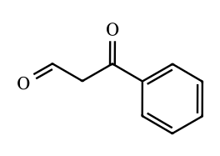
Answer: benzoylacetaldehyde (3-oxo-3-phenylpropanal), largely as its enol
Crossed Claisen condensation: the acetophenone enolate attacks HCOOEt, whose carbonyl is unhindered and cannot itself enolise (no α-H), so a single product forms. The product is a 1,3-dicarbonyl (pK_{a} ≈ 7–9), which is deprotonated by ethoxide and drives the reaction.
CA-49.
Ethyl acetoacetate is treated with (i) NaH (1 equiv), (ii) n-BuLi (1 equiv), (iii) PhCH₂Br, (iv) H₃O⁺. Predict the product and explain the site of alkylation.
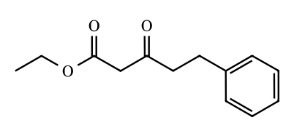
Answer: ethyl 3-oxo-5-phenylpentanoate (γ-alkylation)
NaH removes the most acidic C-2 proton; n-BuLi then removes a proton from the terminal CH₃ (C-4) to give a dianion. In the dianion the less stabilised, more basic carbanion (C-4) is the more nucleophilic and reacts first with the halide. Acid work-up reprotonates C-2.
CA-50.
Arrange in order of increasing rate of E1cB elimination of HO⁻ from β-hydroxy compounds: (a) CH₃CH(OH)CH₂COCH₃, (b) CH₃CH(OH)CH₂COOEt, (c) CH₃CH(OH)CH₂CON(CH₃)₂, (d) CH₃CH(OH)CH₂NO₂.
Answer: c < b < a < d
E1cB rate follows the ease of forming the carbanion (acidity of the α-H): amide (≈ 30) < ester (≈ 25) < ketone (≈ 20) < nitro (≈ 10 in water). Hydroxide is a poor leaving group, but the stabilised carbanion makes expulsion feasible.
CA-52.
Cyclohexanone is treated with methyl vinyl ketone and NaOEt/EtOH, then heated. Give the bicyclic product and name the three steps.
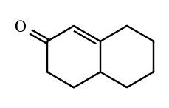
Answer: Δ¹⁽⁹⁾-octalone (4,4a,5,6,7,8-hexahydronaphthalen-2(3H)-one); Michael, intramolecular aldol, E1cB dehydration
The cyclohexanone enolate adds 1,4 to MVK to give the 1,5-diketone; the methyl ketone enolate attacks the ring C=O (6-exo) to give a β-hydroxy ketone, which loses water by E1cB to give the conjugated enone (Robinson annulation).
CA-53.
Diethyl malonate (2 equiv) with NaOEt and 1,2-dibromoethane gives a cyclic diester. Name it and the product after hydrolysis and heating.
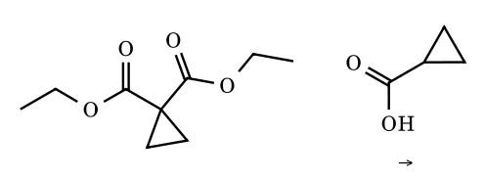
Answer: diethyl cyclopropane-1,1-dicarboxylate; cyclopropanecarboxylic acid
One malonate carbanion displaces bromide (S_{N}2); the remaining acidic C–H is deprotonated and the carbanion closes the three-membered ring (3-exo-tet). Hydrolysis and decarboxylation of the gem-diacid give the mono-acid.
CA-54.
Diethyl 3-methyladipate (diethyl 3-methylhexanedioate) undergoes Dieckmann cyclisation. Which regioisomeric β-keto ester is expected to predominate, and why?
Answer: 2-ethoxycarbonyl-4-methylcyclopentanone (major) over the 3-methyl isomer
Enolate formation at C-5 (remote from the methyl) is less hindered; it attacks the C-1 ester to give the 4-methyl isomer. Enolate formation at C-2 (next to the methyl-bearing C-3) gives the 3-methyl isomer. The product with the acidic ring C–H is deprotonated, which drives either closure.
CA-55.
Nitromethane reacts with benzaldehyde and base (Henry reaction). Give the adduct and the compound formed on dehydration, and explain why only catalytic base is needed.
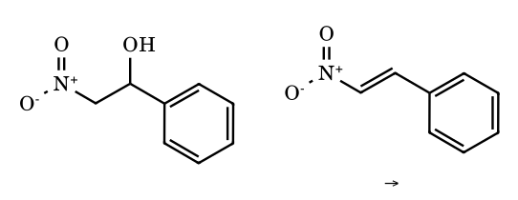
Answer: 2-nitro-1-phenylethanol; β-nitrostyrene
The nitronate (pK_{a} ≈ 10) adds to the aldehyde; the alkoxide is protonated by nitromethane, regenerating the nitronate. Dehydration (E1cB) gives the conjugated nitroalkene.
CA-56.
Which alcohol is formed from (a) ethyl acetate + 2 EtMgBr, (b) ethyl propanoate + 2 CH₃MgBr? Are they the same?
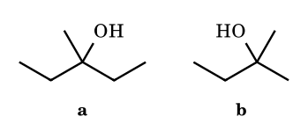
Answer: (a) 3-methylpentan-3-ol; (b) 2-methylbutan-2-ol; different
Two equivalents of R⁻ add to the ester carbonyl; the acyl group supplies one substituent and the OEt is lost after the first addition. (a) acyl = CH₃, R = Et twice; (b) acyl = Et, R = CH₃ twice.
CA-57.
(JEE integer) How many of these give a yellow precipitate with I₂/NaOH: ethanol, propan-2-ol, acetophenone, pentan-3-one, acetaldehyde, propanal, butan-2-one, methyl acetate?
Answer: 5
Ethanol and propan-2-ol (oxidised in situ to CH₃CHO and acetone), acetophenone, acetaldehyde and butan-2-one contain CH₃CO– or CH₃CH(OH)–. Pentan-3-one, propanal and methyl acetate do not.
CA-58.
Benzyl allyl ether is treated with n-BuLi at −78 °C and warmed. Give the product and name the rearrangement.
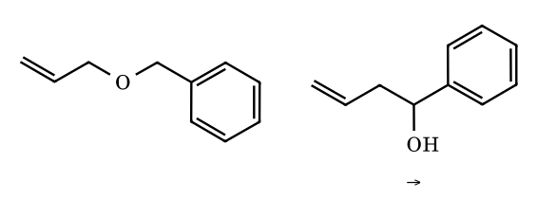
Answer: 1-phenylbut-3-en-1-ol via [2,3]-Wittig rearrangement
BuLi removes the benzylic proton; the carbanion attacks the terminal alkene carbon in a five-membered cyclic transition state while the C–O bond to the allyl group breaks, giving a homoallylic alkoxide.
CA-60.
(GATE/CSIR style) Arrange in order of increasing pK_{a} in water (i.e. decreasing C–H acidity): acetone, ethyl acetate, diethyl malonate, nitromethane, acetylacetone.
Answer: acetylacetone (9) < nitromethane (10) < diethyl malonate (13) < acetone (19) < ethyl acetate (≈25)
Two carbonyl groups (acetylacetone, malonate) share the charge over two oxygens, and a ketone stabilises the carbanion better than an ester because the ester carbonyl is already donated into by OEt. Nitromethane (pK_{a} ≈ 10) is the most acidic mono-activated C–H acid because NO₂ is the strongest acceptor. ⚑ The order is solvent-dependent: in DMSO the values are 13.3 (acac), 16.4 (malonate), 17.2 (MeNO₂), 26.5 (acetone), 29.5 (EtOAc), so malonate and nitromethane swap. In water the nitronate oxygens are strongly H-bonded, which stabilises it more than the delocalised malonate enolate, whereas in DMSO that solvation advantage disappears.
CA-61.
(JEE Advanced style) 2-Methylcyclohexanone is treated (a) with LDA (1.05 equiv), THF, −78 °C, then PhCH₂Br; (b) with KH (0.9 equiv), THF, 25 °C, 2 h, then PhCH₂Br. Give the major product of each and name the type of enolate involved.
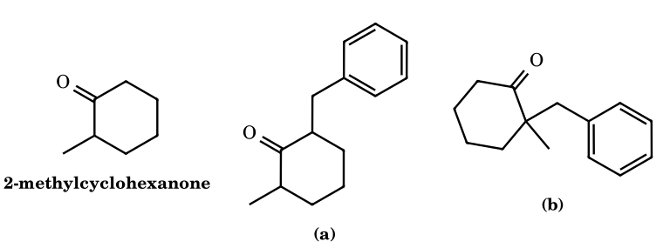
Answer: (a) 2-benzyl-6-methylcyclohexanone (kinetic enolate); (b) 2-benzyl-2-methylcyclohexanone (thermodynamic enolate)
LDA is bulky, strong and used in slight excess at low temperature, so deprotonation is fast and irreversible and occurs at the less hindered C-6 CH₂, giving the less substituted (kinetic) enolate, which is alkylated at C-6. With a sub-stoichiometric strong base at room temperature, proton transfer between enolate and ketone equilibrates the enolates; the more substituted (tetrasubstituted) enolate toward C-2 is more stable and gives the 2,2-disubstituted product.
CA-62.
(Assertion-Reason) Assertion: 2-Oxocyclohexanecarboxylic acid loses CO₂ readily on gentle warming, but the bicyclic acid shown (a bridgehead carboxylic acid β to a ketone) is stable to heating at 150 °C. Reason: Decarboxylation of a β-keto acid proceeds through a six-membered cyclic transition state that produces an enol, and for the bicyclic acid this enol would need a C=C at a bridgehead of a small bicycle (Bredt violation).
(A) Both true, Reason explains Assertion; (B) both true, Reason does not explain; (C) Assertion true, Reason false; (D) Assertion false, Reason true.
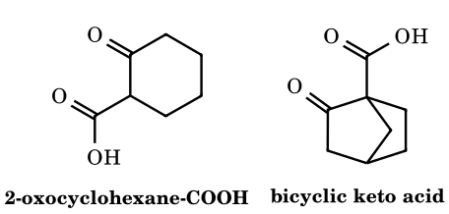
Answer: (A)
β-Keto acids decarboxylate through a concerted six-membered pericyclic TS (O=C–C–C=O with the acid O–H transferring to the ketone O); the immediate product is an enol that tautomerises to the ketone. In the norbornanone acid the carbon bearing COOH is a bridgehead, so the enol C=C would have to be placed at the bridgehead of a bicyclo[2.2.1] system, which is impossible (Bredt), so the acid survives. Thus the Reason explains the Assertion: (A).
CA-63.
(JEE Advanced, match the column) Match each named reaction in Column I with the product of the typical example in Column II (structures 1-4 in the figure). P: Reformatsky (PhCHO, BrCH₂CO₂Et, Zn, then H₃O⁺); Q: Darzens (PhCHO, ClCH₂CO₂Et, NaOEt); R: Knoevenagel (PhCHO, CH₂(CO₂Et)₂, piperidine, heat); S: Dieckmann (EtO₂C(CH₂)₄CO₂Et, NaOEt, then H₃O⁺).
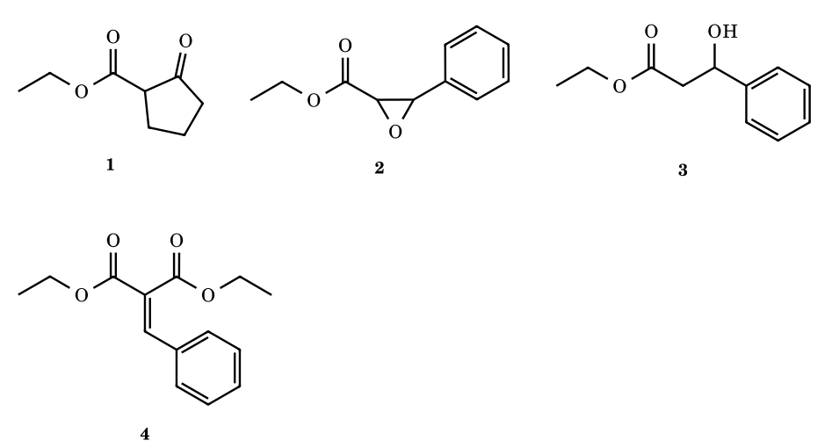
Answer: P–3, Q–2, R–4, S–1
Reformatsky: the organozinc enolate (too unreactive to attack the ester) adds to the aldehyde to give the β-hydroxy ester 3. Darzens: the α-chloro ester enolate adds to PhCHO and the resulting alkoxide displaces chloride (3-exo-tet) to give the glycidic ester 2. Knoevenagel: the malonate carbanion adds, then dehydration (E1cB) gives benzylidene malonate 4. Dieckmann: intramolecular Claisen of diethyl adipate gives the five-membered β-keto ester 1.
CA-64.
(Olympiad style) Two ylides are generated: Ph₃P=CHCO₂Et (stable, isolable) and Ph₃P=CHCH₃ (from the phosphonium salt and NaNH₂ or KHMDS, salt-free THF). Each reacts with benzaldehyde. Give the major organic product of each, including alkene geometry, and the common by-product. Why do the geometries differ?
Answer: (E)-ethyl cinnamate and (Z)-1-phenylpropene; Ph₃P=O
Non-stabilised ylides add under kinetic control through an early, puckered TS to give the cis-oxaphosphetane irreversibly, which collapses (syn-elimination) to the Z-alkene. The ester-stabilised ylide is less reactive and its additions are reversible, so the thermodynamically more stable trans-oxaphosphetane is funnelled to the E-alkene. The driving force in both is the very strong P=O bond of Ph₃P=O. ⚑ Lithium salts can erode Z-selectivity for non-stabilised ylides (hence the salt-free conditions).
CA-65.
(JEE Advanced, integer) Excess MeMgBr is used and the minimum number of moles of MeMgBr consumed per mole of substrate is counted (Grignard acts as a base towards O–H and C≡C–H, and does not deprotonate the ester α-CH). Add the numbers for: (i) ethyl 4-hydroxybenzoate; (ii) ethyl 4-ethynylbenzoate; (iii) diethyl carbonate. Report the sum.
Answer: 9
(i) 1 equiv deprotonates the phenol (ArOMgBr), then 2 equiv add to the ester (ketone intermediate is more reactive than the ester), giving after work-up 4-(2-hydroxypropan-2-yl)phenol: 3. (ii) The terminal alkyne C–H (pK_{a} ≈ 25) is deprotonated (1) and the ester gives the tertiary alcohol (2): 3. (iii) Diethyl carbonate takes three Me groups, giving (CH₃)₃COH after work-up: 3. Sum = 9.
CA-66.
(Olympiad style) The lithium enolate of 2,2-dimethylpentan-3-one (t-Bu ethyl ketone) formed with LDA in THF is the (Z)-enolate, in which OLi and the CH₃ group of the enolate C=C are on the same side. It reacts with benzaldehyde at −78 °C. (a) Which chair transition state geometry (Zimmerman–Traxler) results and where do the t-Bu and Ph groups sit? (b) Is the aldol syn or anti? (c) How many stereoisomers form, and what would an (E)-enolate give?
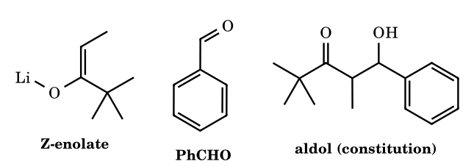
Answer: (b) syn; (c) one racemic diastereomer (2 enantiomers); E-enolate gives the anti aldol
The enolate O–Li–O=C(H)Ph forms a six-membered chair: Li bridges the enolate O and the aldehyde O. The aldehyde Ph prefers the pseudo-equatorial position to avoid 1,3-diaxial interactions with the ligands on Li and the enolate substituents. With a Z-enolate the enolate methyl is forced pseudo-axial next to the aldehyde H, and this chair delivers the syn aldol (Me and OH on the same side in the zig-zag chain). The E-enolate places Me equatorial and gives the anti aldol. Each diastereomer is racemic since no chiral element is present. ⚑ syn/anti refers to the Masamune zig-zag convention.
CA-67.
(IChO-style) Diethyl hexanedioate (diethyl adipate) is treated with (i) NaOEt (1 equiv), EtOH, reflux; (ii) NaOEt, then MeI; (iii) aq. HCl, heat. Give the compounds A, B and the final ketone C, and say why a full equivalent of alkoxide is needed in step (i) and why the same sequence from diethyl pentanedioate (glutarate) fails.
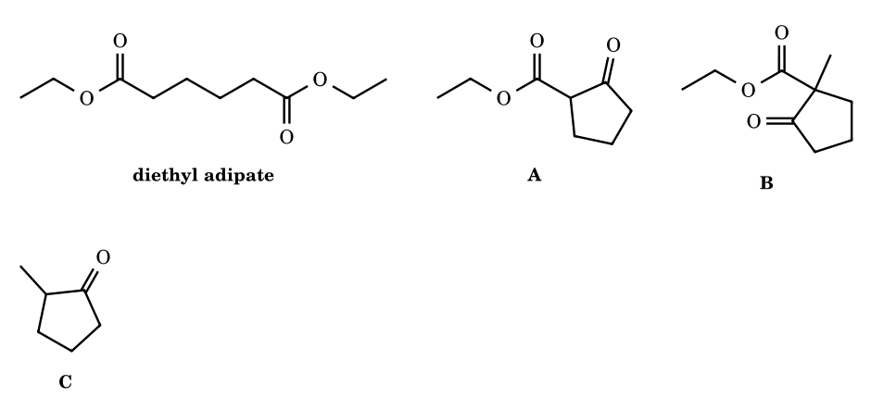
Answer: A: ethyl 2-oxocyclopentanecarboxylate; B: its 1-methyl derivative; C: 2-methylcyclopentanone
Dieckmann cyclisation: the ester enolate attacks the other ester to form a five-membered ring, expelling EtO⁻. The β-keto ester product (pK_{a} ≈ 12) is deprotonated by ethoxide, and this irreversible step drives the otherwise unfavourable equilibrium, so one full equivalent of base is consumed. The stabilised enolate is C-alkylated by MeI to B (quaternary, no acidic H). Acid hydrolysis gives the β-keto acid which decarboxylates (cyclic six-membered TS) to C. Glutarate would have to close a strained four-membered ring and does not cyclise.
CA-68.
(JEE Advanced, integer) Use pK_{a}(EtOH) = 16, pK_{a}(CH₃CO₂Et, C–H) = 25 and pK_{a}(ethyl acetoacetate, C-2 H) = 11. (i) Let K₁ be the equilibrium constant for CH₃CO₂Et + EtO⁻ ⇌ enolate + EtOH, and p = −log₁₀K₁. (ii) The neutral Claisen condensation 2 CH₃CO₂Et ⇌ CH₃COCH₂CO₂Et + EtOH is assumed to have K = 1×10⁻³ (for the purposes of this problem). Let K₂ be the constant for 2 CH₃CO₂Et + EtO⁻ ⇌ acetoacetate enolate + 2 EtOH. Give p and log₁₀K₂.
Answer: p = 9; log K₂ = +2
K₁ = 10^{pKa(EtOH) − pKa(ester)} = 10¹⁶⁻²⁵ = 10⁻⁹, so p = 9: only about one ester molecule in 10^{9–10} is an enolate at a time, enough for the reaction to proceed but too little to push it. The final deprotonation of acetoacetate, EAA + EtO⁻ ⇌ enolate + EtOH, has K = 10¹⁶⁻¹¹ = 10⁵. Therefore K₂ = 10⁻³ × 10⁵ = 10², log K₂ = 2: the condensation becomes favourable only because the product is consumed as its enolate, which is why stoichiometric base is required. ⚑ Real K for the neutral step is only approximately known; the value is a stated assumption.
CA-69.
(IChO-style) Acetophenone is heated with paraformaldehyde and dimethylamine hydrochloride (Mannich reaction) to give A. A is treated with MeI and then aqueous NaHCO₃ to give B (C₉H₈O) plus NMe₃. B is then treated with diethyl malonate and catalytic NaOEt to give C. Give A, B and C and name the key mechanism converting A·MeI into B.
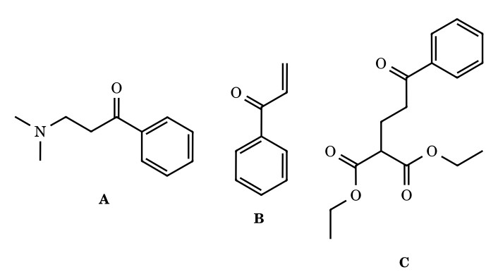
Answer: A: PhCOCH₂CH₂NMe₂; B: phenyl vinyl ketone; C: diethyl 2-(3-oxo-3-phenylpropyl)malonate; E1cB
A is the Mannich base, formed by attack of the acetophenone enol on the iminium CH₂=NMe₂⁺. Quaternisation turns NMe₂ into the good leaving group NMe₃. Mild base removes the acidic α-H (pK_{a} ≈ 25 in DMSO, accessible with bicarbonate in equilibrium) to give the enolate which expels NMe₃ in an E1cB step, delivering the very reactive enone B. B is a Michael acceptor: the malonate carbanion adds 1,4 and protonation gives C (1,5-dicarbonyl).
CA-70.
(Olympiad style) 2-Methylcyclohexanone is converted to its pyrrolidine enamine (cat. TsOH, toluene, Dean-Stark). The enamine is then treated with methyl acrylate and the mixture is hydrolysed with aqueous acetic acid. Draw the major enamine regioisomer, give the final keto-ester and explain the regiochemistry. Why does the sequence not give a double Michael addition?
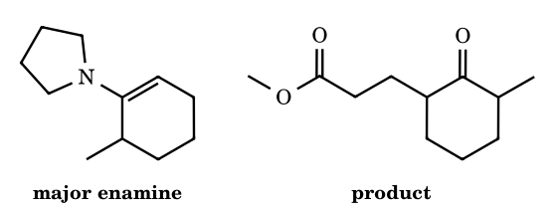
Answer: less substituted enamine; methyl 3-(3-methyl-2-oxocyclohexyl)propanoate (alkylation at C-6)
In the enamine from 2-methylcyclohexanone the more substituted C=C would force the N-pyrrolidine ring out of conjugation because of A^{1,3}(allylic 1,3) strain between the N-CH₂ and the methyl group. The nitrogen therefore conjugates better with the less substituted C=C (towards C-6), and this is the nucleophile. Michael addition at C-6 and hydrolysis of the resulting iminium/enamine gives the 2,6-disubstituted ketone. The ketone is released only in the final hydrolysis, after the acceptor has been consumed, so enamine alkylation stops at monoalkylation (unlike enolate alkylation, there is no proton-transfer equilibration to a more reactive polyalkylating enolate).
CA-71.
(JEE Advanced, multi-correct) Ambident enolates (see figure) react at carbon or at oxygen depending on conditions. Which of the following changes will increase the proportion of O-alkylation of a ketone enolate? (A) Using a primary alkyl tosylate in place of the corresponding alkyl iodide; (B) replacing THF by THF containing 10% HMPA; (C) replacing Li⁺ as counter-cation by K⁺; (D) replacing the aprotic solvent by tert-butanol.
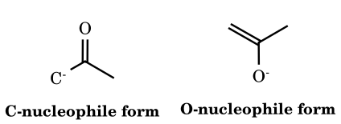
Answer: A, B and C
O-alkylation is favoured by a hard electrophile with a leaving group that is hard and ionic (OTs, OSO₂OMe, Cl rather than I) because the oxygen holds most of the negative charge (greatest charge control). Free, dissociated enolates (HMPA or DMSO solvation of the cation, large K⁺, R₄N⁺) also react more at oxygen, while tight Li–O ion pairs shield oxygen. A protic solvent such as t-BuOH hydrogen-bonds to the oxygen, blocking it and favouring C-alkylation, so D decreases O-alkylation.
CA-72.
(IChO-style) Cyclohexanone is treated with ethyl chloroacetate and t-BuOK (A, C₁₀H₁₆O₃). A is saponified with NaOH, acidified and gently heated to give B (C₇H₁₂O) with loss of CO₂. Identify A and B and explain the mechanism of the final step, explaining why B is an aldehyde and not a ketone.
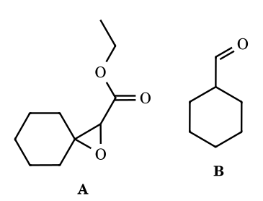
Answer: A: ethyl 1-oxaspiro[2.5]octane-2-carboxylate (glycidic ester); B: cyclohexanecarbaldehyde
Darzens condensation: the chloroacetate enolate adds to the ketone, and the alkoxide displaces Cl intramolecularly (3-exo-tet) to give the spiro-epoxy ester A. After hydrolysis the epoxy acid loses CO₂ with simultaneous opening of the strained epoxide: the electrons of the C–COOH bond form a C=C, and the C–O bond to the spiro carbon breaks, leaving oxygen on the former α-carbon as an enol(ate) of an aldehyde. Tautomerisation gives the aldehyde B (one-carbon homologation of the ketone to the aldehyde).
CA-73.
(Olympiad style) 2-Chlorocyclohexanone in which the carbon bearing Cl (C-2) is enriched with ¹³C is treated with NaOMe/MeOH to give methyl cyclopentanecarboxylate. (a) Give the key intermediate. (b) Where does the ¹³C label end up in the product, and what would a semibenzilic (non-scrambling) pathway predict instead?
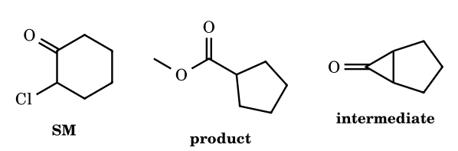
Answer: cyclopropanone; label found about 1:1 at ring C-1 (bearing CO₂Me) and ring C-2; semibenzilic would give label only at C-1
Methoxide removes the α′-H at C-6 (the only acidic position, since C-2 has Cl); the enolate displaces Cl intramolecularly to give the bicyclic cyclopropanone (C-2 and C-6 now joined). MeO⁻ adds to the C=O, and the cyclopropane C1–C2 or C1–C6 bond cleaves with equal probability (the cyclopropanone is symmetrical) to give the more stable carbanion, which is protonated. Cleavage of C1–C6 leaves the label on the carbon bearing CO₂Me, cleavage of C1–C2 leaves it on the neighbouring CH₂. A semibenzilic mechanism (migration of C-6 to C-2 with chloride loss) would keep the label on the carbon bearing the ester. The observed ≈ 1:1 distribution supports the cyclopropanone. ⚑ This is for enolisable α′-H; α-halo ketones with no α′-H react by the semibenzilic pathway.
CA-74.
(Olympiad style) Salicylaldehyde reacts with diethyl malonate in ethanol with catalytic piperidine at room temperature to give a crystalline lactone (C₁₂H₁₀O₄). Give its structure and the sequence of steps, and explain why a weak amine base is used rather than NaOEt.
Answer: ethyl 2-oxo-2H-chromene-3-carboxylate (ethyl coumarin-3-carboxylate)
Knoevenagel condensation: piperidine forms an iminium ion with the aldehyde (and/or buffers the malonate as its enolate), the malonate carbanion adds and dehydration (E1cB) gives the ortho-hydroxybenzylidene malonate. The Z-configured (ester cis to the ring OH) isomer is trapped by intramolecular transesterification of the phenol on one ester, losing EtOH, to give the coumarin (C₁₂H₁₀O₄). A mild amine avoids Cannizzaro-type and ester-scrambling chemistry and a large equilibrium concentration of phenoxide, and since salicylaldehyde has no α-H the only enolisable partner is malonate (pK_{a} ≈ 13).
CA-75.
(Olympiad style) (E)-Crotyl benzyl ether, PhCH₂OCH₂CH=CHCH₃, is treated with n-BuLi in THF at −78 °C and allowed to warm to 0 °C, then quenched. (a) Give the major product and name the rearrangement. (b) A minor constitutional isomer forms increasingly at higher temperature; identify it and its mechanism. (c) How many stereoisomers does the major product have?
Answer: [2,3]-Wittig: 2-methyl-1-phenylbut-3-en-1-ol; minor from [1,2]-Wittig; 4 stereoisomers
n-BuLi removes the benzylic α-H (adjacent to O, activated by Ph) to give a carbanion. In a concerted five-membered envelope TS, the carbanion attacks the γ-carbon (CH–CH₃) of the allyl unit while the O–CH₂ bond breaks, so the allyl group is transposed ([2,3]-sigmatropic shift) and the branched homoallylic alcohol results. The competing [1,2]-Wittig proceeds by homolysis to a radical pair that recombines at the original CH₂ to give 1-phenylpent-3-en-1-ol; this pathway becomes more competitive at higher temperature. The major product has two stereocentres (C-1 and C-2): 2² = 4 stereoisomers (2 diastereomers).
CA-76.
(Olympiad style) Two experiments are described. (a) Ph₂C(OH)SiMe₃ with a catalytic amount of KOtBu in THF gives an isomer P. (b) PhCH₂OSiMe₃ with sec-BuLi in THF at −78 °C gives, after aqueous work-up, an isomer Q. Identify P and Q, name both rearrangements, and explain why they run in opposite directions.
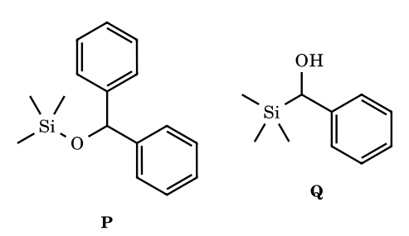
Answer: P = Ph₂CH–OSiMe₃ ([1,2]-Brook); Q = PhCH(OH)SiMe₃ ([1,2]-retro-Brook)
(a) The alkoxide attacks silicon to form a three-membered pentacoordinate silicate (Si–O bond formation is very favourable, ≈ 110 kcal/mol vs ≈ 75 for Si–C), cleaving the C–Si bond to give the diphenylmethyl carbanion, which is protonated by more substrate (chain reaction). With K⁺ the O–metal bond is weak, so the O-to-C silyl shift is downhill because the diphenyl-stabilised carbanion is accessible. (b) With Li, deprotonation of the benzylic C–H gives an α-silyloxy organolithium; the very strong Li–O bond makes the lithium alkoxide the thermodynamic sink, so the silyl group migrates C-ward (retro-Brook). Silicon configuration is retained in both. ⚑ The direction is governed by counter-cation, solvent and carbanion-stabilising groups, not by the rearrangement name alone.
CA-77.
(Olympiad style) 1-Chloro-2,2,2-triphenylethane (Ph₃CCH₂Cl) is treated with excess lithium (or sodium) in THF; the organometallic is then quenched with water. A hydrocarbon C₂₀H₁₈ is obtained that is not 1,1,1-triphenylethane. (a) Identify it. (b) Give the intermediate. (c) Would PhC(CH₃)₂CH₂Li (neophyllithium) undergo the analogous shift?
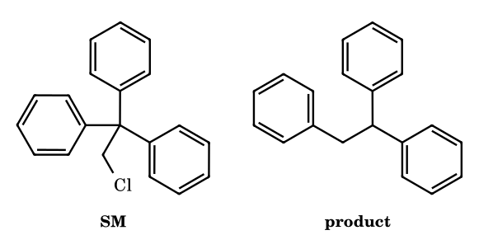
Answer: 1,1,2-triphenylethane (via Ph₂C(Li)CH₂Ph); neophyllithium does not
Halogen–metal exchange gives Ph₃C–CH₂M, a primary alkyl anion (conjugate acid pK_{a} ≈ 50). A phenyl migrates 1,2 (Grovenstein–Zimmerman rearrangement): the carbanion adds to the ipso carbon of an adjacent phenyl, forming a spiro[2.5]octadienyl anion (a cyclohexadienyl anion fused to a cyclopropane), and the three-membered ring opens at the other C–C bond to put the charge on CPh₂. The product anion Ph₂C(−)CH₂Ph is a diphenylmethyl-type carbanion (pK_{a} ≈ 32 for Ph₂CH₂), strongly stabilised; water gives Ph₂CHCH₂Ph. For neophyllithium the shift would give a tertiary alkyl anion, less stable than the primary one, so it does not rearrange (unlike the neophyl radical). ⚑ Whether the spiro species is a true intermediate or a transition state is debated.
CA-78.
(IChO-style) 2-Methylcyclohexane-1,3-dione reacts with methyl vinyl ketone (MVK) in the presence of a base (Et₃N or pyrrolidine), then the intermediate is heated. Give (i) the Michael adduct, (ii) the cyclic β-ketol, and (iii) the final enone (Wieland–Miescher ketone). State the number of new C–C bonds formed and the number of stereogenic centres in the final product.
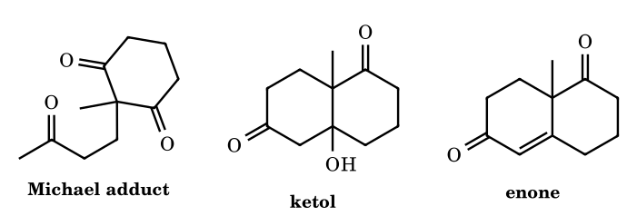
Answer: 2 new C–C bonds; 1 stereocentre (quaternary C-CH₃); product racemic with achiral base
The dione (pK_{a} ≈ 10, enolised readily) is C-2 alkylated by Michael addition to MVK to give the triketone (first C–C bond). The CH₃ of the side-chain methyl ketone then forms an enol(ate) and adds to one of the two enantiotopic ring C=O groups (intramolecular aldol, second C–C bond, six-membered ring) to give the bicyclic β-ketol. Dehydration (E1cB) of the ketol gives the conjugated enone. The only stereocentre is the quaternary ring-junction carbon bearing CH₃; an achiral base gives the racemate, while chiral amine catalysts (e.g. (S)-proline) desymmetrise the two C=O groups by enamine formation and give an enantioenriched product.
CA-79.
(IChO-style) Compound X (C₆H₁₀O₂) gives a negative Tollens test and a positive iodoform test (the other product being succinic acid). On heating with dilute aqueous NaOH, X forms Y (C₆H₈O). Identify X and Y, give the mechanism, and say why a cyclopropane- or cyclobutane-forming aldol is not observed. What would heptane-2,6-dione give under the same conditions?
Answer: X = hexane-2,5-dione; Y = 3-methylcyclopent-2-en-1-one; heptane-2,6-dione gives 3-methylcyclohex-2-en-1-one
X has two methyl ketones (iodoform positive), no CHO, and C₆H₁₀O₂ fits hexane-2,5-dione. The CH₃ enolate (C-1) attacks the C-5 carbonyl in an intramolecular aldol (5-exo-trig, five-membered ring), and E1cB dehydration gives the conjugated cyclopentenone Y (C₆H₈O). The alternative enolate at C-3 would have to attack C-5 and form a three-membered ring (and C-3 onto C-2 gives nothing), so it is strained and reversible. Heptane-2,6-dione similarly closes a six-membered ring and gives 3-methylcyclohex-2-enone. ⚑ The iodoform detail is only a diagnostic for CH₃CO– groups.
CA-80.
(Olympiad style) Allyl propanoate is treated with LDA in THF at −78 °C, then Me₃SiCl, and the mixture is warmed to room temperature and hydrolysed. (a) Give the product and the intermediate that undergoes the key step. (b) What do (E)-crotyl propanoate and a 'THF/HMPA' variant of the same procedure give, and why is the diastereoselectivity dependent on solvent?
Answer: 2-methylpent-4-enoic acid (via silyl ketene acetal, Ireland–Claisen [3,3]); crotyl gives 2,3-dimethylpent-4-enoic acid (two diastereomers selectively)
LDA forms the lithium ester enolate, which is trapped by TMSCl at oxygen as the allyl silyl ketene acetal CH₃CH=C(OTMS)OCH₂CH=CH₂. This undergoes a [3,3]-sigmatropic (Claisen) shift via a chair-like TS at room temperature: the new C–C bond forms between the enolate carbon and the terminal allyl carbon, and the C–O allyl bond breaks. Hydrolysis of the silyl ester gives the acid. With (E)-crotyl the product has two stereocentres; THF favours one enolate geometry and THF/HMPA the other, and the geometry, together with the chair TS, delivers opposite diastereomers. ⚑ The labels E/Z for the enolate flip depending on CIP priorities (OLi vs OSiMe₃), so state geometry by drawing.
CA-81.
(Olympiad style) 2-Methylcyclohexanone tosylhydrazone is treated with 2.2 equiv of n-BuLi in THF (0 °C to rt). (a) What is the reactive intermediate and which alkene is formed after aqueous quench? (b) If DMF is added before work-up, what is formed? (c) How does the regiochemistry differ from Bamford–Stevens decomposition in a protic medium?
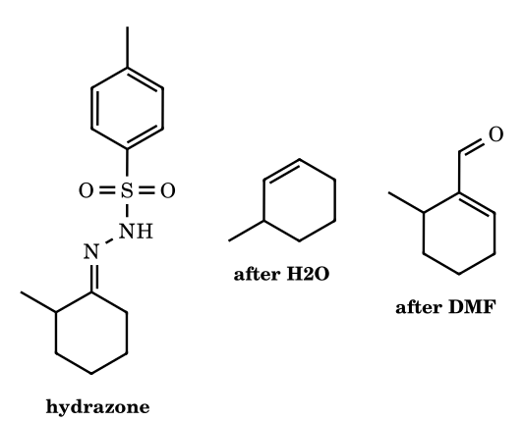
Answer: vinyllithium; 3-methylcyclohexene; 6-methylcyclohex-1-ene-1-carbaldehyde
The first equivalent of BuLi removes N–H and the second removes an α-H syn to the tosylamide anion, on the less hindered side (C-6; the NTs sits anti to the CH(CH₃) side), giving a dianion. This loses Ts⁻ to give a diazenide, which loses N₂ to give the vinyllithium at C-1, with the C=C between C-1 and C-6 (the less substituted alkene). Quenching with H₂O gives 3-methylcyclohexene; DMF acylates the vinyllithium to give the α,β-unsaturated aldehyde after hydrolysis. Bamford–Stevens decomposition in protic media proceeds through carbocations and tends to give the more substituted (Zaitsev-like) alkene, e.g. 1-methylcyclohexene as the main component.

Part 9 Free Radicals: Structure, Generation, Stability and Reactions
A free radical is a species with an unpaired electron: R₃C• has seven valence electrons on carbon (three bond pairs + one unpaired electron). It is neutral, paramagnetic (spin ½, doublet; μ = √3 BM), usually short-lived (diffusion-controlled dimerisation, k ≈ 10⁹–10¹⁰ L mol⁻¹ s⁻¹), and is formed by homolysis – each atom keeps one electron of the bond – which is drawn with a single-barbed (fish-hook) arrow, while heterolysis uses a double-barbed arrow. Free radicals are electron-deficient in the sense that the carbon is one electron short of an octet, so they behave as weak electrophiles towards electron-rich partners and as nucleophiles towards electron-poor ones; their reactivity is dominated by the strength of the bond formed, not by charge.

9.0 Homolysis and bond dissociation energy
Homolysis A–B → A• + B• needs energy equal to the bond dissociation energy D(A–B); it is promoted by heat (Δ), light (hν), or an initiator that decomposes at a low temperature. Representative values (kJ mol⁻¹ in parentheses are in kcal mol⁻¹; recalled approximate figures):
Bond | D (kcal mol⁻¹) | Bond | D (kcal mol⁻¹)
H–CH₃ | 105 | H–F | 136
H–CH₂CH₃ (primary) | 101 | H–Cl | 103
H–CH(CH₃)₂ (secondary) | 98.5 | H–Br | 87.5
H–C(CH₃)₃ (tertiary) | 96.5 | H–I | 71
H–CH₂CH=CH₂ (allylic) | 88 | F–F | 38
H–CH₂Ph (benzylic) | 89.8 | Cl–Cl | 58
H–CH=CH₂ (vinylic) | 111 | Br–Br | 46
H–C₆H₅ (phenyl) | 112 | I–I | 36
CH₃–CH₃ | 90 | CH₃–Cl / –Br / –I | 85 / 70 / 57
RO–OR (peroxide) | ≈ 35–38 | N≡C–C(CH₃)₂–N=N– (AIBN, N–C) | ≈ 31 (loses N₂)

9.1 Structure and geometry
- Alkyl radicals R₃C• are planar or very shallow pyramids (CH₃• is planar, sp² with the unpaired electron in a p orbital; t-Bu• is slightly pyramidal). The inversion barrier is tiny, so a radical centre is racemised – radical halogenation at a chiral carbon gives the racemate. The geometry lies between the planar carbocation and the pyramidal carbanion.
- Vinyl radicals are bent (σ radical, sp² orbital in the plane, inverts rapidly); aryl radicals are σ radicals with the unpaired electron in the plane of the ring (orthogonal to the π cloud, no resonance); CF₃• is pyramidal (≈ 110°) because the electronegative fluorines increase the s-character of the carbon orbitals that bind them, leaving more p-character in the half-filled orbital.
- π radicals (allyl, benzyl, trityl) are planar with the unpaired electron delocalised over several atoms. The spin density is shown by ESR hyperfine couplings (benzyl: ortho/para positions).
- Stable radicals exist when the unpaired electron is delocalised and the centre is hindered: Ph₃C• (Gomberg 1900, in equilibrium with its quinoid dimer), 2,4,6-tri-tert-butylphenoxyl, DPPH, galvinoxyl, TEMPO (a nitroxide), Fremy’s salt. NO, NO₂ and O₂ (triplet, a biradical) are also paramagnetic.

9.2 Stability of free radicals
Stability is measured by the bond dissociation energy of the C–H bond that yields the radical (smaller D = more stable radical). Three effects, in order of importance: (i) resonance delocalisation (allyl, benzyl, trityl, α-carbonyl, α-N, α-O); (ii) hyperconjugation of the adjacent C–H/C–C σ bonds into the singly occupied orbital (3° > 2° > 1° > CH₃•); (iii) hybridisation (sp² σ radicals such as vinyl and phenyl are unstabilised).
Order | Statement
Alkyl radicals | 3° > 2° > 1° > CH₃• (more α-C–H/C–C bonds donate electron density into the half-filled orbital; D(C–H) 96.5 < 98.5 < 101 < 105)
Delocalised radicals | Ph₃C• > Ph₂CH• > PhCH₂• ≳ CH₂=CH–CH₂• > 3° alkyl > 2° > 1° > CH₃• > CH₂=CH• ≈ C₆H₅• (σ radicals least stable)
α-Heteroatom (captodative) | a radical flanked by a donor and an acceptor (e.g. •C(OR)(CN)) is specially stabilised; α-O and α-N lone pairs also stabilise (three-electron two-orbital interaction)
Substituted benzyl radicals | stabilised by both donors and acceptors (spin delocalisation, no charge separation) – so radical stability does not follow σ⁺ the way cation stability does; the rate of side-chain chlorination, ArCH₃ → ArCH₂Cl, is only weakly affected by Ar (but p-NO₂ slows it slightly because the radical-abstracting chlorine atom is electrophilic: your note’s ‘Ar = phenyl faster than p-nitrophenyl’)
Do not transfer carbocation reasoning blindly. (1) Radicals do not rearrange by 1,2-H or 1,2-alkyl shifts (the three-centre TS would need 3 electrons and has a high barrier); the neopentyl radical stays neopentyl. They do undergo 1,2-aryl (neophyl), 1,2-vinyl, 1,2-acyl, 1,2-Cl/Br shifts and β-scission. (2) Radical stability is a bond-energy property, not a charge property: both +M and −M substituents stabilise it. (3) The allylic radical is stabilised by resonance and allylic substitution gives a mixture of regioisomers (resonance) – see 9.5.

9.3 Generation of free radicals
Method | Example | Notes
Thermolysis (Δ) | ROOR → 2 RO•; R–N=N–R → 2 R• + N₂; PhCOO–OOCPh → 2 PhCOO• → 2 Ph• + 2 CO₂ | weak O–O (35–38 kcal mol⁻¹) and C–N bonds; AIBN at 60–80 °C
Photolysis (hν) | Cl₂ → 2 Cl•; Br₂ → 2 Br•; R–I → R• + I•; ketones (Norrish) | light of the correct energy; used in radical halogenation
Redox (single electron transfer) | Fe²⁺ + H₂O₂ → Fe³⁺ + HO⁻ + HO• (Fenton); Cu⁺ + ArN₂⁺ → Cu²⁺ + Ar• + N₂ (Sandmeyer); Na + ketone → ketyl radical anion | metal ions and electrodes
Electrolysis (Kolbe) | 2 RCOO⁻ → 2 RCOO• + 2e⁻ → 2 R• + 2 CO₂ → R–R | anodic oxidation of carboxylate; products from mixtures are statistical
Atom abstraction by a radical | X• + R–H → H–X + R• | the chain-carrying step of halogenation
Addition of a radical to a π bond | X• + C=C → X–C–C• | polymerisation, anti-Markovnikov addition
Fragmentation | RCOO• → R• + CO₂; R–CH₂–CH₂• → R• + CH₂=CH₂ (β-scission) | decarboxylation and ring opening

9.4 Reactions of free radicals
Reaction | Scheme | Example / use
Atom (H) abstraction | R• + H–X → R–H + X• | propagation in halogenation; selectivity 3° > 2° > 1°
Addition to C=C | R• + CH₂=CHY → R–CH₂–C•HY | chain polymerisation; adds to the less hindered carbon to give the more stable radical
Halogen abstraction | R• + X–X → R–X + X• | second propagation step
Combination (termination) | R• + R• → R–R | diffusion controlled; ethane from 2 CH₃•
Disproportionation | 2 CH₃CH₂• → CH₃CH₃ + CH₂=CH₂ | H transfers from one radical to another
β-Scission / fragmentation | R–CH₂–C•H₂ → R• + CH₂=CH₂; RCOO• → R• + CO₂ | ring-opening of cyclopropylcarbinyl radical (k ≈ 10⁸ s⁻¹, a ‘radical clock’)
Rearrangement | 1,2-aryl (neophyl), 1,2-vinyl, 1,2-acyl; no 1,2-H or alkyl shift | PhC(CH₃)₂CH₂• → PhCH₂C•(CH₃)₂
Oxidation / reduction (electron transfer) | R• + Cu²⁺ → R⁺ + Cu⁺; R• + e⁻ → R⁻ | Sandmeyer, S_{RN}1

9.5 Radical halogenation of alkanes: thermochemistry and selectivity
Mechanism (chain). Initiation X₂ → 2 X•. Propagation X• + R–H → HX + R• (1); R• + X₂ → R–X + X• (2). Termination any two radicals combine. A single photon can cause thousands of cycles (quantum yield > 1) – the proof of a chain mechanism. Inhibitors (O₂, hydroquinone, I₂, BHT) trap the chain-carrying radicals by forming less reactive radicals; a short induction period is observed.
Halogen | Step (1): X• + CH₄ ΔH | Step (2): CH₃• + X₂ ΔH | Overall | Reactivity / selectivity
F₂ | −31 (105 − 136) | ≈ −72 | ≈ −103 | explosive; non-selective (early TS)
Cl₂ | +2 (105 − 103) | −27 | −25 | fast; poorly selective (1° : 2° : 3° ≈ 1 : 3.8 : 5)
Br₂ | +17.5 (105 − 87.5) | −24 | −6.5 | slow; highly selective (≈ 1 : 82 : 1600)
I₂ | +34 (105 − 71) | −21 | +13 | step (1) too endothermic: no iodination (HI even reduces R–I)
Hammond postulate: chlorine’s step (1) is nearly thermoneutral, so its transition state is early and resembles the reactants (little radical character developed, so little discrimination between C–H types); bromine’s step (1) is endothermic by 17 kcal mol⁻¹, so its TS is late, resembles the alkyl radical, and is sensitive to radical stability. Probability × reactivity gives the product ratio: product % ∝ (number of H of that type) × (relative reactivity). Propane with Cl₂: 6 × 1 : 2 × 3.8 = 6 : 7.6 → 44 % 1-chloro, 56 % 2-chloro; with Br₂: 6 : 164 → 3.5 % : 96.5 %. Isobutane with Cl₂: 9 × 1 : 1 × 5 = 9 : 5 → 64 % isobutyl chloride, 36 % t-butyl chloride (Nucleus Q51: the primary chloride predominates because there are nine primary H). Isotope effect: C–D bonds (zero-point energy lower, D(C–D) ≈ 1.2 kcal mol⁻¹ higher than D(C–H)) are abstracted more slowly, so CD₃CD₃ chlorinates more slowly than CH₃CH₃ (primary kinetic isotope effect k_{H}/k_{D} ≈ 1.3 for Cl•, ≈ 4.6 for Br•), and a tertiary C–H of neopentane-type alkanes ranks by the number of H.

9.6 Counting problems in radical halogenation
Substrate | Structural monochlorides (type of H) | Including stereoisomers
CH₃CH₃, neopentane, cyclopentane, benzene (side-chain none) | 1 | 1
propane | 2 (1°, 2°) | 2
n-butane | 2 | 3 (2-chlorobutane is chiral)
isobutane | 2 | 2
2-methylbutane (isopentane) | 4 | 6 (1-chloro-2-methyl- and 2-chloro-3-methylbutane are chiral)
2,3-dimethylbutane | 2 | 3
n-pentane | 3 | 5
methylcyclopentane | 4 (CH₃, C1, C2, C3) | 10 (2- and 3-chloro each as cis/trans, each chiral)
2-methylpentane (isohexane) | 5 | 8 (see Nucleus II-B Q8)

9.7 Allylic and benzylic halogenation; the HBr peroxide effect; polymerisation
- NBS (N-bromosuccinimide), CCl₄, peroxide/hν: allylic and benzylic bromination. NBS supplies a very low, steady concentration of Br₂ (NBS + HBr → succinimide + Br₂), so Br• abstracts the weak allylic C–H (88 kcal mol⁻¹) and Br₂ reacts with the allylic radical faster than it can add across C=C by the ionic pathway. An unsymmetrical allylic radical gives two regioisomers (both radical termini carry spin): 1-butene → 3-bromo-1-butene + 1-bromo-2-butene. Count the distinct allylic hydrogens first (Nucleus II-A Q4: 1-methylcyclopentene has 7 allylic H and gives 9 allylic bromides when stereoisomers are included).
- Anti-Markovnikov addition of HBr (peroxide effect, Kharasch): RO• + HBr → ROH + Br•; Br• adds to the terminal carbon of the alkene to give the more stable (secondary) radical; the radical abstracts H from HBr to give the 1-bromoalkane and a new Br•. HCl does not show the effect because step (2) (R• + HCl) is endothermic by ≈ +12.6 kJ mol⁻¹; HI does not because step (1) (I• adds to C=C) is endothermic (+46 kJ mol⁻¹) and I• tends to combine (data of Nucleus II-B Q7).
- Radical polymerisation (initiation, propagation, termination): R• + CH₂=CHY → RCH₂C•HY → …; used for polyethylene (LDPE, 1000–2000 atm, O₂/peroxide), polystyrene, PVC, polyacrylonitrile, teflon. Head-to-tail addition is dominant because it forms the more stable radical.
- Wurtz and Kolbe: Wurtz coupling 2 R–X + 2 Na → R–R + 2 NaX has both carbanion (R–Na) and radical features; Kolbe electrolysis of 2 RCOONa gives R–R, 2 CO₂, H₂ (cathode) and NaOH (the pH increases, Nucleus Q50). A mixture of two different carboxylates gives three alkanes (R–R, R′–R′, R–R′), statistically 1 : 1 : 2.

9.8 Mechanisms (fish-hook arrows; each step electron-count validated)
9.1 Initiation: homolysis of chlorine
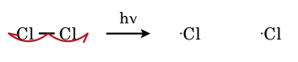
Each chlorine receives one electron of the Cl–Cl bond; one fish-hook for each electron. Light of wavelength ≈ 350 nm supplies the 58 kcal mol⁻¹.
9.2 Chain propagation: chlorination of methane
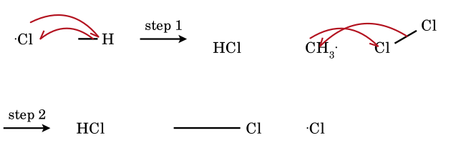
Step 1: the chlorine radical pairs its electron with one electron of the C–H bond to form H–Cl; the other electron of the C–H bond stays on carbon (CH₃•). Step 2: CH₃• pairs with one electron of Cl–Cl to form C–Cl; the other electron remains on the second Cl, which is the chain carrier again. The two steps repeat 10³–10⁶ times per photon.
9.3 Termination by combination; disproportionation
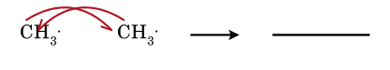
Two radicals pair their electrons. Termination steps are rare in the propagating chain because radical concentrations are about 10⁻⁸ M; they end the chain when they occur.
9.4 Disproportionation of two ethyl radicals
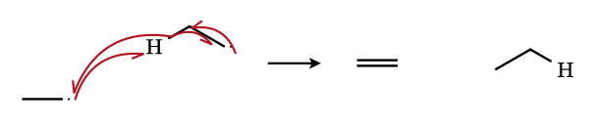
One radical abstracts a β-hydrogen from the other: the abstracted H forms the new C–H bond of ethane and the remaining C–H electron pairs with the radical electron to give the C=C of ethene. Disproportionation/combination ratio for ethyl radicals ≈ 0.13.
9.5 Peroxide effect, step 1: Br• adds to the terminal carbon of propene
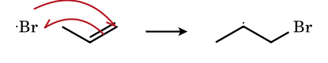
Bromine adds to the CH₂ terminus: the new radical is secondary (CH₃–C•H–CH₂Br), more stable than the primary radical that would form by attack at C-3. The regiochemistry is set by the stability of the radical, and is the reverse of Markovnikov addition of H⁺.
9.6 Peroxide effect, step 2: chain transfer
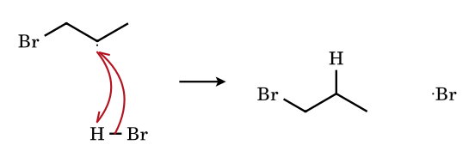
The secondary radical takes the H atom of HBr (the weak H–Br bond, 87.5 kcal mol⁻¹, makes this step exothermic by 50 kJ mol⁻¹), giving 1-bromopropane and regenerating Br•.
9.7 Allylic bromination of cyclohexene with NBS: H abstraction, allylic resonance, Br₂ transfer
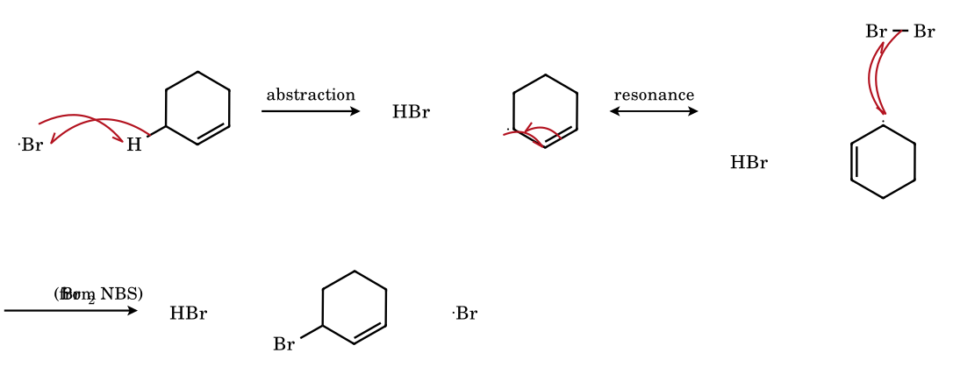
Br• removes the allylic H (88 kcal mol⁻¹); the allyl radical is delocalised over C-2 and C-5 (the two forms are equivalent for cyclohexene, so one product, 3-bromocyclohexene). With an unsymmetrical alkene the two resonance forms give two bromides. The low [Br₂] supplied by NBS prevents the competing ionic addition to the double bond.
9.8 Kolbe electrolysis: decarboxylation of the acyloxy radical
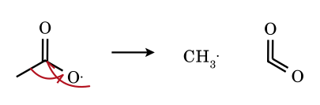
Anodic oxidation removes one electron from acetate (CH₃COO⁻ → CH₃COO•). The acyloxy radical loses CO₂ in a β-scission: the O-radical electron and one electron of the C–C σ bond make the second C=O π bond, and the other σ electron stays on CH₃•. Two CH₃• then combine (9.3) to give ethane.
9.9 Radical polymerisation of styrene: initiation and first propagation step
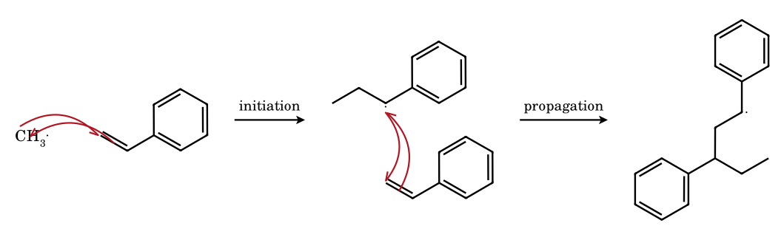
The initiator radical adds to the CH₂ end of the vinyl monomer so that the new radical is benzylic (resonance-stabilised); the same regiochemistry is repeated in each propagation step (head-to-tail polymer). Chain transfer and termination by combination/disproportionation end the chain.
9.10 Radical clock: cyclopropylcarbinyl → but-3-enyl (β-scission, k ≈ 10⁸ s⁻¹)
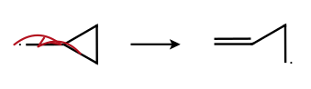
The unpaired electron and one electron of the strained ring C–C bond form a C=C π bond; the other electron of the broken bond becomes the new radical. Strain relief (27 kcal mol⁻¹) drives the opening. The reaction is used as a ‘clock’: if a radical trapped by an H-donor gives the ring-opened product, its lifetime was longer than 10⁻⁸ s.
9.11 Neophyl rearrangement: 1,2-aryl shift via a spiro cyclohexadienyl radical
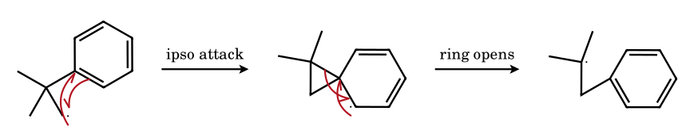
The radical centre attacks the ipso carbon of the neighbouring phenyl group, forming a three-membered spiro intermediate (cyclohexadienyl radical delocalised over the ring); the ring bond C–C(CH₃)₂ then breaks to relieve strain and re-aromatise, leaving the more stable tertiary radical. This is the only common 1,2-shift for radicals; a hydrogen or methyl does not migrate (the TS would have no π participation).

9.9 Radical substitution of aromatics and related reactions
- Sandmeyer (ArN₂⁺ + CuX → ArX + N₂) and Gattermann (Cu powder) proceed by single-electron transfer from Cu(I) to the diazonium ion to give Ar• (σ radical) which abstracts X from Cu(II)X₂.
- Gomberg–Bachmann: ArN₂⁺ + Ar′H/NaOH → Ar–Ar′ (aryl radical adds to the arene to give a cyclohexadienyl radical, then loses H•).
- Hunsdiecker: RCOOAg + Br₂ → R–Br + CO₂ + AgBr (acyloxy radical; one carbon less).
- S_{RN}1: ArX + e⁻ → ArX^{•−} → Ar• + X⁻; Ar• + Nu⁻ → ArNu^{•−} → (electron transfer to ArX) ArNu: a radical chain that explains aryl substitution without an electron-withdrawing group.
- Hofmann–Löffler–Freytag: an N-centred radical abstracts the δ-H through a six-membered TS (1,5-HAT) and gives a pyrrolidine after cyclisation.

9.11 Electronic structure of carbon radicals: SOMO, spin density, EPR
- Orbital picture. In a planar sp² alkyl radical the unpaired electron occupies a p orbital (the SOMO, singly occupied molecular orbital). The SOMO is higher than the filled bonding MOs and lower than the empty antibonding ones, so a radical can interact both with a donor LUMO-type partner and with an acceptor HOMO-type partner. A carbon radical with only three σ bonds is isoelectronic with the planar BH₃ framework plus one electron, and with the amine N–H inversion potential flattened (radical inversion barrier < 1 kcal mol⁻¹ for CH₃•; ≈ 0.6 kcal mol⁻¹ for t-Bu• to pyramidalise).
- Pyramidalisation increases with electronegative and small substituents. CH₃• and alkyl radicals: planar or nearly so; •CF₃: pyramidal (≈ 17° out-of-plane, inversion barrier ≈ 3 kcal mol⁻¹); •CH₂F, •CHF₂ progressively pyramidal; cyclopropyl radical: pyramidal (the ring angle strain favours more p-character in the ring bonds and more s-character in the SOMO; barrier ≈ 3 kcal mol⁻¹); •CH₂OH, •CH₂NH₂: nearly planar with the lone pair donating into the SOMO (three-electron two-orbital interaction; the radical is stabilised by ≈ 5–7 kcal mol⁻¹).
- σ-radicals (vinyl, aryl, acyl, alkynyl) have the odd electron in an sp^{x} orbital in the nodal plane of the π system; they are not stabilised by conjugation, so C–H BDEs are large (vinyl 111, phenyl 112, ethynyl 133 kcal mol⁻¹) and the radicals are very reactive. The acyl radical R–C•=O is a σ radical, bent at carbon; it loses CO (decarbonylation) when R• is stable (e.g. R = t-Bu, benzyl).
- EPR (ESR) spectroscopy detects unpaired electrons. The hyperfine splitting a_{H} from n equivalent protons gives n + 1 lines of binomial intensity, and the magnitude is proportional to the spin density on the carbon bearing H (McConnell equation, a_{H} = Q·ρ, Q ≈ −23 G). Data (approximate): CH₃•: 1:3:3:1 quartet, a_{H} ≈ 23 G; ethyl: α-H (2) ≈ 22 G and β-H (3) ≈ 27 G, giving a triplet of quartets (12 lines); benzyl: ortho (2) ≈ 5 G, meta (2) ≈ 1.8 G, para (1) ≈ 6 G, α (2) ≈ 16 G, showing the spin density is delocalised to ortho/para positions; allyl radical: terminal H 13–14 G, central H 4 G, with 3 sets of lines (2 + 2 + 1 H). The large β-H coupling is hyperconjugation (the C–H bond overlapping the SOMO) and depends on the dihedral angle as cos²θ (Heller–McConnell), which allows conformational analysis of radicals.
- Spin trapping. Very reactive radicals are detected by adding them to a nitrone or nitroso compound (PBN, DMPO), giving a persistent nitroxide whose EPR spectrum identifies the trapped radical.
- CIDNP (chemically induced dynamic nuclear polarisation): NMR signals appear in enhanced absorption or emission during a radical-pair reaction, which is proof of a radical-pair mechanism (e.g. decomposition of benzoyl peroxide, Stevens and Wittig rearrangements).

9.12 Stability of radicals: bond dissociation energies and radical stabilisation energy
Radical stability is measured thermodynamically by the C–H bond dissociation energy of its parent, or by the radical stabilisation energy RSE = D(CH₃–H) − D(R–H). The values below are recalled from standard tables (kcal mol⁻¹); they are accurate to a few units and are used for ranking.
Radical | D(R–H) | RSE | Origin of the stabilisation
•CH₃ | 105 | 0 | reference
CH₃CH₂• (1°) | 101 | 4 | hyperconjugation with 3 β C–H
(CH₃)₂CH• (2°) | 98.5 | 6.5 | 6 β C–H
(CH₃)₃C• (3°) | 96.5 | 8.5 | 9 β C–H, and release of strain on moving from sp³ to sp²
CH₂=CH–CH₂• | 88 | 17 | allylic resonance (two equivalent forms), loses ≈ 13 kcal mol⁻¹ from the π-delocalisation net of rotation barrier
C₆H₅CH₂• | 89.8 | 15 | resonance with benzene ring (four forms), partial loss of aromatic π energy
(C₆H₅)₂CH• | ≈ 84 | 21 | two aryl groups (nonplanar)
(C₆H₅)₃C• | ≈ 81 | 24 | three aryl groups, sterically twisted propeller; persists in solution, dimerises through the para position of one ring (Gomberg dimer)
•CH₂OH, •CH₂OCH₃ | ≈ 96 | 9–10 | n(O) → SOMO donation (3-electron 2-orbital)
•CH₂COCH₃, •CH₂CN, •CH₂COOR | ≈ 92–94 | 11–13 | SOMO conjugation with π* (C=O, C≡N)
C₆H₅• (σ) | 112 | −7 | none; destabilised by high s-character
CH₂=CH• (σ) | 111 | −6 | none
HC≡C• | 133 | −28 | 50 % s-character
CH₃C(=O)• (acyl) | ≈ 89 | ≈ 16 | partly carbonyl-conjugated σ/π hybrid
- The radical is not a charge, so both donors and acceptors stabilise it. The captodative effect: a carbon carrying simultaneously an electron donor (OR, NR₂) and an acceptor (CN, COR) is more stable than the sum of the individual effects (e.g. •C(CN)(OR)H), as both SOMO interactions apply (donor lone pair → SOMO, SOMO → acceptor π*).
- Why RSE for benzyl is lower than for allyl despite more resonance forms: delocalisation into the ring costs some aromatic stabilisation energy; the experimental difference between the BDEs is small (≈ 2 kcal mol⁻¹) and a JEE question that asks for the order normally expects benzyl > allyl by the number of resonance structures (benzyl: 5 including the radical form; allyl: 2). ⚑ The data order is allyl ≈ benzyl; tell which the exam uses.
- Radical versus cation versus anion. Alkyl substituents stabilise radicals (weakly) and cations (strongly) and destabilise anions. Resonance with π systems stabilises all three. The order of stability of alkyl radicals (3° > 2° > 1° > CH₃) is the same as for carbocations, but the spread is a quarter as large: ΔD = 8.5 versus ΔHCIA ≈ 40 kcal mol⁻¹ for cations.
- Steric effects. Bulky groups (t-butyl) raise radical stability by kinetic persistence (no combination): the 2,4,6-tri-t-butylphenoxyl radical, TEMPO (a nitroxide), DPPH, galvinoxyl and the triarylmethyls are persistent or even indefinitely stable. A stable radical can be bottled; a persistent radical lives long because its decay by self-reaction is slow; a transient radical decays at the diffusion limit.

Stable and persistent radicals
Radical | Structure and why it persists | Use
Triphenylmethyl (trityl) | Ph₃C•; steric hindrance to dimerisation at the central carbon; the dimer (Gomberg 1900) is a quinoid compound formed by attack at the para-carbon of one ring (≈ 2 % radical at 0.1 M, 25 °C, in benzene) | first radical ever observed; yellow, reversible with O₂ (gives peroxide)
Nitroxides: TEMPO | 2,2,6,6-tetramethylpiperidin-1-oxyl: N–O• with three-electron N∴O bond and no α-hydrogens (no disproportionation) | oxidation catalyst (alcohol → carbonyl), spin label, radical trap in living polymerisation (NMP)
DPPH | 2,2-diphenyl-1-picrylhydrazyl: spin delocalised over the hydrazyl N–N and the picryl ring | radical scavenger assay; EPR standard (g = 2.0036)
Galvinoxyl; Fremy’s salt | O-centred radicals delocalised through quinone methide; (KSO₃)₂NO• | inhibitor, oxidant (Teuber reaction)
2,4,6-tri-t-butylphenoxyl | ArO•; the t-butyl groups block ortho/para coupling; green, stable for days | model of antioxidant radical
Molecular oxygen | triplet O₂ (ground state is a diradical •O–O•) | traps carbon radicals at diffusion rate; inhibits radical chains and starts autoxidation
NO, NO₂ | odd-electron molecules; NO is a persistent radical trap | atmospheric chemistry, nitrosation

9.13 Reactivity and selectivity: the Hammond postulate for hydrogen abstraction
For X• + R–H → X–H + R•, the transition state is early (reactant-like) when the step is strongly exothermic and late (product-like) when it is endothermic (Hammond). A late TS has substantial radical character on carbon, so the stability of R• is felt strongly in the activation energy; an early TS barely feels it. Hence the more reactive reagent is the less selective.
Halogen radical | ΔH (kcal mol⁻¹) for CH₄ | E_{a} for CH₄ | TS | Relative rate per H: 1° : 2° : 3° | Selectivity
F• | −32 | ≈ 1 | very early | 1 : 1.2 : 1.4 (25 °C) | almost none
Cl• | +1 | 3.8 | early | 1 : 3.8 : 5.0 (25 °C) | low
Br• | +17 | 18 | late | 1 : 82 : 1640 (127 °C) | very high
I• | +34 | ≈ 34 | very late | H abstraction does not occur | —
- Product distribution = (number of H of that type) × (relative reactivity) / Σ. Propane + Cl₂/hν: 6 × 1 = 6 (1-chloro) versus 2 × 3.8 = 7.6 (2-chloro) → 44 : 56. Isobutane + Cl₂: 9 × 1 = 9 versus 1 × 5.0 = 5 → 64 : 36 (primary chloride is the major product). Isobutane + Br₂: 9 × 1 versus 1 × 1640 → > 99 % tert-butyl bromide. Butane + Br₂: 6 × 1 versus 4 × 82 → 98 % 2-bromobutane.
- Bromine is selective because the first step is endothermic: the TS resembles R•, so the energy difference between 1°, 2° and 3° radicals (≈ 2–3 kcal mol⁻¹) appears almost fully in ΔE_{a}.
- Chlorine is less selective for two reasons: an early TS (low E_{a}) and a high collision-controlled rate. In solvents that complex Cl• (benzene, CS₂, alkenes) the Cl•–π complex is more selective (3° : 1° rises from 5 to 50 in 8 M benzene).
- Polar effects. The TS has charge-transfer character: Cl• (electrophilic) prefers electron-rich C–H and avoids H on carbons bearing EWG: chlorination of CH₃CH₂COCl gives mainly the β-chloride (CH₃CHClCOCl is minor), and chlorination of 1-chloropropane gives 1,2-, 1,3- and 1,1-dichloro products in a ratio 50 : 30 : 10 : 10 (approx.), not statistical. Bromine radical is even more discriminating and reacts with toluene at the benzylic position at least 10⁵ times faster than with methane.
- Isotope effects. k_{H}/k_{D} for H abstraction: Cl• ≈ 1.3–1.5 (small, early TS, little C–H stretching), Br• ≈ 4.6 (large, late TS), but the free energy of the abstracted C–H dominates. A competition experiment between C₆H₅CH₃ and C₆H₅CD₃ brominated with NBS gives k_{H}/k_{D} = 4.9, proving C–H cleavage is rate-determining and Br• (not Br₂ ionic path) is the chain carrier.
- Why fluorination and iodination are not used: F₂ reacts violently (the C–H abstraction is −32 kcal mol⁻¹, and homolysis of F₂ needs only 38), leading to C–C cleavage; with I₂ the second step is fine but the first (I• + R–H → HI + R•) is +34 kcal mol⁻¹ uphill, and HI reduces the alkyl iodide back to RH (RI + HI ⇌ RH + I₂), so iodoalkanes are made by halide exchange (Finkelstein) rather than radical iodination.

9.14 Radical addition to C=C; regiochemistry, polarity and Baldwin–Beckwith rules
- Regiochemistry. A radical X• adds to the less hindered carbon of a C=C so that the new radical is the more stable one (benzylic, allylic, tertiary, α to C=O). Addition to styrene occurs at CH₂; addition to methyl acrylate at CH₂ (giving the α-ester radical); to 1,3-butadiene at C-1 (giving the allylic radical).
- Polar effects in radical addition. Nucleophilic radicals (alkyl, α-hydroxyalkyl, α-aminoalkyl) add faster to electron-poor alkenes (acrylonitrile, acrylates), electrophilic radicals (•CF₃, •CCl₃, Br•, RS•, malonyl radicals) add faster to electron-rich alkenes (vinyl ethers, enamines). This ‘polar effect’ explains copolymerisation behaviour: styrene (donor) and maleic anhydride (acceptor) copolymerise in strict alternation.
- Thiyl, bromine, and CCl₃ addition: Br• and RS• add reversibly; the equilibrium allows cis→trans isomerisation of alkenes by catalytic Br• or RS• (add–rotate–eliminate), the basis of the trans-fat formation and the Z/E isomerisation of oleic to elaidic acid. CBrCl₃ and CCl₄ add across alkenes by chain: Cl₃C• + CH₂=CHR → Cl₃C–CH₂–C•HR, which abstracts Br (from CBrCl₃) to give Cl₃C–CH₂–CHBr–R (Kharasch addition).
- Anti-Markovnikov addition of HBr (peroxide effect). Only HBr adds by the radical chain: HCl is too strong an H-donor bond (103 kcal mol⁻¹; the step R• + H–Cl is endothermic by ≈ 4–7); HI adds to the alkene, but I• then adds reversibly and is too unreactive (I• + alkene is endothermic, ΔH ≈ +4): the chain does not propagate. HBr is the only hydrogen halide for which both propagation steps are exothermic or thermoneutral (Br• + alkene ≈ −5, R• + HBr ≈ −8 to −10 kcal mol⁻¹).
- Cyclisation of ω-alkenyl radicals (Baldwin–Beckwith). The 5-hexenyl radical cyclises 5-exo (k ≈ 2 × 10⁵ s⁻¹ at 25 °C) in preference to 6-endo (k ≈ 4 × 10³ s⁻¹), 50 : 1, though the six-membered radical is the more stable; this is stereoelectronic: the chair-like TS of the 5-exo path places the SOMO in better overlap with π* (Beckwith–Houk model). Methyl substituents at C-5 reverse the selectivity (6-endo) by hindering the exo attack. 4-pentenyl (4-exo) and 3-butenyl cyclisations are unfavourable; 6-heptenyl gives 6-exo, 7-endo slowly. Cyclisation onto C≡C and C=O is also known (Bu₃SnH-mediated radical cyclisations used in natural-product synthesis).
- Intermolecular versus intramolecular competition is controlled by concentration of the H-donor: slow addition of Bu₃SnH (syringe pump, 0.02 M) favours cyclisation; high [Bu₃SnH] gives reduction without ring closure. This is the basis of using a ‘radical clock’ cyclisation to time a reaction.

9.15 Radical chain reactions: initiation, propagation, termination, inhibition
Stage | Description | Examples
Initiation | formation of the first radicals, usually by homolysis of a weak bond | Cl–Cl (hν, 58); RO–OR (≈ 35); PhCO–O–O–COPh (≈ 30); AIBN (N–C, 31, loses N₂); Br–Br; N–Br of NBS (via HBr + NBS → Br₂); photolysis of ketones (Norrish I, II); Fenton: Fe²⁺ + H₂O₂ → Fe³⁺ + HO⁻ + HO•
Propagation | each step consumes one radical and produces another; the number of radical produced is conserved | X• + R–H → HX + R•; R• + X₂ → RX + X•. The kinetic chain length (steps per initiation) is 10³–10⁶; quantum yield Φ = molecules of product per photon is then ≫ 1
Termination | two radicals combine or disproportionate | R• + R• → R–R; 2 CH₃CH₂• → CH₃CH₃ + CH₂=CH₂ (disproportionation); radical + wall; radical + inhibitor
Inhibition / retardation | a species that reacts with chain carriers to give unreactive radicals; induction period | O₂, I₂, quinones, phenols (BHT, α-tocopherol), nitroxides, DPPH, NO
- Test for a chain. (i) quantum yield Φ ≫ 1; (ii) rate is first order in [initiator]^{1/2} (because termination is second order in radicals: R_{i} = 2k_{t}[R•]²); (iii) strongly inhibited by traces of O₂, hydroquinone or galvinoxyl; (iv) accelerated by hν or initiator; (v) insensitive to polar solvents (a radical rather than ionic mechanism).
- Why only a small amount of peroxide is needed: each initiating radical produces a long chain. Peroxide is used catalytically (0.1–1 mol %).
- Why radical addition to alkenes is not driven by hν alone for HBr: thermochemistry of the two propagation steps decides whether a chain is possible (HF, HCl, HI fail).
- Autoxidation (aerial oxidation) is a radical chain: R• + O₂ → ROO• (k ≈ 10⁹ M⁻¹s⁻¹); ROO• + R–H → ROOH + R• (the rate-determining step, selective for weak C–H bonds: benzylic, allylic, tertiary, α to O). Examples: cumene → cumene hydroperoxide (industrial phenol/acetone synthesis, the Hock process), peroxide formation in ethers and THF (isopropyl ether is dangerous), drying of linseed oil, rancidity of fats (allylic C–H of polyunsaturated acids), ageing of rubber. Antioxidants (BHT, vitamin E) donate H• to ROO•, converting it to an unreactive ArO•.

9.16 Radical polymerisation
Vinyl monomers CH₂=CHX polymerise by a radical chain: initiation (In• + CH₂=CHX → In–CH₂–C•HX), propagation (head-to-tail addition to the less substituted carbon, so the growing radical is always α to X) and termination (combination or disproportionation, or chain transfer to monomer, solvent or polymer). Termination by combination gives chains twice the kinetic chain length.
Polymer | Monomer | Notes
Polyethylene (LDPE) | CH₂=CH₂ | high pressure (1000–3000 atm), 200 °C, trace O₂ or peroxide; branching through 1,5-backbiting (intramolecular H transfer via a six-membered TS) gives short-chain branches (butyl)
Polystyrene | PhCH=CH₂ | AIBN or BPO, 60–80 °C; atactic
PVC | CH₂=CHCl | chain transfer to monomer dominates
PAN (Orlon, Acrilan) | CH₂=CHCN
PMMA (Perspex, Lucite) | CH₂=C(CH₃)COOCH₃ | termination mostly by disproportionation; Trommsdorff (gel) effect
Teflon (PTFE) | CF₂=CF₂ | persulfate initiator, aqueous
Neoprene | CH₂=CCl–CH=CH₂ (chloroprene) | 1,4-addition through allylic radical
Buna-S (SBR) | butadiene + styrene (3 : 1) | copolymer, emulsion
Buna-N | butadiene + acrylonitrile | oil-resistant rubber
Polyvinyl acetate | CH₂=CHOCOCH₃ | hydrolysed to PVA
- Why polymerisation is thermodynamically allowed: a C=C π bond (≈ 63 kcal mol⁻¹) is replaced by a σ bond (≈ 88), ΔH ≈ −20 to −25 kcal mol⁻¹ per addition; ΔS is negative, so there is a ceiling temperature (T_{c} = ΔH/ΔS), above which depolymerisation wins (α-methylstyrene: T_{c} = 61 °C).
- Head-to-tail regiochemistry is due to the preference for attack at the unsubstituted CH₂ (steric access and radical stability).
- Inhibitors and retarders (hydroquinone, BHT) are added to stabilise monomers during storage; O₂ is the most common inhibitor in practice.
- Controlled radical polymerisation: ATRP (R–X + Cu(I) ⇌ R• + Cu(II)X), RAFT, NMP (TEMPO-capped chain ends) keep the radical concentration very low with a dynamic equilibrium between active radicals and dormant species, giving narrow molecular-weight distributions.

9.17 Fragmentation and rearrangement of radicals
Process | Equation | Comment
β-Scission (C–C) | R–CH₂–C•H₂ ⇌ R• + CH₂=CH₂ | reverse of radical addition; important in thermal cracking (~500 °C) and in the combustion and pyrolysis of hydrocarbons; the thermodynamically favoured direction depends on ΔH (about +21 for ethyl → ethene + H•)
Decarboxylation of acyloxy | RCOO• → R• + CO₂ | very fast for alkanoyloxy (k ≈ 10⁹ s⁻¹), slow for aroyloxy (10⁶; benzoyloxy partly abstracts or adds to arenes)
Decarbonylation | RC•=O → R• + CO | easy when R• is stabilised (tertiary, benzylic); the aldehyde chain reaction R–CHO → R–H + CO
Alkoxy radical β-scission | R₃C–O• → R• + R₂C=O | releases the most stable alkyl radical; alkoxy radical from tert-butyl hydroperoxide gives CH₃• + acetone; used for ring expansion and the Barton nitrite photolysis
1,5-Hydrogen atom transfer (1,5-HAT) | RO• ... H–C_{δ} via a six-membered chair-like TS | Barton nitrite reaction (nitrite ester photolysis; δ-C–H → oxime), Hofmann–Löffler–Freytag (N-chloroamine, δ-H, pyrrolidine), 1,5-backbiting of PE chains; 1,2-H shifts of radicals do not occur (cf. carbocations)
1,2-Aryl migration (neophyl) | PhC(CH₃)₂CH₂• → •C(CH₃)₂CH₂Ph | via a spirocyclohexadienyl radical (3-membered bridged); 1,2-vinyl, 1,2-acyl (Dowd–Beckwith), 1,2-Cl, Br shifts (via bridged radicals) also happen; alkyl and H do not
Ring opening of cyclopropylcarbinyl | •CH₂–cPr → CH₂=CH–CH₂CH₂• | k ≈ 10⁸ s⁻¹ at 25 °C: ‘radical clock’; cyclobutylcarbinyl 5 × 10³ s⁻¹
Dowd–Beckwith ring expansion | ring-bearing CH₂• attached to a ketone α-carbon; adds to C=O then ring-opens | a ring-expansion of β-ketoesters by one or more CH₂ via alkoxy radical intermediate (3-exo attack on C=O)

9.18 Other named radical reactions and their key features
Reaction | Reagents / conditions | Radical intermediate and outcome
Wohl–Ziegler bromination | NBS, CCl₄, hν or peroxide | Br• abstracts allylic/benzylic H; R• + Br₂; Br₂ supplied in tiny concentration from NBS + HBr; allylic transposition for unsymmetrical alkenes
Hunsdiecker–Borodin | RCOOAg + Br₂, CCl₄ | RCOOBr → RCOO• → R• + CO₂; R–Br with one carbon less; fails for tertiary acids in some cases and requires dry salt
Kolbe electrolysis | RCOO⁻, anode (Pt), MeOH, high current density | RCOO• → R•; 2R• → R–R; mixed Kolbe gives all three couplings
Barton decarboxylation | N-acyloxy-2-thiopyridone ester + Bu₃SnH, hν | R• formed by radical-chain fragmentation; reduced to R–H
Sandmeyer | ArN₂⁺ + CuCl/CuBr/CuCN | single-electron transfer Cu(I) → ArN₂⁺ gives Ar• + N₂; Ar• + CuX₂ → ArX + CuX
Gomberg–Bachmann | ArN₂⁺ + Ar′H, NaOH | Ar• adds to Ar′H (ortho/para to substituents, almost regardless of electronic effect), cyclohexadienyl radical, −H•: biaryls in low yield
Pschorr cyclisation | o-substituted diazonium of a stilbene/biarylamine, Cu | intramolecular radical arylation → phenanthrene/fluorenone
Kharasch addition | CCl₄, CBrCl₃, ICH₂COOR + alkene, peroxide | R• adds to alkene; adduct radical abstracts X
Anti-Markovnikov HBr | HBr, ROOR | Br• chain (9.14)
Pinacol coupling (Mg/Hg, SmI₂) | ketone + 2e⁻ | ketyl radical anion dimerises → 1,2-diol (see Part 13)
Acyloin condensation | RCOOR′ + Na, toluene reflux, then TMSCl | ester radical anion couples to α-diketone → enediolate → α-hydroxy ketone; high yield for ring closure of medium and large rings
Birch reduction | arene + Na/NH₃(l), ROH | arene radical anion, protonation, second electron, protonation: 1,4-cyclohexadiene (Part 13)
Hofmann–Löffler–Freytag | N-chloroamine, H₂SO₄, hν; then base | aminium radical, 1,5-HAT, Cl abstraction, S_{N}2 ring closure: pyrrolidine
Barton nitrite photolysis | R–CH₂–O–N=O, hν | RO• 1,5-HAT, trapped by NO; δ-nitroso → oxime; used for functionalising the unactivated C-18 methyl of steroids (aldosterone synthesis)
Fenton / Haber–Weiss | Fe²⁺ + H₂O₂ | HO• (very reactive, abstracts any C–H, adds to arenes: hydroxylation); oxidative damage in biology
Autoxidation, Hock process | cumene + O₂ | cumyl radical → cumyl-OO• → cumene hydroperoxide; acid-catalysed rearrangement (Part 7 type, aryl migration to O) gives phenol + acetone

9.19 Stereochemistry of radical reactions
- Radical formation at a stereocentre usually gives a planar (or rapidly inverting) radical, so the product is racemic: bromination of (S)-3-methylhexane at C-3 gives racemic 3-bromo-3-methylhexane.
- Radical addition to a cycloalkene typically gives trans-addition products because the second group is delivered anti to the first group already on the ring, e.g. HBr/peroxide addition to 1-methylcyclohexene gives mainly trans-1-bromo-2-methylcyclohexane ([Br•] adds to C-2 equatorial first; H-transfer occurs from the opposite face).
- Radical cyclisation of 2-substituted 5-hexenyl radicals gives mainly cis-1,3 / trans-1,2 product (Beckwith chair rule): 1- or 3-substituents give cis-, 2- or 4-substituents give trans-disubstituted cyclopentanes.
- In a cage, a radical pair can recombine with retention of configuration (Wittig [1,2], Stevens, Barton nitrite) when the pair is held in the solvent cage faster than it diffuses apart.
- A radical α to an existing stereocentre is attacked from the less hindered face (1,2-asymmetric induction), as in the Giese addition to chiral radicals; the selectivity improves at low temperature.
Typical errors in radical questions. (1) Writing H or alkyl 1,2-shifts for radicals. (2) Giving HBr anti-Markovnikov addition for HCl or HI. (3) Counting each H as equally reactive in chlorination of an unsymmetrical alkane; use (number of H) × (relative rate). (4) Treating the radical as charged and applying −I/+I arguments: use bond energies and delocalisation. (5) Forgetting that allyl radicals give both regioisomers (NBS on 1-heptene gives 3-bromo- and 1-bromo-hept-2-ene). (6) Using AIBN/peroxide as a reactant: it is an initiator (catalytic). (7) Assuming a radical chain is operating in the presence of O₂/quinone; those inhibit it. (8) Treating the Sandmeyer reaction as nucleophilic substitution (it is radical-nucleophilic, SRN1-like, with SET from Cu(I)).

9.20 Additional validated mechanisms
9.12 Initiation: homolysis of AIBN with loss of N₂
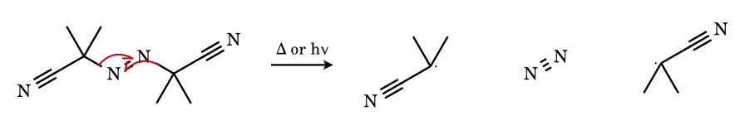
Both C–N bonds break; the two electrons that would remain on N each pair to give the very strong N≡N bond (226 kcal mol⁻¹), which is why AIBN decomposes readily at 60–80 °C. One electron of each broken σ bond stays with its carbon, giving two 2-cyano-2-propyl radicals. Each fish-hook ends at the same N–N bond: two arrows = one extra bond order.
9.13 Decarboxylation of the benzoyloxy radical (from benzoyl peroxide)
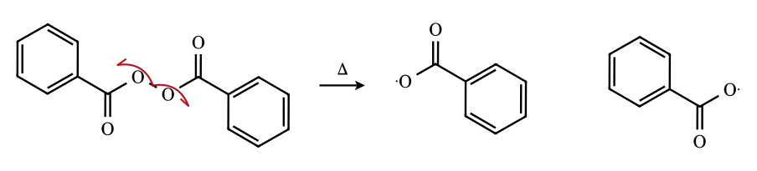
The weak O–O bond (≈ 30 kcal mol⁻¹) breaks homolytically. Benzoyloxy radicals lose CO₂ only slowly (k ≈ 10⁶ s⁻¹) so many add to the monomer or arene before decarboxylating, unlike alkanoyloxy radicals, which lose CO₂ within nanoseconds.
9.14 5-Exo cyclisation of the 5-hexenyl radical
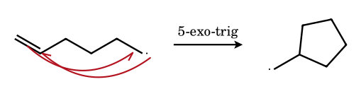
The SOMO attacks the nearer carbon of the alkene (C-5), forming a five-membered ring; the π electron pair splits, one forming the new σ bond and the other left on C-6 (primary, exocyclic cyclopentylmethyl radical). The product radical is less stable than the 6-endo secondary alternative, yet 5-exo is faster by a factor of ≈ 50 (stereoelectronic control, Beckwith). With Bu₃SnH the radical is reduced to methylcyclopentane.
9.15 1,5-Hydrogen atom transfer in an alkoxy radical (Barton / Hofmann–Löffler type)
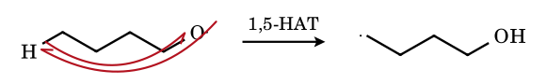
The oxygen radical reaches the δ-hydrogen through a six-membered, chair-like transition state; the O–H bond formed (105 kcal mol⁻¹) is stronger than the C–H bond broken (99), so the step is exothermic by ≈ 6 kcal mol⁻¹, with a very low barrier (k ≈ 10⁷ s⁻¹). The new carbon radical is trapped by NO (Barton) or Cl (Hofmann–Löffler–Freytag).
9.16 Autoxidation: carbon radical traps O₂
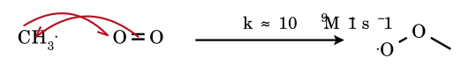
Triplet O₂ is a diradical, so it adds to a carbon radical at nearly the diffusion-controlled rate to give the peroxyl radical R–O–O•. The peroxyl radical then abstracts H from another molecule of R–H (slow, rate-determining) to give R–OOH and propagate the chain. This is why O₂ inhibits other radical chains (it traps R• faster than R• can react with the substrate) and why ethers, aldehydes and alkenes slowly oxidise in air.
9.17 Reduction by chain transfer: alkyl radical + thiol (RS–H) in radical polymerisation
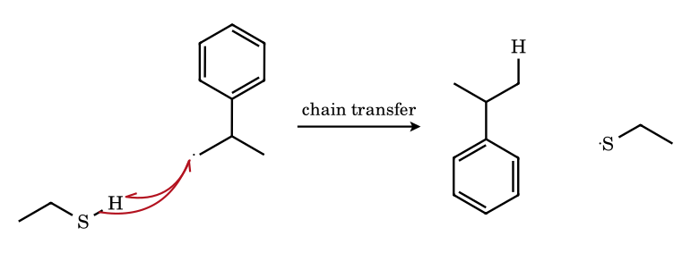
Thiols have weak S–H bonds (≈ 87 kcal mol⁻¹), so they are excellent H-atom donors; a growing polymer radical abstracts the thiol hydrogen to give a dead chain and a thiyl radical, which re-initiates polymerisation. This ‘chain transfer’ reduces the average molecular weight (mercaptans are used as molecular-weight regulators in SBR production, e.g. dodecyl mercaptan).
9.18 β-Scission of the tert-butoxy radical
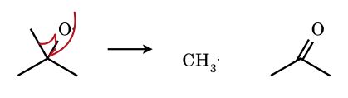
The oxygen radical electron and one electron of an adjacent C–C σ bond form the C=O π bond (the stronger C=O compensates for the lost C–C), while the other electron stays on CH₃•. This competes with H-abstraction by t-BuO•: in non-H-donor solvents at higher temperatures it gives acetone and CH₃• (the source of methane/ethane in t-BuOOt-Bu photolysis).

9.21 Problems on free radicals
FR-1.
Arrange in decreasing stability: (a) CH₃•, (b) CH₃CH₂•, (c) (CH₃)₃C•, (d) PhCH₂•, (e) CH₂=CH–CH₂•, (f) CH₂=CH•.
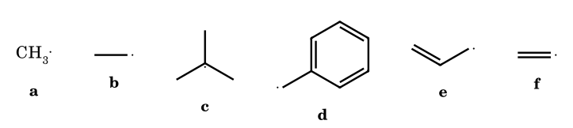
Answer: d > e > c > b > a > f
Benzyl (resonance over the ring) > allyl (two forms) > tertiary (hyperconjugation, 9 C–H) > primary > methyl > vinyl (σ radical, 33 % s). BDE of the parent C–H: 89.8, 88, 96.5, 101, 105, 111 kcal mol⁻¹ (⚑ benzylic and allylic BDEs are within 2 kcal mol⁻¹; the key follows ‘more resonance forms’).
FR-2.
Arrange the C–H bonds in decreasing bond strength: (a) C₆H₅–H, (b) CH₂=CH–H, (c) CH₃–H, (d) (CH₃)₃C–H, (e) PhCH₂–H, (f) CH₂=CHCH₂–H.
Answer: a > b > c > d > e > f
The stronger the C–H, the less stable the radical formed: 112, 111, 105, 96.5, 89.8, 88 kcal mol⁻¹.
FR-3.
Propane is chlorinated and brominated (light). Using relative reactivities (1° : 2° = 1 : 3.8 for Cl; 1 : 82 for Br per H), find the percentage of 2-halopropane.
Answer: Cl: 56 %; Br: 96.5 %
Cl: (2 × 3.8)/(6 × 1 + 2 × 3.8) = 7.6/13.6 = 56 %. Br: (2 × 82)/(6 + 164) = 164/170 = 96.5 %. Bromine is more selective because its H-abstraction TS is late and resembles the radical.
FR-4.
Isobutane is chlorinated with Cl₂ in diffuse sunlight. Which chloride is the major product?
Answer: (B) isobutyl chloride (≈ 64 %)
9 primary H × 1.0 = 9; 1 tertiary H × 5.0 = 5. The numerical advantage of the nine primary H outweighs the reactivity of the single tertiary H (with Br₂ the tertiary bromide would predominate: 9 : 1600).
FR-5.
How many monochlorinated products (without stereoisomers) can be obtained from 2-methylbutane, and how many with stereoisomers?
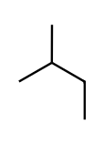
Answer: 4; 6
H types: CH₃–C (6 H, 1-chloro-3-methylbutane... see below); C(CH₃)H (1 H); CH₂ (2 H); CH₃–CH₂ (3 H). Four structural isomers: 1-chloro-2-methylbutane (chiral), 2-chloro-2-methylbutane, 2-chloro-3-methylbutane (chiral), 1-chloro-3-methylbutane. Two are chiral, so 4 + 2 = 6 with stereoisomers.
FR-6.
Which alkane gives only one monochloro derivative? (a) n-pentane, (b) isopentane, (c) neopentane, (d) cyclopentane, (e) 2,2,3,3-tetramethylbutane.
Answer: (c), (d), (e)
All H are equivalent in neopentane (12 H), cyclopentane (10 H) and hexamethylethane (18 H).
FR-7.
Explain why HBr adds to propene anti-Markovnikov in the presence of peroxide while HCl and HI do not.
Answer: thermochemistry of the two propagation steps
Step 1 (X• + C=C): ΔH = −25.1 (Br), −67 (Cl), +46 (I) kJ mol⁻¹; step 2 (R• + HX): ΔH = −50.2 (Br), +12.6 (Cl), −117.1 (I) kJ mol⁻¹. Only for HBr are both steps exothermic. For HCl step 2 is endothermic (C–H bond formed is not strong enough to pay for breaking the strong H–Cl bond); for HI step 1 is endothermic (the weak C–I bond) and I• mostly dimerises.
FR-8.
NBS/peroxide is reacted with 1-butene. Name the products.
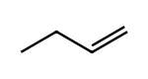
Answer: 3-bromobut-1-ene and 1-bromobut-2-ene
Br• removes an allylic H from C-3 giving CH₂=CH–C•H–CH₃ ↔ •CH₂–CH=CH–CH₃. Br₂ reacts at either terminus. The secondary bromide has a chiral centre (racemic); the primary bromide is a mixture of E and Z (E major).
FR-9.
Toluene is treated with (i) Cl₂, light, (ii) Cl₂, Fe. Name the main products.
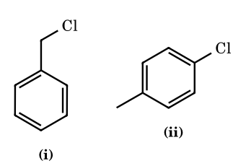
Answer: (i) benzyl chloride (then benzal chloride, benzotrichloride); (ii) o- and p-chlorotoluene
(i) Light gives Cl•, which abstracts the benzylic H (89.8 kcal mol⁻¹): a radical chain at the side chain. (ii) Fe gives FeCl₃, a Lewis acid that makes Cl⁺: electrophilic substitution on the ring.
FR-10.
Electrolysis of (i) potassium propanoate and (ii) an equimolar mixture of sodium acetate and sodium propanoate. Give the hydrocarbons.
Answer: (i) n-butane; (ii) ethane, propane, n-butane (≈ 1 : 2 : 1)
Kolbe: 2 RCOO⁻ → R–R + 2 CO₂ + 2e⁻. With a mixture the radicals CH₃• and C₂H₅• combine at random: CH₃–CH₃, C₂H₅–C₂H₅ (butane), CH₃–C₂H₅ (propane, statistically twice as probable). The solution becomes alkaline (HO⁻ forms at the cathode).
FR-11.
Which of the following radicals will undergo a 1,2-shift? (a) neopentyl, (b) 2,2-dimethyl-2-phenylethyl (neophyl), (c) 3-methyl-2-butyl, (d) cyclopropylcarbinyl (ring opening).
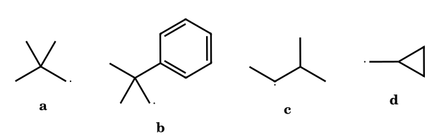
Answer: (b) 1,2-aryl; (d) is a ring-opening (β-scission), not a shift
Radicals do not undergo 1,2-H or 1,2-methyl shifts, so (a) and (c) do not rearrange (unlike the corresponding cations). The neophyl radical undergoes 1,2-phenyl shift to the tertiary radical via the spiro intermediate.
FR-12.
2,4,6-Tri-tert-butylphenoxyl radical is stable and does not dimerise. Why?
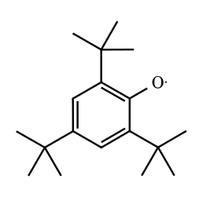
Answer: delocalisation + steric protection
The unpaired electron is delocalised over O and the ortho and para carbons; these positions are blocked by tert-butyl groups, so the radical cannot dimerise through C–O or C–C bonds without large strain.
FR-13.
Rank in decreasing rate of free-radical allylic substitution (NBS): (I) CH₃CH=CH₂, (II) CH₃CH₂CH=CH₂, (III) (CH₃)₂CHCH=CH₂.
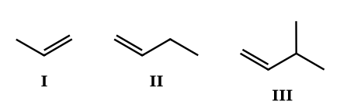
Answer: III > II > I (Nucleus Q40)
III has a tertiary allylic H (weakest allylic C–H, most stable radical); II has a secondary allylic H; I a primary allylic H.
FR-14.
Match: (A) peroxides, (B) NBS, (C) AIBN, (D) HI; with (P) source of Br₂ at low concentration, (Q) source of RO•, (R) source of alkyl radicals + N₂, (S) reducing agent for R–I.
Answer: A–Q; B–P; C–R; D–S
Dialkyl or diacyl peroxides give alkoxy/acyloxy radicals; NBS maintains low [Br₂]; AIBN gives (CH₃)₂C•CN + N₂; HI reduces alkyl iodides to alkanes (the reverse of iodination).
FR-15.
Why does the photochlorination of ethane-d₆ proceed more slowly than that of ethane?
Answer: primary kinetic isotope effect
The C–D bond has a lower zero-point energy and is stronger (≈ 1.2 kcal mol⁻¹), so the H-abstraction step, which is rate-determining, is slower (k_{H}/k_{D} ≈ 1.3–2 for Cl•; Nucleus Q47: II < I < III with neopentane the fastest).
FR-16.
An optically active alkane R¹R²R³C–H is brominated at the stereocentre by NBS. What is the stereochemical outcome?
Answer: racemic bromide
The radical formed at the stereocentre is planar (or rapidly inverting), so Br₂ attacks from either face with equal probability.
FR-17.
Chlorination of 2-methylbutane (C₅H₁₂) at 25 °C: relative rates per H are 1° : 2° : 3° = 1 : 3.8 : 5. Calculate the percentage of each monochloro constitutional isomer.
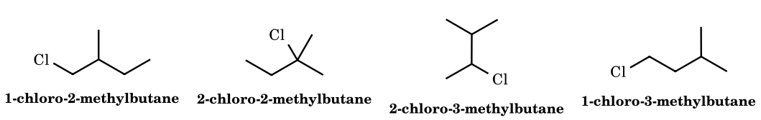
Answer: 27.8 % : 23.1 % : 35.2 % : 13.9 %
Weighted counts: the two CH₃ on C-2 (6 H × 1 = 6) → 1-chloro-2-methylbutane; tertiary C-2 H (1 × 5 = 5) → 2-chloro-2-methylbutane; CH₂ (2 × 3.8 = 7.6) → 2-chloro-3-methylbutane; terminal CH₃ (3 × 1 = 3) → 1-chloro-3-methylbutane. Total 21.6; shares 6/21.6, 5/21.6, 7.6/21.6, 3/21.6.
FR-18.
How many monochlorination products (including stereoisomers) can be formed from 2-methylbutane? How many constitutional isomers are chiral?
Answer: 4 constitutional isomers, 6 including stereoisomers; 2 of the constitutional isomers are chiral
1-Chloro-2-methylbutane (stereocentre C-2: 2 enantiomers) and 2-chloro-3-methylbutane (stereocentre C-2: 2 enantiomers) are chiral; 2-chloro-2-methylbutane and 1-chloro-3-methylbutane are achiral. 2 + 2 + 1 + 1 = 6.
FR-19.
At 127 °C, bromination of propane gives 2-bromopropane almost exclusively (97 %), while chlorination gives a 45 : 55 mixture. Explain with the Hammond postulate and give the energy diagrams in words.
Answer: late versus early transition state
Br• + R–H is endothermic (+17 for CH₄; ≈ +7 for secondary C–H), so the TS resembles the alkyl radical and the 6.5-kcal gap between 1° and 2° radicals appears almost fully in ΔE_{a} (≈ 2–3 kcal mol⁻¹). Cl• + R–H is exothermic for 1°/2° C–H, an early TS in which little radical character has developed, so the barrier difference is only ≈ 0.5 kcal mol⁻¹.
FR-20.
Why does HBr but not HCl or HI add to propene by the radical chain? Give ΔH of the two propagation steps.
Answer: only HBr has two exothermic propagation steps
Approximate ΔH (kcal mol⁻¹) for X• + CH₂=CHCH₃ and R• + HX: Cl: −22 and +3 (second step is endothermic); Br: −5 and −10 (both favourable); I: +4 and −26 (first step is endothermic, reversible, and the I• adds reversibly so no chain develops). Hence the ‘peroxide effect’ is restricted to HBr.
FR-21.
NBS/CCl₄/hν is used with each of: (a) cyclohexene, (b) toluene, (c) 1-pentene, (d) propene, (e) isobutane, (f) methylcyclohexane. Give the major product or products.
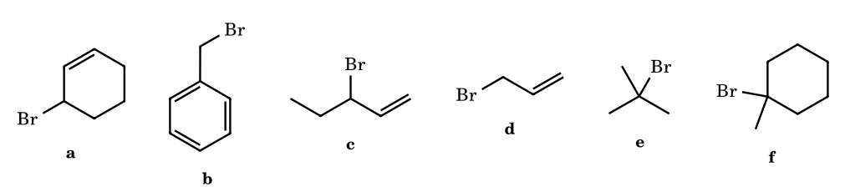
Answer: (a) 3-bromocyclohexene; (b) benzyl bromide; (c) 3-bromo-1-pentene and 1-bromo-2-pentene (mixture); (d) allyl bromide; (e) t-butyl bromide; (f) 1-bromo-1-methylcyclohexane
NBS brominates the weakest C–H: allylic, benzylic, or tertiary. For 1-pentene the allyl radical CH₂=CH–C•H–CH₂CH₃ ↔ •CH₂–CH=CH–CH₂CH₃ reacts at either end; the internal (more substituted, more stable) alkene 1-bromo-2-pentene predominates.
FR-22.
In the Hunsdiecker reaction of silver 3-phenylpropanoate with Br₂, the product is PhCH₂CH₂Br. Write the radical steps and say how the product differs from the acid in carbon count.
Answer: PhCH₂CH₂Br: one carbon less than the acid
RCOOAg + Br₂ → RCOOBr + AgBr; RCOOBr → RCOO• + Br• (initiation); RCOO• → R• + CO₂; R• + RCOOBr → RBr + RCOO• (propagation). The acid PhCH₂CH₂COOH has 9 carbon, the bromide PhCH₂CH₂Br has 8.
FR-23.
Arrange the following radicals in increasing order of stability: (a) CH₃OCH₂•, (b) CH₃CH₂•, (c) PhCH₂•, (d) CH₂=CHCH₂•, (e) (CH₃)₃C•, (f) •CH₂CN.
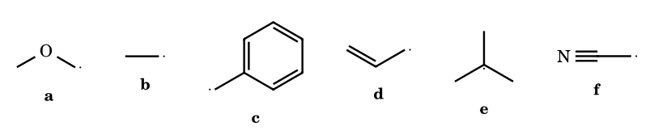
Answer: b < e < a < f < d ≈ c (⚑ d vs c)
RSE values: 4, 8.5, ≈ 9–10 (α-oxygen lone pair), ≈ 11–12 (cyano conjugation), 17, 15. Position of c versus d depends on the data source; most JEE keys put benzyl above allyl on resonance count.
FR-24.
A hydrocarbon C₆H₁₄ gives only two monochlorination products. Identify it and the ratio of the products if relative reactivities are 1 : 3.8 : 5.
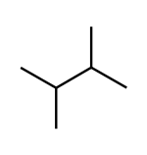
Answer: 2,3-dimethylbutane; (CH₃)₂CHCH(CH₃)₂: 12 primary H : 2 tertiary H → 12 × 1 : 2 × 5 = 12 : 10
The two halves are identical, with 12 primary and 2 tertiary H. 1-chloro-2,3-dimethylbutane : 2-chloro-2,3-dimethylbutane = 54.5 % : 45.5 %. (2,2-dimethylbutane has three products; hexane has three.)
FR-25.
Optically active (S)-1-phenylethyl chloride is treated with Bu₃SnD / AIBN. What is the stereochemistry of the product PhCHDCH₃?
Answer: racemic
Bu₃Sn• abstracts Cl to give the planar (benzylic) radical; deuterium transfer from Bu₃SnD occurs from either face with equal probability, giving a racemate.
FR-26.
Account for the fact that trans-2-butene is formed from cis-2-butene on adding a trace of Br₂ and light (no net addition).
Answer: Br• adds reversibly, the radical rotates, and Br• is eliminated
Br• + cis-CH₃CH=CHCH₃ → CH₃C•H–CHBrCH₃. Free rotation about the C–C single bond (≈ 1000 times faster than Br• loss) before Br• leaves gives the more stable trans isomer. Catalytic Br• or RS• thus equilibrates alkenes to the thermodynamic mixture.
FR-27.
Predict the product of the addition of HBr to (a) propene and (b) 3,3,3-trifluoropropene, in the presence of peroxide; (c) in the dark with no peroxide. Explain the (b) result.
Answer: (a) 1-bromopropane; (b) CF₃CH₂CH₂Br; (c) 2-bromopropane for propene (ionic)
(a) Br• adds at C-1, giving the secondary radical. (b) CF₃CH=CH₂: Br• adds at the CH₂ terminus to give CF₃–C•H–CH₂Br or at CH to give the primary radical; the CF₃ group destabilises the adjacent radical and cation (both polar and field effect), so the experimental product is CF₃CH₂CH₂Br by either mechanism. (c) Ionic addition follows Markovnikov (2-bromopropane).
FR-28.
The rate of polymerisation of styrene initiated by AIBN is proportional to [AIBN]^{1/2} and [styrene]. Derive this from the steady-state hypothesis.
Answer: R_{p} = k_{p}[M](f k_{d}[I]/k_{t})^{1/2}
Steady-state: rate of initiation = rate of termination: 2fk_{d}[I] = 2k_{t}[M•]² ⇒ [M•] = (fk_{d}[I]/k_{t})^{1/2}. Rate of propagation = k_{p}[M•][M]. Substituting gives R_{p} ∝ [M][I]^{1/2}. The half-order in initiator is the signature of bimolecular radical termination.
FR-29.
What is the average degree of polymerisation if the kinetic chain length is 500 and termination is (a) entirely by combination, (b) entirely by disproportionation?
Answer: (a) 1000; (b) 500
Combination joins two kinetic chains in one macromolecule (DP = 2ν); disproportionation gives two molecules, each having one kinetic chain (DP = ν). PMMA terminates mainly by disproportionation; polystyrene by combination.
FR-30.
Identify the product of benzoyl peroxide-initiated bromination of the following: toluene + Br₂ (hν), toluene + Br₂ (Fe), toluene + NBS. State what changes.
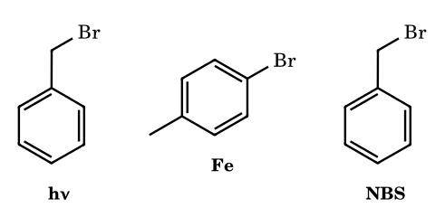
Answer: benzyl bromide (side chain, radical); o- and p-bromotoluene (ring, ionic); benzyl bromide
Light or radical initiator and non-polar solvent: radical substitution at the weakest C–H (benzylic, 89.8). A Lewis acid (FeBr₃) generates Br⁺ equivalents for electrophilic aromatic substitution.
FR-31.
Write the products of the Kolbe electrolysis of (a) CH₃COONa, (b) a 1 : 1 mixture of CH₃COONa and CH₃CH₂COONa, (c) sodium succinate NaOOC–CH₂CH₂–COONa.
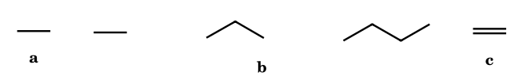
Answer: (a) ethane; (b) ethane + propane + butane (1 : 2 : 1 by statistics); (c) ethene
(a) 2 CH₃• → C₂H₆. (b) CH₃•/C₂H₅• couple randomly: 25 % CH₃–CH₃, 50 % CH₃CH₂CH₃ (propane), 25 % butane. (c) the diradical •CH₂CH₂• forms ethene.
FR-32.
How many monobromo products are possible on treating methylcyclohexane with Br₂/hν? Which one will predominate and why?
Answer: 5 constitutional isomers; the tertiary bromide
H types: CH₃ (1°), C-1 tertiary, C-2 (×2), C-3 (×2), C-4 → 5 constitutional isomers (counting C-2/C-6 and C-3/C-5 as pairs: five different environments in total). Br• discriminates 1600 : 82 : 1, so 1-bromo-1-methylcyclohexane forms almost exclusively.
FR-33.
State and explain the product of the following: (a) CH₃CH₂CH=CH₂ + HBr (ROOR); (b) CH₃CH=CHCH₃ + HBr (ROOR); (c) CH₂=CH–CH=CH₂ + HBr (ROOR).
Answer: (a) 1-bromobutane; (b) 2-bromobutane; (c) 1-bromo-2-butene (mainly) and 3-bromo-1-butene
(a) Br• adds to the terminal CH₂. (b) symmetric alkene gives only 2-bromobutane. (c) Br• adds at C-1 to give a resonance-stabilised allylic radical CH₂Br–CH•–CH=CH₂ ↔ CH₂Br–CH=CH–C•H₂; H-transfer at either end gives 3-bromo-1-butene (kinetic, 1,2-adduct) and 1-bromo-2-butene (1,4, thermodynamic).
FR-34.
A neophyl-type radical PhC(CH₃)₂CH₂• rearranges, but CH₃C(CH₃)₂CH₂• (neopentyl) does not. Why? Which other groups can migrate?
Answer: Ph, vinyl, acyl, Cl/Br can; H and alkyl cannot
Migration needs a low-energy bridged (three-membered) radical TS. For phenyl, the π system provides a stabilised spiro-cyclohexadienyl radical; for H or alkyl, the bridging TS has three centres and three electrons with no stabilisation, and the barrier is much higher than that for intermolecular abstraction. Neopentyl radical therefore abstracts H or fragments instead.
FR-35.
Cumene (isopropylbenzene) is treated with O₂ at 100 °C with a trace of initiator, then with acid. Give the radical chain and the final products.
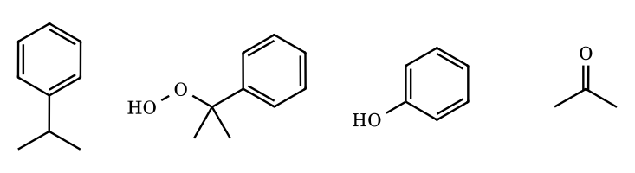
Answer: cumene hydroperoxide, then phenol + acetone (Hock process)
In• + PhCH(CH₃)₂ → PhC•(CH₃)₂ (tertiary benzylic); + O₂ → PhC(CH₃)₂OO•; + cumene → PhC(CH₃)₂OOH + cumyl radical. In acid, the hydroperoxide protonates, loses water as the phenyl migrates from C to O (cationic, Part 7-type shift) to give an oxocarbenium ion, which hydrolyses to phenol and acetone.
FR-36.
Why is the termination step R• + R• → R–R rare in a propagating chain even though it has a rate constant of 10⁹ M⁻¹ s⁻¹?
Answer: radical concentration is ≈ 10⁻⁸ M
Rate of termination = k[R•]² = 10⁹ × 10⁻¹⁶ = 10⁻⁷ M s⁻¹, but propagation = k_{p}[R•][M] ≈ (10²–10⁴) × 10⁻⁸ × 1 M = 10⁻⁶–10⁻⁴ M s⁻¹. Propagation is first order in radical concentration and thus beats the second-order termination until [R•] is high (as in the Trommsdorff gel effect, where termination is slowed by high viscosity).
FR-37.
Which of the following compounds is the best radical inhibitor? (a) benzene, (b) hydroquinone, (c) cyclohexane, (d) benzoyl peroxide, (e) cumene.
Answer: (b) hydroquinone
It donates an H atom (O–H BDE ≈ 80 kcal mol⁻¹) to give a resonance-stabilised semiquinone radical that does not propagate; (d) is an initiator; (a), (c) have strong C–H bonds; (e) is easily autoxidised.
FR-38.
In the HBr addition to 1-hexene catalysed by peroxide, the chain length is about 10⁴. How many HBr molecules are consumed per radical formed by peroxide? What changes if 1 % hydroquinone is added?
Answer: 10⁴; the reaction is inhibited (induction period)
Each initiating radical starts a chain that adds ≈ 10⁴ molecules before termination. Hydroquinone scavenges chain-carrying radicals, so the reaction does not start until it is consumed (induction period), and the product reverts to the ionic Markovnikov addition (2-bromohexane), a slower reaction.
FR-39.
Name the stable free radical among (a) CH₃•, (b) Ph₃C•, (c) TEMPO, (d) t-BuO•, (e) Cl•, and say which of these gives a stable but reactive-solution radical (Gomberg 1900).
Answer: (c) TEMPO is stable (isolable); (b) trityl persists in solution but dimerises on concentration
(c) The four methyl groups block the α-positions, so there is neither disproportionation (no α-H) nor combination; the odd electron is delocalised over N–O. (b) persistent: steric hindrance prevents C–C coupling at the central carbon; the dimer is formed through the para position of one ring.
FR-40.
Complete: (i) Ph–N₂⁺Cl⁻ + Cu powder → ?; (ii) Ph–N₂⁺ + C₆H₆ + NaOH → ?; (iii) CH₃CH₂COO⁻ (anodic oxidation) → ?
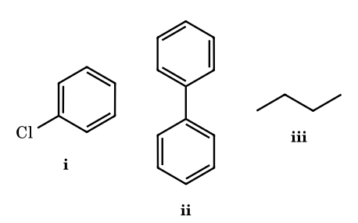
Answer: (i) chlorobenzene (Gattermann); (ii) biphenyl (Gomberg–Bachmann); (iii) butane (Kolbe)
All three involve a radical (Ph• or CH₃CH₂•). In (i) the Cu gives an electron to the diazonium and Cu(II)Cl₂ delivers Cl.
FR-41.
How many different monobromo-alkenes can in principle form on allylic bromination of 1-methylcyclohexene with NBS (constitutional isomers only)? Which positions are allylic?
Answer: 6
Allylic hydrogens are on the CH₃, C-3 and C-6, giving three allylic radicals, each delocalised over two carbons: CH₃-radical → 1-(bromomethyl)cyclohexene and 2-bromo-1-methylenecyclohexane; C-3 radical → 3-bromo-1-methylcyclohexene and 1-bromo-1-methylcyclohex-2-ene; C-6 radical → 6-bromo-1-methylcyclohexene and 2-bromo-1-methylcyclohex-1-ene-type isomer in which the double bond has moved to C-1=C-6. Six distinct constitutional isomers; the most stable (and so usually the major) are those retaining a trisubstituted double bond.
FR-42.
The 5-hexenyl radical can cyclise in two ways. Name them, give the major product and the reason.
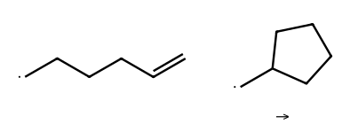
Answer: 5-exo (cyclopentylmethyl) major; 6-endo (cyclohexyl) minor
5-exo-trig versus 6-endo-trig. The exo mode has better SOMO–π* overlap in a chair-like TS; the ratio is about 98 : 2 at 25 °C. A methyl at C-5 raises the exo barrier sterically and reverses the preference.
FR-43.
1-Bromobicyclo[2.2.2]octane is used as a substrate for radical (Bu₃SnH) reduction and as a substrate for S_{N}1 solvolysis. Which proceeds easily, and why?
Answer: radical reduction proceeds; S_{N}1 does not
A bridgehead carbocation cannot become planar and is highly destabilised, so S_{N}1 is extremely slow. A radical only needs a modest degree of delocalisation and tolerates pyramidal geometry (radical inversion barriers are tiny), so the bridgehead radical forms readily from the bromide with Bu₃Sn• (≈ 10⁵ M⁻¹ s⁻¹).
FR-44.
Account for the ratio of products 1-bromo-1-phenylethane : 2-bromo-1-phenylethane = > 99 : 1 in the NBS bromination of ethylbenzene.
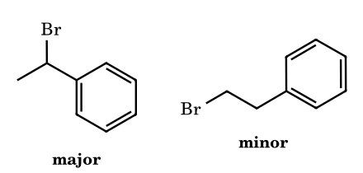
Answer: benzylic H is 10³ times more reactive than the terminal CH₃ H
The secondary benzylic C–H (BDE ≈ 85.4) is 12–15 kcal mol⁻¹ weaker than the terminal C–H, and Br• selects the weak bond.
FR-45.
Using bond energies, show that Cl• + CH₄ → HCl + •CH₃ is nearly thermoneutral while Br• + CH₄ → HBr + •CH₃ is endothermic by 17 kcal mol⁻¹, and use this to explain why Br₂ is more selective than Cl₂.
Answer: ΔH(Cl) = 105 − 103 = +2 (+1); ΔH(Br) = 105 − 87.5 = +17.5
ΔH = D(C–H) − D(H–X). The late (endothermic) TS of bromination resembles the alkyl radical product, so differences in radical stability are felt in the activation energy (Hammond), making bromination selective; the early TS of chlorination does not.
FR-46.
(JEE Advanced style, integer) How many of the following will give the same single monohalogenation product upon radical bromination with one equivalent of Br₂/hν: ethane, neopentane, cyclohexane, benzene, toluene (side-chain), 2,2,3,3-tetramethylbutane, adamantane?
Answer: 5 (ethane, neopentane, cyclohexane, toluene, 2,2,3,3-tetramethylbutane; adamantane gives two isomers, tertiary and secondary; benzene does not react by radical substitution)
Ethane (1 type of H), neopentane (all 12 H equivalent), cyclohexane (12 equivalent H), toluene (only the benzylic H react), hexamethylethane (18 equivalent H). Adamantane has 12 secondary and 4 tertiary H, with Br• giving mainly tertiary (1-bromoadamantane).
FR-47.
2-Methylbutane is brominated with Br₂/hν at 127 °C (relative reactivity per H: 1° : 2° : 3° = 1 : 82 : 1640). Calculate the percentage of 2-bromo-2-methylbutane among the monobromides.
Answer: ≈ 90.5 %
H count: 9 primary (two CH₃ on C-2 plus the C-4 CH₃), 2 secondary, 1 tertiary. Weights: 9 × 1 = 9; 2 × 82 = 164; 1 × 1640 = 1640. Fraction tertiary = 1640/1813 = 0.905.
FR-48.
Using D(C–H) = 105 (CH₃–H), D(Cl–Cl) = 58, D(H–Cl) = 103, D(CH₃–Cl) = 85 kcal mol⁻¹, calculate ΔH for each propagation step and for the overall chlorination of methane.
Answer: step 1 +2; step 2 −27; overall −25 kcal mol⁻¹
Step 1: CH₄ + Cl• → CH₃• + HCl: 105 − 103 = +2. Step 2: CH₃• + Cl₂ → CH₃Cl + Cl•: 58 − 85 = −27. Overall = 105 + 58 − 103 − 85 = −25. The slightly endothermic first step is the rate-determining one (E_{a} ≈ 4).
FR-49.
Styrene is treated with HBr in the presence of benzoyl peroxide. Give the product, name the intermediate radical and explain why no 1-bromoethylbenzene forms.
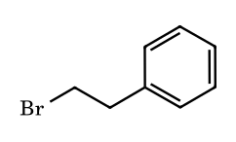
Answer: (2-bromoethyl)benzene via the benzylic radical
Br• adds to the terminal CH₂ to give PhC•H–CH₂Br, a benzylic radical delocalised over the ring. Attack at the other carbon would give a primary radical with no stabilisation. The benzylic radical abstracts H from HBr (chain transfer). Only HBr has both propagation steps favourable.
FR-50.
(Barton–McCombie) A secondary alcohol is converted to its methyl xanthate ROC(=S)SMe and then treated with Bu₃SnH/AIBN. Give the product and the driving force.
Answer: R–H (deoxygenation); formation of a strong C=O (and Sn–S) bond
Bu₃Sn• adds to the thiocarbonyl sulfur to give a stabilised radical, which fragments with C–O cleavage to R• and Bu₃SnS–C(=O)SMe (new C=O bond). R• then abstracts H from Bu₃SnH, regenerating Bu₃Sn•. It deoxygenates secondary alcohols that would eliminate under ionic conditions.
FR-51.
6-Bromohex-1-ene is treated with Bu₃SnH/AIBN at (a) 0.01 M and (b) 1 M Bu₃SnH. Which product predominates in each case?
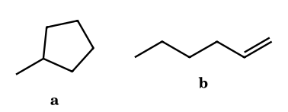
Answer: (a) methylcyclopentane; (b) hex-1-ene
The 5-hexenyl radical either cyclises (first-order, k ≈ 2 × 10⁵ s⁻¹) or is reduced by Bu₃SnH (second-order, k ≈ 2 × 10⁶ M⁻¹ s⁻¹). At 0.01 M the reduction rate is ≈ 2 × 10⁴ s⁻¹, so cyclisation wins; at 1 M it is ≈ 2 × 10⁶ s⁻¹, so direct reduction wins. Rate constants are approximate.
FR-52.
Calculate ΔH for Br• + (CH₃)₃C–H and Cl• + (CH₃)₃C–H using D(C–H) = 96.5, D(H–Br) = 87.5, D(H–Cl) = 103 kcal mol⁻¹, and say what this predicts about selectivity.
Answer: +9 (Br•); −6.5 (Cl•)
ΔH = D(C–H) − D(H–X). Endothermic abstraction by Br• gives a late, radical-like transition state, so it discriminates strongly among 1°/2°/3° C–H; exothermic abstraction by Cl• has an early transition state and low selectivity.
FR-53.
In a radical polymerisation R_{p} = 1 × 10⁻⁴ M s⁻¹ and R_{i} = 1 × 10⁻⁸ M s⁻¹. Find the kinetic chain length and the number-average degree of polymerisation if termination is (a) all by combination, (b) all by disproportionation.
Answer: ν = 10⁴; (a) 2 × 10⁴; (b) 10⁴
ν = R_{p}/R_{i} = 10⁴ monomer units per initiating radical. Combination joins two growing chains (DP = 2ν); disproportionation gives one dead chain per radical (DP = ν). Chain transfer is ignored.
FR-54.
1-Octene is heated with bromotrichloromethane and a peroxide. Give the product and the two propagation steps.
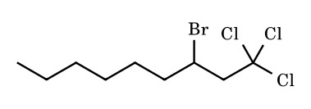
Answer: 3-bromo-1,1,1-trichlorononane
Cl₃C• adds to the terminal CH₂ to give the secondary radical, which abstracts Br from BrCCl₃ (weak C–Br bond), regenerating Cl₃C• (Kharasch addition).
FR-55.
N-Chloro-N-methylbutylamine is irradiated in conc. H₂SO₄ and then made basic. Give the product and the key radical step.
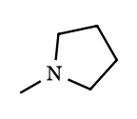
Answer: N-methylpyrrolidine (Hofmann–Löffler–Freytag)
The N-centred aminium radical abstracts the δ-hydrogen through a six-membered transition state (1,5-HAT); the C-radical takes Cl from another N-chloroammonium (chain). On basification the free δ-chloroamine cyclises by intramolecular S_{N}2.
FR-56.
How does BHT (2,6-di-tert-butyl-4-methylphenol) inhibit autoxidation, and why does the resulting radical not propagate the chain?
Answer: it donates its O–H hydrogen to ROO•; the aryloxyl radical is stabilised and hindered
ROO• + ArOH → ROOH + ArO•. The O–H bond is weak (≈ 80 kcal mol⁻¹), the unpaired electron is delocalised into the ring, and the ortho tert-butyl groups block attack, so ArO• neither abstracts H from RH nor adds to O₂; it terminates a second ROO•.
FR-57.
(Integer) NBS/CCl₄/peroxide is used with (E)-hex-2-ene. How many constitutional isomeric monobromoalkenes can form (ignore stereoisomers)?
Answer: 4
Allylic hydrogens are on C-1 and C-4. The C-4 radical (↔ C-2) gives 4-bromohex-2-ene and 2-bromohex-3-ene; the C-1 radical (↔ C-3) gives 1-bromohex-2-ene and 3-bromohex-1-ene. The C-4 pathway predominates (gives disubstituted alkenes).
FR-58.
Arrange R–X in decreasing rate of reduction by Bu₃SnH/AIBN: R–Cl, R–Br, R–I. Explain with bond energies.
Answer: R–I > R–Br > R–Cl
The rate-limiting halogen abstraction by Bu₃Sn• is easier for weaker C–X bonds (CH₃–I 57, –Br 70, –Cl 85 kcal mol⁻¹) and also forms the strong Sn–X bond.
FR-59.
(JEE Advanced, integer type) 2-Methylbutane is monochlorinated with Cl₂/hν at 25 °C. Take the relative reactivities per hydrogen as primary : secondary : tertiary = 1 : 3.8 : 5.0. (a) How many constitutional isomers of C₅H₁₁Cl are formed? (b) What percentage of the product mixture is 2-chloro-3-methylbutane? (c) Treating the selectivity as a pure difference in free energy of activation, calculate ΔΔG‡ (tertiary vs primary C–H abstraction) at 298 K in kJ mol⁻¹.
Answer: (a) 4; (b) ≈ 35 %; (c) ≈ 4.0 kJ mol⁻¹
H count: 6 primary H on the two CH₃ groups at C-2 (gives 1-chloro-2-methylbutane), 3 primary H on C-4 (1-chloro-3-methylbutane), 2 secondary H on C-3 (2-chloro-3-methylbutane), 1 tertiary H (2-chloro-2-methylbutane): four constitutional isomers. Weighted yields: 6 × 1 = 6; 3 × 1 = 3; 2 × 3.8 = 7.6; 1 × 5.0 = 5.0; total 21.6, so 2-chloro-3-methylbutane = 7.6/21.6 = 35.2 %. (c) ΔΔG‡ = RT ln 5 = 8.314 × 298 × 1.609 = 3.99 kJ mol⁻¹. ⚑ Equating per-H rate ratio to ΔΔG‡ assumes equal pre-exponential factors; for Br• (1 : 1640 at 400 K) the same treatment gives RT ln 1640 = 24.6 kJ mol⁻¹, which is why bromination is so much more selective.
FR-60.
(Thermochemistry, BDE data) Bond dissociation enthalpies (kJ mol⁻¹): CH₃–H 439; H–Cl 431; H–Br 366; Cl–Cl 243; Br–Br 193; CH₃–Cl 351; CH₃–Br 293. For the chain reaction CH₄ + X₂ → CH₃X + HX (X = Cl, Br) calculate ΔH for each of the two propagation steps and for the overall reaction. Then estimate the ratio of rate constants k(Br•)/k(Cl•) for hydrogen abstraction from CH₄ at 400 K if E_{a}(Cl•) ≈ 16 kJ mol⁻¹, E_{a}(Br•) ≈ ΔH of the step, and the A factors are equal.
Answer: Cl: +8, −108, overall −100; Br: +73, −100, overall −27 kJ mol⁻¹; ratio ≈ 4 × 10⁻⁸
Step 1 (X• + CH₄ → HX + CH₃•): ΔH = 439 − D(H–X) = +8 (Cl), +73 (Br). Step 2 (CH₃• + X₂ → CH₃X + X•): ΔH = D(X–X) − D(CH₃–X) = 243 − 351 = −108 (Cl); 193 − 293 = −100 (Br). Overall: −100 and −27 kJ mol⁻¹ (check: 439 + 243 − 351 − 431 = −100; 439 + 193 − 293 − 366 = −27). For Br• the barrier cannot be lower than the endothermicity (+73), so k(Br)/k(Cl) = exp[−(73 − 16)×10³/(8.314 × 400)] = exp(−17.1) ≈ 3.6 × 10⁻⁸. ⚑ E_{a}(Br•) = ΔH is the lower limit used as an estimate (Evans–Polanyi style).
FR-61.
(Olympiad style, stereochemistry) (S)-1-Chloro-2-methylbutane is further chlorinated with Cl₂/hν and every possible dichloride (substitution of one C–H) is formed. Of the constitutional isomers of C₅H₁₀Cl₂ obtained, how many are formed as optically active (non-racemic) material? Assume no reaction at the existing C–Cl bond.
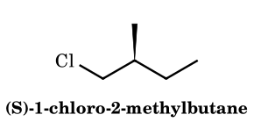
Answer: 3 (1,1-, 1,3- and 1,4-dichloro-2-methylbutane)
Five constitutional dichlorides arise by abstraction at C-1, C-2, C-3, C-4 or the C-2 methyl. Abstraction at C-2 removes the stereocentre hydrogen, giving a planar radical and racemic 1,2-dichloro-2-methylbutane (inactive). Chlorination at the C-2 methyl gives ClCH₂CH(CH₂Cl)CH₂CH₃, in which C-2 carries two identical CH₂Cl groups: achiral. Chlorination at C-1 (1,1-dichloro), C-3 (1,3-dichloro, two diastereomers, which differ in the new centre and are unequal) and C-4 (1,4-dichloro) leaves the C-2 centre untouched, so all three are optically active. Answer 3. ⚑ The CIP descriptor of retained centres can change with substituents; the spatial arrangement is retained.
FR-62.
(JEE Advanced, integer type) 1-Octene is treated with one equivalent of NBS and a trace of peroxide in refluxing CCl₄. Counting each enantiomer and each geometrical isomer separately, how many distinct monobromo compounds can be formed through the allylic radical?
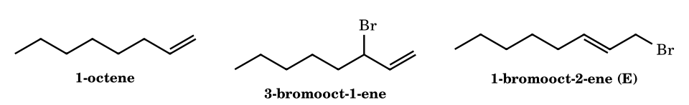
Answer: 4
NBS supplies a low steady concentration of Br₂ (from HBr + NBS), so Br• abstracts the only allylic hydrogen set (C-3) and addition of Br₂ across C=C is suppressed. The resulting allyl radical CH₂=CH–CH•–C₅H₁₁ ↔ •CH₂–CH=CH–C₅H₁₁ is brominated at either terminus: at C-3 gives 3-bromooct-1-ene, a stereocentre formed as a racemate (2 compounds); at C-1 gives 1-bromooct-2-ene as E and Z (2 compounds). Total 4. ⚑ The internal (E)-1-bromo isomer usually predominates because the more substituted alkene is more stable and the allylic bromides can interconvert under the conditions.
FR-63.
(JEE Advanced, multiple correct) Choose the correct statement(s). (A) The tertiary C–H bond of isobutane (≈ 96 kcal mol⁻¹) is weaker than the secondary C–H of propane (≈ 99 kcal mol⁻¹). (B) The phenyl radical is a π-radical delocalised over the ring and is therefore as stable as the benzyl radical. (C) In the allyl radical the unpaired spin density is carried by the two terminal carbons (0.5 each in simple Hückel theory) and is zero on C-2. (D) The benzylic C–H bond of ethylbenzene (≈ 85 kcal mol⁻¹) is weaker than that of toluene (≈ 90 kcal mol⁻¹). (E) The cyclopropyl radical is more stable than the isopropyl radical because angle strain is relieved on forming it. (F) The methyl radical is essentially planar, whereas the tert-butyl radical is slightly pyramidal.
Answer: A, C, D, F
(A) True: weaker bond means more stable radical (hyperconjugation and polarisability). (B) False: the phenyl radical is a σ radical, with the electron in an sp² orbital in the ring plane, orthogonal to the π system; its C–H BDE is ≈ 112 kcal mol⁻¹. (C) True: the non-bonding allyl MO has a node at C-2. (D) True: the extra α-methyl gives additional hyperconjugative stabilisation, so NBS attacks ethyl groups faster than methyl groups on arenes. (E) False: cyclopropyl C–H BDE ≈ 106 kcal mol⁻¹, the radical is σ-like and the ring resists planarity. (F) True; ⚑ the pyramidalisation of t-Bu• is shallow (small inversion barrier), and some texts call it nearly planar.
FR-64.
(Mechanism and stereochemistry) 1-Methylcyclohexene reacts with HBr in the presence of benzoyl peroxide. Give the constitution of the product, the number of stereoisomers possible for it, and the stereoisomer predominantly formed. Why do HCl and HI not give anti-Markovnikov addition under the same conditions?
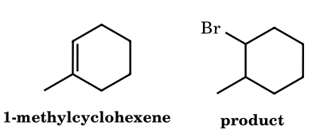
Answer: 1-bromo-2-methylcyclohexane; 4 stereoisomers; mainly trans (anti addition)
Br• adds to the less substituted alkene carbon (C-2) so that the more stable tertiary radical forms at C-1; the radical then abstracts H from HBr (chain propagation, ΔH ≈ −44 kJ mol⁻¹) giving 1-bromo-2-methylcyclohexane with two stereocentres: 4 stereoisomers (cis pair and trans pair of enantiomers). Hydrogen delivery to the tertiary radical occurs anti to the bromine (axial attack on the favoured conformer), so the racemic trans isomer predominates (Goering). ⚑ Under thermodynamic conditions (reversible Br• addition) the cis/trans ratio can change. With HCl the H-abstraction step is endothermic (H–Cl 431 vs C–H ≈ 410 kJ mol⁻¹); with HI the I• addition to the alkene is endothermic and reversible, and I• atoms simply combine to I₂.
FR-65.
(Quantitative, HX addition) Use these average data (kJ mol⁻¹): C=C π bond 265; D(C–Cl) 339; D(C–Br) 285; D(C–I) 213; D(H–Cl) 431; D(H–Br) 366; D(H–I) 298; D(secondary C–H) 410. For the chain addition of HX to propene (X• adds to CH₂, then the secondary radical abstracts H from HX) compute ΔH of the addition step and of the hydrogen-transfer step for X = Cl, Br, I, and the overall ΔH. Which HX can sustain a radical chain and what is the overall ΔH for it?
Answer: only HBr; ΔH(overall) = −64 kJ mol⁻¹
Addition step ΔH = 265 − D(C–X): Cl −74, Br −20, I +52. Hydrogen-transfer step ΔH = D(H–X) − 410: Cl +21, Br −44, I −112. Overall: Cl −53, Br −64, I −60 kJ mol⁻¹ (all favourable overall, but this is not sufficient). For HCl the second step is endothermic, so hydrogen transfer is slow compared with competing steps (telomerisation, termination); for HI the first step is endothermic, so I• addition is reversible and the chain is not sustained. Only HBr has both steps exothermic (−20 and −44), giving an efficient chain. ⚑ Average bond energies are approximate; the conclusion rests on signs and magnitudes, not on the exact numbers.
FR-66.
(Kharasch addition, Olympiad style) 1-Octene is heated with CCl₄ and a catalytic amount of dibenzoyl peroxide. (a) Give the 1:1 adduct and its name. (b) The intermediate carbon radical can either abstract Cl from CCl₄ (rate constant k_{tr}) or add to another octene (k_{p}). With k_{tr}/k_{p} = 2.0, [CCl₄] = 4.0 M and [octene] = 0.50 M (both constant), what percentage of the product chains are the 1:1 adduct and what percentage are the 2:1 telomer?
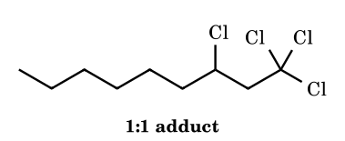
Answer: 1,1,1,3-tetrachlorononane; ≈ 94 % 1:1 and ≈ 5.5 % 2:1
Initiation gives •CCl₃ (peroxide-derived radicals abstract Cl from CCl₄). •CCl₃ adds to the terminal CH₂ of the alkene giving the secondary radical, which abstracts Cl from CCl₄ and regenerates •CCl₃: Cl₃C–CH₂–CHCl–C₆H₁₃, 1,1,1,3-tetrachlorononane (9 carbons). The probability of transfer at each stage is p = k_{tr}[CCl₄]/(k_{tr}[CCl₄] + k_{p}[M]) = 8.0/8.5 = 0.941. The 1:1 adduct fraction is p = 94.1 %; the 2:1 telomer is (1 − p)p = 0.0588 × 0.941 = 5.5 %. ⚑ Treated as geometric (Mayo-type) distribution with constant concentrations.
FR-67.
(Polymerisation kinetics) Styrene (4.0 M) is polymerised in solution at 60 °C using AIBN (0.010 M, assumed constant). Data: k_{d} = 1.0 × 10⁻⁵ s⁻¹, f = 0.60, k_{p} = 3.4 × 10² L mol⁻¹ s⁻¹, k_{t} = 6.0 × 10⁷ L mol⁻¹ s⁻¹ (defined by R_{t} = 2k_{t}[P•]²). Termination is by combination only. Calculate (a) the steady-state radical concentration, (b) R_{p}, (c) the kinetic chain length ν and the number-average degree of polymerisation, (d) M_{n} (styrene = 104.15 g mol⁻¹), and (e) the time to 10 % conversion.
Answer: [P•] = 3.2 × 10⁻⁸ M; R_{p} = 4.3 × 10⁻⁵ M s⁻¹; ν ≈ 358; X_{n} ≈ 717; M_{n} ≈ 7.5 × 10⁴; t ≈ 2.7 h
R_{i} = 2fk_{d}[I] = 2 × 0.60 × 1.0×10⁻⁵ × 0.010 = 1.2 × 10⁻⁷ M s⁻¹. Steady state R_{i} = R_{t}: [P•] = (R_{i}/2k_{t})^{1/2} = (1.0×10⁻¹⁵)^{1/2} = 3.16 × 10⁻⁸ M. R_{p} = k_{p}[M][P•] = 340 × 4.0 × 3.16×10⁻⁸ = 4.30 × 10⁻⁵ M s⁻¹. ν = R_{p}/R_{i} = 358; combination doubles it: X_{n} = 2ν = 717, M_{n} = 717 × 104.15 = 7.47 × 10⁴. Apparent first-order rate constant = k_{p}[P•] = 1.07 × 10⁻⁵ s⁻¹; t = ln(1/0.9)/1.07×10⁻⁵ = 9.8 × 10³ s = 2.7 h. ⚑ Conventions for k_{t} differ (R_{t} = k_{t}[P•]² in some texts); doubling [I] raises R_{p} by √2 and lowers ν by √2.
FR-68.
(Chain transfer and inhibition) In the bulk polymerisation of styrene at 60 °C, [M] = 4.0 M. Without transfer agent 1/X_{n} = 2.0 × 10⁻⁴. Dodecanethiol (RSH) has chain-transfer constant C_{S} = 15. (a) Calculate X_{n} when [RSH] = 2.0 × 10⁻³ M. (b) What [RSH] is needed for X_{n} = 50? (c) How does the thiol change R_{p} and why? (d) In another run with R_{i} = 1.2 × 10⁻⁷ M s⁻¹, benzoquinone (5.0 × 10⁻⁵ M) is added; assuming each inhibitor molecule traps two radicals, find the induction period.
Answer: (a) ≈ 130; (b) ≈ 5.3 × 10⁻³ M; (c) R_{p} unchanged; (d) ≈ 833 s (14 min)
Mayo equation: 1/X_{n} = 1/X_{n0} + C_{S}[S]/[M]. (a) 1/X_{n} = 2.0×10⁻⁴ + 15 × 2.0×10⁻³/4.0 = 7.7 × 10⁻³, X_{n} = 130. (b) 1/50 = 0.0200; 0.0198 = 15[S]/4.0, so [S] = 5.28 × 10⁻³ M. (c) The thiyl radical RS• re-initiates styrene polymerisation quickly, so the number of growing chains is unchanged and R_{p} is unaffected: this is pure chain transfer, not retardation. (d) Radicals are scavenged until the inhibitor is consumed: τ = n[Z]/R_{i} = 2 × 5.0×10⁻⁵/1.2×10⁻⁷ = 833 s. ⚑ The stoichiometric factor n for quinones is not always exactly 2 and depends on the radical.
FR-69.
(Copolymerisation) Styrene (M₁) and methyl methacrylate (M₂) copolymerise radically with r₁ = 0.52 and r₂ = 0.46 (taken as given). (a) Find the mole fraction of styrene in the initial copolymer from an equimolar feed. (b) Find the azeotropic feed composition f₁. (c) What is the mean sequence length of styrene units in the equimolar feed, and what does r₁r₂ tell about the structure?
Answer: (a) F₁ ≈ 0.51; (b) f₁ ≈ 0.53; (c) 1.52; r₁r₂ = 0.24, tendency towards alternation
Mayo–Lewis: F₁ = (r₁f₁² + f₁f₂)/(r₁f₁² + 2f₁f₂ + r₂f₂²) = (0.13 + 0.25)/(0.13 + 0.50 + 0.115) = 0.38/0.745 = 0.510. Azeotrope: f₁ = (1 − r₂)/(2 − r₁ − r₂) = 0.54/1.02 = 0.529. Mean sequence length of M₁ = 1 + r₁[M₁]/[M₂] = 1.52. Since both r < 1 and r₁r₂ = 0.239 < 1, each radical prefers adding the other monomer; the copolymer is rather random with alternating tendency, and composition barely drifts near the azeotrope. ⚑ Reactivity ratios vary with temperature and medium.
FR-70.
(Cyclisation regiochemistry, JEE Advanced integer type) For which of the following radicals is the major cyclic product (after H-atom transfer from Bu₃SnH at low tin hydride concentration) a six-membered ring? (a) hex-5-en-1-yl; (b) 5-methylhex-5-en-1-yl; (c) hept-6-en-1-yl; (d) hept-6-en-2-yl. Give the number of such radicals, and for (d) state the main stereochemical outcome.
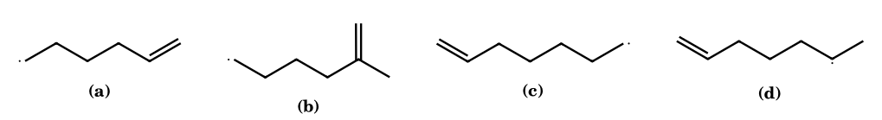
Answer: 2 ((b) and (c)); (d) gives mainly cis-1,2-dimethylcyclopentane
(a) 5-exo (k ≈ 2 × 10⁵ s⁻¹) wins over 6-endo because of better SOMO–π* overlap in the chair-like Beckwith TS: methylcyclopentane. (b) A methyl on C-5 hinders 5-exo attack at the substituted carbon, so 6-endo, giving the tertiary 1-methylcyclohexyl radical, predominates (≈ 2 : 1). (c) For the hept-6-enyl radical 6-exo is still favoured over 7-endo, giving the cyclohexylmethyl radical (about 50 times slower than 5-exo). (d) 5-Exo cyclisation; a 1-substituent in the chair-like TS prefers cis stereochemistry, so cis-1,2-dimethylcyclopentane is the major product (Beckwith rule: 1- and 3-substituted give cis, 2- and 4- give trans). Answer: 2. ⚑ Ratios are approximate and temperature-dependent; the cis preference is modest (about 2 : 1).
FR-71.
(Neophyl rearrangement as a slow radical clock) Neophyl bromide, PhC(CH₃)₂CH₂Br, is reduced by Bu₃SnH (AIBN, 25 °C). The neophyl radical undergoes 1,2-aryl migration with k_{r} = 7.6 × 10² s⁻¹ (taken as given), while trapping by Bu₃SnH has k_{H} = 2.4 × 10⁶ M⁻¹ s⁻¹. (a) Name the two hydrocarbons formed and the intermediate involved in the migration. (b) What percentage of rearranged hydrocarbon is formed at [Bu₃SnH] = 0.10 M (assume constant)? (c) At what [Bu₃SnH] are the two hydrocarbons formed in equal amounts?
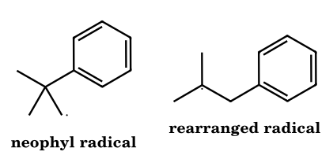
Answer: tert-butylbenzene (unrearranged) and isobutylbenzene (rearranged); (b) ≈ 0.32 %; (c) ≈ 3.2 × 10⁻⁴ M
The primary neophyl radical attacks its own ipso carbon (3-exo) to give a spiro cyclopropyl-cyclohexadienyl radical; ring opening on the other side gives the tertiary radical (CH₃)₂C•–CH₂Ph, driven by primary to tertiary radical conversion. Direct reduction of the neophyl radical gives tert-butylbenzene; reduction of the rearranged radical gives isobutylbenzene (2-methylpropylbenzene). Competition: rearranged/unrearranged = k_{r}/(k_{H}[SnH]) = 760/(2.4×10⁵) = 3.2 × 10⁻³, i.e. 0.316 % of the total. Equal amounts when k_{H}[SnH] = k_{r}: [SnH] = 760/2.4×10⁶ = 3.2 × 10⁻⁴ M. Because k_{r} is small, the neophyl clock needs very low tin hydride (or syringe-pump addition) to be useful. ⚑ The ratio assumes the rearranged radical is not appreciably reverted.
FR-72.
(Barton–McCombie and a built-in clock) The S-methyl xanthate of hept-6-en-2-ol is heated with Bu₃SnH (slow addition, so that [Bu₃SnH] stays constant) and AIBN in benzene at 80 °C. Take k_{c} (5-exo cyclisation of the secondary radical) = 2.0 × 10⁵ s⁻¹ and k_{H} = 2.0 × 10⁶ M⁻¹ s⁻¹ (assumed values). (a) Write the two products and the tin by-product. (b) Calculate the percentage of cyclised product at [Bu₃SnH] = 0.010 M and at 1.0 M. (c) Which tin-containing species adds to the C=S bond, and what drives the fragmentation?
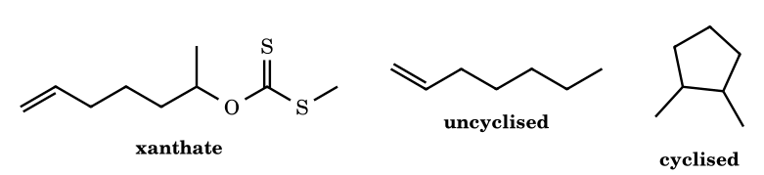
Answer: hept-1-ene and 1,2-dimethylcyclopentane (cis major); 91 % cyclised at 0.010 M, 9.1 % at 1.0 M; Bu₃Sn–S–C(=O)SMe by-product
AIBN generates Bu₃Sn•, which attacks sulfur of C=S to give the stabilised adduct radical; β-scission cleaves the C–O bond, forming the secondary radical CH₃CH•(CH₂)₃CH=CH₂ and Bu₃SnSC(=O)SMe (strong C=O and Sn–S bonds drive it). The radical either takes H from Bu₃SnH (giving hept-1-ene and regenerating Bu₃Sn•) or cyclises 5-exo then is reduced to 1,2-dimethylcyclopentane. Ratio cyclised/uncyclised = k_{c}/(k_{H}[SnH]): at 0.010 M, 2.0×10⁵/2.0×10⁴ = 10, so 10/11 = 91 % cyclised; at 1.0 M, 2.0×10⁵/2.0×10⁶ = 0.10, so 0.1/1.1 = 9.1 %. One equivalent of Bu₃SnH is consumed per xanthate. ⚑ cis-1,2-dimethylcyclopentane is the major diastereomer (Beckwith); the rate constants are given values for the exercise.
FR-73.
(Giese reaction) tert-Butyl iodide and methyl acrylate (1.0 M) are treated with Bu₃SnH (kept at 0.020 M by slow addition) and AIBN. (a) Give the main product. (b) Take k_{add}(t-Bu• + acrylate) = 1.0 × 10⁶ M⁻¹ s⁻¹ and k_{H}(t-Bu• + Bu₃SnH) = 2.0 × 10⁶ M⁻¹ s⁻¹ (assumed); calculate the fraction of t-Bu• that gives the adduct. (c) Why does t-Bu• add to acrylate but not appreciably to 1-hexene, while •CH₂CO₂Et adds readily to 1-hexene?
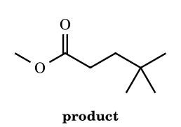
Answer: methyl 4,4-dimethylpentanoate; ≈ 96 %; polarity matching (SOMO–LUMO / SOMO–HOMO)
Bu₃Sn• abstracts I from t-BuI, t-Bu• adds to the β-carbon of acrylate, giving the α-ester radical, which takes H from Bu₃SnH to give t-Bu–CH₂CH₂CO₂Me (methyl 4,4-dimethylpentanoate). Partition: addition 1.0×10⁶ × 1.0 = 1.0×10⁶ s⁻¹; premature reduction 2.0×10⁶ × 0.020 = 4.0×10⁴ s⁻¹; adduct fraction = 1.0×10⁶/1.04×10⁶ = 96 %. The nucleophilic (high-SOMO) tertiary radical reacts quickly only with electron-poor alkenes (low LUMO); the electrophilic radical from the ester has a low SOMO and adds to electron-rich alkenes. High [alkene], low [SnH] favours the Giese adduct. ⚑ Real rate constants vary with temperature and solvent.
FR-74.
(Autoxidation and the Hock process) Cumene (C₉H₁₂, 120.19 g mol⁻¹) is oxidised by O₂ to the hydroperoxide, then cleaved with acid to phenol and acetone. (a) Write the two propagation steps. (b) With D(C–H) of cumene = 84 and D(ROO–H) = 88 kcal mol⁻¹, find ΔH of the hydrogen transfer step. (c) What mass of phenol and of acetone (94.11 and 58.08 g mol⁻¹) forms from 1.00 kg cumene at an overall yield of 85 %? (d) BHT (n = 2 radicals per molecule, 1.0 × 10⁻³ M) is present while R_{i} = 2.0 × 10⁻⁸ M s⁻¹; estimate the induction period.
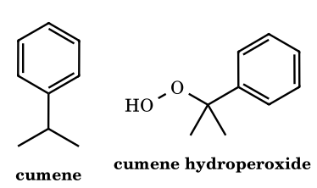
Answer: (b) −4 kcal mol⁻¹; (c) ≈ 666 g phenol, ≈ 411 g acetone; (d) ≈ 1.0 × 10⁵ s (≈ 28 h)
(a) R• + O₂ → ROO• (diffusion controlled); ROO• + RH → ROOH + R•, where R• = PhC•(CH₃)₂. (b) ΔH = D(C–H) − D(O–H) = 84 − 88 = −4 kcal mol⁻¹, so the weak tertiary benzylic C–H bond makes the chain feasible. Acid then protonates the OOH; phenyl migrates to oxygen (Hock rearrangement) with loss of water to give a stabilised oxocarbenium ion, hydration gives a hemiketal, which collapses to PhOH + (CH₃)₂C=O. (c) 1000/120.19 = 8.320 mol; × 0.85 = 7.072 mol; phenol 7.072 × 94.11 = 666 g; acetone 7.072 × 58.08 = 411 g. (d) τ = n[AH]/R_{i} = 2 × 1.0×10⁻³/2.0×10⁻⁸ = 1.0 × 10⁵ s = 27.8 h. ⚑ BDE values are rounded literature numbers; the BHT stoichiometry n = 2 is idealised.
FR-75.
(JEE Advanced, match the column) Match each decarboxylative method applied to pentanoic acid (CH₃CH₂CH₂CH₂CO₂H or its derivative) with the main organic product. Column I: (P) silver salt, Br₂/CCl₄, heat; (Q) sodium salt, electrolysis in methanol; (R) N-hydroxy-2-thiopyridone (Barton) ester, hν, t-BuSH; (S) the same Barton ester, hν, CCl₄; (T) Pb(OAc)₄, Cu(OAc)₂, heat. Column II: (1) butane; (2) 1-bromobutane; (3) octane; (4) 1-chlorobutane; (5) but-1-ene.
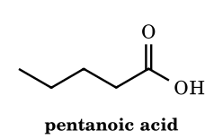
Answer: P–2, Q–3, R–1, S–4, T–5
(P) Hunsdiecker: acyl hypobromite, RCO₂• loses CO₂, the butyl radical abstracts Br: 1-bromobutane. (Q) Kolbe: anodic oxidation to RCO₂•, loss of CO₂, radical dimerisation: octane. (R) Photolysis of the PTOC ester cleaves N–O, CO₂ is lost, and the butyl radical takes H from t-BuSH: butane. (S) In CCl₄ the butyl radical abstracts Cl: 1-chlorobutane. (T) Kochi oxidative decarboxylation: the radical is oxidised by Cu(II) to a Cu(III) alkyl and loses a β-hydrogen, giving the terminal alkene but-1-ene. ⚑ Kochi conditions can also give acetates or alkyl halides depending on the copper ligands; the alkene is the textbook outcome.
FR-76.
(SRN1, very hard) Sodium 2-nitropropanate reacts with 4-nitrobenzyl chloride in DMF to give 1-(2-methyl-2-nitropropyl)-4-nitrobenzene in high yield. The reaction is accelerated by light, and is strongly inhibited by 10 mol % of 1,4-dinitrobenzene or by O₂. (a) How many propagation steps does the SRN1 cycle contain, and what are they? (b) After absorbing 1.25 × 10⁻⁵ mol of photons (one initiating electron transfer per photon), 0.50 mmol of product has formed. Calculate the quantum yield. (c) Why does 1,4-dinitrobenzene inhibit?
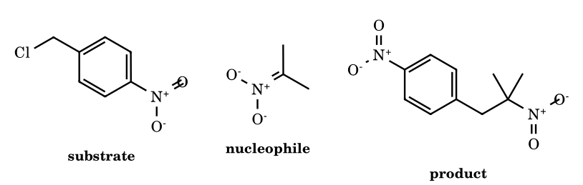
Answer: 3 propagation steps; Φ = 40; dinitrobenzene intercepts the chain-carrying radical anion
Initiation: electron transfer (photo- or thermal) from the nitronate to ArCH₂Cl gives the radical anion. Propagation: (1) ArCH₂Cl•− → ArCH₂• + Cl−; (2) ArCH₂• + (CH₃)₂C=NO₂− → [ArCH₂C(CH₃)₂NO₂]•− (C-alkylation); (3) this radical anion transfers an electron to a fresh molecule of ArCH₂Cl, giving product and regenerating the substrate radical anion. Quantum yield Φ = 0.50 × 10⁻³/1.25 × 10⁻⁵ = 40, i.e. each photon launches a chain of average length 40 before termination. 1,4-Dinitrobenzene is a better electron acceptor than the substrate: it takes the electron from the chain-carrying radical anion, producing a relatively unreactive radical anion that does not fragment, so step (3) is intercepted. O₂ acts likewise by trapping radicals and radical anions. ⚑ Some texts count the initiation electron transfer as step 1; the cycle itself is three steps.
FR-77.
(Sandmeyer and Gomberg–Bachmann) 2.00 g of 4-bromoaniline (172.0 g mol⁻¹) is diazotised at 0 °C. Half of the resulting diazonium salt solution is treated with CuCl, the other half with benzene and aqueous NaOH. (a) Name the main product of each reaction and state the key radical steps. (b) If the Gomberg–Bachmann step gives 30 % yield (based on half of the diazonium salt), what mass of biaryl is obtained? (c) Which position of nitrobenzene is not preferentially attacked in the Gomberg–Bachmann arylation by Ar•?
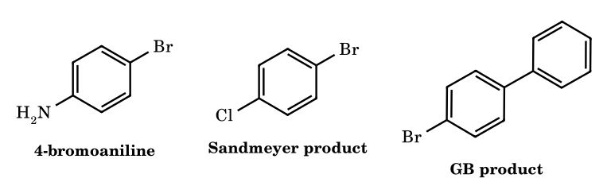
Answer: 1-bromo-4-chlorobenzene; 4-bromobiphenyl, 0.41 g; meta
Sandmeyer: Cu(I) transfers an electron to ArN₂⁺, giving Ar• + N₂ + Cu(II)Cl; Ar• abstracts Cl from CuCl₂ (ligand transfer), regenerating Cu(I): 1-bromo-4-chlorobenzene. Gomberg–Bachmann: under basic conditions the diazonium forms the diazotate Ar–N=N–O−, which gives Ar• (N₂ loss) that adds to benzene, giving a cyclohexadienyl radical, deprotonated/oxidised to 4-bromobiphenyl. (b) Total amine = 2.00/172.0 = 0.01163 mol; half = 0.005814 mol; 30 % gives 0.001744 mol × 233.1 g mol⁻¹ = 0.407 g. (c) Aryl radicals attack nitrobenzene ortho and para (≈ 60 : 30) in preference to meta (≈ 10 %). ⚑ Isomer ratios depend on conditions. (Using the whole 2.00 g in this step would give 0.81 g.)
FR-78.
(EPR) Predict the number of resolved hyperfine lines for each of the following radicals in solution, assuming fast methyl rotation and that every inequivalent set of protons gives a resolved splitting: (i) CH₃CH₂• (a_{β}(3H) = 2.69 mT, a_{α}(2H) = 2.24 mT); (ii) (CH₃)₂CH• (a(6H) = 2.47 mT, a(1H) = 2.21 mT); (iii) PhCH₂• (a(CH₂) = 1.63, a_{o}(2H) = 0.51, a_{m}(2H) = 0.18, a_{p}(1H) = 0.62 mT); (iv) CD₃• (a(H) in CH₃• = 2.30 mT; γ_{D}/γ_{H} = 0.1535, I(D) = 1). Give also the total number of lines for the four radicals and the hyperfine coupling for CD₃•.
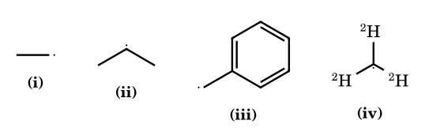
Answer: 12, 14, 54 and 7 lines (total 87); a(D) ≈ 0.35 mT
Lines = ∏(2nI + 1) over sets. (i) 4 (quartet from 3 H) × 3 (triplet from 2 H) = 12. (ii) 7 (septet from 6 equivalent H) × 2 = 14. (iii) CH₂ gives 3, ortho 3, meta 3, para 2: 3 × 3 × 3 × 2 = 54. (iv) three I = 1 nuclei give 2(3)(1) + 1 = 7 lines in the ratio 1 : 3 : 6 : 7 : 6 : 3 : 1 (sum 27 = 3³); a(D) = 2.30 × 0.1535 = 0.353 mT. Total 12 + 14 + 54 + 7 = 87. ⚑ In practice the unresolved weak couplings (meta in benzyl) and overlap of lines may reduce the lines actually seen; the question asks for the idealised count.
FR-79.
(Persistent radicals) Gomberg's trityl radical exists in equilibrium with a dimer: dimer ⇌ 2 Ph₃C•. In benzene at 25 °C a solution containing 0.100 mol L⁻¹ total trityl units is 2.0 % dissociated (fraction of units present as radicals). (a) Calculate K = [Ph₃C•]²/[dimer]. (b) Calculate the percentage of trityl units present as radicals at a total concentration of 1.00 × 10⁻³ mol L⁻¹. (c) Explain, for TEMPO and for the BHT-derived phenoxyl radical, why they are persistent and name one difference between them.
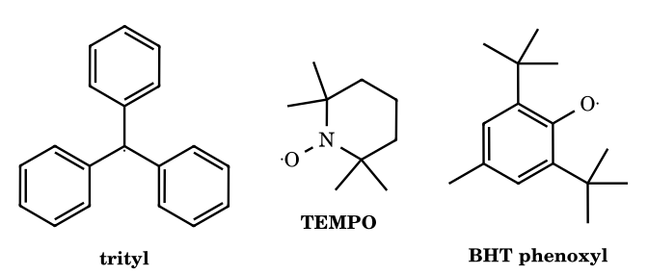
Answer: (a) K ≈ 8.2 × 10⁻⁵ M; (b) ≈ 18 %
(a) With c = 0.100 M of units and 2.0 % radical: [R•] = 2.0×10⁻³ M and [dimer] = (0.100 − 0.0020)/2 = 0.049 M, so K = (2.0×10⁻³)²/0.049 = 8.2 × 10⁻⁵ M. (b) With x = [R•]: x²/[(c − x)/2] = K gives 2x² + Kx − Kc = 0; for c = 1.00×10⁻³ M, x = [−K + (K² + 8Kc)^{1/2}]/4 = 1.83×10⁻⁴ M, i.e. 18 % radical (dilution favours dissociation). The dimer is not hexaphenylethane but the head-to-tail quinoid dimer, because of steric strain. (c) TEMPO: no hydrogens on the carbons α to N, so it cannot disproportionate to a nitrone and hydroxylamine, and the N–O three-electron π bond plus four methyl groups shield the centre; it is isolable. BHT phenoxyl: spin delocalisation into the ring and the two ortho tert-butyl groups shield the O, so dimerisation is slow; but, unlike TEMPO, it has hydrogens (para CH₃) and eventually disproportionates (to the quinone methide), so it is persistent only for a limited time. ⚑ 'Persistent' is kinetic and conditional; K values vary with solvent and temperature.
FR-80.
(Hofmann–Löffler–Freytag, 1,5-HAT) N-Chloro-N-methyl-4-methylpentan-1-amine is irradiated in conc. H₂SO₄, then made basic. (a) Give the final product and the intermediate chloroamine. (b) How many atoms are in the cyclic hydrogen-transfer transition state, and why is that position (not a different C–H) attacked even though other C–H bonds are also weak? (c) What role does H₂SO₄ play?
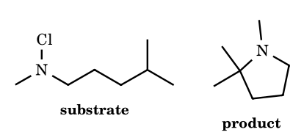
Answer: 1,2,2-trimethylpyrrolidine; the intermediate is 4-chloro-N,4-dimethylpentan-1-amine; six-membered TS
Photolysis of the protonated N–Cl bond gives the aminium radical cation CH₃N•+H–R, which is electrophilic and abstracts a hydridic C–H through a six-membered, chair-like transition state (N, C-1, C-2, C-3, C-4 and H): 1,5-HAT from the δ-carbon C-4, which here is tertiary. The C-4 radical abstracts Cl from another N-chloroammonium, giving the δ-chloroamine and propagating the chain. On treatment with base, the free secondary amine displaces the tertiary chloride intramolecularly to form the five-membered ring, 1,2,2-trimethylpyrrolidine, C₇H₁₅N. Acid protonates the amine so the N-radical is an electrophilic aminium ion, and prevents hydrolysis and N-centred side reactions. Six-membered TS: 1,4-HAT (5-membered TS) is strained, and 1,6-HAT requires a less favourable seven-membered TS. ⚑ Some treat the ring closure of the tertiary chloride as SN1-like rather than SN2.

Part 10 Carbenes: Structure, Generation, Singlet and Triplet States, Reactions
A carbene is a neutral species containing a divalent carbon atom with only six valence electrons: R₂C: (two bonds + two non-bonding electrons). It is a Lewis acid (empty orbital) and a Lewis base (lone pair) at the same atom, and is therefore ambiphilic; most simple carbenes behave as electrophiles because the empty orbital dominates. Carbenes are reaction intermediates of very short lifetime (CH₂: ≈ 10⁻⁹ s in solution) except for stabilised cases (N-heterocyclic carbenes, Arduengo 1991).

10.1 Singlet and triplet carbenes
Property | Singlet carbene | Triplet carbene
Electrons in the two non-bonding orbitals | both in one orbital (σ lone pair, spin-paired); the p orbital is empty | one electron in each of two orbitals (σ and p), spins parallel (↑↑)
Spin multiplicity 2S + 1 | 1 (S = 0) | 3 (S = 1)
Hybridisation / shape | sp², bent; H–C–H ≈ 102–103° for CH₂ | sp (linear, 180°) or sp² bent with a wider angle; H–C–H ≈ 130–136° for CH₂ (ground state, ³B₁)
Magnetic behaviour | diamagnetic | paramagnetic (two unpaired electrons; ESR active)
Character | like a carbocation (empty p) and a carbanion (lone pair): ambiphilic, concerted reactions | like a diradical: stepwise radical reactions
Addition to a C=C | stereospecific, syn (concerted, one step): cis-alkene → cis-cyclopropane; trans → trans | not stereospecific (stepwise through a 1,3-diradical that can rotate): cis and trans mixture
C–H insertion | concerted, with retention of configuration at the carbon that is attacked | H-abstraction then radical recombination (loss of stereochemistry)
Examples | :CCl₂, :CF₂, :CBr₂, :C(OR)₂, :C(NR₂)₂, Arduengo carbene, the carbenoids; CH₂ generated by photolysis of CH₂N₂ in solution (first singlet) | ground-state :CH₂ (triplet is ≈ 9 kcal mol⁻¹ lower), :CHPh, :CPh₂ (diarylcarbenes), :C: (C atom has a triplet ground state)
What decides the spin state? A singlet is favoured when the substituents are π-donors (X–: F, Cl, Br, OR, NR₂) because their lone pair donates into the empty p orbital (stabilising the singlet by delocalisation, 2p–2p overlap best for F, N, O) and σ-withdrawing groups lower the energy of the σ orbital (more s-character in the lone pair). A triplet is favoured by substituents that are π-conjugating without lone pairs (aryl groups: Ph₂C: is a triplet) or sterically demanding groups that widen the angle, and by σ-donors. The 1,2-shift reactions (Wolff, hydride) that occur at carbenes are almost always singlet processes.
Stability order of dihalocarbenes (singlet): :CF₂ > :CCl₂ > :CBr₂ > :CI₂ by π-back-donation of the 2p lone pair of F into the empty p orbital of carbon (effective 2p–2p overlap); Cl, Br, I overlap poorly (3p, 4p, 5p with 2p). ⚑ Do not confuse with the electrophilicity/ease of formation: :CCl₂ forms most easily from CHCl₃ because Cl⁻ is a better leaving group and the CCl₃⁻ anion is more stable than CF₃⁻.

10.2 Generation of carbenes
Method | Equation | Comment
α-Elimination of HX from a haloform | CHCl₃ + KOH → ⁻CCl₃ + H₂O → :CCl₂ + Cl⁻ | carbanion first, then loss of halide; the basis of Reimer–Tiemann, carbylamine and dichlorocyclopropane formation
Photolysis/thermolysis of diazomethane (diazo compounds) | CH₂N₂ → :CH₂ + N₂; R₂C=N₂ → R₂C: + N₂ | the irreversible loss of the superb leaving group N₂; singlet first, then triplet by collisions
Photolysis of ketene | CH₂=C=O → :CH₂ + CO | gas phase source of methylene
Tosylhydrazone salts (Bamford–Stevens/Shapiro) | R₂C=N–NH–Ts + base → R₂C=N–N⁻–Ts → R₂C: + N₂ + Ts⁻ | diazo compound is formed in situ
Simmons–Smith carbenoid | CH₂I₂ + Zn(Cu) → I–CH₂–ZnI | not a free carbene (carbenoid): CH₂ is transferred to alkenes in a concerted way; stereospecific, OH-directed
Diazirines, epoxides (deoxygenation), metal-carbene complexes | diazirine → carbene + N₂ | photolabelling
Wolff rearrangement precursor | R–CO–CHN₂ → R–CO–CH: + N₂ → R–CH=C=O (ketene) | Arndt–Eistert homologation

10.3 Reactions of carbenes
Reaction | Example | Outcome
Cyclopropanation of alkenes | :CCl₂ + cyclohexene → 7,7-dichlorobicyclo[4.1.0]heptane; CH₂I₂/Zn–Cu + alkene | syn addition; carbene is electrophilic so electron-rich alkenes react faster (Me₂C=CMe₂ > Me₂C=CH₂ > CH₂=CH₂ > CH₂=CH–CN)
C–H insertion | :CH₂ + CH₃CH₃ → CH₃CH₂CH₃ | indiscriminate (carbene is so reactive it inserts into primary, secondary, tertiary C–H nearly statistically)
Reimer–Tiemann | PhOH + CHCl₃ + NaOH → salicylaldehyde (major, ortho) + p-hydroxybenzaldehyde (minor) | phenoxide attacks :CCl₂ through the ortho carbon (chelation by Na⁺), then hydrolysis of ArCHCl₂ to ArCHO. With CCl₄ in place of CHCl₃ the product is salicylic acid
Carbylamine (Hofmann isocyanide) test | RNH₂ + CHCl₃ + 3 KOH → R–N≡C + 3 KCl + 3 H₂O | primary amines only (aliphatic or aromatic); isocyanide has an offensive smell (the test). Secondary and tertiary amines do not react
Wolff rearrangement | ArCOCHN₂ → [ArCO–CH:] → Ar–CH=C=O | 1,2-aryl/alkyl shift to the carbene carbon gives a ketene; trapping with H₂O gives ArCH₂COOH (Arndt–Eistert)
Ring expansion (Ciamician–Dennstedt) | pyrrole + :CCl₂ → 3-chloropyridine | dihalocyclopropane intermediate opens with ring expansion
Buchner reaction | benzene + :CHCO₂Et (from N₂CHCO₂Et) → cycloheptatriene ester | addition to benzene then electrocyclic ring opening
Dimerisation | 2 :CPh₂ → Ph₂C=CPh₂ | triplet carbenes in the absence of traps
Reaction with Lewis bases (ylide formation) | :CH₂ + R₃N, R₂S, Ph₃P → ylides | the lone-pair donor attacks the empty p orbital

10.4 Mechanisms (arrow-validated)
10.1 Diazomethane → methylene + N₂
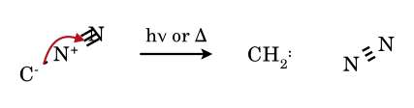
The C–N σ pair leaves with N₂; the carbanion lone pair that was on carbon becomes the lone pair of the carbene. The product is first a singlet methylene (lone pair + empty p), which decays to the triplet ground state.
10.2 α-Elimination: chloroform + HO⁻ → :CCl₂
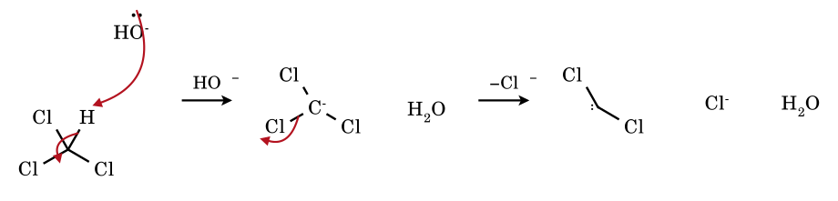
Hydroxide removes the single proton of CHCl₃ (pK_{a} ≈ 24) to give ⁻CCl₃; the carbanion expels chloride from the same carbon (α-elimination) to give dichlorocarbene. The lone pair on carbon is the carbene lone pair; the empty p orbital is the electrophilic site.
10.3 Dichlorocarbene + cyclohexene: concerted syn-cyclopropanation (singlet)
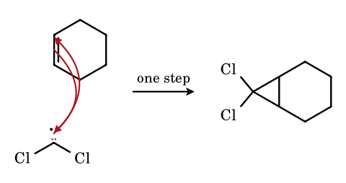
The alkene π electrons attack the empty p orbital of the carbene while the carbene lone pair forms the second C–C bond: both bonds form simultaneously on the same face of the alkene, so the stereochemistry of the alkene is retained (stereospecific syn addition). The product is 7,7-dichlorobicyclo[4.1.0]heptane (a cis-fused, achiral meso compound).
10.4 Carbene C–H insertion: :CH₂ + ethane → propane
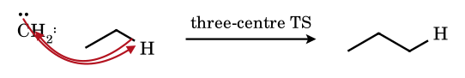
In the singlet insertion the C–H σ electrons attack the empty p orbital of the carbene while the carbene lone pair accepts the hydrogen: a single three-centre transition state with retention at the attacked carbon. Triplet carbenes insert by abstraction–recombination, which loses stereochemistry.
10.5 Wolff rearrangement: α-diazoketone → ketene
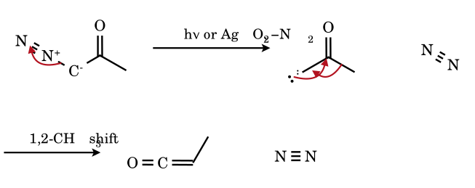
Loss of N₂ gives an α-ketocarbene; the substituent on the carbonyl carbon migrates with its bonding pair to the electron-deficient carbene carbon while the carbene lone pair forms the C=C of the ketene (the migrating group moves to the carbon that was the carbene). Water traps the ketene as the carboxylic acid with one more carbon (Arndt–Eistert chain extension): R–COCl → R–CO–CHN₂ → R–CH₂COOH.
10.6 Simmons–Smith: iodomethylzinc iodide + cyclohexene → norcarane
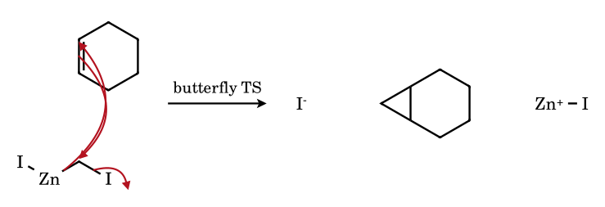
The carbenoid is not a free carbene: the CH₂ is delivered, with simultaneous loss of iodide, from the carbon bound to zinc to both alkene carbons in a three-centre ‘butterfly’ transition state. The addition is stereospecific syn and is accelerated by an allylic OH group that coordinates zinc (the directing effect), which free :CH₂ would not show.

10.5 The Reimer–Tiemann and carbylamine reactions in detail
10.7 Reimer–Tiemann: phenoxide attacks dichlorocarbene at the ortho carbon
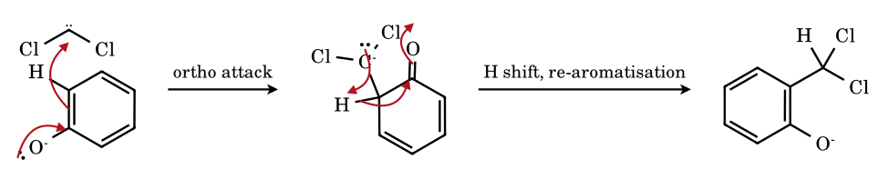
The phenoxide ring is the nucleophile (the negative charge is shared with the ortho and para carbons). It attacks :CCl₂; the resulting dienone carbanion regains aromaticity by a proton shift to give the o-(dichloromethyl)phenoxide. Hydroxide then hydrolyses the benzal chloride (ArCHCl₂) twice to ArCH(OH)₂ → ArCHO. The ortho product predominates because Na⁺ chelates phenoxide O and the carbene; the para isomer is the minor product.
10.8 Carbylamine reaction, first step: primary amine + dichlorocarbene
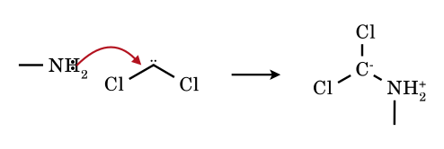
The nitrogen lone pair attacks the empty p orbital of the carbene to give a zwitterion (ammonium/carbanion). Two successive deprotonation–dechlorination steps (base removes N–H, Cl⁻ leaves) then convert R–NH₂⁺–CCl₂⁻ into R–N⁺≡C⁻, the isocyanide: the isocyanide carbon is itself a carbene-like divalent carbon (R–N⁺≡C⁻ ↔ R–N=C:).

10.7 Electronic structure in depth: why CH₂ is a triplet and CF₂ a singlet
The valence orbitals of a bent carbene are a σ orbital (an sp²-like hybrid on carbon, holding the non-bonding pair in the singlet) and a nearly pure p orbital perpendicular to the molecular plane. The two non-bonding electrons can occupy them in two ways: singlet (σ² p⁰, spins paired, ¹A₁) or triplet (σ¹ p¹, spins parallel, ³B₁). The singlet–triplet energy gap ΔE_{ST} = E(singlet) − E(triplet) decides the chemistry.
Carbene | Ground state | ΔE_{ST} (kcal mol⁻¹, recalled) | H–C–H / X–C–X angle | Remark
:CH₂ | triplet (³B₁) | triplet lower by ≈ 9 | ≈ 134° (T), ≈ 102° (S) | the singlet is formed first from CH₂N₂ photolysis, then decays to the triplet in a dilute gas phase
:CHCl, :CHBr | singlet | singlet lower by a few | — | halogen lone pair donates into the empty p
:CF₂ | singlet | singlet lower by ≈ 56 | ≈ 105° | the strongly π-donating, σ-withdrawing F raise the p orbital and lower the σ orbital
:CCl₂ | singlet | singlet lower by ≈ 13 | ≈ 109° | electrophilic carbene, most used in the laboratory
:CH–OH, :C(OCH₃)₂ | singlet | singlet lower by ≥ 10–25 | — | O lone pair → empty p orbital
(R₂N)₂C: (NHC) | singlet | singlet lower by ≈ 80 | N–C–N 101–105° | stable, isolable (Arduengo 1991); nucleophilic
:CPh₂ | triplet | triplet lower by ≈ 3 | ≈ 150° | phenyls delocalise the unpaired electron (benzylic radical-like) and widen the angle; diphenylcarbene is persistent in a rigid matrix (EPR)
fluorenylidene | triplet (≈ degenerate) | ≈ 1 | — | both states react; photolysis of 9-diazofluorene gives mixtures
:C=C=C (vinylidene), :C=CH₂ | singlet | — | linear-like | rearranges to acetylene by 1,2-H shift
HC≡C–C–H (propargylene) | triplet | — | bent | diradical character
- Rule. A carbene is singlet when the σ–p gap is large (> 2 eV, ≈ 46 kcal mol⁻¹), triplet when it is small (< 1.5 eV). Substituents that raise the p orbital (π-donors: N, O, S, halogens, through donation of a lone pair into the empty p orbital) and those that lower the σ orbital (σ-acceptors/electronegative: F, Cl, OR, NR₂ through −I) both stabilise the singlet. Conjugating, bulky or σ-donating groups (H, alkyl, aryl, silyl) narrow the gap and favour the triplet.
- Bond angle follows multiplicity. A smaller angle (≈ 100–110°, more p-character in the σ lone pair, singlet) versus a larger angle (≈ 130–180°, triplet: the linear limit of a carbon with two sp bonds and two p electrons in degenerate p orbitals is a ³Σ⁻ triplet).
- Physical consequences. Singlet carbenes react in concerted, stereospecific steps (zwitterionic character: lone pair nucleophilic, p orbital electrophilic); triplet carbenes react as diradicals (H-atom abstraction, stepwise additions, loss of stereochemistry). Triplet carbenes are paramagnetic and give EPR signals (zero-field splitting D ≈ 0.4 cm⁻¹ for CH₂, 0.4 for Ph₂C) which is how diphenylcarbene was identified (Wasserman, Hutton, 1962; first triplet organic carbene seen by ESR).
- Heavier analogues. Silylenes (SiH₂: singlet, gap 21 kcal mol⁻¹), germylenes, stannylenes and plumbylenes are singlet ground states with ever-growing stability (inert-pair effect); SiCl₂, SnCl₂, PbCl₂ are isolable.

10.8 Generation of carbenes: a complete catalogue
Method | Precursor and conditions | Notes and examples
Diazoalkane decomposition | R₂C=N₂, hν, Δ, or metal (Cu, Rh₂(OAc)₄, Pd(OAc)₂) | CH₂N₂ (from N-methyl-N-nitrosourea or Diazald + base) → :CH₂ + N₂; with metals, metal carbenoids (more selective, bear no free CH₂); explosive and toxic, handle dilute in ether
α-Diazoketones | RCOCHN₂, Ag₂O/H₂O (Arndt–Eistert) or hν | acylcarbene → Wolff rearrangement to ketene → homologated acid/ester/amide (RCOOH → RCH₂COOH via RCOCl + CH₂N₂)
Diazirines | 3H-diazirines (cyclic, 3-membered, C(N=N)); hν (350 nm) | small, stable photolabile source of carbenes (aryl-CF₃-diazirine) used in photoaffinity labelling; also isomerises to the linear diazo compound
Tosylhydrazone salts | R₂C=N–NHTs + NaOMe/Δ (Bamford–Stevens); R₂C=N–NHTs + 2 RLi (Shapiro) | aprotic solvent: carbene (then alkene by 1,2-H shift); protic solvent: carbocation by protonation of the diazo compound; Shapiro: vinyl-lithium via α-elimination of sulfinate, no carbene
Ketene photolysis | CH₂=C=O, hν (λ < 330 nm) | → :CH₂ + CO (historic method for ³CH₂ in the gas phase)
α-Elimination of haloforms | CHX₃ + KOH/tBuOK, or PTC (BnEt₃N⁺Cl⁻, 50 % NaOH) | CCl₃⁻ → :CCl₂ + Cl⁻; CHBr₃ → :CBr₂; CHI₃ would give :CI₂ but is not used
Decarboxylation of trihaloacetate | Cl₃CCOONa, 80–90 °C (DME) or ClCF₂COONa, 180 °C | Cl₃C–COO⁻ → CCl₃⁻ + CO₂ → :CCl₂; neutral conditions, no HO⁻
Organomercurials (Seyferth) | PhHgCCl₂Br, PhHgCCl₃, PhHgCF₃/NaI, Δ | neutral, base-free source of :CCl₂, :CBrCl, :CF₂; mercury is toxic, rarely used now
Reduction of gem-dihalides | CH₂I₂ + Zn(Cu) (Simmons–Smith); CH₂I₂ + Et₂Zn (Furukawa); CH₂Cl₂/BuLi | carbenoid ICH₂ZnI (not free :CH₂); stereospecific syn, directed by allylic OH; ClCH₂Li at −100 °C
Fragmentation of strained rings | cyclopropenes, oxiranes (deoxygenation), thiiranes, epoxy-ketones | cyclopropene → vinylcarbene (reversible); photolysis of bicyclic azirines/cyclopropenones: PhC≡CPh via ring opening, giving :C=O
Photolysis of ketones/alkenes | alkenes (Hg-sensitised) → vinylidenes; allene; 1,2-shifts | H₂C=C: from acetylene by 1,2-H shift (reverse of the alkyne ⇌ vinylidene rearrangement)
Dehydrohalogenation of vinyl halides | R₂C=CHX, KOtBu | 1,1-elimination gives vinylidene :C=CR₂, 1,2-H shift → alkyne (Fritsch–Buttenberg–Wiechell)
Metal-bound carbenes | R₂C=N₂ + LnM (Rh, Cu, Pd, Ru); Fischer-type (CO)₅W=C(OMe)Ph | no free carbene; metal–carbene complex transfers CR₂; important in catalytic cyclopropanation, C–H functionalisation, olefin metathesis (Grubbs, Schrock)
Deprotonation of azolium salts | imidazolium/thiazolium + base (KOtBu, NaH) | NHC; thiazolium carbene is the active catalyst of thiamine (vitamin B₁) and benzoin/Stetter reactions
Reaction of alkyl dihalide with base | CH₂Cl₂, NaNH₂ / CH₂Cl₂, KOtBu (weak) | :CHCl; the haloform route is easier than for CH₂Cl₂ because CCl₃⁻ is more stable

10.9 Reactions of carbenes: a systematic survey

(a) Addition to C=C: cyclopropanation, with Skell’s stereochemical test
- Singlet carbenes add in a single concerted, stereospecific syn step (non-linear approach in which the alkene π electrons enter the empty p orbital while the carbene lone pair attacks the other carbon): cis-2-butene gives cis-1,2-dimethylcyclopropane; trans-2-butene gives only the trans isomer (Skell 1956; Doering).
- Triplet carbenes add in two steps: the first bond gives a 1,3-diradical whose spin must flip before ring closure; internal rotation about C–C competes with closing, so both cis- and trans-cyclopropanes arise from either alkene isomer (with a stereospecificity that falls as the pressure of the gas falls and the lifetime of the diradical rises). Photosensitised (benzophenone) photolysis of diazomethane gives ³CH₂: cis-2-butene → 1:1 cis/trans.
- Dichlorocarbene is an electrophile: its addition is faster to electron-rich alkenes. Approximate order of reactivity: Me₂C=CMe₂ > Me₂C=CHMe > Me₂C=CH₂ > cis-RCH=CHR > RCH=CH₂ > CH₂=CH₂ > electron-poor alkenes (acrylonitrile is almost inert); dichlorocarbene adds to a styrene double bond faster than to a simple alkene. Unsubstituted methylene (¹CH₂) is far less selective (add to every π bond and insert into every C–H).
- Diastereoselectivity. Simmons–Smith cyclopropanation is directed syn to a hydroxyl or ether group on an allylic carbon (the zinc coordinates oxygen); free-carbene additions are controlled by sterics (attack from the less hindered face); bicyclic alkenes (norbornene) give exo products.
- Ring expansion by dihalocarbene. Indole + CHCl₃/NaOEt → 3-chloroquinoline; pyrrole → 3-chloropyridine (Ciamician–Dennstedt rearrangement): the dihalocyclopropane intermediate opens with expulsion of Cl⁻. Cyclic alkenes yield the cyclopropane that can be ring-opened to a ring-expanded cycloalkene (e.g. 7,7-dihalonorcarane + Ag⁺ → 2-halocycloheptenyl cation: used to make cycloheptene derivatives).

(b) Insertion into σ bonds
- Singlet CH₂ inserts into C–H bonds indiscriminately (1° : 2° : 3° ≈ 1 : 1.2 : 1.5 per H in solution, recalled): pentane + CH₂N₂/hν gives hexane, 2-methylpentane and 3-methylpentane in roughly statistical ratio. The insertion has a three-centre TS; the configuration at the carbon is retained when chiral (insertion at a chiral centre proceeds with retention, in concerted insertion).
- Triplet CH₂ reacts by abstraction–recombination: ³CH₂ + R–H → •CH₃ + R• then recombination; thus the products show scrambling and radical by-products (ethane).
- X–H insertion (O–H, N–H, S–H, Si–H, Sn–H): ROH + :CH₂ → ROCH₃ via an oxonium ylide (R–O⁺H–CH₂⁻) and a 1,2-proton shift; with metal carbenoids this is the basis of Rh₂(OAc)₄-catalysed O–H and N–H insertion (β-lactam synthesis in the penem route, Merck thienamycin synthesis).
- Intramolecular C–H insertion by a rhodium carbenoid builds five-membered rings with high selectivity (1,5-insertion preferred; tertiary > secondary > primary C–H; Taber, Doyle). Free carbenes give mixtures; catalysts control site selectivity.
- C–C insertion of carbenes is rare. C–halogen insertion: halocarbenes insert into C–X to give gem-dihalides through ylide formation.

(c) Ylide formation (Doyle–Kirmse, Stevens, carbonyl ylides)
A carbene reacts with a lone pair on O, S, N or halogen to give an onium ylide, which can (i) undergo a proton shift (insertion product), (ii) a [2,3]-sigmatropic rearrangement if an allyl group is on the heteroatom (Doyle–Kirmse: allyl sulfide + diazoacetate/Rh → homoallyl sulfide), (iii) a [1,2]-Stevens shift, (iv) cycloaddition with a dipolarophile if the ylide is a carbonyl ylide (from carbonyl + carbene: [3+2] with alkenes gives tetrahydrofurans), or (v) a Corey–Chaykovsky epoxide when a sulfur ylide is prepared by deprotonation.

(d) Rearrangements of carbenes
Process | Equation | Comment
1,2-Hydride shift | R–CH₂–C̈–R′ → RCH=CHR′ | very fast, k ≈ 10⁷–10¹⁰ s⁻¹; the reason alkylcarbenes (CH₃CH:) rarely give intermolecular reactions, and why Bamford–Stevens in aprotic solvent gives alkenes
1,2-Alkyl/aryl shift | R–C̈–C(R′)₃ → alkene | slower than hydride; neopentylidene gives 2-methyl-2-butene via methyl shift
Wolff rearrangement | RCO–C̈–R′ → R(R′)C=C=O | acylcarbene → ketene (the migrating R retains configuration); basis of Arndt–Eistert homologation and ring contraction of cyclic α-diazoketones (e.g. 2-diazocyclohexanone → cyclopentanecarboxylic acid)
Cyclopropylcarbene → cyclobutene | ring expansion | also cyclobutylidene → methylenecyclopropane; used to interconvert strained rings
Vinylcarbene ⇌ cyclopropene | — | photolysis of cyclopropenes gives vinylcarbenes; vinylcarbene → cyclopropene thermally; used to make furans and indenes
Aryl carbene ring expansion | PhC̈H → cycloheptatetraene (strained cyclic allene) | phenylcarbene/benzocyclopropene interconversion; trapped by amines (Wentrup)
Vinylidene → acetylene | R₂C=C: → RC≡CR (1,2-shift) | Fritsch–Buttenberg–Wiechell
Bridgehead/bicyclic carbene fragmentation | carbene loses N₂ then adds across a nearby π bond | used to build tricyclic skeletons (Buchner’s ester)

(e) Reactions with arenes: Buchner ring expansion
Carbenes add to benzene to give the norcaradiene (bicyclo[4.1.0]hepta-2,4-diene), which opens in a thermally allowed, disrotatory 6π electrocyclic reaction to cycloheptatriene (Buchner 1885: ethyl diazoacetate + benzene, Cu or Rh). Electron-withdrawing substituents at C-7 stabilise the norcaradiene valence tautomer (equilibrium). In intramolecular variants (Buchner–Curtius–Schlotterbeck), α-diazoketones with aryl tethers give azulenones.

10.10 Carbenoids: the ‘free carbene’ is the exception
- A carbenoid is a species with carbene-like reactivity but in which the divalent carbon is bound to a metal and leaving group: LiCH₂Cl, ICH₂ZnI, [Rh]=CHCO₂Et, MeCCl₂Li (Doering–LaFlamme). It transfers CR₂ in a single concerted step (the metal delivers the carbon with its leaving group still partially bound), with selectivity patterns different from the free carbene.
- Simmons–Smith (Zn–Cu couple, CH₂I₂, ether): I–CH₂–Zn–I (zinc carbenoid) adds to the alkene through a three-centre ‘butterfly’ TS to give the cyclopropane with retention of alkene geometry. Reaction with electron-rich alkenes is faster; allylic alcohols and ethers direct the addition syn. Furukawa modification: Et₂Zn replaces Zn(Cu). Charette: enantioselective with chiral dioxaborolane ligands.
- Doering–LaFlamme allene synthesis: 1,1-dihalocyclopropane + RLi (or Mg) → carbenoid → cyclopropylidene → ring opening to the allene (via disrotatory electrocyclic opening). Combined with dihalocarbene addition, it converts an alkene R₂C=CR₂ into an allene R₂C=C=CR₂ with one more carbon.
- Rh₂(OAc)₄ and Cu(acac)₂-catalysed decompositions of diazo compounds proceed via a metal carbenoid (M=CR₂); chiral Rh₂(S-DOSP)₄ and Cu–bis(oxazoline) give enantioselective cyclopropanations (Davies, Doyle, Pfaltz; Nobel-related work in asymmetric catalysis). The first commercial application was the synthesis of the pyrethroid insecticide chrysanthemic ester (Aratani, Sumitomo).
- Fischer carbenes (CO)₅Cr=C(OMe)R: a low-oxidation-state metal with π-acceptor ligands makes the carbene carbon electrophilic (attack by nucleophiles at C), whereas Schrock carbenes (high-oxidation-state early metals, e.g. Ta(=CHtBu)) are nucleophilic at C. Grubbs/Schrock olefin-metathesis catalysts are metal alkylidenes: [2+2] with an alkene gives a metallacyclobutane which cycloreverts to a new alkene and a new carbene (Chauvin mechanism; Nobel Prize 2005).

10.11 Stable carbenes: from curiosity to catalysts
- Wanzlick (1960s) proposed N-heterocyclic carbenes; Arduengo isolated the first crystalline NHC (1,3-di-adamantylimidazol-2-ylidene, 1991) by deprotonation of the imidazolium chloride with NaH/DMSO. Bertrand reported the first stable acyclic carbene (phosphino-silyl, 1988) and cyclic (alkyl)(amino)carbenes (CAAC).
- Why NHCs are stable. (i) Two adjacent nitrogen atoms donate their lone pairs into the empty carbene p orbital (π-donation, aromatic six-π-electron imidazole ring), (ii) the electronegative nitrogens inductively stabilise the σ lone pair, which raises the singlet–triplet gap to ≈ 80 kcal mol⁻¹, (iii) bulky N-substituents (adamantyl, 2,6-diisopropylphenyl, mesityl) prevent dimerisation to the tetra-aminoethylene (Wanzlick equilibrium).
- Reactivity of NHCs: strongly σ-donating and nucleophilic; excellent ligands for metals (Grubbs II, Pd–PEPPSI), organocatalysts for the benzoin condensation (aryl aldehyde → benzoin), Stetter (aldehyde + Michael acceptor), umpolung of aldehydes; the same pattern as thiamine pyrophosphate (thiazolium ylide) in pyruvate decarboxylase and transketolase.
- Link to Part 8: an NHC adds to PhCHO to give the Breslow intermediate (an enaminol), the acyl-anion equivalent. This is the NHC equivalent of the cyanohydrin anion (mechanism 8.9) used for the benzoin condensation: both achieve ‘umpolung’ (polarity inversion) of the carbonyl carbon.

10.12 Evidence for carbenes and experimental techniques
- Trapping with alkenes (cyclopropane), with O–H/N–H/Si–H, or with a cheletropic acceptor; the stereochemistry reveals the spin state (Skell test).
- Matrix-isolation IR/UV (argon, 10 K) identifies the carbene directly; ESR detects triplets (³CH₂ by Wasserman, Ph₂C: by Hutton).
- Laser flash photolysis gives lifetimes: Ph₂C: ≈ 1 μs in solution, reacting with methanol (O–H insertion) at ≈ 10⁸ M⁻¹ s⁻¹ (singlet) and with O₂ at 10⁹ (triplet); the product ratio with alcohol versus with O₂/alkene identifies the state in equilibrium.
- Isotope and cross-over experiments: Hine showed that :CCl₂ from CHCl₃/HO⁻ is formed in a reversible deprotonation (H/D exchange of CHCl₃ in D₂O/OD⁻ is faster than hydrolysis) followed by the rate-limiting loss of Cl⁻ (so CCl₃⁻ is an intermediate; the rate law is first order in HO⁻ and in CHCl₃, retarded by added Cl⁻: common-ion effect, the signature of S_{N}1-like rate-determining α-elimination).
- Hydrolysis of CHCl₃ by the carbene path gives formate and CO: :CCl₂ + 2 HO⁻ → CO + 2 Cl⁻ + H₂O (and, with more hydroxide, HCOO⁻).
Typical errors in carbene questions. (1) Calling a carbene ‘electron-deficient with a positive charge’: it is neutral with a sextet. (2) Assuming all carbenes give stereospecific syn addition; only singlets do. (3) Giving a carbocation product under Bamford–Stevens conditions: it depends on the solvent. (4) Forgetting that the Reimer–Tiemann reaction yields mainly the ortho aldehyde (via the phenoxide), and that para is minor. (5) Writing :CCl₂ inserting into C–H bonds: dichlorocarbene prefers addition to C=C. (6) Using :CH₂ from CH₂Cl₂/base in exam questions where Simmons–Smith is meant: CH₂I₂/Zn–Cu gives a carbenoid, not free methylene. (7) Mistaking Wolff for a carbocation 1,2-shift: the carbene α to carbonyl rearranges concertedly with loss of N₂; a tertiary R group migrates with retention.

10.13 Additional validated mechanisms
10.9 Buchner ring expansion: benzene + :CH₂ → norcaradiene → cycloheptatriene
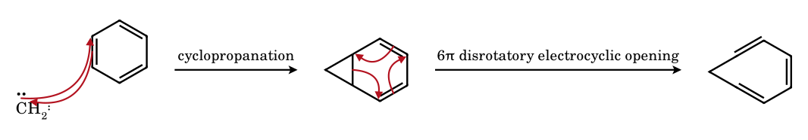
Methylene adds to one π bond of benzene (cyclopropanation) to give norcaradiene, a cyclohexadiene with a cyclopropane fused at C-1/C-6. The cyclopropane σ bond shared with the six-membered ring and the two double bonds form a 6π electron system (σ + π + π); thermally, a disrotatory electrocyclic ring-opening gives the seven-membered cycloheptatriene (the two valence tautomers interconvert; electron-withdrawing groups at C-7 favour norcaradiene).
10.10 Triplet methylene adds stepwise: diradical intermediate, then ring closure after spin flip
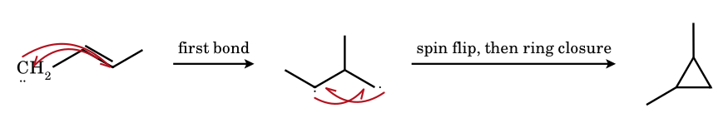
In the triplet the two non-bonding electrons have parallel spin, so the first bond leaves a 1,3-diradical that cannot close until a spin flip (intersystem crossing) converts it into a singlet. During this time (10⁻¹⁰–10⁻⁹ s) rotation about the former C=C bond can occur, so cis- and trans-2-butene both give a mixture of cis- and trans-1,2-dimethylcyclopropane: the lack of stereospecificity is the experimental signature of the triplet (Skell).
10.11 Diazomethane esterification: no carbene, a protonation / S_{N}2 sequence
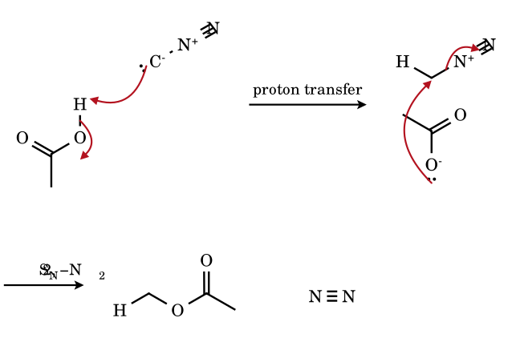
The nucleophilic carbon of CH₂N₂ is protonated by the acid (pK_{a} ≲ 10 needed), giving the methyldiazonium ion – an extremely good alkylating agent (leaving group N₂) – which is attacked by the carboxylate in an S_{N}2 step. Diazomethane therefore methylates carboxylic acids and phenols quantitatively under mild conditions, though no free CH₂ appears; it is the same compound that gives :CH₂ on photolysis.
10.12 Doering–LaFlamme: cyclopropylidene → allene (disrotatory electrocyclic ring opening)

The cyclopropylidene (formed from a 1,1-dihalocyclopropane and BuLi or Mg through the α-halo-lithium carbenoid) opens by breaking the distal C–C bond of the ring. The carbene lone pair and the σ electrons of the C2–C3 bond are converted into the two C=C π bonds of the allene: the process is a two-electron ring-opening that releases the cyclopropane strain (27 kcal mol⁻¹) and converts a carbene into a stable cumulene. Together with the addition of :CBr₂ to an alkene, it converts C=C into C=C=C with one additional carbon.

10.14 Problems on carbenes
CE-1.
How many valence electrons does the carbon atom of a carbene have, and how many are non-bonding?
Answer: 6; 2 non-bonding
Two electrons in each of the two σ bonds, plus two non-bonding electrons (a lone pair in the singlet; two unpaired electrons in the triplet) = 6 around carbon, an incomplete octet.
CE-2.
Which statements about singlet methylene are correct? (A) sp², bent, H–C–H ≈ 103°; (B) paramagnetic; (C) shows stereospecific syn addition to alkenes; (D) has an empty p orbital.
Answer: (A), (C), (D)
Singlet CH₂ has a filled sp² lone pair and an empty p orbital; it is diamagnetic (all electrons paired). Triplet methylene is paramagnetic with H–C–H ≈ 136°.
CE-3.
The addition of singlet :CBr₂ to cis-but-2-ene gives how many products, and what are they? What happens with a triplet carbene?
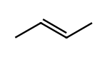
Answer: singlet: one (cis-1,1-dibromo-2,3-dimethylcyclopropane, meso); triplet: two (cis and trans)
Concerted syn addition retains the cis relationship of the two methyl groups, giving the achiral meso cyclopropane. A triplet carbene adds stepwise through a 1,3-diradical that can rotate before the second bond closes, giving cis and trans (the trans is chiral, as a racemate).
CE-4.
Phenol is heated with CHCl₃ and aqueous NaOH, and then acidified. Name the major and minor organic products and the electrophile.
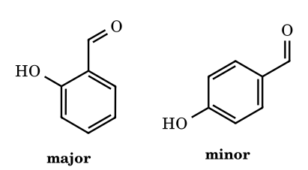
Answer: salicylaldehyde (major) and p-hydroxybenzaldehyde (minor); electrophile :CCl₂
Hydroxide converts CHCl₃ into :CCl₂ (electrophilic carbene) and phenol into phenoxide (activated ring). Ortho attack is favoured by Na⁺ chelation. Replace CHCl₃ by CCl₄ and the product is salicylic acid.
CE-5.
Which of the following give a positive carbylamine test? (a) CH₃NH₂, (b) (CH₃)₂NH, (c) C₆H₅NH₂, (d) (CH₃)₃N, (e) CH₃CONH₂, (f) C₆H₅NHCH₃.
Answer: (a) and (c)
The sequence R–NH₂ + :CCl₂ → R–N⁺≡C⁻ needs two N–H bonds that can both be lost. Secondary (b, f) and tertiary (d) amines lack them and amides (e) are not nucleophilic enough.
CE-6.
Arrange in decreasing stability: :CF₂, :CCl₂, :CBr₂, :CI₂.
Answer: :CF₂ > :CCl₂ > :CBr₂ > :CI₂
π back-donation from the halogen lone pair into the empty carbon p orbital is best for the 2p orbital of fluorine (similar size and energy); it decreases as the halogen orbital becomes larger and more diffuse. (Part 5D, problem D-38, statement vi.)
CE-7.
Name the carbene (or carbenoid) and the product when cyclohexene reacts with (a) CH₂I₂ + Zn–Cu, (b) CHBr₃ + KOtBu, (c) CH₂N₂ + hν.
Answer: (a) ICH₂ZnI (carbenoid) → norcarane; (b) :CBr₂ → 7,7-dibromonorcarane; (c) :CH₂ → norcarane (plus C–H insertion products)
Each adds one carbon across the double bond to give a bicyclo[4.1.0]heptane. Free :CH₂ from diazomethane also inserts into C–H bonds and gives a mixture (low selectivity); the Simmons–Smith carbenoid is the clean method.
CE-8.
What is the product of the Arndt–Eistert sequence starting from CH₃COOH? (i) SOCl₂; (ii) CH₂N₂; (iii) Ag₂O, H₂O.
Answer: propanoic acid, CH₃CH₂COOH
CH₃COCl + CH₂N₂ → CH₃COCHN₂; Ag₂O gives the carbene, Wolff shift gives CH₃CH=C=O (methylketene), water gives CH₃CH₂COOH: homologation by one CH₂.
CE-9.
Which of the following is not a method of generating a carbene? (A) CHCl₃ + KOH, (B) CH₂N₂ + hν, (C) CH₂=C=O + hν, (D) CH₃Cl + AlCl₃.
Answer: (D)
CH₃Cl + AlCl₃ gives CH₃⁺ (a carbocation, Friedel–Crafts), not a carbene.
CE-10.
Hydrolysis of CHCl₃ with aqueous alkali would be expected to give HCOOH via :CCl₂. Write the intermediate sequence.
Answer: CHCl₃ → CCl₃⁻ → :CCl₂ → HCCl(OH)… → HCOO⁻
Hydroxide removes the proton (carbanion), Cl⁻ is lost (carbene), the carbene is attacked by HO⁻ and the resulting dichlorohydrin/formyl species loses two Cl⁻ to give formate (or CO + HCl). This is the same carbene that does the Reimer–Tiemann reaction.
CE-11.
Why is the triplet the ground state of methylene while the singlet is the ground state of :CF₂?
Answer: π-donation and electronegativity
In CH₂ the two non-bonding orbitals (σ and p) are close in energy (≈ 9 kcal mol⁻¹), so Hund’s rule puts one electron in each. In :CF₂ the fluorine lone pairs donate into the empty p orbital and raise its energy, while the σ-withdrawing F lowers the energy of the σ orbital: the gap widens (≈ 56 kcal mol⁻¹) and the singlet becomes the ground state.
CE-12.
A stable, crystalline carbene is made from an imidazolium salt and a base. Which features make it stable?
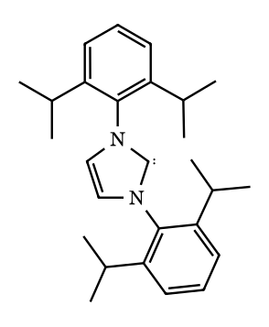
Answer: two π-donating N atoms and bulky N-substituents
The two nitrogen lone pairs donate into the empty p orbital (singlet stabilised, amidine-like resonance) and the σ-withdrawing N atoms lower the σ lone pair energy; the large aryl groups prevent dimerisation to the tetraaminoethylene. Arduengo (1991).
CE-13.
Predict the products and the stereochemistry: (a) cis-2-butene + CH₂N₂/hν (direct photolysis, dilute in liquid), (b) cis-2-butene + CH₂N₂/hν/benzophenone, (c) trans-2-butene + CHCl₃/KOtBu.
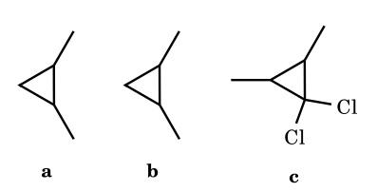
Answer: (a) cis-1,2-dimethylcyclopropane only (plus C–H insertion products); (b) mixture of cis and trans; (c) trans-1,1-dichloro-2,3-dimethylcyclopropane (stereospecific)
(a) singlet CH₂ (direct photolysis): one-step, stereospecific syn addition. (b) triplet sensitisation: stepwise diradical, scrambling of stereochemistry. (c) :CCl₂ is a singlet; the trans-alkene stereochemistry is preserved.
CE-14.
How many monobromo/mono-methylated insertion products (C_{n+1} alkanes) are formed when singlet methylene reacts with propane? Estimate the ratio assuming statistical insertion (1° : 2° = 1 : 1.2 per H).
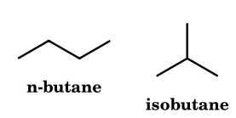
Answer: 2 products: n-butane : isobutane = 6 : 2.4 = 71 : 29 (statistical would be 75 : 25)
Insertion into a 1° C–H (6 H) gives n-butane; into the 2° C–H (2 H) gives isobutane (2-methylpropane). Weights 6 × 1 = 6 and 2 × 1.2 = 2.4.
CE-15.
Account for the fact that CHCl₃ + OD⁻ in D₂O exchanges H for D faster than it hydrolyses, and that the hydrolysis is retarded by added Cl⁻.
Answer: reversible carbanion formation followed by rate-limiting loss of Cl⁻
CHCl₃ + HO⁻ ⇌ CCl₃⁻ + H₂O (fast, reversible: D exchange); CCl₃⁻ → :CCl₂ + Cl⁻ (slow); :CCl₂ + H₂O/HO⁻ → CO + HCOO⁻. Added chloride pushes the second step backwards (common-ion effect), exactly as in an S_{N}1 reaction (Hine, 1950s).
CE-16.
Arrange in decreasing order of stability of the singlet over the triplet: :CH₂, :CHF, :CF₂, :C(OCH₃)₂, :CPh₂.
Answer: :CF₂ ≈ :C(OCH₃)₂ > :CHF > :CH₂ (triplet ground) > :CPh₂ (triplet ground, widest angle)
π-donation from lone pairs on F and O into the empty p orbital plus inductive stabilisation of the σ orbital favour the singlet; two such substituents act cumulatively. H and alkyl do not; conjugating phenyls favour the triplet.
CE-17.
An unknown carbene gives 100 % cis-cyclopropane from cis-2-butene in solution but a 1:1 cis/trans mixture in the gas phase at low pressure. Interpret.
Answer: singlet carbene that relaxes (intersystem crossing) to the triplet before reacting
In solution, collisions with solvent quickly deactivate the energy but the singlet reacts at once: stereospecific. At low pressure the initially formed singlet has a long time before reacting and collisions induce ISC to the triplet ground state, giving the stepwise, non-stereospecific path (Skell/Bader). The cross-over from stereospecific to non-stereospecific with dilution shows that the singlet is the initial state.
CE-18.
Phenol is heated with chloroform and NaOH. (a) Name the main product, (b) say why para isomer is minor, (c) identify the electrophile and write the intermediate before hydrolysis.
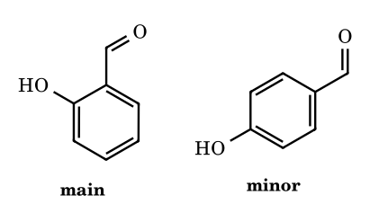
Answer: (a) salicylaldehyde (2-hydroxybenzaldehyde); (b) ion-pair / coordination of Na⁺ with the phenoxide and carbene directs ortho; (c) :CCl₂; the intermediate is the dichloromethyl cyclohexadienone which loses Cl⁻ to give the o-quinone methide-type chloride that is hydrolysed
Phenoxide is a strong activator; dichlorocarbene (electrophile) attacks the ortho (and para) carbon; Na⁺ coordination of the oxygen and the incoming carbene favour ortho (ortho : para ≈ 3 : 1). Hydrolysis of the ArCHCl₂ (aryl-CHCl₂ with phenoxide → o-quinone methide → ArCHO) gives the aldehyde. With CCl₄ the product is the carboxylic acid (salicylic acid) and with CHBr₃ the same aldehyde.
CE-19.
Give the products: (a) PhCOCl + CH₂N₂ (excess), then Ag₂O/H₂O/Δ; (b) the same with C₂H₅OH in place of water; (c) 2-diazocyclohexanone, hν, H₂O.
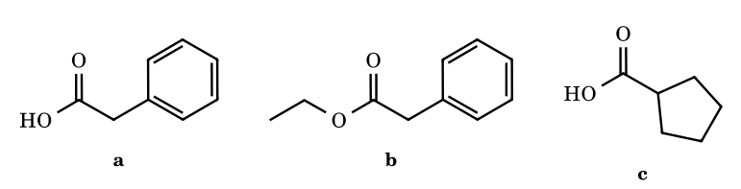
Answer: (a) phenylacetic acid; (b) ethyl phenylacetate; (c) cyclopentanecarboxylic acid
Arndt–Eistert: acid chloride + CH₂N₂ → diazoketone (second equivalent removes HCl as CH₃Cl); Ag⁺ catalyses Wolff rearrangement to a ketene PhCH=C=O; water or ethanol adds. In (c) the Wolff rearrangement contracts the ring by one carbon.
CE-20.
Explain why diazomethane methylates RCOOH and phenols (ArOH) but not alcohols (ROH) in the absence of a catalyst (BF₃ or HBF₄).
Answer: pK_{a} threshold for protonating CH₂N₂
The first step is proton transfer to carbon. The conjugate acid CH₃N₂⁺ is a very strong acid; CH₂N₂ is protonated significantly only by acids with pK_{a} ≲ 10 (carboxylic acids, phenols, enols, 1,3-dicarbonyls); alcohols (≈ 16) are too weak. A Lewis-acid catalyst makes the alcohol react.
CE-21.
Which of the following gives a free carbene? (a) CH₂I₂ + Zn(Cu); (b) CH₂N₂ + hν; (c) CHCl₃ + tBuOK; (d) Ph₂C=N₂ + Δ; (e) CH₂I₂ + Et₂Zn; (f) CH₂N₂ + CH₃COOH.
Answer: (b), (c), (d)
(a) and (e) give the zinc carbenoid ICH₂ZnI; (f) is protonation of CH₂N₂ and S_{N}2 (ester formation). The others lose N₂ or Cl⁻ to produce :CH₂, :CCl₂ and Ph₂C: respectively.
CE-22.
How many different constitutional isomers of C₇H₁₆ can be formed by insertion of singlet :CH₂ into the C–H bonds of 2-methylpentane?
Answer: 5
2-Methylpentane (CH₃)₂CH–CH₂–CH₂–CH₃ has five sets of non-equivalent hydrogens (C-1/C-1′, C-2, C-3, C-4, C-5). Insertion into each gives a different heptane: C-1–H → 3-methylhexane; C-2–H → 2,2-dimethylpentane; C-3–H → 2,3-dimethylpentane; C-4–H → 2,4-dimethylpentane; C-5–H → 2-methylhexane. All five are different constitutional isomers.
CE-23.
A student states that all carbenes are intermediates that add to alkenes with retention of alkene stereochemistry. Give two counterexamples.
Answer: triplet carbenes; carbenoids of different type
(1) ³CH₂ and Ph₂C: (triplet) add stepwise and scramble stereochemistry. (2) Metal carbenes (Fischer type) undergo [2+2]/metathesis rather than cyclopropanation. Also singlet carbenes with electron-poor alkenes can give nucleophilic ylide-type additions.
CE-24.
What is the product when bicyclo[4.1.0]heptane-7,7-dichloride (7,7-dichloronorcarane) is treated with methyllithium?
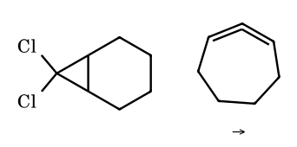
Answer: 1,2-cycloheptadiene (strained cyclic allene, via the carbenoid and the cyclopropylidene), trapped as a dimer or cycloadduct
Li/Cl exchange gives the carbenoid, loss of LiCl gives the bicyclic cyclopropylidene, which opens (Doering–LaFlamme) to the strained cyclic allene (1,2-cycloheptadiene) – isolable only as dimer or Diels–Alder adduct; with a more substituted ring the allene is isolable (eight-membered or larger).
CE-25.
Write a balanced equation for the complete alkaline hydrolysis of dichlorocarbene by hydroxide, and state the carbon-containing product.
Answer: :CCl₂ + 2 HO⁻ → CO + 2 Cl⁻ + H₂O (and HCOO⁻ with more hydroxide)
Hydroxide attacks the carbene carbon; loss of chloride and a proton shift give HO–C̈–Cl-type species that lose HCl to carbon monoxide. Under strongly basic conditions CO is further hydrated to formate (CO + HO⁻ → HCOO⁻). The formation of CO and formate in the hydrolysis of chloroform was part of the evidence for :CCl₂ (Hine).
CE-26.
Dichlorocarbene is added to buta-1,3-diene. How many constitutional isomers form from one equivalent of carbene? How many stereoisomers are possible when two equivalents add to give the bis-cyclopropane?
Answer: 1 constitutional isomer (1,1-dichloro-2-vinylcyclopropane, as a racemate); the bis-adduct has 3 stereoisomers (R,R; S,S; meso)
Carbenes add 1,2 to a conjugated diene (no 1,4-addition). Both double bonds of butadiene are equivalent, so one monoadduct forms. In the bis-adduct 2,2,2′,2′-tetrachloro-bicyclopropyl the two ring carbons attached to each other are stereocentres: (R,R), (S,S) and the meso (R,S) form.
CE-27.
What are the intermediate and the final product of heating the sodium salt of trichloroacetic acid in the presence of cyclohexene?
Answer: CCl₃⁻ → :CCl₂; 7,7-dichloronorcarane
Decarboxylation of Cl₃CCOO⁻ gives the trichloromethyl carbanion without needing HO⁻, so a base-sensitive alkene or ester can be cyclopropanated under neutral conditions (Wagner, 1954).
CE-28.
Compare the stability and the reaction type of a carbene, a carbocation, a carbanion and a radical in a table (valence electrons on carbon, charge, geometry, typical role).
Answer: see table
CH₃⁺: 6 e, + charge, planar sp², electrophile; CH₃•: 7 e, neutral, planar-shallow pyramid, radical; CH₃⁻: 8 e, − charge, pyramidal sp³, nucleophile/base; :CH₂: 6 e, neutral, bent (singlet 102°, triplet 134°), ambiphilic (singlet) or diradical (triplet). Full comparison in Part 14.
CE-29.
How does the Bamford–Stevens reaction of a ketone tosylhydrazone differ from the Shapiro reaction, and how do the products differ for 2-methylcyclohexanone tosylhydrazone?
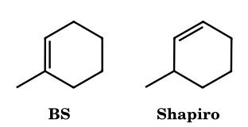
Answer: Bamford–Stevens (NaOMe, Δ): more substituted alkene (carbene, 1,2-H shift, thermodynamic: 1-methylcyclohexene); Shapiro (2 RLi): less substituted alkene (3-methylcyclohexene) via the less hindered vinyl-lithium
In the BS reaction a diazo compound/carbene (or carbocation in protic solvent) leads to the thermodynamic Zaitsev-type alkene; in the Shapiro reaction the dianion removes the more accessible, α′ proton syn to the N–Ts group and extrudes sulfinate and N₂ to give the vinyllithium (no carbene), which is protonated to the kinetic, less substituted alkene.
CE-30.
(Assertion–Reason) Assertion: dichlorocarbene reacts with propene faster than with acrylonitrile. Reason: dichlorocarbene is an electrophile. Choose.
Answer: both true; the reason explains the assertion
:CCl₂ has a vacant p orbital and attacks the electron-rich π bond; the CN group withdraws electron density from CH₂=CH–CN, so the reaction is slow.
CE-31.
A chiral ketone R(R′)CH–CO–CHN₂ with R and R′ different is subjected to the Wolff rearrangement. What is the configuration of the migrating carbon in the product acid R(R′)CH–CH₂COOH?
Answer: retention
The migrating group moves from the carbonyl carbon to the carbene carbon with its pair of electrons while retaining configuration, as in all 1,2-shifts to an electron-deficient centre with a concerted three-centre TS (Part 7).
CE-32.
Predict the product of the intramolecular reaction of 1-diazo-5-phenylpentan-2-one with Rh₂(OAc)₄ (Buchner) and name the ring formed.
Answer: a bicyclic azulenone (5–7 fused) via carbene attack on the phenyl ring
The rhodium carbenoid adds to the arene ring in an intramolecular manner (Buchner reaction) forming the norcaradiene which opens to the cycloheptatriene fused to a cyclopentanone: bicyclo[5.3.0]decatrienone (the azulenone skeleton).
CE-33.
Why does CH₂Cl₂ with KOtBu give less carbene than CHCl₃?
Answer: CHCl₂⁻ is a less stable carbanion than CCl₃⁻
The acidity of the substrate depends on the number of chlorines (pK_{a} ≈ 24 for CHCl₃, ≈ 32 for CH₂Cl₂), and the loss of Cl⁻ from CHCl₂⁻ gives the more reactive, less stable :CHCl.
CE-34.
What is the major difference in the products obtained from 1-hexene by (a) CH₂N₂/Cu₂Cl₂ and (b) CH₂N₂/hν?
Answer: (a) butylcyclopropane (selective, carbenoid); (b) butylcyclopropane plus C–H insertion products (isomeric heptenes and alkanes)
The copper carbenoid is selective for the C=C bond; free ¹CH₂ from photolysis reacts with every C–H bond and gives a mixture.
CE-35.
Methylene generated from the photolysis of ketene (CH₂=C=O) in the gas phase reacts with a large excess of N₂ (inert gas) at high pressure. Which spin state reacts and why?
Answer: triplet
Collisions with the inert gas relax ¹CH₂ (ISC) to the triplet ground state (≈ 9 kcal below) before reaction. The cis-2-butene products become a mixture of cis and trans dimethylcyclopropanes as the pressure rises (Frey).
CE-36.
Write the product of treating trans-stilbene with CHBr₃/50 % NaOH/PTC and then hot with Ag⁺. Name the types of reaction.
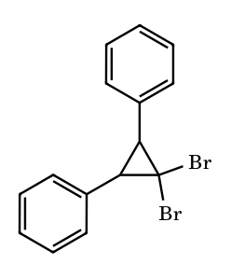
Answer: 1,1-dibromo-trans-2,3-diphenylcyclopropane; Ag⁺ ionises it to a cyclopropyl cation that ring-opens (disrotatory) to a substituted allyl cation (→ 2-bromo-1,3-diphenylallyl derivatives)
Cyclopropanation by :CBr₂ followed by silver-assisted electrocyclic ring-opening (Woodward–Hoffmann disrotatory) of the cyclopropyl cation: a stereospecific route to allylic bromides.
CE-37.
Rank the following by relative rate of addition of :CCl₂ (fastest first): ethylene, 2-methyl-2-butene, 1-hexene, tetramethylethylene, cis-2-butene.
Answer: tetramethylethylene > 2-methyl-2-butene > cis-2-butene > 1-hexene > ethylene
The electrophilic carbene reacts faster with more highly alkyl-substituted, electron-rich C=C bonds (hyperconjugative donation): the relative rate roughly tracks the number of alkyl groups (≈ 1 : 10 : 10²… in the Doering series).
CE-38.
Predict the products (count stereoisomers) of CH₂I₂/Zn–Cu with (a) cis-2-butene, (b) trans-2-butene.
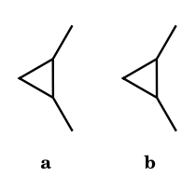
Answer: (a) one product, meso cis-1,2-dimethylcyclopropane; (b) trans-1,2-dimethylcyclopropane as a racemate (two enantiomers)
The carbenoid adds in one concerted syn step, so alkene geometry is retained. The cis product has a mirror plane (meso, achiral); the trans product has two stereocentres and no mirror plane, so it is chiral and forms as a 1 : 1 mixture of enantiomers.
CE-39.
Acetyl chloride is treated with excess CH₂N₂, and the product is heated with Ag₂O in water. Identify each product and the carbene-related step.
Answer: diazoacetone, then propanoic acid
CH₃COCl + 2 CH₂N₂ → CH₃COCHN₂ + CH₃Cl + N₂. Ag⁺ promotes loss of N₂ to an acylcarbene, which undergoes the Wolff rearrangement (CH₃ migrates) to the ketene CH₃CH=C=O; water adds to give CH₃CH₂COOH (one carbon added to the acid).
CE-40.
Dichlorocarbene reacts with norbornene. Give the major product and state its stereochemistry.
Answer: exo-3,3-dichlorotricyclo[3.2.1.0^{2,4}]octane
Attack occurs from the less hindered exo face of the strained double bond, giving the exo-fused dichlorocyclopropane. The addition is syn, as for any singlet carbene.
CE-41.
A thiazolium salt catalyses the benzoin condensation of benzaldehyde. Identify the carbene and the key intermediate, and say what is inverted.
Answer: thiazol-2-ylidene (NHC); the Breslow intermediate; the polarity of the carbonyl carbon (umpolung)
Base deprotonates C-2 of the thiazolium to give the NHC. It adds to PhCHO; proton transfer gives the Breslow enaminol, in which the former carbonyl carbon is nucleophilic (acyl-anion equivalent). It attacks a second PhCHO and the catalyst is expelled, giving benzoin.
CE-42.
p-Cresol undergoes the Reimer–Tiemann reaction. Give the normal product and the ‘abnormal’ product.
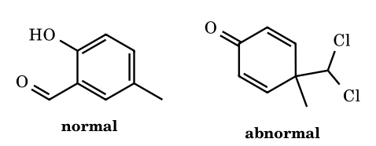
Answer: 2-hydroxy-5-methylbenzaldehyde; 4-(dichloromethyl)-4-methylcyclohexa-2,5-dienone
Ortho attack of :CCl₂ on the phenoxide followed by hydrolysis gives the aldehyde. Para attack at the methyl-bearing carbon cannot rearomatise, so the dichloromethyl dienone is isolated.
CE-43.
Pyrrole is treated with CHCl₃/NaOEt. Give the product and the key intermediate.
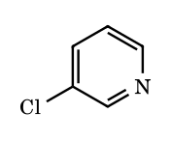
Answer: 3-chloropyridine; a 6,6-dichloro-2-azabicyclo[3.1.0]hexene (dichlorocyclopropane)
(Ciamician–Dennstedt) :CCl₂ adds across the C2=C3 bond; the cyclopropane opens with loss of Cl⁻ and ring expansion to the six-membered aromatic pyridine. Indole gives 3-chloroquinoline.
CE-44.
1,1-Dibromo-2,2-dimethylcyclopropane is treated with MeLi. Give the product.
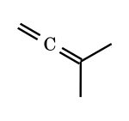
Answer: 3-methylbuta-1,2-diene
Li/Br exchange and loss of LiBr give the cyclopropylidene, which opens (Doering–LaFlamme) by cleaving the C2–C3 bond to the allene.
CE-45.
1-Diazohex-5-en-2-one (CH₂=CHCH₂CH₂COCHN₂) is treated with Cu(acac)₂. Give the product.
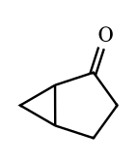
Answer: bicyclo[3.1.0]hexan-2-one
The copper carbenoid adds intramolecularly to the C=C, forming a cyclopentanone ring fused to a cyclopropane.
CE-46.
Why are aryl–CF₃ diazirines preferred over aryl azides for photoaffinity labelling?
Answer: they give a carbene that inserts into C–H/X–H bonds indiscriminately
Photolysis (≈ 350 nm) of the diazirine gives a carbene that inserts non-selectively into nearby bonds. Aryl azides give nitrenes that ring-expand to azepines and react mainly with nucleophiles, and the CF₃ group suppresses isomerisation of the diazirine to the diazo compound.
CE-47.
(JEE Advanced, integer) Eight reactions are listed: (a) CHCl₃ + KOC(CH₃)₃; (b) CH₂N₂, hν; (c) CH₂I₂ + Zn(Cu) in ether; (d) CH₂=C=O, hν; (e) 3-phenyl-3-(trifluoromethyl)diazirine, hν; (f) CH₃CH₂Br + NaOEt, EtOH; (g) Ph₃P=CH₂ in THF; (h) the sodium salt of benzaldehyde tosylhydrazone heated in diglyme (aprotic). In how many of these is a carbene or a carbenoid (a species that transfers CH₂/CR₂ like a carbene) generated as the reactive intermediate?
Answer: 6 (a, b, c, d, e, h)
(a) α-Elimination of HCl from CCl₃⁻ gives :CCl₂. (b) CH₂N₂ loses N₂ to give :CH₂. (c) ICH₂ZnI is a zinc carbenoid. (d) Ketene photolysis expels CO to give :CH₂. (e) Diazirine photolysis loses N₂ to give Ph(CF₃)C:. (h) The Bamford–Stevens aprotic pathway gives the diazo compound PhCHN₂ and then PhCH:. (f) is a plain E2 (no carbene) and (g) is a phosphorus ylide, which is a stable carbanion-type reagent and not a free carbene. Count = 6 ⚑ (if only free carbenes are counted, (c) is excluded and the answer is 5).
CE-48.
(JEE Advanced, integer) cis-But-2-ene is allowed to react with methylene (:CH₂) to give 1,2-dimethylcyclopropanes. Let x be the total number of distinct stereoisomers of 1,2-dimethylcyclopropane that can form when only singlet :CH₂ reacts, and y the number that can form when the reacting species is triplet :CH₂. Give x and y. (Count each enantiomer separately.)
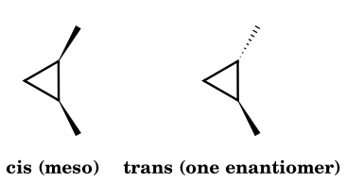
Answer: x = 1, y = 3
Singlet carbene adds in a single concerted step with retention of alkene geometry (Skell): cis-butene gives only cis-1,2-dimethylcyclopropane, which is meso, so x = 1. Triplet carbene adds one bond at a time to give a 1,3-diradical; ring closure requires spin inversion, which is slower than rotation about the former C=C bond, so both cis (meso) and trans products form. The trans compound is chiral and forms as a racemate (two enantiomers), so y = 1 + 2 = 3.
CE-49.
(JEE Advanced, integer) Racemic 4-methylcyclohexene is treated with CHCl₃, 50% aq. NaOH and a catalytic amount of benzyltriethylammonium chloride. The product is a 7,7-dichloronorcarane. How many stereoisomers (counting enantiomers separately) of the product can be formed? Why is the quaternary ammonium salt needed?
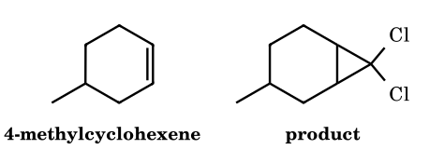
Answer: 4 stereoisomers (two diastereomers, each as a pair of enantiomers)
The product is 7,7-dichloro-3-methylbicyclo[4.1.0]heptane. :CCl₂ adds syn to the C=C, so the ring fusion is necessarily cis (C1 and C6 are fixed relative to each other: 2 possibilities). C3 (bearing CH₃) is a third stereocentre, so there are 2 × 2 = 4 stereoisomers; C7 is not a stereocentre because it carries two identical Cl. Attack from the face syn or anti to the CH₃ gives the two diastereomers, and because the alkene is racemic each diastereomer is racemic (face selectivity is poor because CH₃ is remote; the ratio is close to 1:1 ⚑). The ammonium salt transports HO⁻/CCl₃⁻ ion pairs across the phase boundary; the interfacial CCl₃⁻ expels Cl⁻ in the organic phase, so water-sensitive :CCl₂ is generated next to the alkene and is not hydrolysed.
CE-50.
(Assertion–Reason) For each pair choose: (a) A and R true, R explains A; (b) A and R true, R does not explain A; (c) A true, R false; (d) A false, R true.
Pair 1. A: Photolysis of diazomethane in cis-but-2-ene diluted with a large excess of an inert gas at high pressure gives progressively less stereospecific cyclopropanation. R: Collisions deactivate the initially formed singlet :CH₂ to the triplet state, which adds in a stepwise manner.
Pair 2. A: The ground state of methylene, :CH₂, is the singlet. R: The singlet–triplet energy gap in :CH₂ is about 9 kcal mol⁻¹.
Pair 3. A: Dichlorocarbene adds to trans-but-2-ene to give trans-1,1-dichloro-2,3-dimethylcyclopropane stereospecifically. R: Ground-state :CCl₂ is a triplet.
Pair 4. A: Triplet carbenes react with alkenes through diradical intermediates. R: Triplet :CH₂ is paramagnetic and can be detected by EPR.
Answer: Pair 1: (a); Pair 2: (d); Pair 3: (c); Pair 4: (b)
Pair 1: true. Singlet :CH₂ formed from CH₂N₂ is relaxed by collisions to the lower-lying triplet (intersystem crossing), whose stepwise addition scrambles geometry, so R explains A. Pair 2: A is false because the ground state is triplet (³B₁); R is true (the singlet lies about 9 kcal mol⁻¹ higher). Pair 3: A is true (singlet :CCl₂ is stabilised by π-donation from the Cl lone pairs into the empty p orbital and adds concertedly), but R is false because :CCl₂ has a singlet ground state. Pair 4: both statements are true, but paramagnetism is a property of the spin state and does not explain the mechanism of addition.
CE-51.
(CSIR-NET style) p-Cresol is heated with CHCl₃ and aqueous NaOH (Reimer–Tiemann). Give (i) the normal product and (ii) the abnormal product that is formed because the para position is blocked, and explain why the second product cannot rearomatise.
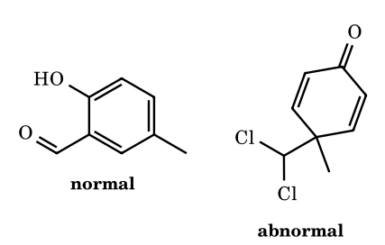
Answer: 2-hydroxy-5-methylbenzaldehyde (normal); 4-(dichloromethyl)-4-methylcyclohexa-2,5-dienone (abnormal)
The phenoxide (ortho/para nucleophile) attacks electrophilic :CCl₂. Ortho attack, proton loss and hydrolysis of the ArCHCl₂/ArCH(OH)Cl species give salicylaldehyde-type product 2-hydroxy-5-methylbenzaldehyde. Attack of the phenoxide at C-4 (the carbon bearing CH₃) gives a cyclohexadienone carrying CH₃ and CHCl₂ on the same sp³ carbon. That carbon has no hydrogen to lose, so the ring cannot regain aromaticity; the cross-conjugated dienone is isolated (the dichloromethyl group is only slowly hydrolysed).
CE-52.
(JEE Advanced, integer) The carbylamine (isocyanide) test uses CHCl₃ and alcoholic KOH. How many of the following amines give a positive test: CH₃NH₂, (CH₃)₂NH, C₆H₅NH₂, (CH₃)₃CNH₂, (C₂H₅)₃N, C₆H₅NHCH₃? Write the key steps for aniline.
Answer: 3 (CH₃NH₂, C₆H₅NH₂, (CH₃)₃CNH₂)
Only primary amines can lose two N–H protons (overall two HCl) to reach the isocyanide R–N⁺≡C⁻. Steps for aniline: KOH + CHCl₃ → :CCl₂; PhNH₂ attacks the carbene to give PhNH₂⁺–CCl₂⁻, then PhNH–CHCl₂; base removes HCl twice (N–H and C–H with chloride loss) to give PhNC (foul odour). Secondary and tertiary amines (N–H count insufficient) do not give isocyanides; tert-butylamine does, because the reaction occurs at N and not at the alkyl carbon.
CE-53.
(IChO-style) Geraniol, (E)-3,7-dimethylocta-2,6-dien-1-ol, has one allylic and one remote trisubstituted C=C. Predict the main product with (i) 1.0 equiv Et₂Zn / CH₂I₂ (Furukawa) in CH₂Cl₂, and (ii) 1.0 equiv m-CPBA. State the stereochemical consequence of (i) for the substituents on the new ring, and what changes with 2.5 equiv of the zinc reagent.
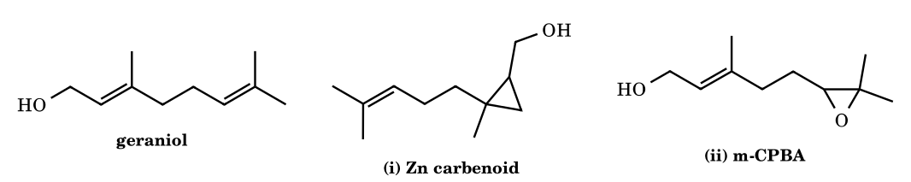
Answer: (i) cyclopropanation of the C2=C3 (allylic) alkene; (ii) epoxidation of the C6=C7 alkene
(i) The zinc carbenoid is delivered by coordination to the alkoxide/OH oxygen, so the proximal C2=C3 bond reacts even though the remote C6=C7 is more electron-rich. The cyclopropanation is syn and stereospecific, so the E geometry is kept: CH₂OH ends up cis to CH₃ and trans to the C4 chain. Product: [2-methyl-2-(4-methylpent-3-enyl)cyclopropyl]methanol. (ii) m-CPBA is an electrophilic oxidant with no directing effect; the allylic C2=C3 is deactivated inductively by the OH, so the more electron-rich C6=C7 is epoxidised preferentially (not exclusively ⚑). With 2.5 equiv of the zinc reagent both alkenes are cyclopropanated (the second more slowly, undirected).
CE-54.
(IChO-style) (S)-2-Methylbutanoic acid is converted into its homologue by: (1) SOCl₂; (2) excess CH₂N₂ (≥ 2 equiv); (3) Ag₂O (or PhCO₂Ag/Et₃N), H₂O, warm. Give the product with its CIP descriptor, name the key intermediate in step 3, and explain (a) why 2 equiv of CH₂N₂ are needed and (b) what happens to the stereocentre.
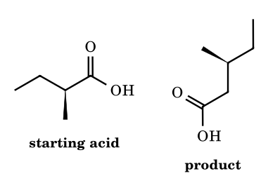
Answer: (S)-3-methylpentanoic acid; intermediate: ketene (from Wolff rearrangement)
Step 2: the acid chloride reacts with CH₂N₂ to give the α-diazoketone RCOCHN₂; the second equivalent of CH₂N₂ destroys the HCl formed (giving CH₃Cl + N₂), otherwise HCl would convert the diazoketone to RCOCH₂Cl. Step 3: Ag(I) promotes loss of N₂ to a silver carbenoid, and Wolff rearrangement (1,2-shift of R to the carbenoid carbon) gives the ketene R–CH=C=O, which water captures to give RCH₂CO₂H. The migrating carbon moves with retention of configuration. The spatial order of groups is unchanged and the CIP priorities (CH₂CO₂H > C₂H₅ > CH₃ > H) follow the same order as before (CO₂H > C₂H₅ > CH₃ > H), so the descriptor stays S.
CE-55.
(IChO-style) (a) Ethyl diazoacetate and benzene with Rh₂(OAc)₄ give a C₉H₁₀O₂ product through a norcaradiene intermediate: name the major isomer and the process. (b) 1-Diazo-4-phenylbutan-2-one, PhCH₂CH₂COCHN₂, with Cu or Rh catalyst gives a bicyclic C₁₀H₁₀O ketone: draw it and give the ring sizes. (c) Which type of C-7 substituent shifts the norcaradiene ⇌ cycloheptatriene equilibrium toward norcaradiene? Name one example.
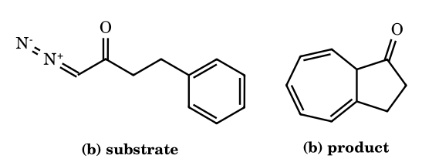
Answer: (a) ethyl cyclohepta-2,4,6-triene-1-carboxylate (Buchner ring expansion); (b) a 5–7 fused hydroazulenone; (c) π-acceptors (e.g. 7,7-dicyano)
(a) The rhodium carbenoid adds to one C=C of benzene to give a norcaradiene (bicyclo[4.1.0]hepta-2,4-diene), which undergoes a rapid, reversible electrocyclic ring opening (6π, disrotatory) to the cycloheptatriene; the ester at C-7 gives ethyl cycloheptatriene-7-carboxylate (C₉H₁₀O₂). (b) Intramolecular Buchner reaction: the carbene carbon adds across the ipso/ortho bond (giving a 5-membered ketone ring: carbene C, C=O, CH₂, CH₂, ipso C); ring opening of the norcaradiene gives a cycloheptatriene fused to cyclopentanone (bicyclo[5.3.0]decatrienone). (c) π-acceptor substituents (CN, CO₂R when doubled up) at C-7 lower the Walsh orbital energy of the cyclopropane and stabilise the norcaradiene; 7,7-dicyanonorcaradiene is the observed form.
CE-56.
(IChO-style) Starting from 2,3-dimethylbut-2-ene: (i) CHBr₃, KOC(CH₃)₃; (ii) CH₃Li, −78 °C → 25 °C (Doering–LaFlamme). Give the final product, its number of ¹³C NMR signals, and the intermediates. Then say what is formed from cis-cyclooctene by the same two steps and why that product is chiral.
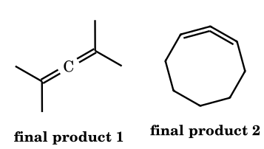
Answer: tetramethylallene (3 ¹³C signals); 1,2-cyclononadiene (chiral allene)
Step (i): dibromocarbene cyclopropanation gives 1,1-dibromo-2,2,3,3-tetramethylcyclopropane. Step (ii): Br/Li exchange gives a cyclopropylidene carbenoid, which loses LiBr with concerted electrocyclic ring opening (cleavage of the C2–C3 bond opposite to the carbenoid carbon) to give Me₂C=C=CMe₂. Tetramethylallene (D_{2d}) shows 3 ¹³C lines (central sp C, equivalent terminal sp² C, equivalent CH₃). From cyclooctene one obtains 9,9-dibromobicyclo[6.1.0]nonane and then cyclonona-1,2-diene. Each terminal allene carbon carries H and a ring CH₂, so the allene axis is a chiral axis (axial chirality); the nine-membered ring keeps the two ends from interconverting easily, so the enantiomers do not racemise by simple bond rotation.
CE-57.
(GATE/CSIR style) 2-Methylcyclohexanone tosylhydrazone is subjected to (A) 2.2 equiv n-BuLi, THF, 0 °C, then H₂O (Shapiro), (B) the same sequence but quenched with DMF, and (C) NaOMe in ethylene glycol at 160 °C (protic Bamford–Stevens). Give the principal organic product in each case and the reason for the difference between A and C.
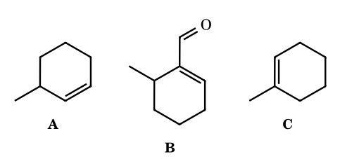
Answer: A: 3-methylcyclohexene; B: 6-methylcyclohex-1-ene-1-carbaldehyde; C: 1-methylcyclohexene (major)
Shapiro: the first equivalent of base deprotonates N–H, the second removes an α-proton under kinetic control, at the less hindered CH₂ (C-6) syn to the tosylamide anion. Loss of Ts⁻ and N₂ gives the vinyllithium at C-1 (alkene C1=C6) which is protonated (A) or formylated by DMF (B). Protic Bamford–Stevens: the diazo compound is protonated to a diazonium ion; loss of N₂ gives a secondary cation which undergoes 1,2-H shift/E1 to the more substituted, thermodynamically favoured alkene 1-methylcyclohexene (C is usually a mixture with 3-methylcyclohexene, the ratio being conditions-dependent ⚑). The Shapiro reaction is kinetically controlled at carbon, the protic Bamford–Stevens reaction is cationic and thermodynamically controlled.
CE-58.
(Multi-correct) Choose all correct statements about metal carbene complexes: (A) The carbene carbon of (CO)₅Cr=C(OMe)Ph is electrophilic. (B) Schrock alkylidenes such as Ta(=CHCMe₃)(CH₂CMe₃)₃ are typically early-metal, high-oxidation-state, and have a nucleophilic carbene carbon. (C) The α-CH₃ protons of (CO)₅Cr=C(OMe)CH₃ are far more acidic (pK_{a} ≈ 12) than those of methyl acetate. (D) A Fischer carbene is conveniently described as a singlet carbene donating a σ pair to the metal with some M→C π back-donation, whereas a Schrock alkylidene is a triplet fragment forming a covalent M=C bond. (E) The carbene carbon of Cp₂Ta(=CH₂)CH₃ is electrophilic. (F) Replacing OMe by NMe₂ in a Fischer carbene makes the carbene carbon more electrophilic.
Answer: A, B, C, D
(A) The heteroatom π-donates into the empty carbene p orbital but the electron-poor, π-accepting M(CO)₅ fragment keeps the carbon electrophilic (attacked by amines, hydride etc.). (B) Correct: Schrock alkylidenes react like phosphorus ylides (Wittig-type with carbonyls). (C) Deprotonation gives a metal-stabilised anion (charge delocalised onto the Cr(CO)₅ acceptor), so the α-H are acidic (pK_{a} ≈ 12 in water, versus ≈ 25 for esters). (D) is the standard bonding picture. (E) is false because Schrock-type carbenes have a nucleophilic carbon. (F) is false: the more strongly π-donating NMe₂ reduces the electrophilicity of the carbene carbon. ⚑ Formal oxidation-state counting of Schrock carbenes (neutral CR₂ versus CR₂²⁻ ligand) is convention-dependent, which does not affect the answers.
CE-59.
(IChO-style, Chauvin) Norbornene (C₇H₁₀) reacts with a catalytic amount of Ru(=CHPh)Cl₂(L)₂ in two different ways: (i) neat, concentrated: ring-opening metathesis polymerisation; (ii) in solution saturated with ethylene (1 atm): a single C₉H₁₄ product. Give the repeating unit of (i), the structure and relative stereochemistry of (ii), and explain with the Chauvin mechanism why cyclohexene does not polymerise under the same conditions.
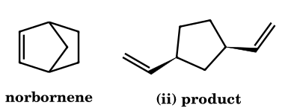
Answer: (i) poly(1,3-cyclopentylenevinylene); (ii) cis-1,3-divinylcyclopentane (meso)
Chauvin cycle: the Ru=CHR carbene undergoes [2+2] with the strained C=C to give a ruthenacyclobutane, whose retro-[2+2] opens the ring and regenerates a Ru alkylidene that is now attached to the cyclopentane chain; repeating this gives the polymer (units –CH=CH–C₅H₈–). With ethylene, Ru=CH₂ forms and cleaves the chain ends so that each ring-opened unit gets two vinyl groups (C₇H₁₀ + C₂H₄ = C₉H₁₄). The vinyl groups remain cis because they were the two bridgehead substituents on the same face of the bicycle; the product is the meso cis isomer, not the chiral trans pair. Ring-opening needs a thermodynamic driver: norbornene releases ≈ 27 kcal mol⁻¹ of strain, whereas cyclohexene has ≈ 1–2 kcal mol⁻¹, and the entropy loss of polymerisation outweighs that, so no polymer forms.
CE-60.
(IChO-style) Benzaldehyde and methyl vinyl ketone are stirred with 10 mol% 3-benzyl-5-(2-hydroxyethyl)-4-methylthiazolium chloride and Et₃N in EtOH at 70 °C. (a) Give the product. (b) Draw the Breslow intermediate formed from benzaldehyde and the carbene. (c) Without MVK, what is formed, and why is the Stetter product favoured when MVK is present?
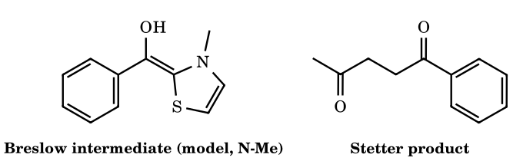
Answer: (a) 1-phenylpentane-1,4-dione; (c) benzoin
The base deprotonates the thiazolium C2–H (pK_{a} ≈ 17–19) to give the N-heterocyclic carbene. The carbene adds to PhCHO to give the tetrahedral alkoxide, whose C–H proton transfers to give the enaminol (Breslow intermediate): an acyl-anion equivalent (umpolung). Without an acceptor, the Breslow intermediate attacks a second PhCHO (1,2-addition), then collapses to PhCOCH(OH)Ph (benzoin). Benzoin formation is reversible, whereas conjugate addition to the enone is irreversible and the enolate formed is protonated, after which the catalyst is expelled to give PhCO–CH₂CH₂–COCH₃ (Stetter reaction). The Michael acceptor therefore drains the equilibrium toward the 1,4-diketone.
CE-61.
(IChO-style) Crotyl phenyl sulfide (CH₃CH=CHCH₂SPh) reacts with ethyl diazoacetate in the presence of 1 mol% Rh₂(OAc)₄. (a) Give the product (Doyle–Kirmse reaction) and the key intermediate. (b) How many stereoisomers does the product have? (c) Why is the C=C bond not cyclopropanated?
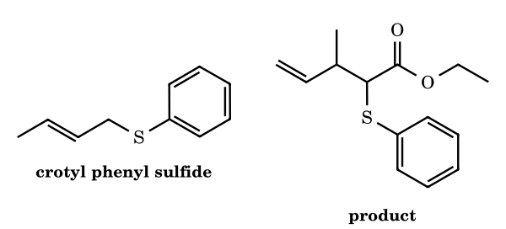
Answer: ethyl 3-methyl-2-(phenylsulfanyl)pent-4-enoate; 4 stereoisomers (2 racemic diastereomers)
The electrophilic Rh-carbenoid is attacked by the sulfur lone pair (the most nucleophilic site) to give a sulfonium ylide Ph–S⁺(CH₂CH=CHCH₃)–CH⁻CO₂Et. This undergoes a [2,3]-sigmatropic rearrangement: the ylide carbon bonds to the γ-carbon (the CH–CH₃ terminus) while the S–CH₂ bond breaks, giving PhS–CH(CO₂Et)–CH(CH₃)–CH=CH₂. Two new stereocentres (C-2, C-3) give 2² = 4 stereoisomers, i.e. two diastereomers each as a racemate. Ylide formation is faster than cyclopropanation of an unactivated alkene because the sulfide is a better Lewis base toward the carbenoid than the alkene.
CE-62.
(IChO-style) 1-Diazo-5-methylhexan-2-one is treated with 1 mol% Rh₂(OAc)₄ in CH₂Cl₂. (a) Give the major product and explain the regiochemistry in terms of ring size and C–H type. (b) The (S)-diazoketone N₂CHCO(CH₂)₂CH(CH₃)CH₂CH₃ reacts the same way; assuming insertion with retention at the carbon that inserts, give the CIP descriptor of the product.
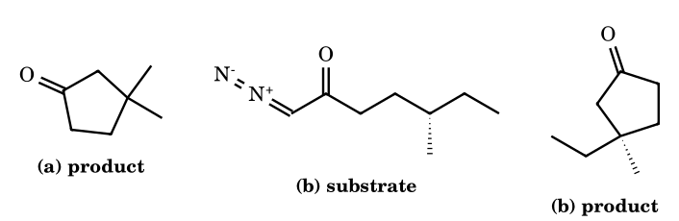
Answer: (a) 3,3-dimethylcyclopentanone; (b) (R)-3-ethyl-3-methylcyclopentanone
(a) The electrophilic Rh-carbenoid inserts into a C–H bond in a concerted, three-centre, hydride-transfer-like transition state. Insertion is fastest at the electron-rich tertiary C–H and a five-membered ring (1,5-insertion, favoured over 1,6) is formed, giving 3,3-dimethylcyclopentanone (not the six-membered 3-methylcyclohexanone that would arise from the primary methyl C–H). (b) The inserting carbon keeps its configuration (the new C–C bond forms on the face where H was), so the spatial arrangement is unchanged. The priorities change because the old H is replaced by a ring CH₂, and the CIP label computed for the product is R (the label changes S → R although the geometry is retained). ⚑ Retention is the established stereochemical outcome for these insertions.
CE-63.
(IChO-style, very hard) (a) (4-MeOC₆H₄)(C₆H₅)C=CBr₂ is treated with 1 equiv n-BuLi at −78 °C and warmed to 20 °C (Fritsch–Buttenberg–Wiechell). Give the product. Why can the product not tell you whether anisyl or phenyl migrated? If the β-carbon is ¹³C-labelled, what does a labelled carbon bonded to the phenyl ring tell you? (b) 3-Phenylpropanal is treated with the Ohira–Bestmann reagent (MeO)₂P(O)C(N₂)COCH₃ and K₂CO₃ in MeOH. Give the product and the carbene involved, and the final step by which the alkyne forms.
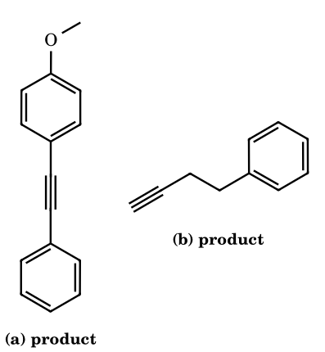
Answer: (a) 1-methoxy-4-(phenylethynyl)benzene; label on the carbon bonded to Ph means the anisyl group migrated; (b) 4-phenylbut-1-yne via alkylidene carbene and 1,2-H shift
(a) Br/Li exchange gives the lithium carbenoid Ar(Ph)C=C(Li)Br; loss of LiBr gives the vinylidene (alkylidene carbene) Ar(Ph)C=C:, and a 1,2-aryl shift from Cβ to the carbene carbon gives ArC≡CPh. Whichever aryl group moves, the same alkyne results, so the product alone is uninformative. With ¹³C at Cβ (the carbon that carries Ar and Ph before the shift): if anisyl migrates, Cβ keeps phenyl and the label sits on the alkyne carbon bonded to Ph; if phenyl migrates, the label sits next to the anisyl ring. (b) In MeOH, K₂CO₃ cleaves the acetyl group to give the anion (MeO)₂P(O)C(N₂)⁻; it adds to the aldehyde and a Horner–Wadsworth–Emmons-type elimination gives the vinyl diazo compound RCH=CN₂, which loses N₂ to give the alkylidene carbene RCH=C:. A 1,2-H shift from CH to the carbene carbon gives the terminal alkyne PhCH₂CH₂C≡CH.
CE-64.
(IChO-style, very hard) Pyrrole is treated with CHCl₃ and NaOEt/EtOH (Ciamician–Dennstedt). (a) Give the main ring-expanded product and the bicyclic intermediate. (b) If ¹³CHCl₃ is used, which position of the product carries the label? (c) Indole reacts analogously: give the product. (d) What by-product is formed in Reimer–Tiemann conditions and why is it not the ring-expansion product?
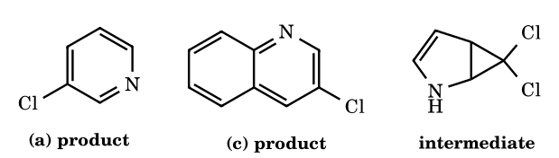
Answer: (a) 3-chloropyridine; (b) C-3; (c) 3-chloroquinoline; (d) pyrrole-2-carbaldehyde
Dichlorocarbene adds across C2=C3 of pyrrole to give 6,6-dichloro-2-azabicyclo[3.1.0]hex-3-ene (a gem-dichlorocyclopropane). Ionisation of C–Cl and disrotatory opening of the cyclopropyl cation (the cleavage of the old C2–C3 bond) insert the carbene carbon between old C2 and C3, with loss of HCl giving the aromatic ring, 3-chloropyridine. The labelled carbon becomes C-3 (it carries the retained Cl). Indole gives 3-chloroquinoline in the same manner. Under Reimer–Tiemann conditions (aqueous NaOH) the pyrrolide anion attacks :CCl₂ through C-2, and hydrolysis of the resulting CHCl₂ group gives pyrrole-2-carbaldehyde as the competing normal product. Ring expansion (driven by release of cyclopropane strain and aromatisation) competes with this substitution; the ratio depends on conditions, and the ring-expanded 3-chloropyridine is typically the minor product ⚑.
CE-65.
(IChO-style, very hard) 1-Diazohex-5-en-2-one, N₂CHCO(CH₂)₂CH=CH₂, is decomposed with Cu(acac)₂ in refluxing benzene. (a) Give the product and the number of stereoisomers. (b) Why is only the cis-fused ring system possible? (c) The product is then treated with Li / liquid NH₃ (then NH₄Cl). Give the major product and state the stereoelectronic rule that decides which cyclopropane bond breaks.
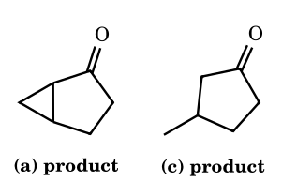
Answer: (a) bicyclo[3.1.0]hexan-2-one, 2 stereoisomers (enantiomers); (c) 3-methylcyclopentanone
(a) The copper carbenoid adds intramolecularly to the C5=C6 double bond: carbene C-1 binds to C-5 and C-6, forming a five-membered ring (C1, C2, C3, C4, C5) fused to a cyclopropane (C1, C5, C6). Two stereocentres (C-1, C-5) are present, but the molecule is chiral and cis fusion is the only possible geometry, so there are two enantiomers (racemic product with an achiral catalyst). (b) Carbene addition to the C=C is syn, so the cyclopropane is formed on one face of the alkene; with a three-atom tether the new five-membered ring can only close on that same face, i.e. the CH₂ (C-3 and C-6 sides) must be cis across the C1–C5 fusion bond. A trans-fused bicyclo[3.1.0]hexane is far too strained to form. (c) Dissolving-metal reduction of the cyclopropyl ketone proceeds through a ketyl radical anion; the cyclopropane bond that overlaps best with the C=O π system breaks (Stork–Dauben rule), here the external C1–C6 bond rather than the internal C1–C5 bond, giving 3-methylcyclopentanone after protonation ⚑ (stereoelectronic selectivity; the alternative internal cleavage would give hexan-2-one).
CE-66.
(IChO-style, very hard) 2-Diazo-1-tetralone (C₁₀H₈N₂O) is irradiated in methanol. The product B (C₁₁H₁₂O₂) has an IR band at 1735 cm⁻¹, shows a 3H singlet at δ 3.7 and only 7 signals in its ¹³C NMR spectrum. (a) Identify B and the ketene intermediate. (b) Show how the 13C count excludes the isomeric methyl indane-1-carboxylate. (c) What are the products when the same photolysis is run in water, and with 2-diazocyclohexanone in methanol?
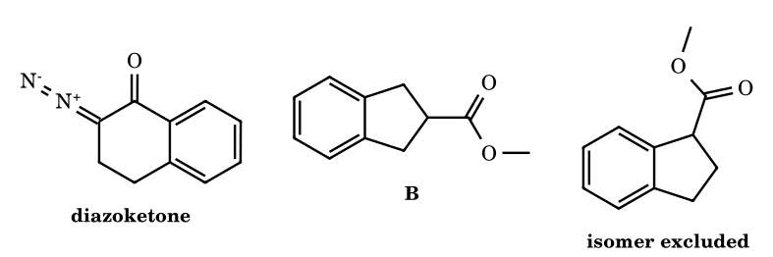
Answer: B = methyl indane-2-carboxylate; ketene = indan-2-ylideneketene; excluded isomer has 11 signals
Photolysis expels N₂ to give the α-ketocarbene at C-2, which undergoes Wolff rearrangement: the aryl carbon attached to C-1 migrates to the carbene carbon (C-2), giving the ring-contracted ketene (indan-2-ylideneketene; the former C=O carbon becomes the ketene carbon). Methanol adds to give methyl indane-2-carboxylate. This molecule has a mirror plane, so its ¹³C spectrum shows 3 aromatic + CH₂ (2C) + CH + C=O + OCH₃ = 7 signals. Methyl indane-1-carboxylate would show 6 aromatic + 3 aliphatic ring carbons + C=O + OCH₃ = 11 signals. In water the product is indane-2-carboxylic acid; 2-diazocyclohexanone in MeOH gives methyl cyclopentanecarboxylate (via cyclopentylideneketene).
CE-67.
(IChO-style, very hard) Benzaldehyde-d₁ (PhCDO, > 99% D) is converted to benzoin with a thiazolium salt/Et₃N in EtOH. (a) Where does the deuterium appear in the product (¹H NMR: no singlet at δ ≈ 5.95; mass spectrum of M = 213)? (b) Labelled benzoin PhCO–CD(OH)Ph is then stirred with p-anisaldehyde (ArCHO) and fresh catalyst; ignoring minor processes, predict the isotopic composition of the two crossed benzoins PhCO–CH(OH)Ar and ArCO–CH(OH)Ph that appear first (and which is labelled). (c) Explain how the mechanism accounts for (a) and for (b).
Answer: (a) D on the carbinol carbon only: PhCO–CD(OH)Ph; (b) PhCO–CH(OH)Ar is unlabelled; ArCO–CD(OH)Ph carries the D
(a) Addition of the carbene to PhCDO gives a tetrahedral alkoxide; the former aldehyde C–D proton is transferred to O to give the Breslow enaminol Ph–C(OD)=C(cat). The acyl carbon of the product comes from this unit, so it carries no D; the O–D exchanges with EtOH. The enaminol attacks a second molecule of PhCDO, whose D stays on the new carbinol carbon, giving PhCO–CD(OH)Ph (M = 213; the carbinol C–H signal is absent). (b) Benzoin formation is reversible: the carbene adds to the ketone of PhCO–CD(OH)Ph and the C–C bond breaks to give the Breslow intermediate of the PhCO unit and releases the carbinol fragment as PhCDO. The Ph–C(OH)=cat unit adds to ArCHO to give PhCO–CH(OH)Ar (no D), while the released PhCDO is picked up by the anisoyl Breslow intermediate to give ArCO–CD(OH)Ph (labelled). The D never moves to the acyl carbon in either direction.
CE-68.
(IChO-style, very hard) Cr(CO)₅=C(OMe)Ph is heated with 3-hexyne in THF (60 °C), then the mixture is exposed to air or oxidised. (a) Give the organic product (Dötz benzannulation). (b) With 1-hexyne as the alkyne, which regioisomer is formed? (c) Which atoms of the product come from the carbene carbon, one CO ligand and the aryl ring?
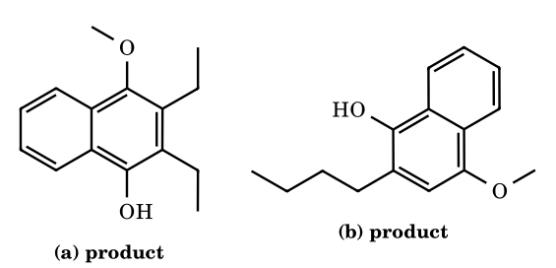
Answer: (a) 2,3-diethyl-4-methoxynaphthalen-1-ol; (b) 2-butyl-4-methoxynaphthalen-1-ol
Sequence: CO loss, alkyne insertion into the Cr=C bond, CO insertion to give a vinylketene–Cr complex, electrocyclisation onto the ortho position of the phenyl ring, and tautomerisation to the aromatic naphthol, which is the Cr(CO)₃ complex that is freed on oxidation. The carbene carbon becomes C-4 (it bears OMe), the CO becomes C-1 (it bears OH, para to OMe), the alkyne carbons become C-2 and C-3, and the phenyl ring supplies C-4a to C-8a (the benzo ring). With 1-hexyne the larger butyl group ends up adjacent to the phenolic oxygen (C-2), giving 2-butyl-4-methoxynaphthalen-1-ol. ⚑ This regiochemistry is the usual steric outcome and weaker for electronically biased alkynes. Oxidative work-up (CAN) of such 4-methoxy-1-naphthols gives 1,4-naphthoquinones.

Part 11 Nitrenes: Structure, Generation, Reactions and the Rearrangements that Mimic Them
A nitrene (azene, imene) is the nitrogen analogue of a carbene: R–N:, a monovalent nitrogen with six valence electrons (one bond pair + two non-bonding pairs-worth of electrons = a lone pair and two further electrons). It is electron-deficient (sextet on N), neutral, and highly reactive. Because nitrogen is more electronegative than carbon, nitrenes are somewhat less electrophilic than carbenes of the same substituent, but they undergo the same family of reactions (insertion, addition, rearrangement).

11.1 Singlet and triplet nitrenes
 | Triplet nitrene (ground state for most R–N, NH) | Singlet nitrene
Electron arrangement | lone pair in the s-type orbital; one electron in each of two degenerate p orbitals, spins parallel (↑ ↑): like O₂ and CH₂ (triplet) | lone pair in an sp-type orbital and a second pair in one p orbital; the other p orbital is empty
Magnetism | paramagnetic (S = 1; ESR) | diamagnetic
Reactions | radical-like: H-abstraction then recombination; dimerisation to R–N=N–R; non-stereospecific addition to alkenes | concerted: stereospecific aziridine formation (syn); C–H insertion with retention; rearrangements (acyl → isocyanate)
Generated first from | photolysis/thermolysis of azides gives singlet nitrene first; intersystem crossing to the triplet competes (fast for alkyl and aryl nitrenes) | most acyl and sulfonyl nitrenes in solution
The singlet–triplet gap of NH is ≈ 36 kcal mol⁻¹ (triplet lower), much larger than that of CH₂ (9), so triplet is the ground state of almost all nitrenes. Aryl nitrenes can ring-expand to dehydroazepines (see 11.4). Also compare: nitrenium ions R₂N⁺ (six electrons, positive charge; analogues of carbenium ions) and nitrenoids (N–X species that transfer N like a nitrene without free R–N:).

11.2 Generation of nitrenes
Method | Equation | Remarks
Azide decomposition | R–N=N⁺=N⁻ → R–N: + N₂ (hν or Δ) | the standard source (alkyl, aryl, acyl, sulfonyl azides); N₂ is the leaving group
α-Elimination from N-halo or N-sulfonyloxy compounds | R–NH–X (X = Br, OSO₂Ar) + base → R–N: + HX | Hofmann bromamide and Lossen rearrangements are of this type (but see 11.3)
Deoxygenation of nitro/nitroso compounds | Ar–NO₂ + 2 P(OEt)₃ → Ar–N: + 2 O=P(OEt)₃ (Cadogan) | nitrene cyclises onto a neighbouring ring (2-nitrobiphenyl → carbazole)
Iminoiodinanes | PhI=NTs + Cu(I) or Rh₂(OAc)₄ → metal-nitrene → aziridine | transition-metal-catalysed nitrene transfer
Photolysis of isocyanates or diazirines | R–N=C=O → R–N: + CO (hν) | less common

11.3 Rearrangements that proceed through nitrene-like (nitrenoid) steps
Four named reactions end in the same isocyanate R–N=C=O by a 1,2-shift of R from C to N with simultaneous loss of a leaving group from N; each is classically drawn through an acyl nitrene R–CO–N:, but the migration and the loss of the leaving group are concerted (no free nitrene is formed), which explains the retention of configuration at the migrating carbon. Hydrolysis of the isocyanate gives the amine R–NH₂ with one carbon less:
Name | Substrate | Reagents | Leaving group from N | Product
Hofmann bromamide | RCONH₂ | Br₂ + 4 NaOH | Br⁻ | R–NH₂ (1° amine, one C less) + Na₂CO₃
Curtius | RCON₃ (from RCOCl + NaN₃) | Δ, then H₂O | N₂ | R–NH₂ (or R–NH–COOR′ in ROH)
Lossen | RCONH–OCOR′ (hydroxamic acid ester) | base, Δ | R′COO⁻ | R–NH₂
Schmidt | RCOOH + HN₃ (conc. H₂SO₄) | Δ | N₂ | R–NH₂
Migratory aptitude in these shifts is aryl ≈ tertiary alkyl > secondary > primary > methyl; the migrating group retains its configuration; the reaction works for R = alkyl, aryl and gives an amine in which N is attached to the same carbon that was attached to C=O. (Contrast the Beckmann rearrangement of an oxime (R₂C=N–OH → amide), in which the group anti to the leaving group migrates: C → N with loss of water, a carbocation-like (nitrilium) pathway.) The Stieglitz rearrangement of trityl hydroxylamine and N-chloroamines is the all-carbon-to-N shift with a positively charged (nitrenium-like) nitrogen.
11.1 Alkyl azide → nitrene + N₂
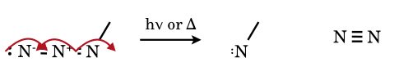
The azide is a resonance hybrid R–N=N⁺=N⁻ ↔ R–N⁻–N⁺≡N. Loss of N₂ leaves the nitrogen attached to R with only one bond and six electrons: the nitrene. The N≡N is the thermodynamic driving force (≈ 226 kcal mol⁻¹ bond energy).
11.2 Singlet methylnitrene + ethene → N-methylaziridine (concerted)
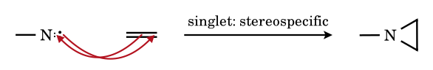
As for carbene cyclopropanation, the alkene π pair attacks the empty p orbital of the nitrene while the nitrene lone pair forms the second C–N bond: a one-step syn addition giving the aziridine with retention of alkene geometry. A triplet nitrene would give a mixture of cis and trans aziridines through a 1,3-diradical.
11.3 Curtius rearrangement: acyl azide → isocyanate (concerted, no free nitrene)
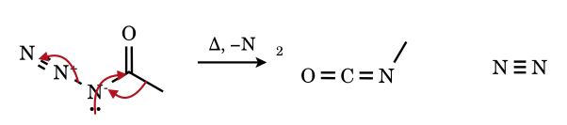
In the acyl azide the methyl group migrates from the carbonyl carbon to the adjacent nitrogen as N₂ leaves; the nitrogen lone pair makes the new C=N π bond. All three arrows act in one step (a concerted 1,2-shift with retention of the migrating group’s configuration). Methyl isocyanate is trapped by water: R–NHCOOH → R–NH₂ + CO₂.
11.4 Hofmann bromamide: N-bromoamide anion → isocyanate
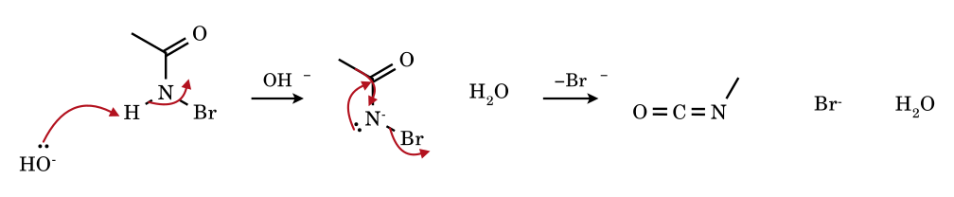
Br₂/NaOH brominates the amide nitrogen; a second HO⁻ removes the remaining N–H (the proton is acidic: pK_{a} ≈ 9) to give the bromoamide anion. The methyl group then migrates to nitrogen as bromide leaves: the isocyanate. Hydroxide adds to R–N=C=O to give the carbamate, which loses CO₂: overall CH₃CONH₂ → CH₃NH₂ (one carbon less).
11.5 Aryl azide: ring expansion (dehydroazepine) after nitrene formation
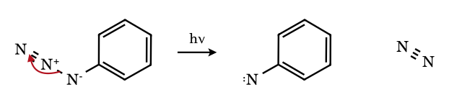
Photolysis gives the singlet phenylnitrene, which can close to a benzazirine and then ring-expand to a 1-aza-1,2,4,6-cycloheptatetraene (didehydroazepine); in the presence of diethylamine this is trapped as a 2-diethylamino-3H-azepine. In the absence of traps the triplet nitrene dimerises to azobenzene. (Structure shown as the nitrene only.)

11.4 Reactions of nitrenes: summary
Reaction | Example | Product
Addition to C=C (aziridination) | PhI=NTs, Cu(OTf)₂, styrene; EtO₂C–N: + alkene | N-substituted aziridine; singlet: stereospecific; triplet: not
C–H insertion | alkyl/aryl/sulfonyl nitrene + R–H | amine (N–H bond forms at the C–H carbon); intramolecular insertion gives pyrrolidines, indolines
Rearrangement | R–CO–N: → R–N=C=O (Hofmann, Curtius, Lossen) | isocyanate → amine, urethane, urea
Dimerisation | 2 ArN: → Ar–N=N–Ar | azo compound (triplet nitrenes)
Ring expansion of aryl nitrenes | PhN: → azirine → azepine | 3H-azepines
Hydrogen abstraction | triplet nitrene + solvent R–H → R–NH• + R• | R–NH₂ after H abstraction
Cadogan cyclisation | 2-nitrobiphenyl + P(OEt)₃ | carbazole

11.6 Electronic structure of nitrenes, nitrenoids and nitrenium ions
- Valence electron count. N has five valence electrons. In R–N: one is in the R–N σ bond and four are non-bonding: a total of six electrons around N (sextet), two of them in the σ-bonding pair. The four non-bonding electrons occupy an s-like (sp) orbital and two degenerate p orbitals (p_{x}, p_{y}) perpendicular to the R–N axis. Three electronic states arise from placing two electrons in the two p orbitals: the ground-state triplet ³Σ⁻ (↑ in p_{x}, ↑ in p_{y}), and two closed-shell-like singlets (¹Δ, ¹Σ⁺). For NH: triplet X ³Σ⁻, singlet a ¹Δ at ≈ 36 kcal mol⁻¹, b ¹Σ⁺ at ≈ 60.
- Why the gap is larger than in carbenes. The two p orbitals of R–N: are exactly degenerate (the R–N axis is a C∞ axis for a monovalent N), so Hund’s rule places the electrons in separate orbitals with parallel spin; in a bent carbene the σ and p orbitals differ in energy and the singlet is competitive. Nitrene triplets are ground states for alkyl, aryl and NH; singlets are ground states only when strongly stabilised (e.g. N-amino-nitrenes R₂N–N: ‘aminonitrenes’, and some acyl/imino nitrenes by lone-pair donation).
- Substituent effects. π-Donating R groups (NR₂, OR, X) donate to an empty p orbital of the singlet and so reduce the gap: aminonitrenes (R₂N–N:) are singlets; the nitrene of the acyl type RC(=O)–N: is a triplet in the gas phase but the singlet is lower than expected because C=O π overlaps one p orbital. Aryl nitrenes: triplet ground state by 14–18 kcal mol⁻¹ for phenylnitrene (the unpaired electron is delocalised into the ring, giving a strong ESR signal of the triplet in a matrix). Alkyl nitrenes: triplet ground state, but a singlet alkylnitrene undergoes 1,2-H shift to an imine so fast (k > 10¹⁰ s⁻¹) that it is rarely seen.
- Nitrenoids. Many ‘nitrene’ reactions are really transfers from metal-bound or N–X nitrogen with no free R–N:. Examples: iminoiodinanes PhI=NTs, chloramine-T and bromamine-T with Cu, Rh, Fe or Mn catalysts (metal–imido/nitrenoid intermediates, Du Bois C–H amination, Sharpless aminohydroxylation with Os); N-chloroamines + base; azides + metal. The metal-bound nitrenoid is more selective than a free nitrene and can be rendered enantioselective.
- Nitrenium ions. R₂N⁺ (six electrons, positive charge, isoelectronic with a carbene) are singlets (or triplets for diarylnitrenium) formed by heterolysis of N–X (N-chloroamines + Ag⁺), protonation of N-hydroxy-/N-acyloxyarylamines (the metabolic activation of aromatic amine carcinogens: ArN(OH)Ac → ArN⁺Ac, which alkylates DNA at guanine C-8) and in Bamberger rearrangement of N-phenylhydroxylamine in aqueous acid (PhNHOH + H⁺ → PhNH⁺ → p-aminophenol by attack of water at the para position). Nitrenium ions are delocalised (iminium–carbocation resonance: Ar–N⁺R ↔ cyclohexadienyl-type cation with positive charge at ortho and para carbons), which is why nucleophiles attack the ring.

11.7 Generation of nitrenes: a complete catalogue
Method | Precursor and conditions | Notes
Alkyl/aryl azides | R–N₃, hν (254–300 nm) or Δ (> 150 °C; aryl azides 100–140 °C) | the cleanest source; hazard: low-MW azides are shock-sensitive and explosive (rule of six: ≥ 6 carbons per azide); N₂ is the leaving group; initially singlet, relaxes to triplet in solution
Acyl azides | RCON₃, Δ (60–100 °C) → isocyanate directly; hν → acylnitrene (partly) | concerted Curtius; the same azide photolysed gives nitrene insertion products besides isocyanate
Sulfonyl and phosphoryl azides | ArSO₂N₃, hν or Δ; (RO)₂P(O)N₃ | sulfonylnitrenes insert into C–H, add to alkenes (aziridines) and to arenes; DPPA (diphenyl phosphoryl azide) for the Shioiri–Yamada one-pot Curtius
Vinyl azides | R₂C=CR–N₃, Δ or hν | give 2H-azirines (Neber-type ring closure) via vinylnitrene or concerted loss of N₂; azirines are versatile building blocks
Azidoformates | ROCON₃, hν or Δ (or Rh₂) | carbalkoxynitrenes: aziridines and C–H insertion (carbamates of amines)
N-Aminophthalimide / N-amino heterocycles | Pb(OAc)₄ or PhI(OAc)₂ oxidation | Atkinson: N-phthalimidonitrene (singlet) adds stereospecifically to alkenes: a high-yield aziridination
α-Elimination of N-halo / N-sulfonyloxy | R–NH–X + base; ArSO₂O–NHR | Hofmann (Br), Lossen (carboxylate), Tiemann (sulfonates); nitrenoid
Deoxygenation of nitroarenes / nitroso | ArNO₂ + P(OEt)₃, Δ (Cadogan–Sundberg); ArNO + PPh₃ | arylnitrene → carbazoles, indoles (Sundberg: 2-nitrostyrene), benzimidazoles, 2H-indazoles
Iminoiodinanes + metals | PhI=NTs/Cu(I)Cl or Rh₂(OAc)₄, Ru-porphyrin | metallonitrene transfer: aziridination of alkenes (Evans), C–H amination (Du Bois/Che: sulfamate esters + Rh₂(esp)₂/PhI(OAc)₂ → cyclic sulfamidates)
Photolysis of isocyanates, azirines, tetrazoles | RNCO → R–N: + CO; azirine ⇌ vinylnitrene | less common
Thermolysis of triazoles/tetrazoles | 5-substituted tetrazoles → imidoyl nitrene | heterocyclic nitrene chemistry; ring-chain isomerism

11.8 Reactions of nitrenes in detail

(a) Insertion into C–H bonds (and into N–H, O–H, Si–H)
- Singlet nitrenes insert in a single step with retention of configuration at the carbon (like singlet carbenes); triplet nitrenes abstract H and the resulting radical pair recombines (loss of configuration, mixtures).
- Selectivity: sulfonyl- and carbalkoxy-nitrenes (electrophilic) favour tertiary > secondary > primary C–H (≈ 1 : 7 : 30–100 for metal nitrenes), and activated C–H (benzylic, allylic, α to O) are the most reactive.
- Intramolecular C–H amination builds pyrrolidines (1,5-insertion through a six-membered TS) and indolines from azides: the basis of C–H functionalisation in total synthesis (Du Bois: carbamates give oxazolidinones; sulfamates give oxathiazinanes; each the key step of tetrodotoxin and manzacidin syntheses).

(b) Addition to C=C: aziridination, and why the alkene geometry tells the spin state
Singlet nitrenes add syn and stereospecifically: cis-alkene → cis-aziridine. Triplet nitrenes add stepwise to a 1,3-diradical that closes after intersystem crossing, so geometry is partly lost. With arenes, nitrenes give azepines (ring expansion), by aziridination of one arene bond (azanorcaradiene ⇌ azepine, the nitrogen analogue of the Buchner reaction).

(c) Dimerisation, abstraction, and fragmentation
- Two triplet nitrenes dimerise to the azo compound: 2 ArN: → ArN=NAr (azobenzene from phenylnitrene; the major product of triplet aryl nitrenes in the absence of traps).
- Triplet nitrenes abstract hydrogen from the solvent to give the aminyl radical R–NH•, then R–NH₂ (aniline from phenyl azide in cyclohexane).
- Alkyl nitrenes undergo a 1,2-H or 1,2-alkyl shift to an imine (R–CH₂–N: → R–CH=NH), the nitrogen version of the carbene 1,2-H shift; acylnitrenes → isocyanates; vinyl nitrenes → azirines; azidoalkenes → nitriles by fragmentation; α-azido ketone → loss of N₂ gives α-imino ketone.

11.9 The nitrogen-migration family: scope, mechanism, stereochemistry, applications
The four reactions below (and the related Beckmann, Stieglitz and Tiemann rearrangements) all convert a C–R bond into an N–R bond by a 1,2-shift to an electron-deficient nitrogen. In the Hofmann–Curtius–Lossen–Schmidt family the migrating terminus is the carbonyl carbon and the product is an isocyanate; the amine formed after hydrolysis has one carbon fewer (CO₂ lost). In the Beckmann and Schmidt (ketone) variants the product is an amide/lactam with the carbonyl carbon retained.
Reaction | Substrate | Reagents | Group lost from N | Product | Key features
Hofmann | RCONH₂ | Br₂/NaOH (NaOBr); or NaOCl; Pb(OAc)₄; PhI(OCOCF₃)₂ | Br⁻ | RNH₂ (+ CO₃²⁻) | 4 NaOH + Br₂ per amide; isocyanate trapped by ROH gives carbamates (modified Hofmann: NBS/DBU/MeOH)
Curtius | RCON₃ | Δ; or RCOOH + DPPA/Et₃N (one pot) | N₂ | RNCO → RNH₂, RNHCO₂R′, RNHCONHR′ | mildest, no strong base; compatible with sensitive groups; Boc-protected amines with t-BuOH
Lossen | RCONHOCOR′ (O-acyl hydroxamate) or ArSO₂ONHCOR | base or Δ | R′COO⁻ | RNH₂ | hydroxamic acids from ester + NH₂OH; useful when halogen oxidant is undesirable
Schmidt (acid) | RCOOH | HN₃, conc. H₂SO₄, Δ | N₂ | RNH₂ | acylium + HN₃ → protonated acyl azide
Schmidt (ketone) | R₂C=O | HN₃, H₂SO₄ (or TiCl₄) | N₂ | amide RCONHR or lactam | cyclohexanone → caprolactam (nylon-6); anti group to N₂ migrates
Beckmann | R₂C=N–OH (oxime) | H₂SO₄, PCl₅, TsCl/py, SOCl₂, PPA | H₂O | amide RCONHR′ | group anti to the leaving OH migrates (stereospecific); nitrilium ion; fragmentation when R is stabilised (abnormal Beckmann)
Stieglitz | R₃C–NH–OH or N-chloroamine | Ag⁺, PCl₅ | H₂O or Cl⁻ | imine R₂C=NR | carbon → nitrogen shift to nitrenium; trityl hydroxylamine
Tiemann | amidoxime RC(=NOH)NH₂ + ArSO₂Cl | base | ArSO₃⁻ | N-substituted cyanamide | —
- Evidence against a free acylnitrene in Hofmann/Curtius reactions in solution. (i) Thermolysis of acyl azides gives isocyanate quantitatively with no insertion or addition products from the nitrene; (ii) photolysis of the same azide gives nitrene products (C–H insertion, aziridines) besides isocyanate; (iii) the rate of Curtius rearrangement correlates with migratory aptitude of R and is accelerated by electron-releasing R, which implies migration is concerted with N₂ loss; (iv) migration occurs with retention of configuration at the migrating carbon (Wallis and Nagel, 1931: optically active 2-methyl-2-phenylbutanamide → optically active amine); (v) crossover experiments show no free acylnitrene.
- Migratory aptitude. tertiary alkyl > cyclohexyl ≈ secondary alkyl ≈ benzyl ≈ aryl > primary alkyl > methyl (electron-rich groups migrate best). Mixed alkyl–aryl behaviour depends on conditions: in Hofmann, p-methoxy aryl > aryl; ⚑ for JEE state: ‘the group attached to C=O migrates’ and ignore competition; there is only one migrating group in an amide RCONH₂.
- The carbon-count rule. RCONH₂ → RNH₂; for the dicarboxylic diamide H₂NCO–(CH₂)_{n}–CONH₂ the product is H₂N–(CH₂)_{n}–NH₂ (two carbons less in total); for phthalimide → anthranilic acid (o-aminobenzoic acid) (industrial route to anthranilate esters and indigo, 4 NaOH + Br₂/NaOCl); for succinimide → β-alanine; for phthalamide → o-phenylenediamine… (with 2 Hofmann steps).
- The Hofmann elimination is a different reaction (E2 of a quaternary ammonium hydroxide, giving the least substituted alkene). Do not confuse ‘Hofmann bromamide degradation’ and ‘Hofmann exhaustive methylation/elimination’.
- Industrial and synthetic uses. Curtius: biologically active carbamates (Boc/Cbz amines from acids), the Tamiflu synthesis; Hofmann: production of anthranilic acid; Schmidt: caprolactam alternative route (HN₃ is dangerous; Beckmann with H₂SO₄ is used on the 10⁶-tonne scale); Lossen: amino-acid-derived isocyanates; isocyanates are monomers of polyurethanes (TDI, MDI: made industrially from phosgene, whose accident was the Bhopal MIC release).

11.10 Choosing the right rearrangement: a decision table
Question asks for… | Think of | Check
amine with one carbon less than the amide | Hofmann (Br₂/KOH) | RCONH₂ must be a primary amide
amine from acid chloride via azide | Curtius | NaN₃ then Δ then H₂O
carbamate/urethane R–NH–COOR′ | Curtius or Hofmann in the presence of ROH | isocyanate + R′OH
amide from ketone with HN₃ | Schmidt | larger/aryl group migrates more easily
amide from oxime | Beckmann | anti group migrates; nylon-6 from cyclohexanone oxime
aziridine from alkene + sulfonyl azide / iminoiodinane + Cu | nitrene transfer | stereochemistry retained for singlet
carbazole from 2-nitrobiphenyl + P(OEt)₃ | Cadogan reductive cyclisation | aryl nitrene inserts into the neighbouring C–H
N-chloramine + hν, H₂SO₄ → pyrrolidine | Hofmann–Löffler–Freytag | radical 1,5-HAT, not nitrene (Part 9)
p-aminophenol from N-phenylhydroxylamine | Bamberger rearrangement | nitrenium ion
Typical errors in nitrene/rearrangement questions. (1) Writing the Hofmann reaction with a tertiary or N-substituted amide – an N–H on the nitrogen is required to form the bromoamide anion. (2) Forgetting that the product amine is formed after loss of CO₂ (as carbonate in alkaline medium), and that the amine has the same R as the amide. (3) Applying Hofmann to a nitrile or an ester. (4) Believing the migrating group in Beckmann is the larger group: it is the one anti to the leaving group. (5) Treating the Curtius as proceeding through a free nitrene. (6) Confusing nitrene (neutral, six electrons, monovalent) with nitrile oxide/azide/amide anion. (7) Writing Hofmann bromamide reaction for alcohol/oxime. (8) Forgetting that aryl azide photolysis in the presence of amine gives azepines, not anilines.

11.11 Additional validated mechanisms
11.6 Lossen rearrangement: O-acylhydroxamate anion → isocyanate
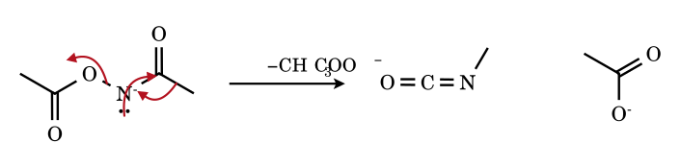
After deprotonation of the N–H (pK_{a} ≈ 8–9), the methyl group migrates from carbonyl carbon to nitrogen as carboxylate leaves, exactly as bromide leaves in the Hofmann reaction (11.4) and N₂ in the Curtius reaction (11.3). The leaving-group ability (N₂ > carboxylate ≈ Br⁻ in the anion) controls the temperature required: Curtius 60–100 °C, Lossen 25–100 °C with base.
11.7 Isocyanate trapped by methanol: carbamate (urethane) formation
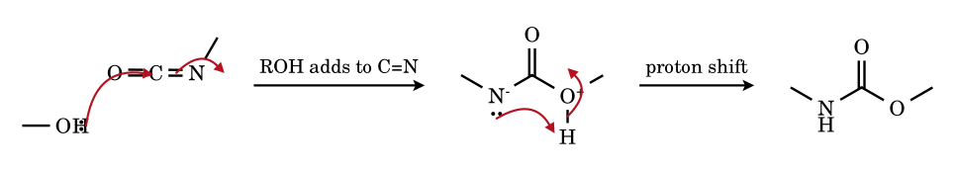
The alcohol oxygen attacks the electrophilic isocyanate carbon (the C=N π bond is the more reactive, giving an amidate anion), and a proton transfer yields the carbamate CH₃NHCO₂CH₃. With water the carbamic acid decarboxylates to the amine; with an amine the product is a urea. The same chemistry is the basis of polyurethane and polyurea manufacture.
11.8 Alkylnitrene → imine (1,2-hydride shift)
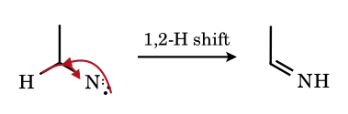
The C–H bond pair migrates to the electron-deficient nitrogen and a lone pair of nitrogen forms the C=N π bond. The shift is very fast (> 10¹⁰ s⁻¹) for singlet alkylnitrenes, which is why alkyl azides photolysed at low temperatures give imines rather than insertion products.
11.9 Beckmann rearrangement: anti-methyl migrates in protonated acetone oxime
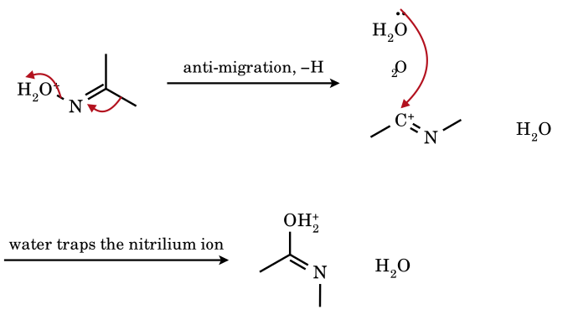
Protonation converts OH into the leaving group H₂O. As water leaves, the group anti to it (here a methyl) migrates from carbon to nitrogen, forming the nitrilium ion CH₃–C⁺=N–CH₃ ↔ CH₃–C≡N⁺–CH₃. Water adds to carbon, and after a proton transfer the amide N-methylacetamide results. Contrast the Hofmann/Curtius: there the migrating group is on the carbonyl carbon and the leaving group is on the same nitrogen; here the migrating group is the one in the anti position on the C=N.

11.12 Problems on nitrenes
NI-1.
How many electrons does the nitrogen of a nitrene R–N: have in its valence shell? Is it a Lewis acid or base?
Answer: 6; both (lone pair + empty/half-filled p orbitals); mainly electrophilic
N contributes one electron to the N–R bond; the remaining four are two non-bonding electrons in each of two orbitals in the singlet arrangement (a pair in one orbital, a vacant p) = six electrons around nitrogen: a sextet. The lone pair makes it a base, the incomplete octet makes it a Lewis acid.
NI-2.
Identify the reactive intermediate in each: (a) RCONH₂ + Br₂ + KOH; (b) RCON₃, Δ; (c) R–CH₂–N₃, hν; (d) CHCl₃ + KOH.
Answer: (a) acyl nitrene (nitrenoid; concerted isocyanate formation), (b) same, (c) alkylnitrene, (d) dichlorocarbene
(a) and (b) are drawn through R–CO–N:, but experimentally the R-shift and loss of Br⁻ or N₂ occur together. In (c) photolysis expels N₂ from the azide to give R–CH₂–N:. (d) is the carbene reaction of Part 10.
NI-3.
Propanamide is treated with Br₂/KOH. Name the product and say how the carbon count changes.
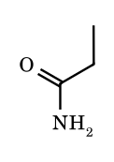
Answer: ethanamine (ethylamine), one carbon less
Hofmann degradation: the ethyl group migrates from C to N to give ethyl isocyanate, which is hydrolysed and decarboxylated to CH₃CH₂NH₂ + CO₃²⁻.
NI-4.
Benzamide → ? and phenylacetamide → ?; (Br₂/NaOH).
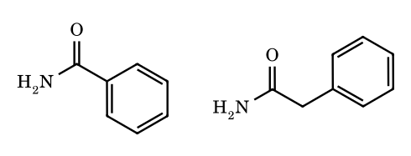
Answer: aniline; benzylamine
The group attached to the carbonyl carbon migrates to nitrogen: phenyl in benzamide (→ PhNH₂) and benzyl in phenylacetamide (→ PhCH₂NH₂). The migrating carbon keeps its configuration (R-CH(CH₃)CONH₂ optically active → retained).
NI-5.
A chiral amide (S)-CH₃CH(C₂H₅)CONH₂ undergoes Hofmann degradation. What is the stereochemical result?
Answer: retention of configuration (the amine is (S)-sec-butylamine in the CIP sense)
The migrating carbon moves with its bonding pair in a 3-centre transition state and never becomes planar; no inversion and no racemisation occur.
NI-6.
Which is not an intermediate or product in the Curtius rearrangement of RCOCl? (A) RCON₃, (B) RN=C=O, (C) RNH₂, (D) R–CH₂NH₂.
Answer: (D)
RCOCl + NaN₃ → RCON₃ → RN=C=O + N₂ → (H₂O) RNH₂ + CO₂. The amine has one carbon less than the acid; R–CH₂NH₂ would have the same carbon count.
NI-7.
Compare the Curtius, Hofmann, Lossen and Schmidt reactions by giving the leaving group lost from nitrogen.
Answer: N₂; Br⁻; carboxylate; N₂
Curtius (from acyl azide): N₂; Hofmann (N-bromoamide anion): Br⁻; Lossen (O-acylhydroxamate anion): R′COO⁻; Schmidt (carboxylic acid + HN₃, protonated acyl azide): N₂. All give the isocyanate by a 1,2-shift.
NI-8.
Phenyl azide is irradiated in the presence of excess diethylamine. Which product is expected, and what does it show about the intermediate?
Answer: 3H-azepine (2-diethylamino-3H-azepine); ring-expanded didehydroazepine
The singlet phenylnitrene cyclises to a benzazirine, which opens to the strained cyclic ketenimine; the amine traps it. If the amine is absent the triplet nitrene dimerises to azobenzene.
NI-9.
How does the stereochemistry of aziridine formation distinguish singlet from triplet nitrenes?
Answer: singlet: stereospecific; triplet: loss of stereochemistry
Singlet nitrene adds in one concerted step (syn); triplet nitrene adds one bond at a time forming a 1,3-diradical that can rotate before ring closure, so cis- and trans-alkenes give the same cis/trans aziridine mixture.
NI-10.
Why is the triplet the ground state for most nitrenes?
Answer: two degenerate p orbitals each hold one electron (Hund’s rule)
In R–N: the two non-bonding p orbitals on nitrogen are degenerate (cylindrical symmetry about the R–N axis), so the lowest-energy arrangement places one electron in each with parallel spins, exactly as in O₂ or the NH radical.
NI-11.
Give the product of Hofmann bromamide degradation of (a) CH₃CONH₂, (b) (CH₃)₃CCONH₂, (c) C₆H₅CH₂CONH₂, (d) cyclohexanecarboxamide, (e) H₂NCO(CH₂)₄CONH₂.
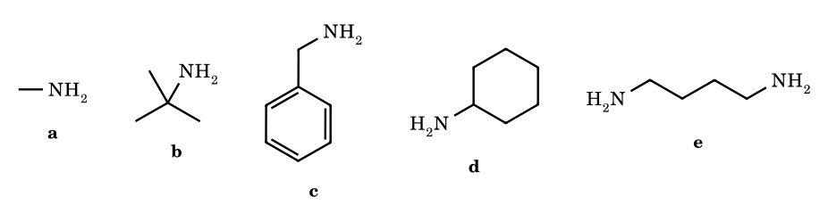
Answer: (a) CH₃NH₂; (b) t-BuNH₂; (c) benzylamine; (d) cyclohexylamine; (e) 1,4-diaminobutane (putrescine)
R–CONH₂ → R–NH₂; for the diamide both CONH₂ groups are degraded, leaving H₂N–(CH₂)₄–NH₂ (adipamide has 6 C: two are lost as carbonate).
NI-12.
Phthalimide is treated with Br₂ and excess aqueous NaOH. Identify the product after acidification, and state its use.
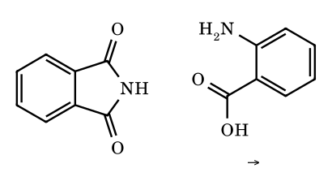
Answer: anthranilic acid (2-aminobenzoic acid)
NaOH opens the imide to the phthalamate; the remaining CONH₂ undergoes Hofmann degradation to give NH₂ on the ring while the carboxylate stays. Anthranilic acid is the starting material for indigo, methyl anthranilate (perfumery) and benzyne generation (via diazotisation to benzenediazonium-2-carboxylate).
NI-13.
Convert (a) CH₃CH₂COOH to CH₃CH₂NH₂ by two methods, (b) CH₃CH₂COOH to CH₃CH₂CH₂NH₂.
Answer: (a) (i) SOCl₂; NaN₃; Δ; H₂O (Curtius), or (ii) SOCl₂; NH₃; Br₂/KOH (Hofmann); (b) reduce acid or its amide to the alcohol/amine: CH₃CH₂COOH → CH₃CH₂CONH₂ → LiAlH₄ → CH₃CH₂CH₂NH₂
Hofmann/Curtius remove one carbon; to preserve the carbon count use LiAlH₄ reduction of the amide (or nitrile). To add one carbon: acid → alcohol → bromide → CN⁻ → LiAlH₄.
NI-14.
An optically active amide, (R)-2-phenylbutanamide, is subjected to Hofmann degradation. State the product, its configuration and why optical purity is retained.
Answer: (R)-1-phenylpropylamine (retention); no racemisation
The migrating carbon never becomes a free cation or radical; it is bound to both C and N in the three-centre transition state throughout, so its configuration is retained (the change of CIP descriptor depends only on priority changes: here NH₂ > Ph > Et, so the descriptor remains R).
NI-15.
Which of the following can undergo Hofmann bromamide degradation? (a) CH₃CONH₂, (b) CH₃CONHCH₃, (c) CH₃CON(CH₃)₂, (d) CH₃COOC₂H₅, (e) CH₃CN, (f) HCONH₂.
Answer: (a) only (and arguably (f) gives NH₃/HNCO but not a meaningful amine)
Only primary amides RCONH₂ have two N–H bonds: one is replaced by Br, the other deprotonated to the bromoamide anion that rearranges. N-Substituted amides lack the second N–H, and (d), (e) have no N–H at all.
NI-16.
Name the product of Schmidt reaction of (a) cyclohexanone + HN₃/H₂SO₄, (b) acetophenone + HN₃/H₂SO₄, (c) benzoic acid + HN₃/H₂SO₄.
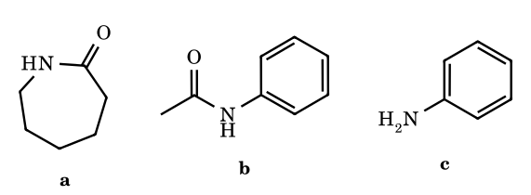
Answer: (a) ε-caprolactam; (b) acetanilide (phenyl migrates); (c) aniline
(a) ring expansion: the ring carbon migrates to nitrogen of the iminodiazonium ion. (b) the group that migrates is the one anti to N₂⁺ in the preferred geometry; with aryl alkyl ketones the aryl group migrates to give an N-aryl amide. (c) acid → amine with one carbon less.
NI-17.
Compare the Beckmann rearrangement of cyclohexanone oxime with the Schmidt reaction of cyclohexanone. What do they have in common, and which is used industrially for nylon-6?
Answer: same product (ε-caprolactam); Beckmann
Both produce a seven-membered lactam by ring-carbon migration to nitrogen with loss of a leaving group (H₂O or N₂). Industrially the Beckmann (oleum) is used because HN₃ is toxic and explosive. ε-Caprolactam is polymerised (ring-opening, 250 °C) to nylon-6.
NI-18.
In the Beckmann rearrangement of the E-oxime of 4-methylacetophenone the group anti to OH is the aryl group. Write the product and predict the product from the Z-oxime.
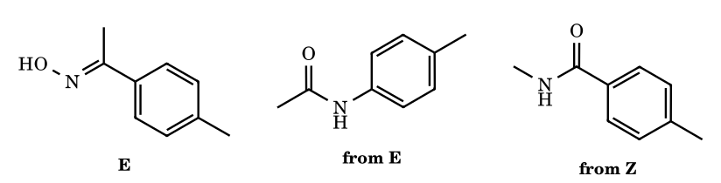
Answer: E: N-(4-methylphenyl)acetamide (aryl migrates); Z: N-methyl-4-methylbenzamide
The migrating group is always the one anti to the leaving group; under acid conditions oximes interconvert and the more stable E isomer predominates, but under non-equilibrating conditions (TsCl/pyridine, PCl₅ at low T) the product reflects the oxime geometry.
NI-19.
State whether each of the following contains a free nitrene intermediate under the stated conditions: (a) CH₃CON₃, 80 °C; (b) CH₃CON₃, hν; (c) PhN₃, hν; (d) TsN=IPh + Cu(I); (e) o-nitrobiphenyl + P(OEt)₃.
Answer: (a) no (concerted Curtius); (b) partly yes; (c) yes (singlet then triplet); (d) no (copper–imido, nitrenoid); (e) yes (arylnitrene, or nitrenoid with phosphorus)
Thermal Curtius gives isocyanate cleanly; photolysis yields insertion/addition products indicating real acylnitrene; phenylnitrene is formed from PhN₃ and ring-expands; Cu and Rh give metal-bound nitrene, and Cadogan intermediates are nitrene-like species whose cyclisation is on the nitrene or its deoxygenation precursor (nitroso).
NI-20.
Phenyl azide is heated in benzene and the product is mainly azobenzene together with aniline; when irradiated at −196 °C in a glass, an ESR signal appears. Identify the intermediate.
Answer: triplet phenylnitrene
The ESR signal (zero-field splitting D ≈ 1 cm⁻¹) is the fingerprint of a triplet (S = 1). Dimerisation of two triplet nitrenes gives PhN=NPh; H-abstraction from solvent gives PhNH• and PhNH₂.
NI-21.
(Match the column) Reaction – leaving group lost from nitrogen: (A) Hofmann, (B) Curtius, (C) Lossen, (D) Beckmann (P) N₂, (Q) Br⁻, (R) RCOO⁻, (S) H₂O.
Answer: A–Q; B–P; C–R; D–S
Hofmann: N-bromoamide anion → bromide; Curtius: acyl azide → N₂; Lossen: O-acyl hydroxamate → carboxylate; Beckmann: protonated oxime → water.
NI-22.
A compound A (C₅H₁₁NO) is a primary amide. On Hofmann degradation it gives an optically active amine B (C₄H₁₁N). Identify A and B.
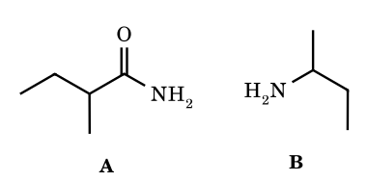
Answer: A = 2-methylbutanamide; B = butan-2-amine
Of the four C₅ primary amides only 2-methylbutanamide gives a chiral amine, since the migrating sec-butyl carbon retains configuration. The others give n-butyl, isobutyl and tert-butylamines, all achiral.
NI-23.
Explain why bromamide anion RCON⁻Br rearranges at 60–80 °C but N-chloroamides or N-bromoamides are stable at 0 °C.
Answer: the amide N–H must be removed to give the anion; the neutral N-bromoamide is stable
Rearrangement requires the negatively charged nitrogen whose lone pair forms the new C=N π bond as the migrating group moves; in the neutral N-haloamide that lone pair is delocalised into C=O. Only with base is the nitrogen deprotonated and the isocyanate-forming step possible.
NI-24.
Predict the product: 2-nitrobiphenyl + triethyl phosphite, 160 °C.
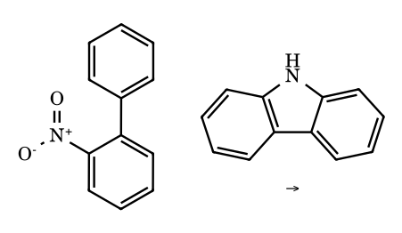
Answer: carbazole
P(OEt)₃ deoxygenates the nitro group twice (to the nitroso then nitrene stage; 2 equiv of phosphite give 2 O=P(OEt)₃); the aryl nitrene then inserts into the adjacent ring C–H bond (electrocyclisation/1,5-insertion) to form the five-membered ring (Cadogan).
NI-25.
N-aminophthalimide is oxidised with Pb(OAc)₄ in the presence of cis-2-butene and trans-2-butene separately. Predict the stereochemistry.
Answer: cis → cis-aziridine; trans → trans-aziridine
N-Phthalimidonitrene is a singlet aminonitrene; singlets add in a single concerted syn step, so alkene stereochemistry is retained (Atkinson).
NI-26.
Which is more stable, a triplet or singlet phenylnitrene, and why does phenyl azide photolysis in diethylamine give an azepine rather than N,N-diethyl-N′-phenylhydrazine?
Answer: triplet; azepine arises from singlet-derived ring expansion
Triplet PhN: is the ground state, but the initially formed singlet is converted (k ≈ 10⁹–10¹⁰ s⁻¹) to benzazirine then didehydroazepine before it can intersystem-cross; the strained cyclic ketenimine reacts with nucleophiles (Et₂NH adds) to give 2-diethylamino-3H-azepine. With ortho substituents or at low T the ISC pathway wins.
NI-27.
Distinguish nitrene, nitrenium ion, nitrenoid and nitrile by (i) electron count, (ii) charge, (iii) typical reactivity.
Answer: see reasoning
Nitrene R–N: (6 e, neutral, electrophilic/insertion/addition); nitrenium R₂N⁺ (6 e, +, electrophile; attacks aromatic ring or DNA bases); nitrenoid M=NR or X–NR⁻ (transfer of NR, with metal/halide still attached); nitrile R–C≡N (8 e, stable).
NI-28.
In the Hofmann degradation of the amide PhCH₂CONH₂ with Br₂/KOH in methanol (instead of water) the product is a carbamate. Give its structure and explain.
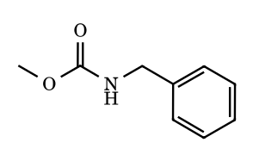
Answer: methyl N-benzylcarbamate
The isocyanate PhCH₂N=C=O is trapped by the solvent methanol (faster than by hydroxide). This ‘modified Hofmann’ is used to obtain protected amines; the carbamate can be hydrolysed or hydrogenolysed to the amine.
NI-29.
How many different primary amines C₄H₁₁N can be obtained by Hofmann degradation of primary amides C₅H₁₁NO?
Answer: 4
The four pentanamide skeletons (pentanamide, 2-methylbutanamide, 3-methylbutanamide, 2,2-dimethylpropanamide) give n-butylamine, sec-butylamine, isobutylamine and tert-butylamine – the four primary C₄H₁₁N amines.
NI-30.
Why do aryl azides decompose at lower temperatures than alkyl azides, and why do aryl nitrenes ring-expand while alkyl nitrenes undergo 1,2-H shifts?
Answer: conjugation with the arene lowers the TS energy; the aryl π system offers cyclisation, the alkyl group offers a migrating H
Conjugation of the azide with the ring stabilises the transition state for N₂ loss (aryl azides lose N₂ at ≈ 100–140 °C, alkyl azides at higher temperatures or by photolysis). The singlet arylnitrene can attack the ortho carbon (benzazirine → didehydroazepine); an alkylnitrene has no π system and the adjacent C–H bond migrates to nitrogen to give an imine.
NI-31.
(S)-2-Phenylpropanoic acid is converted to its acyl azide, heated, and hydrolysed. Give the product and its configuration.
Answer: (S)-1-phenylethylamine
Curtius migration of the 1-phenylethyl group occurs with retention. In the acid the priority order is COOH > Ph > CH₃ > H and in the amine NH₂ > Ph > CH₃ > H, so NH₂ takes the rank of COOH and the descriptor stays S.
NI-32.
Write the balanced equation for the Hofmann degradation of RCONH₂ with Br₂/NaOH and state the moles of NaOH consumed per mole of amide.
Answer: RCONH₂ + Br₂ + 4 NaOH → RNH₂ + Na₂CO₃ + 2 NaBr + 2 H₂O; 4 mol
The Na, O and H balance: Na 4 = 2 + 2; O 1 + 4 = 3 + 2; H 2 + 4 = 2 + 4. NaOH is used to form NaOBr, to deprotonate the N–H, and to convert CO₂ (from the isocyanate) to carbonate.
NI-33.
2-Azidobiphenyl is heated in an inert solvent. Give the main product and the intermediate.
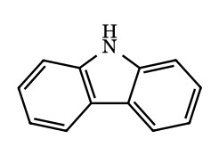
Answer: carbazole via an aryl nitrene (insertion into the adjacent ring C–H)
Loss of N₂ gives the nitrene on one ring, which inserts into the ortho C–H of the other ring to form the five-membered pyrrole ring. The same carbazole arises from 2-nitrobiphenyl and P(OEt)₃ (Cadogan).
NI-34.
Ethyl azidoformate is photolysed in cyclohexene. Name the two kinds of product and say how stereochemistry would reveal the spin state.
Answer: N-ethoxycarbonyl-7-azabicyclo[4.1.0]heptane (aziridine) and allylic C–H insertion product
A singlet carbalkoxynitrene adds to C=C in one step (syn, stereospecific) and can insert into allylic C–H. A triplet nitrene adds in two steps via a diradical; with cis- or trans-2-butene it would give aziridines of mixed configuration.
NI-35.
A carboxylic acid is treated with DPPA/Et₃N and then t-BuOH under reflux. Give the product type and the intermediates.
Answer: R–NH–Boc via acyl azide and isocyanate
RCOOH is converted to the acyl azide (via the mixed phosphoryl anhydride), which rearranges on heating to RN=C=O; t-BuOH adds to give the Boc carbamate (Shioiri–Yamada). Retention at R.
NI-36.
N-Phenylhydroxylamine is warmed in dilute H₂SO₄. Give the product and the intermediate.
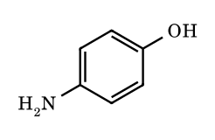
Answer: p-aminophenol via a nitrenium ion (Bamberger rearrangement)
Protonation of OH and loss of water give the phenylnitrenium ion, delocalised onto the para carbon; water attacks there and tautomerisation gives p-aminophenol.
NI-37.
Terephthalamide is treated with excess NaOBr. Give the product.
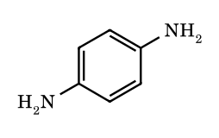
Answer: p-phenylenediamine
Each CONH₂ undergoes Hofmann degradation, losing its carbonyl carbon as carbonate and leaving NH₂ on the ring carbon.
NI-38.
Styrene reacts with PhI=NTs and Cu(OTf)₂. Give the product, and say where a nucleophile will open it.
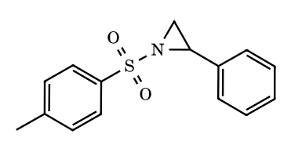
Answer: 2-phenyl-1-tosylaziridine; opening at the benzylic carbon
A copper-nitrenoid transfers NTs to the C=C (Evans aziridination). Nucleophiles open the activated aziridine at the benzylic carbon, which best stabilises the developing positive charge.
NI-39.
(Medium, JEE Advanced style, integer) (S)-2-Methylbutanoic acid is treated with (i) SOCl₂; (ii) NaN₃; (iii) toluene, 80 °C; (iv) aqueous HCl, heat; (v) NaOH. Let x be the number of carbon atoms in the final organic product and y the number of moles of gas evolved per mole of acid in steps (iii)–(iv). Give x + y and the CIP descriptor of the product.
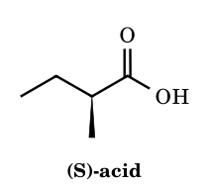
Answer: 6 ; (S)-butan-2-amine
Acid chloride, acyl azide, then thermal Curtius rearrangement: R migrates from C to N with loss of N₂ (1 mol) giving the isocyanate; acid hydrolysis of RNCO gives a carbamic acid that loses CO₂ (1 mol), so y = 2. The product is butan-2-amine, x = 4, so x + y = 6. The migrating carbon keeps its configuration (retention), and the priority order (N or COOH > ethyl > methyl > H) is unchanged, so the product is (S)-butan-2-amine.
NI-40.
(Medium, integer) Adipamide (hexanediamide) is treated with excess Br₂/NaOH in water. How many moles of NaOH and of Br₂ are consumed per mole of diamide, and what is the organic product? Give (moles NaOH) + (moles Br₂).
Answer: 10 (8 NaOH + 2 Br2); butane-1,4-diamine
Each CONH₂ group follows RCONH₂ + Br₂ + 4 NaOH → RNH₂ + Na₂CO₃ + 2 NaBr + 2 H₂O (N-bromination, deprotonation, 1,2-shift of R to N with loss of Br⁻, hydrolysis of RNCO, and CO₂ captured as carbonate). Two groups consume 2 Br₂ and 8 NaOH. Each C(=O) is lost, so the C₆ diamide gives the C₄ diamine H₂N(CH₂)₄NH₂ (putrescine).
NI-41.
(Medium, multi-correct) Choose the correct statement(s): (A) singlet nitrenes add to cis-but-2-ene to give cis-2,3-dimethylaziridines stereospecifically, whereas triplet nitrenes give a mixture of cis and trans aziridines; (B) NH and simple alkyl nitrenes have triplet ground states; (C) free alkyl nitrenes are rarely trapped intermolecularly because the singlet state undergoes very fast 1,2-H shift to an imine; (D) in the thermal Curtius rearrangement of an acyl azide a free acyl nitrene is formed first and R then migrates onto it; (E) nylon-6 is made by ring-opening polymerisation of ε-caprolactam, which itself comes from the Beckmann rearrangement of cyclohexanone oxime; (F) PhI=NTs delivers a free triplet nitrene TsN to a Cu catalyst.
Answer: A, B, C, E
(A) is correct: singlet addition is concerted, triplet addition is stepwise through a 1,3-diradical that can rotate. (B) NH and CH₃N are triplets in the ground state. (C) Singlet alkylnitrenes rearrange to imines essentially without barrier. (D) is false: thermal Curtius is concerted, R migrates as N₂ leaves, with no free nitrene (photolysis can give some). (E) is correct. (F) is false: Cu or Rh nitrenoids (metal-bound imido species) are the transfer agents, not free nitrenes.
NI-42.
(Medium, GATE/CSIR style) Acetophenone oxime exists as an (E) isomer (OH anti to phenyl, major) and a (Z) isomer. Each isomer is treated separately with PCl₅ and then water. Give the amide from each isomer and the two fragments obtained when each amide is hydrolysed with aqueous HCl (heat).
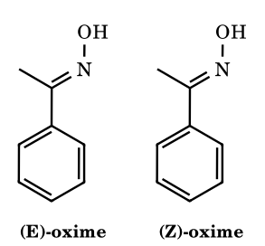
Answer: E: acetanilide → aniline + acetic acid; Z: N-methylbenzamide → methylamine + benzoic acid
In the Beckmann rearrangement the group anti to the departing OH (as O–PCl₄ or protonated OH) migrates to nitrogen, stereospecifically. In the (E) isomer phenyl is anti, so Ph–N results: PhNHCOCH₃, which hydrolyses to anilinium chloride and acetic acid. In the (Z) isomer methyl is anti: CH₃NHCOPh, hydrolysing to methylammonium chloride and benzoic acid.
NI-43.
(Medium) 2-Methylpentanamide is subjected to: (i) Br₂/NaOH; (ii) excess CH₃I; (iii) moist Ag₂O; (iv) heat. Name the organic products of steps (i) and (iv), say which alkene is major, and state the number of carbon atoms in it. Distinguish the two ‘Hofmann’ reactions involved.
Answer: pentan-2-amine; major pent-1-ene (C5)
Step (i) is the Hofmann rearrangement: C₆ amide → C₅ amine, pentan-2-amine, with loss of the carbonyl carbon as carbonate. Steps (ii)–(iv) are Hofmann exhaustive methylation/elimination of the trimethylammonium hydroxide: E2 with the bulky NMe₃ leaving group removes the most accessible, most acidic β-H (the CH₃ hydrogens), giving pent-1-ene (Hofmann product) as the major alkene, with minor (E)- and (Z)-pent-2-ene and NMe₃. The two reactions share a name but are unrelated mechanistically.
NI-44.
(Medium) Three cyclic imides are each treated with Br₂/KOH (aq) and then neutralised: phthalimide, succinimide and glutarimide. Give the amino acid obtained from each and the sum of the numbers of carbon atoms in the three products.
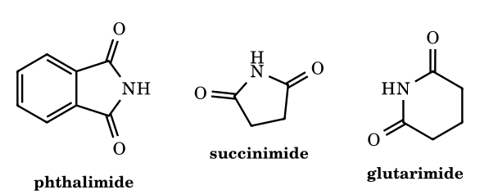
Answer: anthranilic acid (C7), β-alanine (C3), 4-aminobutanoic acid (C4); sum = 14
Hydroxide opens the imide to an amide-carboxylate (phthalamate, succinamate, glutaramate); the free CONH₂ then undergoes Hofmann rearrangement, losing its carbon as carbonate and leaving the carboxylate as the other end. Phthalimide gives 2-aminobenzoic (anthranilic) acid, succinimide gives H₂N(CH₂)₂COOH, glutarimide gives H₂N(CH₂)₃COOH (GABA). Carbons: 7 + 3 + 4 = 14.
NI-45.
(Hard) (E)-2-Nitrostilbene is heated at about 160 °C with an excess of triethyl phosphite. (a) Give the organic product. (b) What is the minimum number of equivalents of P(OEt)₃ and what P-containing product forms? (c) Why is the 5-membered ring product formed and not a 3-membered one? (Cadogan–Sundberg indole synthesis.)
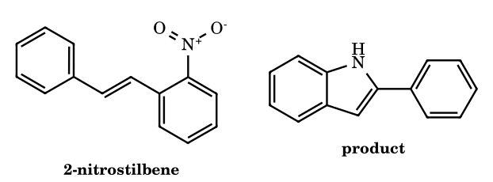
Answer: 2-phenylindole; 2 equiv P(OEt)3, giving 2 OP(OEt)3 (triethyl phosphate)
Each equivalent of phosphite removes one oxygen: ArNO₂ → ArNO → ArN (nitrene or nitrene-like species), forming 2 O=P(OEt)₃. The electron-deficient N then bonds to the alkene carbon bearing the phenyl group (5-membered ring: N, two aryl carbons, two alkene carbons); attack on the nearer alkene carbon would give a strained azirine-type 3-ring. A 1,2-H shift (formally) then aromatises to the NH indole, 2-phenylindole. ⚑ Whether a free nitrene or a 2-nitrosoarene/N-hydroxy-type intermediate is the cyclising species is still debated; the product is the same.
NI-46.
(Hard) Phenyl azide is irradiated (UV) at room temperature in neat diethylamine. (a) Give the product and its molecular formula. (b) List, in order, the intermediates between singlet phenylnitrene and the product. (c) How many sp³ carbon atoms does the product contain?
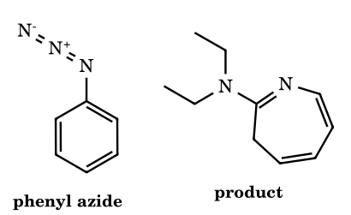
Answer: 2-(diethylamino)-3H-azepine, C10H16N2; 5 sp3 carbons
Loss of N₂ gives singlet phenylnitrene, which closes to a benzazirine (fused 2H-azirine), which opens to the strained ketenimine 1-aza-1,2,4,6-cycloheptatetraene (didehydroazepine). Et₂NH adds to the central ketenimine carbon C-2 and the proton ends on C-3, giving 2-(diethylamino)-3H-azepine, C₆H₅N + C₄H₁₁N = C₁₀H₁₆N₂. sp³ carbons: ring C-3 (CH₂) plus four ethyl carbons = 5. Without a trap the ketenimine gives tars; the triplet nitrene (favoured by low temperature or heavy atoms) dimerises to azobenzene.
NI-47.
(Hard) (S)-2-Methyl-3-(phenylthio)propanoic acid is converted by diphenylphosphoryl azide (DPPA)/Et₃N in toluene at 80 °C, followed by t-BuOH, into a Boc carbamate. (a) Does the stereocentre change its spatial arrangement? (b) Give the CIP descriptor of the carbamate and explain any change from the acid.
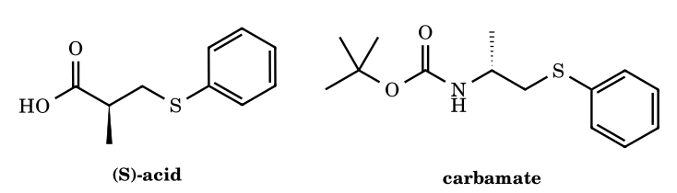
Answer: No; spatial arrangement retained but descriptor changes S → R
DPPA converts the acid to the acyl azide, which rearranges to the isocyanate; t-BuOH traps it as BocNH–. The migrating carbon moves with full retention (concerted shift), so the stereocentre is not touched. In the acid the priorities are CH₂SPh (S,H,H) > COOH (O,O,O) > CH₃ > H, because S outranks O at the first point of difference. In the carbamate N outranks C, so N > CH₂SPh > CH₃ > H. The group that replaced COOH moved from rank 2 to rank 1 and CH₂SPh from 1 to 2, a swap, so the label changes from (S) to (R) without any inversion.
NI-48.
(Hard, match the column) Match each reaction in Column I with the species that undergoes the 1,2-shift (just before the migrating group moves) in Column II. Column I: P Hofmann rearrangement of RCONH₂ with Br₂/NaOH; Q Curtius rearrangement; R Lossen rearrangement; S Beckmann rearrangement of a ketoxime in H₂SO₄; T Schmidt reaction of a ketone with HN₃/H₂SO₄. Column II: 1 acyl azide; 2 conjugate base of an N-bromoamide; 3 anion of an O-acyl (or O-sulfonyl) hydroxamic acid; 4 O-protonated oxime; 5 iminodiazonium ion; 6 free nitrene.
Answer: P–2, Q–1, R–3, S–4, T–5 (6 matches none)
Hofmann: the N-bromoamide anion RC(=O)N⁻Br loses Br⁻ as R shifts. Curtius: the acyl azide loses N₂ as R shifts. Lossen: the activated hydroxamate RC(=O)N⁻OCOR′ loses carboxylate as R shifts. Beckmann: the O-protonated oxime loses H₂O as the anti group shifts. Schmidt: the azidohydrin dehydrates to the iminodiazonium ion R₂C=N–N₂⁺, which loses N₂ as R shifts. In all five the shift is concerted with loss of the leaving group, so a free nitrene (6) is not involved.
NI-49.
(Hard) (S)-2-Methylcyclohexanone gives an oxime in which the OH is anti to C-2 (the more substituted α-carbon, the (E) oxime). This is treated with PCl₅, then water. (a) Give the lactam, with ring size and descriptor. (b) What lactam would the isomer with OH syn to C-2 give? (c) What is the repeating unit of the polymer made by ring-opening polymerisation of the parent unsubstituted lactam from cyclohexanone oxime?
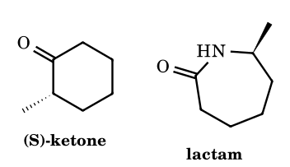
Answer: (S)-7-methylazepan-2-one; 3-methylazepan-2-one; nylon-6 unit –[NH(CH2)5CO]–
The group anti to OH migrates, so with OH anti to C-2 the substituted C-2 moves from C-1 to N. N is then bonded to C(CH₃) and the carbonyl carbon (old C-1) to C-6, giving a seven-membered lactam, 7-methylazepan-2-one. The stereocentre C-2 is the migrating carbon and keeps its configuration; the priority order (C-1 or N > C-3 > CH₃ > H) is unchanged, so (S) stays (S). The other oxime isomer would shift C-6 instead, putting the methyl α to the carbonyl: 3-methylazepan-2-one. Unsubstituted ε-caprolactam polymerises to nylon-6, repeating unit –NH(CH₂)₅C(=O)–.
NI-50.
(Hard) The hydroxylamine (4-nitrophenyl)diphenylmethyl–NHOH is treated with PCl₅, and the product is then hydrolysed with aqueous acid. (a) Give the intermediate imine (Stieglitz rearrangement). (b) Give the two final organic products. (c) Explain which aryl group migrates.
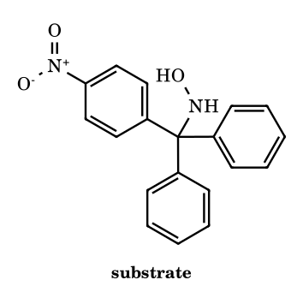
Answer: imine Ph(4-O2NC6H4)C=N-Ph (N-phenyl imine); then 4-nitrobenzophenone + aniline
Activation of the N–O bond (O–PCl₄, leaving group) triggers a 1,2-shift of an aryl group from the trityl carbon to the electron-deficient nitrogen, as in Hofmann/Curtius; the carbon is left as an iminium ion (R₂C=N⁺HAr after loss of the N–H proton, giving the neutral N-aryl ketimine). Phenyl migrates in preference to the strongly electron-poor 4-nitrophenyl (a poor migrating group in cationic shifts), so N bears phenyl and the C=N carbon keeps one phenyl and the nitrophenyl. Hydrolysis gives 4-nitrobenzophenone and anilinium ion. ⚑ Relative migratory aptitudes of aryl groups here are electronic and assumed from the cationic-shift trend.
NI-51.
(Hard) N-Phenylhydroxylamine is warmed in (i) dilute aqueous H₂SO₄ and (ii) H₂SO₄ in methanol (Bamberger rearrangement). Give the main product in each case, identify the key electrophilic intermediate, and state at how many atoms (N plus ring carbons) the positive charge of that intermediate is delocalised in the resonance picture.
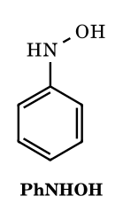
Answer: (i) 4-aminophenol; (ii) 4-methoxyaniline; phenylnitrenium ion, charge on 4 atoms
Protonation on O and loss of water (a formal N–O heterolysis) gives the phenylnitrenium ion PhNH⁺, an electron-sextet nitrogen cation that is stabilised by the ring: positive charge on N and on the two ortho and the para carbons, 4 atoms in all. The nucleophile (H₂O or CH₃OH, the only nucleophile in the medium) attacks para, and tautomerisation restores aromaticity: 4-aminophenol in water, 4-methoxyaniline in methanol. ⚑ Whether a discrete nitrenium ion or a tight ion pair is involved is system-dependent; the para selectivity is the same.
NI-52.
(Hard, assertion–reason) Choose for each pair: (A) both true and R explains A; (B) both true but R does not explain A; (C) A true, R false; (D) A false, R true. Pair 1. A: Insertion of a singlet alkylnitrene into the tertiary C–H bond of an optically active alkane occurs with retention of configuration. R: Singlet insertion is a concerted three-centre process that does not generate a free radical pair. Pair 2. A: The Hofmann rearrangement of an optically active α-chiral primary amide gives the amine with retention. R: The migrating carbon moves with its bonding pair while Br⁻ leaves, without becoming a free carbocation. Pair 3. A: Thermal decomposition of an acyl azide at 80 °C proceeds through a free acyl nitrene, so C–H insertion and aziridination by-products are formed. R: Photolysis of acyl azides can give acyl nitrenes.
Answer: Pair 1: A; Pair 2: A; Pair 3: D
Pair 1: singlet insertion proceeds through a concerted three-centre transition state with no radical pair, so the migrating configuration is retained; R explains A (a triplet nitrene would abstract H and recombine, giving racemisation). Pair 2: a concerted 1,2-shift with simultaneous loss of the leaving group on N keeps the configuration of the migrating carbon; R explains A. Pair 3: A is false, since thermal Curtius rearrangement is concerted and gives isocyanate cleanly without nitrene by-products; R is true, as acyl nitrenes are formed photochemically, so the answer is D.
NI-53.
(Hard) Cyclohexene is treated with PhI=NTs and a Cu(I) catalyst to give aziridine A. A is heated with NaN₃ in aqueous DMF to give B, and B is hydrogenated (H₂, Pd/C) to C. (a) Identify A, B, C. (b) State the relative configuration in B and C and the number of stereoisomers formed. (c) Is a free nitrene involved in the first step?
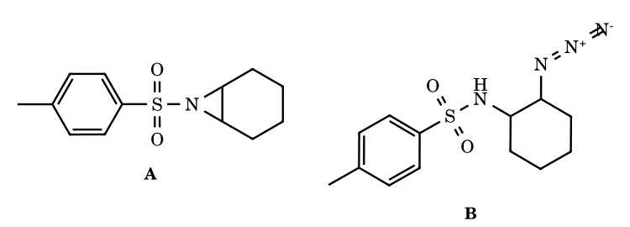
Answer: A cis-fused N-tosylaziridine; B trans-azido sulfonamide; C trans-N-tosyl-1,2-diaminocyclohexane (racemic, 2 stereoisomers); no free nitrene
The Cu-bound iminoiodinane gives a Cu-nitrenoid (nitrenoid, not a free nitrene) that transfers NTs to the alkene, giving the cis-fused 7-azabicyclo[4.1.0]heptane A (a bicyclic aziridine can only be cis). Azide opens the activated aziridine by SN2 with inversion at the carbon attacked, so the N and the new N₃ are trans on the ring: B is trans-N-(2-azidocyclohexyl)-4-methylbenzenesulfonamide. Catalytic hydrogenation reduces N₃ to NH₂ without touching stereochemistry, giving trans-TsNH–C₆H₁₀–NH₂. Since no chiral catalyst or auxiliary is used, the (1R,2R) and (1S,2S) forms arise equally: a racemate (2 stereoisomers).
NI-54.
(Hard) (E)-Cinnamamide, PhCH=CH–CONH₂, is subjected to (i) NaOCl, aqueous NaOH, and separately (ii) Br₂, NaOMe, MeOH. Give the main product in each case, with carbon count, and explain why they differ.
Answer: (i) phenylacetaldehyde (C8); (ii) methyl (E)-styrylcarbamate, PhCH=CH–NHCO2CH3 (C10)
Both reactions give the vinyl isocyanate (E)-PhCH=CH–N=C=O by Hofmann rearrangement; the vinyl carbon migrates with retention of the (E) geometry ⚑ (stereospecific for sp² migration). In water the isocyanate is hydrolysed to the unstable carbamic acid, which loses CO₂ to give the enamine PhCH=CH–NH₂, whose tautomer PhCH₂CH=NH hydrolyses to phenylacetaldehyde, C₈H₈O (loss of one carbon from the C₉ amide). In methanol the isocyanate is trapped faster as the enecarbamate methyl (E)-N-styrylcarbamate, which is stable.
NI-55.
(Very hard) Design a short conversion of cyclohexanone into hexa-1,5-diene that uses a Beckmann rearrangement and two Hofmann eliminations. Give the reagents and every intermediate, count the total equivalents of CH₃I consumed, and name the nitrogen-containing by-product of the last step. Why can this sequence only give the terminal alkene?
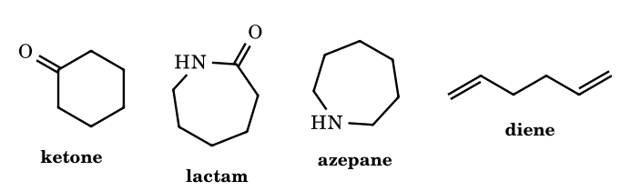
Answer: oxime; caprolactam; azepane; N,N-dimethylhex-5-en-1-amine; hexa-1,5-diene; 3 CH3I; NMe3
(1) NH₂OH gives the oxime; (2) H₂SO₄/oleum (Beckmann) gives ε-caprolactam (azepan-2-one); (3) LiAlH₄ reduces the lactam to azepane; (4) excess CH₃I (2 equiv), then Ag₂O/H₂O and heat: the ring N⁺Me₂ hydroxide undergoes Hofmann elimination to give Me₂N(CH₂)₄CH=CH₂; (5) 1 more equiv of CH₃I, Ag₂O, heat: the acyclic Me₃N⁺ eliminates with the only β-H set (C-2), giving CH₂=CH(CH₂)₂CH=CH₂ and NMe₃. Total 3 CH₃I. Both eliminations give terminal C=C: in the azepanium ion the two N-bearing carbons are equivalent by symmetry and each has one β-carbon, and in the second step the Me₃N⁺-bearing C-1 has only C-2 as β-carbon.
NI-56.
(Very hard) 3-Methylbutyl sulfamate, (CH₃)₂CHCH₂CH₂OSO₂NH₂, is treated with Rh₂(OAc)₄ (cat.), PhI(OAc)₂ and MgO in CH₂Cl₂ to give P. P is then treated with NaN₃ in DMF, followed by aqueous acid, to give Q, and finally H₂/Pd gives R. Identify P, Q, R, state the ring size of P and the type of reactive species, and explain the site of ring opening.
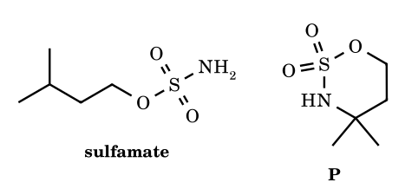
Answer: P 4,4-dimethyl-1,2,3-oxathiazinane 2,2-dioxide (6-ring); Q 4-azido-2-methylbutan-2-amine; R 3-methylbutane-1,3-diamine
PhI(OAc)₂ and the sulfamate generate an iminoiodinane in situ that reacts with Rh₂(OAc)₄ to give a Rh-nitrenoid (not a free nitrene). Its geometry prefers a six-membered chair-like transition state, so it inserts into the γ-C–H, here the weak tertiary C–H, forming the six-membered cyclic sulfamate P: O–SO₂–N–C(CH₃)₂–CH₂–CH₂. Azide attacks by SN2 at the primary O–CH₂ carbon (the quaternary C–N carbon cannot undergo SN2); the N-sulfate that results is hydrolysed in acid to NH₂, giving Q = N₃CH₂CH₂C(CH₃)₂NH₂. Hydrogenation of the azide gives the 1,3-diamine R, H₂NCH₂CH₂C(CH₃)₂NH₂.
NI-57.
(Very hard) (S)-2-Methylbutanoic acid is converted to a single amine by: (i) SOCl₂; (ii) excess CH₂N₂; (iii) Ag₂O, H₂O (Wolff rearrangement) to give acid X; (iv) DPPA, Et₃N, then H₂O/H⁺ (Curtius). (a) Give X and the final amine, with carbon counts. (b) State the CIP descriptors of X and the amine and the configuration changes at the stereocentre. (c) Compare with the amine from direct Curtius of the starting acid.
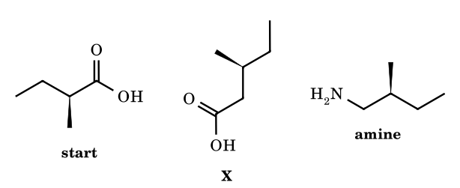
Answer: X = (S)-3-methylpentanoic acid (C6); amine = (S)-2-methylbutan-1-amine (C5); direct Curtius gives (S)-butan-2-amine (C4)
Arndt–Eistert homologation adds one CH₂ between the stereocentre and COOH: the Wolff shift occurs at the carbonyl-attached carbon (the stereocentre) with retention, so X is (S)-3-methylpentanoic acid, C₆H₁₂O₂. The CH₂COOH group still outranks ethyl (second sphere O,O,O versus H,H,H), so the descriptor stays (S). Curtius then removes the COOH carbon, with retention at the migrating CH₂ (not the stereocentre), giving (S)-2-methylbutan-1-amine, C₅H₁₃N, in which CH₂NH₂ outranks ethyl. Direct Curtius of the starting acid instead would give the C₄ amine (S)-butan-2-amine. Net: homologation followed by degradation puts a CH₂ between the stereocentre and N.
NI-58.
(Very hard, counting) Ethoxycarbonylnitrene (singlet, from photolysis of ethyl azidoformate) is generated in 2-methylbutane as solvent and inserts into C–H bonds to give N-alkyl carbamates EtO₂C–NH–R. How many different constitutional isomers of the carbamate are possible, and how many stereoisomers (counting each enantiomer separately, all isomers) can form in total? Which isomer is expected to be the major product?
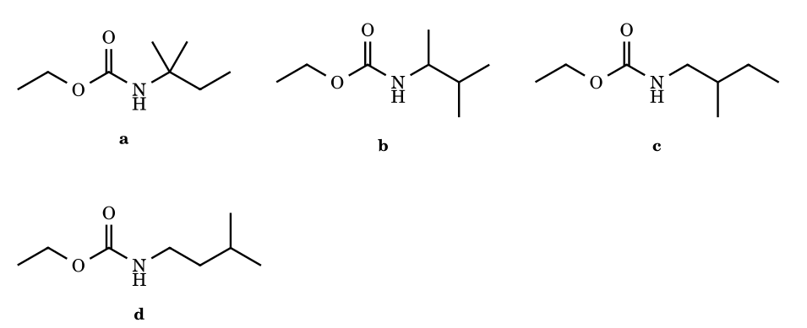
Answer: 4 constitutional isomers; 6 stereoisomers; major: ethyl N-(2-methylbutan-2-yl)carbamate
2-Methylbutane, (CH₃)₂CH–CH₂–CH₃, has four types of C–H: the two equivalent CH₃ on C-2, the C-2 methine, the C-3 methylene and the C-4 CH₃. Hence 4 constitutional carbamates (a–d). Inserting at C-3 gives CH₃CH(NHR)CH(CH₃)₂, with a stereocentre (2 enantiomers); inserting at one of the C-2 methyls gives NHCH₂CH(CH₃)CH₂CH₃, also chiral (2 enantiomers); the tertiary insertion and the C-4 insertion products are achiral (1 each). Total 2 + 2 + 1 + 1 = 6. The weak tertiary C–H is the most reactive site per hydrogen, so isomer a is the main product. ⚑ The selectivity of singlet carbonylnitrene insertion is modest, so a is the major but not an exclusive product.
NI-59.
(Very hard, structure elucidation) Compound K, C₉H₁₀O, shows IR 1688 cm⁻¹ and ¹H NMR δ 1.22 (t, 3H), 2.99 (q, 2H), 7.4–7.6 (m, 3H), 7.95 (d, 2H). K with NH₂OH gives a single major oxime A. A with PCl₅, then water, gives B, C₉H₁₁NO, IR 3300 and 1660 cm⁻¹, ¹H NMR δ 1.2 (t, 3H), 2.4 (q, 2H), 7.0–7.6 (m, 5H), 7.9 (br s, 1H). Hot 6 M HCl converts B into C (an anilinium salt) and D. Identify K, A, B, C, D and state the number of distinct ¹³C signals of B. Why is the isomeric N-ethylbenzamide ruled out?
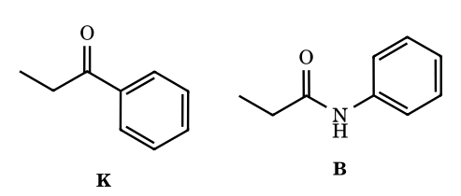
Answer: K propiophenone; A (E)-oxime; B N-phenylpropanamide; C anilinium chloride; D propanoic acid; 7 13C signals
The ketone C₉H₁₀O with ethyl (t 1.22, q 2.99; the CH₂ is deshielded by C=O) and a monosubstituted conjugated aryl ketone is propiophenone, K. The ketoxime A is mainly (E) with OH anti to the bulky phenyl, so Beckmann rearrangement moves phenyl to N: B is PhNHC(=O)CH₂CH₃. In B the CH₂ is at δ 2.4 (next to C=O, typical of an amide), and there is no deshielded N–CH₂ (a CH₂ attached to N, as in N-ethylbenzamide, would be near δ 3.4 (a quintet-like multiplet) with an NH at ≈ 6.2 and ortho H at 7.8 d). Hydrolysis gives anilinium chloride (C) and propanoic acid (D). 13C signals of B: CH₃, CH₂, C=O, and four aromatic (ipso, ortho, meta, para) = 7.
NI-60.
(Very hard) The trans-2-phenylcyclopropanecarboxylic acid with (1S,2S) configuration is converted by (i) ClCO₂Et, Et₃N; (ii) NaN₃; (iii) toluene, reflux; (iv) aqueous HCl, heat; (v) NaOH to trans-2-phenylcyclopropylamine (tranylcypromine). (a) Give the CIP descriptors of the amine and the relative configuration. (b) Explain why a descriptor changes even though the reaction proceeds with retention at the migrating carbon. (c) Why can this amine not be made by SN2 from the corresponding bromide?
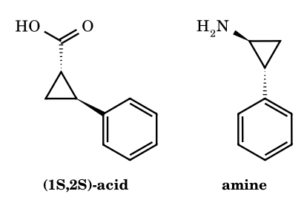
Answer: (1S,2R)-trans-2-phenylcyclopropylamine; C-2 descriptor flips S → R though geometry is retained
Mixed anhydride, acyl azide, Curtius (isocyanate, N₂ lost), then hydrolysis and loss of CO₂ give the amine; the cyclopropyl carbon C-1 migrates with retention, so the trans relationship persists. At C-1 the priorities N (replacing COOH) > C-2 > C-3 > H keep the same order, so C-1 remains (S). At C-2 the substituents are Ph (C,C,C), C-1 and C-3: in the acid C-1 is (C,C,H), below Ph, but in the amine C-1 carries N, so C-1 is (N,C,H), which outranks Ph (C,C,C) at the first point of difference. The ranks of Ph and C-1 are swapped, so C-2 changes from (S) to (R) with no change in geometry. The amine is (1S,2R), which is still trans. A cyclopropyl halide cannot undergo SN2 (backside attack in a 3-ring is prohibited by geometry) and its SN1 pathway would give a very unstable cyclopropyl cation, so the carboxylic acid route is used.

Part 12 Benzyne (Arynes): Structure, Generation, Evidence and Reactions
Benzyne (1,2-didehydrobenzene, C₆H₄) is a highly strained, short-lived reaction intermediate in which two adjacent carbons of a benzene ring have lost their substituents and share an additional, in-plane, bond. It is the simplest aryne (aromatic ring with a formal triple bond), first proposed by Wittig (1942) and demonstrated by Roberts (1953, 14C-labelled chlorobenzene) and by trapping with furan (Wittig, 1955).

12.1 Structure and bonding
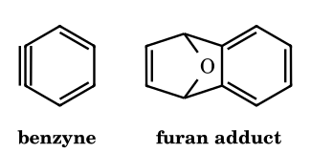
Left: benzyne drawn as cyclohexa-1,3-dien-5-yne (the ‘triple bond’ is one σ + one π of the aromatic sextet + one extra in-plane bond). Right: the Diels–Alder adduct with furan (1,4-epoxy-1,4-dihydronaphthalene), the standard proof of existence.
- The aromatic π sextet (six p orbitals perpendicular to the ring plane) is intact: benzyne is still aromatic.
- The ‘third’ bond is formed by the sideways overlap of the two sp² orbitals that held the leaving groups (H and X); these orbitals lie in the plane of the ring, pointing away from the ring centre at ≈ 120°, so they cannot overlap well. The overlap is poor, the extra bond is very weak and strained (strain ≈ 50 kcal mol⁻¹) and the LUMO is low: benzyne is a strong electrophile/dienophile.
- It is not a true alkyne: the C≡C is not linear (ring angles ≈ 127° at the benzyne carbons), the bond is longer (≈ 1.24 Å) than a normal triple bond (1.20 Å) and shorter than an aromatic bond, and the carbons are sp² (not sp). It has no net charge, no unpaired electrons (diamagnetic) and a dipole moment; lifetime ≈ 10⁻⁶–10⁻³ s; observed in matrix isolation (IR 1846 cm⁻¹, ‘C≡C’ stretch, intermediate between a double and a triple bond).

12.2 Generation of benzyne
Method | Reagents | Equation | Comment
Elimination–addition (strong base) | Ar–X + NaNH₂/liquid NH₃; KNH₂; PhLi; LDA | ArX + NH₂⁻ → C₆H₄ + X⁻ + NH₃; benzyne + NH₂⁻ → anilide → aniline | requires an ortho H (2,6-disubstituted halides do not react); rate X: Br > I > Cl ≫ F
From o-dihalides | 1-bromo-2-fluorobenzene + Mg (THF); o-dibromobenzene + n-BuLi (−100 °C); Li–Hg | metal–halogen exchange gives o-haloaryl-M, which loses MX | o-FC₆H₄MgBr → C₆H₄ + MgBrF
From benzenediazonium-2-carboxylate | anthranilic acid + isopentyl nitrite (diazotisation), or the zwitterion | C₆H₄(N₂⁺)(COO⁻) → C₆H₄ + N₂ + CO₂ (Δ) | clean, but the zwitterion is explosive when dry
Kobayashi precursor | 2-(trimethylsilyl)phenyl triflate + F⁻ (CsF, Bu₄NF) | F⁻ attacks Si; C–Si electrons expel OTf⁻ | mild, neutral, the modern method
From phthalic anhydride / benzothiadiazole dioxide / 1-aminobenzotriazole (oxidation) | Pb(OAc)₄, hν | loss of N₂, CO, CO₂ from a fused five-membered ring | gas-phase and photochemical routes
Dehalogenation of o-halo triflates | ArBr(OTf) + n-BuLi | Li–Br exchange then loss of LiOTf | fast, low temperature

12.3 Mechanisms (arrow-validated)
12.1 Elimination step: bromobenzene + NH₂⁻ → benzyne
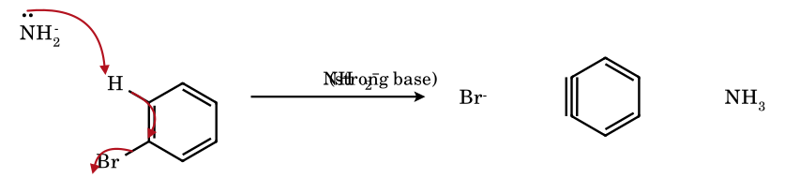
Amide removes the proton ortho to Br (the sp² C–H is acidified by the adjacent C–Br dipole), the C–H electrons form the in-plane bond to C-1, and bromide leaves. In terms of mechanism this is E2 (or E1cB with the aryl anion of F). The reaction needs a base strong enough to remove an aromatic H (pK_{a} ≈ 43): NaNH₂ (NH₃ pK_{a} ≈ 38) is effective only because C–X departure is concerted.
12.2 Addition step: benzyne + NH₂⁻ → aryl anion → aniline
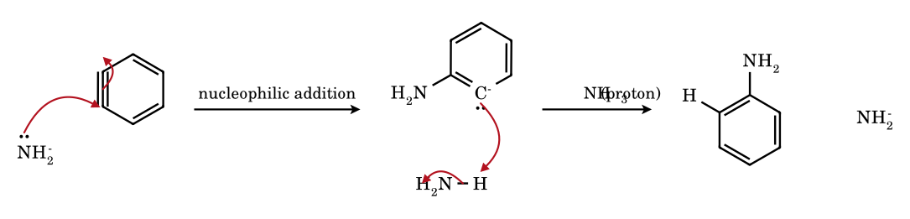
The nucleophile adds to one carbon of the strained C≡C and the in-plane π pair moves to the neighbouring carbon, giving an aryl σ-carbanion (lone pair in the sp² orbital in the plane, not conjugated with the ring), which is protonated by ammonia: aniline. In the Roberts experiment 1-¹⁴C-chlorobenzene gave aniline with 50 % of the label at C-1 and 50 % at C-2, because the two benzyne carbons are equivalent: this is cine substitution evidence.
12.3 Benzyne from benzenediazonium-2-carboxylate
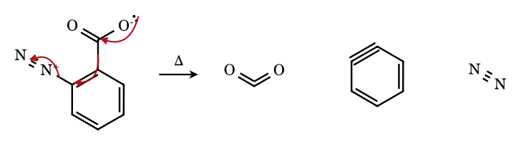
Three simultaneous electron shifts: the carboxylate oxygen forms the second C=O of CO₂, the C–C σ pair becomes the new in-plane bond, and N₂ leaves with the C–N pair. All three leaving groups (CO₂, N₂) are gases, so the reaction is irreversible and clean.
12.4 Kobayashi benzyne: 2-(trimethylsilyl)phenyl triflate + F⁻
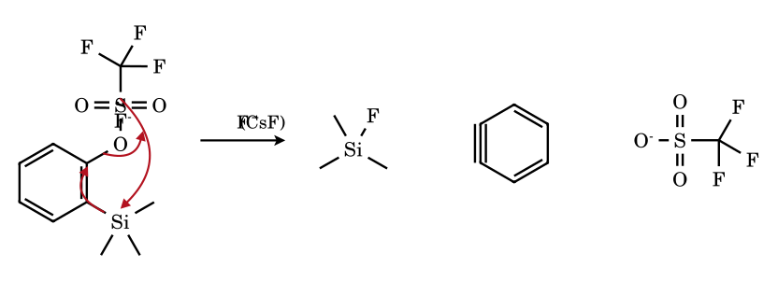
Fluoride, a hard nucleophile with a huge affinity for silicon (Si–F 135 kcal mol⁻¹), attacks Si; the C–Si bond pair becomes the in-plane bond while triflate (an excellent leaving group) departs. No strong base is needed, so benzyne can be generated in the presence of base-sensitive traps.
12.5 Diels–Alder trapping of benzyne with furan (the proof of benzyne)
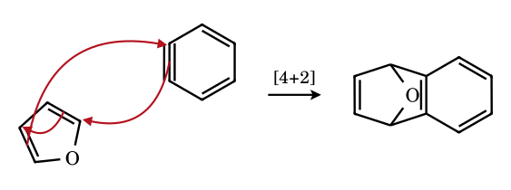
The diene (furan) and the dienophile (benzyne) join in one concerted step in which the weak in-plane bond of benzyne is converted into two σ bonds. The adduct, 1,4-dihydronaphthalene-1,4-endoxide, is stable and isolated; it is the classical evidence that benzyne forms when no nucleophile is present. Anthracene (→ triptycene) and cyclopentadiene are also used as traps.

12.4 Evidence for the benzyne mechanism
Observation | Meaning
Roberts (1953): PhCl(1-¹⁴C) + KNH₂/NH₃ gave aniline with 14C at C-1 and C-2 in equal amounts | the two benzyne carbons are equivalent: elimination then addition (cine substitution)
o-, m- and p-bromotoluene with NaNH₂ give mixtures of toluidines (o-: o- + m-; m-: o- + m- + p-; p-: m- + p-) | different benzynes are formed; the nucleophile may attack either carbon
2,6-dimethylbromobenzene (no ortho H) does not react with NaNH₂/NH₃ | an ortho H is required for the elimination
Trapping with furan, anthracene, tetraphenylcyclopentadienone, cyclopentadiene, or reaction with a nucleophile present | an intermediate that is both an electrophile and a dienophile
Isotope exchange: PhBr in KNH₂/ND₃ exchanges ortho H with D before reaction | the aryl anion (E1cB) is formed reversibly
Halide reactivity order Br > I > Cl ≫ F in NaNH₂/NH₃ | for F the C–F cleavage (leaving group loss) is the slow step; for Cl, Br the C–H proton removal is fast and C–X cleavage is rate-determining at intermediate X; the order reflects both acidity and leaving-group ability

12.5 Regiochemistry of nucleophilic addition to substituted benzynes
The nucleophile adds to that carbon of the benzyne triple bond that gives the more stable aryl carbanion (an sp² σ-carbanion). The carbanion is not conjugated to the ring π system, so only the inductive effect of the substituent matters: an −I group stabilises the carbanion best when it is closest to the carbanion carbon.
Benzyne | Substituent effect | Where Nu⁻ adds; major product
3-methoxybenzyne (from o- or m-bromoanisole) | −I of OMe (σ-withdrawing) | C-1 (meta to OMe) so that the carbanion forms at C-2, next to OMe → m-anisidine (3-methoxyaniline)
3-methylbenzyne (from o-bromotoluene) | CH₃ is +I: slight effect; steric | ≈ 50 : 50 or slightly favouring meta → o-toluidine and m-toluidine (nearly equal)
4-methylbenzyne (from p-bromotoluene or m-bromotoluene) | the methyl is remote from both carbons | m- and p-toluidine, ≈ 1 : 1
3-(trifluoromethyl)benzyne | strong −I (CF₃) | attack at C-1 (meta) gives the carbanion next to CF₃: meta product
4-(trifluoromethyl)benzyne | −I of CF₃ is felt more at the nearer carbon (C meta to CF₃ is closer than the para carbon) | attack so that the carbanion forms meta to CF₃ (nearer) – i.e. the nucleophile ends up para to CF₃
Counting problems. A halotoluene with NaNH₂ gives 2 aminotoluenes (o- or p-halo) or 3 (m-halo). o-Bromotoluene has one ortho H and gives one benzyne (3-methylbenzyne → o- and m-toluidine). m-Bromotoluene has two different ortho H (at C-2 and C-4) and gives two benzynes (3-methyl- and 4-methylbenzyne → o-, m-, p-toluidine: 3 products with m- from both). p-Bromotoluene has two equivalent ortho H and gives one benzyne (4-methylbenzyne → m- and p-toluidine). A substrate with no ortho H (2,6-disubstituted aryl halide) cannot form benzyne with NaNH₂.

12.6 Reactions of benzyne
Reaction | Example | Product
Nucleophilic addition | Nu⁻ = NH₂⁻, RO⁻, R₂N⁻, RS⁻, enolates, Grignards | ArNu after protonation (aniline, phenyl ethers, aryl ketones by enolate addition)
[4+2] Diels–Alder | furan, anthracene, cyclopentadiene, 1,3-butadiene | bicyclic adducts (1,4-epoxynaphthalene, triptycene)
[2+2] with alkenes | benzyne + enol ether, ketene acetals | benzocyclobutenes
Ene reaction | benzyne + propene | allylbenzene
σ-Insertion | benzyne + C–C(=O), N–Si, Sn–Sn | ortho-disubstituted arenes
Trimerisation (Pd) / dimerisation | 3 C₆H₄ → triphenylene; 2 C₆H₄ → biphenylene | in the absence of traps
Reaction with a second molecule of aryl anion | ArH + benzyne → biaryl | diarylamine/ biaryl by-products

12.8 Electronic structure of benzyne in depth
- Orbital picture. Benzyne (1,2-didehydrobenzene, C₆H₄) retains the aromatic sextet in the π system perpendicular to the ring (six p orbitals, one on each carbon). The 'triple bond' is a formal description: the two ortho carbons each have an sp² orbital that would have held a C–H or C–X bond; these two orbitals point outward in the ring plane and lie nearly parallel, overlapping only sideways and poorly (the ring geometry forces an inter-orbital angle of 120° rather than 180°). The resulting in-plane 'π' bond is weak and high in energy, and the corresponding antibonding orbital is low-lying, which makes benzyne a strong electrophile (LUMO energy ≈ −1.0 eV) and a very reactive dienophile.
- Geometry and spectroscopy. Computed C≡C ≈ 1.24 Å (between a double bond, 1.34, and a triple bond, 1.20), with the ring angles at the 'triple bond' ≈ 127° and a distorted hexagon. Matrix-isolation IR (Chapman, 1973, from phthaloyl peroxide or benzocyclobutenedione photolysis at 8 K) shows a band near 1846 cm⁻¹ assigned to the strained C≡C stretch, lower than that of a normal alkyne (≈ 2150) because of the weak bond. The ground state is a closed-shell singlet; its first triplet is ≈ 37 kcal mol⁻¹ above.
- Resonance forms. Benzyne is described by the hybrid of the cumulene-like form (four electrons in two in-plane orbitals forming a weak bond) and a zwitterionic/diradical form (C⁺/C⁻), which explains both its electrophilicity at carbon and its ability to react with nucleophiles in two orientations. The in-plane bond does not interact with the aromatic π system (orthogonal), so benzyne retains its aromatic stabilisation.
- Why alkynes are linear but benzyne is not. A linear sp-hybridised carbon needs 180°; the six-membered ring cannot accommodate it. The cost is ≈ 50 kcal mol⁻¹ of strain, the energy that is released when benzyne reacts; cyclohexyne, cycloheptyne and cyclooctyne are analogous strained cycloalkynes (cyclooctyne is the smallest stable one; strain-promoted azide–alkyne click chemistry uses it).
- The three isomers. 1,2-Didehydrobenzene (ortho-benzyne, the usual one), 1,3-didehydrobenzene (meta-benzyne) and 1,4-didehydrobenzene (para-benzyne) are all C₆H₄. Meta- and para-benzyne are singlet diradicals with the two radical centres separated by one or two carbons; p-benzyne is formed by the Bergman cyclisation of (Z)-hex-3-ene-1,5-diynes at 200 °C, and by the 'enediyne' antitumour antibiotics (calicheamicin, esperamicin, dynemicin, neocarzinostatin) under physiological conditions: the generated p-benzyne abstracts two H atoms from DNA sugar rings (C-4′, C-5′), leading to strand cleavage and cell death. Enyne-allenes cyclise by the analogous Myers–Saito reaction (to α,3-didehydrotoluene).

12.9 Generation of benzyne: complete catalogue
Precursor | Conditions | Mechanism / remarks
Aryl halide (ArX with ortho H) | NaNH₂/NH₃(l), −33 °C; KNH₂; LDA; LiTMP; PhLi; KOtBu/DMSO | E2 or E1cB: base removes the ortho H (acidified by the inductive effect of X), X⁻ leaves. Elimination rate (leaving group in the E1cB step) Br > I > Cl ≫ F (in NH₃/KNH₂); however, for F the ortho H is the most acidic (strong −I) and ArF reacts with LiTMP/PhLi via ArLi, in which F⁻ is lost slowly: the C–F bond is strong. Substrates with no ortho H (2,6-disubstituted halides) do not give benzyne
o-Dihaloarenes + Mg or Li | o-BrC₆H₄F + Mg, THF; o-FC₆H₄Li (−78 °C → warm) | Wittig 1942: ArMgX/ArLi with ortho-F eliminates MgXF/LiF at room temperature; in the presence of furan gives the 1,4-epoxy-1,4-dihydronaphthalene adduct, the first trapping evidence
Anthranilic acid (via diazonium) | o-H₂NC₆H₄COOH + isoamyl nitrite (or HONO) → benzenediazonium-2-carboxylate (zwitterion), Δ | loses CO₂ and N₂ (Stiles–Miller 1960); aprotic route; the zwitterion is explosive when dry, so is prepared in situ
1-Aminobenzotriazole | Pb(OAc)₄ or NBS | Campbell–Rees: oxidation gives benzyne + 2 N₂
Phthaloyl peroxide, benzothiadiazole dioxide, benzocyclobutenedione | hν or Δ | photolytic routes used for matrix isolation and spectroscopy
2-(Trimethylsilyl)aryl triflates (Kobayashi, 1983) | CsF or TBAF, MeCN or THF, 25 °C | fluoride attacks Si; C–Si electrons form the in-plane bond while triflate leaves: the standard mild method (no strong base); used for natural-product synthesis
o-(Trimethylsilyl)aryl iodonium triflates | Bu₄N⁺F⁻ | Kitamura: loses PhI as leaving group
Hexadehydro-Diels–Alder (HDDA) | triyne (1,3-diyne + diynophile), 80–120 °C | Hoye: thermal [4+2] of a diyne with an alkyne gives a benzyne from acyclic precursors without any base or halide (Hoye 2012)
Benzene-1,2-diazonium and aryl diazonium salts + base | ArN₂⁺, ortho-H, base | rare
Photolysis of o-iodophenyl... or flash vacuum pyrolysis | FVP of phthalic anhydride (950 °C) | gas-phase benzyne; mass spectrometric detection

12.10 Evidence for benzyne as an intermediate: Roberts, trapping, isotope effects
- Roberts’ ¹⁴C-labelling experiment (1953). Chlorobenzene labelled with ¹⁴C at C-1 reacts with KNH₂ in liquid NH₃ to give aniline with 50 % ¹⁴C at C-1 and 50 % at C-2. A direct substitution (S_{N}Ar, ipso) would have given 100 % C-1 aniline. The 1 : 1 distribution requires a symmetrical intermediate in which C-1 and C-2 are equivalent: benzyne.
- Absence of ortho hydrogen. 2-Bromo-1,3-dimethylbenzene (both ortho positions blocked by CH₃) does not react with KNH₂; 2,6-dimethylhalobenzenes are inert — in contrast, S_{N}Ar reactions are not blocked by methyl groups in the 2,6-positions.
- Isotope effect and exchange. Fluorobenzene-2-d and bromobenzene-2-d: H/D exchange at the ortho position occurs faster than substitution in NH₃/KNH₂ for the weakly leaving fluorine, showing a reversible aryl carbanion (E1cB), while for bromobenzene the removal of H is rate-limiting (E2-like, k_{H}/k_{D} ≈ 5.5).
- Trapping. Benzyne gives Diels–Alder adducts with furan (1,4-epoxy-1,4-dihydronaphthalene), anthracene (triptycene, Wittig 1956), tetraphenylcyclopentadienone (1,2,3,4-tetraphenylnaphthalene after loss of CO), cyclopentadiene (benzonorbornadiene), 2,5-dimethylfuran and 1,3-diphenylisobenzofuran, even when no nucleophile is present. Dimer biphenylene and trimer triphenylene arise in the absence of traps.
- Cine substitution. Substituted halobenzenes give mixtures of isomers in which the nucleophile enters at the carbon bearing the leaving group (ipso) or the adjacent carbon (cine): o-bromoanisole → m-anisidine only; p-chlorotoluene → p- and m-toluidine (1 : 1); m-chlorotoluene → o-, m-, p-toluidine; o-chlorotoluene → o- and m-toluidine (≈ 1 : 1). The incoming group is never found at positions ‘para’ to the leaving group unless the substituent pattern allows it.
- Spectroscopic detection. Matrix IR (1846 cm⁻¹), NMR of benzyne trapped inside a hemicarcerand (Cram, 1997: the cage prevents dimerisation; ¹³C shift of the triple-bond carbons 182 ppm), and gas-phase photoionisation mass spectrometry.

12.11 Regiochemistry of nucleophilic addition to substituted benzynes: Roberts and Gilchrist rules
For a benzyne with a substituent Z at C-3 (adjacent to the triple bond) or C-4 (one carbon removed), the nucleophile attacks the position that gives the more stable aryl carbanion. The anion is in the plane of the ring and cannot be stabilised by resonance; its stability is controlled by inductive/field effects (and in some cases by coordination of the metal cation). Rules:
Substituent position | Z | Preferred site of Nu⁻ attack | Product
3-Z-benzyne (Z adjacent) | −I (OMe, OR, F, Cl, CF₃, NR₃⁺) | C-1 (remote from Z), so the carbanion at C-2 is adjacent to Z and is stabilised inductively | meta-substituted product predominates (e.g. o-bromoanisole → m-anisidine, > 99 %)
3-Z-benzyne | +I (CH₃) | ~1 : 1 (small steric preference for C-1) | mixture of o- and m-
3-Z-benzyne | large steric group (t-Bu, SiMe₃) | C-1 (steric) | meta
4-Z-benzyne (Z one carbon removed) | −I (OMe, CF₃) | attack at C-1 gives carbanion at C-2 (meta to Z); attack at C-2 gives carbanion at C-1 (para to Z). The carbanion nearer to Z is favoured, but the effect is small (the distances are similar) | mixture of meta and para (m ≥ p; e.g. p-chloroanisole → ca. 1 : 1)
4-Z-benzyne | alkyl | ~1 : 1 | m : p ≈ 1 : 1
Distortion model (Garg–Houk, 2010) | — | aryne is distorted by the substituent so that the more linear carbon (bigger bond angle, more electrophilic) is attacked: 3-OMe: C-1 attack; indolynes and 3,4-pyridynes with the substituent-induced distortion | predicts selectivity in heteroarynes: 3,4-pyridyne with 5-bromo-substituent → attack at C-3 selectively

12.12 Reactions of benzyne: a systematic classification
Class | Partner | Product | Notes
Nucleophilic addition–protonation | NH₂⁻, RO⁻, RS⁻, R₂N⁻, CN⁻, enolates, ArLi, RMgX, amines (neutral), halide, azide | ArNu after protonation of the aryl anion by the solvent (NH₃, ROH) | α-arylation of ketones/nitriles (Caubère: NaNH₂/ t-BuONa 'complex base' with ArX and a ketone); intramolecular attack gives rings (indoles, benzofurans)
Diels–Alder [4+2] | furan, cyclopentadiene, anthracene, pyrrole (N-protected), isobenzofuran, cyclohexadiene, α-pyrone, tetracyclone, 2-pyridones | benzo-fused bicyclics, triptycene, naphthalenes (with extrusion of CO₂ or CO) | most reliable trapping; the endo/exo and π-facial selectivity are governed by sterics
[2+2] cycloaddition | enol ethers, ketene acetals, alkenes with e-donors, ketenes | benzocyclobutenes (with ArH loses nothing) | Ar + CH₂=C(OR)₂ → 1,1-dialkoxybenzocyclobutene; in the absence of trap, 2 ArH → biphenylene
[3+2] 1,3-dipolar | azides, nitrones, diazo compounds, nitrile oxides, sydnones | benzotriazoles, benzisoxazolines, indazoles | click-type; mild with Kobayashi precursors
Ene reaction | propene, allylbenzene, alkenes with allylic H | allylbenzenes (Ar–C–C=C with H transfer) | benzyne acts as enophile: a concerted six-membered TS; e.g. benzyne + propene → allylbenzene
σ-Bond insertion | C–C (β-ketoester α-acylation), C–N (amides), N–Si, S–S, Sn–Sn, C–Cl | ortho-disubstituted arenes | Stoltz acyl-alkylation of β-ketoesters (aryne inserts into the C–C bond of the enolate, via a four-membered ring)
Dimerisation, trimerisation | benzyne + benzyne; Pd(0)-catalysed | biphenylene; triphenylene (3 arynes, Pd) | the last is a metal-templated [2+2+2]
Radical/ligand | transition-metal arynes (Ni, Zr, Pt complexes) | stable benzyne–metal complexes | e.g. Zr(η²-C₆H₄)Cp₂(PMe₃)
Multi-component coupling | aryne + isocyanide + carbonyl; aryne + DMF + NaN₃ | one-pot ortho difunctionalisation | typical modern application of arynes in diversity synthesis

12.13 Heteroarynes and cycloalkynes
- 3,4-Pyridynes (from 3-halopyridines + base: 3-bromopyridine + NaNH₂ → 3- and 4-aminopyridine mixture; 4-halopyridine similarly) are the reason that meta- and para-halopyridines give mixtures with amide, but 2-halopyridines undergo normal S_{N}Ar. 2,3-Pyridynes also form.
- Indolynes (3,4-, 4,5-, 5,6-, 6,7-indolyne) are made from bromoindoles with strong base, or from silyl triflates; Garg used them in total synthesis of indolactam V, tubingensin A, and the distortion model above explains their regioselectivity.
- Cyclohexyne, cycloheptyne exist only as intermediates (trapped by Diels–Alder, e.g. cyclohexyne from 1-chloro-cyclohexene + NaNH₂ (Wittig, Scardiglia) or from Kobayashi precursors); cyclooctyne is the smallest isolable cycloalkyne (bp 90 °C/ 65 mmHg), and strained dibenzocyclooctynes (DIBO, DBCO) enable copper-free click chemistry (Bertozzi, Nobel Prize 2022).
- 1,2-Cyclohexadiene, 1,2,3-cyclohexatriene (Garg 2012): strained cyclic allenes and cumulenes generated from silyl triflates and trapped in cycloadditions; the logical extension of the aryne concept.

12.14 Three pathways to nucleophilic aromatic substitution compared
 | S_{N}Ar (addition–elimination) | Benzyne (elimination–addition) | S_{N}1 (diazonium) | S_{RN}1 (radical chain)
Substrate | ArX with strong EWG (NO₂, CN, COR) ortho/para to X | ArX with ortho-H and no activating group | ArN₂⁺ | ArX (X = I, Br) + photostimulation; no EWG needed
Reagent | Nu⁻ or neutral nucleophile | very strong base (NH₂⁻, RLi, LDA) at low T | H₂O/Δ (phenol), HX/Cu, KI, H₃PO₂ | enolate, thiolate, amide; electron-transfer initiation
Intermediate | Meisenheimer complex (carbanion delocalised into EWG) | benzyne then aryl anion | aryl cation (very unstable), or radical (Cu) | radical anion ArX^{•−} → Ar•
Leaving-group order | F ≫ Cl ≈ Br > I (rate-limiting addition) | Br > I > Cl ≫ F (elimination) | N₂ | I > Br > Cl
Regiochemistry | ipso only; Nu enters where X was | ipso + cine mixtures (nucleophile at either end of ‘triple bond’) | ipso | ipso
Key evidence | isolable Meisenheimer salts; second-order kinetics | ¹⁴C scrambling; trapping; no reaction when ortho-H are blocked | N₂ evolution; salt-free arenes | chain inhibition by radical traps
Typical errors in benzyne questions. (1) Treating chlorobenzene + NaOH (aqueous, 300 °C Dow process) as benzyne: the Dow process includes benzyne-type cine products with some substrates, but plain chlorobenzene + NaOH at 623 K, 300 atm gives phenol (ipso/cine mixtures confirmed by ¹⁴C labelling). (2) Forgetting that p-substituted halobenzenes give two products and o-substituted ones can give one or two. (3) Choosing the nitro-substituted halide: 1-chloro-2,4-dinitrobenzene reacts by S_{N}Ar, not benzyne. (4) Drawing benzyne with a linear triple bond. (5) Assuming the NH₂⁻ adds with the usual Markovnikov-like selectivity. (6) Thinking benzyne has a stable carbanion (aryl anion lone pair is in an sp² orbital, orthogonal to the π system, not delocalised). (7) Missing that the ortho-H must be present: 2-bromo-1,3-dimethylbenzene cannot form a benzyne.

12.15 Additional validated mechanisms
12.6 meta-Selectivity: 3-methoxybenzyne + NH₂⁻ → m-anisidine (carbanion adjacent to OMe)
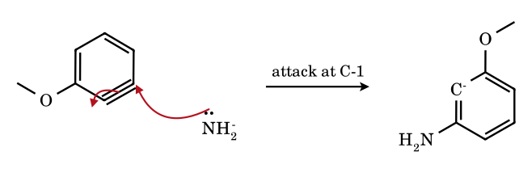
The nucleophile adds to the benzyne carbon farther from the OMe group (C-1), so the developing aryl carbanion lies on C-2, next to the electronegative oxygen where the σ-withdrawing (−I) effect stabilises the localised in-plane lone pair. The aryl anion (an sp² lone pair in the ring plane) is then protonated by NH₃ (the solvent) and the product is meta-anisidine only. The same product is formed from 2-bromoanisole (benzyne with OMe at C-3) and from 3-bromoanisole (via deprotonation at C-2, between OMe and Br).
12.7 Dimerisation of benzyne to biphenylene ([2+2])
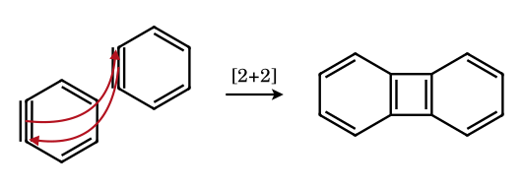
In the absence of a trap, the strongly electrophilic and strongly dienophilic benzyne reacts with a second molecule: the in-plane π bonds of two molecules combine to form the two C–C σ bonds of a cyclobutadiene-like four-membered ring flanked by two benzene rings (biphenylene). A third molecule gives triphenylene (the trimer, more common with Pd(0) catalysis).
12.8 Aryne ene reaction: benzyne + propene → allylbenzene
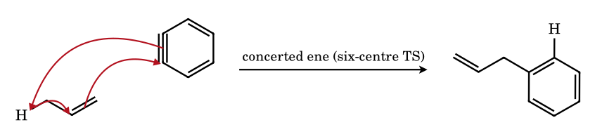
The benzyne acts as an enophile: the C=C π bond of propene forms a new C–C σ bond to one aryne carbon, the allylic C–H bond shifts to the other aryne carbon, and the double bond migrates; all three electron pairs move in a single six-membered transition state. The product is allylbenzene (3-phenylprop-1-ene). In competition, benzyne also adds [2+2] to alkenes, the ene reaction being preferred when allylic H are available.

12.16 Problems on benzyne
BZ-1.
Which statements about benzyne are correct? (A) the ‘triple bond’ is a normal sp–sp bond; (B) the extra bond is formed by overlap of two in-plane sp² orbitals; (C) the aromatic sextet is retained; (D) it is a strong dienophile.
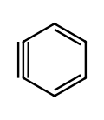
Answer: (B), (C), (D)
The ring carbons stay sp²; the weak in-plane overlap makes the bond very strained and reactive, so benzyne is a powerful electrophile and dienophile while remaining aromatic.
BZ-2.
Bromobenzene is treated with NaNH₂ in liquid NH₃. Name the intermediate and the product. What if the starting material is 2,6-dimethylbromobenzene?
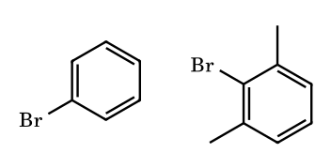
Answer: benzyne → aniline; no reaction for 2,6-dimethylbromobenzene
The mechanism needs an H on the carbon ortho to Br to be removed by the base. 2,6-Dimethylbromobenzene has none, so it cannot form an aryne (it could only react by the very slow S_{N}Ar).
BZ-3.
How many distinct aminotoluenes are formed from (a) o-, (b) m-, (c) p-bromotoluene with NaNH₂/NH₃?
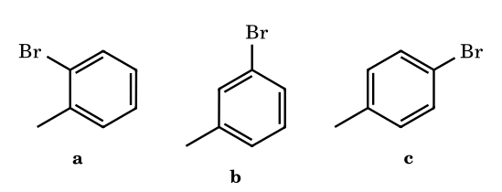
Answer: (a) 2; (b) 3; (c) 2
(a) one benzyne (3-methylbenzyne): attack at either carbon gives o- and m-toluidine. (b) two benzynes (2,3 and 3,4 pairs): 3-methylbenzyne → o-, m-; 4-methylbenzyne → m-, p-: o-, m-, p- in total. (c) one benzyne (4-methylbenzyne): m- and p-toluidine.
BZ-4.
o-Bromoanisole + NaNH₂/NH₃ gives mainly which product and why?
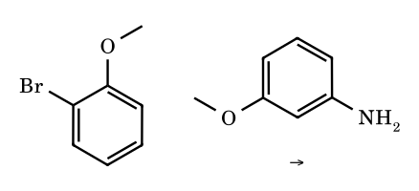
Answer: m-anisidine (3-methoxyaniline)
The benzyne is 3-methoxybenzyne. NH₂⁻ attacks C-1, the carbon farther from OMe (meta), so that the carbanion forms at C-2, adjacent to the electronegative OMe where its −I effect stabilises the in-plane carbanion.
BZ-5.
Chlorobenzene and the following reagents: (i) NaNH₂/NH₃, (ii) NaOH, 350 °C (Dow process), (iii) OH⁻, 25 °C. Which proceed through benzyne?
Answer: (i) and (ii)
Strong bases (NH₂⁻; HO⁻ at 350 °C and high pressure) remove ortho H to give benzyne. At 25 °C hydroxide does not react with unactivated PhCl at all. With an o- or p-nitro group the reaction is addition–elimination (S_{N}Ar, Meisenheimer complex), not benzyne.
BZ-6.
Arrange the aryl halides in decreasing reactivity toward KNH₂/NH₃ via benzyne: C₆H₅F, C₆H₅Cl, C₆H₅Br, C₆H₅I.
Answer: Br > I > Cl ≫ F (Roberts)
The rate depends on two steps – removal of the ortho H and loss of X⁻. The H of fluorobenzene is the most acidic (strong −I of F) but F is a poor leaving group; for I the C–I bond is weak but the ortho H is less acidic. Bromine balances both best.
BZ-7.
Benzenediazonium-2-carboxylate is heated in the presence of furan. Give the product.
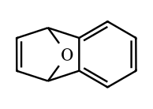
Answer: 1,4-dihydro-1,4-epoxynaphthalene
Loss of CO₂ and N₂ gives benzyne, trapped by the diene in a [4+2] cycloaddition.
BZ-8.
In the benzyne mechanism, what is the hybridisation of the carbons of the strained bond and what is the C≡C bond angle?
Answer: sp²; ≈ 120–127° (not 180°)
A linear sp-hybridised alkyne carbon would need 180°; in a six-membered ring the angle is forced to ≈ 120–127°, so each benzyne carbon is sp² with an in-plane orbital.
BZ-9.
A halobenzene with a strongly electron-withdrawing group ortho or para to the halogen reacts with HO⁻ at room temperature. By which mechanism?
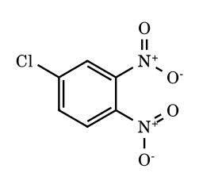
Answer: addition–elimination (S_{N}Ar), not benzyne
The nucleophile adds to the ipso carbon, giving a resonance-stabilised Meisenheimer anion with negative charge on the nitro groups, then chloride is lost. The benzyne path needs a very strong base and has no requirement of an EWG. (Chlorine as a leaving group: F ≫ Cl ≈ Br ≈ I in S_{N}Ar, the reverse of the benzyne order.)
BZ-10.
Compare benzyne with the other reactive intermediates: how many π electrons in the ring, and is it charged?
Answer: 6π (aromatic) + 2 electrons in the extra in-plane bond; neutral
Benzyne has all electrons paired, no charge and no unpaired electrons; the unusual reactivity arises from strain and from the low-lying in-plane LUMO.
BZ-11.
Which of the following aryl halides cannot form a benzyne with NaNH₂/NH₃: (a) bromobenzene, (b) 2-bromo-1,3-dimethylbenzene, (c) 4-bromotoluene, (d) 1-bromo-2,4,6-trimethylbenzene, (e) 3-bromoanisole?
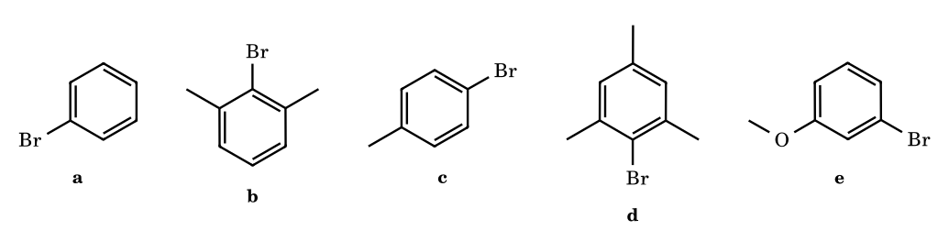
Answer: (b) and (d)
Benzyne formation requires an H on a carbon ortho to the leaving group. Both ortho positions of (b) and (d) carry CH₃, so no elimination; in S_{N}Ar there is no such requirement (but no EWG either), so these halides are essentially inert to amide.
BZ-12.
How many isomeric toluidines (aminotoluenes) are formed from (a) o-chlorotoluene, (b) m-chlorotoluene, (c) p-chlorotoluene with KNH₂/NH₃?
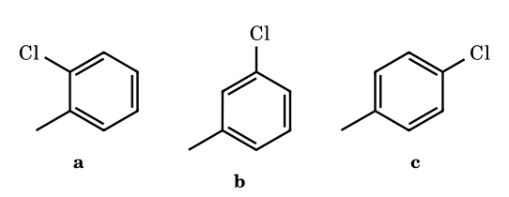
Answer: (a) 2 (o- and m-); (b) 3 (o-, m-, p-); (c) 2 (m- and p-)
(a) only one ortho H (C-6): 3-methylbenzyne, attack at C-1 (→ o-toluidine) or C-6 (→ m-toluidine). (b) two ortho Hs: C-2 gives 3-methylbenzyne (o- and m-) and C-6 gives 4-methylbenzyne (m- and p-); total three. (c) 4-methylbenzyne: attack at either carbon gives m- or p-toluidine in a ca. 1 : 1 ratio.
BZ-13.
o-Bromoanisole, m-bromoanisole and p-bromoanisole each react with KNH₂/NH₃. Predict the amine(s) formed in each case.
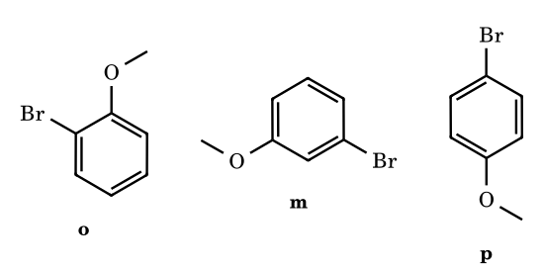
Answer: o → m-anisidine (only); m → m-anisidine (only); p → m- and p-anisidine (≈ 1 : 1)
OMe is −I at the carbanion position: the carbanion forms adjacent to OMe, so Nu attacks the carbon meta to OMe. For the p-isomer both aryne carbons are meta/para to OMe and the inductive differentiation is weak, giving a nearly equal mixture.
BZ-14.
Complete and balance the sequence: anthranilic acid + isoamyl nitrite (aprotic, Δ) + anthracene.
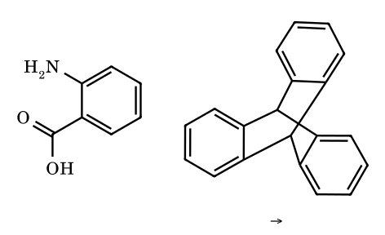
Answer: triptycene (+ CO₂ + N₂ + 2 isoamyl alcohol)
The diazonium carboxylate generates benzyne, which adds across the 9,10-positions of anthracene (Diels–Alder) to give triptycene, a rigid three-bladed paddle-wheel hydrocarbon (Wittig 1956).
BZ-15.
(Assertion–Reason) Assertion: the reaction of chlorobenzene with KNH₂/NH₃ gives a 1 : 1 mixture of aniline-1-¹⁴C and aniline-2-¹⁴C when chlorobenzene is labelled at C-1. Reason: the nucleophile adds equally to the two carbons of a symmetrical benzyne intermediate.
Answer: both correct; the reason explains the assertion
The symmetrical intermediate makes C-1 and C-2 equivalent, so label ends up equally at both positions. A direct displacement (ipso) would give 100 % at C-1.
BZ-16.
The reaction of 1-chloro-2-nitrobenzene with NaOH (aq) gives o-nitrophenol, while chlorobenzene + NaOH under the same conditions does not react. Identify the mechanism in each case.
Answer: o-chloronitrobenzene: S_{N}Ar (addition–elimination); chlorobenzene: no reaction (needs benzyne conditions, NaNH₂, or 623 K/300 atm)
The ortho NO₂ stabilises the Meisenheimer anion by resonance, so addition of HO⁻ is feasible. Chlorobenzene has no activating group; at very high T the Dow process proceeds in part by benzyne (some cine substitution).
BZ-17.
Give the product of benzyne + (a) furan, (b) cyclopentadiene, (c) tetraphenylcyclopentadienone, (d) 2-pyrone. Which loses a small molecule?
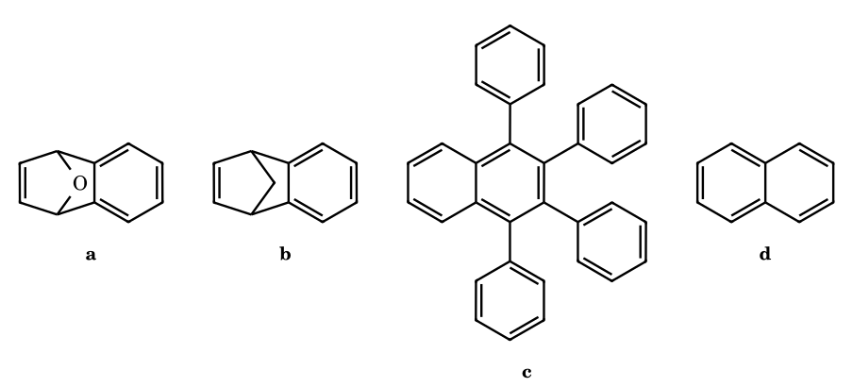
Answer: (a) 1,4-epoxy-1,4-dihydronaphthalene; (b) benzonorbornadiene; (c) 1,2,3,4-tetraphenylnaphthalene (loses CO); (d) naphthalene (loses CO₂)
(c) and (d): the bicyclic adduct has a bridging C=O (ketone) or O–C(=O) that extrudes CO or CO₂ in a retro-Diels–Alder (cheletropic), aromatising the new ring.
BZ-18.
What is the product of o-bromofluorobenzene with NaNH₂/NH₃(l)? Explain the regiochemistry.
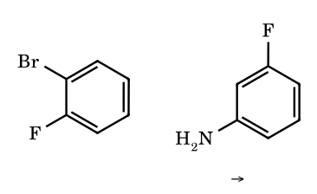
Answer: m-fluoroaniline
The only ortho hydrogen is at C-6 (next to Br); loss of H and Br⁻ gives 3-fluorobenzyne. The nucleophile adds to C-6, the carbon remote from F, so that the aryl carbanion is on C-1 adjacent to the electronegative fluorine (−I stabilisation). Protonation gives the meta isomer.
BZ-19.
Account for the following: 2-chloropyridine + KNH₂ gives 2-aminopyridine (Chichibabin-like S_{N}Ar); 3-bromopyridine + KNH₂ gives a 1 : 1 mixture of 3- and 4-aminopyridine.
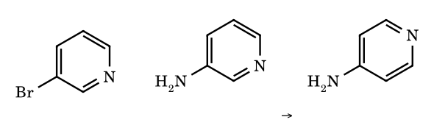
Answer: 3-bromopyridine forms 3,4-pyridyne; 2-halopyridine reacts by S_{N}Ar
In 2-halopyridine the ring nitrogen stabilises the Meisenheimer anion (like an ortho/para nitro group). 3-Halopyridine has no such activation, so the strong base eliminates HBr to 3,4-pyridyne; the amide then adds at C-3 or C-4 in nearly equal amounts (cine substitution).
BZ-20.
A student heats 2,6-dimethylbromobenzene with NaNH₂/NH₃ and recovers it unchanged. Another student treats 2,4-dinitrobromobenzene with aqueous ammonia and obtains 2,4-dinitroaniline quickly. Explain both.
Answer: no ortho H: no benzyne; but strongly activated ring: S_{N}Ar
The first lacks a hydrogen ortho to Br (both are CH₃) and has no EWG; the second has activating nitro groups ortho and para to Br and reacts by addition–elimination via a Meisenheimer complex.
BZ-21.
Why does fluorobenzene give benzyne with PhLi or LDA, but the benzyne from fluorobenzene is formed more slowly with KNH₂ than that from bromobenzene?
Answer: C–F bond is strong and F⁻ is a poor leaving group, although the ortho-H is more acidic
The first step (deprotonation) is easier for F because of its strong −I effect; the aryl-lithium or aryl-potassium is formed readily but the loss of fluoride (strong C–F bond, 125 kcal mol⁻¹) is slow, so for KNH₂ the elimination step is rate-limiting (E1cB) and H/D exchange is faster than substitution. Bromide is a much better leaving group; with bromobenzene proton removal is rate-limiting.
BZ-22.
Compare the reaction of m-chloro-trifluoromethylbenzene vs. o-chloro-trifluoromethylbenzene with KNH₂ (Roberts, 1956). Which product(s) form and why?
Answer: o-chloro: m-CF₃-aniline only; m-chloro: m-CF₃-aniline predominantly
CF₃ is strongly −I. In 3-CF₃-benzyne the nucleophile adds to C-1, remote from CF₃, giving the anion on C-2 adjacent to CF₃. Both substrates therefore lead to 3-(trifluoromethyl)aniline (meta), exactly as for OMe and F.
BZ-23.
The Stobbe-type (Caubère) arylation: benzyne is generated from bromobenzene in the presence of the sodium enolate of acetone. Give the product and name the reaction type.
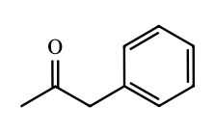
Answer: phenylacetone (1-phenylpropan-2-one)
The enolate carbon adds to benzyne (nucleophilic addition) and the aryl anion is protonated. This is a useful transition-metal-free α-arylation of ketones; with excess base, di-arylation can occur.
BZ-24.
o-Bromofluorobenzene is treated with magnesium in THF at room temperature in the presence of furan. Name the intermediate and the final product.
Answer: o-fluorophenylmagnesium bromide, then benzyne (loss of MgBrF); 1,4-epoxy-1,4-dihydronaphthalene
Mg inserts selectively into the C–Br bond to give the ortho-fluoro Grignard reagent, which eliminates MgBrF at room temperature to give benzyne; furan traps it in a Diels–Alder reaction (Wittig, 1942).
BZ-25.
m-Bromoanisole is treated with KNH₂ in liquid ammonia. How many isomeric anisidines are possible by benzyne pathways, and which is actually obtained?
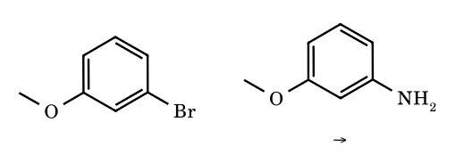
Answer: 3 possible (o-, m-, p-); m-anisidine is obtained
Two ortho H (C-2 and C-6). Removal of C-2–H (between Br and OMe, the most acidic) gives 3-methoxybenzyne: attack at the carbon remote from OMe gives m-anisidine (attack at the adjacent carbon would give o-anisidine). Removal of C-6–H gives 4-methoxybenzyne with m- and p-anisidine as possible products. Experimentally the more acidic C-2 route and the −I orientation rule give essentially only m-anisidine.
BZ-26.
Why does the 1,4-didehydrobenzene (p-benzyne) formed from enediynes cleave DNA, while ortho-benzyne reacts with nucleophiles?
Answer: p-benzyne is a σ,σ-diradical; ortho-benzyne is a strained electrophilic alkyne
p-Benzyne has two radical centres at para positions; it abstracts two H-atoms (from the sugar C–H bonds of DNA) to give benzene, creating DNA radicals that cleave the strand. ortho-Benzyne has a closed-shell electronic structure with a polarised in-plane bond that accepts nucleophiles and cycloaddition partners.
BZ-27.
Give the products of (a) benzyne + NH₃(l)/NH₂⁻, (b) benzyne + CH₃OH/CH₃O⁻, (c) benzyne + PhLi, (d) benzyne + N-methylpyrrole.
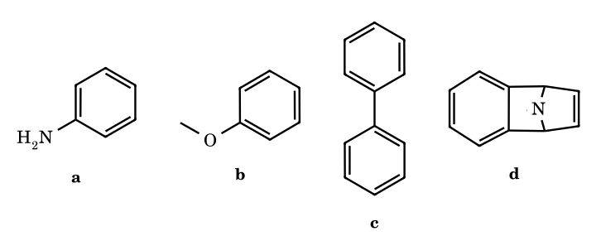
Answer: (a) aniline; (b) anisole; (c) biphenyl; (d) N-methyl-1,4-dihydronaphthalen-1,4-imine (Diels–Alder adduct)
Nucleophilic additions give the aryl anion which is protonated (a, b) or, in (c), gives aryl lithium and then protonation (biphenyl after work-up). The pyrrole acts as the diene.
BZ-28.
Explain why the nitro group in 1-chloro-4-nitrobenzene accelerates S_{N}Ar but 4-chlorotoluene with the same reagents (NH₂⁻) reacts via benzyne.
Answer: NO₂ stabilises the Meisenheimer anion; CH₃ cannot, so the strong base removes the ortho H
In 1-chloro-4-nitrobenzene the NO₂ (−M, para) delocalises the negative charge of the addition intermediate. In 4-chlorotoluene there is no stabilisation, so S_{N}Ar is impossible; the base instead deprotonates the ortho H giving 4-methylbenzyne.
BZ-29.
A mixture of 3- and 4-aminopyridine is obtained from 3-bromopyridine and KNH₂, but only 4-aminopyridine from 4-bromopyridine. Explain.
Answer: 3,4-pyridyne from 3-bromopyridine gives both; 4-bromopyridine reacts partly by S_{N}Ar
4-Bromopyridine has N para to the leaving group: strongly activated for S_{N}Ar (the Meisenheimer anion puts charge on N), so ipso substitution dominates; the 3-isomer lacks that activation and goes through 3,4-pyridyne, with attack at either carbon.
BZ-30.
1-Bromo-3-methoxy-2-methylbenzene is treated with NaNH₂/NH₃. How many benzyne intermediates and how many isomeric amines are possible?
Answer: 1 benzyne, 2 amines
The only hydrogen ortho to Br is at C-6 (C-2 carries CH₃), so there is one aryne (C-1≡C-6, with CH₃ at C-2 and OMe at C-3). The nucleophile can add at C-1 or C-6, giving two isomeric amines: 3-methoxy-2-methylaniline (Nu at C-1, anion at C-6) and 4-methoxy-3-methylaniline (Nu at C-6, anion at C-1 next to the electron-releasing CH₃, which destabilises it). The alkyl group therefore favours the first, but the effect is small, so a mixture is expected.
BZ-31.
The oxabenzonorbornadiene (furan–benzyne adduct) is treated with dilute HCl. Give the product.
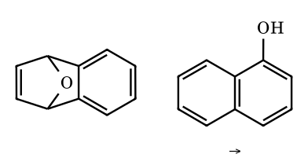
Answer: 1-naphthol
Protonation opens the strained C–O bridge to a benzylic/allylic cation; a 1,2-hydride shift and loss of H⁺ aromatise the new ring, giving 1-naphthol.
BZ-32.
o-Dibromobenzene is treated with 1 equiv of n-BuLi in THF at (a) −100 °C and (b) 0 °C. What species forms in each case?
Answer: (a) o-bromophenyllithium; (b) benzyne (LiBr lost)
Bromine–lithium exchange is fast at −100 °C and gives the stable ortho-bromoaryllithium. On warming, elimination of LiBr is thermally easy (the C–Li bond and the ortho C–Br are syn-periplanar in the plane), giving benzyne, which is trapped if a diene is present.
BZ-33.
How many ¹H NMR signals (aromatic and bridgehead types) does triptycene show, and from which reagents is it made?
Answer: 3 signal types; benzyne + anthracene
Each of the three benzo rings has two types of aromatic H (AA′BB′ pattern: H next to the bridgehead and H farther away), and the two bridgehead H are equivalent: 3 signal types. Benzyne from anthranilic acid/isoamyl nitrite adds across C-9/C-10 of anthracene.
BZ-34.
Account for the observation that 1-chloro-2,4-dinitrobenzene reacts with aqueous NaOH at 25 °C to give the phenol but 4-chlorotoluene needs NaNH₂/NH₃ and gives two products.
Answer: S_{N}Ar versus elimination–addition
The nitro groups ortho and para to Cl stabilise the Meisenheimer anion, so addition of HO⁻ occurs without strong base (ipso substitution, one product). 4-Chlorotoluene has no activation; only a very strong base can remove the ortho H, giving 4-methylbenzyne, which is attacked at either carbon to give m- and p-cresol-type products (here m- and p-toluidine).
BZ-35.
(Z)-Hex-3-ene-1,5-diyne is heated in 1,4-cyclohexadiene. Name the intermediate and the final aromatic product.
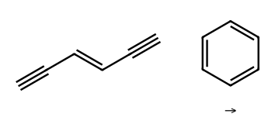
Answer: 1,4-didehydrobenzene (p-benzyne) diradical; benzene
Bergman cyclisation forms the σ,σ-diradical, which abstracts two H atoms from 1,4-cyclohexadiene (itself aromatising to benzene). The same chemistry in enediyne antibiotics cleaves DNA.
BZ-36.
Three benzyne molecules combine in the presence of Pd(0). Give the product and its molecular formula.
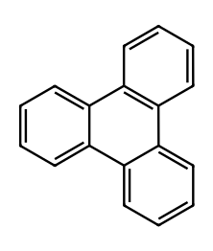
Answer: triphenylene, C₁₈H₁₂
A palladium-templated [2+2+2] cyclotrimerisation of three C₆H₄ units gives the fully fused triphenylene (3 × C₆H₄ = C₁₈H₁₂).
BZ-37.
(JEE Advanced, integer) 2-, 3- and 4-Chlorotoluene are treated separately with excess NaNH₂ in liquid NH₃ (−33 °C). Let x, y and z be the numbers of different constitutionally isomeric toluidines (aminotoluenes) that can form from the 2-, 3- and 4-isomer respectively, assuming that every accessible benzyne is formed and each is attacked at both of its carbons. Find x + y + z.
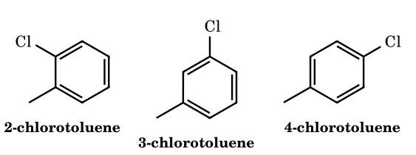
Answer: 7
2-Chlorotoluene has only one ortho hydrogen (C-3), so only 3-methylbenzyne forms; attack at either carbon gives o- and m-toluidine, x = 2. 3-Chlorotoluene has two ortho hydrogens (C-2 and C-4): the 2,3-aryne gives o- and m-toluidine, the 3,4-aryne gives m- and p-toluidine; the union is o, m, p, so y = 3. 4-Chlorotoluene gives 4-methylbenzyne only, hence m- and p-toluidine, z = 2. Sum = 2 + 3 + 2 = 7 (only three distinct toluidines exist overall, but the question counts per substrate).
BZ-38.
(Roberts experiment) Chlorobenzene labelled with ¹⁴C only at C-1 (the carbon carrying Cl) is treated with KNH₂ in liquid NH₃. The aniline obtained is degraded and the position of the label determined. (a) What distribution of ¹⁴C between C-1 and C-2 of aniline is observed? (b) What distribution would an SNAr (Meisenheimer) or SN1 pathway require? (c) Why is the observed result a proof of a symmetrical intermediate?
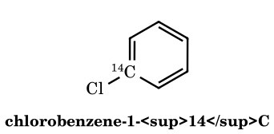
Answer: about 1 : 1 (C-1 : C-2); a direct substitution would give 100 : 0
Amide removes the ortho hydrogen (C-2–H) and chloride leaves from C-1, giving benzyne in which the labelled carbon and its neighbour are equivalent by symmetry. NH₂⁻ adds to either carbon with equal probability, and protonation of the resulting aryl anion gives aniline with the label equally at C-1 and C-2 (the ¹⁴C isotope effect on the addition is negligible). SNAr or SN1 replaces Cl at the carbon that carried it, so all the label would remain at C-1. The roughly 1:1 distribution therefore requires an intermediate in which C-1 and C-2 become equivalent, the elimination–addition (aryne) mechanism.
BZ-39.
(JEE Advanced, assertion–reason) Assertion: 2-Chloro-1,3-dimethylbenzene is recovered unchanged when treated with NaNH₂ in liquid NH₃, whereas chlorobenzene is converted into aniline. Reason: The benzyne mechanism requires a hydrogen atom ortho to the leaving group, and both ortho positions of 2-chloro-1,3-dimethylbenzene carry methyl groups. (a) Both true and Reason explains Assertion; (b) both true but Reason does not explain; (c) Assertion true, Reason false; (d) Assertion false, Reason true.
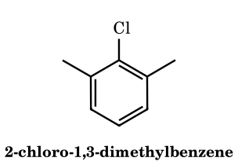
Answer: (a)
Elimination–addition needs amide to abstract an ortho proton in an E2/E1cB-like step. Here the two ortho carbons are quaternary (CH₃-bearing), so no benzyne can form. The ring has no activating nitro-type groups, so SNAr is impossible, and an aryl cation (SN1) is far too unstable. The benzylic C–H of the methyls is not a suitable site for forming an aryne. The Reason is true and is exactly why the Assertion holds.
BZ-40.
(Match the column) Match each benzyne-generating system in Column I with the small species expelled in forming the aryne, Column II.
Column I: (P) benzenediazonium-2-carboxylate, warm; (Q) 2-(trimethylsilyl)phenyl triflate + CsF; (R) 1-bromo-2-fluorobenzene + Mg, THF; (S) 1,2-dibromobenzene + n-BuLi, then warming from −100 °C; (T) bromobenzene + NaNH₂/liq. NH₃.
Column II: (1) N₂ + CO₂; (2) Me₃SiF + triflate ion; (3) MgBrF; (4) n-BuBr + LiBr; (5) NH₃ + NaBr.
Answer: P–1, Q–2, R–3, S–4, T–5
P: the zwitterion loses N₂ and CO₂ (explosive when dry). Q: fluoride attacks silicon, the C–Si bond becomes a carbanion that expels triflate (Kobayashi), giving Me₃SiF and TfO⁻. R: the Grignard forms at the weaker C–Br bond and the o-fluoro arylmagnesium bromide eliminates MgBrF. S: Br/Li exchange gives n-BuBr and 2-bromophenyllithium, which loses LiBr on warming. T: amide removes the ortho proton and bromide leaves, giving NH₃ and NaBr.
BZ-41.
Benzenediazonium-2-carboxylate (from anthranilic acid and isoamyl nitrite) is decomposed in refluxing 1,2-dichloroethane in the presence of excess furan to give A (C₁₀H₈O). Treatment of A with dilute HCl gives an isomer B that dissolves in aqueous NaOH and gives a violet colour with FeCl₃. Identify A and B and state the number of stereoisomers of A.
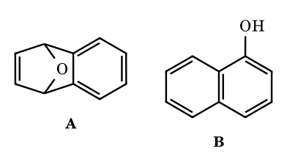
Answer: A = 1,4-dihydro-1,4-epoxynaphthalene (achiral, 1 stereoisomer); B = 1-naphthol
Benzyne acts as a dienophile towards furan in a [4+2] cycloaddition, giving the oxa-bridged bicycle A (7-oxabenzonorbornadiene). Its mirror plane through O and the midpoint of the C=C makes it achiral (one stereoisomer). Acid protonates the bridging oxygen; C–O cleavage gives a stabilised benzylic/allylic cation (C-1) with OH at C-4; a 1,2-hydride shift from C-4 (or loss of H⁺ from the corresponding ketonic species) and tautomerisation gives the aromatic phenol, 1-naphthol (FeCl₃ test).
BZ-42.
(Match the column) Match each reaction with the mechanism by which the substitution occurs. Reactions: (P) 2,4-dinitrochlorobenzene + piperidine; (Q) chlorobenzene + KNH₂/liq. NH₃; (R) benzenediazonium tetrafluoroborate in warm water giving phenol; (S) iodobenzene + K⁺ −CH₂COCH₃, liq. NH₃, hv, giving phenylacetone; (T) 4-chloronitrobenzene + NaOMe. Mechanisms: (i) SNAr, addition–elimination via a Meisenheimer complex; (ii) elimination–addition via benzyne; (iii) SN1 (aryl cation); (iv) S_{RN}1 (radical chain with radical-anion intermediates).
Answer: P–i, Q–ii, R–iii, S–iv, T–i
P and T have o/p nitro groups that stabilise the anionic sigma-complex (SNAr). Q has no activating group and a strong base: ortho-deprotonation/loss of Cl⁻ gives benzyne. R: ArN₂⁺ loses N₂, an excellent leaving group, giving Ar⁺ captured by water. S: photostimulated electron transfer to PhI gives PhI^{•−}, which fragments to Ph• + I⁻; Ph• adds to the enolate and the product radical anion transfers an electron to a new PhI (chain).
BZ-43.
2-Bromoanisole and 3-bromoanisole are treated separately with NaNH₂ in liquid NH₃. (a) Show that both give the same single methoxyaniline and name it. (b) Classify the substitution as ipso or cine for each substrate. (c) Explain the regiochemistry of amide addition to the aryne.
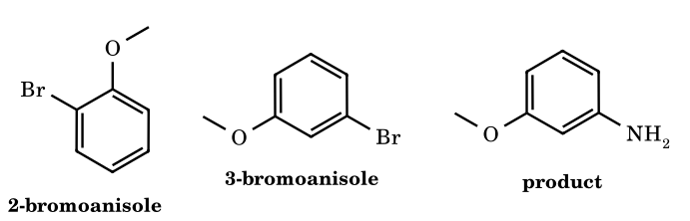
Answer: both give 3-methoxyaniline; 2-bromoanisole: cine, 3-bromoanisole: ipso
2-Bromoanisole can lose only the C-3 proton, and 3-bromoanisole loses the doubly activated C-2 proton (between OMe and Br, both −I); both give 3-methoxybenzyne. OMe is −I, so amide adds to the aryne carbon meta to OMe (C-3 in the numbering of the anisole), leaving the carbanion on the carbon adjacent to the OMe-bearing carbon where the inductive effect stabilises it. In 2-bromoanisole this carbon is the one that bore H (NH₂ enters next to the old C–Br position: cine); in 3-bromoanisole it is the carbon that bore Br (ipso). ⚑ Selectivity is very high but not absolute: the minor C-4 deprotonation of 3-bromoanisole would give 4-methoxybenzyne, which is expected to give a meta/para mixture.
BZ-44.
Benzyne generated from benzenediazonium-2-carboxylate in the presence of anthracene gives the hydrocarbon T. (a) Give the molecular formula and name of T. (b) How many signals are expected in its ¹H NMR and ¹³C NMR spectra, and what is the ¹H integration ratio? (Assume ideal D_{3h} symmetry.)
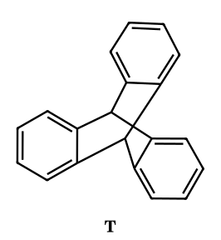
Answer: T = triptycene, C₂₀H₁₄; 3 ¹H signals (2H : 6H : 6H) and 4 ¹³C signals
Benzyne adds across the 9,10-positions of anthracene ([4+2], the central ring acting as the diene), giving triptycene (9,10-dihydro-9,10-benzenoanthracene), C₁₄H₁₀ + C₆H₄ = C₂₀H₁₄. In the D_{3h} structure the two bridgehead CH are equivalent (2H singlet, about 5.4 ppm); the 18 aromatic H fall into two sets of six (positions 1,4 type and 2,3 type, an AA′BB′ pattern). In the ¹³C spectrum: bridgehead CH, quaternary ring-fusion C (all six equivalent), and two types of aromatic CH, so 4 signals.
BZ-45.
Benzyne (from 2-(trimethylsilyl)phenyl triflate/CsF) is allowed to react separately with (i) tetraphenylcyclopentadienone and (ii) 2-pyrone. In each case a bicyclic [4+2] adduct forms but cannot be isolated; a gas is lost spontaneously and an aromatic hydrocarbon results. Identify each hydrocarbon (with molecular formula) and the gas lost.
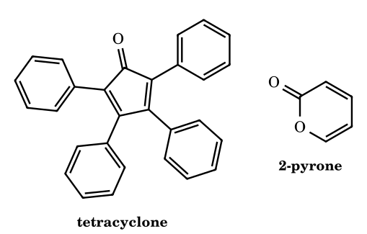
Answer: (i) 1,2,3,4-tetraphenylnaphthalene, C₃₄H₂₄ + CO; (ii) naphthalene, C₁₀H₈ + CO₂
(i) The cyclopentadienone is a 4π diene; the adduct is a 7-norbornadienone, which extrudes CO in a cheletropic retro-[4+2] to aromatise: C₂₉H₂₀O + C₆H₄ − CO = C₃₄H₂₄. (ii) 2-Pyrone reacts across C-3/C-6 to give a 2-oxabicyclo[2.2.2]octadienone (bridged lactone); retro-Diels–Alder expels CO₂ and leaves the new benzene ring of naphthalene: C₅H₄O₂ + C₆H₄ − CO₂ = C₁₀H₈.
BZ-46.
Benzyne is generated (CsF, 2-(trimethylsilyl)phenyl triflate) in neat isobutene (2-methylpropene). The main product P (C₁₀H₁₂) arises by a concerted pericyclic reaction in which aryne acts as the enophile. (a) Name the reaction and give P. (b) Name one minor isomeric product. (c) If (CD₃)₂C=CH₂ were used, how many deuterium atoms would sit on the benzene ring of P?
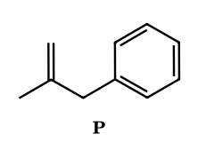
Answer: ene reaction; P = (2-methylallyl)benzene; minor: 1,1-dimethylbenzocyclobutene ([2+2]); 1 D on the ring
Isobutene has allylic hydrogens, so benzyne undergoes an ene reaction: the CH₂= terminus bonds to one aryne carbon, an allylic H from a CH₃ group is delivered to the neighbouring aryne carbon, and the double bond shifts to give PhCH₂C(CH₃)=CH₂, C₆H₄ + C₄H₈ = C₁₀H₁₂. The competing stepwise or concerted [2+2] gives 1,1-dimethylbenzocyclobutene. ⚑ The ene:[2+2] ratio depends on the aryne source and conditions. With the CD₃ compound the transferred atom is D, so the ring carries 1 D (ortho to the new CH₂), the chain CD₃ and =CD₂ carry the other five.
BZ-47.
Benzyne (Kobayashi method) is generated in the presence of (i) benzyl azide and (ii) the nitrone PhCH=N⁺(CH₃)O⁻. Both react as 1,3-dipoles. Give the products and the total number of ring heteroatoms in the new heterocycle in each case.
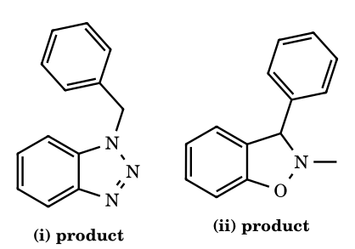
Answer: (i) 1-benzylbenzotriazole (3 ring N); (ii) 2-methyl-3-phenyl-2,3-dihydro-1,2-benzisoxazole (ring N and O, 2 heteroatoms)
A [3+2] dipolar cycloaddition of the 4π dipole across the aryne π bond (the in-plane, strained one) gives a five-membered ring fused to the benzene ring. Benzyl azide adds with its terminal N (N₃) and substituted N (N₁) to the two aryne carbons: aromatic 1-benzyl-1H-benzotriazole, which has three nitrogens in the ring. The nitrone adds with O bonded to one aryne carbon and the nitrone carbon to the other, giving the benzo-fused isoxazolidine (benzisoxazoline): N and O in the ring. Because benzyne itself is symmetrical, no regioisomers arise from the aryne side.
BZ-48.
(Multi-correct) Which of the following statements about nucleophilic addition to 3-substituted and 4-substituted benzynes are correct? (A) Amines add to 3-methoxybenzyne mainly at the aryne carbon meta to OMe (C-1). (B) In the distortion model this is accounted for by the aryne carbon meta to OMe having the larger internal angle (being flatter), so the transition state for attack there needs less distortion. (C) Attack at C-1 places the developing negative charge on C-2, next to the oxygen-bearing carbon, where the inductive (−I) effect of OMe stabilises it. (D) 4-Methoxybenzyne is expected to be attacked with high regioselectivity because OMe is conjugated with the triple bond. (E) 3-Methylbenzyne, with a +I substituent, shows an even stronger regiochemical preference than 3-methoxybenzyne.
Answer: A, B and C
A, B and C are the standard rationale (inductive rule/Garg–Houk distortion model): a −I 3-substituent directs the nucleophile meta to itself; the aryne is bent more strongly at the carbon nearer the substituent, so the distal carbon is the flatter, more electrophilic site. D is false: in a 4-substituted aryne the substituent is remote and the two carbons are almost equally accessible, so meta/para mixtures are obtained. E is false: methyl is a weak perturbation, so selectivity in 3-methylbenzyne is low. ⚑ The distortion angles are computed values.
BZ-49.
(Integer) 2-Chloropyridine and 3-bromopyridine are treated separately with NaNH₂ in liquid NH₃. Let n be the total number of different aminopyridines isolated from the two reactions (counting each isomer once per reaction). Which of the two reactions involves an aryne? What is n?
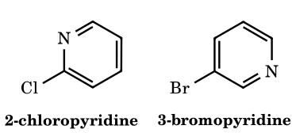
Answer: 3-bromopyridine (3,4-pyridyne); n = 3
In 2-chloropyridine the C-2 carbon is activated by the ring nitrogen (like an ortho-nitro position), so NH₂⁻ displaces Cl by addition–elimination (Meisenheimer-type anion with charge on N): only 2-aminopyridine (1 product). 3-Bromopyridine has no such activation at C-3; amide removes H-4 and bromide leaves, giving 3,4-pyridyne, which is attacked at C-3 or C-4 to give 3- and 4-aminopyridine (2 products). Total n = 1 + 2 = 3. ⚑ By the same logic, 4-chloropyridine is intercepted mainly by SNAr, and the proportion of 3,4-pyridyne there depends on conditions.
BZ-50.
N-Methyl-6,7-indolyne (a 1-methylindole with the triple bond between C-6 and C-7) is generated in the presence of an amine R₂NH (e.g. morpholine). Two constitutional isomers can form. Predict the major one and justify the regiochemistry from the inductive rule.
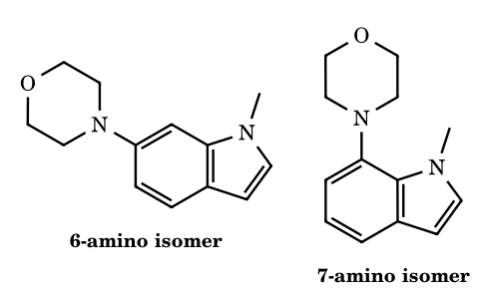
Answer: 6-(dialkylamino)-1-methylindole (attack at C-6)
C-7 is adjacent to the ring-fusion carbon C-7a, which bears the electronegative nitrogen. Seen as a 3-substituted benzyne, the heteroatom-bearing carbon exerts a −I effect, so the nucleophile adds at the carbon meta to it (C-6) and the aryl anion develops at C-7, next to C-7a, where it is inductively stabilised. The distortion model agrees: C-6 is the flatter carbon. Hence the 6-amino indole predominates. ⚑ Selectivity is high but not complete, and it is much lower for the 5,6-indolyne, which has no such bias.
BZ-51.
(Multi-correct) Which statements about strained alkynes and cyclic allenes are correct? (A) Cyclooctyne is the smallest cycloalkyne that can be isolated as a stable compound at room temperature. (B) Cyclohexyne and cycloheptyne are known only as transient intermediates, detected by trapping (for example with furan or dienes). (C) Cyclooctynes react with organic azides at room temperature without a catalyst largely because strain is released in the [3+2] cycloaddition. (D) 1,2-Cyclohexadiene is a strongly bent, chiral allene that can be trapped as a transient intermediate. (E) The C–C≡C angle in cyclooctyne is nearly 180°.
Answer: A, B, C and D
A: cyclooctyne is isolable (it polymerises slowly), smaller rings are not. B: cyclohexyne (e.g. from 2-(trimethylsilyl)cyclohex-1-enyl triflate/fluoride) and cycloheptyne are intercepted in situ. C: the bent alkyne carries roughly 18 kcal/mol of strain, which accounts for strain-promoted azide–alkyne cycloadditions (Bertozzi-type click chemistry). D: 1,2-cyclohexadiene has a C=C=C angle far from 180° (about 130°), is chiral because the allene is twisted, and is trapped by furan or styrene. E is false: the angle is about 158°, which is the source of strain. ⚑ Numerical values are computational or crystallographic estimates.
BZ-52.
(Bergman cyclisation) Cyclodeca-3-ene-1,5-diyne (a ten-membered ring with a cis C=C between two C≡C) undergoes thermal cycloaromatisation at about 37 °C (t_{1/2} a matter of hours). In the presence of 1,4-cyclohexadiene, (a) which diradical forms? (b) what is the final organic product from the enediyne (give formula) and what does 1,4-cyclohexadiene become? (c) why is the ring size important?
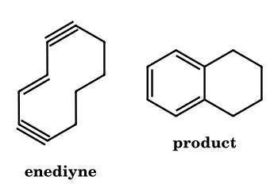
Answer: p-benzyne (5,6,7,8-tetrahydronaphthalene-1,4-diyl); tetralin C₁₀H₁₂ and benzene
The Bergman reaction forms a C–C bond between the two inner alkyne carbons (C-1 and C-6), creating a benzene ring bearing two radical centres para to each other (a 1,4-didehydroarene, p-benzyne). The remaining four CH₂ groups form the saturated ring. The singlet diradical abstracts two H atoms from 1,4-cyclohexadiene (which becomes benzene), giving tetralin, C₁₀H₁₀ + 2H = C₁₀H₁₂. Ring size matters because it fixes the distance between the reacting alkyne termini: in cyclic enediynes a distance of about 3.2–3.3 Å is roughly the threshold between kinetically stable and spontaneously cyclising compounds (shorter cyclises faster) (Nicolaou criterion).
BZ-53.
(IChO-style counting) The following chloroxylenes are heated separately with NaNH₂ in liquid NH₃: A 4-chloro-1,2-dimethylbenzene, B 5-chloro-1,3-dimethylbenzene, C 2-chloro-1,3-dimethylbenzene, D 1-chloro-2,3-dimethylbenzene. Assume every possible benzyne forms and is attacked at both ends (no regiochemical bias). How many different dimethylanilines are obtained altogether from A + B + C + D? Name them.
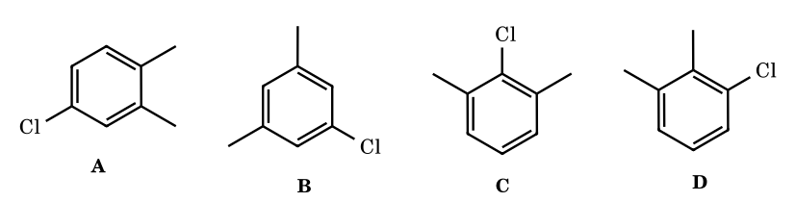
Answer: 4: 2,3-, 3,4-, 2,4- and 3,5-dimethylaniline
A: two ortho H (C-3, C-5). The 3,4-aryne gives 3,4- and 2,3-dimethylaniline; the 4,5-aryne gives 3,4-dimethylaniline from either end. B: both ortho H are equivalent; the single aryne gives 3,5-dimethylaniline (NH₂ at the old C–Cl carbon) and 2,4-dimethylaniline (NH₂ at the other end, now flanked by one Me ortho and one para). C: both ortho carbons carry Me, so no aryne forms and no amine results. D: only H-6 is available; the aryne gives 2,3-dimethylaniline (ipso) and 3,4-dimethylaniline. Distinct set = {2,3; 3,4; 2,4; 3,5} = 4 (six products are listed if counted per substrate, but 2,3- and 3,4- each appear twice).
BZ-54.
Benzyne generated without a trap dimerises to biphenylene and trimerises to triphenylene. (a) Give the formulas of these two hydrocarbons. (b) 4-Methylbenzyne is generated under the same conditions. How many different dimethylbiphenylenes form on dimerisation, and which are they? (Biphenylene positions 1–4 and 5–8; the ring-fusion carbons are 4a, 4b, 8a, 8b.)
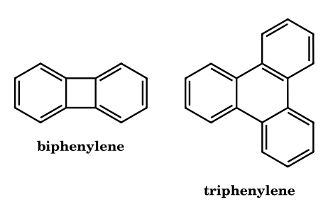
Answer: (a) C₁₂H₈ and C₁₈H₁₂; (b) two: 2,6- and 2,7-dimethylbiphenylene
Dimerisation is a formal [2+2] of two arynes (biphenylene, C₁₂H₈); a formal [2+2+2] of three gives triphenylene (C₁₈H₁₂). In 4-methylbenzyne the Me is para to one aryne carbon (C_{p}) and meta to the other (C_{m}). Two molecules can join with C_{p}–C_{p} and C_{m}–C_{m} bonds, giving the 2,7-isomer (C_{2v}), or with C_{p}–C_{m} bonds, giving the 2,6-isomer (C_{2h}). No other pairing exists, so two products form (1:1 within statistics, ignoring regiochemical bias).
BZ-55.
Ethyl acetoacetate, 2-(trimethylsilyl)phenyl triflate and CsF in MeCN give mainly an acyl–alkylation product X (C₁₂H₁₄O₃) rather than the simple C-arylation product (ethyl 2-phenylacetoacetate). Identify X and describe the key steps of its formation.
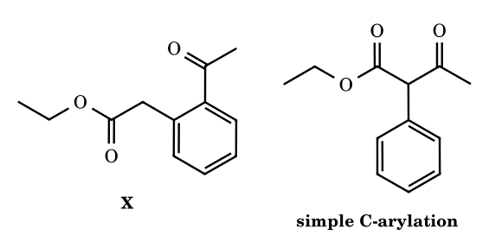
Answer: X = ethyl 2-(2-acetylphenyl)acetate (C–C σ-bond insertion)
Fluoride generates benzyne and also the enolate of the 1,3-dicarbonyl. Step 1: the enolate carbon adds to benzyne giving an aryl anion. Step 2: this anion attacks the neighbouring ketone C=O intramolecularly, forming a strained benzocyclobutenoxide. Step 3: ring-opening by cleavage of the former acyl C–C bond is driven by relief of strain and formation of a stabilised ester enolate; protonation gives the ortho-acylated arylacetate. The net result is insertion of the aryne into the C–C σ bond between the carbonyl and the α-carbon. ⚑ The ratio of insertion to ordinary arylation depends on solvent and counter-ion.
BZ-56.
(Multi-step synthesis) 3-Phenylphthalide is treated with PhMgBr (1 equiv) then aqueous work-up to give a lactol L; acid dehydrates L to the intensely fluorescent D (C₂₀H₁₄O). D is allowed to react with benzyne to give E (C₂₆H₁₈O), and E is deoxygenated (low-valent titanium) to F (C₂₆H₁₈). Identify D, E and F.
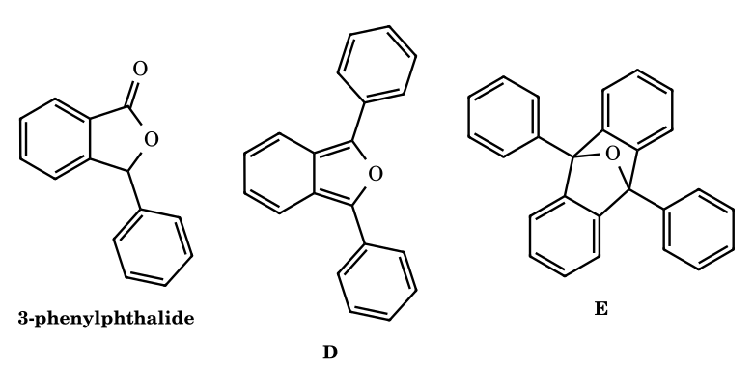
Answer: D = 1,3-diphenylisobenzofuran; E = its benzyne [4+2] adduct (9,10-diphenyl-9,10-epoxy-9,10-dihydroanthracene); F = 9,10-diphenylanthracene
PhMgBr adds to the lactone carbonyl to give the hemiketal (lactol) L, which on acid loses water to give the o-quinoid isobenzofuran D, a very reactive diene (1,3-diphenylisobenzofuran, C₂₀H₁₄O). Benzyne adds across the 1,3-positions in a Diels–Alder reaction giving the oxa-bridged adduct E (C₂₀H₁₄O + C₆H₄ = C₂₆H₁₈O). Reductive removal of the bridging oxygen then aromatises the central ring to 9,10-diphenylanthracene F, C₂₆H₁₈.
BZ-57.
(Olympiad-style mechanism) The enediyne antitumour antibiotic calicheamicin γ₁^{I} contains a methyl trisulfide trigger. Arrange the events in order and name the key intermediate: (1) abstraction of H atoms from deoxyribose of DNA; (2) intramolecular Michael addition of the new thiolate to the enone of the bicyclic core; (3) Bergman cyclisation; (4) reduction of the trisulfide by cellular thiol; (5) change of hybridisation/geometry that brings the alkyne termini closer. Also state how the Myers–Saito reaction of neocarzinostatin chromophore differs in its diradical.
Answer: 4, 2, 5, 3, 1; key intermediate p-benzyne; Myers–Saito gives an α,3-didehydrotoluene (σ,π) biradical
A thiol cleaves the S–S bond of the trisulfide (4). The resulting thiolate adds in a conjugate fashion to the enone (2), converting an sp² carbon to sp³ and thereby bending the bicycle so that the two alkyne termini approach (5). Bergman cyclisation (3) then gives the 1,4-didehydrobenzene (p-benzyne) diradical, which abstracts H atoms from deoxyribose of the two DNA strands (typically C-5′ on one strand and C-4′ or C-5′ on the other) (1) causing double-strand cleavage. Neocarzinostatin's activated enyne–allene cyclises by the Myers–Saito reaction (C2–C7 bond) to an α,3-didehydrotoluene biradical with one σ and one benzylic π radical centre.
BZ-58.
(Olympiad-style) The rate of reaction of halobenzenes PhX with KNH₂ in liquid NH₃ (aryne pathway) follows Br > I > Cl >> F, whereas in SNAr reactions of 2,4-dinitrohalobenzenes with piperidine the order is F >> Cl ≈ Br > I. (a) Explain why the orders differ. (b) In KND₂/ND₃, fluorobenzene exchanges its ortho hydrogens for deuterium much faster than it forms aniline. What does this say about the mechanism?
Answer: aryne: C–X cleavage is rate-limiting-type; SNAr: addition is rate-limiting; fluorobenzene: fast reversible deprotonation, slow loss of F⁻
In SNAr the slow step is nucleophilic attack to give the Meisenheimer complex; fluorine, the most electronegative halogen, makes the ipso carbon most electrophilic and stabilises the anionic sigma-complex, so F is fastest and C–X cleavage (fast step) is not rate-limiting. In the aryne route, ortho-deprotonation gives an aryl anion and then expulsion of X⁻ occurs with significant C–X bond breaking in the rate-limiting stage, so the better leaving groups (Br, I) win and the strong C–F bond is slowest. Hence fluorobenzene is deprotonated easily (strong −I of F acidifies the ortho H) but the o-fluorophenyl anion mostly returns to substrate, which gives H/D exchange without much aniline: the elimination is a two-step E1cB-like process. ⚑ The exact order of Br and I depends on conditions.

Part 13 Radical Ions: Radical Anions and Radical Cations
A radical ion has both an unpaired electron and a net charge. A radical anion forms when a neutral molecule accepts one electron into its lowest empty π* orbital; a radical cation forms when it loses one electron from its highest filled orbital. They are the intermediates of single-electron-transfer (SET) chemistry: dissolving-metal reductions, electrochemistry, radiolysis, mass spectrometry (M^{•+} is the molecular ion) and photoinduced electron transfer. They are normally observed by ESR spectroscopy, the hyperfine splittings giving the spin density at each atom.
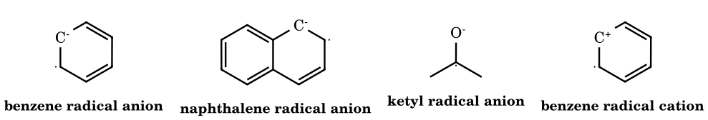
Radical-ion structures (one resonance contributor; the unpaired electron and the charge are delocalised over the ring or over C and O in the ketyl).
Species | Formation | Typical chemistry | Why it matters
Arene radical anion (naphthalenide, benzene^{•−}) | arene + Na or Li in THF / liquid NH₃ (electron into π*) | strong reducing agent; protonated by ROH to a cyclohexadienyl radical, then reduced again to a carbanion and protonated | Birch reduction: benzene + Na/NH₃(l)/ROH → 1,4-cyclohexadiene (EDG on the ring end up on the double bond carbons; EWG on sp³ carbons)
Ketyl radical anion R₂C•–O⁻ | ketone + Na, Mg, SmI₂ | radical combination (dimerisation) or further reduction to the carbanion/alkoxide | Pinacol coupling (2 R₂C=O + Mg(Hg) → diol), acyloin condensation (2 RCOOR + Na → α-hydroxyketone), the benzophenone ketyl (a deep-blue, solvent-drying indicator)
Nitroarene / quinone radical anion | electrolytic or chemical one-electron reduction | semiquinone (ArO•/ArO⁻) are redox intermediates in biology (ubiquinone) | ESR detection; antibiotic and DNA-damage mechanisms
Radical anion in S_{RN}1 | ArX + e⁻ → ArX^{•−} → Ar• + X⁻ | chain: Ar• + Nu⁻ → ArNu^{•−}; ArNu^{•−} + ArX → ArNu + ArX^{•−} | substitution without an activating group
Arene radical cation | anodic oxidation, SET to a photoexcited acceptor, Ce⁴⁺, mass-spectrometric ionisation | deprotonation at benzylic C–H gives benzyl radicals; nucleophile addition | mass spectrometry: M^{•+} fragmentation; Kolbe anodic oxidation; conducting polymers (polyaniline, polypyrrole)
Amine radical cation R₃N^{•+} (aminium) | oxidation of amines (e.g. Wurster’s blue from N,N,N′,N′-tetramethyl-p-phenylenediamine) | α-C–H deprotonation gives α-amino radical; the N-centred radical performs 1,5-HAT (Hofmann–Löffler) | stable, coloured radical cations
Birch reduction in four steps (benzene, Na, NH₃(l), EtOH): (1) electron transfer gives the radical anion; (2) protonation by ethanol (a weak acid; NH₃ is too weak) gives a cyclohexadienyl radical; (3) a second electron gives the cyclohexadienyl anion (a pentadienyl carbanion, charge at C-1, C-3, C-5); (4) protonation at the central carbon (C-3, the position of greatest charge density) gives the non-conjugated 1,4-diene. Electron-donating groups (OMe, alkyl) sit on the sp² carbons of the product; electron-withdrawing groups (COOH) sit at the sp³ end because they stabilise the carbanion at their own carbon.

13.2 Dissolving-metal reductions: regiochemistry and scope
- Birch reduction rules. Arene + Na (or Li)/NH₃(l) with an alcohol gives a 1,4-cyclohexadiene. Electron-donating substituents (alkyl, OR, NR₂) end up on the sp² carbons of the product (the radical anion is protonated, and the carbanion forms, at the positions least destabilised: ortho/meta to the donor). Electron-withdrawing substituents (COOH, CONH₂, CN) end up on the sp³ carbon (para protonation, carbanion stabilised by the acceptor). Anisole → 1-methoxycyclohexa-1,4-diene (hydrolysis gives the β,γ-unsaturated ketone, then the conjugated enone: a route to cyclohexenones); benzoic acid → cyclohexa-2,5-diene-1-carboxylic acid; toluene → 1-methylcyclohexa-1,4-diene.
- Why an alcohol is needed: NH₃ (pK_{a} ≈ 38) is too weak an acid to protonate the benzene radical anion at a useful rate; ROH (≈ 16–18) does so. The first protonation is rate-determining. The 1,4-diene (not the conjugated 1,3-diene) forms because the pentadienyl anion is protonated at its central carbon, where the charge density (and the kinetic basicity) is highest.
- Alkynes → trans-alkenes (Na/NH₃). The vinyl radical anion (intermediate) is protonated to a vinyl radical that adopts the less hindered trans geometry before a second electron gives the trans-vinyl anion, protonated to the trans-alkene; terminal alkynes are deprotonated first (acetylide) and are not reduced. Lindlar (H₂, Pd/CaCO₃, quinoline) gives the cis-alkene by syn addition.
- Bouveault–Blanc (ester + Na/EtOH → two alcohols) via ketyl and carbanion stages; replaced by LiAlH₄ today. Acyloin condensation (diester + Na, toluene, then TMSCl) closes rings from C₅ to C₃₀ through a diradical dianion on the metal surface (high dilution is not needed because the sodium surface holds both ends). McMurry coupling (2 R₂C=O + TiCl₃/LiAlH₄ or Zn–Cu → R₂C=CR₂): ketyl radical anions on low-valent titanium couple to a pinacolate and deoxygenate (Ti–O strength); used for tetrasubstituted alkenes and macrocycles. SmI₂ (Kagan) (THF/HMPA) reduces ketones, halides, and promotes ketyl–olefin cyclisations (a ketyl adds to an alkene in 5-exo mode).
- Benkeser reduction (Li/ethylamine): further reduces arenes to cyclohexenes. Clemmensen (Zn(Hg)/HCl) and Wolff–Kishner are not Birch-type; Clemmensen proceeds by zinc-carbenoid surface species.
- Pinacol coupling: 2 R₂C=O + Mg(Hg)/or Al/or SmI₂ → vicinal diol. Intramolecular versions give cis-1,2-diols in rings (1,5- and 1,6-dicarbonyls give 5-/6-membered rings with cis selectivity because the metal chelates both oxygens). The acid-catalysed pinacol–pinacolone rearrangement of the product is a carbocation 1,2-shift (Part 7).
- Nitroarene reduction steps (one-electron stages): ArNO₂ → ArNO₂^{•−} → ArNO → ArNHOH → ArNH₂; with Zn/NH₄Cl stops at hydroxylamine; in alkali, bimolecular products (azoxy, azo, hydrazo) form by coupling of nitroso and hydroxylamine intermediates (Part 14 table).

13.3 Radical cations: mass spectrometry, anodic chemistry, photoredox
- Electron-impact ionisation (70 eV) removes the electron of highest energy: n(O), n(N) lone pairs > π > σ. The molecular ion M^{•+} then fragments by pathways that give the most stable cation plus a neutral radical (or a neutral molecule plus a radical cation). Rules: (i) nitrogen rule: an odd number of N gives an odd M^{•+} mass; (ii) α-cleavage next to O, N or C=O (radical on the heteroatom pairs with an α C–C electron): CH₃CH₂COCH₃^{•+} → CH₃CO⁺ (m/z 43, loss of the larger radical is favoured) and C₂H₅CO⁺ (57); (iii) McLafferty rearrangement of carbonyls with a γ-H: six-membered TS 1,5-H transfer to O and β-cleavage gives an enol radical cation and an alkene (e.g. butanal m/z 44; ketone/ester/acid/amide); (iv) benzylic cleavage to the tropylium ion (m/z 91) from alkylbenzenes; (v) loss of small neutral molecules: H₂O (M − 18) from alcohols, CO (28), CO₂ (44), HCN (27), C₂H₄ (28, retro-Diels–Alder of cyclohexenes), HX; (vi) isotopic patterns: Cl (3 : 1 for M : M+2), Br (1 : 1).
- Anodic oxidation (electro-organic). Kolbe (carboxylates, Part 9), Shono oxidation (carbamate/amide → N-acyliminium via α-C–H, then nucleophile trapping), oxidation of enol ethers, aromatic ethers (anisole → quinone ketals in MeOH). The radical cation of an electron-rich arene reacts with nucleophiles at the position of highest spin/charge density (e.g. para to OMe).
- Chemical oxidants: CAN (Ce⁴⁺), DDQ (hydride/SET abstraction from benzylic C–H of electron-rich arenes, deprotection of PMB ethers: ArCH₂OR → ArCH=O⁺R → ArCHO + ROH), Fe(III)/Cu(II) in Scholl coupling, NO⁺BF₄⁻, Wurster-type amine radical cations. Photoredox catalysis ([Ru(bpy)₃]^{2+*}, Ir(ppy)₃, organic dyes; Nobel-adjacent field) uses visible light to generate radical anions/cations by SET: reductive quenching gives a radical anion of the substrate, oxidative quenching a radical cation; applications include radical dehalogenation, amine α-functionalisation, alkene hydrofunctionalisation, [2+2] cycloadditions via radical cation chains.
- Radical-cation chain reactions. The Bauld cation-radical Diels–Alder: an electron-rich dienophile radical cation (e.g. from trans-anethole with a triarylaminium salt) adds to a diene much faster than the neutral pair; the new radical cation oxidises another neutral dienophile (chain). Rate acceleration > 10⁶ and complementary regiochemistry.
- Amine radical cations: loss of α-H⁺ gives α-aminoalkyl radicals; loss of an electron again gives iminium ions (the basis of photoredox α-functionalisation of tertiary amines and of the biological oxidation of N-methyl amines by cytochrome P450 to formaldehyde + dealkylated amine).

13.4 Radical anions in substitution: S_{RN}1 and electron-transfer mechanisms
- S_{RN}1 (Bunnett, 1970): ArX + e⁻ → ArX^{•−} → Ar• + X⁻ (initiation by hν, Na/NH₃, electrochemistry, or Fe²⁺); Ar• + Nu⁻ → ArNu^{•−}; ArNu^{•−} + ArX → ArNu + ArX^{•−} (chain). Features: no EWG needed; leaving-group order I > Br > Cl ≫ F (opposite to S_{N}Ar); nucleophiles are enolates, thiolates, amide, phosphide, acetone enolate; inhibited by radical traps and O₂ and by radical-anion scavengers (p-dinitrobenzene); promoted by light and by electron-transfer initiators; no cine substitution (distinguishes it from benzyne). The nucleophile enters where the leaving group was (ipso).
- Single-electron transfer (SET) in organometallic reactions: the formation of Grignard reagents (RX + Mg surface: RX^{•−} → R• + X⁻), the reaction of RLi/RMgX with hindered ketones (benzophenone gives the deep-blue/purple ketyl observed by ESR), the Wurtz reaction (Na + RX), the Ullmann coupling. The SET versus polar-mechanism question is generally settled by radical probes: cyclopropylcarbinyl and 5-hexenyl halides give ring-opened/cyclised products if a free radical forms (Part 9).
- Radical anions of alkyl halides have a three-electron σ*(C–X) bond that dissociates in < 10⁻¹² s (concerted dissociative ET), giving R• + X⁻ directly.
Typical errors in radical-ion questions. (1) Placing the Birch product double bonds in conjugation: they are 1,4 (skipped). (2) Putting EWG on sp² carbon and EDG on sp³: it is the opposite. (3) Using NH₃ alone as the proton source without an alcohol. (4) Reducing a terminal alkyne with Na/NH₃: it is deprotonated first. (5) Assuming that the ionisation in MS removes an σ electron: it removes the highest-energy lone-pair/π electron. (6) Forgetting the nitrogen rule. (7) Treating S_{RN}1 as S_{N}Ar.

13.5 Additional validated mechanisms
13.1 Pinacol coupling: two ketyl radical anions (from acetone + Mg) combine at carbon
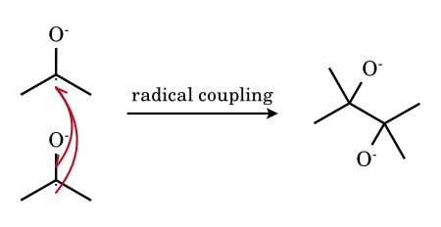
Each ketyl carries the unpaired electron on carbon (the spin is largely on C, the charge on O). Two ketyls pair their electrons to form the new C–C σ bond; the dialkoxide is protonated on work-up to the 1,2-diol (pinacol), or held by Mg²⁺ as a five-membered chelate.
13.2 Mass spectrum of butan-2-one: α-cleavage of the radical cation (m/z 43)
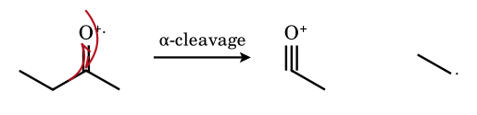
The radical on oxygen pairs with one electron of the adjacent C–C σ bond to form the third bond of the acylium ion CH₃–C≡O⁺ (m/z 43); the other σ electron stays on the departing ethyl radical, which is lost as a neutral. Cleavage that expels the larger alkyl radical is preferred, so m/z 43 is the base peak of butanone (m/z 57 is smaller).

13.1 Problems on radical ions
RI-1.
What is the major product of Na/NH₃(l)/EtOH on anisole, and on benzoic acid?
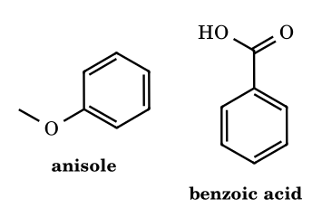
Answer: 1-methoxycyclohexa-1,4-diene; cyclohexa-2,5-diene-1-carboxylic acid
A donor (OMe) stays on the double bond (sp² carbon), because the carbanion is least stabilised there, so the protonation occurs at the ortho and meta carbons; an acceptor (COOH) stays on the sp³ carbon because it stabilises the carbanion on its own carbon, which is protonated.
RI-2.
Mg(Hg), then H₂O, is allowed to react with acetone. Name the intermediate, the product, and the acid-catalysed product.
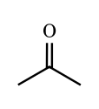
Answer: ketyl radical anion; pinacol; pinacolone
Mg transfers one electron to C=O (ketyl radical anion); two ketyls couple at carbon to the dimeric dialkoxide (pinacol after hydrolysis); H⁺ then rearranges pinacol to pinacolone (Part 7.0, 7.10).
RI-3.
Which species is paramagnetic? (a) benzene radical anion, (b) tropylium cation, (c) naphthalene, (d) benzophenone ketyl.
Answer: (a) and (d)
Both have one unpaired electron. The tropylium cation and naphthalene have all electrons paired.
RI-4.
Mass spectrometry: what is M^{•+}, and why do its fragments follow carbocation-stability rules?
Answer: the molecular radical cation; fragmentation gives the more stable carbocation + radical
Electron impact removes one electron (usually from a lone pair or π bond) to give M^{•+}. Its cleavage into a cation and a neutral radical follows the order of carbocation stability (tertiary > secondary > primary; benzyl/tropylium and oxonium ions are particularly abundant, e.g. m/z 91 for alkylbenzenes).
RI-5.
Predict the Birch product from (a) toluene, (b) p-xylene, (c) benzoic acid, (d) anisole, all with Na/NH₃(l)/EtOH.
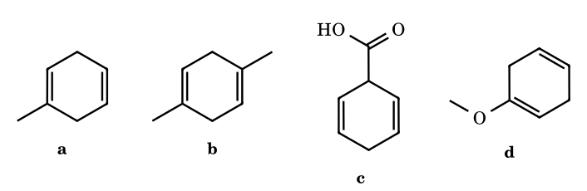
Answer: (a) 1-methylcyclohexa-1,4-diene; (b) 1,4-dimethylcyclohexa-1,4-diene; (c) cyclohexa-2,5-diene-1-carboxylic acid; (d) 1-methoxycyclohexa-1,4-diene
Donor groups (CH₃, OMe) stay on the double bonds; the acceptor (COOH) sits on the sp³ carbon, with protonation at the ipso and para carbons. The two products of the second (para-dialkyl) case are the 1,4-diene with both methyls on sp² carbons.
RI-6.
Complete: (a) hex-3-yne + Na/NH₃(l); (b) hex-3-yne + H₂, Lindlar; (c) hex-1-yne + Na/NH₃(l) (1 equiv Na).
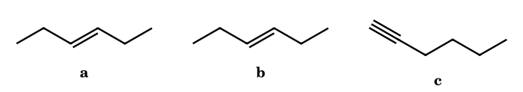
Answer: (a) (E)-hex-3-ene; (b) (Z)-hex-3-ene; (c) the terminal alkyne is deprotonated, giving sodium hex-1-ynide (not reduced)
Dissolving-metal reduction proceeds through a trans-configured vinyl radical/anion; Lindlar hydrogenation is syn. A terminal C–H (pK_{a} 25) is removed by the amide/NH₂⁻ formed in solution before reduction.
RI-7.
(Integer) How many of the following form a radical anion on treatment with sodium metal in THF: naphthalene, benzophenone, cyclohexane, anthracene, acetone, tert-butyl alcohol?
Answer: 4 (naphthalene, benzophenone, anthracene, acetone)
Sodium transfers an electron into a low-lying π* orbital: arenes with extended π systems and ketones form radical anions (naphthalenide green, benzophenone ketyl blue/purple, anthracenide green; acetone mainly pinacolises). Cyclohexane has no low-energy acceptor orbital; t-BuOH is deprotonated (H₂ evolution).
RI-8.
A ketyl radical anion from benzophenone is generated with Na in dry THF. (a) What is its colour and what is it used for? (b) What happens on adding water?
Answer: (a) deep blue/purple; indicator of dryness and O₂-free conditions in solvent stills; (b) the colour is discharged and benzhydrol/benzopinacol form
The persistent ketyl is destroyed by traces of water or O₂, so its colour signals that the THF is dry. Protonation gives Ph₂C•–OH → benzhydrol by H-atom pickup or benzopinacol by dimerisation.
RI-9.
Arrange the following in decreasing order of intensity of the M^{•+} peak in EI-MS: benzene, hexane, 2-methylpentan-2-ol, ethanol.
Answer: benzene > hexane > ethanol > 2-methylpentan-2-ol
Aromatic molecular ions are the most stable (charge delocalised); linear alkanes give weak M^{•+}, primary alcohols weaker still (rapid loss of H₂O and α-cleavage), and tertiary alcohols are almost absent (very fast α-cleavage and dehydration).
RI-10.
In the EI mass spectrum of 2-pentanone (C₅H₁₀O), the base peak is m/z 43 and there is a significant peak at m/z 58. Account for both.
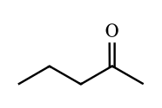
Answer: m/z 43: CH₃CO⁺ by α-cleavage; m/z 58: McLafferty rearrangement (loss of ethene)
α-Cleavage on the propyl side expels •C₃H₇ to give CH₃C≡O⁺ (43). The γ-H (on C-5) is transferred to O through a six-membered transition state with cleavage of the α,β C–C bond, giving CH₂=C(OH)CH₃^{•+} (58) and neutral C₂H₄.
RI-11.
A chloro compound shows M^{•+} peaks at m/z 78 and 80 in a 3 : 1 ratio, and an odd/even pattern that fits C₃H₇Cl. Identify the isotope pattern and give one fragmentation.
Answer: one chlorine (³⁵Cl : ³⁷Cl ≈ 3 : 1); loss of Cl• gives C₃H₇⁺ (m/z 43)
The 3 : 1 intensity ratio of M and M+2 is the signature of one Cl atom (Br gives 1 : 1). C₃H₇Cl has M = 78 (³⁵Cl) and 80 (³⁷Cl); C–Cl cleavage gives the propyl cation, m/z 43.
RI-12.
Why does S_{RN}1 show leaving-group order I > Br > Cl ≫ F, opposite to S_{N}Ar, and why is there no cine substitution?
Answer: the rate-limiting step is C–X cleavage of the radical anion, not nucleophilic addition; no aryne is involved
In S_{N}Ar the addition (needing a polarised C–X, i.e. F) is rate-limiting. In S_{RN}1 the fragmentation of ArX^{•−} depends on C–X bond strength, favouring I and Br. The aryl radical couples with Nu⁻ at the carbon that carried X, so the product is ipso (no cine).
RI-13.
Acetone enolate reacts with iodobenzene under photostimulation in liquid ammonia to give phenylacetone; no product forms in the dark or in the presence of di-tert-butyl nitroxide. What is the mechanism?
Answer: S_{RN}1 radical chain
Light supplies the initial electron transfer; phenyl radical (from PhI^{•−}) couples with the enolate to give the radical anion of phenylacetone, which transfers an electron to PhI to propagate the chain. Radical scavengers (nitroxide) terminate the chain; the dark reaction does not initiate.
RI-14.
Give the products of (a) acetophenone + SmI₂/THF (ketyl coupling) and (b) benzaldehyde + TiCl₃/Zn–Cu (McMurry).
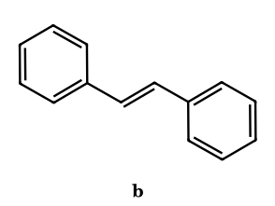
Answer: (a) 2,3-diphenylbutane-2,3-diol (pinacol); (b) (E)-stilbene
(a) ketyl radical anions couple at carbon. (b) Low-valent titanium couples the ketyls to a titanium pinacolate and then deoxygenates it (Ti–O bond formation), giving mainly trans-stilbene.

Part 14 Reaction Intermediates Compared, and Integrated Problems

14.1 The six intermediates at a glance
 | Carbocation | Carbanion | Free radical | Carbene | Nitrene | Benzyne
Species | R₃C⁺ | R₃C⁻ | R₃C• | R₂C: | R–N: | C₆H₄
Valence electrons on the key atom | 6 (sextet) | 8 (octet) | 7 | 6 | 6 | ring carbons octet; extra in-plane bond
Charge | + | − | 0 | 0 | 0 | 0
Hybridisation / shape | sp², planar, 120°; empty p | sp³, pyramidal (planar if delocalised) | sp², planar or shallow pyramid | singlet: sp² bent; triplet: bent or linear | singlet/triplet; one σ bond | sp² carbons, in-plane overlap, strained
Magnetism | diamagnetic | diamagnetic | paramagnetic (1 e⁻) | singlet dia; triplet para (2 e⁻) | singlet dia; triplet para | diamagnetic
Character | electrophile, Lewis acid | nucleophile, base | weakly electrophilic or nucleophilic | electrophile (ambiphilic) | electrophile (ambiphilic) | strong electrophile, dienophile
Formed by | heterolysis (loss of LG), H⁺/E⁺ addition to π bond | deprotonation, metal insertion, decarboxylation | homolysis (Δ, hν, peroxides) | α-elimination, diazo compounds | azides, N-halo/N-sulfonyloxy amides | ArX + NaNH₂, anthranilate, Kobayashi
Stability order | 3° > 2° > 1° > CH₃; benzyl, allyl; aromatic (C₇H₇⁺); +M groups | sp > sp² > sp³; CH₃ > 1° > 2° > 3°; −M, −I; aromatic (C₅H₅⁻) | benzyl ≈ allyl > 3° > 2° > 1° > CH₃ > vinyl | X₂C: with π-donor X (F > Cl > Br > I); NHC | — | —
Rearrangement | 1,2-H, 1,2-alkyl, 1,2-aryl; ring expansion/contraction (to a more stable cation) | rare (1,2-Wittig, Favorskii-type) | 1,2-aryl (neophyl), vinyl, acyl; no H/alkyl shift | 1,2-H, Wolff 1,2-shift | acyl → isocyanate; aryl → azepine | none
Stereochemistry at the centre | racemisation (planar) | racemisation (rapid inversion) | racemisation | singlet: syn, stereospecific; triplet: loses stereochemistry | same as carbene | —
Typical reaction | S_{N}1, E1, Friedel–Crafts, hydration, pinacol | Grignard, aldol, Claisen, E1cB, Michael | halogenation, anti-Markovnikov HBr, polymerisation, Kolbe, Wurtz | cyclopropanation, Reimer–Tiemann, carbylamine, Wolff | Hofmann, Curtius, aziridination | nucleophilic aromatic via aryne, Diels–Alder

14.2 Decision guide: which intermediate does this reaction go through?
Clue in the question | Intermediate
Alkyl halide + Lewis acid or AgNO₃; alcohol + conc. H₂SO₄; alkene + H⁺; ArN₂⁺ on warming | carbocation (and look for a 1,2-shift)
Aldehyde/ketone + base; Grignard; acetylide; soda lime; E1cB; Michael | carbanion
Light, peroxides, high temperature, NBS, AIBN, Kolbe, HBr + peroxide, Cl₂/hν | free radical
CHCl₃ + KOH; CH₂N₂; CH₂I₂/Zn(Cu); Reimer–Tiemann; carbylamine; Wolff | carbene (or carbenoid)
RCONH₂ + Br₂/NaOH; RCON₃ + Δ; azide photolysis; one-carbon-less amine | nitrene / nitrenoid (isocyanate)
Aryl halide + NaNH₂/NH₃; no EWG on ring; mixture of meta and ortho/para products; no reaction if both ortho positions blocked | benzyne

14.3 Integrated problems
IP-1.
Identify the intermediate in each: (a) n-propyl chloride + AlCl₃ (in benzene gives cumene), (b) toluene + NBS/peroxide, (c) chlorobenzene + NaNH₂, (d) CH₃COONa + soda lime, (e) benzamide + Br₂/KOH, (f) CHCl₃ + KOH + aniline.
Answer: (a) carbocation (after a hydride shift); (b) benzylic radical; (c) benzyne; (d) carbanion CH₃⁻; (e) isocyanate via acyl nitrenoid; (f) dichlorocarbene (→ phenyl isocyanide)
Each reagent combination is the textbook signature of the intermediate. (a) The primary cation is not formed; ionisation occurs with a concerted hydride shift to the isopropyl cation (Part 2.E3).
IP-2.
Which of the six intermediates have an incomplete octet on the key atom?
Answer: carbocation (6), carbene (6), nitrene (6) and free radical (7)
The carbanion has 8 electrons; benzyne has a complete octet at each ring carbon (the extra bond is an in-plane partial bond).
IP-3.
Arrange by the number of unpaired electrons (decreasing): triplet carbene, free radical, carbocation, singlet carbene, triplet nitrene.
Answer: triplet carbene = triplet nitrene (2) > free radical (1) > carbocation = singlet carbene (0)
Spin multiplicity 2S + 1: triplet = 3, doublet = 2, singlet = 1.
IP-4.
How many of these species can undergo a 1,2-hydride shift? CH₃CH₂CH₂⁺, CH₃CH₂CH₂•, CH₃CH₂CH₂⁻, CH₃CH₂CH:, CH₃CH₂CH₂N:.
Answer: 3 (cation, carbene, nitrene)
A 1,2-H shift is fast in the cation (to the secondary ion), in the alkylcarbene (CH₃CH₂CH: → propene) and in the alkylnitrene (→ imine). The radical does not undergo 1,2-H shifts and the carbanion does so only under forcing conditions.
IP-5.
Phenol is treated with CHCl₃/NaOH. Name every intermediate in order.
Answer: CCl₃⁻ (carbanion) → :CCl₂ (carbene) → o-dienone carbanion → o-(dichloromethyl)phenoxide → ArCH(OH)₂ → ArCHO
Hydroxide deprotonates CHCl₃ (carbanion) which expels Cl⁻ (carbene); phenoxide attacks the carbene (Part 10.7). Hydrolysis of the benzal chloride gives the aldehyde. So: two carbanions, one carbene.
IP-6.
A compound C₇H₇Br gives a pale yellow precipitate with alcoholic AgNO₃ immediately and, on reaction with NaNH₂, forms no benzyne. Identify it.
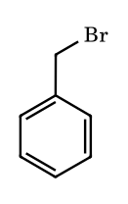
Answer: benzyl bromide
Alcoholic AgNO₃ precipitates AgBr at once through the resonance-stabilised benzyl cation; the bromine is on sp³ carbon so there is no aryne pathway. The isomeric bromotoluenes (aryl bromides) give nothing with AgNO₃ but do react with NaNH₂ via benzyne.
IP-7.
Match: (A) Wurtz reaction, (B) Hofmann bromamide, (C) Kolbe electrolysis, (D) Reimer–Tiemann; with (P) carbene, (Q) free radical, (R) nitrene-type, (S) carbanion.
Answer: A–S,Q; B–R; C–Q; D–P,S
Wurtz: organosodium (carbanion) and radical character; Hofmann: isocyanate formed by a nitrene-type shift; Kolbe: acyloxy and alkyl radicals; Reimer–Tiemann: CCl₃⁻ and :CCl₂.
IP-8.
Toluene can be converted into the benzyl cation, benzyl radical and benzyl anion. Give a reagent for each and say what stabilises all three.
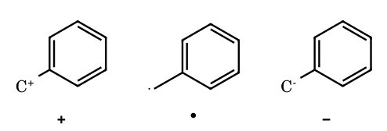
Answer: cation: hydride abstraction (Ph₃C⁺); radical: NBS or Cl₂/hν; anion: n-BuLi/KNH₂
In all three the benzylic p orbital overlaps with the six π electrons of the ring, so the empty orbital (cation), half-filled orbital (radical) or filled orbital (anion) is delocalised onto the ortho and para carbons. Resonance stabilises cations, radicals and anions alike, whereas inductive/hyperconjugative effects stabilise cations and radicals but destabilise anions.
IP-9.
Compare the products and stereochemistry: (a) 1-phenylethyl chloride (R) + SbCl₅, (b) the radical bromination of the corresponding alkane, (c) the Hofmann degradation of (R)-2-phenylpropanamide.
Answer: (a) racemic substitution product (planar cation); (b) racemic bromide (planar radical); (c) retention: (R)-1-phenylethylamine
Carbocation and radical centres are planar, so stereochemical information at that carbon is lost; the 1,2-shift to nitrogen (Hofmann, Curtius) is intramolecular and goes with retention at the migrating carbon.
IP-10.
In which reaction are a carbanion and a carbene formed one after the other?
Answer: CHCl₃ + KOH (α-elimination)
HO⁻ removes the proton to give CCl₃⁻ (carbanion), which expels Cl⁻ from the same carbon to give :CCl₂ (carbene).
IP-11.
Predict the major product and the intermediate: (i) neopentyl alcohol + HBr; (ii) neopentyl radical (from neopentyl bromide, Bu₃SnH).
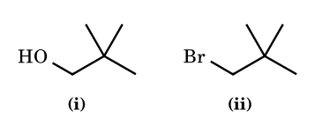
Answer: (i) 2-bromo-2-methylbutane via the t-amyl cation (methyl shift); (ii) neopentane (no rearrangement)
The same carbon skeleton gives a rearranged product through a cation but not through a radical: radicals do not shift methyl groups. This is the cleanest experimental distinction between cationic and radical pathways.
IP-12.
1-Chloro-2,4-dinitrobenzene reacts with NH₃ at room temperature to give 2,4-dinitroaniline only, whereas chlorobenzene needs NaNH₂ in liquid NH₃ and may give regioisomeric products when substituted. Explain.
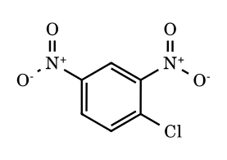
Answer: S_{N}Ar (addition–elimination) vs benzyne (elimination–addition)
The two nitro groups make the ring electron-poor and stabilise the Meisenheimer anion, so the weak nucleophile NH₃ adds directly at the carbon bearing Cl: a single (ipso) product. Chlorobenzene has no such activation; only a base strong enough to remove an ortho H produces benzyne, and the nucleophile then adds at either carbon.

Part 15 Important Orders in General Organic Chemistry: Quick Reference with Reasons
This part collects the orders that GOC questions ask for repeatedly. Each order is followed by the reason, because a ranking that is memorised without its reason fails as soon as the question changes a substituent. pK_{a} values are approximate textbook values in water at 25 °C unless stated, and are meant for ranking. Nucleophilicity comparisons are deliberately left out. Items marked ⚑ differ between sources, so check the convention your paper uses.

15.1 Acid strength
Family | Order (increasing acid strength →) | Reason
Common oxygen/carbon/nitrogen acids | CH₃CH₃ (50) < NH₃ (36) < HC≡CH (25) < ROH (16–18) < H₂O (15.7) < ArOH (10) < H₂CO₃ (6.4) < RCOOH (4–5) < HF (3.2) | stability of the conjugate base: electronegativity of the atom bearing the charge, then resonance. Carboxylate delocalises charge over two O, phenoxide into the ring, alkoxide not at all
Hydrogen halides | HF < HCl < HBr < HI | bond strength falls down the group (H–F 136, H–I 71 kcal mol⁻¹) and the larger anion disperses charge, which outweighs the electronegativity trend
Hybridisation of C–H | alkane (sp³) < alkene (sp²) < alkyne (sp) | carbanion lone pair in an orbital with more s-character is closer to the nucleus and is stabilised (25 / 33 / 50 % s)
Aliphatic acids | CH₃COOH (4.76) < ICH₂COOH (3.17) < BrCH₂COOH (2.90) < ClCH₂COOH (2.86) < FCH₂COOH (2.66) < Cl₂CHCOOH (1.3) < Cl₃CCOOH (0.7) | −I effect of halogen stabilises the carboxylate; it grows with electronegativity and with the number of halogens
Position of Cl | butanoic (4.82) < 4-chloro (4.52) < 3-chloro (4.06) < 2-chloro (2.84) | the inductive effect falls off by roughly a factor of 2–3 per bond
Alkyl group on RCOOH | (CH₃)₃CCOOH (5.03) < CH₃COOH (4.76) < HCOOH (3.75) | +I effect of alkyl destabilises the anion; formic acid has no alkyl. ⚑ solvation of the anion also matters
Benzoic acids | p-OCH₃ (4.47) < p-CH₃ (4.34) < H (4.20) < m-OCH₃ (4.09) < p-Cl (3.98) < m-NO₂ (3.45) ≈ p-NO₂ (3.44) < o-NO₂ (2.17) | p-OMe donates by +M, which outweighs its −I; at the meta position only −I operates (so it is more acidic than benzoic acid). Ortho substituents nearly always increase acidity (the ortho effect: steric twisting of COOH out of the ring plane removes conjugation of the acid form)
Phenols | p-cresol (10.3) < phenol (10.0) < p-chlorophenol (9.4) < m-nitro (8.4) < p-nitro (7.15) ≈ o-nitro (7.2) < 2,4-dinitro (4.1) < picric acid (0.4) | −M and −I groups at ortho/para delocalise the phenoxide charge onto the nitro oxygens; meta can use only −I. Intramolecular H-bond in o-nitrophenol stabilises the acid form and so slightly offsets the effect
Alcohols | solution: t-BuOH (17–18) < i-PrOH (≈ 17) < EtOH (15.9) < H₂O (15.7) < MeOH (15.5)*; gas phase: the order is reversed | *MeOH is slightly more acidic than water by these values (⚑ many JEE keys instead rank H₂O > ROH, so check the convention). In solution small anions are better solvated (hence primary > tertiary); in the gas phase the polarisability of larger alkyl groups stabilises the anion
Carbon acids | CH₃CN (25) < CH₃COCH₃ (19) < CH₂(CO₂Et)₂ (13) < CH₃NO₂ (10) < CH₃COCH₂COCH₃ (9) | number and strength of carbanion-stabilising groups (Part 8)

15.2 Basic strength
Family | Order (increasing basicity →) | Reason
Aliphatic amines in water (pK_{b} trend by pK_{a} of ammonium) | NH₃ (9.25) < (CH₃)₃N (9.8) < CH₃NH₂ (10.6) < (CH₃)₂NH (10.7); ethyl series: EtNH₂ (10.65) < Et₃N (10.75) < Et₂NH (11.0) | +I effect raises electron density on N, but the ammonium ion is stabilised by hydration (N–H···OH₂) and the tertiary ion has only one N–H, so the order in water is not simply 3° > 2° > 1°. ⚑ In the gas phase the order is 3° > 2° > 1° > NH₃
Aromatic amines | p-nitroaniline (1.0) < m-nitroaniline (2.5) < aniline (4.6) < p-toluidine (5.1) < p-anisidine (5.3) | the lone pair of aniline is delocalised into the ring; −M groups at para withdraw it further, +M/+I groups at para release electron density. Ortho substituents (the ortho effect) reduce basicity by steric hindrance to solvation of the ammonium ion
Nitrogen hybridisation | nitrile (sp, ≈ −10) < pyridine/imine (sp², 5.2) < amine (sp³, 10–11) | lone pair in an orbital with more s-character is held more tightly and is less available
Heterocycles and amidines | pyrrole (conjugate acid ≈ −3.8) < aniline (4.6) < pyridine (5.2) < imidazole (7.0) < piperidine (11.1) < guanidine (13.6) | in pyrrole the N lone pair is part of the aromatic sextet; in imidazole the pyridine-type N is protonated and the cation is stabilised by two equivalent resonance forms; guanidinium is a symmetrical, Y-delocalised cation
Amide vs amine | amide (≈ 0, protonates on O) < aryl amine < alkyl amine | the amide N lone pair is delocalised into C=O
Conjugate-base rule | basicity of anions: F⁻ > Cl⁻ > Br⁻ > I⁻; RO⁻ > HO⁻ > ArO⁻ > RCOO⁻ | the weaker the conjugate acid, the stronger the base

15.3 Electronic effects
Effect | Order | Comment
−I (electron-withdrawing) | −NR₃⁺ > −NO₂ > −SO₂R > −CN > −F > −Cl > −Br > −I > −OR > −OH > −C₆H₅ > −CH=CH₂ > H | increases with electronegativity of the attached atom and with s-character (sp > sp² > sp³); the order of −OH vs −OR vs −NH₂ varies by source ⚑
+I (electron-releasing) | −C(CH₃)₃ > −CH(CH₃)₂ > −CH₂CH₃ > −CH₃ > H; −O⁻ > −COO⁻ | more alkyl carbons, more electron release (hyperconjugation adds to this)
+M (resonance donor) | −O⁻ > −NR₂ > −NH₂ > −OR ≈ −OH > −NHCOR > −OCOR > −F > −Cl > −Br > −I | lone-pair donation; poorer overlap for larger halogens (3p–2p) and electronegativity oppose donation
−M (resonance acceptor) | −NO₂ > −CN > −SO₃H > −CHO > −COR > −COOH ≈ −COOR > −CONH₂ | ability to accept π electrons onto an electronegative atom
Hyperconjugation (number of α-H) | CH₃ > CH₂R > CHR₂ > CR₃ | Baker–Nathan order of C–H hyperconjugation; it controls the stability of alkenes and the rate of reactions in non-solvating media

15.4 Reactive intermediates (summary; details in Parts 4, 8, 9)
Species | Order of stability | Reason
Carbocations | tropylium > Ph₃C⁺ > Ph₂CH⁺ > 3° ≈ allyl(2°) > 2° > 1° > CH₃⁺ > vinyl, aryl | delocalisation and hyperconjugation. ⚑ benzyl vs t-butyl depends on phase and source
Carbanions | CH₃⁻ < 1° < 2° < 3° (stability falls as alkyl groups are added); vinyl < alkynyl; allyl < benzyl < Ph₃C⁻ < Cp⁻ | s-character, resonance, aromaticity; +I destabilises
Free radicals | CH₃• < 1° < 2° < 3° < allyl ≈ benzyl < Ph₃C• | bond dissociation energy of the C–H; both donors and acceptors stabilise

15.5 Substitution, elimination and leaving groups (substrate and leaving-group orders only)
Topic | Order | Reason
S_{N}1 rate by substrate | CH₃X < 1° < 2° < 3°; allyl and benzyl X are fast | stability of the carbocation
S_{N}2 rate by substrate | 3° < 2° < 1° < CH₃; neopentyl is very slow | steric hindrance to back-side attack
E2/E1 alkene product | Zaitsev: the more substituted alkene predominates; bulky bases (t-BuOK) give the Hofmann (less substituted) product | alkene stability versus steric access to the proton
Leaving group | HO⁻ < F⁻ < Cl⁻ < Br⁻ < I⁻ ≈ TsO⁻; H₂O (from ROH₂⁺) is a good neutral leaving group; poor: HO⁻, RO⁻, NH₂⁻, H⁻ | weak bases that are stable as anions leave best; weaker C–X bond (C–I 57, C–Cl 85 kcal mol⁻¹)
Dehydration of alcohols (acid) | 1° < 2° < 3° | carbocation stability in the E1 pathway
Ease of hydrohalogenation of alkenes | ethene < propene < 2-methylpropene < 2,3-dimethylbut-2-ene | stability of the carbocation formed

15.6 Reactivity of carbonyl compounds and derivatives
Topic | Order | Reason
Towards nucleophilic addition | HCHO > RCHO > ArCHO > RCOR′ > ArCOR > ArCOAr | less steric hindrance and less electron donation at C=O; aryl groups conjugate and reduce electrophilicity
Hydrate stability | Cl₃CCHO (chloral hydrate is isolable) > HCHO (≈ 99.9 % hydrated) > CH₃CHO (≈ 58 %) > (CH₃)₂CO (≈ 0.1 %) | EWG destabilise C=O; alkyl groups stabilise it and add steric strain on hydration
Acid derivatives, nucleophilic acyl substitution | RCOCl > (RCO)₂O > RCOOR′ ≈ RCOOH > RCONH₂ > RCOO⁻ | electrophilicity of C=O and leaving-group ability (Cl⁻ > RCOO⁻ > RO⁻ > NH₂⁻); lone-pair donation into C=O lowers reactivity
Resonance stabilisation of acid derivatives | RCOCl < (RCO)₂O < RCOOR′ < RCONH₂ | better donation of the heteroatom lone pair (N > O > Cl)
α-H acidity | RCHO (17) > R₂CO (19–20) > RCOOR (25) > RCONR₂ (30) | ability of the carbonyl to accept the negative charge

15.7 Aromatic substitution and alkene stability
Topic | Order | Reason
Rate of electrophilic aromatic substitution | −NH₂ ≈ −O⁻ > −OH > −OCH₃ > −NHCOCH₃ > −CH₃ > H > −Cl > −CHO ≈ −COR > −CN > −NO₂ > −NR₃⁺ | electron donors stabilise the arenium ion; acceptors destabilise it. Halogens deactivate (−I) but direct ortho/para (+M)
Directing effect | o/p-directors: all +M/+I groups and halogens; m-directors: all −M groups and −NR₃⁺ | which arenium ion has charge placed next to the substituent
Alkene stability (heat of hydrogenation, kcal mol⁻¹) | 1-butene (30.3) < cis-2-butene (28.6) ≈ 2-methylpropene (28.4) < trans-2-butene (27.6) < trisubstituted (26.9) < tetrasubstituted (26.6) (stability increases →) | more alkyl groups on the C=C (hyperconjugation, sp²–sp³ bonds) and trans over cis (less steric strain)
Stability of conjugated dienes | isolated < conjugated < (cumulated is least stable) | conjugation stabilises by ≈ 3.5 kcal mol⁻¹
Resonance energy (kcal mol⁻¹) | benzene (36) > naphthalene (61 total; 30.5 per ring) ; furan (16) < pyrrole (21) < thiophene (29) < benzene (36) | aromatic stabilisation falls as the heteroatom is more electronegative and holds its lone pair more tightly
Common errors. (1) Treating the +I order of amines in water as 3° > 2° > 1°: hydration changes it. (2) Forgetting that p-methoxybenzoic acid is weaker than benzoic acid while the meta isomer is stronger. (3) Reading −M as always stronger than −I for acidity: for halogens, −I dominates. (4) Applying the carbocation order to carbanions (it reverses). (5) Using one phase (gas) order for a question set in solution.

15.8 Problems on orders
OR-1.
Arrange in increasing acid strength: ClCH₂COOH, CH₃COOH, FCH₂COOH, Cl₂CHCOOH, Cl₃CCOOH.
Answer: CH₃COOH < ClCH₂COOH < FCH₂COOH < Cl₂CHCOOH < Cl₃CCOOH
pK_{a} 4.76, 2.86, 2.66, 1.3, 0.7: −I effect rises with electronegativity (F > Cl) and with the number of Cl.
OR-2.
Arrange in increasing acidity: p-cresol, phenol, m-nitrophenol, p-nitrophenol, 2,4-dinitrophenol.
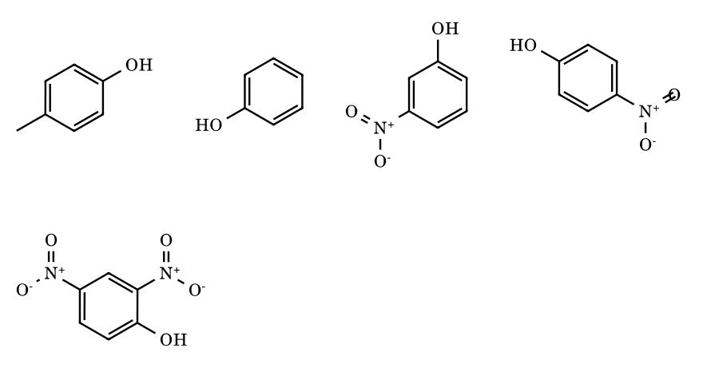
Answer: p-cresol < phenol < m-nitrophenol < p-nitrophenol < 2,4-dinitrophenol
pK_{a} 10.3, 10.0, 8.4, 7.15, 4.1. Methyl donates; nitro at para or ortho withdraws by −M and −I; at meta only by −I; two nitro groups act cumulatively.
OR-3.
Arrange in increasing acidity: p-methoxybenzoic acid, p-toluic acid, benzoic acid, m-methoxybenzoic acid, p-nitrobenzoic acid.
Answer: p-OMe < p-CH₃ < benzoic < m-OMe < p-NO₂
pK_{a} 4.47, 4.34, 4.20, 4.09, 3.44. +M of p-OMe outweighs −I; at meta only −I acts, so the meta isomer is more acidic than benzoic acid.
OR-4.
Arrange in increasing basicity in water: aniline, NH₃, (CH₃)₃N, CH₃NH₂, (CH₃)₂NH.
Answer: aniline < NH₃ < (CH₃)₃N < CH₃NH₂ < (CH₃)₂NH
pK_{a} of the ammonium: 4.6, 9.25, 9.8, 10.6, 10.7. Alkyl groups increase basicity by +I, but solvation of the ammonium ion makes 3° less basic than 2° and 1° in water.
OR-5.
Arrange in increasing basicity: pyrrole, aniline, pyridine, imidazole, piperidine.
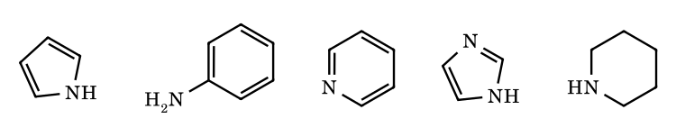
Answer: pyrrole < aniline < pyridine < imidazole < piperidine
Conjugate-acid pK_{a} ≈ −3.8, 4.6, 5.2, 7.0, 11.1. In pyrrole the lone pair belongs to the aromatic sextet; in aniline it is delocalised; pyridine N is sp²; imidazolium has two equivalent resonance forms; piperidine N is sp³ and localised.
OR-6.
Why is methanol a stronger acid than tert-butanol in solution but the order is reversed in the gas phase?
Answer: solvation of the smaller anion versus polarisability of the larger alkyl groups
In solution CH₃O⁻ is the best solvated alkoxide and tert-butoxide, with bulky alkyl groups, the worst. In the gas phase there is no solvent, and the polarisable tert-butyl group stabilises the charge better.
OR-7.
Arrange in increasing reactivity towards nucleophilic acyl substitution: CH₃CONH₂, CH₃COOCH₃, (CH₃CO)₂O, CH₃COCl.
Answer: amide < ester < anhydride < acid chloride
Reactivity follows leaving-group ability (Cl⁻ > RCOO⁻ > RO⁻ > NH₂⁻) and weaker lone-pair donation into C=O (Cl < O < N).
OR-8.
Arrange in increasing reactivity towards HCN addition: acetone, acetaldehyde, formaldehyde, benzaldehyde, acetophenone.
Answer: acetophenone < acetone < benzaldehyde < acetaldehyde < formaldehyde
Two alkyl/aryl groups hinder and donate electrons; aryl conjugation lowers C=O electrophilicity (so benzaldehyde is less reactive than acetaldehyde); formaldehyde has no donating group. ⚑ benzaldehyde and acetone are close in some sources.
OR-9.
Arrange in increasing rate of electrophilic nitration: nitrobenzene, chlorobenzene, benzene, toluene, anisole.
Answer: nitrobenzene < chlorobenzene < benzene < toluene < anisole
−M/−I deactivation (NO₂) is strongest; Cl deactivates by −I though it directs o/p; CH₃ activates by +I and hyperconjugation; OCH₃ activates strongly by +M.
OR-10.
Arrange in decreasing stability: 1-butene, cis-2-butene, trans-2-butene, 2-methylbut-2-ene, 2,3-dimethylbut-2-ene.
Answer: 2,3-dimethylbut-2-ene > 2-methylbut-2-ene > trans-2-butene > cis-2-butene > 1-butene
Heats of hydrogenation 26.6, 26.9, 27.6, 28.6, 30.3 kcal mol⁻¹: more alkyl substituents on C=C, and trans over cis.
OR-11.
Arrange in decreasing order of the –I effect: –NO₂, –F, –CN, –Br, –OCH₃, –C₆H₅.
Answer: –NO₂ > –CN > –F > –Br > –OCH₃ > –C₆H₅
Charged or multiply bonded electronegative groups and sp-carbon (CN) withdraw more strongly than single-bonded halogens, then oxygen; phenyl is weakly withdrawing (sp² carbon).
OR-12.
Arrange in increasing leaving-group ability: HO⁻, F⁻, Cl⁻, Br⁻, I⁻. Why is CH₃OH₂⁺ a better substrate for substitution than CH₃OH?
Answer: HO⁻ < F⁻ < Cl⁻ < Br⁻ < I⁻; protonation turns HO⁻ into neutral H₂O
A good leaving group is the conjugate base of a strong acid (HI ≫ HCl ≫ HF ≫ H₂O). Protonation converts the very poor leaving group HO⁻ into H₂O, a stable neutral molecule.
OR-13.
Arrange in increasing S_{N}2 and, separately, in increasing S_{N}1 reactivity: CH₃Br, CH₃CH₂Br, (CH₃)₂CHBr, (CH₃)₃CBr.
Answer: S_{N}2: (CH₃)₃CBr < (CH₃)₂CHBr < CH₃CH₂Br < CH₃Br; S_{N}1: the reverse (CH₃Br < 1° < 2° < 3°)
S_{N}2 is controlled by steric hindrance to back-side attack; S_{N}1 by carbocation stability.
OR-14.
Why is p-nitroaniline a weaker base than m-nitroaniline, and why is aniline a weaker base than cyclohexylamine?
Answer: −M at para delocalises the lone pair more; aryl N lone pair is delocalised into the ring
At the para position NO₂ withdraws electron density from the N lone pair by both −M and −I (pK_{a} 1.0), at meta only by −I (2.5). In aniline the lone pair conjugates with the ring (4.6), whereas in cyclohexylamine it is localised and the +I effect of the ring raises basicity (10.6).
OR-15.
(Integer) How many of these are stronger acids than benzoic acid (pK_{a} 4.20): p-nitrobenzoic acid, m-methoxybenzoic acid, p-methoxybenzoic acid, o-nitrobenzoic acid, p-toluic acid, p-chlorobenzoic acid?
Answer: 4
p-NO₂ (3.44), m-OMe (4.09), o-NO₂ (2.17) and p-Cl (3.98) are stronger; p-OMe (4.47) and p-CH₃ (4.34) are weaker.

Answers Part 3 — Leaving-Group Problems: Answers and Explanations
LG1.
Answer: D > C > B > A
Rate-limiting heterolysis of C–X. Bond strength (C–I 57 ≪ C–F 110 kcal mol⁻¹), polarisability and conjugate-acid strength (HI −10, HBr −9, HCl −7, HF +3.2) all point the same way. Solvation of F⁻ by hydrogen bonding is the strongest of the four but cannot make up for the C–F bond: t-BuF is usually considered inert to neutral solvolysis. The three heavier halides differ only by modest factors (a few-fold between I and Br; tens between Br and Cl) because the TS is highly ionic and the solvent levels the differences.
LG2.
Answer: A > B > C > D
Leaving-group quality follows conjugate-acid strength: CF₃SO₃H (≈ −14) ≫ TsOH (≈ −2.8) ≫ CH₃CO₂H (4.76) ≫ H₂O (15.7). Triflates ionise ≈ 10⁴–10⁸ times faster than tosylates depending on substrate; acetates are practically inert under these conditions, and the alcohol D does not ionise at all (HO⁻ is not a leaving group without protonation). A secondary substrate is chosen so that all three active derivatives react by borderline S_{N}1/S_{N}2 with solvent assistance; the order is the same for either.
LG3.
Answer: A > B > C > D
N₂ is a vastly better leaving group than anything else (a very stable, non-basic molecule; ionisation of an alkyl diazonium is practically barrierless). H₂O leaves from the protonated alcohol readily at 25 °C in acid (conjugate acid H₃O⁺, pK_{a} −1.7). NH₃ is a much stronger base (NH₄⁺ pK_{a} 9.25), so the t-butylammonium ion is stable at room temperature and needs heat or very strong acid to lose NH₃. Hydroxide in D is the worst: C–OH ionisation does not occur without protonation (D is therefore last, essentially inert).
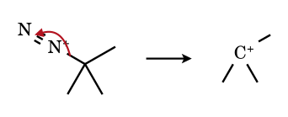
LG4.
Answer: C > D > B > A
Carboxylate leaving groups follow the pK_{a} of the parent acid: CF₃CO₂H 0.5 < p-O₂NC₆H₄CO₂H 3.44 < C₆H₅CO₂H 4.20 < CH₃CO₂H 4.76. The same trend is the basis of the classical use of p-nitrobenzoates as ‘better’ leaving groups than acetates in mechanistic work on tertiary benzylic systems. Resonance donation within the ester (which strengthens the C–O bond) is similar for all four and cancels.
LG5.
Answer: A > B > C
In SNAr the rate-determining step is addition of the nucleophile to give the anionic Meisenheimer complex; C–X cleavage comes afterwards (fast). Fluorine, the most electronegative halogen, lowers the energy of the first TS by induction and polarises C–X; the C–F bond strength is irrelevant to the rate. Hence the ‘element effect’ F ≫ Cl ≳ Br > I, the reverse of S_{N}2 – a decisive demonstration that leaving-group ability is mechanism-dependent. (Cl and Br are close; iodine is slowest.)
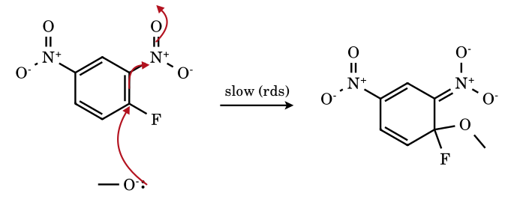
LG6.
Answer: D > C > B > A
The poorer the leaving group, the less C–LG bond cleavage has occurred in the E2 transition state; the TS becomes carbanion-like (E1cB-like) and the base removes the more acidic, more accessible hydrogen from the CH₃ group, giving the Hofmann alkene. Literature trend for 2-pentyl X with ethoxide: I < Br (≈ 30 %) ≲ Cl (≈ 33 %) < F (≈ 70 %) < NMe₃⁺ (≈ 95 % 1-pentene); I and Br differ only slightly. Here LG ability controls selectivity, not only rate.
LG7.
Answer: A > B > C > D > E
Y (recalled values): H₂O 3.49 > HCO₂H 2.05 > CF₃CH₂OH 1.15 > CH₃OH −1.09 > C₂H₅OH −2.03. Ionising power combines hydrogen-bond donation to the departing chloride (high for water, HCO₂H, fluorinated alcohols) with dielectric screening and low nucleophilicity. TFE is a poor nucleophile yet an excellent ionising medium, so S_{N}1 reactions of secondary substrates are favoured there; a leaving group’s ‘ability’ is therefore also a property of the solvent.
LG8.
Answer: A > C > B
E2 needs the C–H and C–Br bonds anti-periplanar, which on a chair means both axial. In the cis isomer (A) the Br is axial (the locked t-Bu is equatorial), so reaction is fast. In the trans isomer (B) Br is equatorial, no anti-periplanar H exists, the ring would have to flip into the diaxial-t-Bu chair, and E2 is slow (substitution/E1 intrude). Bromocyclohexane (C) populates the axial conformer to a modest extent (≈ 30 %), so its rate lies between. The axial/equatorial labels refer to chairs, which these flat drawings cannot show; wedge/dash give the relative (cis/trans) configuration.
LG9.
Answer: A > B > C > D
The rate follows both the leaving-group stability (Cl⁻, pK_{a}(HCl) −7; CH₃CO₂⁻ 4.76; EtO⁻ 16; NH₂⁻ 38) and the ability of the substituent to donate into C=O (N ≫ O > Cl). The tetrahedral intermediate expels the best leaving group; amides, with strong n(N) → π*(C=O) donation and a very poor LG, are the least reactive. Contrast with S_{N}1/S_{N}2 at sp³ carbon, where resonance donation is irrelevant.
LG10.
Answer: A > B > C
Trimethyloxonium (Meerwein) salts are among the strongest methylating agents; trimethylsulfonium is a weak methylating agent (it needs warming), and tetramethylammonium is inert. The leaving groups are Me₂O, Me₂S and Me₃N. Basicity (pK_{aH} of Me₃N 9.8 ≫ Me₂O ≈ −3.8, Me₂S ≈ −6 to −7) explains why ammonium is last, but not why oxonium beats sulfonium: sulfur is the weaker base. Here the intrinsic C–X⁺ bond strength and the charge density at the cationic centre dominate – a clear failure of a pure pK_{a} rule. (Experimental trend: O⁺ ≫ S⁺ ≫ N⁺.)
LG11.
Answer: A > B > C > D
Ag⁺ coordinates the halogen lone pair and ‘pulls’ the bromide off (halophilic assistance); the substrate then ionises. The ease of forming the cation is 3° ≫ 2° > 1° (t-Bu⁺ ≫ i-Pr⁺ ≫ n-Bu⁺); the n-butyl bromide reacts only slowly (a partial S_{N}2-like displacement by solvent) and bromobenzene (an sp² aryl cation would be needed) gives no precipitate. Same leaving group, different cation – the LG is only as good as the cation it can generate.
LG12.
Answer: A > B > C
β-Silicon effect: a C–Si σ bond is an excellent hyperconjugative donor (σ_{C–Si} is higher in energy than σ_{C–C}/σ_{C–H}) and stabilises a β cation by σ→p donation (a bridged, silicon-stabilised cation). The overlap is best when C–Si and C–OTs are anti-periplanar, which the trans isomer reaches in the diaxial chair (A: very large acceleration, ≈ 10¹² in rigid models). The cis isomer (B) has them gauche (synclinal) only: still accelerated (≈ 10⁴ in rigid models) but far less. Cyclohexyl tosylate (C) has no silicon. (Orders of magnitude quoted from Lambert’s work, recalled.)
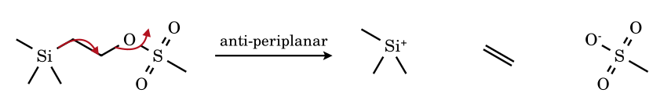
LG13.
Answer: A > B > C > D
The aryl ring attacks the carbon carrying OTs from the rear, forming a bridged phenonium (spiro-cyclohexadienyl) ion; the rate rises with the electron-donating power of the para substituent (σ⁺: OMe −0.78, Me −0.31, H 0, NO₂ +0.79). The p-nitro compound cannot use the ring and reacts by the slower, unassisted S_{N}2-like route (k_{s}). The ‘leaving group’ is identical (TsO⁻) in all four; the substituent changes how effectively it is displaced.
LG14.
Answer: A > B > C > D
The leaving group is the protonated oxygen (an alcohol or ether oxygen that becomes neutral on C–O cleavage), and the driving force is the release of ring strain: oxirane (≈ 27 kcal mol⁻¹) and oxetane (≈ 25) are strained; oxolane (THF, ≈ 6) is slightly strained; oxane (THP, ≈ 0.5) is not. Epoxides react far faster than oxetanes despite similar strain energies because the TS gains from poorer C–O–C orbital overlap (bent bonds) in the three-membered ring; THF is cleaved only under more forcing conditions, THP hardly at all.
LG15.
Answer: A > B > C > D
The sulfonate anion is stabilised by electron-withdrawing substituents (lower pK_{a} of ArSO₃H), so the leaving-group ability follows the Hammett σ constants: NO₂ (σ_{p} +0.78) > Br (+0.23) > CH₃ (−0.17) > OCH₃ (−0.27); ρ for the leaving group is positive and modest. Brosylates and nosylates are therefore used when tosylates are too unreactive; mesylates are comparable to tosylates.

Answers Part 7.1 — Counting Problems: Answers and Explanations
R1.
Answer: 5 (a, d, e, h, j)
Item | ? | Reason
a n-butyl | Yes | primary; 1,2-H shift → 2-butyl (secondary)
b isopropyl | No | H or CH₃ shift would give a primary cation, or a degenerate secondary one
c tert-butyl | No | any shift gives a primary cation
d 3,3-dimethylbut-2-yl | Yes | 1,2-CH₃ shift → tertiary 2,3-dimethylbut-2-yl
e neopentyl | Yes | 1,2-CH₃ shift → tertiary tert-amyl
f cyclohexyl | No | H shift gives another secondary ring cation (degenerate); the ring does not strain-relieve
g 1-methylcyclohexyl | No | tertiary; shifts lead to less stable ions
h cyclobutylmethyl | Yes | ring expansion → cyclopentyl (secondary, strain relief), or H shift → 1-methylcyclobutyl (tertiary)
i benzyl | No | resonance-stabilised; a shift would give an unstabilised ion
j 2-methylcyclohexyl | Yes | 1,2-H shift from the ring C–H bearing CH₃ → tertiary 1-methylcyclohexyl
R2.
Answer: 4 (a, b, d, e)
Item | ? | Reason
a cyclobutylmethyl | Yes | ring C–C bond migrates to the CH₂⁺: 4 → 5 ring, primary → secondary
b 1-cyclobutylethyl | Yes | ring bond migrates to the exocyclic cationic carbon: 2-methylcyclopentyl (secondary, ring strain relieved)
c cyclopentyl | No | the cation is in the ring; no exocyclic carbon to take a ring bond
d (1-methylcyclobutyl)methyl | Yes | ring bond migrates → 1-methylcyclopentyl, a tertiary cation with relief of strain (much better than the methyl-shift alternative)
e (1-methylcyclopentyl)methyl | Yes | ring bond migrates → 1-methylcyclohexyl (tertiary, strain-free); the competing methyl shift gives 1-ethylcyclopentyl (also tertiary), so ring expansion is the thermodynamic choice
f 1-methylcyclohexyl | No | tertiary cation on the ring: expansion impossible
g cyclobutyl | No | cation is in the ring (it can ring-contract to cyclopropylcarbinyl, the reverse)
h neopentyl | No | no ring: methyl shift is a rearrangement but not a ring expansion
R3.
Answer: (i) 2 (ii) 1
Shifts available: H from C-3 → 2-methylbut-2-yl, tertiary (more stable); CH₃ from C-3 → regenerates a 3-methylbutan-2-yl cation (degenerate, not a new ion); H from the CH₃ on C-2 → 3-methylbutyl, primary (less stable). Distinct new cations: tertiary and primary = 2; more stable: only the tertiary = 1. (Hydride shift is the productive path, reached through a three-centre transition state with σ(C–H) → p overlap.)
R4.
Answer: 2
Step 1: 1,2-hydride shift from the CH₂ next to the quaternary carbon → 3,3-dimethylbut-2-yl (secondary). Step 2: 1,2-methyl shift from the quaternary carbon → 2,3-dimethylbut-2-yl (tertiary, the most stable ion in this manifold). A direct primary → tertiary shift is impossible because the tertiary centre is two bonds away. (The same cation is the one formed from 3,3-dimethylbutan-2-ol; see R5.)
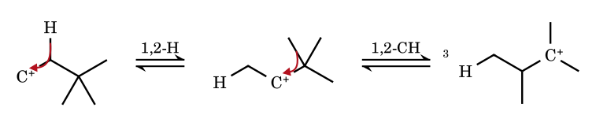
R5.
Answer: 3
Unrearranged secondary cation (3,3-dimethylbut-2-yl): loses H⁺ only from CH₃ (the other neighbour is quaternary) → 3,3-dimethylbut-1-ene (minor). After the 1,2-CH₃ shift the tertiary 2,3-dimethylbut-2-yl cation loses H⁺ from the CH (→ 2,3-dimethylbut-2-ene, tetrasubstituted, major) or from a CH₃ (→ 2,3-dimethylbut-1-ene). Total 3; the Zaitsev (2,3-dimethylbut-2-ene) dominates.
R6.
Answer: 4 (a, d, e, h)
Item | ? | Reason
a n-propylamine | Yes | R–N₂⁺ loses N₂ (with 1,2-H shift) → n-propyl/isopropyl cation; mixture of propanols, propene, chloropropanes
b aniline | No | ArN₂⁺ Cl⁻ is stable at 0–5 °C (resonance, sp² C–N); the aryl cation forms only on warming
c dimethylamine | No | secondary amine → N-nitrosodimethylamine, Me₂N–N=O
d tert-butylamine | Yes | t-Bu–N₂⁺ → tert-butyl cation
e benzylamine | Yes | PhCH₂N₂⁺ → benzyl cation
f trimethylamine | No | tertiary amine: only the ammonium nitrite salt; no diazonium
g N-methylaniline | No | secondary arylamine → N-nitroso-N-methylaniline
h cyclohexylamine | Yes | c-C₆H₁₁N₂⁺ → cyclohexyl cation (and cyclohexene, cyclohexanol, ring-contracted products)
R7.
Answer: 4 (c, d, f, g)
Item | ? | Reason
a butan-1-ol | No | primary, unbranched: S_{N}2 → 1-bromobutane
b butan-2-ol | No | secondary cation (S_{N}1/S_{N}2 mixture); a shift would give a primary or an identical secondary ion
c 3-methylbutan-2-ol | Yes | H shift → tertiary → 2-bromo-2-methylbutane
d neopentyl alcohol | Yes | concerted CH₃ shift → 2-bromo-2-methylbutane
e tert-butyl alcohol | No | tertiary cation
f 3,3-dimethylbutan-2-ol | Yes | CH₃ shift → tertiary → 2-bromo-2,3-dimethylbutane
g cyclobutylmethanol | Yes | ring expansion / rearrangement → bromocyclopentane and 1-bromo-1-methylcyclobutane type products
h cyclohexanol | No | secondary ring cation; H shift is degenerate
R8.
Answer: 4 (a, b, e, g)
Item | ? | Reason
a 1-chloropropane | Yes | H shift in the R–Cl···AlCl₃ complex → isopropylbenzene (cumene)
b 1-chloro-2-methylpropane | Yes | H shift → tert-butyl → tert-butylbenzene
c chloroethane | No | no more stable cation reachable (ethyl is the only possibility)
d tert-butyl chloride | No | tertiary cation, no shift
e 1-chloro-2,2-dimethylpropane | Yes | CH₃ shift → tert-amyl → (2-methylbutan-2-yl)benzene
f benzyl chloride | No | benzylic cation; gives diphenylmethane without rearrangement
g 1-chlorobutane | Yes | H shift → sec-butyl → sec-butylbenzene as the major component (n-butylbenzene is also formed; the ratio depends on temperature, roughly 2 : 1 in favour of sec-butyl at 0 °C – recalled value)
h 2-chlorobutane | No | secondary → secondary: the same sec-butyl product

