3. Cryptography & Security Primitives
SynQ embeds post‑quantum cryptography (PQC) directly into the language. Contracts can work with PQC keys and signatures without relying on off‑chain libraries. This section details the supported algorithms, their types, verification functions, batch operations, gas model, and underlying security assumptions.

3.1 Post‑Quantum Algorithm Overview
SynQ currently supports three families of PQC algorithms:
- Dilithium – a lattice‑based digital signature scheme standardised by NIST. Variants include Dilithium2 (level 2), Dilithium3 (level 3), and Dilithium5 (level 5). Higher levels offer greater security at the cost of larger keys and signatures.
- Falcon – an NTRU lattice‑based signature scheme offering compact signatures. Supported parameter sets include Falcon512 and Falcon1024.
- Kyber – a module‑lattice KEM used for encrypted message passing and sealed votes. Parameter sets Kyber512 and Kyber768 determine the security level.
PQC algorithms rely on hard lattice problems that are believed to resist quantum attacks. SynQ leaves open the possibility of integrating additional schemes (e.g., SPHINCS+) via governance (§3.8).

3.2 Key Types & Sizes
Scheme | Key Type | Public Key Size | Signature Size | Notes
Dilithium2 | DilithiumPublicKey<2> | ~1.3 KB | ~2.4 KB | Moderate security, balanced performance.
Dilithium3 | DilithiumPublicKey<3> | ~1.8 KB | ~3.2 KB | Higher security, used for governance keys.
Dilithium5 | DilithiumPublicKey<5> | ~2.9 KB | ~4.5 KB | Maximal security, expensive verification.
Falcon512 | FalconPublicKey<512> | ~897 B | ~666 B | Compact signature, higher verify cost.
Falcon1024 | FalconPublicKey<1024> | ~1.7 KB | ~1.3 KB | Higher security, used for high‑value assets.
Kyber512 | KyberPublicKey<512> | ~800 B | – | KEM only; ciphertext ~768 B.
Kyber768 | KyberPublicKey<768> | ~1.18 KB | – | KEM only; ciphertext ~1.08 KB.
Levels <L> and <N> are encoded in the type names and compile‑time constants. Developers must choose the level appropriate for their security and performance needs.

3.3 Signature Verification Functions
SynQ exposes built‑in functions for verifying signatures. Verification is deterministic and returns a boolean. Gas costs are proportional to the size and complexity of the operation (§3.6).
// Dilithium verification
function verify_dilithium<L>(msg: Bytes, sig: DilithiumSignature<L>, pk: DilithiumPublicKey<L>) -> Bool;
// Falcon verification
function verify_falcon<N>(msg: Bytes, sig: FalconSignature<N>, pk: FalconPublicKey<N>) -> Bool;
// Composite signature verification
function verify_composite_auth<L,N>(msg: Bytes, d_sig: DilithiumSignature<L>, f_sig: FalconSignature<N>, auth: PQAuth) -> Bool;
The verify_composite_auth function verifies a pair of signatures against the corresponding keys contained within a PQAuth structure. This is useful for multi‑signature authentication where different algorithms must be combined.

3.4 Key Encapsulation Mechanism (Kyber)
Kyber enables parties to derive a shared secret without exposing their private keys. SynQ exposes both encapsulation and decapsulation operations:
function kyber_encapsulate<K>(pk: KyberPublicKey<K>) -> (KyberCiphertext<K>, Bytes);
function kyber_decapsulate<K>(ct: KyberCiphertext<K>, sk: KyberKeyPair<K>) -> Bytes;
The kyber_encapsulate function returns a ciphertext and a shared secret. The ciphertext is sent to the counterparty, who then calls kyber_decapsulate with their secret key to recover the shared secret. Gas costs reflect the work done (§3.6). Kyber is frequently used for sealed votes (§10.3) and privacy‑preserving channels.

3.5 Hybrid & Composite Signatures
Some protocols require the combination of multiple PQC schemes. For example, a high‑value transaction might require both a Dilithium and a Falcon signature to guard against future algorithmic breakthroughs. SynQ defines a PQAuth struct:
struct PQAuth {
dilithium_key: DilithiumPublicKey<3>;
falcon_key: FalconPublicKey<1024>;
}
The verify_composite_auth function accepts both signatures and the PQAuth structure. Composite verification charges the sum of the gas costs for each constituent verification. Composite signatures are used extensively in the QuantumDAO example (§10.2).

3.6 Gas Model for PQC Operations
Because PQC algorithms are computationally intensive, SynQ introduces a fine‑grained gas model. Each PQC operation consumes gas according to the formula:
$$extTotalGas=extBaseCost+extDataCost+extComputeCost$$
- BaseCost: fixed overhead for dispatching the precompile. Larger for higher security levels.
- DataCost: proportional to the size of the inputs (message, key, signature).
- ComputeCost: determined by benchmarking the algorithm on reference hardware.
The table below summarises typical costs (values are illustrative and subject to governance):
Operation | Level | BaseCost | DataCost | ComputeCost | Total
verify_dilithium | 2 | 5,000 | 6,000 | 14,000 | 25,000
 | 3 | 6,000 | 9,000 | 20,000 | 35,000
 | 5 | 7,000 | 13,000 | 30,000 | 50,000
verify_falcon | 512 | 4,000 | 6,000 | 10,000 | 20,000
 | 1024 | 6,000 | 9,000 | 15,000 | 30,000
kyber_encapsulate | 768 | 5,000 | 5,000 | 15,000 | 25,000
kyber_decapsulate | 768 | 5,000 | 6,000 | 14,000 | 25,000
dilithium_keygen | 3 | 5,000 | 0 | 20,000 | 25,000
Figure 3‑1 plots the relative gas cost of verifying Dilithium, Falcon, and Kyber operations at different parameter levels. The curve illustrates the trade‑off between security and cost.
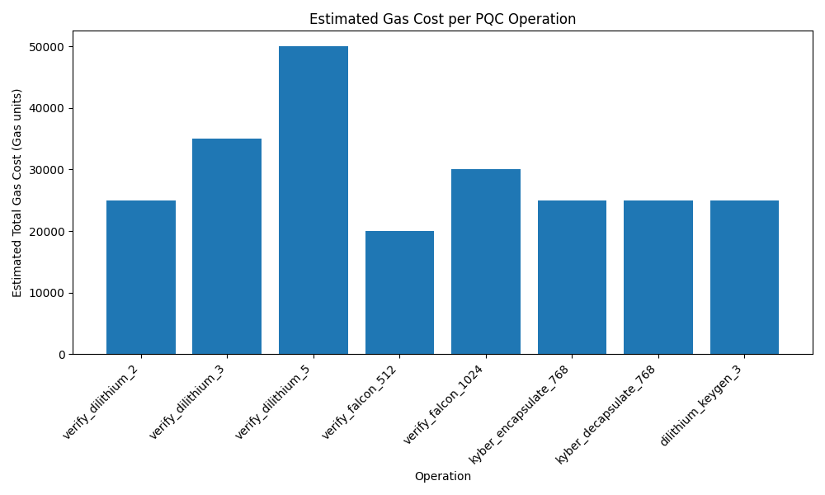
Gas cost comparison for PQC operations
The gas schedule is encoded in the genesis block and may be updated via governance (§6.8). Transactions that exceed the per‑operation or per‑transaction PQC gas limit (max_pqc_gas_per_tx) will revert.

3.7 Security Assumptions and Threat Model
SynQ assumes the hardness of lattice problems such as Learning With Errors (LWE) and NTRU. Adversaries are computationally bounded but may possess quantum computers. The following security assumptions apply:
- Existential unforgeability: It is infeasible to forge a valid Dilithium or Falcon signature without knowledge of the private key.
- IND‑CCA security: Kyber provides indistinguishability under chosen ciphertext attack; encapsulated secrets cannot be learned without the private key.
- Random oracle model: Hash functions (SHA3‑256, BLAKE3) behave as random oracles. Addresses are derived via hashing of public keys.
- Batch soundness: Batch verification precompiles compute a vector of booleans indicating success for each element. Adversaries cannot craft a batch where one invalid signature causes another to be incorrectly marked valid.
SynQ does not assume any specific network synchrony for cryptographic security. Liveness and consensus properties are handled at the protocol layer (see the PoSy spec). The gas model prevents denial‑of‑service by making PQC operations cost‑reflective.

3.8 PQC Agility and Upgradability
Cryptography evolves. Should vulnerabilities be discovered in Dilithium, Falcon, or Kyber, SynQ allows the community to upgrade to new schemes. Upgrades follow these steps:
- Research & Benchmarking: Candidate algorithms (e.g., SPHINCS+) are studied for security and performance.
- Governance Proposal: A formal proposal specifies the new types, precompile interfaces, and gas costs.
- VM Upgrade: The new precompiles are added, and wallet software updates to support new key pairs.
- Grace Period: Old schemes remain supported for a transition period. Contracts may verify both old and new signatures via composite authentication (§3.5).
This agility ensures that SynQ remains secure in the face of future cryptanalytic advances while maintaining backward compatibility.

