**EXERCISES – FRONTEND TRAINING**

**Exercise 01 – Customer Registration Form for Online Books Library (HTML, CSS & JavaScript)**

Your task is to design the form elements used to create the form shown in Figure 1.

***Figure 1. A simple form web page***

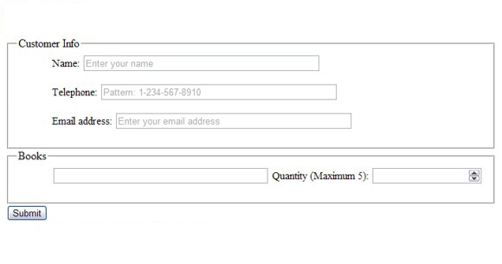

In addition to looking like the form shown in Figure 1, your form must include the constructs listed in the following instructions. When creating the code for your form, you must use the HTML5 tags that are appropriate to replicate the form and fulfill all the specifications listed.

1. Code the form with autocomplete active.
2. Given the image shown in Figure 1, it is easy to see that two field sets are used to create the main structure of the form. Your task is to create the field sets, including the names **Customer Info** and **Books**.
3. The **Name** field you create should have *autofocus*, placeholder text and be required.
4. The **Telephone** field should have placeholder text, a pattern to restrict entry, and be required.
5. The **Email** address field should have placeholder text and allow multiple entries. This field should also be required.
6. The **Books** field should have a data list. You can select the content you would like to list.
7. The **Quantity** (Maximum 5) field should have a minimum value of 1 and a maximum value of 5.
8. Decorate the form and fields using CSS3 properties.

**Exercise 02 – Weather App (React)**

Display a 5-day weather forecast, where each day shows the high and low temperatures, and an image for sunny/rainy/cloudy/snowy.

***Figure 2. Forecast display on web page***

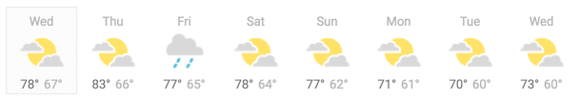

For practice, you could expand on the app by incorporating following steps:

1. Add the ability to click on a day and see its hourly forecast. You can just maintain the current view in the top-level App state.
2. Add React Router to the project (npm install react-router) and follow the quick start guide here to add routes, such that **/** shows the 5-day forecast, and **/[name-of-day]** shows the hourly forecast for a particular day.
3. Sign up for a free API key from Open Weather Map (https://openweathermap.org) , fetch a real 5-day forecast, and feed that data into your app.

This app starts off simple but can be expanded and customized to increase the challenge and learn specific new skills.

**Angular Project – Customer Management App**

This project shows how Angular can be used to integrate with RESTful service that uses Firebase. The application relies on an Angular service that can perform CRUD (create, read, update and delete) operations and also demonstrates using reactive forms. Observables and RxJS plays a key role in the async operations that the application performs.

***Figure 3. List of all customers on home page***

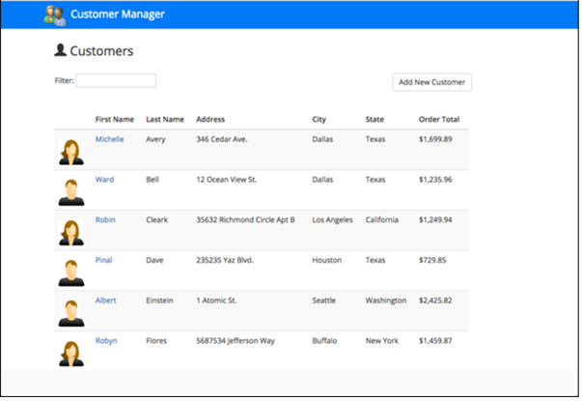

***Figure 4. New customer form***

